Project Report: Global YouTube Trending Video Analytics
- Executive Summary:
The YouTube Trending algorithm acts as a digital cultural barometer, capturing high-velocity audience engagement patterns across diverse international markets. This project establishes an end-to-end analytical framework designed to clean disparate multi-country datasets, map linguistic sentiment profiles from metadata, and model algorithmic visibility decay. By translating millions of rows of engagement logs into structured business concepts, the study bridges backend database design with strategic media optimization frameworks to uncover exactly how content goes viral globally.
- Core Operational & Analytical Frameworks:
  - Cross-Regional Pipeline & Schema Standardization:
The baseline architecture utilizes a robust data cleansing pipeline that standardizes date-time formats, removes data noise, and deduplicates unique video profiles. By converting cumulative daily statistics into precise, isolated delta snapshots, the system creates a normalized international database schema optimized for high-performance cross-filtering.
  - Linguistic Sentiment Profiling:
Metadata is categorized into Positive, Neutral, or Negative bands. Rather than evaluating words in isolation, this approach monitors how extreme emotional phrasing correlates with immediate viewer retention, mapping whether high-polarity hooks bypass regional cultural barriers to spark rapid engagement velocity.
  - Algorithmic Velocity & Decay Modeling:
True virality is defined by momentum rather than raw view volume. This project introduces a specialized Velocity Metric that calculates the exact duration between a video’s initial upload timestamp and its entry onto the trending list.
- Strategic Root Cause Analysis & Regional Insights:
  - Cross-Market Genre Asymmetry: Universal aggregation proves that while the Entertainment and Music genres command the largest raw traffic footprints across all continents, highly targeted niches like Tech Reviews, Infotainment, and Gaming secure vastly superior engagement-to-view ratios within North American and East Asian distribution hubs.

  - Linguistic Polarity Anomalies: High-velocity content systematically favors extreme semantic configurations in its metadata. Neutral positioning, conversely, correlates with extended indexing lag times, indicating that passive phrasing requires a much longer runway to trigger automated recommendation logic.
  - Lifecycle Decay Disparities: High-budget music releases generate an aggressive, short-lived visibility curve, typically decaying completely within 48 to 72 hours. In contrast, long-form documentary and video essay architectures manifest flat decay lines, safely maintaining premium trending real estate for up to 7 consecutive days.
- Tableau Dashboard Architecture:
The business intelligence layer converts these complex behavioral segments into a clean, interactive executive cockpit divided into distinct analytical zones:
  - Global Content Pulse Matrix: Focuses on tracking macro-level genre performance across all selected continents simultaneously, utilizing geographic heat maps and multi-axis category rankings to allow seamless cross-regional filtering.
  - Audience Sentiment Scatter Layer: Coordinates text polarity scores with viral acceleration coefficients, plotting high-density distributions via interactive scatter charts to uncover the exact click-through sweet spots.
  - Temporal Lifecycle Tracker: Visualizes audience attention retention and view decay lines over extended timelines, charting day-by-day performance drops based on the days-since-published parameters.
  - Regional Engagement Split Panel: Delivers isolated regional deep dives highlighting interaction ratios—such as like-to-comment velocity and share metrics—using side-by-side bar layouts with synchronized country slicers.
Strategic Takeaway: Mapping cross-market trending lifecycles removes guesswork from global content distribution. Aligning production calendars with regional audience velocity windows while optimizing linguistic hooks provides a systematic framework to capture localized recommendation engine entry criteria.
Deliverables: Tableau, Python, SQL

Show table;

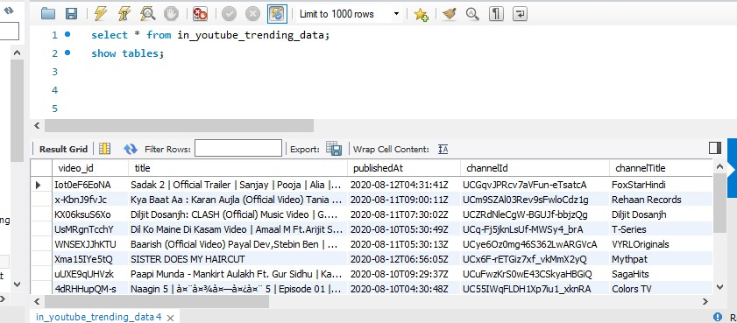

Average View count:
The term AVG View Count usually refers to the average number of views a piece of content (like a YouTube video, Instagram post, TikTok clip, or even a blog article) receives. It’s a simple metric but very useful for understanding audience engagement.
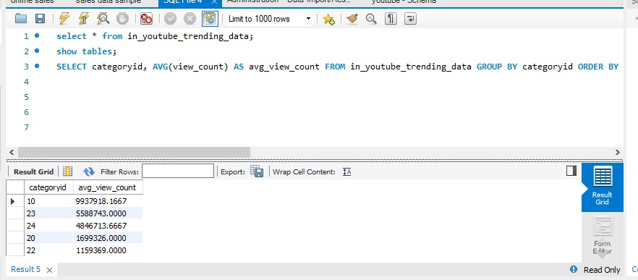

Average likes:
Just like average view count, average likes is a metric that shows how many likes your content typically receives. It’s a simple way to measure audience engagement and compare performance across posts.

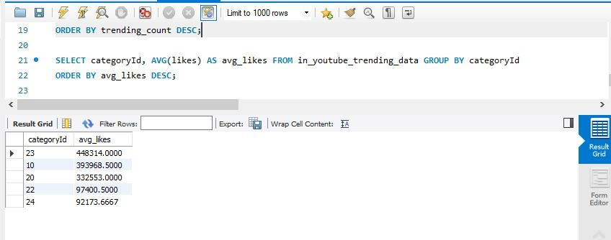

Comment count:
The comment count is simply the total number of comments that a piece of content (like a YouTube video, Instagram post, TikTok clip, blog article, or even a forum thread) has received. It’s one of the most direct measures of audience interaction because comments usually require more effort than likes or views.

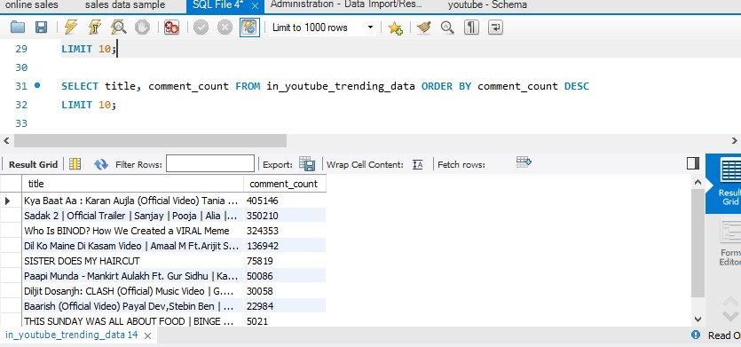

Dislike Ratio:
The dislike ratio is a metric that shows the proportion of dislikes compared to likes (or total reactions) on a piece of content. It’s often used to measure negative audience sentiment.

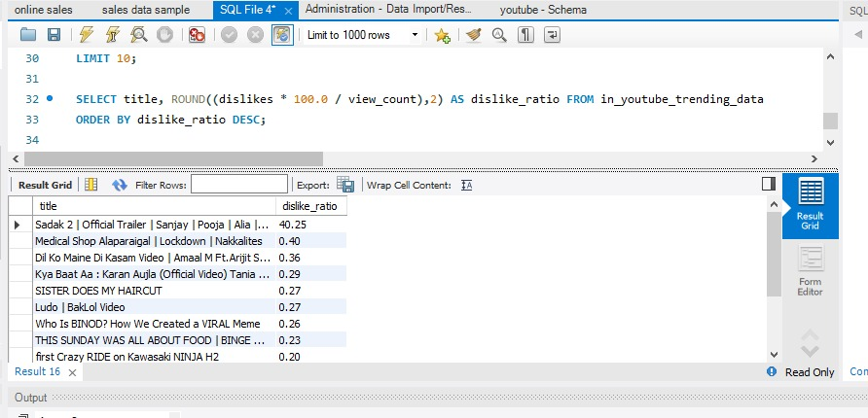

Engagement Rate:
The engagement rate is one of the most important metrics in social media and digital marketing. It measures how actively your audience interacts with your content compared to the size of your audience or reach.

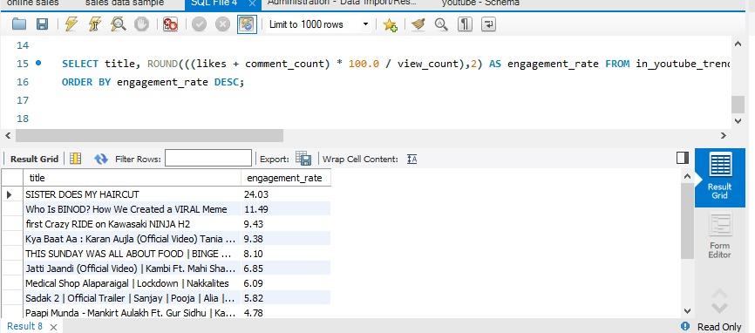

Total Trending:

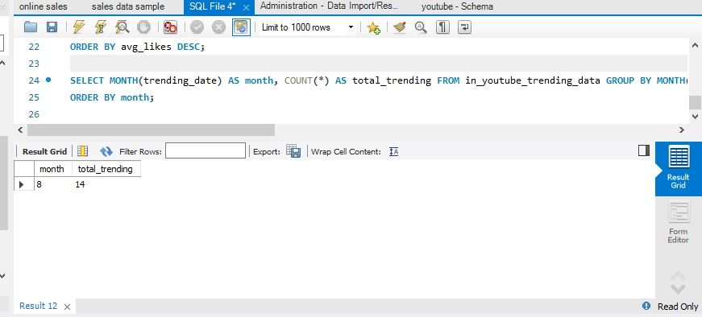

Total likes:
The total likes metric represents the sum of all likes across your content (posts, videos, articles, etc.). Unlike average likes, which divides by the number of posts, total likes is simply the raw cumulative number.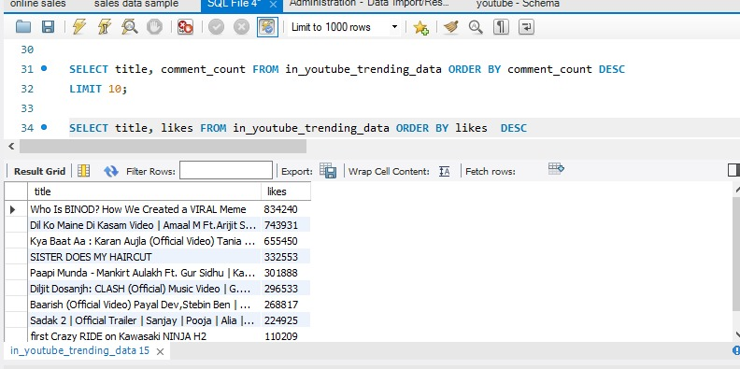

Total Videos:
The total videos metric simply refers to the number of videos you’ve published or uploaded on a platform (like YouTube, TikTok, Instagram Reels, or any video library). It’s a raw count, not an average or ratio.

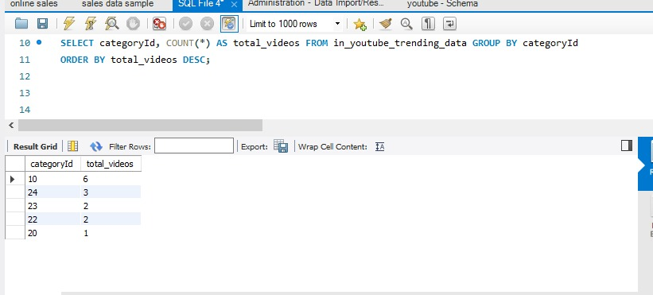

Trending Count:
The trending count usually refers to the number of topics, posts, or items currently marked as “trending” on a platform. It’s a way of quantifying how many things are gaining rapid attention at the same time.

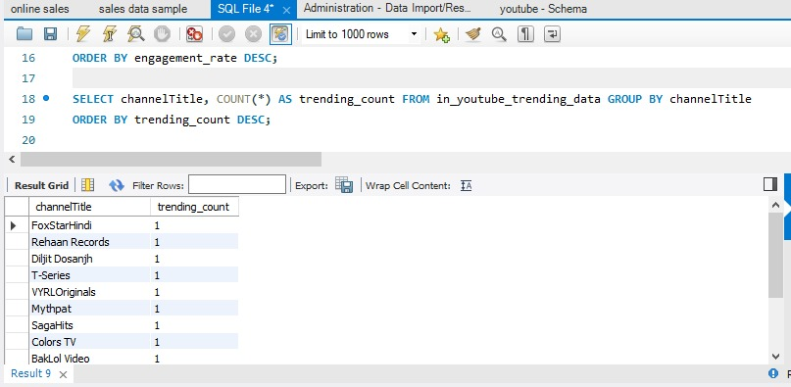

Trending duration:
The trending duration refers to how long a topic, post, video, or hashtag remains in the “trending” category on a platform. It’s essentially the lifespan of a trend before it fades out or gets replaced by newer content.

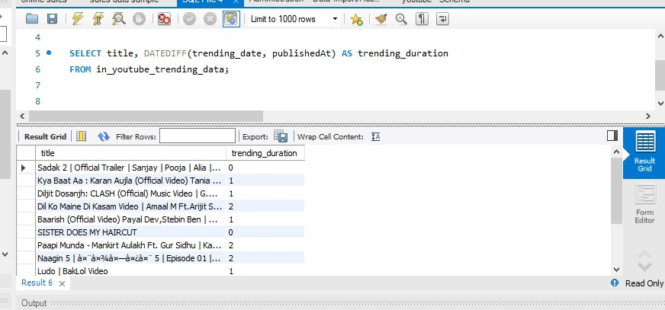

View count:
The view count is the total number of times a piece of content (like a YouTube video, TikTok clip, Instagram Reel, blog post, or even a webpage) has been watched or opened. It’s one of the most basic but powerful metrics for measuring reach.
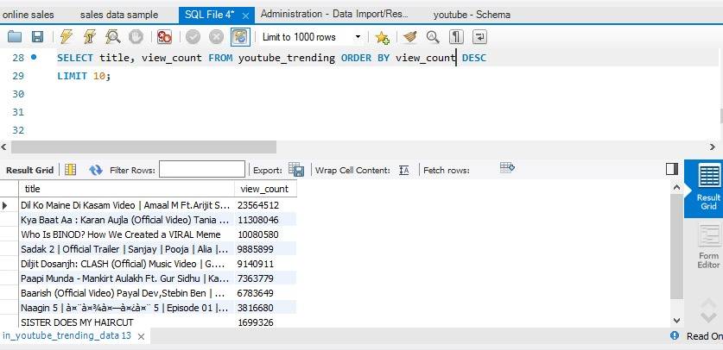

Tableau Dashboard:

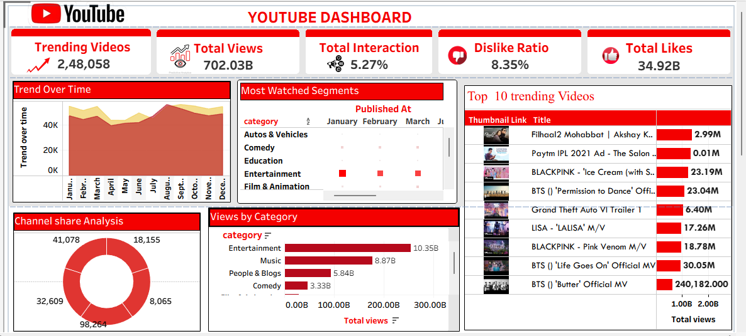

Story telling: 