Contents

**Overall system infrastructure** 2

**How to setup Neo4J** 2

**1.** **Step by step setup Neo4J environment** 2

**2.** **Queries** 2

**How to setup API** 3

**1.** **Step by step setup .Net Core** 3

**2.** **Introduce information infrastructure** 3

- **Presentation** : include RESTfulAPI 3

- **Service**: 4

- **Domain**: include Data, Data.EF and Settings 5

- **Infrastructure**: base infrastructure and some utilities 6

- **UnitTest**: test Repository and Service 6

**How to setup Administrator, Client page** 7

**1.** **How to setup VueJS** 7

**2.** **Introduce system** 7

**Administrator: *http://192.168.206.43:8000*** 7

**Client: *http://192.168.206.43:8001*** 9

# **Overall system infrastructure**

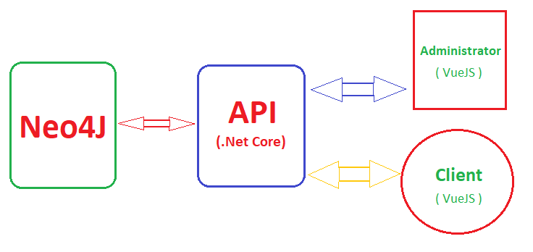

# **How to setup Neo4J**

1. **Step by step setup Neo4J environment**

* Install JDK <https://www.oracle.com/technetwork/java/javase/downloads/index.html> (my recommend is JDK 8)
* Download Neo4J https://neo4j.com/download-center/#releases . On this, we have three options need to be confirmed (Enterprise, Community and Desktop)
* Refer to bin folder, open cmd and type *neo4j console for* startingand login with username and password default: *neo4j*

1. **Queries**

In order to run on non-local remote, just modified some code *conf/neo4j.conf* as follow:

# To have Bolt accept non-local connections, uncomment this line:

*dbms.connector.bolt.address=<your_ip>:7687*

# HTTPS Connector. There can be zero or one HTTPS connectors.

*dbms.connector.https.enabled=true*

*dbms.connector.https.listen_address=<your_ip>:7473*

Ex: Match(p:Product) return p

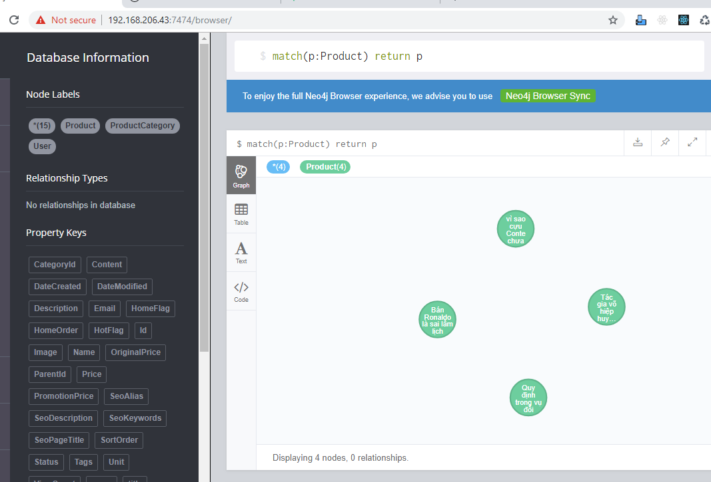

# **How to setup API**

1. **Step by step setup .Net Core**

* Link download: <https://visualstudio.microsoft.com/downloads/>
* Opening folder contain .Net core source code, remove *obj* folder. Come back to top file, type cmd: *dotnet restore*

1. **Introduce information infrastructure**

There have five layers in project including: Presentation, Service, Domain, Infrastructure and UnitTest.

* **Presentation** : include RESTfulAPI

At *Startup.cs*, to register some ServiceCollection.

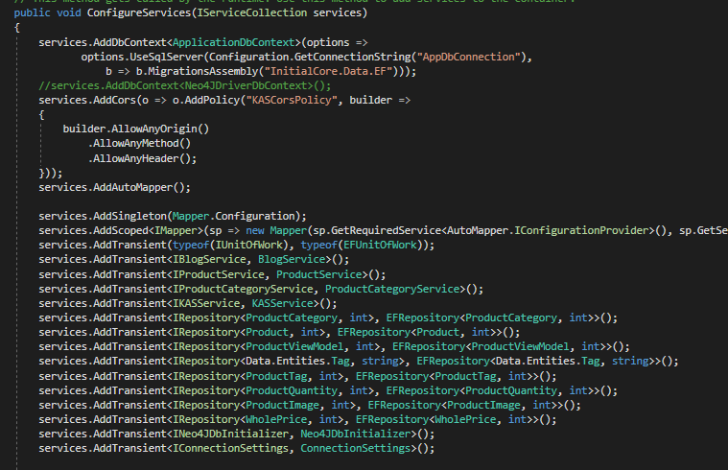

At Controller, to declare some API classes and inject some dependency injections via interface

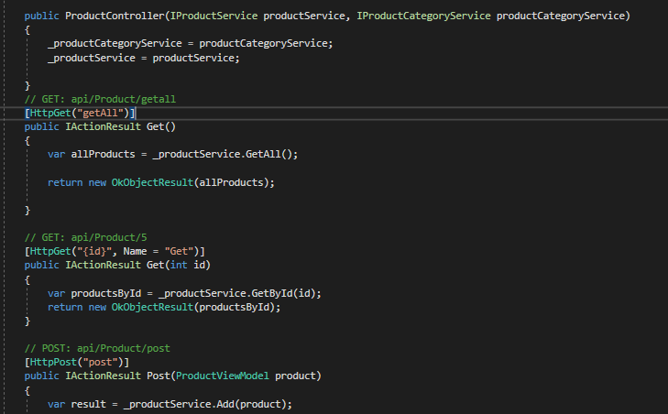

* **Service**:
  + create a couple of interfaces and to implement them based on Implementation and Interfaces folder
  + Auto mapper
* **Domain**: include Data, Data.EF and Settings
  + Data: to initial entities, enums, interface in advance, ViewModels and IRespository necessary.
  + Data.EF: to create repository base based on EFRepository which will implement from IRepository

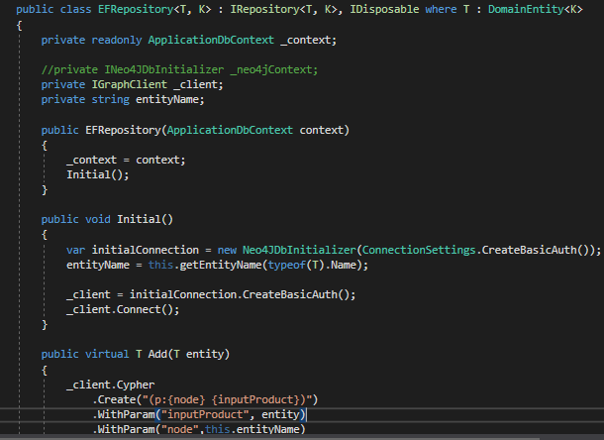

* + Settings:

Install **Neo4jClient** package

To setup connection string parameters and graph client in order to reach into **Neo4J**

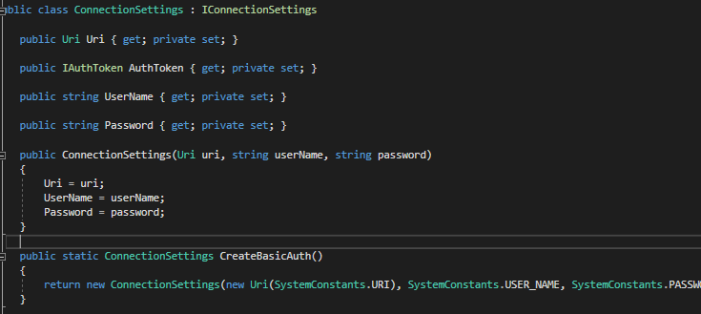

* **Infrastructure**: base infrastructure and some utilities
  + Base infrastructure

To create IUnitOfWork.cs and IRepository.cs interface

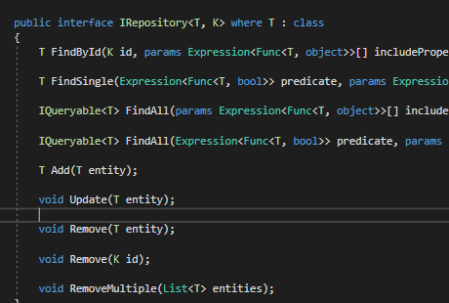

* + Some utilities: Constants, Dtos, Extensions and Helpers
* **UnitTest**: test Repository and Service

To install **Moq** package

At Service:

* + To inject Mock<IRepository<your_model>, int> _mockProduct; and Mock<IUnitOfWork> _ mockUnitOfWork;
  + To Initialize test
  + To create test method
  + Successful: 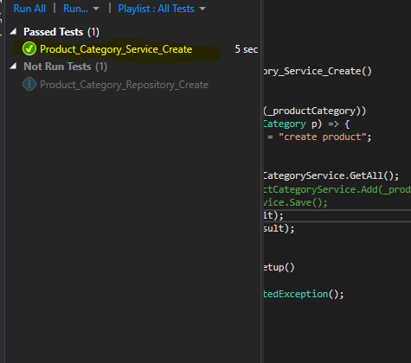

# **How to setup Administrator, Client page**

1. **How to setup VueJS**

* Install NodeJS : <https://nodejs.org/en/download/>
* Download source VueJS from git: *git clone <your_link>*
* At top folder, just type*: npm install*
* In order to run app: *npm run dev*

1. **Introduce system**

### **Administrator: *http://192.168.206.43:8000***

* **Login page**

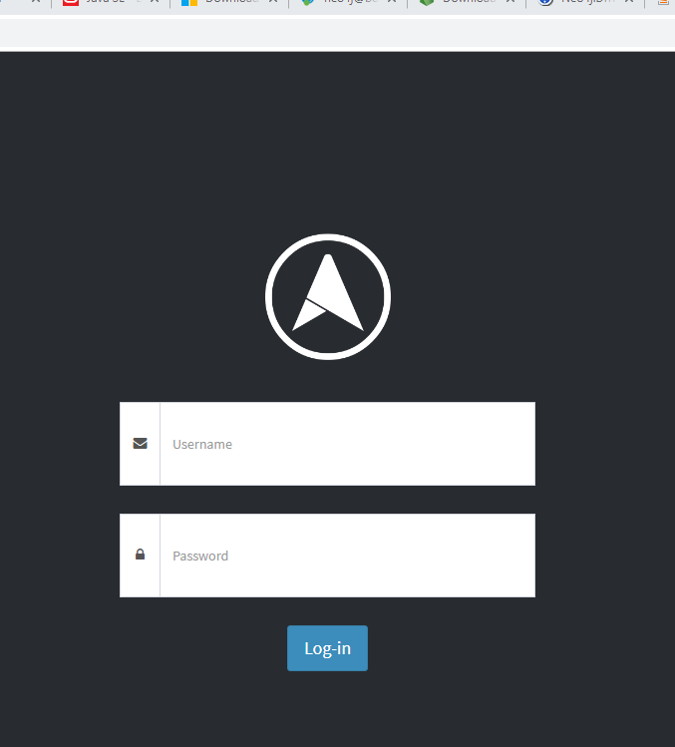

* **Administrator page:**

Home

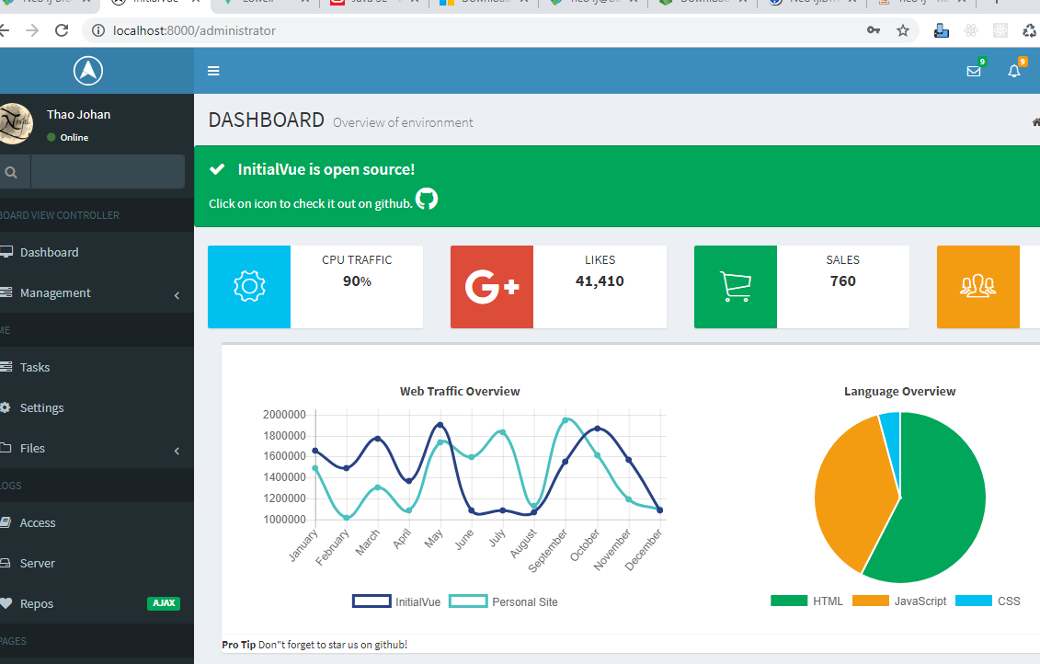

Products Management

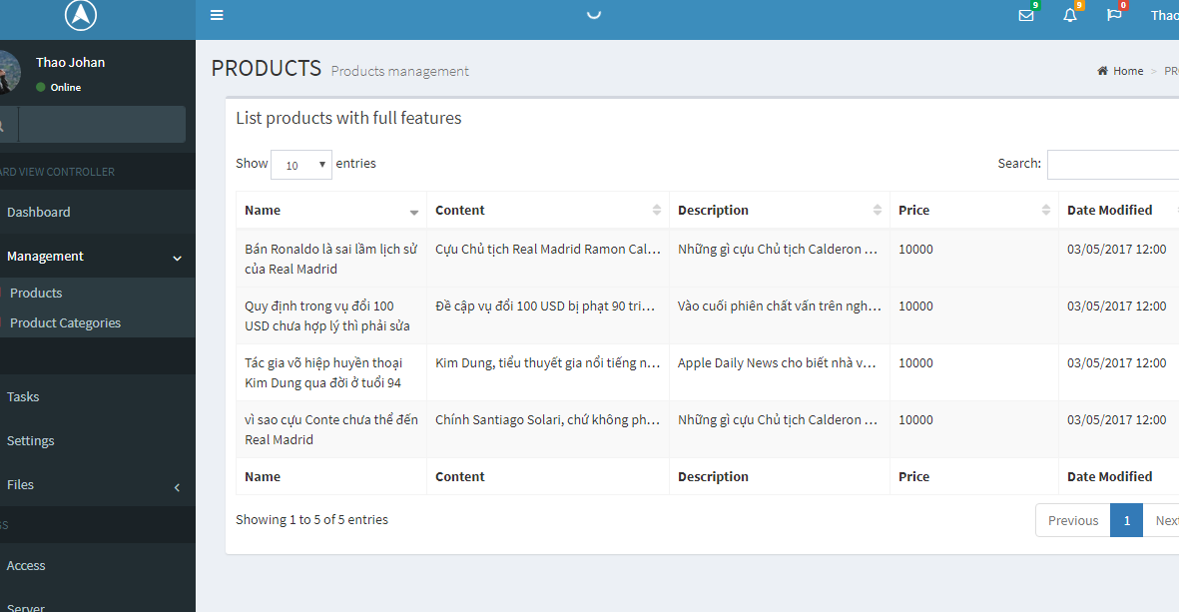

### **Client: *http://192.168.206.43:8001***

* **List of News**



* **Detail of News**

