PHẦN 1 – XÂY DỰNG WEB API

* Tạo lớp Product model trong thư mục Model như sau

public class Product

{

public int Id { get; set; }

public string Name { get;set;}

public string Type { get; set; }

public string Description { get; set; }

public decimal Price { get; set; }

}

* Thiết lập chuỗi kết nối trong web.config

<connectionStrings>

<add name="DefaultConnection" connectionString="Data Source=(local);database=ATMDB;Integrated Security=True"

providerName="System.Data.SqlClient" />

</connectionStrings>

* Tạo lớp ProductContext

public class ProductContext:DbContext

{

public ProductContext()

: base("name=DefaultConnection")

{

}

public DbSet<Product> Products { get; set; }

}

* Biên dịch, click chuột phải trên thư mục Controllers, chọn Add new Controller và chọn như hình sau

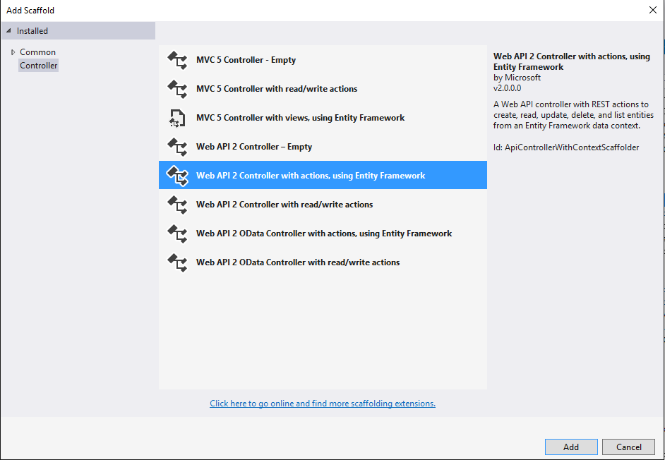

* Mã nguồn sinh ra như sau

public class ProductsController : ApiController

{

private ProductContext db = new ProductContext();

// GET: api/Products

public IQueryable<Product> GetProducts()

{

return db.Products;

}

// GET: api/Products/5

[ResponseType(typeof(Product))]

public IHttpActionResult GetProduct(int id)

{

Product product = db.Products.Find(id);

if (product == null)

{

return NotFound();

}

return Ok(product);

}

// PUT: api/Products/5

[ResponseType(typeof(void))]

public IHttpActionResult PutProduct(int id, Product product)

{

if (!ModelState.IsValid)

{

return BadRequest(ModelState);

}

if (id != product.Id)

{

return BadRequest();

}

db.Entry(product).State = EntityState.Modified;

try

{

db.SaveChanges();

}

catch (DbUpdateConcurrencyException)

{

if (!ProductExists(id))

{

return NotFound();

}

else

{

throw;

}

}

return StatusCode(HttpStatusCode.NoContent);

}

// POST: api/Products

[ResponseType(typeof(Product))]

public IHttpActionResult PostProduct(Product product)

{

if (!ModelState.IsValid)

{

return BadRequest(ModelState);

}

db.Products.Add(product);

db.SaveChanges();

return CreatedAtRoute("DefaultApi", new { id = product.Id }, product);

}

// DELETE: api/Products/5

[ResponseType(typeof(Product))]

public IHttpActionResult DeleteProduct(int id)

{

Product product = db.Products.Find(id);

if (product == null)

{

return NotFound();

}

db.Products.Remove(product);

db.SaveChanges();

return Ok(product);

}

protected override void Dispose(bool disposing)

{

if (disposing)

{

db.Dispose();

}

base.Dispose(disposing);

}

private bool ProductExists(int id)

{

return db.Products.Count(e => e.Id == id) > 0;

}

}

PHẦN 2 – XÂY DỰNG WEB API Client

* Hiển thị danh sách sản phẩm
  + Tạo ActionMethod mới trong HomeController

public ActionResult ListProduct()

{

ViewBag.Title = "Home Page";

return View();

}

* + Add View và viết mã như sau

@{

ViewBag.Title = "ListProduct";

}

<h2>ListProduct</h2>

<div>

<h4>Product List</h4>

<input type="button" value="View All Products" onclick="GetAllProducts();" />

<ul id="ProductList" />

</div>

@section Scripts{

<script type="text/javascript">

var hostUrl = "http://" + document.location.hostname + ":" + window.location.port;

var apiUrl = '/api/Products';

$(document).ready(function() {});

function GetAllProducts()

{

$.ajax(

{

url: hostUrl + apiUrl,

type: 'GET',

dataType: 'json',

success: function(data)

{

DisplayProductList(data);

},

error: function()

{

alert('Some error occured');

}

});

}

function DisplayProductList(products) {

$("#ProductList").empty();

var result = "<table><th>ID</th><th>Name</th><th>Type</th><th>Description</th><th>Price</th>";

$.each(products, function (index, product) {

result += "<tr><td>" + product.Id + "</td><td> " + product.Name + "</td><td>" + product.Type + "</td><td>" + product.Description + "</td><td>" + '₹ ' + product.Price + "</td></tr>";

});

result += "</table>";

$("#ProductList").html(result);

}

</script>

}

* Thêm sản phẩm
  + Viết ActionMethod trong HomeController

public ActionResult AddProduct()

{

ViewBag.Title = "Home Page";

return View();

}

* + Tạo View

@{

ViewBag.Title = "AddProduct";

}

<h2>AddProduct</h2>

<table>

<tr>

<td>Name</td>

<td>

<input type="text" id="Name" />

</td>

</tr>

<tr>

<td>Type</td>

<td>

<input type="text" id="Type" />

</td>

</tr>

<tr>

<td>Description</td>

<td>

<input type="text" id="Description" />

</td>

</tr>

<tr>

<td>Price</td>

<td>

<input type="text" id="Price" />

</td>

</tr>

<tr>

<td colspan="3" align="center">

<input type="button" value="Add" onclick="AddProduct();" />

</td>

</tr>

</table>

@section Scripts

{

<script type="text/javascript">

var hostUrl = "http://" + document.location.hostname + ":" + window.location.port;

var apiUrl = '/api/Products';

$(document).ready(function () { });

function GetAllProducts() {

$.ajax(

{

url: hostUrl + apiUrl,

type: 'GET',

dataType: 'json',

success: function (data) {

DisplayProductList(data);

},

error: function () {

alert('Some error occured');

}

});

}

function AddProduct() {

var product = {

Name: $('#Name').val(),

Type: $('#Type').val(),

Description: $('#Description').val(),

Price: $('#Price').val()

};

$.ajax(

{

url: hostUrl + apiUrl,

type: 'POST',

data: JSON.stringify(product),

contentType: "application/json;charset=utf-8",

success: function (data) {

alert('Product added');

//GetAllProducts();

},

error: function () {

alert('Some error occured');

}

});

}

function DisplayProductList(products) {

$("#ProductList").empty();

var result = "<table><th>ID</th><th>Name</th><th>Type</th><th>Description</th><th>Price</th>";

$.each(products, function (index, product) {

result += "<tr><td>" + product.Id + "</td><td> " + product.Name + "</td><td>" + product.Type + "</td><td>" + product.Description + "</td><td>" + '₹ ' + product.Price + "</td></tr>";

});

result += "</table>";

$("#ProductList").html(result);

}

</script>

}

* Xóa sản phẩm
  + Tạo ActionMethod

public ActionResult DeleteProduct()

{

ViewBag.Title = "Home Page";

return View();

}

* + Tạo View

@{

ViewBag.Title = "DeleteProduct";

}

<h2>DeleteProduct</h2>

<input type="text" id="delProductID" size="5" />

<input type="button" value="Delete" onclick="DeleteProduct();" />

@section Scripts{

<script type="text/javascript">

var hostUrl = "http://" + document.location.hostname + ":" + window.location.port;

var apiUrl = '/api/Products';

$(document).ready(function () { });

function DeleteProduct() {

var id = $('#delProductID').val();

$.ajax(

{

url: hostUrl + apiUrl + '/' + id,

type: 'DELETE',

dataType: 'json',

success: function (data) {

alert('Product deleted');

//GetAllProducts();

},

error: function (request, status, error) {

alert(request.responseText);

}

});

}

</script>

}

* Update Sản phẩm
  + Tạo action method

public ActionResult EditProduct()

{

ViewBag.Title = "Home Page";

return View();

}

* + Tạo view

@{

ViewBag.Title = "EditProduct";

}

<h2>EditProduct</h2>

<div>

<h4>Search by ID</h4>

<input type="text" id="searchProductID" size="5" />

<input type="button" value="Search" onclick="FindProduct();" />

<p id="prod" />

</div>

@section Scripts

{

<script type="text/javascript">

var hostUrl = "http://" + document.location.hostname + ":" + window.location.port;

var apiUrl = '/api/Products';

$(document).ready(function () { });

function FindProduct() {

var id = $('#searchProductID').val();

$.getJSON(apiUrl + '/' + id).done(function (data) {

DisplayProductForEdit(data);

}).fail(function (jqXHR, textStatus, err) {

$('#prod').text('Error: ' + err);

});

}

function UpdateProduct() {

var product = {

Id: $('#searchProductID').val(),

Name: $('#EditName').val(),

Type: $('#EditType').val(),

Description: $('#EditDescription').val(),

Price: $('#EditPrice').val()

};

$.ajax(

{

url: hostUrl + apiUrl,

type: 'PUT',

data: JSON.stringify(product),

contentType: "application/json;charset=utf-8",

success: function (data) {

alert('Product updated');

},

error: function (request, status, error) {

alert(request.responseText);

}

});

}

function DisplayProductForEdit(product) {

$("#prod").empty();

if (product == null) {

alert('Product Not Found')

return;

}

$("#prod").empty();

var result = "<table>" + "<tr><td>Name</td><td><input type='text' id='EditName' value='" + product.Name + "'</td></tr>" + "<tr><td>Type</td><td><input type='text' id='EditType' value='" + product.Type + "'</td></tr>" + "<tr><td>Description</td><td><input type='text' id='EditDescription' value='" + product.Description + "'</td></tr>" + "<tr><td>Price</td><td><input type='text' id='EditPrice' value='" + product.Price + "'</td></tr>" + "<tr><td colspan='3'align='center'><input type='button' value='Update' onclick='UpdateProduct();' </td></tr>" + "</table>";

$("#prod").html(result);

}

</script>

}

