Thiết kế giao diện layout mới như dưới đây

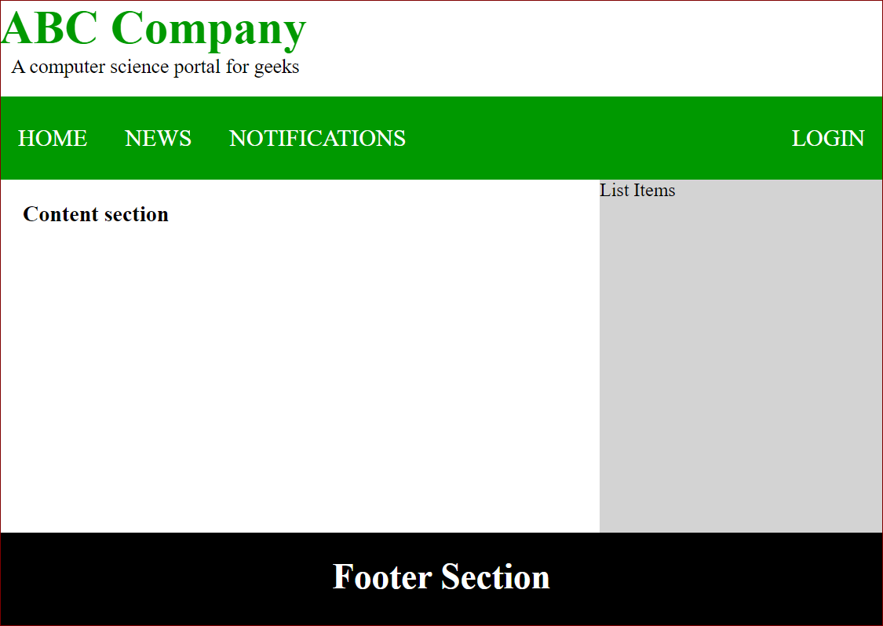

<!DOCTYPE html>

<html>

<head>

<title>Page Layout</title>

<style>

*{box-sizing: border-box;}

.head1 { font-size:40px; color:#009900; font-weight:bold; }

.head2 { font-size:17px; margin-left:10px; margin-bottom:15px; }

body { margin: 0 auto; background-position:center; background-size: contain; }

.menu { position: sticky; top: 0; background-color: #009900; padding:10px 0px 10px 0px; color:white;

margin: 0 auto; overflow: hidden; }

.menu a { float: left; color: white; text-align: center; padding: 14px 16px; text-decoration: none;

font-size: 20px; }

.menu-log { right: auto; float: right; }

footer { width: 100%; bottom: 0px; background-color: #000; color: #fff; padding-top:20px; padding-bottom:50px; text-align:center; font-size:30px; font-weight:bold; clear: both;

}

.body_sec { margin-left:20px;}

#Content {width: 67%;float: left;}

#right {width: 33%;height:300px;float: left;background-color: lightgray;}

</style>

</head>

<body>

<!-- Header Section -->

<header>

<div class="head1">ABC Company</div>

<div class="head2">A computer science portal for geeks</div>

</header>

<!-- Menu Navigation Bar -->

<div class="menu">

<a href="#home">HOME</a>

<a href="#news">NEWS</a>

<a href="#notification">NOTIFICATIONS</a>

<div class="menu-log">

<a href="#login">LOGIN</a>

</div>

</div>

<!-- Body section -->

<div class = "body_sec">

<section id="Content">

<h3>Content section</h3>

</section>

<aside id="right">

<div>List Items</div>

</aside>

</div>

<!-- Footer Section -->

<footer>Footer Section</footer>

</body>

</html>

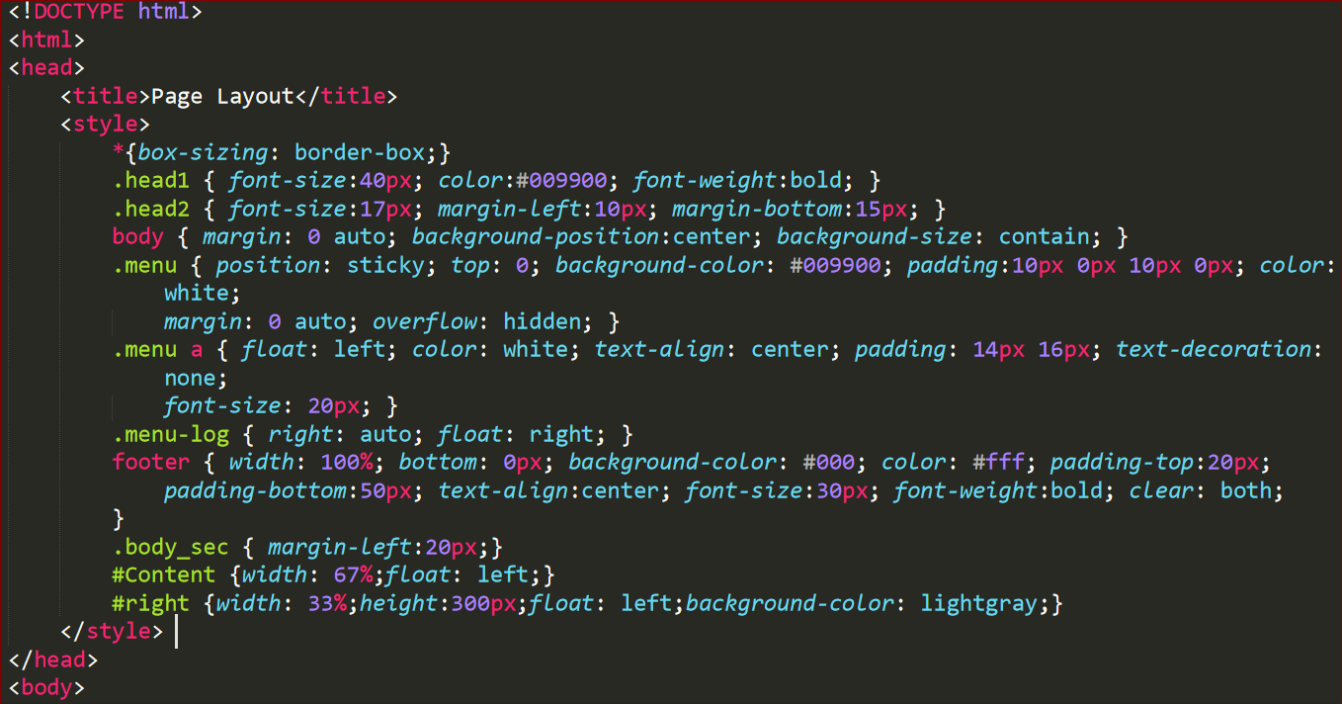

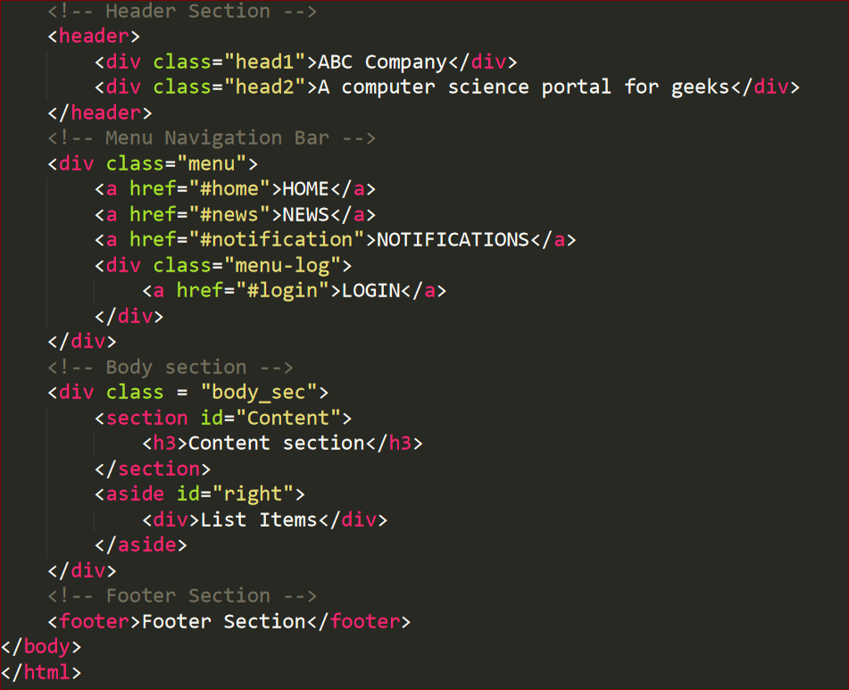

Phần 2 – Thiết kế giao diện admin cho ShoppingOnline

Gợi ý mẫu

