Presentation

Introduction

Shape fitting Point Clouds to Building Shapes
- Motivation: Getting absolute position for point clouds, necessary to e.g. reconstruct cityscapes
- Goal: Implement a method to reliably fit a SfM point cloud to 2D building shapes
  - Shapes are provided by OSM (manually created)
  - Point cloud data acquired by SfM (from photographs)

ICP approach to fitting
- Using “Iterative Closest Point” (ICP) algorithm for fitting building shapes
- 2D project building outlines into ground plane
- If GPS available, use for initial fit
- Evaluate removing undetectable things from OSM (holes, inside walls)
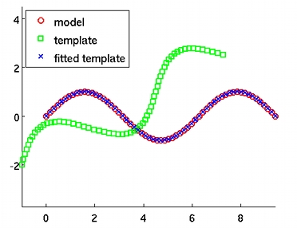
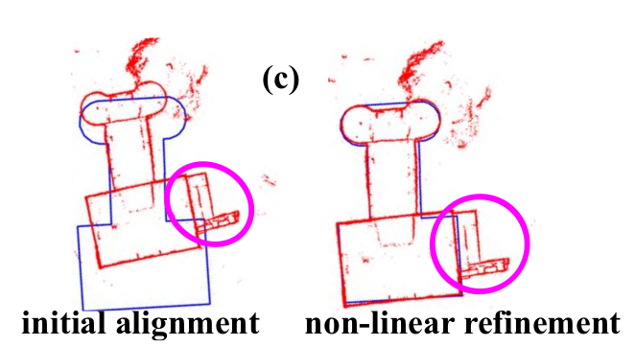

Building Height + Roof Shape Estimation
- Building height estimation by taking plane in upvector (can be contributed back to OSM)
- Absolute value known because of merging with OSM data
- Roof Shape estimation: Harder problem (point cloud on top sparse, because images taken from groundlevel)
- Take images from above, or use symmetry, and maybe human input to estimate roof shapes

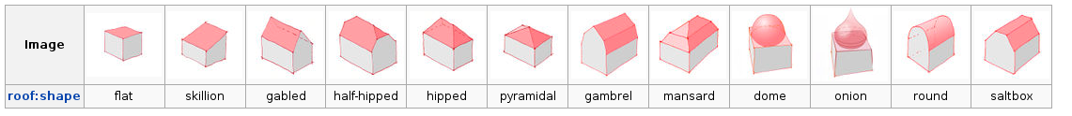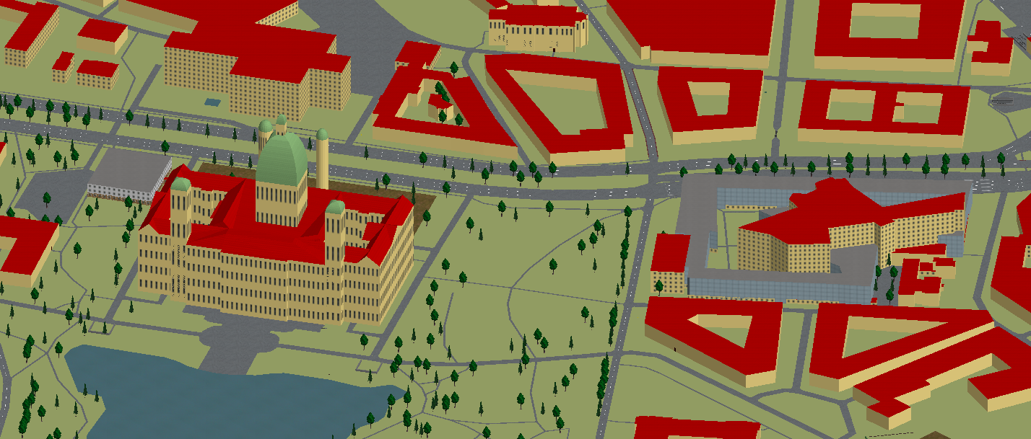

http://openstreetmaps.org

