INTRODUCTION: Territorial arterial spin labeling (tASL) offers unique opportunity to visualize vascular territories by selectively labeling main brain feeding arteries including right ICA, left ICA and posterior circulation. One of the major disadvantages of tASL is its relatively long acquisition time, which results from the requirement of labeling multiple feeding arteries. This issue is particularly important in actual clinical setting where patients are not necessarily cooperative. One way to minimize this effect is to use shared rotating control slab for subtraction. Compared to the normal 3 slabs method, this would allow reduction of scan time by 30% or 50% in combination with dual-vessel labeling [1]. This shared control slab potentially results in inaccurate estimate of ΔM from each feeding vessels due to incomplete compensation of magnetization transfer (MT) effects. Zimine et al. described that there were no significant differences between normal and shared rotating control method in mean ΔM/M₀ values computed in 3 territorial masks [2]. However, validity of this method needs to be further proven in actual clinical interpretation. Therefore we introduced an observer test comparing normal method against rotating control method in the assessment of territorial flow.

METHODS: In a full cycled acquisition of 3 territories (Right ICA, Left ICA, Posterior), labeling (l)/control (c)scheme is “Ll Lc Rl Rc Pl Pc Ll Lc…”, while shared rotating control scheme would correspond to “Ll Rl Pl Lc Ll Rl Pl Rc Ll Rl Pl Pc…”. Twenty-four patients (chronic cerebral arterial steno-occlusive diseases: 15, moyamoya disease: 4, cerebral aneurysm: 4, left atrial thrombosis: 1) were studied using QUASAR ASL [1] on a 3T clinical scanner (Achieva, Philips). Imaging parameters were as follows: FOV=240 mm, matrix=64x64, 7 slices (6mm, 2mm gap), TR/TE=4000/22 ms, flip=35°, TI₁/ΔTI=50/300 ms (13 time points), SENSE=2.5, V_{enc}=∞. 22 label-control pairs per territory were acquired in 9 min. For each subject, two sets of perfusion maps were generated as normal averaged control-label in corresponding territories and as simulated rotating control scheme. Individual territories were combined into RGB maps for visual assessment. The territorial flow was assessed on the RGB maps generated by the two methods within 13 anatomic segments per hemisphere (26 segments for each patient) defined according to the vascular territories [3] (Fig 1). These 13 segments included 10 segments of the main intracranial arteries (A1,2; M1–6;P1,2) as well as 3 perforator territories (insula, basal ganglia and corona radiata). Most dominant colors (Red vs Green vs Blue) within the respective segments at 3 post-labeling time points (650, 950, 1250 ms after labeling) were reported by 2 independent radiologists in a double-blinded manner, and were compared between normal and rotating control methods. The degree of agreement was analyzed by kappa statistics.
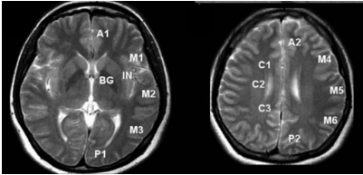
Fig.1: Vascular territories on MRI.
IN: insula, BG: basal ganglia, C: corona radiate
A: anterior cerebral, M: middle cerebral,
P: posterior cerebral artery teritories

RESULTS: Over all agreement between the two readers was excellent (kappa =0.98). Table shows the kappa coefficients for the agreement of the two methods in the respective sites at 3 post-labeling time points. Over all, excellent agreements between the two methods were observed (kappa =0.98). There appears a tendency that kappa values were lower in the posterior cerebral artery (PCA) territories, especially in the later post-labeling phase. Figure 2 shows combined RGB tASL maps in a patient with left ICA stenosis. All perfusion maps show very similar territorial information. Figure 3 shows tASL maps in a patient with moyamoya disease. In the right PCA territory, blood from left ICA (red) looks dominant in normal method, whereas blood from right ICA (green) looks dominant in rotating control method.

CONCLUSION: Our observer test demonstrated that tASL using shared rotating control acquisition over all provided comparable information on territorial flow to normal control acquisition, with the advantage of shortened scan time, confirming the efficacy of shared rotating control method. Our data suggested that, in the shared rotating control method, the territorial information may be less reliable in the PCA territories, presumably due to the incomplete compensation of the MT effects.
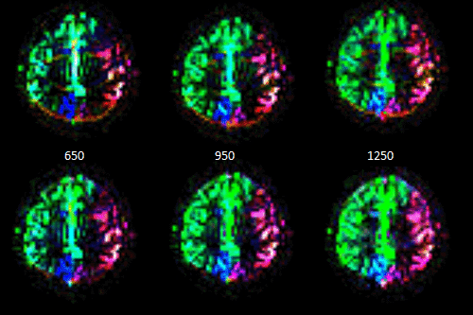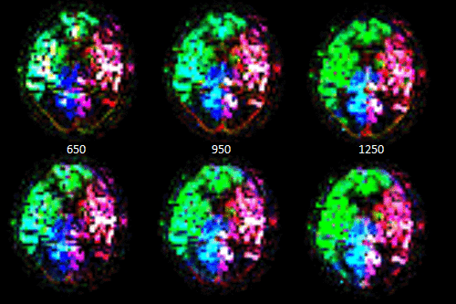
Fig.2: Combined tASL maps in a patient with left ICA stenosis generated using normal (top) and rotating (bottom) control methods (left/right panels = lower/higher slices).

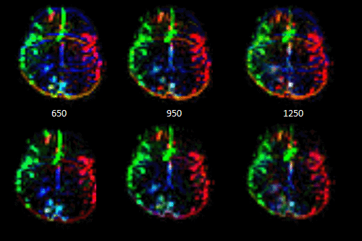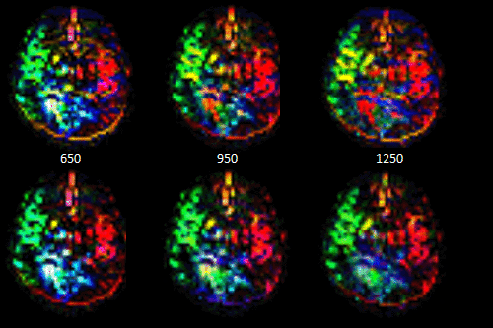
Fig.3: Combined tASL maps in a patient with moyamoya disease generated using normal (top) and rotating (bottom) control methods (left/right panels = lower/higher slices).

REFERENCES: [1] Zimine I. et al. MRM 56:1140 (2006),[2] Zimine I. et al. Proc. ISMRM (2009),[3]Barber PA et al. Lancet 355: 1670 (2000)
[4] Pavia FF et al., NMR Biomed 20:633 (2007)
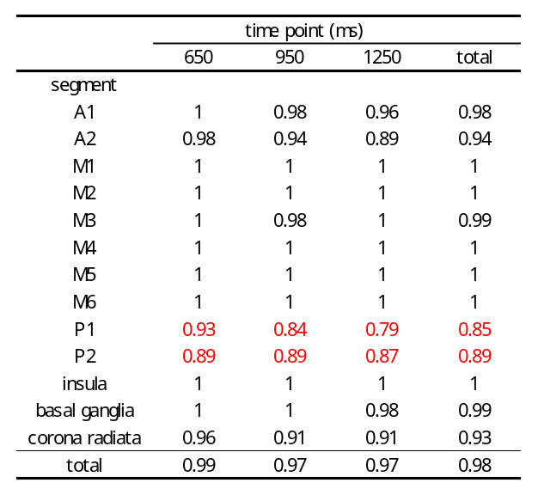
Table: Kappa coefficients for 13 segments at 3 post-labeling time points.

