Simple viewer for RPI data (rpiview)
Notes for users

Author: Ivan Zimine
Date: 2008-01-29

General:
RPIview is a tool to display Regional Perfusion Imaging (RPI) data acquired with full QUASAR patch (from Drs. X. Golay and E.T. Petersen, National Neuroscience Institute, Singapore, developed on Achieva 3.0T R2.1.3.3 (SWID90)). The main difference with any previous RPI capable patches is that data for all territories is acquired in a single acquisition in an interleaved manner. The advantage of this approach is reduced probability of subject motion that may affect selective labeling.

QUASAR patch allows several options with respect of how labeling and control experiments are done for an RPI acquisition. “Normal” labeling corresponds to 3-slab approach where Left ICA, Right ICA and POSTerior circulation are labeled individually as described in (1). “Dual” labeling corresponds to 2-slab approach (2), which still requires more clinical validation. “Hadamard” option is also available in the patch, but not in RPIview. It refers to the approach described in (3), but it is completely unclear whether it has any clinically utility.
In addition to these, there are also three options which affect “control” acquisitions. “Individual” control means that for each territory, label and control pulses are applied in the same slab. This is the standard approach. “Rotating” control means that first labeling pulses are applied to all slabs followed by a single control in one of the slabs. In the next dynamic cycle, again after all labeling pulses, control pulse is done in another slab. This approach allows further reduction of total scan time. However subtraction errors due to magnetization transfer effects still need to be investigated. “Common” control is similar to “Rotating” with respect to label/control cycling, but all controls are done in an addition slab which can be positioned independently from labeling slabs.

With current patch implementation, it is not possible to infer directly from the data how “label” and “control” conditions were acquired. Therefore, it is important to set the same options for post-processing in RPIview as those used for data acquisition.

User interface:
Load Par/Rec
Basic Data Information
Save current screen (png, jpg, tif)
Zoom In/Out
4x4 grid view (only for RPI map)
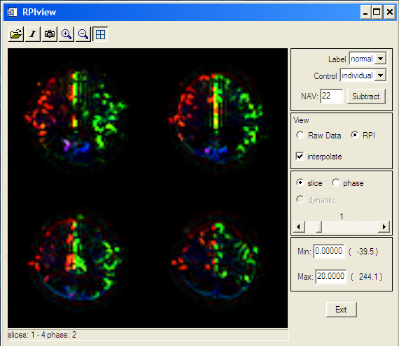
normal / dual
Individual / rotating
real min
real max
When data is loaded, 1st slice of the 1st phase of the 1st dynamic is displayed (raw data). It is a very low intensity image, and unless “Max:” value is not lowered, it is very difficult to see the image on the screen. “Min/Max” is used for color scaling in a way similar to Window/Level: min,max=level±window/2. Only data between min and max is displayed.

Normally subtraction between “controls” and “labels” is done using all available data. It is possible to subtract less data by lowering “NAV” (nb of averages) value. This number represents the number of “control/label” pairs for one territory. It is assumed that all territories have the same number of acquired pairs (ex: total nb of dynamics=132, territories =3, control for each label… 22=132/3/2). Lower NAV allows to check how RPI maps would look if overall smaller number of images was acquired, i.e. mainly useful for protocol optimization. This option may disappear in future versions of RPIview.


Current version of RPIview, uses color convention for displaying RPI maps as proposed by Drs. Hendrikse and Golay. Namely: red for RightICA, green for LeftICA and blue for POST.

REFERENCES
1. Hendrikse J, van der Grond J, Lu H, van Zijl PCM, Golay X. Flow territory mapping of the cerebral arteries with regional perfusion MRI. Stroke 2004;35:882.
2. Zimine I, Petersen ET, Golay X. Dual vessel arterial spin labeling scheme for regional perfusion imaging. Magn Reson Med 2006;56:1140.
3. Günther M. Efficient visualization of vascular territories in the human brain by cycled arterial spin labeling MRI. Mag Reson Med 2006;56:671.

Labeling pulse is a 180˚ adiabatic inversion. Control pulse is a 0˚ adiabatic null pulse applied with same RF power as the labeling pulse.

