Result
A Workbench screenshot of each query result (monthly revenue, top 10, new vs repeat, product change)
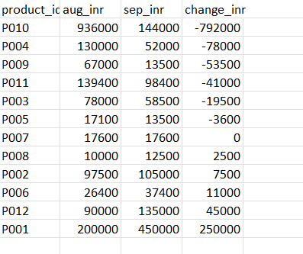
chart1_monthly_revenue
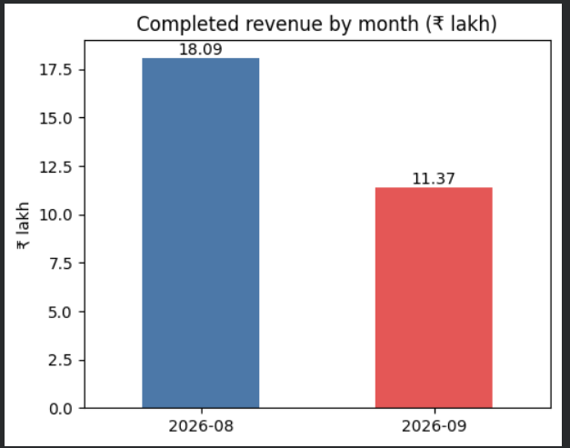
chart2_product_change


