- When you navigate to blink it page.
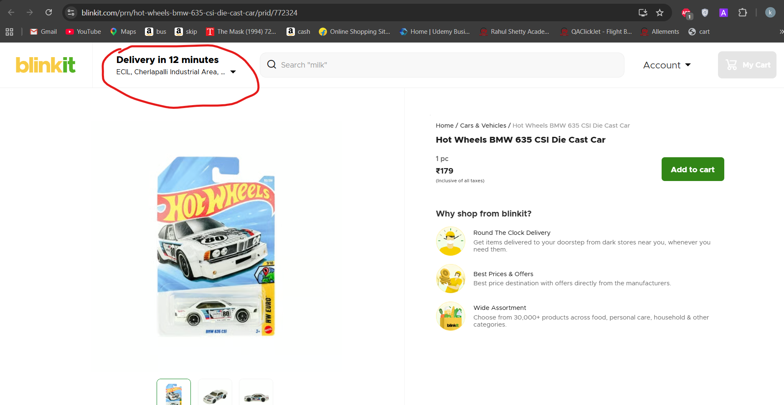

Click on rounded delivery drop down
Xpath for it is: //*[@id="app"]/div/div/div[1]/header/div[1]/div[2]/div/div[2]/div[1]
After clicking pop up for change location will be come in ui

As shown in below image it will appears.
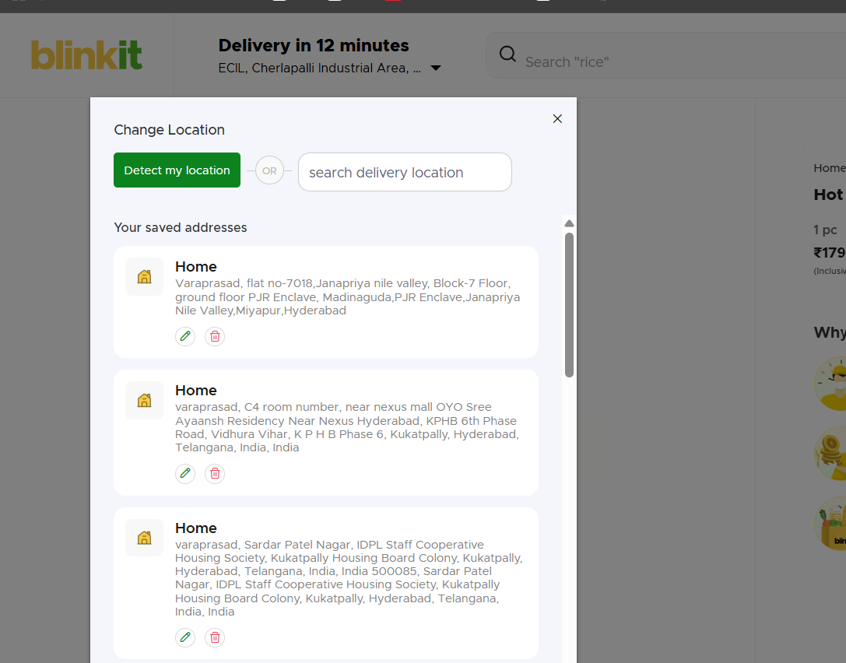
You need enter pincode in search deliver lication text box.
Text box xpath is -//*[@id="app"]/div/div/div[1]/header/div[2]/div[2]/div/div/div[1]/div/div/div/div[2]/div[2]/div/div/div/input

Example I have enter 500062 pincode.
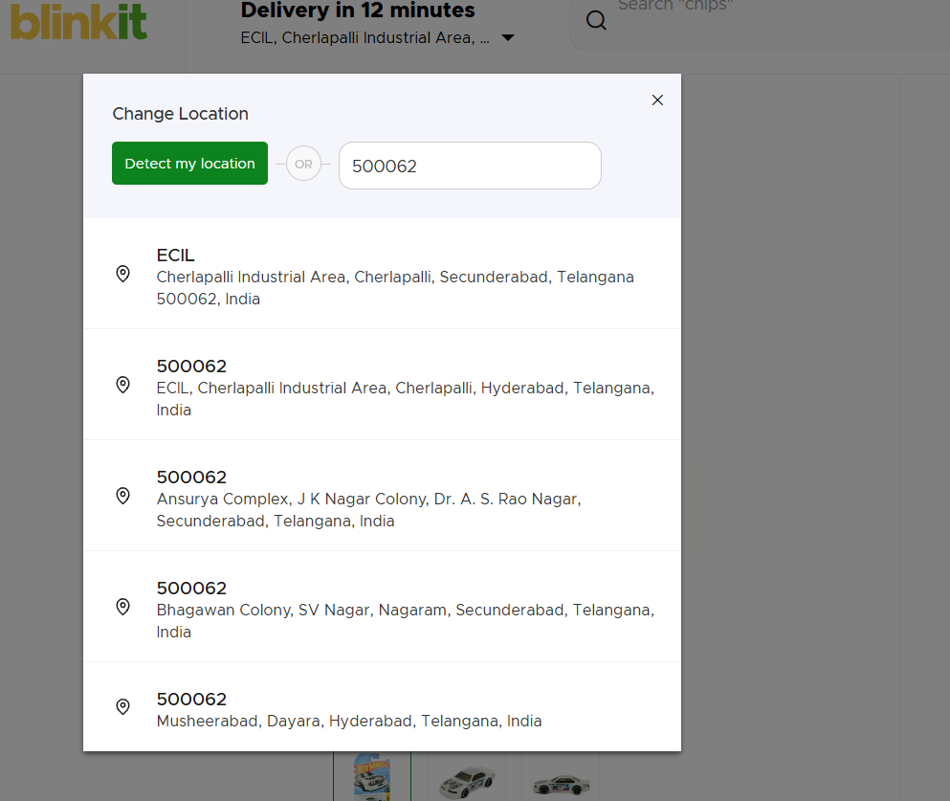
You will get list of location under that pincode.

Here not xpath you need to built xpath.

Element - class="LocationSearchList__LocationDetailContainer-sc-93rfr7-1 bBiSUM"

LocationSearchList__LocationDetailContainer common , -sc-93rfr7-1 bBiSUM – varies.
Bulild a xpath it should have like operation sreach for element which has class like LocationSearchList__LocationDetailContainer and select first option in the list and select that elevement

