DBMS – PRODUCT AND CATEGORY MANAGEMENT
TITAN EYE – EYEWEAR E-COMMERCE DATABASE SYSTEM
1.DATABASE DESIGN
1.1 CATEGORY TABLE
Attribute | Description
Category_ID | Unique category ID
Category_Name | Category name
1.2 PRODUCT TABLE
Attribute | Description
Product_ID | Unique product ID
Product_Name | Eyewear product name
Price | Product price
Stock | Available stock
Category_ID | Category ID
Frame_Color | Frame color
Lens_Type | Lens type

2.Category → Product
- Category.Category_ID → Primary Key
- Product.Product_ID → Primary Key
- Product.Category_ID → Foreign Key referencing Category.Category_ID
- Relationship: One-to-Many (1:M)

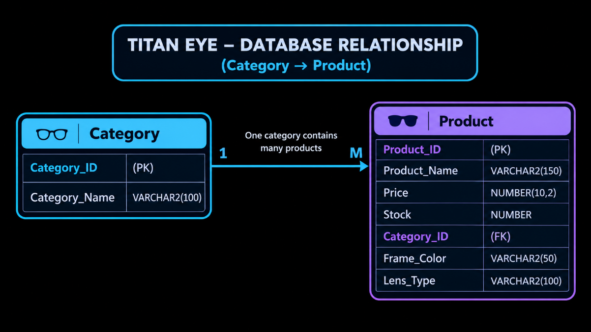
3.TABLE CREATION
3.1 CREATE CATEGORY TABLE

3.2 CREATE PRODUCT TABLE
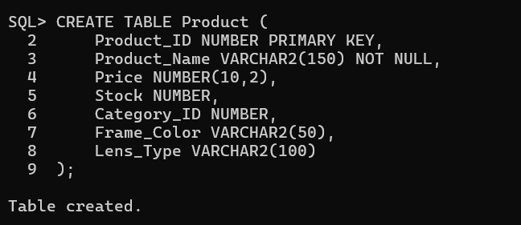

4.DATA INSERTION
4.1 CATEGORY RECORDS
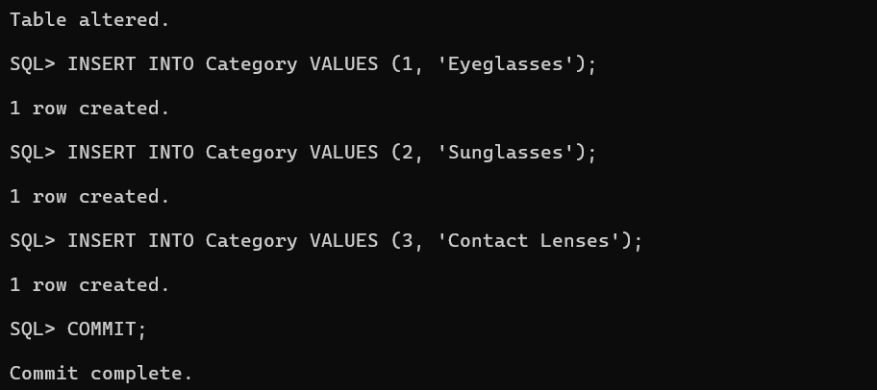
4.2 PRODUCT RECORDS
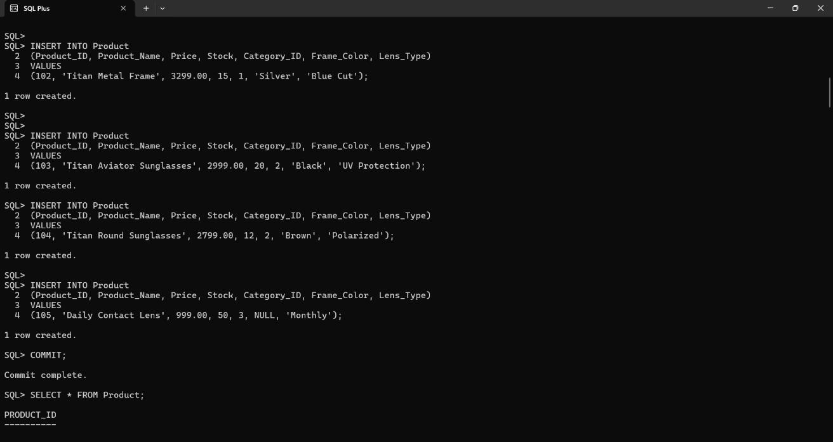

5. DATA RETRIEVAL
5.1 DISPLAY CATEGORY RECORDS

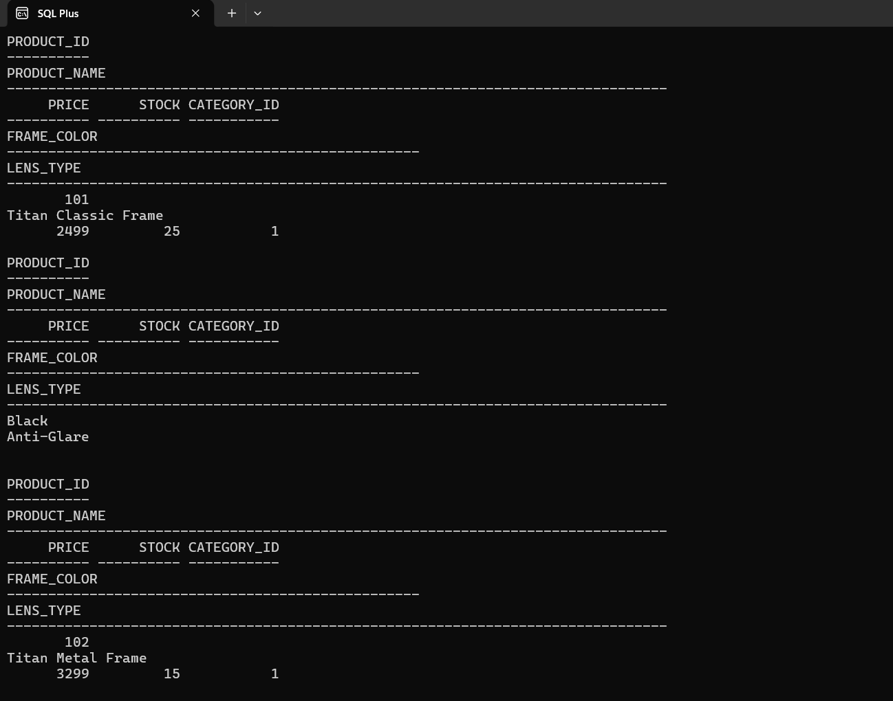
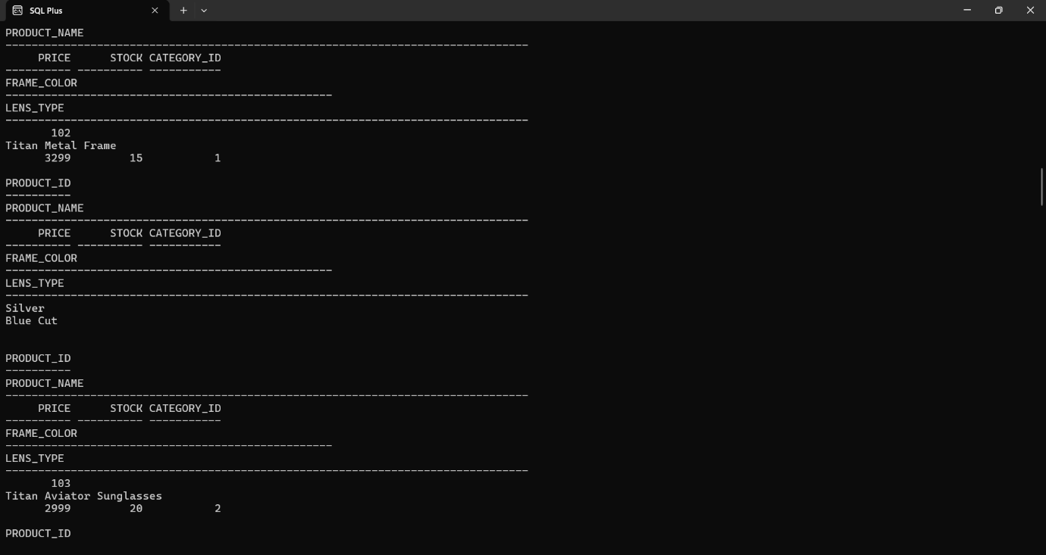
6. PRODUCT UPDATE

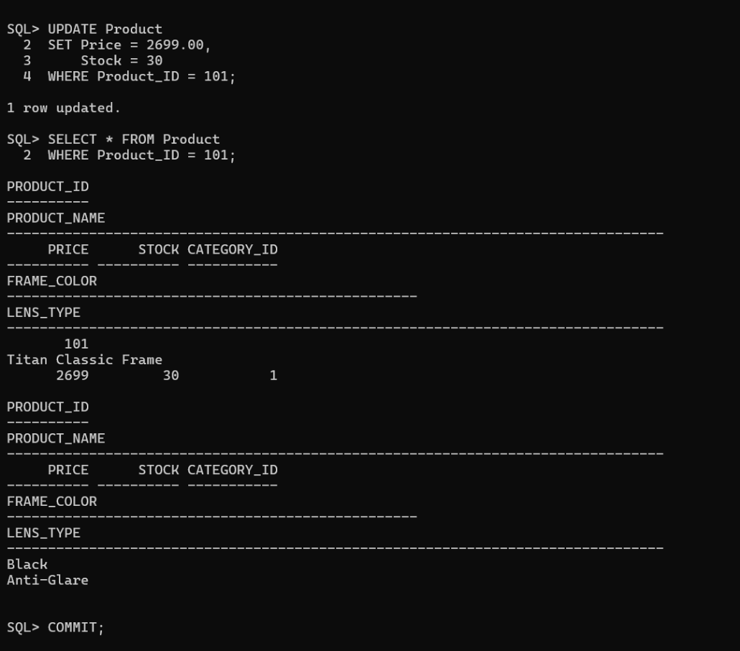
7. PRODUCT DELETION

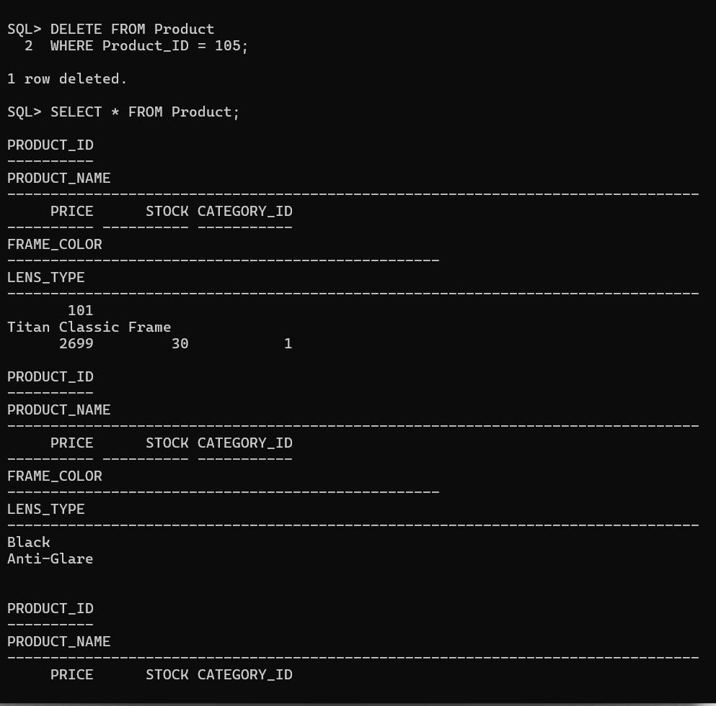
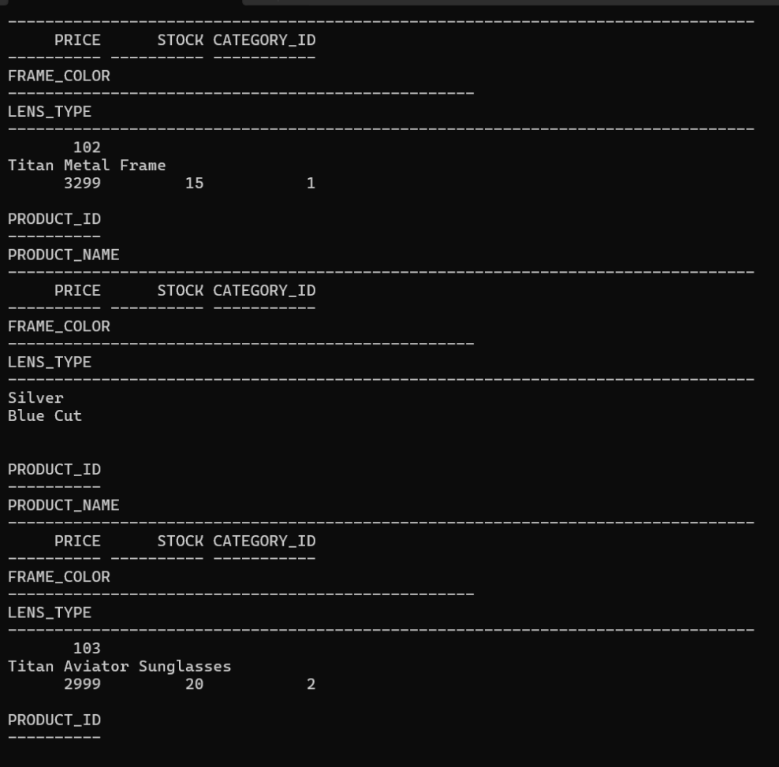
8. CATEGORY-WISE PRODUCT REPORT 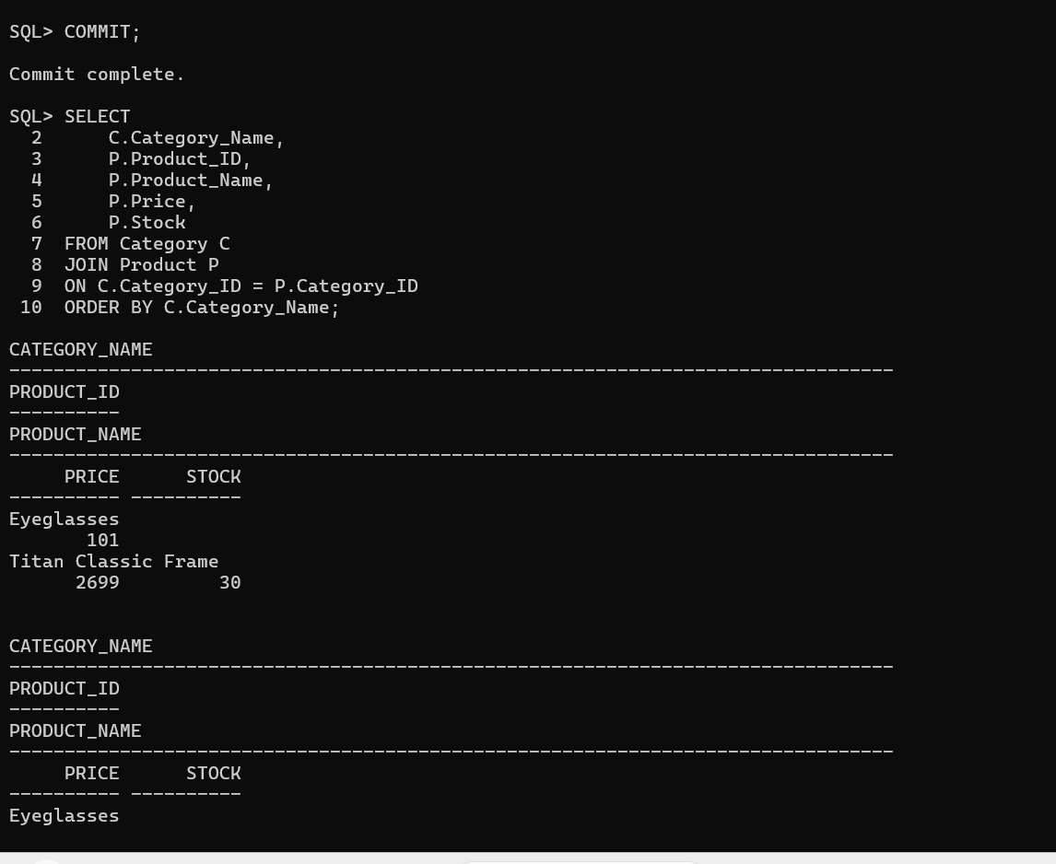
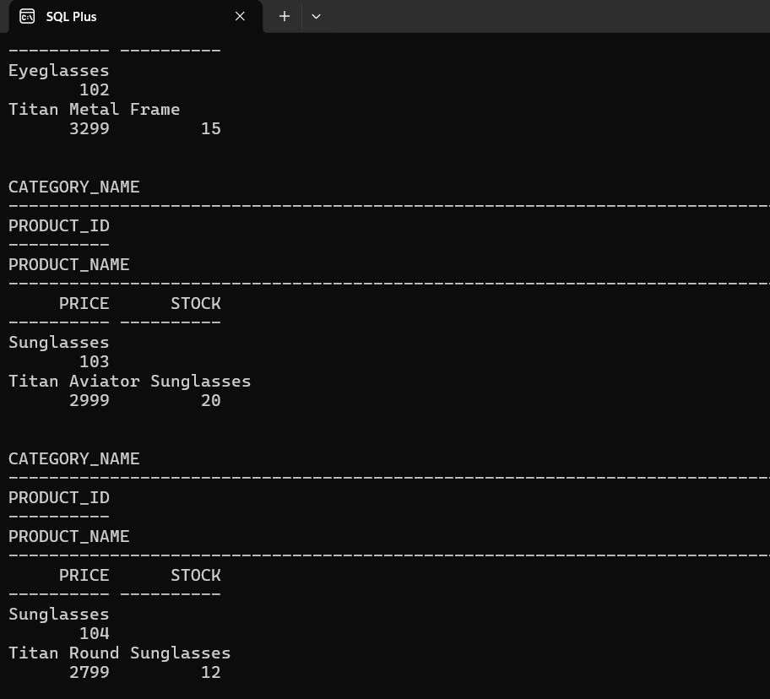
9.Category-wise Total Products Report.
