
Groundwater Depletion and Sustainable Agricultural Planning
Submitted In Partial Fulfillment of Requirements
For the Degree Of
Bachelor of Technology
(Computer Science and Business Systems)
By
Varad Bele
Roll No: ____________________ (Varad Bele)
Mrunmai Bhagat
Roll No: ____________________ (Mrunmai Bhagat)
Prayaag Bhanushali
Roll No: ____________________ (Prayaag Bhanushali)
Guide
Prof. Umang Patel

Somaiya Vidyavihar University
Vidyavihar, Mumbai - 400 077
2026-27

Somaiya Vidyavihar University

K. J. Somaiya College of Engineering

Certificate

This is to certify that the mini project report entitled Groundwater Depletion and Sustainable Agricultural Planning submitted by Varad Bele, Mrunmai Bhagat and Prayaag Bhanushali at the end of semester III of SY B. Tech is a bona fide record for partial fulfillment of requirements for the degree Bachelor of Technology (Computer Science and Business Systems) of Somaiya Vidyavihar University

_________________ _____________________
Guide Head of the Department

_________________
Principal

Date:
Place: Mumbai-77

Somaiya Vidyavihar University

K. J. Somaiya College of Engineering

DECLARATION
We declare that this written report submission represents the work done based on our and / or others’ ideas with adequately cited and referenced the original source. We also declare that we have adhered to all principles of intellectual property, academic honesty and integrity as we have not misinterpreted or fabricated or falsified any idea/data/fact/source/original work/ matter in my submission.
We understand that any violation of the above will be cause for disciplinary action by the college and may evoke the penal action from the sources which have not been properly cited or from whom proper permission is not sought.
______________________________  Signature of the Student  Varad Bele  _______________________________  Roll No. | ______________________________  Signature of the Student  Mrunmai Bhagat  _______________________________  Roll No.
______________________________
Signature of the Student
Prayaag Bhanushali
_______________________________
Roll No.

Date:
Place: Mumbai-77

Abstract
Groundwater is the main source of irrigation water in India, and the intensive cultivation of water-demanding crops such as rice, sugarcane, cotton and wheat has been widely linked to falling water tables. Policy makers, however, need district-level evidence that shows where the stress is highest and what a change in cropping pattern could achieve. This project combines district-level groundwater level records with district-level crop production records to study the relationship between water-intensive crop area and groundwater depth, to classify districts by groundwater stress, and to forecast groundwater level under alternative cropping scenarios.
Two datasets, one on groundwater level (metres below ground level, mbgl) and one on crop area and production, were cleaned, aggregated to the district-year level and merged. The analysis was implemented in Python and consists of three parts: Pearson correlation analysis between crop area and groundwater depth; a district risk-scoring index, aligned with the principles of the Central Ground Water Board (CGWB), that combines recent water level and rate of depletion into four categories; and a multivariate forecasting model (SARIMAX with crop area as an exogenous variable) compared against a univariate ARIMA baseline. The results are presented in a four-panel visual dashboard.
The correlation between water-intensive crop area and groundwater depth is statistically significant (p = 2.7×10⁻⁷) but very weak (r = -0.0746), which shows that crop area alone does not explain the variation in groundwater depth across districts. The risk index classified 535 districts as Safe (132, 24.7%), Semi-Critical (291, 54.4%), Critical (66, 12.3%) and Over-Exploited (46, 8.6%); the deepest water tables are in districts such as Gandhinagar (Gujarat, 94.99 mbgl) and Jhunjhunu (Rajasthan, 59.59 mbgl). For the case-study district of Ananthapuramu, the multivariate model gives a five-year forecast of 7.23 mbgl under the status-quo scenario and 6.66 mbgl when water-intensive crop area is reduced by 20%, an indicative benefit of 0.57 m. These forecasts rest on a short annual series and are intended as a scenario illustration, not as a precise prediction.
Key words: Groundwater depletion, crop area, district risk index, CGWB, ARIMA, SARIMAX, forecasting, sustainable agriculture.
Contents
List of Figures vi
List of Tables vi
Nomenclature vii
1 Introduction 1
1.1 Background 1
1.2 Motivation 1
1.3 Scope of the project 2
1.4 Brief description of project undertaken 2
1.5 Organization of the report 3
2 Literature Survey 4
2.1 Review of related work 4
2.2 Research gap 4
3 Project design 6
3.1 Introduction 6
3.2 Problem statement 6
3.3 Block diagram / system diagram 6
3.4 Objectives 6
3.5 Statistical and forecasting methods 7
4 Implementation and experimentation 9
4.1 Tools and environment 9
4.2 Dataset details 9
4.3 Data cleaning and manipulation 10
4.4 Statistical correlation analysis 11
4.5 District risk-scoring index 11
4.6 Multivariate forecasting and policy simulation 12
4.7 Data visualization 13
4.8 Results and discussion 14
5 Conclusions and scope for further work 18
5.1 Conclusions 18
5.2 Scope for further work 18
Bibliography 19
Appendix A: Project repository and files 20
Acknowledgements 21
List of Figures
3.1 System architecture of the proposed analysis pipeline 6
4.1 Integrated evaluation dashboard 14
4.2 Water-intensive crop area vs groundwater level 14
4.3 Correlation matrix heatmap 15
4.4 District risk classification (CGWB aligned) 16
4.5 Multivariate forecast and policy simulation for Ananthapuramu 16

List of Tables
2.1 Summary of related work 4
4.1 Python libraries used and their roles 9
4.2 Attributes of the groundwater dataset 9
4.3 Attributes of the crop production dataset 10
4.4 Data cleaning and manipulation steps 10
4.5 Pearson correlation coefficients 11
4.6 District risk classification rules 12
4.7 Distribution of districts by risk category 12
4.8 Five most deeply stressed Over-Exploited districts 12
4.9 Forecast summary for Ananthapuramu 13
A.1 Project files and their purpose 20
Nomenclature
ARIMA | Autoregressive Integrated Moving Average model
ARIMAX | ARIMA model with exogenous (external) regressors
CGWB | Central Ground Water Board, Government of India
GW | Groundwater
ha | Hectare, unit of cultivated area
mbgl | Metres below ground level (depth to the water table)
m/yr | Metres per year (rate of change of water level)
SARIMAX | Seasonal ARIMA with exogenous regressors (statsmodels implementation)
r | Pearson correlation coefficient
p-value | Probability of observing the sample correlation if the true correlation were zero
y(t) | Groundwater level (mbgl) in year t
x(t) | Water-intensive crop area (ha) in year t, used as exogenous variable
Δy(t) | First difference of the water level, y(t) − y(t−1)
d | Order of differencing in ARIMA
p | Order of the autoregressive term in ARIMA
q | Order of the moving-average term in ARIMA
Slope | Least-squares linear trend of water level against year, used as depletion rate

1 Introduction

1.1 Background
Groundwater is the largest source of irrigation water in India. Millions of wells and tube wells allow farmers to grow crops in areas and seasons where rainfall or canal supply alone would not be enough. This access has supported high agricultural output, but it has also led to sustained withdrawal in many regions. When water is extracted faster than it is recharged by rainfall and seepage, the water table falls, wells have to be deepened, pumping costs rise and, in the worst cases, shallow aquifers run dry.
The depth of the water table is conventionally reported in metres below ground level (mbgl). A larger value means that the water is deeper below the surface, so an increasing mbgl value over the years indicates depletion, while a decreasing value indicates recovery. In this report, the terms "groundwater level" and "groundwater depth" are both used for this quantity.
Some crops need far more irrigation water than others. Rice, sugarcane, cotton and wheat are among the crops that are most often cited as water-intensive in Indian agriculture, and they occupy large areas in many states. Understanding how the area under such crops relates to the observed groundwater level at district scale is therefore a natural question for sustainable agricultural planning. The Central Ground Water Board (CGWB) assesses groundwater resources of India and classifies assessment units into the categories Safe, Semi-Critical, Critical and Over-Exploited; these categories are widely used to communicate the severity of groundwater stress.

1.2 Motivation
Decisions on cropping patterns, subsidies and water-conservation programmes are taken at district or block level, but they are often not supported by an integrated view that connects water-level observations with cultivation data. Two open datasets are available, one on groundwater levels and one on crop area and production, and they can be linked through district names and years. Combining them allows an analyst to ask three practical questions: how strongly are crop area and groundwater depth related, which districts show the highest stress, and what could happen to the water table in a particular district if the area under water-intensive crops were reduced.
The motivation of this mini project is to answer these questions using a reproducible data-science workflow built entirely with open-source Python libraries, and to present the findings in a form that is easy to interpret for evaluators and decision makers.

1.3 Scope of the project
The project covers the following:
• District-level analysis across India, using the districts that are present in both the groundwater and the crop datasets for the same year.
• Four water-intensive crops: rice, sugarcane, cotton and wheat. Their area and production are aggregated for each district and year.
• Cleaning, manipulation and aggregation of the two datasets, and a statistical correlation analysis between crop area and groundwater level.
• A rule-based district risk-scoring index, aligned with the principles of the CGWB categories, that uses the recent water level and the rate of depletion.
• A forecasting case study for one district (Ananthapuramu), comparing a univariate ARIMA baseline with a SARIMAX model that uses crop area as an exogenous variable, and simulating a 20% reduction in water-intensive crop area.
The project does not model rainfall, canal irrigation, pumping or energy use, soil type or cropping seasons, and it does not claim to establish causal relationships. These aspects are listed as scope for further work in Chapter 5.

1.4 Brief description of project undertaken
The project is implemented as a single Python pipeline. The groundwater records (district-wise water level observations with dates) and the crop production records (district-wise area and production by crop and year) are first loaded and cleaned. Groundwater readings are averaged for each district and year, while the area and production of the four selected crops are summed for each district and year. The two tables are then merged on state, district and year.
On the merged table, three analyses are performed. First, the Pearson correlation between crop area and groundwater level is computed. Second, a risk index is calculated for each district from the mean of its three most recent annual water levels and the linear trend of its water level over time, and each district is assigned to one of four risk categories. Third, for the Ananthapuramu district, ARIMA and SARIMAX models are fitted and used to forecast the water level five years ahead under a status-quo scenario and a scenario in which water-intensive crop area is reduced by 20%. The results are summarised in a four-panel dashboard and a CSV file of district classifications.

1.5 Organization of the report
The remainder of this report is organised as follows. Chapter 2 reviews related work and identifies the gap addressed by this project. Chapter 3 presents the project design, including the problem statement, system diagram, objectives and the statistical and forecasting methods used. Chapter 4 describes the datasets, the cleaning and manipulation steps, the implementation of each analysis, the visualisations, and a discussion of the results and limitations. Chapter 5 concludes the report and lists possible extensions. The Bibliography, Appendix A (project repository and files) and Acknowledgements follow.

2 Literature Survey

2.1 Review of related work
Groundwater depletion in India and its relationship with irrigated agriculture have been studied with satellite observations, hydrological models and statistical methods. Table 2.1 summarises the works that are most relevant to this project, together with the software and statistical references on which the implementation relies.
Table 2.1: Summary of related work
Ref. | Focus of the work | Relevance to this project
[1] | Satellite gravimetry (GRACE) was used to estimate groundwater loss in north-western India and to link it to irrigation withdrawals. | Establishes that irrigation-driven groundwater depletion is large enough to be observed at regional scale.
[2] | Overview of the global groundwater crisis, including the role of agriculture in aquifer depletion. | Provides the global context and motivates agricultural planning as a response.
[3] | Analysis of how monsoon rainfall variability and groundwater pumping together drive changes in groundwater storage in India. | Shows that rainfall is an important confounder, which is a limitation of a crop-area-only analysis.
[4] | Global inventory of groundwater use for irrigation. | Supports the use of irrigated agriculture as the main pressure on groundwater.
[5] | Dynamic Ground Water Resources assessment of India by the CGWB, including the Safe / Semi-Critical / Critical / Over-Exploited categories. | Source of the category names used by the district risk index in this project.
[6], [7] | Standard references on ARIMA modelling and forecasting. | Basis of the ARIMA and ARIMAX/SARIMAX models used for forecasting.
[8]-[12] | Python data-analysis, statistics, time-series and plotting libraries. | Tools used to implement the pipeline.

2.2 Research gap
Most of the large-scale studies cited above rely on satellite data or hydrological models and are not designed to be re-run by a district officer or student on open tabular data. At the same time, simple district tables of water level and crop area are rarely combined with a transparent scoring rule and a scenario-based forecast in one workflow. This project addresses that gap by building a small, fully reproducible pipeline on open tabular data that (i) tests the association between water-intensive crop area and groundwater depth, (ii) ranks and classifies districts with an interpretable rule set, and (iii) shows how a crop-area scenario can be fed into a time-series forecast of the water table.
The work in this report should be read as a data-driven screening and scenario tool. It does not replace the official CGWB assessment, which is based on a water-balance computation (stage of groundwater extraction) rather than on water-level depth and trend alone.

3 Project design

3.1 Introduction
This chapter defines the problem, presents the structure of the analysis pipeline, states the objectives and explains the statistical and forecasting methods used in the project.

3.2 Problem statement
To examine how the area under water-intensive crops relates to groundwater level across Indian districts, to classify districts by groundwater stress using an interpretable index aligned with the CGWB categories, and to forecast groundwater level under alternative cropping scenarios in order to support sustainable agricultural planning.

3.3 Block diagram / system diagram
Figure 3.1 shows the structure of the pipeline. The two raw datasets are cleaned separately. Groundwater readings are averaged and crop records are filtered and summed so that both tables have one row per district and year, and they are then joined. The merged table is the input to the three analysis modules, whose outputs are the dashboard and the classification file.
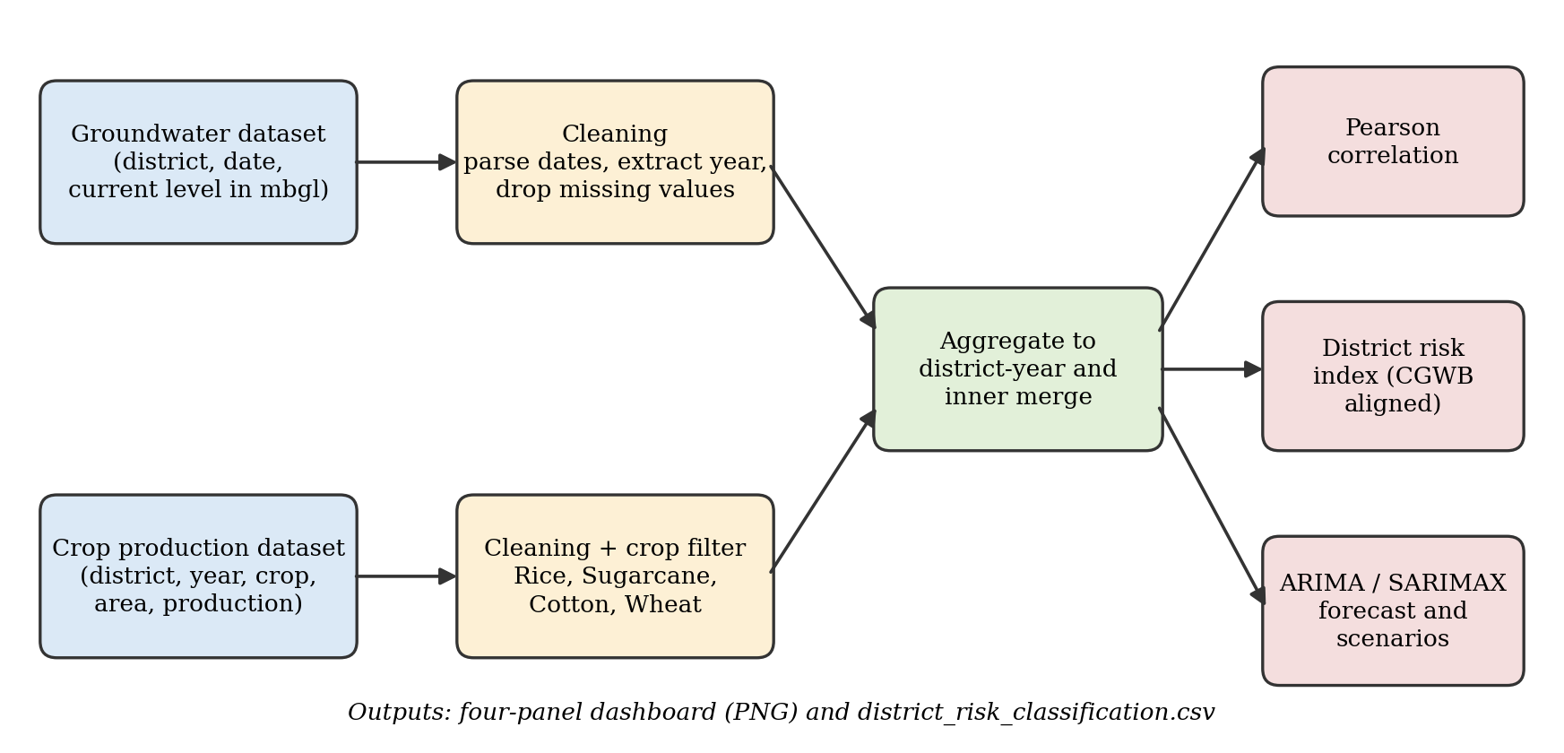
Figure 3.1: System architecture of the proposed analysis pipeline

3.4 Objectives
1. To load, clean and integrate district-level groundwater level data and crop production data into a single analysis-ready table.
2. To isolate four water-intensive crops (rice, sugarcane, cotton and wheat) and aggregate their area and production per district and year.
3. To measure the strength and statistical significance of the linear relationship between water-intensive crop area and groundwater depth using Pearson correlation.
4. To build a district risk-scoring index, aligned with CGWB categories, using the recent water level and the rate of depletion, and to classify every district.
5. To forecast groundwater level for a stressed case-study district with a univariate ARIMA baseline and a multivariate SARIMAX model, and to simulate a 20% reduction in water-intensive crop area.
6. To present the results in a clear visual dashboard and to publish the code in a public repository.

3.5 Statistical and forecasting methods

3.5.1 Pearson correlation
The Pearson correlation coefficient r measures the strength and direction of the linear relationship between two variables. It is the covariance of the two variables divided by the product of their standard deviations, and it lies between -1 and +1. A value near zero indicates a weak linear relationship. A p-value is reported with the coefficient; a p-value below 0.05 is taken as statistically significant at the 95% confidence level. Statistical significance only says that the coefficient is unlikely to be exactly zero; it does not say that the relationship is strong or causal.

3.5.2 Depletion rate
The depletion rate of a district is the slope of an ordinary least-squares straight line fitted to the district's annual mean water level against year, expressed in metres per year. A positive slope means that the water table is getting deeper. When a district has fewer than three annual observations, a trend is not computed and the rate is set to zero.

3.5.3 ARIMA
An ARIMA(p, d, q) model describes a time series using p autoregressive terms, d differences and q moving-average terms (Box and Jenkins). In this project the order (1, 1, 0) is used: the series is differenced once to remove the trend, and the differenced series is modelled as a first-order autoregressive process. This model uses only the past values of the water level and serves as the baseline.

3.5.4 SARIMAX with an exogenous variable
SARIMAX extends ARIMA by adding seasonal terms and exogenous regressors. In this project the same non-seasonal order (1, 1, 0) is used and the annual area under water-intensive crops is supplied as the exogenous variable. Because the data are annual and no seasonal order is specified, the model works as an ARIMA model with an external regressor (ARIMAX). The forecast for a future year then requires future values of crop area, which are provided by the scenarios described in Section 4.6.

4 Implementation and experimentation

4.1 Tools and environment
The entire pipeline is written in Python. Table 4.1 lists the libraries and their roles.
Table 4.1: Python libraries used and their roles
Library | Role in the project
pandas | Loading CSV files, date handling, cleaning, grouping, aggregation and merging.
NumPy | Numerical operations, linear trend fitting and construction of scenario arrays.
SciPy | Pearson correlation coefficient and p-value.
statsmodels | ARIMA and SARIMAX time-series models and forecasting.
matplotlib, seaborn | Scatter plot with regression line, heatmap, bar chart, forecast plot and the combined dashboard.

4.2 Dataset details
Two cleaned CSV files are used. The first (groundwater_cleaned.csv) contains groundwater level observations for districts, and the second (crop_production_cleaned.csv) contains crop area and production records for districts. Both files carry state and district names, which are used as join keys together with the year. Source of the data: Central Ground Water Board (CGWB), Department of Water Resources, Ministry of Jal Shakti, Government of India via the India-WRIS portal (https://indiawris.gov.in) for groundwater monitoring levels; and the Directorate of Economics and Statistics (DES), Department of Agriculture & Farmers Welfare, Ministry of Agriculture & Farmers Welfare, Government of India via the Agricultural Production Statistics portal (https://aps.dac.gov.in) and Open Government Data (data.gov.in) for district-level crop statistics (accessed October 2026). Number of records: groundwater 550,850 rows across 565 districts, crop production 345,407 rows across 701 districts (obtained from the shape of each loaded table). Years covered: 2013 to 2023 for groundwater observations and 1997 to 2022 for crop production records, with the integrated analytical dataset spanning 4,735 district-year observations across 533 districts for the overlapping period (2013–2021).
Table 4.2: Attributes of the groundwater dataset
Attribute | Description
state_name | Name of the state.
district_name | Name of the district.
date | Date of the groundwater observation; converted to a datetime and used to derive the year.
currentlevel | Groundwater level in metres below ground level (mbgl); a larger value means a deeper water table.

Table 4.3: Attributes of the crop production dataset
Attribute | Description
state_name | Name of the state.
district_name | Name of the district.
year | Agricultural year recorded in the form YYYY-YYYY; the starting year is used.
crop_name | Name of the crop; used to select rice, sugarcane, cotton and wheat.
area | Area under the crop in hectares.
production | Production of the crop, in the unit given by the data source.

4.3 Data cleaning and manipulation
The cleaning and manipulation steps are listed in Table 4.4. Dates in the groundwater data are parsed and the calendar year is extracted. In the crop data the year is stored as a range such as 2015-2016, so the first year of the range is taken as an integer. Rows with a missing water level, or with a missing area or production value, are dropped because they cannot be used in the correlation or the trend calculation.
Table 4.4: Data cleaning and manipulation steps
Step | Operation | Purpose
1 | Parse the date column and extract the year (groundwater data). | Create a common time key at annual resolution.
2 | Take the first year of the YYYY-YYYY range as an integer (crop data). | Make the crop year compatible with the groundwater year.
3 | Drop rows with a missing current level (groundwater data). | Avoid undefined water-level values.
4 | Drop rows with missing area or production (crop data). | Avoid undefined cultivation values.
5 | Average groundwater levels per state, district and year. | Obtain one representative water level per district-year.
6 | Keep crops whose name contains Rice, Sugarcane, Cotton or Wheat (case-insensitive). | Isolate the water-intensive crops.
7 | Sum area and production per state, district and year. | Obtain total water-intensive crop area and production per district-year.
8 | Inner join the two tables on state, district and year. | Keep only district-years that have both water-level and crop data.

Groundwater readings are averaged because the water level is a state variable measured at several wells and several times in a year, whereas area and production are additive quantities and are therefore summed. The inner join means that a district-year is analysed only when both datasets contain it. This avoids imputing values, but it also means that districts with incomplete coverage are under-represented.

4.4 Statistical correlation analysis
The Pearson correlation between the total area under the selected crops and the groundwater level was computed on the merged district-year table. The script also reports the p-value and prints a plain-language finding depending on whether the p-value is below 0.05. The pairwise correlations among groundwater depth, crop area and production are shown in Table 4.5 and in the heatmap of Figure 4.3.
Table 4.5: Pearson correlation coefficients
Variable pair | r | Interpretation
Crop area vs groundwater depth | -0.0746 | Very weak negative linear relationship.
Production vs groundwater depth | -0.026 | Practically no linear relationship.
Crop area vs production | 0.426 | Moderate positive relationship, as expected.

The script printed r = -0.0746 with a p-value of 2.7379e-07, so the relationship is statistically significant at the 95% confidence level. With a very large number of district-year observations even a tiny correlation becomes significant, so the practical size of the effect matters more: r² is about 0.006, meaning that crop area explains roughly 0.6% of the variation in groundwater depth.

4.5 District risk-scoring index
For every district the index uses four metrics computed from the district's yearly series: the recent water level (mean of the latest three annual values), the overall mean water level, the depletion rate (linear slope in m/yr) and the average water-intensive crop area. The first and third metrics drive the classification. The rules are applied in the order shown in Table 4.6, so that a district receives the most severe category for which it qualifies. The threshold values are chosen in the spirit of the CGWB categories, using depth and trend as a proxy; they are design choices of this project and can be changed.
Table 4.6: District risk classification rules
Category | Rule (recent level in mbgl, depletion rate in m/yr)
Over-Exploited | Recent level ≥ 20, or (recent level ≥ 15 and depletion rate > 0.2)
Critical | Recent level ≥ 10, or (recent level ≥ 8 and depletion rate > 0.1)
Semi-Critical | Recent level ≥ 5, or depletion rate > 0
Safe | All remaining districts

The results are written to a CSV file (district_risk_classification.csv) with the state, district, the four metrics and the assigned category. Table 4.7 gives the distribution of the 535 classified districts.
Table 4.7: Distribution of districts by risk category
Risk category | Number of districts | Share of districts
Safe | 132 | 24.7%
Semi-Critical | 291 | 54.4%
Critical | 66 | 12.3%
Over-Exploited | 46 | 8.6%
Total | 535 | 100%

Table 4.8 lists the five Over-Exploited districts with the deepest recent water level, as printed by the script.
Table 4.8: Five most deeply stressed Over-Exploited districts
District (State) | Recent level (mbgl) | Depletion rate (m/yr)
Gandhinagar (Gujarat) | 94.99 | 2.044
Jhunjhunu (Rajasthan) | 59.59 | 0.364
Sikar (Rajasthan) | 45.77 | -0.229
Mahendragarh (Haryana) | 38.89 | 1.679
Barnala (Punjab) | 37.98 | 1.716

4.6 Multivariate forecasting and policy simulation
A district is selected by name for the forecasting case study; Ananthapuramu was used in this project. Its merged series is sorted by year and at least five observations are required. Two models are then fitted to the groundwater level:
• ARIMA baseline: an ARIMA(1, 1, 0) model that uses only the past water levels, forecasting five years ahead.
• SARIMAX model: the same order with the annual water-intensive crop area as an exogenous variable.
Two scenarios are fed into the SARIMAX model for the five forecast years. In the status-quo scenario, the crop area stays at its latest observed value. In the sustainable planning scenario, the crop area is 20% lower than the status-quo value in every forecast year. The difference between the two forecasts at the end of the horizon is reported as the estimated recharge benefit of crop diversification. Table 4.9 summarises the outcome using the values printed by the script (see also Figure 4.5).
Table 4.9: Forecast summary for Ananthapuramu
Quantity | Value
Current water level (2021) | 7.02 mbgl
5-year forecast, ARIMA univariate | 7.25 mbgl
5-year forecast, SARIMAX status-quo area | 7.23 mbgl
5-year forecast, SARIMAX 20% crop shift | 6.66 mbgl
Estimated benefit of crop diversification | +0.57 m

4.7 Data visualization
The results are collected in a single four-panel dashboard (Figure 4.1), saved as a high-resolution image. The panels are: (1) a scatter plot of water-intensive crop area against groundwater level with a regression line; (2) a correlation heatmap of groundwater depth, crop area and production; (3) a bar chart of the number of districts in each risk category with counts and percentages, using a green-to-red colour scale; and (4) the forecast plot with the historical series, the ARIMA baseline and the two SARIMAX scenarios.
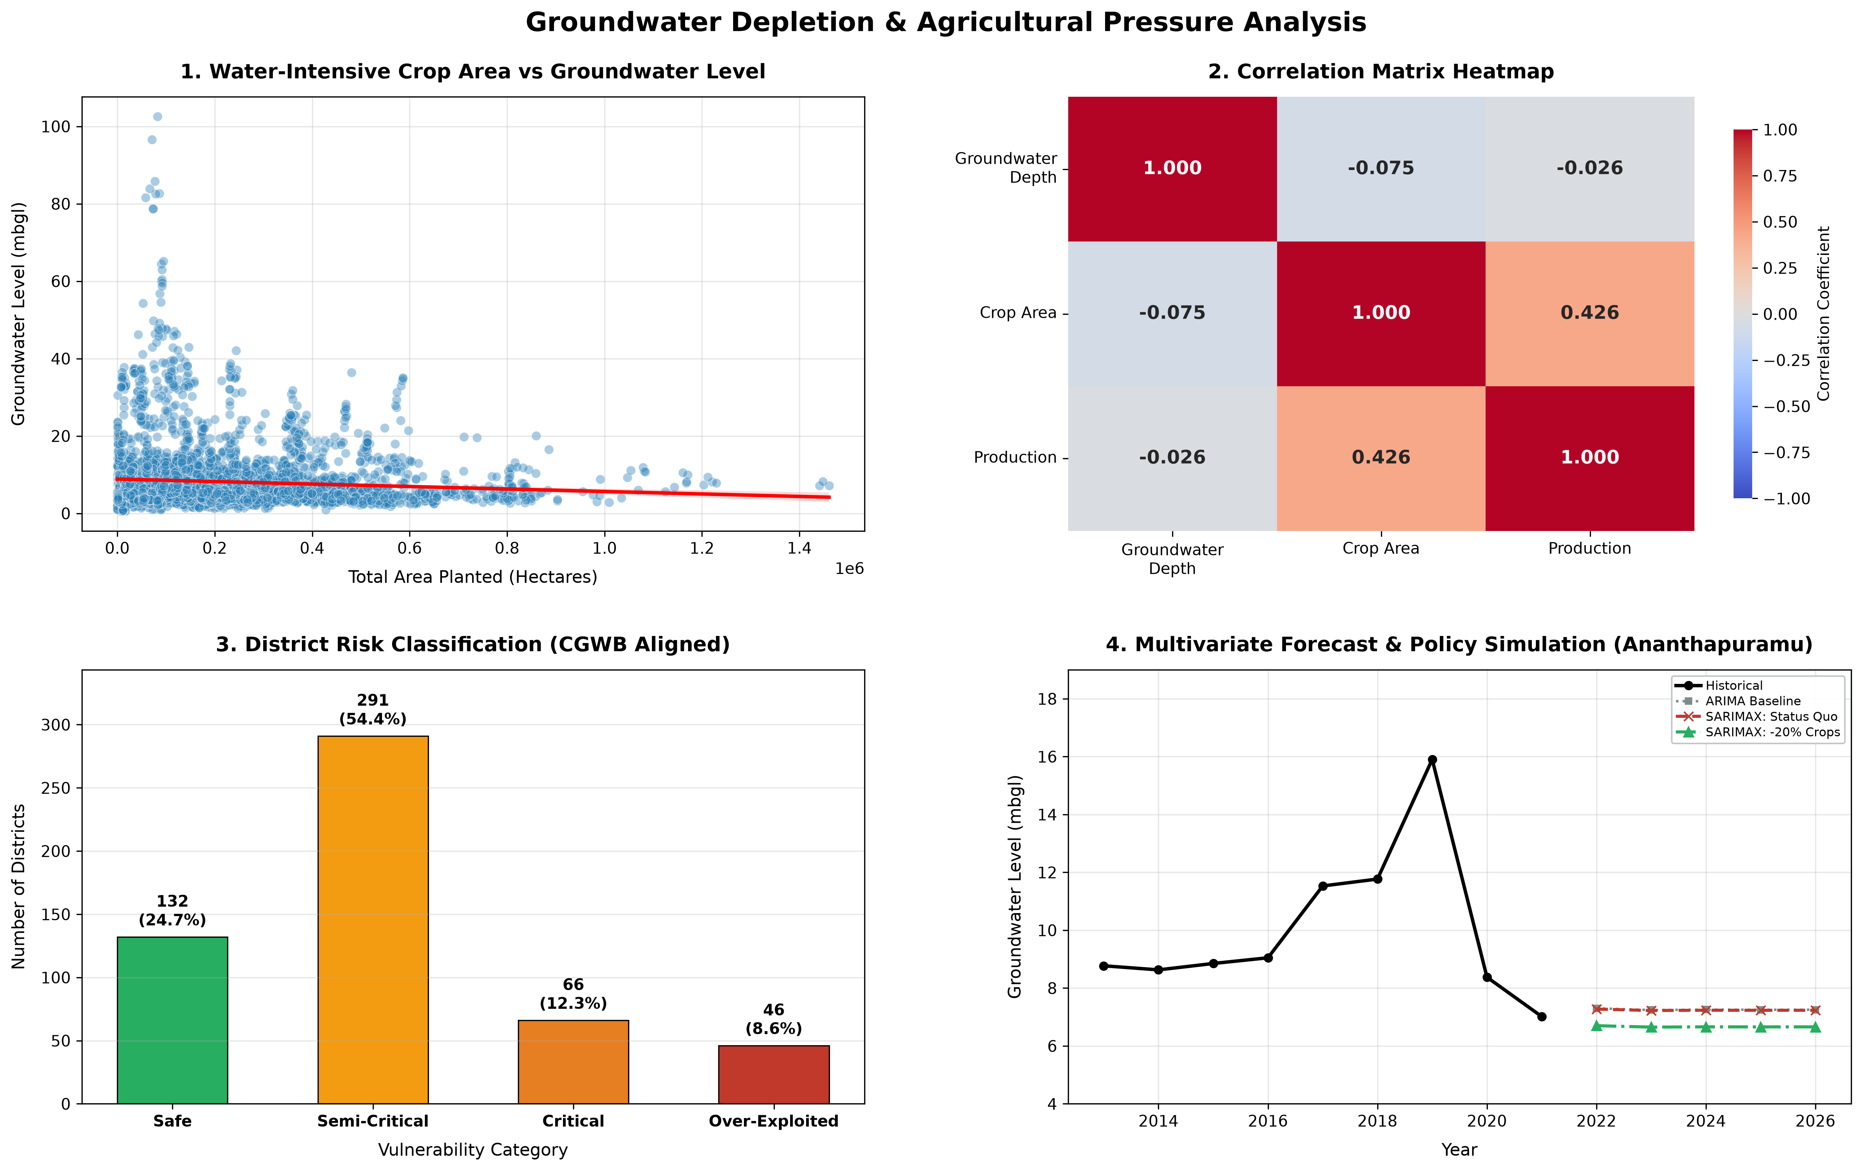
Figure 4.1: Integrated evaluation dashboard

4.8 Results and discussion

4.8.1 Crop area and groundwater depth
Figure 4.2 shows the relationship between the total area under the four crops and the groundwater level. Most district-year observations lie below about 20 mbgl and the cloud is dense at small and moderate areas. A few observations are much deeper, with values of up to about 100 mbgl, and they occur at relatively small crop areas. The fitted line slopes slightly downwards, from roughly 9 mbgl at very small areas to about 4.5 mbgl at areas above one million hectares.
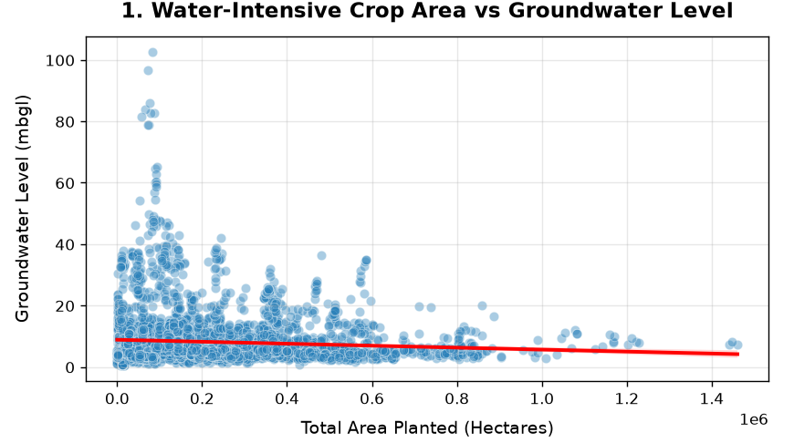
Figure 4.2: Water-intensive crop area vs groundwater level
The heatmap in Figure 4.3 confirms that the linear relationship is very weak: r = -0.075 (-0.0746 before rounding, p = 2.7×10⁻⁷) for crop area and -0.026 for production. The only moderate relationship is between crop area and production (r = 0.426), which is expected because a larger area produces more.
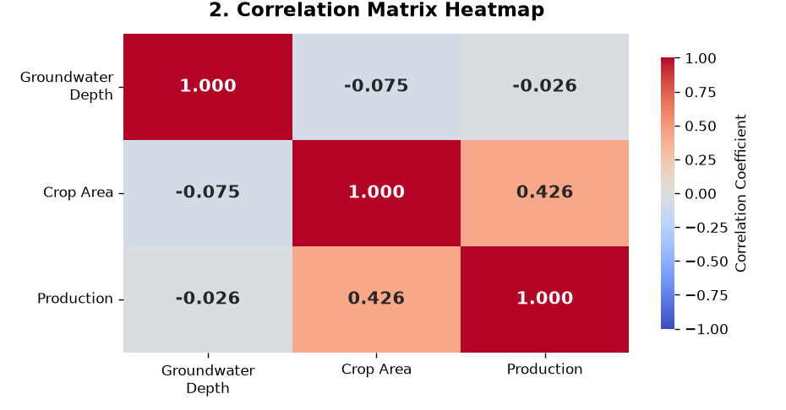
Figure 4.3: Correlation matrix heatmap
The negative sign should not be read as evidence that more water-intensive cultivation improves groundwater. Districts with large areas of these crops are often those with abundant surface water, canal irrigation or high rainfall, where the water table is naturally shallow, whereas very deep water tables occur in drier districts with smaller cropped areas. Differences in rainfall, geology and irrigation source between districts are not in the data and are likely to dominate the relationship. A weak national-scale correlation therefore says that crop area alone is not a good predictor of groundwater depth; it does not say that crops have no effect on groundwater.

4.8.2 District risk classification
Figure 4.4 shows that more than half of the classified districts (291 of 535, 54.4%) fall in the Semi-Critical category, and 132 districts (24.7%) are Safe. A further 66 districts (12.3%) are Critical and 46 districts (8.6%) are Over-Exploited, so about one in five districts (20.9%) is in one of the two most severe categories. Table 4.8 shows that the deepest recent water levels are in Gandhinagar (94.99 mbgl, depleting at 2.044 m/yr) and Jhunjhunu (59.59 mbgl). Sikar is Over-Exploited because its level exceeds 20 mbgl even though its fitted trend is slightly negative (-0.229 m/yr), which shows that the rule is driven by the absolute depth as well as by the trend. The Semi-Critical share is large partly because the rule places a district in this category when its recent level is at least 5 mbgl or when its trend is positive at all, which is a sensitive criterion. The thresholds can be tightened or relaxed to match a different policy preference, and the CSV output allows district officers to inspect the individual metrics.
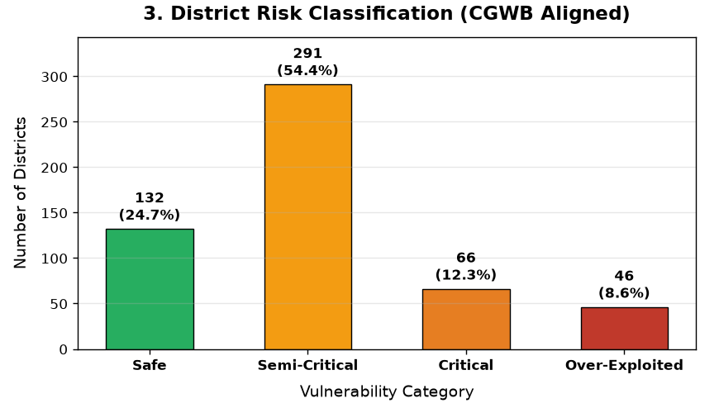
Figure 4.4: District risk classification (CGWB aligned)

4.8.3 Forecast and policy simulation for Ananthapuramu
In Figure 4.5 the observed water level in Ananthapuramu stays near 9 mbgl between 2013 and 2016, rises to about 16 mbgl in 2019, and then drops to about 7 mbgl in 2021. The ARIMA baseline (7.25 mbgl) and the SARIMAX status-quo forecast (7.23 mbgl) are almost identical and stay nearly flat up to 2026. When the water-intensive crop area is reduced by 20%, the SARIMAX forecast falls to 6.66 mbgl, which is 0.57 m shallower than the status quo.
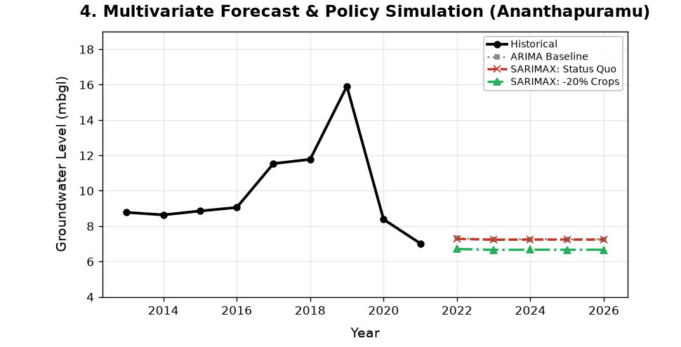
Figure 4.5: Multivariate forecast and policy simulation for Ananthapuramu
The direction of the scenario effect is consistent with the expectation that less irrigated area reduces pumping, but the model should be interpreted with care. The series has only about nine annual points, the exogenous coefficient is estimated from this short record, the sharp peak in 2019 and the fall afterwards are not explained by the model, and the near-flat forecast reflects how an ARIMA(1, 1, 0) process behaves rather than a hydrological prediction. The scenario result is therefore an indicative illustration of how the framework can be used for planning, not a quantified recharge estimate.

4.8.4 Limitations
• Rainfall, canal irrigation, groundwater pumping, soil and aquifer properties are not included, and they strongly influence water levels.
• The correlation and the forecasting model show association, not causation.
• Crop area is aggregated over four crops and over all seasons recorded in the data, so seasonal differences in water use are not captured.
• The inner join keeps only district-years present in both datasets, so some districts or years may be missing.
• The risk index is a depth-and-trend proxy with project-defined thresholds. It is not the official CGWB assessment, which uses the stage of groundwater extraction.
• The forecast uses a single district and a short annual series. Prediction intervals and hold-out validation are not reported, and the forecast years (2022-2026) lie after the last observed year (2021).

5 Conclusions and scope for further work

5.1 Conclusions
This project built a reproducible pipeline that integrates district-level groundwater and crop data, analyses the relationship between water-intensive crop area and groundwater depth, classifies districts by stress, and forecasts groundwater level under cropping scenarios. The main conclusions are:
• Across districts, the linear correlation between water-intensive crop area and groundwater depth is statistically significant but very weak (r = -0.0746, p = 2.7×10⁻⁷). Crop area alone does not explain differences in groundwater depth, and other factors such as rainfall and irrigation source must be considered.
• The risk index classifies 535 districts into Safe (24.7%), Semi-Critical (54.4%), Critical (12.3%) and Over-Exploited (8.6%), and identifies 112 districts in the two most severe categories for priority attention.
• In the Ananthapuramu case study, the multivariate model indicates that a 20% reduction in water-intensive crop area would lower the forecast water level by 0.57 m compared with the status quo. The result is indicative because of the short series and the absence of validation.
• The pipeline is transparent and modular, so thresholds, crop lists, districts and scenarios can be changed easily.

5.2 Scope for further work
• Add rainfall, canal irrigation, pumping and soil data to control for confounding and to improve the explanatory power.
• Replace the single correlation with panel or mixed-effects regression with state or district effects, and with lagged crop-area terms.
• Validate the forecast with a hold-out period, report prediction intervals, compare with other models, and forecast all Critical and Over-Exploited districts rather than one district.
• Use seasonal (kharif and rabi) crop data and crop-specific water requirements instead of a single aggregate area.
• Map the district risk categories with GIS, compare them with the official CGWB stage of extraction, and build an interactive dashboard in which planners can vary the percentage reduction and the crop mix.

Bibliography
[1] M. Rodell, I. Velicogna and J. S. Famiglietti, "Satellite-based estimates of groundwater depletion in India," Nature, vol. 460, pp. 999-1002, 2009.
[2] J. S. Famiglietti, "The global groundwater crisis," Nature Climate Change, vol. 4, pp. 945-948, 2014.
[3] A. Asoka, T. Gleeson, Y. Wada and V. Mishra, "Relative contribution of monsoon precipitation and pumping to changes in groundwater storage in India," Nature Geoscience, vol. 10, pp. 109-117, 2017.
[4] S. Siebert et al., "Groundwater use for irrigation - a global inventory," Hydrology and Earth System Sciences, vol. 14, pp. 1863-1880, 2010.
[5] Central Ground Water Board, Ministry of Jal Shakti, Government of India, "National Compilation on Dynamic Ground Water Resources of India, 2022."
[6] G. E. P. Box, G. M. Jenkins, G. C. Reinsel and G. M. Ljung, Time Series Analysis: Forecasting and Control, 5th ed., Wiley, 2015.
[7] R. J. Hyndman and G. Athanasopoulos, Forecasting: Principles and Practice, 3rd ed., OTexts, 2021.
[8] S. Seabold and J. Perktold, "Statsmodels: Econometric and statistical modeling with Python," Proc. 9th Python in Science Conference, 2010.
[9] W. McKinney, "Data structures for statistical computing in Python," Proc. 9th Python in Science Conference, 2010.
[10] P. Virtanen et al., "SciPy 1.0: fundamental algorithms for scientific computing in Python," Nature Methods, vol. 17, pp. 261-272, 2020.
[11] J. D. Hunter, "Matplotlib: A 2D graphics environment," Computing in Science & Engineering, vol. 9, no. 3, pp. 90-95, 2007.
[12] M. L. Waskom, "seaborn: statistical data visualization," Journal of Open Source Software, vol. 6, no. 60, 3021, 2021.

Appendix A: Project repository and files
GitHub repository: https://github.com/varadbele/groundwater-crop-depletion-analysis
The complete project code is available in the public repository above. The report describes the method in words and tables; the source code is not reproduced here. Table A.1 lists the main project files.
Table A.1: Project files and their purpose
File | Purpose
capstone1.py | Python script containing the whole pipeline: cleaning, merging, correlation, risk index, forecasting and dashboard.
groundwater_cleaned.csv | Input: groundwater level records by state, district and date.
crop_production_cleaned.csv | Input: crop area and production records by state, district, crop and year.
district_risk_classification.csv | Output: district metrics and risk category.
capstone_evaluation_dashboard.png | Output: four-panel evaluation dashboard (Figure 4.1).

Steps to reproduce: clone the project repository (https://github.com/varadbele/groundwater-crop-depletion-analysis.git); install Python 3.10+ with required dependencies using pip install -r requirements.txt; place groundwater_cleaned.csv and crop_production_cleaned.csv in the root folder; execute python capstone1.py; the console outputs the statistical correlation results, the CGWB-aligned risk breakdown, the top over-exploited districts, and the SARIMAX policy forecasts, and generates district_risk_classification.csv and capstone_evaluation_dashboard.png in the project directory.

Acknowledgements
We express our sincere gratitude to our guide, Prof. Umang Patel, for the guidance, encouragement and valuable feedback throughout this mini project. We thank the Head of the Department, the faculty members and the evaluators for their support and suggestions, and K. J. Somaiya College of Engineering for providing the facilities needed to carry out this work. We also thank the providers of the open datasets used in this study.
Varad Bele
Mrunmai Bhagat
Prayaag Bhanushali

