PIMPRI CHINCHWAD EDUCATION TRUST's.

**PIMPRI CHINCHWAD COLLEGE OF ENGINEERING**

(An Autonomous Institute)



___________________________________________________________________________________________

**Class : SY BTech Acad. Yr. 2025-26 Semester : I**

**Name of the student: Varad Amol Pisale PRN : 124B1B043**

**Department: Computer Engineering Division : A**

**Course Name :** **Data Structures Laboratory Code:BCE23PC02**

**Completion Date : 13/08/2025**

___________________________________________________________________________________________

**Assignment No.**

Problem Statement:

An education platform needs to rank students based on their exam scores to publish results and generate merit lists. Write a program for above scenario.

Hint:

Given a list of student scores, use Quick Sort to sort them in descending order. Handle cases where many students have the same score and analyze how this affects the performance of Quick Sort.

Source Code :

#include <bits/stdc++.h>

using namespace std;

struct Student

{

string name;

double score;

};

// Partition

int partition(vector<Student> &arr, int low, int high)

{

int pivot = arr[high].score;

int i = low - 1;

for (int j = low; j < high; j++)

{

if (arr[j].score > pivot)

{

i++;

swap(arr[i], arr[j]);

}

}

swap(arr[i + 1], arr[high]);

return i + 1;

}

// Quick Sort

void quickSort(vector<Student> &arr, int low, int high)

{

if (low < high)

{

int pIndex = partition(arr, low, high);

quickSort(arr, low, pIndex - 1);

quickSort(arr, pIndex + 1, high);

}

}

int main()

{

int n;

cout << "Enter number of students: ";

cin >> n;

cout << endl

<< endl;

vector<Student> students(n);

for (int i = 0; i < n; i++)

{

cout << "Enter name of student " << i + 1 << ": ";

getchar();

getline(cin, students[i].name);

cout << endl

<< "Enter score of student " << i + 1 << ": ";

cin >> students[i].score;

cout << endl

<< endl;

}

quickSort(students, 0, n - 1);

cout << "\n=== Merit List (Descending Order) ===\n";

for (int i = 0; i < n; i++)

{

cout << i + 1 << ". " << students[i].name << " - " << students[i].score << endl;

}

return 0;

}

Screen Shot of Output :

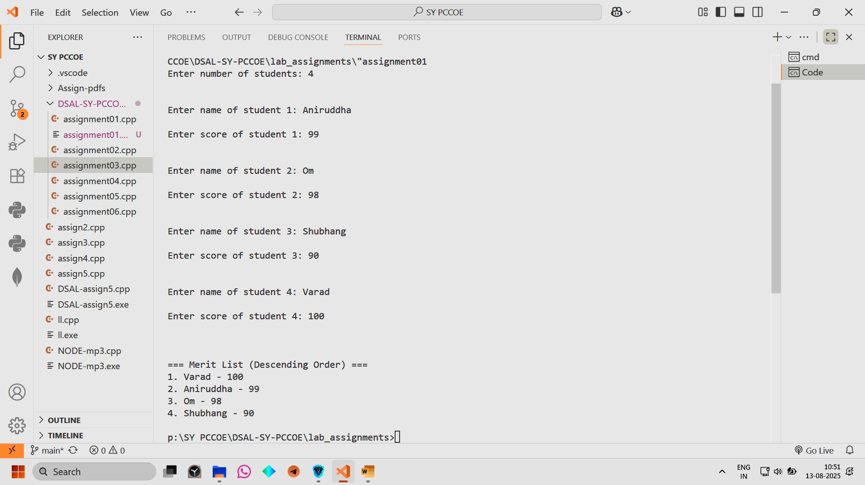

Conclusion: Hence we have implemented an education platform needs to rank students based on their exam scores to publish results and generate merit lists.