PIMPRI CHINCHWAD EDUCATION TRUST's.

**PIMPRI CHINCHWAD COLLEGE OF ENGINEERING**

(An Autonomous Institute)



___________________________________________________________________________________________

**Class : SY BTech Acad. Yr. 2025-26 Semester : I**

**Name of the student: Varad Amol Pisale PRN : 124B1B043**

**Department: Computer Engineering Division : A**

**Course Name :** **Data Structures Laboratory Code:BCE23PC02**

**Completion Date : 29/10/2025**

___________________________________________________________________________________________

**Assignment No. 10**

Problem Statement: Write a C++ Program to insert elements in Hash Table using Separate Chaining.

Source Code :

#include <bits/stdc++.h>

using namespace std;

class Node

{

public:

int key;

Node *next;

Node(int k)

{

key = k;

next = nullptr;

}

};

class HashTable

{

int tableSize;

vector<Node *> table;

public:

HashTable(int size)

{

tableSize = size;

table.resize(tableSize, nullptr);

}

int hashFunction(int key)

{

return key % tableSize;

}

void insert(int key)

{

int index = hashFunction(key);

Node *newNode = new Node(key);

newNode->next = table[index];

table[index] = newNode;

cout << "Inserted " << key << " at index " << index << endl;

}

void display()

{

cout << "\nHash Table Contents:\n";

for (int i = 0; i < tableSize; i++)

{

cout << i << ": ";

Node *curr = table[i];

while (curr)

{

cout << curr->key << " -> ";

curr = curr->next;

}

cout << "NULL\n";

}

}

};

int main()

{

int size;

cout << "Enter hash table size: ";

cin >> size;

HashTable ht(size);

int n;

cout << "Enter number of elements to insert: ";

cin >> n;

cout << "Enter elements:\n";

for (int i = 0; i < n; i++)

{

int key;

cin >> key;

ht.insert(key);

}

ht.display();

return 0;

}

Screen Shot of Output :

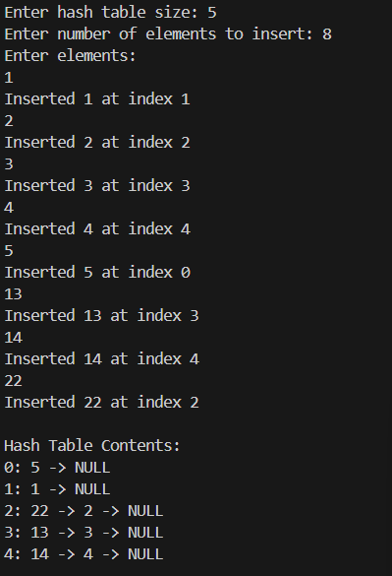

Conclusion: Hence we have implemented a C++ Program to insert elements in Hash Table using Separate Chaining.