PIMPRI CHINCHWAD EDUCATION TRUST's.

**PIMPRI CHINCHWAD COLLEGE OF ENGINEERING**

(An Autonomous Institute)



___________________________________________________________________________________________

**Class : SY BTech Acad. Yr. 2025-26 Semester : I**

**Name of the student: Varad Amol Pisale PRN : 124B1B043**

**Department: Computer Engineering Division : A**

**Course Name :** **Data Structures Laboratory Code:BCE23PC02**

**Completion Date : 04/08/2025**

___________________________________________________________________________________________

**Assignment No.**

Problem Statement:

Quick sort A warehouse management system wants to sort inventory items by stock quantity to prioritize restocking. Write a program for above scenario.

Hint:

Given an unsorted list of inventory quantities, implement Quick Sort to sort items by stock quantity in ascending order. Discuss how the presence of many duplicate quantities affects Quick Sort’s efficiency.

Source Code :

#include <bits/stdc++.h>

using namespace std;

// partition and sort

int partition(vector<int> &arr, int low, int high)

{

int pivot = arr[high];

int i = low - 1;

for (int j = low; j < high; j++)

{

if (arr[j] <= pivot)

{

i++;

swap(arr[i], arr[j]);

}

}

swap(arr[i + 1], arr[high]);

return i + 1;

}

// quick sort

void quickSort(vector<int> &arr, int low, int high)

{

if (low < high)

{

int pi = partition(arr, low, high);

quickSort(arr, low, pi - 1);

quickSort(arr, pi + 1, high);

}

}

int main()

{

vector<int> q;

int n;

cout << "Enter number of inventory items: ";

cin >> n;

cout << "Enter stock quantities:\n";

for (int i = 0; i < n; i++)

{

int temp;

cin >> temp;

q.push_back(temp);

}

quickSort(q, 0, n - 1);

cout << "\nSorted stock quantities (Ascending):\n";

for (int i = 0; i < q.size(); i++)

{

cout << q[i] << " ";

}

cout << endl;

return 0;

}

Screen Shot of Output :

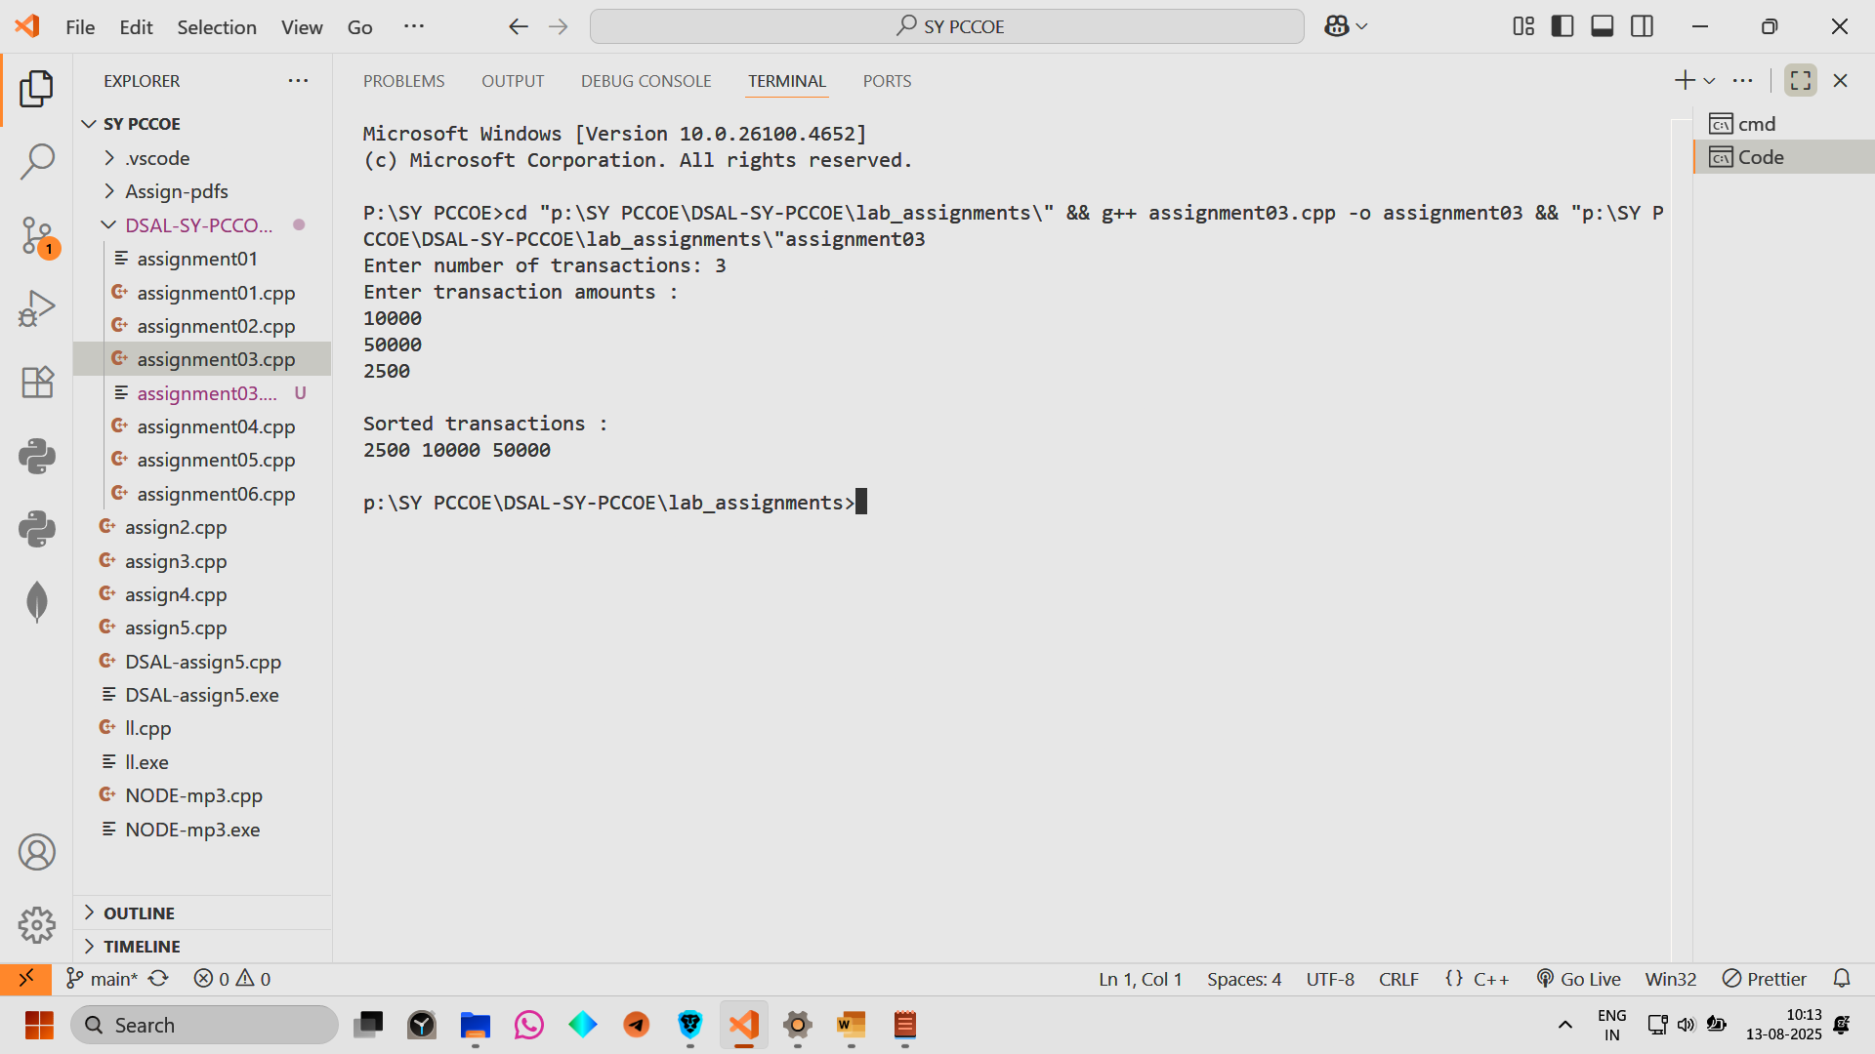

Conclusion: Hence we have implemented a warehouse management system wants to sort inventory items by stock quantity