PIMPRI CHINCHWAD EDUCATION TRUST's.

**PIMPRI CHINCHWAD COLLEGE OF ENGINEERING**

(An Autonomous Institute)



___________________________________________________________________________________________

**Class : SY BTech Acad. Yr. 2025-26 Semester : I**

**Name of the student: Varad Amol Pisale PRN : 124B1B043**

**Department: Computer Engineering Division : A**

**Course Name :** **Data Structures Laboratory Code:BCE23PC02**

**Completion Date : 06/08/2025**

___________________________________________________________________________________________

**Assignment No.**

Problem Statement:

3 Merge sort A banking app needs to display a user’s transaction history sorted by

transaction amount to quickly identify large deposits or withdrawals.

Write a program for above scenario.

Hint:

Given a list of transaction amounts (positive and negative),implement Quick Sort to sort transactions in ascending order of amount. The solution should efficiently handle thousands of

transactions.

Source Code :

#include <bits/stdc++.h>

using namespace std;

// partition

int partition(vector<long double> &arr, int low, int high)

{

int pivot = arr[high];

int i = low - 1;

for (int j = low; j < high; j++)

{

if (arr[j] <= pivot)

{

i++;

swap(arr[i], arr[j]);

}

}

swap(arr[i + 1], arr[high]);

return i + 1;

}

// quick sort

void quickSort(vector<long double> &arr, int low, int high)

{

if (low < high)

{

int pi = partition(arr, low, high);

quickSort(arr, low, pi - 1);

quickSort(arr, pi + 1, high);

}

}

int main()

{

vector<long double> t; // long double to handle large transactions

int n;

cout << "Enter number of transactions: ";

cin >> n;

cout << "Enter transaction amounts :\n";

for (int i = 0; i < n; i++)

{

long double amount;

cin >> amount;

t.push_back(amount);

}

quickSort(t, 0, n - 1);

cout << "\nSorted transactions :\n";

for (int i = 0; i < t.size(); i++)

{

cout << t[i] << " ";

}

cout << endl;

return 0;

}

Screen Shot of Output :

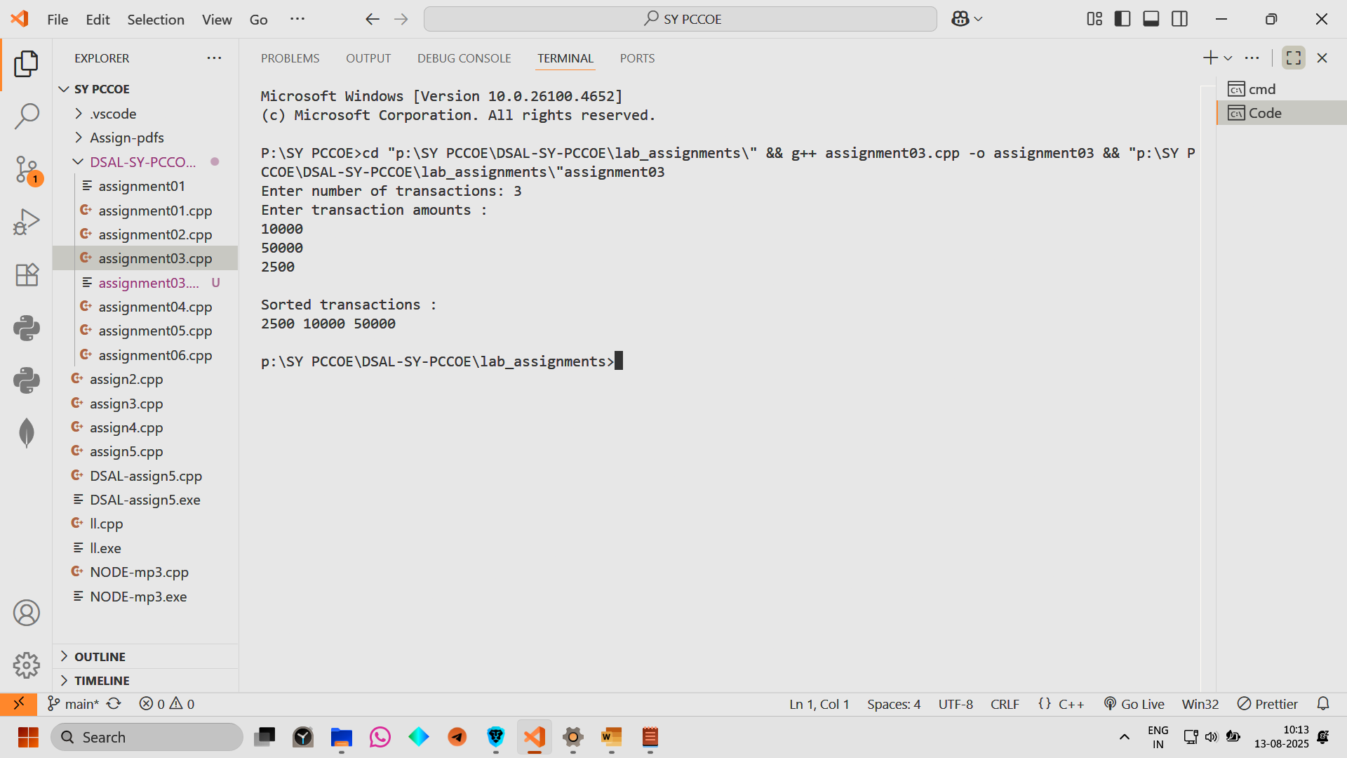

Conclusion: Hence we have implemented a banking app needs to display a user’s transaction history sorted by transaction amount