PIMPRI CHINCHWAD EDUCATION TRUST's.

**PIMPRI CHINCHWAD COLLEGE OF ENGINEERING**

(An Autonomous Institute)



___________________________________________________________________________________________

**Class : SY BTech Acad. Yr. 2025-26 Semester : I**

**Name of the student: Varad Amol Pisale PRN : 124B1B043**

**Department: Computer Engineering Division : A**

**Course Name :** **Data Structures Laboratory Code:BCE23PC02**

**Completion Date : 15/10/2025**

___________________________________________________________________________________________

**Assignment No. 6**

Problem Statement: Write a program for Mathematical Expression Evaluation in Calculator: Implement a calculator that supports evaluation of complex arithmetic expressions using stacks for operands and operators.

Source Code :

#include <bits/stdc++.h>

using namespace std;

int main()

{

    string exp;

    stack<char> st;

    cout << "Enter Exp: ";

    getline(cin, exp);

    // getchar();

    for (int i = 0; i < exp.size(); i++)

    {

        if (exp[i] == '+' || exp[i] == '-' || exp[i] == '*' || exp[i] == '/')

        {

            int t1 = st.top() - '0';

            st.pop();

            int t2 = st.top() - '0';

            st.pop();

            int sol = 0;

            switch (exp[i])

            {

            case '+':

                sol = t1 + t2;

                break;

            case '-':

                sol = t2 - t1;

                break;

            case '*':

                sol = t1 * t2;

                break;

            case '/':

                sol = t2 / t1;

                break;

            default:

                break;

            }

            st.push(char(sol)+'0');

        }else{

            st.push(exp[i]);

        }

    }

    cout<<"Ans is: "<<st.top();

    return 0;

}

Screen Shot of Output :

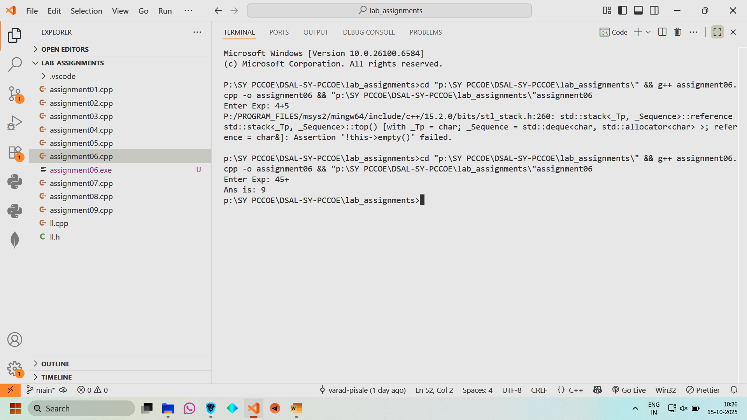

Conclusion: Hence we have successfully implemented a calculator using stack.