PIMPRI CHINCHWAD EDUCATION TRUST's.

**PIMPRI CHINCHWAD COLLEGE OF ENGINEERING**

(An Autonomous Institute)



___________________________________________________________________________________________

**Class : SY BTech Acad. Yr. 2025-26 Semester : I**

**Name of the student: Varad Amol Pisale PRN : 124B1B043**

**Department: Computer Engineering Division : A**

**Course Name :** **Data Structures Laboratory Code:BCE23PC02**

**Completion Date : 15/10/2025**

___________________________________________________________________________________________

**Assignment No. 7**

Problem Statement: Write a program to check whether a string is a palindrome using stack operations.

Source Code :

#include <bits/stdc++.h>

using namespace std;

int main()

{

    string str;

    // mam,madam,racecar,maam

    // list<char> ll;

    // SLL ll;

    stack<char> st;

    cout << "Enter string: ";

    getline(cin, str);

    int n = str.size(), i = 0;

    while (i < n / 2)

    {

        st.push(str[i]);

        // cout << st.top()<<endl;

        i++;

    }

    // cout << "out of loop" << endl;

    if (n % 2 != 0)

    {

        i++;

        // cout << str[i] << endl;

    }

    while (i < n)

    {

        // cout << st.top() << " " << str[i]<<endl;

        if (st.top() != str[i])

        {

            cout << "Not a palindrome" << endl;

            return 0;

        }

        st.pop();

        i++;

    }

    cout << "Is Palindrome" << endl;

    return 0;

}

Screen Shot of Output :

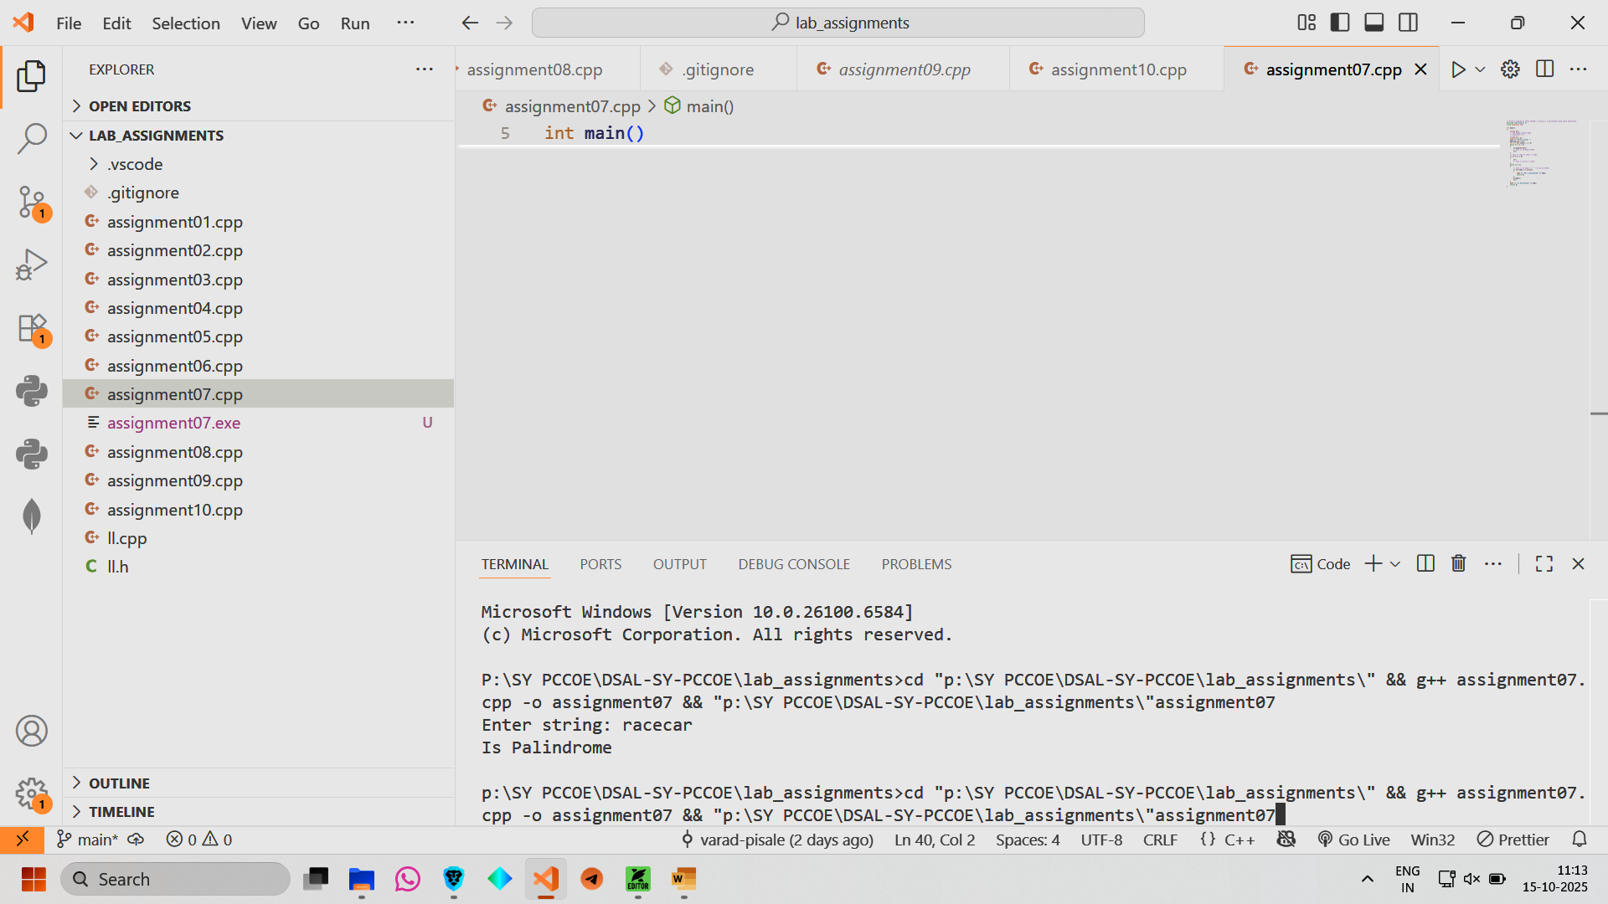

Conclusion: Hence we have implemented a stack to check whether a string is plaindrome.