PIMPRI CHINCHWAD EDUCATION TRUST's.

**PIMPRI CHINCHWAD COLLEGE OF ENGINEERING**

(An Autonomous Institute)



___________________________________________________________________________________________

**Class : SY BTech Acad. Yr. 2025-26 Semester : I**

**Name of the student: Varad Amol Pisale PRN : 124B1B043**

**Department: Computer Engineering Division : A**

**Course Name :** **Data Structures Laboratory Code:BCE23PC02**

**Completion Date : 15/10/2025**

___________________________________________________________________________________________

**Assignment No. 8**

Problem Statement: Simulate a ticketing system where customers raise support tickets and are added to a queue. The support team dequeues and resolves tickets. Allow urgent issues to be placed at the front.Write a program for above scenario.

Source Code :

#include <bits/stdc++.h>

using namespace std;

class Qqueue

{

public:

    int ID;

    string customerName;

    Qqueue *next;

    Qqueue(string name, int id)

    {

        customerName = name;

        ID = id;

        next = NULL;

    }

};

class TicketingSystem

{

    Qqueue *front;

    Qqueue *rear;

public:

    TicketingSystem()

    {

        front = rear = NULL;

    }

    void enqueue(string name, int id)

    {

        Qqueue *newNode = new Qqueue(name, id);

        if (front == NULL)

        {

            front = rear = newNode;

            rear->next = front;

            return;

        }

        rear->next = newNode;

        rear = newNode;

        rear->next = front;

    }

    // Urgent Enqueue

    void urgentEnqueue(string name, int id)

    {

        Qqueue *newNode = new Qqueue(name, id);

        if (front == NULL)

        {

            front = rear = newNode;

            rear->next = front;

            return;

        }

        newNode->next = front;

        front = newNode;

        rear->next = front;

    }

    void dequeue()

    {

        if (front == NULL)

        {

            cout << "No tickets to resolve. ; Queue is empty \n";

            return;

        }

        Qqueue *temp = front;

        if (front == rear)

        {

            cout << "Resolving ticket: " << temp->ID << " " << temp->customerName << endl;

            delete temp;

            front = rear = NULL;

            return;

        }

        cout << "Resolving ticket: " << temp->ID << " " << temp->customerName << endl;

        front = front->next;

        rear->next = front;

        delete temp;

    }

    void display()

    {

        if (front == NULL)

        {

            cout << "Queue is empty\n";

            return;

        }

        Qqueue *temp = front;

        cout << "\n Tickets in Queue:\n";

        do

        {

            cout << "Ticket ID: " << temp->ID << " || Customer Name: " << temp->customerName << endl;

            temp = temp->next;

        } while (temp != front);

        cout << endl;

    }

};

int main()

{

    int GlobalID = 1;

    TicketingSystem ts;

    cout << "\n1. Add ticket"

         << "\n2. Add urgent ticket"

         << "\n3. Resolve ticket"

         << "\n4. Display tickets"

         << "\n5. Exit\n";

    while (true)

    {

        int choice;

        cout<<"Enter Choice: ";

        cin >> choice;

        cin.ignore();

        switch (choice)

        {

        case 1:

        {

            string name;

            cout << "Enter Name: ";

            getline(cin, name);

            ts.enqueue(name, GlobalID++);

            break;

        }

        case 2:

        {

            string name;

            cout << "Enter Name: ";

            // cin.ignore();

            getline(cin, name);

            ts.urgentEnqueue(name, GlobalID++);

            break;

        }

        case 3:

            ts.dequeue();

            break;

        case 4:

            ts.display();

            break;

        case 5:

            return 0;

        default:

            cout << "Enter valid choice!\n";

        }

    }

}

Screen Shot of Output :

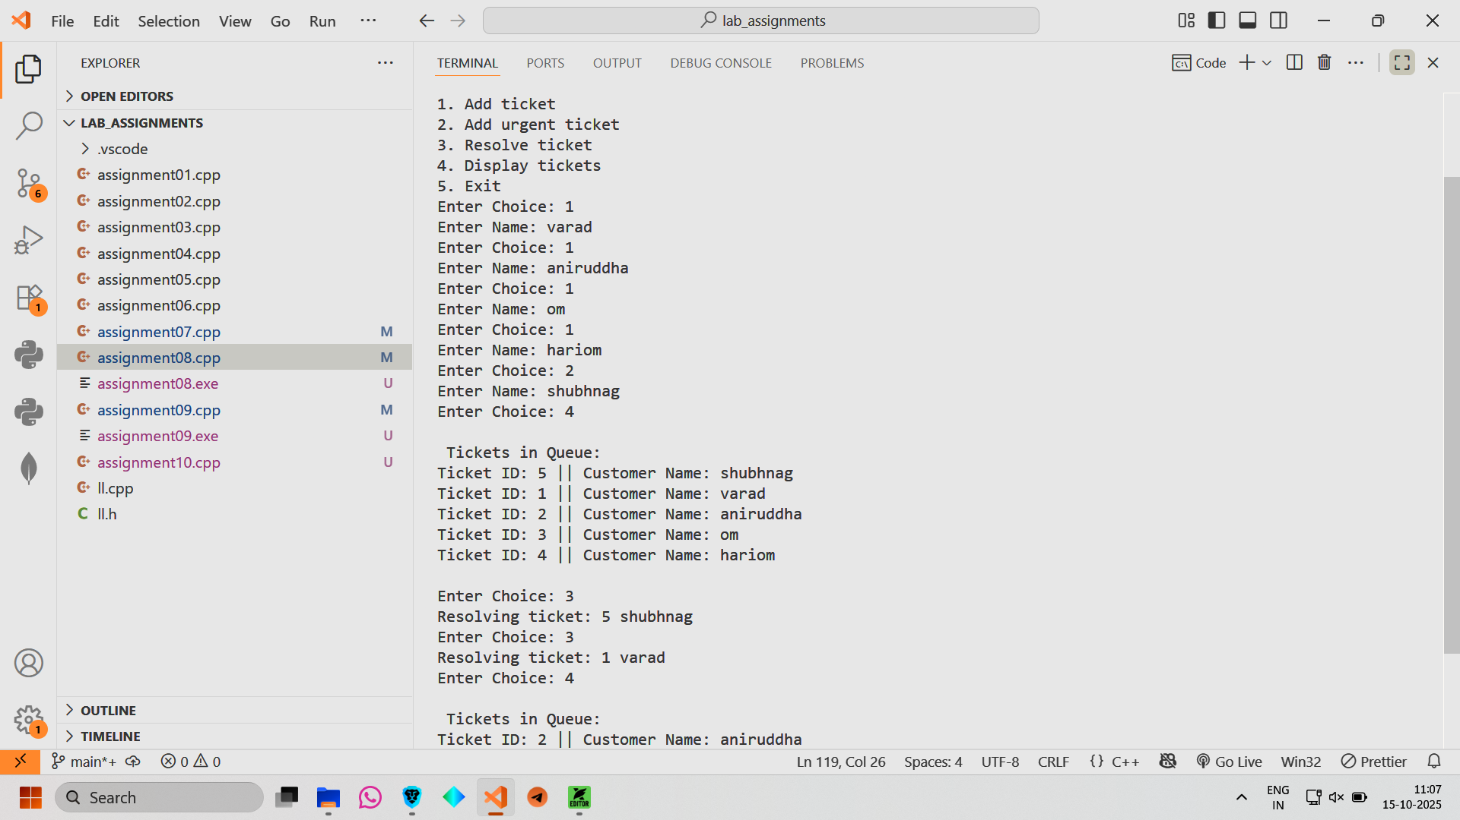

Conclusion: Hence we have implemented a ticket management system.