PIMPRI CHINCHWAD EDUCATION TRUST's.

**PIMPRI CHINCHWAD COLLEGE OF ENGINEERING**

(An Autonomous Institute)



___________________________________________________________________________________________

**Class : SY BTech Acad. Yr. 2025-26 Semester : I**

**Name of the student: Varad Amol Pisale PRN : 124B1B043**

**Department: Computer Engineering Division : A**

**Course Name :** **Data Structures Laboratory Code:BCE23PC02**

**Completion Date : 15/10/2025**

___________________________________________________________________________________________

**Assignment No. 9**

Problem Statement: Design a simplified railway reservation system where users can book, cancel, and view tickets. Use an array to store booking details and a queue to manage the waiting list.

Source Code :

#include <bits/stdc++.h>

using namespace std;

class Queue

{

    int ID;

    string name;

    Queue *next = nullptr;

public:

    Queue() {}

    Queue(string n, int id)

    {

        name = n;

        ID = id;

    }

    friend class Ticket_system;

};

class Ticket_system

{

    static const int MAX = 5; // total confirmed seats

    string booked[MAX];

    int bookedCount = 0;

    int identy = 1;

    Queue *front = nullptr, *rear = nullptr;

public:

    void add_ticket(string name)

    {

        if (bookedCount < MAX)

        {

            booked[bookedCount++] = name;

            cout << "Ticket confirmed for " << name << " (ID " << identy++ << ")\n";

        }

        else

        {

            Queue *temp = new Queue(name, identy++);

            if (rear == nullptr)

            {

                front = rear = temp;

            }

            else

            {

                rear->next = temp;

                rear = temp;

            }

            cout << "All seats full! Added to waiting list: " << name << endl;

        }

    }

    void remove_ticket()

    {

        if (bookedCount == 0)

        {

            cout << "No confirmed bookings to cancel!\n";

            return;

        }

        cout << "Cancelled ticket of " << booked[0] << endl;

        // shift all bookings left

        for (int i = 1; i < bookedCount; i++)

            booked[i - 1] = booked[i];

        bookedCount--;

        // if waiting queue not empty, move front person to booked list

        if (front != nullptr)

        {

            booked[bookedCount++] = front->name;

            cout << "Moved from waiting list to confirmed: " << front->name << endl;

            Queue *temp = front;

            front = front->next;

            delete temp;

            if (front == nullptr)

                rear = nullptr;

        }

    }

    void print_all()

    {

        cout << "\n--- Confirmed Tickets ---\n";

        if (bookedCount == 0)

            cout << "None\n";

        else

            for (int i = 0; i < bookedCount; i++)

                cout << i + 1 << ". " << booked[i] << endl;

        cout << "\n--- Waiting List ---\n";

        if (front == nullptr)

            cout << "None\n";

        else

        {

            Queue *temp = front;

            while (temp != nullptr)

            {

                cout << temp->ID << ". " << temp->name << endl;

                temp = temp->next;

            }

        }

        cout << endl;

    }

};

int main()

{

    Ticket_system obj;

    cout << "=== Railway Reservation System ===\n";

    cout << "1. Book Ticket\n";

    cout << "2. Cancel Ticket\n";

    cout << "3. View All Tickets\n";

    cout << "4. Exit\n";

    while (true)

    {

        int op;

        cout << "\nEnter Option: ";

        cin >> op;

        cin.ignore();

        switch (op)

        {

        case 1:

        {

            string name;

            cout << "Enter Passenger Name: ";

            getline(cin, name);

            obj.add_ticket(name);

            break;

        }

        case 2:

            obj.remove_ticket();

            break;

        case 3:

            obj.print_all();

            break;

        case 4:

            return 0;

        default:

            cout << "Invalid option!\n";

            break;

        }

    }

}

Screen Shot of Output :

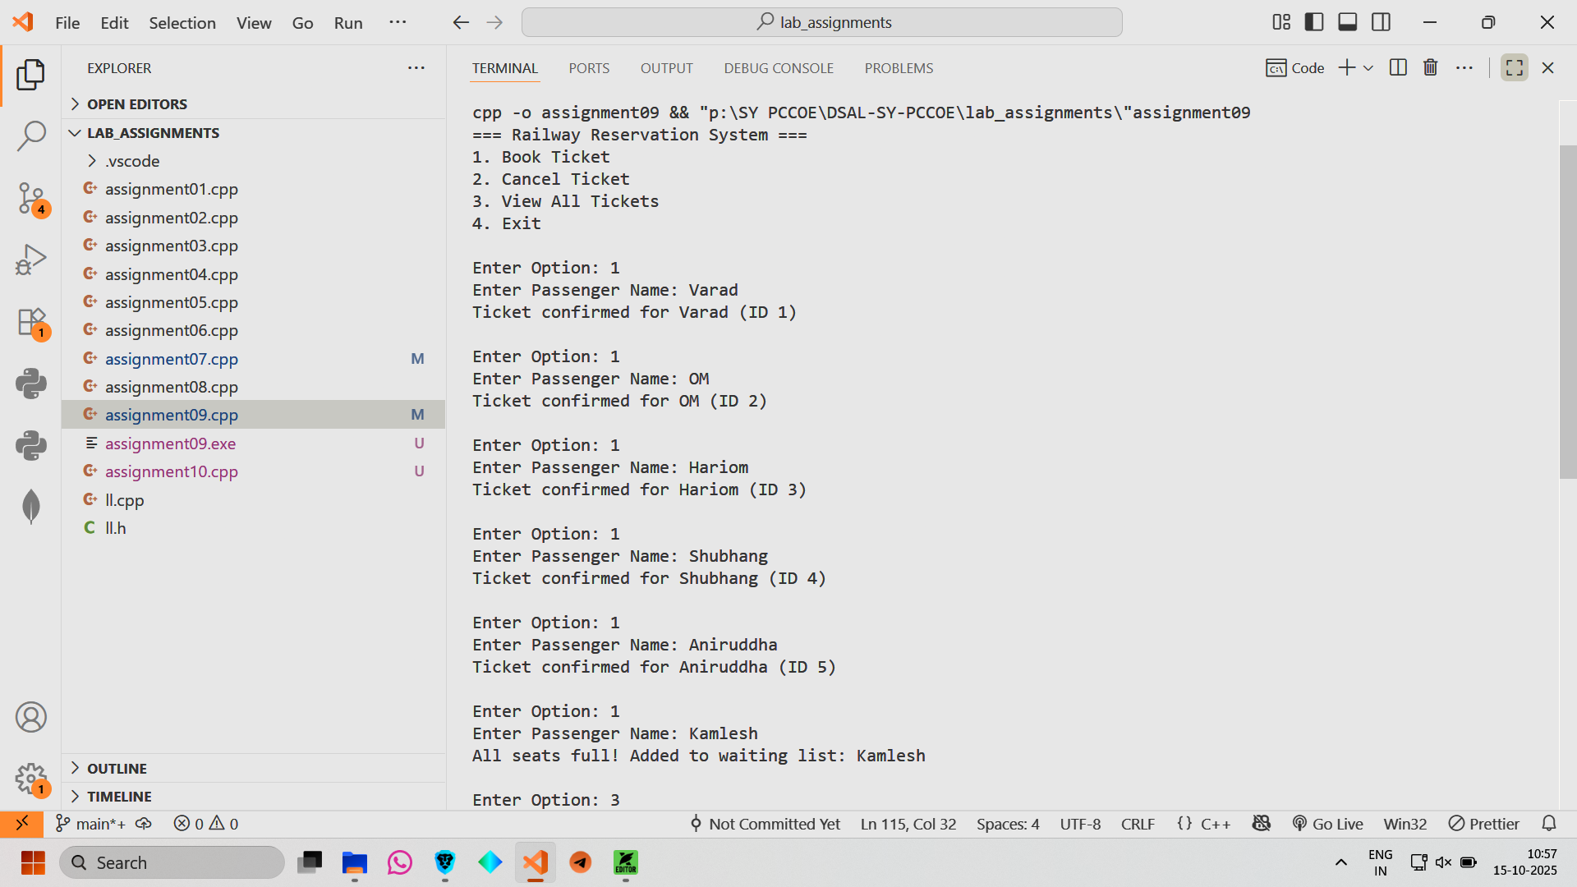

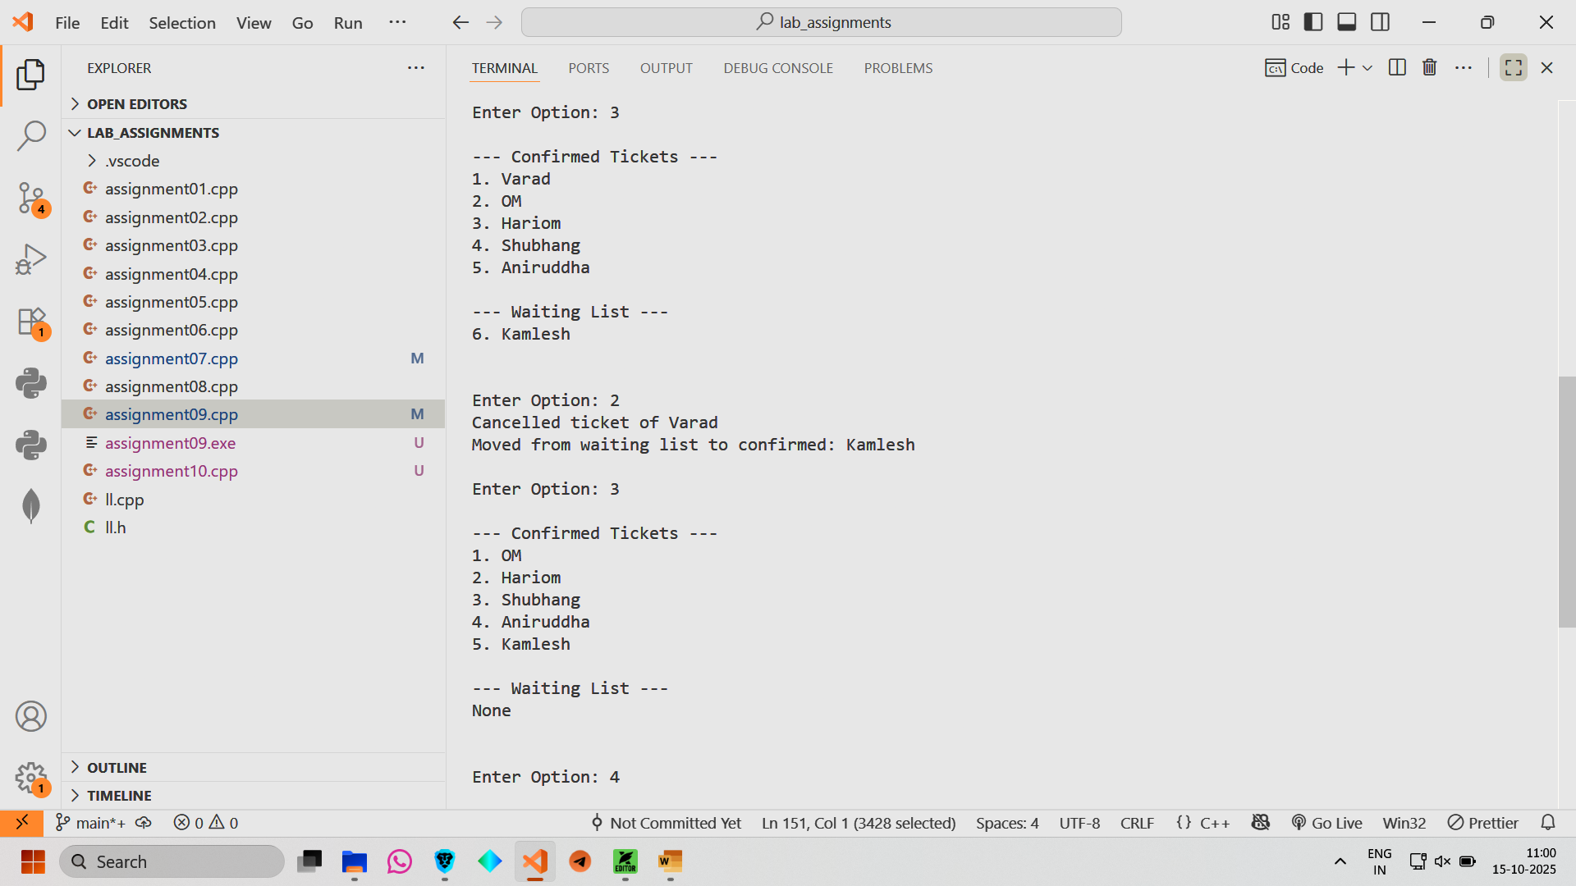

Conclusion: Hence we have implemented a Railway Reservation system using array and queue.