Code Screenshots

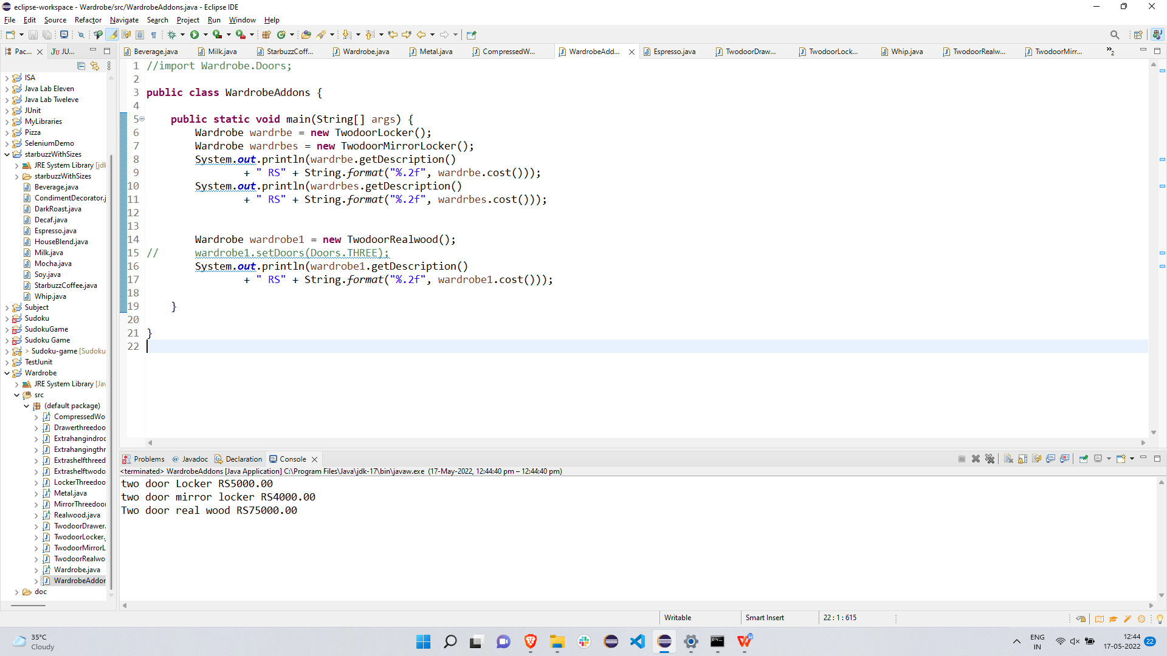

JAVA doc

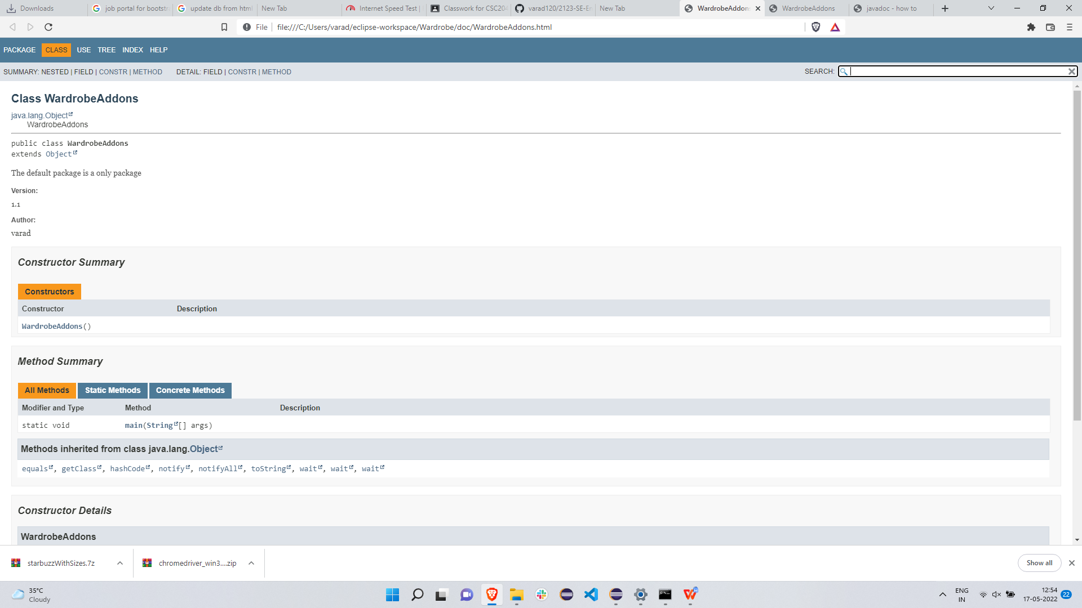

Link to repo: [https://github.com/varad120/2123-SE-EndSem.git](2123-SE-EndSem.docx)