INF 552: Assignment 3

Dimensionality Reduction

*Priyambada Jain (*[*priyambj@usc.edu)*](mailto:priyambj@usc.edu))

*Sai Sree Kamineni (*[*skaminen@usc.edu)*](mailto:skaminen@usc.edu))

*Varad Kulkarni (*[*vdkulkar@usc.edu)*](mailto:vdkulkar@usc.edu))

Part 1: Implementation

Language used – Python 2.7

1. **PCA**

Command to run – python PCA.py *path of pca-data.txt*

python PCA.py pca-data.txt

Data Structures Used: Numpy array for data points

Result: Output file “*PCA_output.txt”* has 2D coordinates of the points.

**First Principal Component Direction X**

**Second Principal Component Direction Y**

Code Level Optimizations:

* numpy.linalg.eig() to calculate eigen values & eigen vector.
* Numpy.hstack() to create new matrix with selected eigen vector coordinates.

Algorithm:

1. Read data points and calculate covariance matrix
2. Calcualte eigen values & eigen vector
3. Find the 2 largest eigen values & change the eigen vector matrix by removing vector corresponding to least eigen valued direction.
4. With the new eigen matrix, compute new coordinates by applying dot product.

Challenges Faced:

Data storage in array and keeping note of dimensions of array was tough.

1. **FastMap**

Command to run – python fastmap.py *path of* fastmap-data*.txt path of fastmap-wordlist.txt*

python fastmap.py fastmap-data.txt fastmap-wordlist.txt

Data Structures Used: Numpy array for data points

Results:

Final 2D points -

**array([[ 3.875 , 6.0625 ],**

**[ 3. , 7.75 ],**

**[ 0. , 4. ],**

**[ 1.04166667, 1.1875 ],**

**[ 2.45833333, 0. ],**

**[ 9.5 , 5.1875 ],**

**[ 2.45833333, 8. ],**

**[ 1.5 , 1.5625 ],**

**[ 2.45833333, 1. ],**

**[ 12. , 4. ]])**

Plot of words in 2D

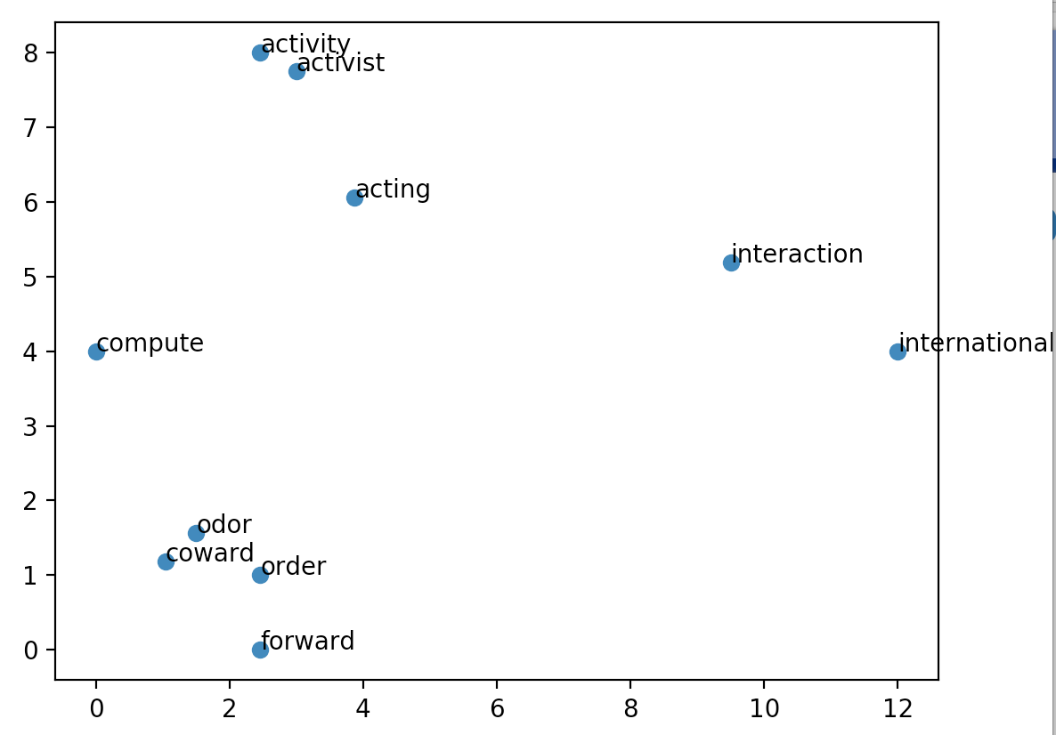

Code Level Optimizations:

* Math.sqrt to find square root in calculating distance
* Matplotlib.pyplot.subplots to plot the final points

Algorithm:

1. Start with k = n, where n is final space dimensions.
2. Initially choose farthest points (OA, OB)
3. For every new point (i) calculate the distance

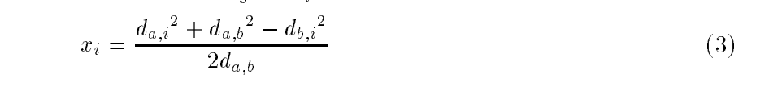

1. Update this distance and repeat the process till k>0

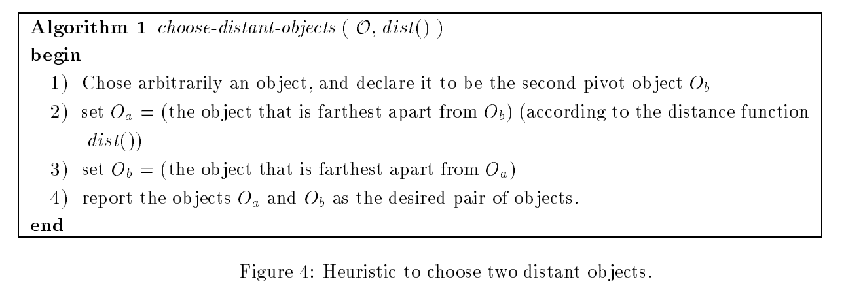

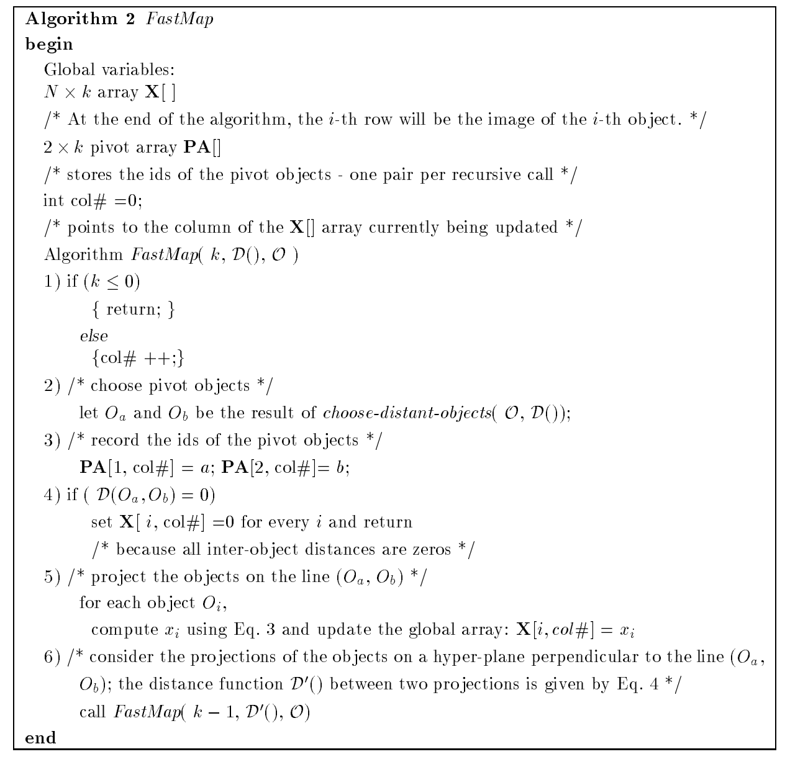

Challenges Faced:

Coming up with and algorithm to implement was hard.

Finding the farthest pair considering time complexity was challenging.

Part 2: Software Familiarization

1. **PCA**

Python sklearn has an implementation for PCA.

*sklearn.decomposition.PCA* function:

pca = PCA(n_components=2)

pca.fit(input data)

Comparing the results

|  |  |  |
| --- | --- | --- |
| **Feature** | **Code** | **Sklearn** |
| Covariance | [[ 81.23061223 -15.83982766 31.66606691]  [-15.83982766 13.70079979 -15.26416298]  [ 31.66606691 -15.26416298 31.36555593]] | [[ 81.22845778 -15.83817402 31.66312677]  [-15.83817402 13.69953054 -15.26190629]  [ 31.66312677 -15.26190629 31.36154358]] |
| Matrix from eigen vectors | [[ 0.8666528 -0.49630987]  [-0.23278176 -0.49246586]  [ 0.44127722 0.71495027]] | [[ 0.86667137 -0.4962773]  [-0.23276482 -0.4924792]  [ 0.44124968 0.71496368]] |
| First data point in 2D | [ 10.9534134 7.41334173] | [ 10.95314032 7.41375984] |

1. **FastMap**

Part 3: Applications

1. PCA

* *Email Classification* – Emails are part of day-to-day life. As the usage increases fraudulent activities increase as well. So the emails should be classified before reaching the user. Emails are classified by the words in it. Of all the words, few words like credit, pay, lottery etc imply fraud. So PCA is applied to the words (dimensions).
* *Neuroscience* – Neural responses of stimulus has many dimensions out of which very few are relevant. Maximally informative dimensions is a variation of PCA used to reduce the dimensions to *k* relevant subspaces.
* *Taxonomy* – A number of unweighted characters can be analyzed to group plant and animal species. PCA helps reduce the number of possible groupings. It replaces the original characters with only significant ones.

1. FastMap

* *Data Clustering* – Data in N dimensions is reduced to k dimensions using FastMap and objects are projected onto k-dimensional space. Clustering algorithm is applied in low dimensional space.
* *Cluster Validation* – Clustering is performed in original space and FastMap is used to project clusters on low dimensional space and visualize them. If the cluster appears to be separate from other objects on the low dimensional plots, then it can be claimed that the cluster is also separate from original objects.

**References**:

1. <https://www.intechopen.com/books/principal-component-analysis-multidisciplinary-applications/application-of-pca-in-taxonomy-research-thrips-insecta-thysanoptera-as-a-model-group>
2. <http://dataconomy.com/2016/01/understanding-dimensionality-reduction/>
3. <https://en.wikipedia.org/wiki/Maximally_informative_dimensions>
4. <http://repository.cmu.edu/cgi/viewcontent.cgi?article=1577&context=compsci>
5. <http://scikit-learn.org/stable/modules/generated/sklearn.decomposition.PCA.html>
6. [https://books.google.com/books?id=Dc9rCQAAQBAJ&pg=PA234&lpg=PA234&dq=fastmap+applications&source=bl&ots=Gos-txJRJv&sig=anyQPr_Y70WvGCC2TOPVkeOjnJo&hl=en&sa=X&ved=0ahUKEwjZ66Wi1uLWAhWixVQKHWdIDvkQ6AEITzAH - v=onepage&q=fastmap applications&f=false](https://books.google.com/books?id=Dc9rCQAAQBAJ&pg=PA234&lpg=PA234&dq=fastmap+applications&source=bl&ots=Gos-txJRJv&sig=anyQPr_Y70WvGCC2TOPVkeOjnJo&hl=en&sa=X&ved=0ahUKEwjZ66Wi1uLWAhWixVQKHWdIDvkQ6AEITzAH#v=onepage&q=fastmap%20applications&f=false)

**Appendix**:

PCA.py – Implementation of PCA.

pca-data.txt – Input file for PCA.

PCA_output.txt – Output file for PCA.

fastmap.py – Implementation of FastMap.

fastmap-data.txt, fastmap-wordlist.txt – Input files for FastMap.