This is a real time dataset of the ineuron technical consultant team. You have to perform hive analysis on this given dataset.

Download Dataset 1 - https://drive.google.com/file/d/1WrG-9qv6atP-W3P_-gYln1hHyFKRKMHP/view

Download Dataset 2 - https://drive.google.com/file/d/1-JIPCZ34dyN6k9CqJa-Y8yxIGq6vTVXU/view

Note: both files are csv files.

1. Create a schema based on the given dataset

create table agent_loging_report(

sl_no int,

agent string,

date string,

login_time string,

logout_time string,

duration string)

row format delimited

fields terminated by ','

tblproperties("skip.header.line.count" = "1");

create table agent_performance(

sl_no int,

date string,

agent string,

total_chats int,

average_reponse_time string,

average_resolution_time string,

average_rating float,

total_feedback int)

row format delimited

fields terminated by ','

tblproperties("skip.header.line.count"="1");

2. Dump the data inside the hdfs in the given schema location.

load data local inpath 'file:///home/cloudera/data/AgentLogingReport.csv' into table agent_loging_report;

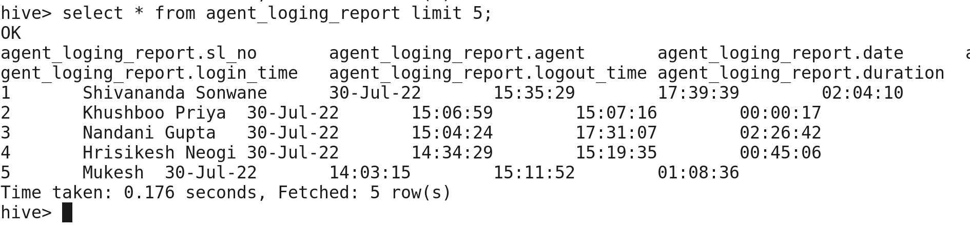

load data local inpath 'file:///home/cloudera/data/AgentPerformance.csv' into table agent_performance;

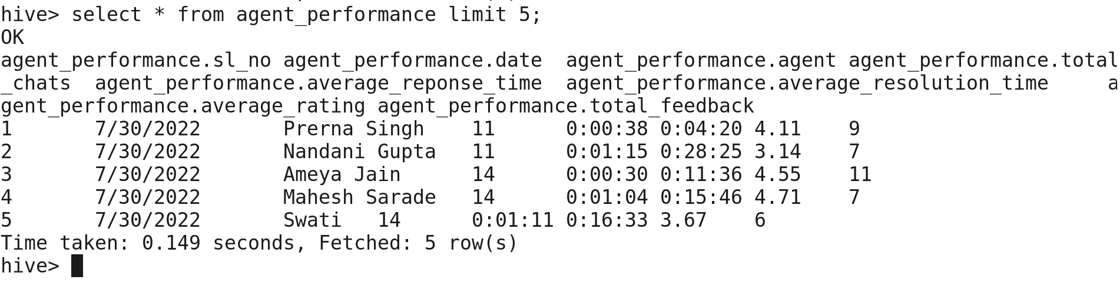

3. List of all agents’ names.

select agent from agent_loging_report limit 5;

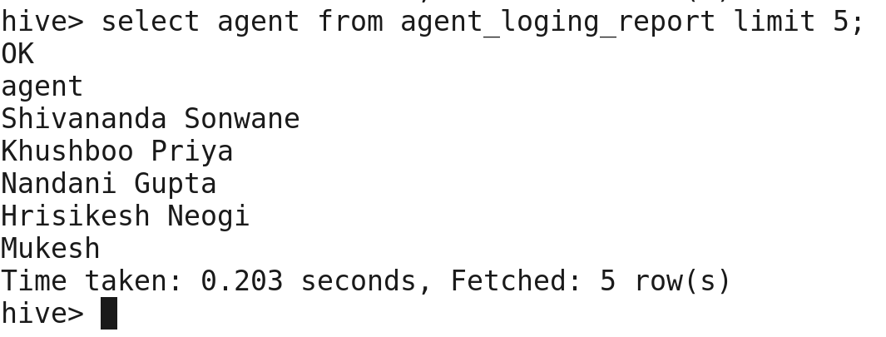

4. Find out agent average rating.

select agent,round(avg(average_rating),2)avg_rating from agent_performance group by agent limit 5;

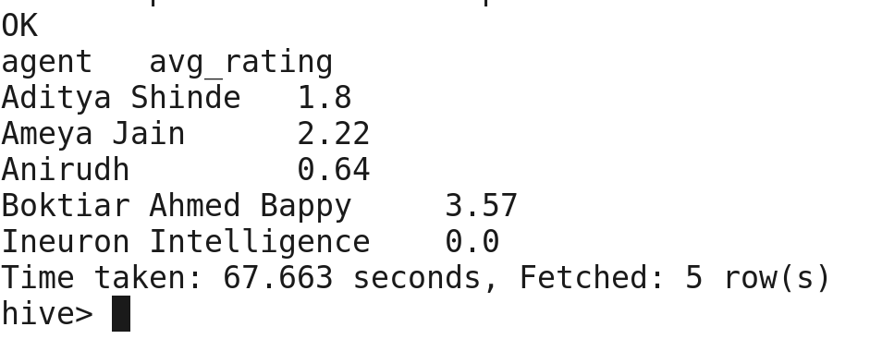

5. Total working days for each agent

select count (distinct date) as total_working_days, agent from agent_loging_report group by agent limit 5;

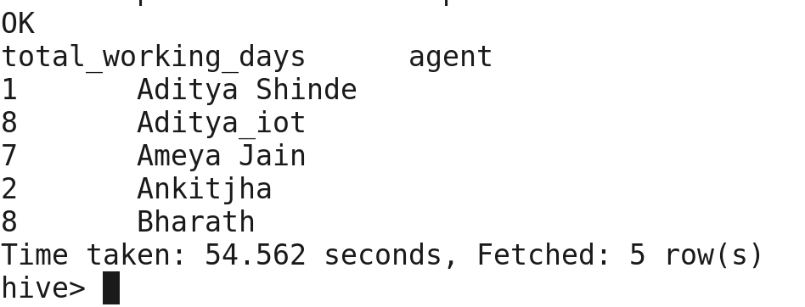

6. Total query that each agent has taken

select agent,sum(total_chats) total_queries from agent_performance group by agent limit 5;

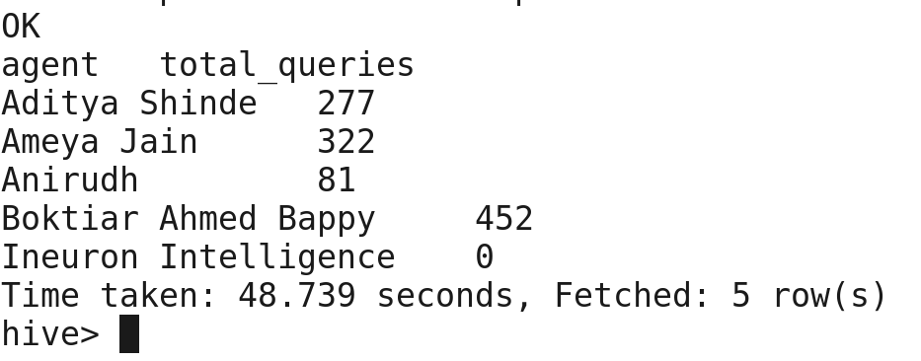

7. Total Feedback that each agent has received

select count(total_feedback) as total_feedback, agent from agent_performance group by agent limit 5;

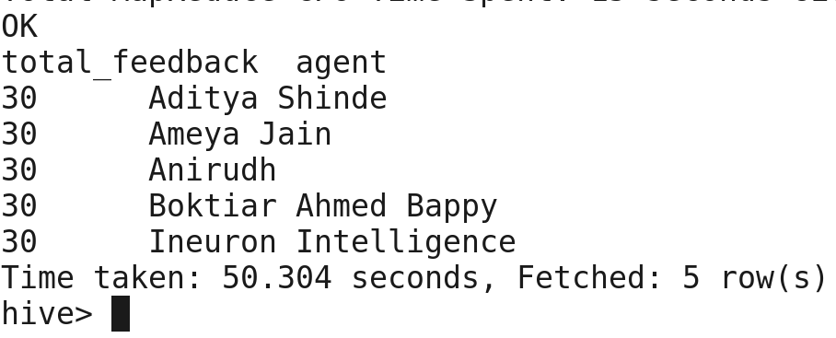

8. Agent name who have average rating between 3.5 to 4

select agent,average_rating from agent_performance where average_rating between 3.5 and 4 limit 5;

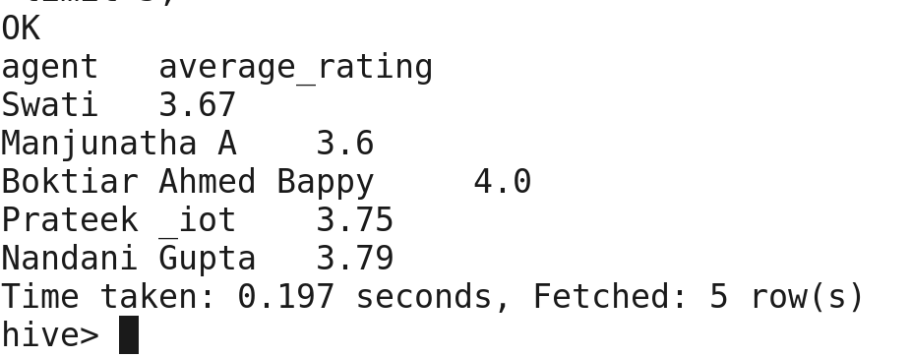

9. Agent name who have rating less than 3.5

select agent,average_rating from agent_performance where average_rating < 3.5 limit 5;

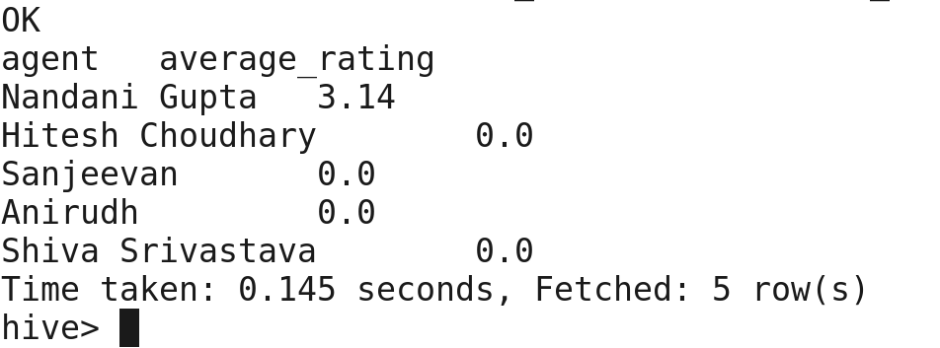

10. Agent name who have rating more than 4.5

select agent,average_rating from agent_performance where average_rating > 4.5 limit 5;

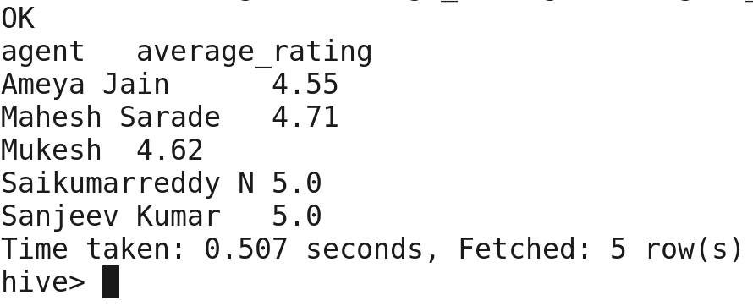

11. How many feedback agents have received more than 4.5 average

select agent,feedback_count from (select agent, avg(total_feedback)avg_feedback, count(total_feedback)feedback_count from agent_performance group by agent)a where avg_feedback > 4.5 limit 5;

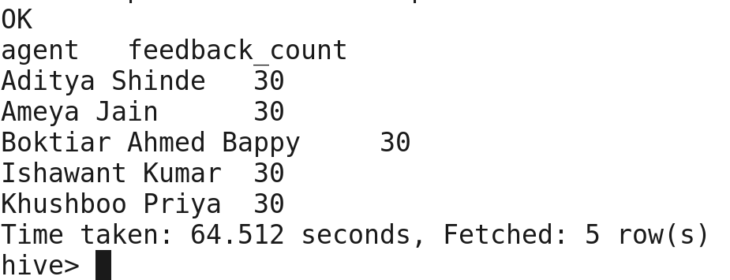

12. average weekly response time for each agent

tried a lot but getting date formatting error.

13. average weekly resolution time for each agent

tried a lot but getting date formatting error.

14. Find the number of chats on which they have received feedback

Select agent,count(total_feedback) as chats_with_feedback from agent_performance group by agent limit 5;

15. Total contribution hour for each and every agent’s weekly basis

tried a lot but getting date formatting error.

16. Perform inner join, left join and right join based on the agent column and after joining the table export that data into your local system.

set hive.enforce.sortmergebucketmapjoin = false;

set hive.auto.convert.sortmerge.join=true;

set hive.optimise.bucketmapjoin=true;

set hive.optimise.bucketmapjoin.sortedmerge=true;

inner join -

hive -e 'select * from agent_loging_report_part_buck l inner join agent_performance_part_buck p on l.agent=p.agent limit 5' > file:///home/cloudera/data/innerjoin.csv

left join -

hive -e 'select * from agent_loging_report_part_buck l left join agent_performance_part_buck p on l.agent=p.agent limit 5' > <file:///home/cloudera/data/leftjoin.csv>

right join -

hive -e 'select * from agent_loging_report_part_buck l right join agent_performance_part_buck p on l.agent=p.agent limit 5' > file:///home/cloudera/data/rightjoin.csv

17. Perform partitioning on top of the agent column and then on top of that perform bucketing for each partitioning.

create table agent_loging_report_part_buck(

sl_no int,

date string,

login_time string,

logout_time string,

duration string)

partitioned by (agent string)

clustered by (date)

sorted by (date)

into 6 buckets

row format delimited

fields terminated by ',';

set hive.exec.dynamic.partition=true;

set hive.exec.dynamic.partition.mode=nonstrict;

insert overwrite table agent_loging_report_part_buck partition (agent) select sl_no, agent, date, login_time, logout_time,duration from agent_loging_report;

create table agent_performance_part_buck(

sl_no int,

date string,

total_chats int,

average_reponse_time string,

average_resolution_time string,

average_rating float,

total_feedback int)

partitioned by (agent string)

clustered by (date)

sorted by (date)

into 3 buckets

row format delimited

fields terminated by ',';

set hive.exec.dynamic.partition=true;

hive> set hive.exec.dynamic.partition.mode=nonstrict;

insert overwrite table agent_performance_part_buck partition (agent) select * from agent_performance;

inserted data

