**1a)**

.8086

.model small

.data

a db 06h

b db 02h

c db ?

.code

start:

MOV AX,@data

MOV DS,AX

MOV AL,a

MOV BL,b

ADD AL,BL

MOV c,AL

MOV AH,4Ch

INT 21h

end start

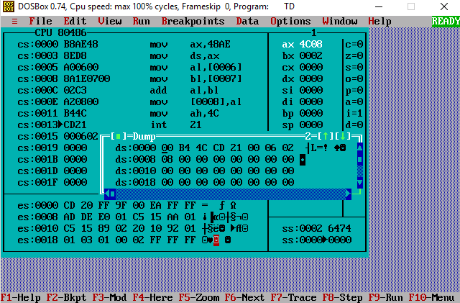

**1b)**

.8086

.model small

.data

a dw 2001h

b dw 1212h

c dw ?

.code

start:

MOV AX,@data

MOV DS,AX

MOV AX,a

MOV BX,b

ADD AX,BX

MOV c,AX

MOV AH,4Ch

INT 21h

end start

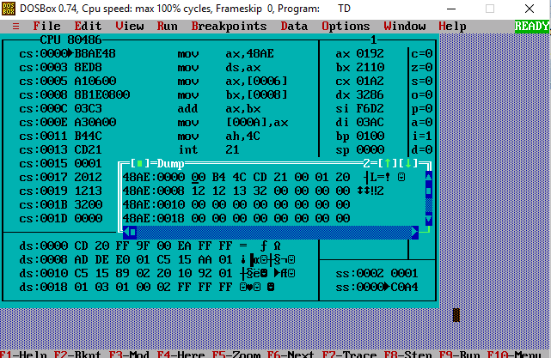

**1c)**

.8086

.model small

.data

a db 08h

b db 04h

c db ?

.code

start:MOV AX,@data

MOV DS,AX

MOV AH,a

MOV BH,b

SUB AH,BH

MOV c,AH

MOV AH,4Ch

int 21h˘

end start

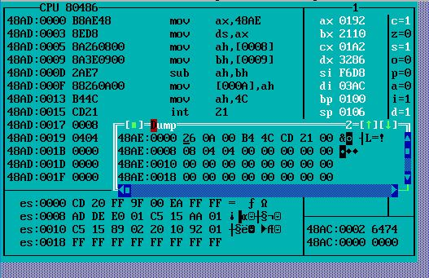

**2a)**

.8086

.model small

.data

a db 05h

b db 02h

c dw ?

.code

start:

MOV AX,@data

MOV DS,AX

MOV AL,a

MOV BL,b

MUL BL

MOV c,AX

MOV AH,4Ch

INT 21h

end start

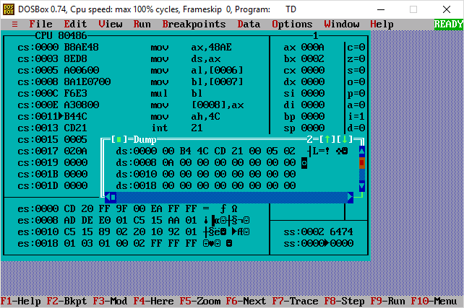

**2b)**

.8086

.model small

.data

a dw 2000h

b dw 0002h

c dd ?

.code

start:

MOV AX,@data

MOV DS,AX

MOV AX,a

MOV BX,b

MUL BX

MOV c,AX

MOV AH,4Ch

INT 21h

end start

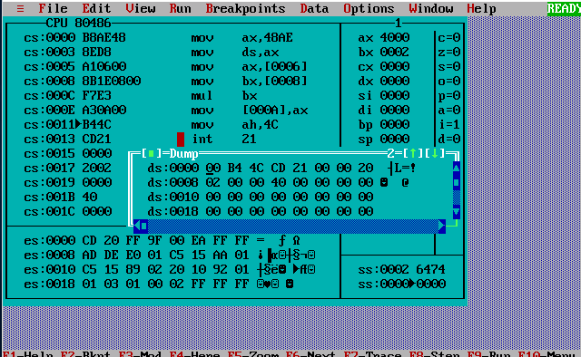

**3a)**

.8086

.model small

.data

STR1 db 01h,02h,03h,04h,05h,06h,07h,08h,09h,10h

STR2 db ?

.code

start:

MOV AX,@data

MOV DS,AX

MOV ES,AX

LEA SI,STR1

LEA DI,STR2

MOV CX,0Ah

CLD

REP MOVSB

INT 21h

end start

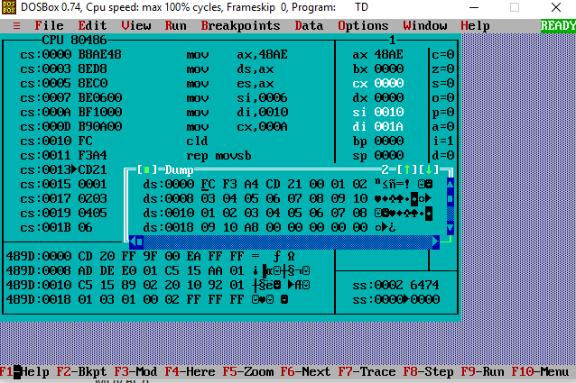

**3b)**

.8086

.model small

.data

a db 01h,02h,03h,04h,05h,06h,07h,08,09h,0Ah

b db ?

.code

START: MOV AX,@DATA

MOV DS,AX

MOV ES,AX

LEA SI,a

LEA DI,b

MOV AX,0000h

MOV CL,0Ah

MOV BL,0Ah

CLC

LOOP1: ADD AL,[SI]

INC SI

DEC CL

JNZ LOOP1

DIV BL

MOV DX,AX

MOV AH,4Ch

INT 21h

END START

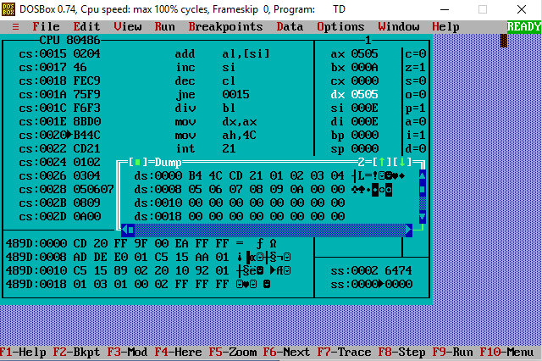

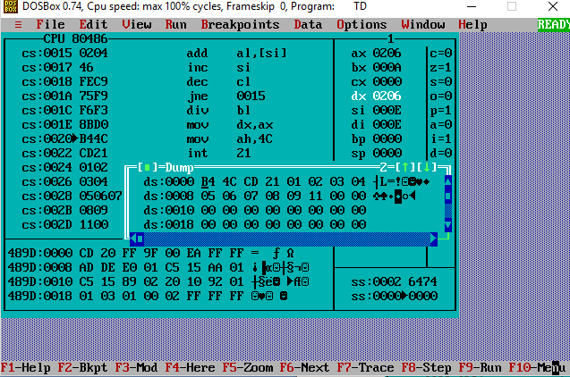

**3c)**

.8086

.model small

.data

a dw 0008h

b dw 0004h

c dw ?

.code

start:MOV AX,@data

MOV DS,AX

MOV AX,a

MOV BX,b

DIV BX

MOV c,AX

MOV AH,4Ch

INT 21h

end start

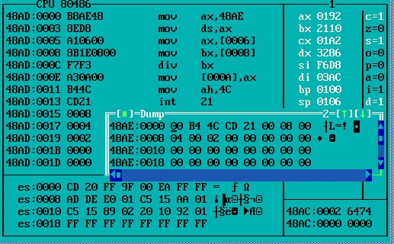

**4a)**

.8086

.model small

.data

a db 02h,01h,06h,03h

b db ?

.code

start:MOV AX,@data

MOV DS,AX

MOV ch,04h

Loop2:MOV CL,04h

LEA SI,a

Loop1:MOV AL,[SI]

MOV BL,[SI+1]

CMP AL,BL

JC DOWN

MOV DL,[SI+1]

XCHG [SI],DL

MOV [SI+1],DL

DOWN:INC SI

DEC CL

JNZ Loop1

DEC CH

JNZ Loop2

MOV AH,4Ch

INT 21h

end start

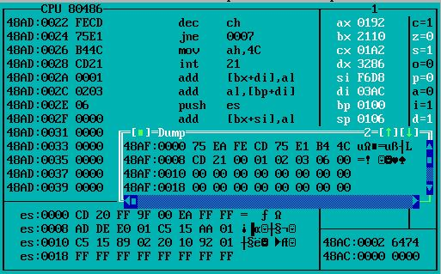

**4b)**

.8086

.model small

.data

a db 02h,01h,06h,03h

b db ?

.code

start:MOV AX,@data

MOV DS,AX

MOV CH,04h

Loop2:MOV CL,04h

LEA SI,a

Loop1:MOV AL,[SI]

MOV BL,[SI+1]

CMP AL,BL

JNC DOWN

MOV DL,[SI+1]

XCHG [SI],DL

MOV [SI+1],DL

DOWN:INC SI

DEC CL

JNZ Loop1

DEC CH

JNZ Loop2

MOV AH,4Ch

INT 21h

end start

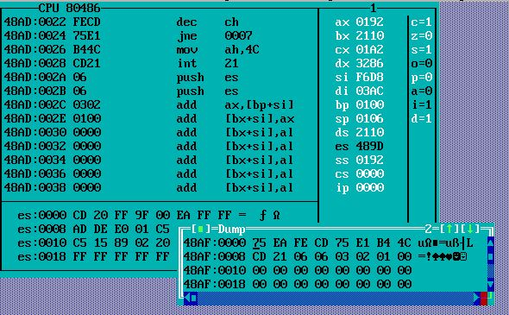

**5a)**

.8086

.model small

.data

a dw 01h,02h,03h,04h,05h,06h,07h,08h,09h,10h

.code

start:MOV AX,@data

MOV DS,AX

LEA SI,A

MOV DX,00h

MOV BL,02h

MOV CL,10h

Loop1:MOV AX,[SI]

DIV BL

CMP AH,00h

JNZ Loop2

INC DH

JMP Loop3

Loop2:INC DL

Loop3:ADD SI,2

DEC CL

CMP CL,00h

JNZ Loop1

MOV AH,4Ch

INT 21h

end start

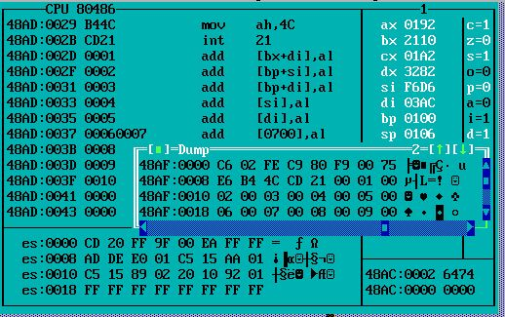

**5b)**

.model small

.data

a db 01h,02h,03h,04h,05h,06h,07h,08h,09h,0ah

.code

start: mov ax,@data

mov ds,ax

lea si,a

mov bx,02h

mov ch,0ah

xor cl,cl

xor ax,ax

l1: mov al,[si]

div bl

cmp ah,00h

jnz odd

add cl,[si]

odd: inc si

dec ch

jnz l1

mov ah,4ch

int 21h

end start

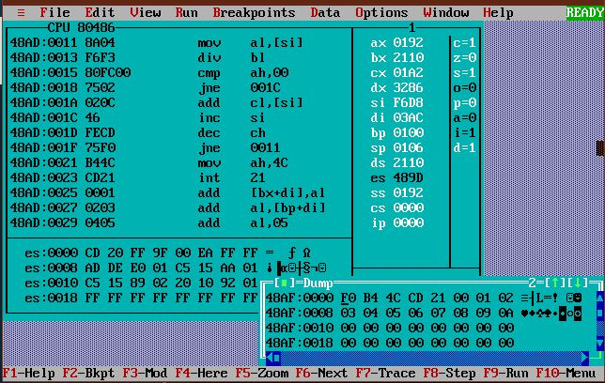

**6a)**

.model small

.data

a dw 3629h

b dw 4738h

.code

start:

mov ax,@data

mov ds, ax

mov ax,a

mov bx,b

add al,bl

daa

mov bl,al

adc ah,bh

mov al,ah

daa

mov bh,al

mov cx, 0404h

l2: rol bx, cl

mov dl, bl

and dl, 0fh

cmp dl,09

jbe l4

add dl,07

l4: add dl,30h

mov ah,02

int 21h

dec ch

jnz l2

mov ah, 4ch

int 21h

end start

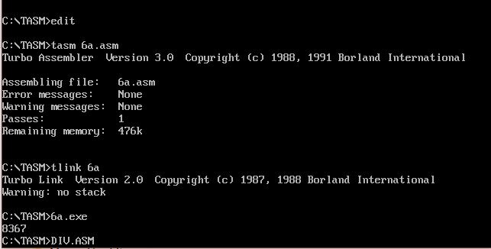

**6b)**

.model small

.data

a dw 5102h

b dw 3203h

.code

start: mov ax,@data

mov ds, ax

mov ax, a

mov bx, b

sub al,bl

das

mov bl,al

sbb ah,bh

mov al,ah

das

mov bh,al

mov cx,0404h

l2: rol bx,cl

mov dl,bl

and dl,0fh

cmp dl,09

jbe l4

add dl,07

l4: add dl,30h

mov ah,02

int 21h

dec ch

jnz l2

mov ah,4ch

int 21h

end start

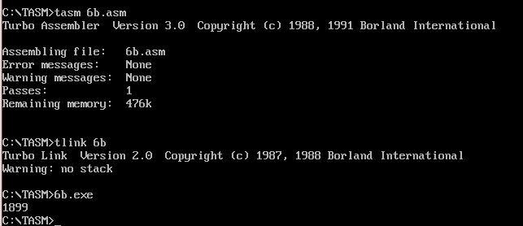

**7a)**

.model small

.data

a db 0Eh

.code

start: mov ax,@data

mov ds,ax

mov al,a

mov bl,al

add al,bl

xor al,bl

shr al,01

mov cl,02h

mov bl,al

l1: rol bl,04

mov dl,bl

and dl,0fh

cmp dl,09

jbe l2

add dl,07

l2: add dl,30h

mov ah,02h

int 21h

dec cl

jnz l1

mov ah,4ch

int 21h

end start

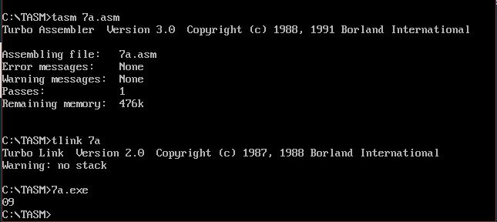

**7b)**

.model small

.data

a db 78h

.code

start: mov ax,@data

mov ds,ax

mov al,a

mov ah,al

rol ah,04

and ax,0f0fh

or ax,3030h

mov bx,ax

mov dl,bh

mov ah,02

int 21h

mov dl,bl

mov ah,02

int 21h

mov ah,4ch

int 21h

end start

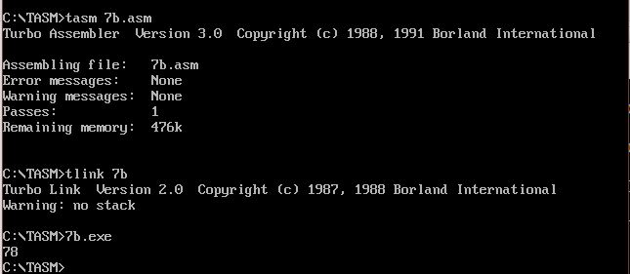

**7c)**

.model small

.data

a db 78h

digit1 db ?

digit2 db ?

.code

start: mov ax,@data

mov ds,ax

mov bl,0fh

mov al,a

and al,bl

mov digit1,al

mov al,a

rol al,04

and al,bl

mov digit2,al

mov ah,4ch

int 21h

end start

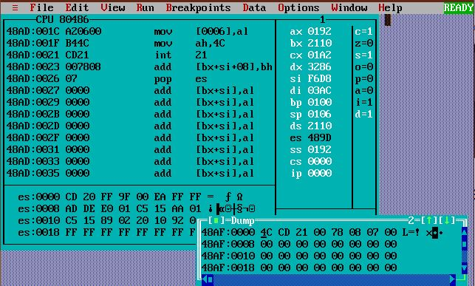

**8a)**

.model small

.data

a db 41h,42h,43h,44h,45h,46h,47h,48h,49h,4ah,4bh,4ch,4dh,4eh,4fh,50h,51h,52h,53h,54h,55h,56h,57h,58h,59h,5ah

.code

start: mov ax,@data

mov ds,ax

lea si,a

mov cl,1ah

l1: mov dl,[si]

mov ah,02

int 21h

inc si

dec cl

jnz l1

mov ah,4ch

int 21h

end start

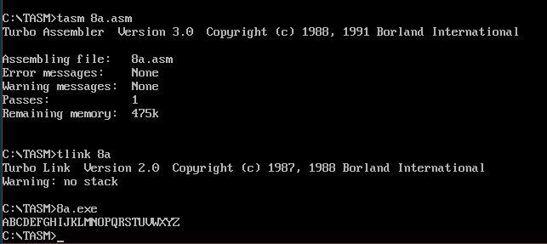

**8b)**

.model small

.data

.code

start: mov ax,@data

mov ds,ax

l1: mov ah,08

int 21h

cmp al,30h

jz last

mov dl,al

mov ah,02

int 21h

jmp l1

last: mov ah,4ch

int 21h

end start

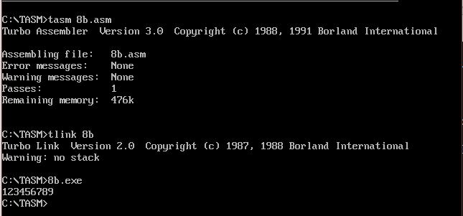

**9a)**

.model small

.data

mat1 db 02h,01h,01h,01h,01h,01h,01h,01h,01h

mat2 db 01h,02h,01h,01h,01h,01h,01h,01h,01h

mat3 db 9 DUP(0)

.code

start: mov ax,@data

mov ds,ax

mov ch,03h

mov cl,03h

mov bp,03h

lea bx,mat3

lea si,mat1

lea di,mat2

mul3: mov al,[si]

mov bh,[di]

mul bh

mov bh,00h

add [bx],al

inc si

add di,03h

dec cl

done1: jnz mul3

mov dl,[bx]

add dl,30h

mov ah,02

int 21h

mov dl,20h

mov ah,02

int 21h

inc bx

mov cl,03h

sub si,03h

sub di,08h

dec bp

rdone: jnz mul3

mov dl,0ah

mov ah,02

int 21h

mov dl,0dh

mov ah,02

int 21h

add si,03h

sub di,03h

mov bp,03h

dec ch

jnz mul3

mov ah,4ch

int 21h

end start

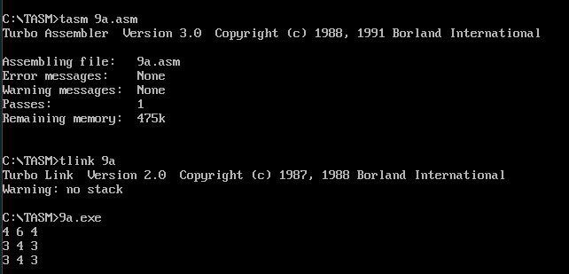

**9b)**

.model small

.data

mat1 db 01h,99h,01h,67h,01h,01h,01h,01h,01h

mat2 db 01h,87h,01h,01h,01h,01h,01h,01h,01h

mat3 dw 9 dup(?)

.code

start: mov ax,@data

mov ds,ax

lea si,mat1

lea bx,mat2

lea di,mat3

mov cl,09h

xor ax,ax

l1: mov al,[si]

add al,[bx]

mov dl,al

jnc ncarry

inc dh

ncarry: mov [di],dx

inc si

inc bx

inc di

dec cl

jnz l1

mov ah,4ch

int 21h

end start

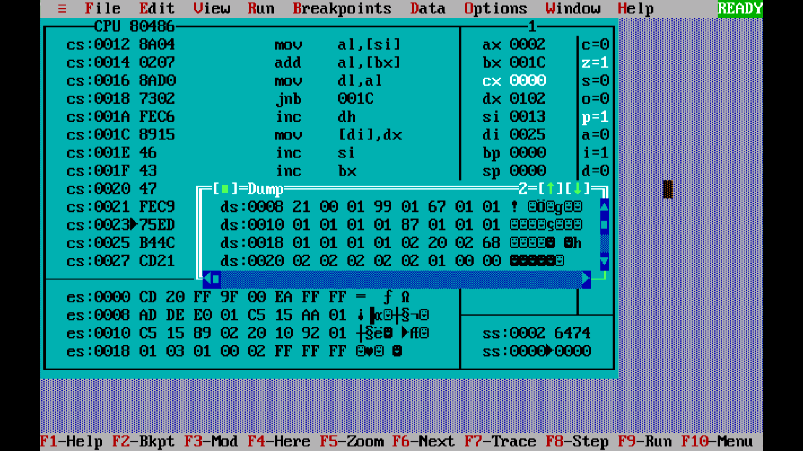

**10)**

.model small

.data

phrase db 13,10,'Enter password: ',13,10,'$'

correct db 13,10,'Password is correct$'

incorrect db 13,10,'Entered password is wrong$'

pwd db 'password123'

.code

start: mov ax,@data

mov ds,ax

mov cl,0bh

lea bx,pwd

lea dx,phrase

mov ah,09

int 21h

l1: mov ah,08h

int 21h

cmp al,[bx]

jnz wrong

mov dl,2ah

mov ah,02

int 21h

inc bx

dec cl

jnz l1

lea dx,correct

mov ah,09

int 21h

jmp over

wrong: lea dx,incorrect

mov ah,09

int 21h

over: mov ah,4ch

int 21h

end start

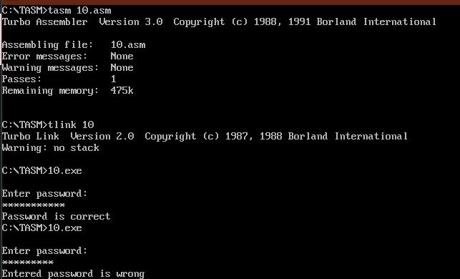

**11)**

.model small

.data

msg db 'Enter string(end input with 0):',13,10,'$'

palin db 13,10,'It is a palindrome$'

notpalin db 13,10,'It is not a palindrome$'

inputstorage db 10 dup(?)

.code

start: mov ax,@data

mov ds,ax

lea si,inputstorage

lea dx,msg

mov ah,09

int 21h

l1: mov ah,08

int 21h

cmp al,30h

jz endin

mov dl,al

mov ah,02

int 21h

inc cl

mov [si],al

inc si

jmp l1

endin: lea di,inputstorage

mov ax,cx

mov cl,02h

div cl

mov cx,ax

dec si

check: mov al,[si]

cmp al,[di]

jnz notp

inc di

dec si

dec cl

jnz check

lea dx,palin

mov ah,09

int 21h

jmp done

notp: lea dx,notpalin

mov ah,09

int 21h

done: mov ah,4ch

int 21h

end start

