.8086

.model small

.data

STR1 db 01h,02h,03h,04h,05h,06h,07h,08h,09h,10h

STR2 db ?

.code

start:

MOV AX,@data

MOV DS,AX

MOV ES,AX

LEA SI,STR1

LEA DI,STR2

MOV CX,0Ah

CLD

REP MOVSB

INT 21h

end start

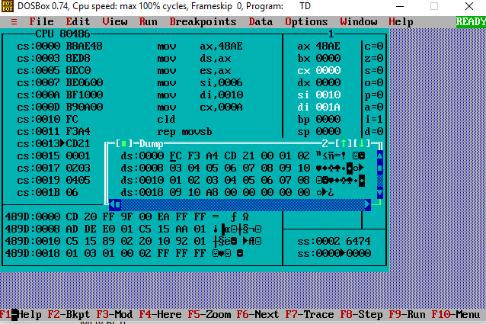

.8086

.model small

.data

a db 01h,02h,03h,04h,05h,06h,07h,08,09h,0Ah

b db ?

.code

START: MOV AX,@DATA

MOV DS,AX

MOV ES,AX

LEA SI,a

LEA DI,b

MOV AX,0000h

MOV CL,0Ah

MOV BL,0Ah

CLC

LOOP1: ADD AL,[SI]

INC SI

DEC CL

JNZ LOOP1

DIV BL

MOV DX,AX

MOV AH,4Ch

INT 21h

END START

