1. INTRODUCTION
Livestock is an important part of agriculture and rural life. Cattle contribute milk, meat, manure, and other products, and they can provide a source of income and security for farming households. The health of cattle therefore affects both animal welfare and farm productivity. When an animal becomes sick, the effects may include reduced production, costs for veterinary care, and the risk of illness spreading to other animals. The Food and Agriculture Organization (FAO) recognizes that animal diseases can affect food security, livelihoods, trade, and public health. This makes timely attention to animal health an important part of sustainable livestock production.
Recognizing a possible disease early can help farmers decide when to seek professional advice. However, identifying cattle diseases is not always straightforward. The visible signs may be subtle, may change over time, or may resemble signs of another condition. A farmer may notice changes in the animal’s skin, eyes, mouth, feet, or udder, but a photograph by itself may not provide enough information to determine the cause. Veterinary assessment may also involve examining the animal’s history and overall condition, and sometimes requires diagnostic tests. As a result, an image-based tool should be viewed as an initial screening aid rather than a substitute for veterinary examination.
This project focuses on classifying cattle images into six classes: lumpy skin disease, foot-and-mouth disease, infectious bovine keratoconjunctivitis (IBK), mastitis, ringworm, and healthy. These classes represent conditions that affect different parts of the animal. Lumpy skin disease is associated with skin nodules; foot-and-mouth disease may produce blisters around the mouth and feet; IBK affects the eyes; mastitis affects the udder; and ringworm is a fungal skin condition. The World Organisation for Animal Health describes foot-and-mouth disease as a highly contagious viral disease and lists signs that may include blisters on the mouth, teats, or feet.
The selected classes also show why the project is broader than skin-image analysis alone. Some photographs may need to focus on an eye, udder, mouth, or foot rather than on the animal’s skin. The model can only learn patterns represented in its labelled training images, so correct labels and clear photographs are important. If a photo does not show the relevant body area clearly, or if its label is incorrect, the model may produce an unreliable result. The system is therefore described as a cattle visible-condition screening system. It does not claim to identify every cattle disease or to confirm a diagnosis from an image.
Image classification provides a way to examine photographs consistently using a trained computer model. In this project, a convolutional neural network based on MobileNetV2 is adapted through transfer learning to predict the six project classes. The image folders are divided into training, validation, and test sets. The training set is used to teach the model; the validation set is used to monitor it during development; and the test set is used to evaluate it on images held aside from training. Keeping the test images separate is important for obtaining a more meaningful estimate of the model’s performance.
The trained model is connected to a web application so that it can be used through a simple interface. A user selects and uploads a cattle photograph. The application sends the image to the backend, which prepares it for the model and obtains a predicted class and confidence score. The result page displays the model’s estimate and general precautions associated with the predicted class. The application uses a SQLite database to store care-guidance information and prediction records. This connects the image-classification model with a practical user flow: image upload, model prediction, result display, and record storage.
The confidence score is included to communicate how strongly the model selected its top predicted class for a particular image. It must not be interpreted as proof that the animal has the predicted disease. A high score can still be wrong, especially if the image differs from those used for training, shows more than one condition, or belongs to a condition outside the model’s classes. A low score indicates that the result is uncertain and should not be used to make disease-specific care decisions. For animal-health concerns, the appropriate next step is to contact a veterinarian.
The project aims to demonstrate a complete prototype that combines image classification, a web interface, and database storage for cattle-health screening. Its usefulness depends on the quality and variety of the image dataset, the accuracy of its labels, and the model’s performance across all six classes. The system is limited to the types of images and classes used in training; it does not consider the animal’s full clinical history or replace laboratory testing. Consequently, its output should be treated as an educational screening estimate to support further review not as a veterinary diagnosis, prescription, or treatment plan.

2. LITERATURE REVIEW
2.1 2023: Lumpy Skin Disease Detection Using ResNet-50
Chinta et al. studied “Lumpy Skin Disease Detection in Cows Using ResNet-50.” Their work used the ResNet-50 deep-learning model to identify lumpy skin disease (LSD) from cattle images. This study showed that image classification can support the screening of livestock diseases by learning visual patterns from photographs. It also provided a starting point for later research in automated cattle-disease detection.
The study focused mainly on LSD, however. A model trained for one disease may not be able to distinguish it from other conditions, such as foot-and-mouth disease (FMD) or infectious bovine keratoconjunctivitis (IBK). This created a need for research that could consider more than one cattle-disease category.
2.2 2024: Cattle Disease Detection Using VGG16 CNN
Shinde et al. proposed “Cattle Disease Detection Using VGG16 CNN Architecture.” The study used a VGG16-based convolutional neural network (CNN) to classify cattle disease images. CNN models can learn useful visual features from images and use them to predict a category. This approach continued the development of automated disease screening and considered cattle-disease classification beyond a single LSD-focused study.
A model’s coverage still depends on the classes included in its dataset. Also, a research model may not include a simple interface for people to upload an image and view the prediction. These points create an opportunity to build a system that supports multiple classes and presents results in an easy-to-use way.
2.3 2025: LSD Detection Using Deep Feature Extraction
The paper “Machine Learning-Based Detection of Lumpy Skin Disease in Cattle Using Deep Feature Extraction Techniques” explored feature extraction using VGG-16, VGG-19, and Inception-v3. It combined the extracted image features with classifiers such as K-nearest neighbours, support vector machines, Naive Bayes, artificial neural networks, and logistic regression. Comparing different feature extractors and classifiers can help researchers understand which combinations work for a particular image-classification task.
This study broadened the methods used for LSD detection, but its main focus remained on LSD. It did not combine LSD, FMD, and IBK classification in one system. Further work is therefore needed to provide a single screening tool for several cattle conditions.
2.4 2025: Mobile Diagnosis of Foot-and-Mouth Disease
Kwenda et al. introduced “Mobile Diagnosis of Foot and Mouth Disease in Cattle Based on Hybrid Deep Neural Networks.” Their method combined MobileNet and NASNetMobile to analyze images of FMD lesions. The paper reports that the model correctly classified 781 of 800 images. This study is relevant to our project because FMD is one of the conditions included in our image-screening system.
The study focuses on FMD, so it does not provide a combined result for other cattle conditions. Our project aims to address this gap by allowing users to upload an image and receive a prediction for one of the supported classes, along with a confidence score and primary recommendation. The system is intended for preliminary screening; a veterinarian should assess any health concern.
Together, these studies show the growing use of image-based deep learning for cattle-disease screening. They also highlight the need for a simple system that can handle multiple supported classes and present its results clearly to users.

3. PROBLEM STATEMENT
To develop an AI-powered system that detects livestock skin diseases from images using deep learning and provides accurate disease information.

4. OBJECTIVES
  - To develop a livestock disease screening system using a MobileNetV2-based CNN and transfer learning.
  - To classify cattle images into the disease and healthy categories supported by the trained model.
  - To display the predicted category and confidence score for an uploaded image.
  - To provide primary care recommendations through a simple, user-friendly web interface.

5. SYSTEM ARCHITECTURE

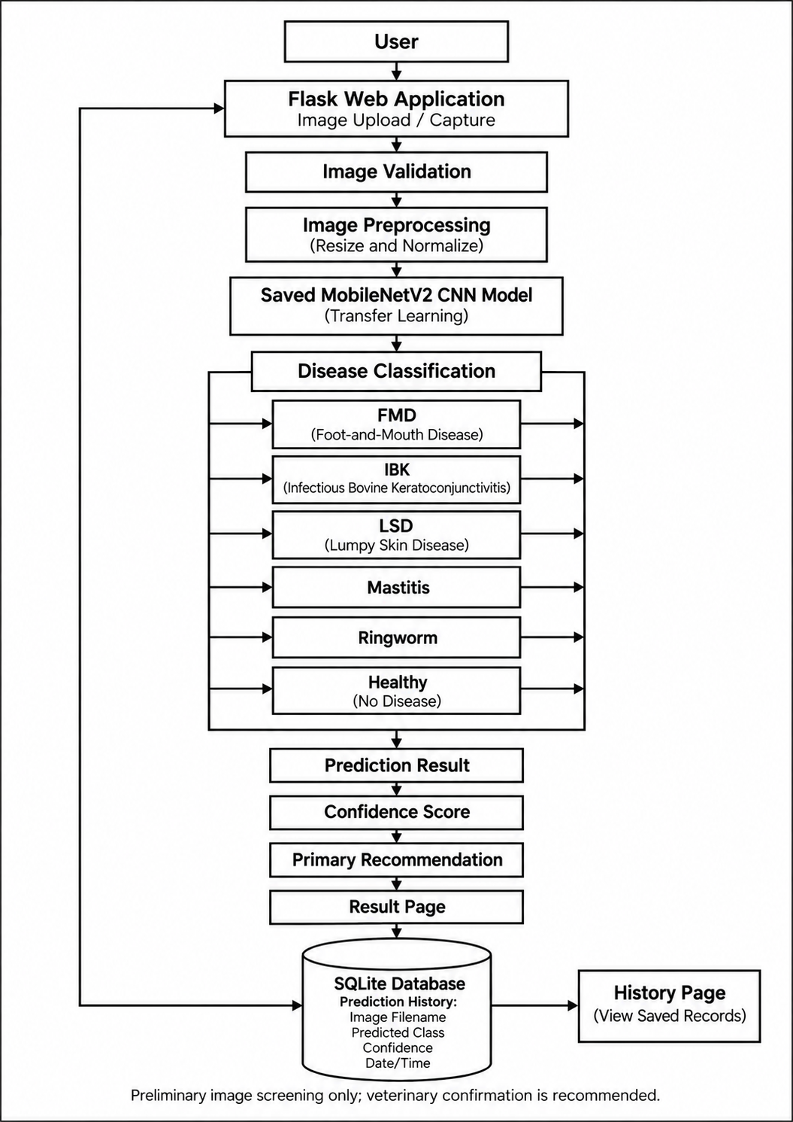
Fig. 5.1. System Architecture
6. METHODOLOGY
The proposed system uses image classification to screen cattle images for the disease and healthy categories supported by the trained model. The methodology includes dataset preparation, image preprocessing, model training, evaluation, web-based prediction, recommendation display, and storage of prediction history.
6.1 Dataset Preparation
The image dataset is organized into three subsets: training, validation, and testing. Each subset contains class-specific folders for foot-and-mouth disease (FMD), infectious bovine keratoconjunctivitis (IBK), lumpy skin disease (LSD), mastitis, ringworm, and healthy cattle. This directory structure enables the image-loading process to assign labels according to folder names.
The training subset is used to teach the model, the validation subset is used to monitor training performance, and the test subset is reserved for final evaluation. Duplicate images are removed during dataset preparation to reduce repeated examples. The labels and image files are checked to ensure that each image is placed in the appropriate class folder. Similar or duplicate images should not be shared across subsets, as this may produce an overly optimistic evaluation.
6.2 Image Preprocessing
Images are loaded using TensorFlow and Keras and resized to the dimensions expected by the model. In the prediction workflow, an uploaded image is resized to 160 × 160 pixels. Pixel values are preprocessed according to the requirements of MobileNetV2.
Consistent preprocessing is applied during training and inference. This ensures that the model receives images in a format similar to the format used during training. If image size or preprocessing differs between these stages, prediction performance may be affected.
6.3 Data Augmentation
Data augmentation is applied to training images to introduce visual variation. Transformations such as rotation, zoom, and flipping may be used to help the model learn features that are not dependent on the exact position or orientation of an image.
Augmentation is restricted to the training subset. Validation and test images are not augmented, so they provide consistent data for monitoring and final evaluation. Augmentation modifies existing images and does not replace the need for a sufficiently varied dataset.

6.4 MobileNetV2-Based CNN Model
The project uses MobileNetV2, a convolutional neural network (CNN), through transfer learning. The pretrained network provides learned image features, which are adapted to the cattle-disease classification task. A classification layer is configured to produce predictions for the six project classes.
During training, the model learns to associate visual features in the input images with their corresponding labels. The order of the class names is maintained consistently with the model’s output so that each output score can be mapped to the correct disease or healthy category.
6.5 Model Training and Validation
The model is trained on batches of images from the training subset. During training, its predictions are compared with the correct labels, and model parameters are updated to reduce classification error. This process is repeated over multiple epochs.
After each epoch, the validation subset is used to monitor loss and accuracy on images not used for parameter updates. Comparing training and validation performance helps identify possible overfitting, in which the model performs well on training images but does not generalize as well to other images.
6.6 Model Evaluation and Saving
After training, the model is evaluated on the separate test subset. Test loss and test accuracy are calculated to measure its performance on held-out images. The test subset is not used for training or validation, preserving its role as an independent evaluation set.
The trained model is saved in the models directory in Keras format (.keras). The corresponding class names are saved in a JSON file. The Flask application loads these saved files for inference; retraining is not required for each prediction request.
6.7 Image Prediction Using the Web Application
The Flask application provides the interface for uploading a cattle image. The uploaded file is checked to confirm that it is an accepted image type. The application then resizes and preprocesses the image using the same procedure used for model input.
The processed image is passed to the saved MobileNetV2-based model. The model produces a score for each class. The class with the highest score is selected as the predicted category, and the class-name mapping is used to display the corresponding label.

6.8 Result and Recommendation Display
The result page displays the uploaded image, predicted category, and confidence score. The confidence score represents the model’s output for its selected class and should not be interpreted as a guarantee of diagnostic correctness.
A primary recommendation associated with the predicted category is also shown. These recommendations provide general preliminary guidance and do not replace veterinary examination, diagnosis, or treatment advice.
6.9 Prediction History Database
After an image is analyzed, the application stores a prediction record in an SQLite database. The record includes the image filename, predicted category, confidence score, and date and time of analysis. The history page retrieves and displays saved records for review.
The database stores prediction history; it is separate from the training dataset and does not modify the trained model. The overall workflow connects dataset preparation, model training, image-based inference, result presentation, recommendations, and prediction-history storage.

7. DATASET FEATURES AND EVALUATION METRICS
7.1 Dataset Features
The dataset contains cattle images arranged into training, validation, and test subsets. Each image belongs to one of six categories: foot-and-mouth disease (FMD), healthy, infectious bovine keratoconjunctivitis (IBK), lumpy skin disease (LSD), mastitis, or ringworm. Images are provided to the MobileNetV2-based CNN as RGB inputs resized to 160 × 160 pixels.
Table I. Class-Wise Dataset Distribution
Class label | Training | Validation | Test | Total
foot_mouth_disease | 1,767 | 300 | 46 | 2,113
healthy | 1,778 | 222 | 233 | 2,233
ibk_disease | 1,750 | 201 | 61 | 2,012
lumpy_skin_disease | 1,671 | 301 | 141 | 2,113
mastitis | 200 | 35 | 26 | 261
ringworm | 68 | 14 | 15 | 97
Total | 7,234 | 1,073 | 522 | 8,829
Table II. Dataset Characteristics
Feature | Description
Dataset type | Cattle image-classification dataset
Total images | 8,829
Number of classes | 6
Image formats | 8,812 JPG, 13 JPEG, 3 PNG, and 1 WebP
Original image dimensions | 220 distinct width-and-height combinations
Most frequent original dimensions | 256 × 256 (1,439 images), 640 × 640 (1,111 images), and 224 × 224 (779 images)
Model input | 160 × 160 pixels, RGB
Label format | Categorical class label based on the image’s class folder
Dataset split | Training: 7,234; validation: 1,073; test: 522
The dataset is imbalanced. Mastitis has 261 images and ringworm has 97, whereas each of the other four classes has more than 2,000 images. This difference should be considered when interpreting the model’s performance for each class.
7.2 Evaluation Metrics
The model is evaluated on the test subset, which is kept separate from training and validation. The main metrics used to describe classification performance are accuracy and loss. Precision, recall, F1-score, and the confusion matrix can provide additional class-level detail when calculated from test predictions.
Table III. Evaluation Metrics
Metric | Description
Test accuracy | Proportion of test images for which the predicted class matches the actual class
Test loss | Measures the difference between the model’s predicted class scores and the true labels
Precision | For a class, the proportion of images predicted as that class that truly belong to it
Recall | For a class, the proportion of actual images of that class that the model correctly identifies
F1-score | Harmonic mean of precision and recall for a class
Confusion matrix | Shows correct and incorrect predictions for every actual and predicted class
Test Accuracy = ( Ntest​ / Ncorrect )​​ × 100
where $N_{\text{correct}}$represents the number of correctly classified test samples and $N_{\text{test}}$represents the total number of test samples used for evaluation. The calculated accuracy indicates the model's classification performance on the test dataset.
The earlier model evaluation reported a test accuracy of 80.65%. However, the current dataset audit found 328 exact duplicate image groups across splits 302 between training and validation and 26 between training and test. The duplicates should be removed and the data repartitioned before reporting a final test result, because overlap may affect the evaluation. Precision, recall, F1-score, and confusion-matrix values should be included only after calculating them from the cleaned test set.
8. SYSTEM REQUIREMENTS
The system requirements are divided into hardware and software. A compatible computer is required to prepare the cattle-image dataset, train and evaluate the MobileNetV2 model, and run the Flask-based web application.
Table I. Minimum Hardware Requirements
Component | Minimum Requirement
Processor | Intel Core i3 or equivalent
RAM | 8 GB
Free storage | At least 10 GB
GPU | Optional; NVIDIA GPU recommended for faster model training
Camera | Optional; images can be uploaded instead

Table II. Software Requirements
Software / Tool | Minimum Requirement
Operating system | Windows 10/11 or Linux
Programming language | Python 3.10 or later
Development environment | Visual Studio Code or Jupyter Notebook
Deep-learning framework | TensorFlow and Keras
Libraries | NumPy, Pillow, Matplotlib, and Scikit-learn
Web framework | Flask
Frontend | HTML, CSS, and JavaScript
Database | SQLite
Web browser | Google Chrome or Microsoft Edge

9. RESULTS
9.1 Home Page - Shows the Home Page, which give information about system.
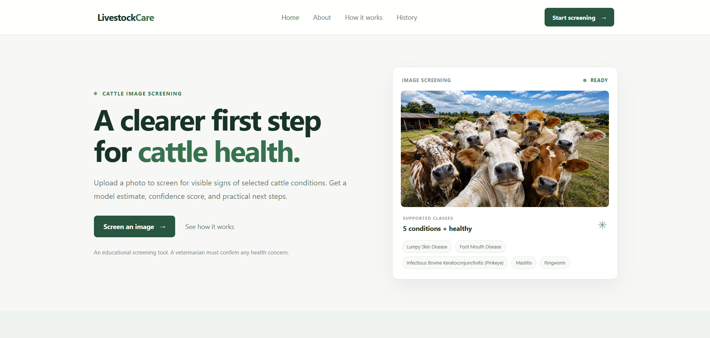
Fig. 9.1. Home Page interface.

9.2 Image Upload Page - Shows the upload control and selected cattle image.
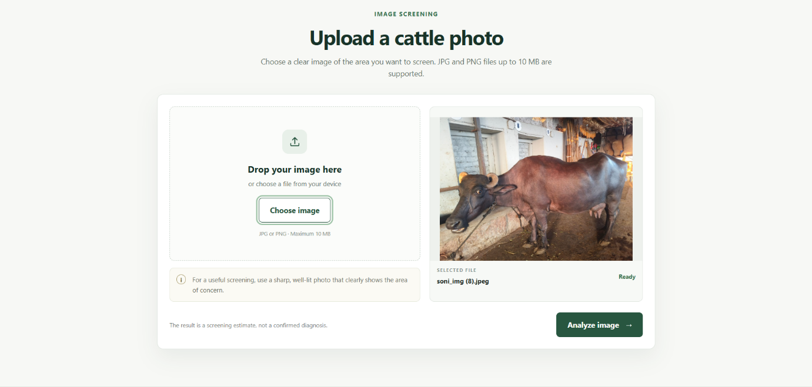
Fig. 9.2. Image upload interface.

9.3 Disease Prediction Result - show one result with the uploaded image, predicted class, confidence score, and primary recommendation.
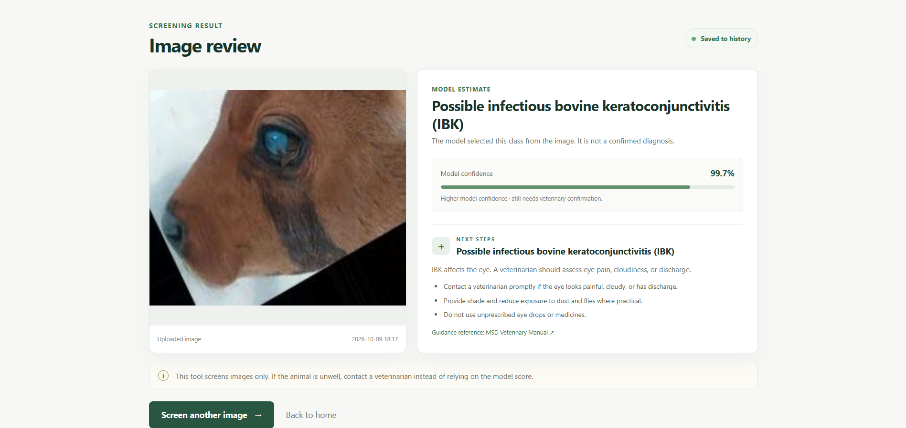
Fig. 9.3. Disease prediction and recommendation.

9.4 Healthy Prediction Result - shows how the application reports the healthy class.
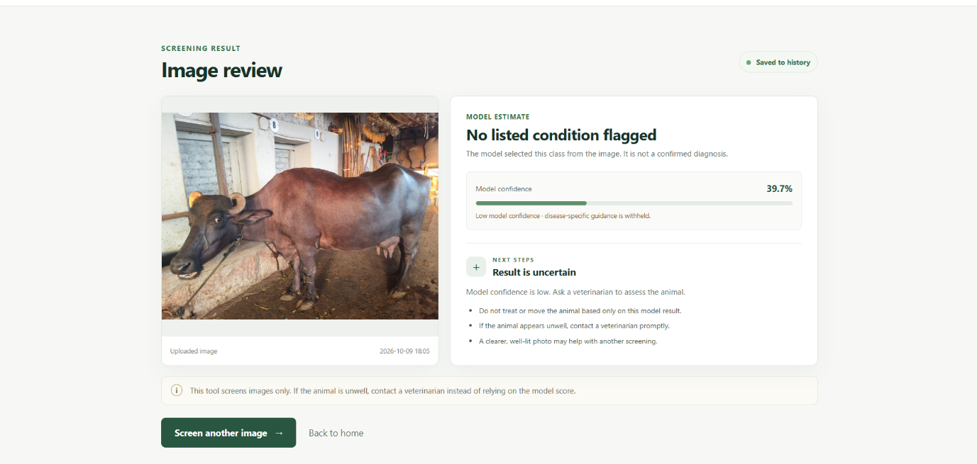
Fig. 9.4. Healthy-class prediction

9.5 Prediction History Page - shows that prediction records are saved and displayed from the database.
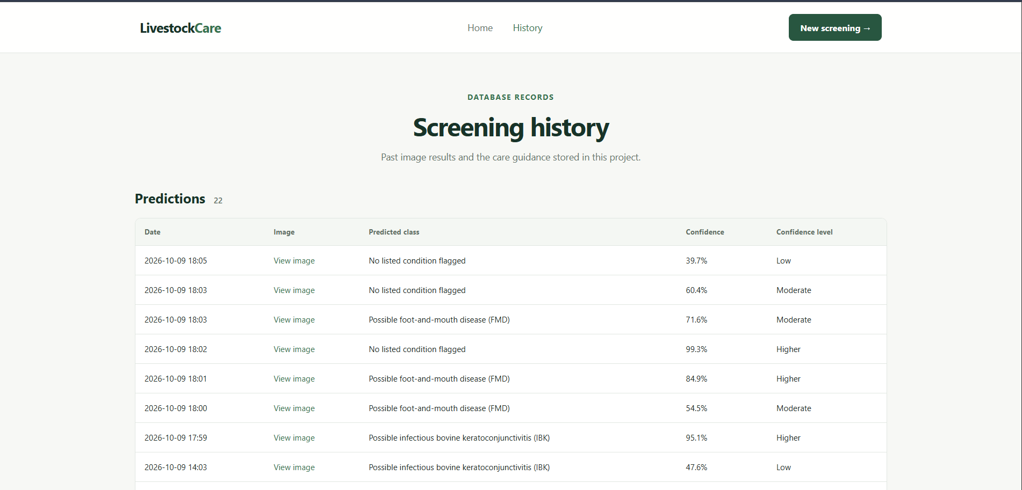
Fig. 9.5. Prediction history stored in the database.

10. CONCLUSION
This project developed a web-based system for preliminary screening of cattle images using a MobileNetV2-based convolutional neural network. The model was trained to classify images into six categories: foot-and-mouth disease (FMD), healthy, infectious bovine keratoconjunctivitis (IBK), lumpy skin disease (LSD), mastitis, and ringworm. The system combines image classification with a Flask web application, allowing users to upload an image and view the predicted class, confidence score, and primary recommendation. It also uses an SQLite database to store prediction history for later review.
The project demonstrates how image recognition and deep learning can be integrated into an accessible application for livestock screening. It provides a practical example of the complete machine-learning workflow, from organizing and preprocessing images to training a model and presenting its results through a user interface. In an earlier evaluation, the model achieved 80.65% test accuracy. However, this value should be treated as preliminary: the dataset audit found exact duplicate images across the training, validation, and test subsets. The dataset also contains substantially fewer mastitis and ringworm images than images from the other classes. These issues may affect the model’s evaluation and its ability to recognize less represented categories.
Therefore, the current system should be considered an educational screening tool rather than a diagnostic system. Removing duplicate images, repartitioning the dataset, and retraining the model are necessary before reporting a final test result. Additional labelled images particularly for mastitis and ringworm may also improve class balance. The system’s recommendations provide general guidance only; a veterinarian should confirm health concerns and advise on treatment.

11. FUTURE SCOPE
The system can be extended to support a wider range of livestock diseases and animal species. Future versions may include additional cattle conditions, as well as diseases affecting buffaloes, sheep, and goats. Each new class would require a sufficiently large, accurately labelled image dataset and evaluation on independent images. The system could also be expanded beyond visible skin conditions to screen for other image-recognizable conditions, such as eye or hoof problems, subject to veterinary review of the dataset and recommendations.
Further development may include a mobile application for use on farms and in veterinary clinics, an offline mode for areas with limited internet access, and support for local languages. Model performance should be reassessed on images collected under varied field conditions, with class-wise metrics reported for every supported disease. Recommendations should be reviewed by veterinary professionals. The system should remain a preliminary screening aid; a veterinarian must confirm any suspected condition and determine treatment.
Future versions could also integrate with farm-management systems to maintain animal-wise screening records, monitor repeated cases, and help veterinarians identify possible disease trends across a herd. Such features would require secure data handling and validation with real farm data.

12. REFERENCES
[1] A. Chinta, G. K. Vathumilli, S. S. Dhara, and L. P. Uriti, “Lumpy skin disease detection in cows using ResNet-50,” in Proc. 2023 Int. Conf. Ambient Intelligence, Knowledge Informatics and Industrial Electronics (AIKIIE), 2023, pp. 1–6.
[2] S. Shinde, A. Himpalnerkar, S. Shendurkar, S. Deshmane, and S. Jadhav, “Cattle disease detection using VGG16 CNN architecture,” in Proc. 2024 15th Int. Conf. Computing Communication and Networking Technologies (ICCCNT), 2024, pp. 1–6.
[3] K. Ananda and M. J. Prasanna Kumar, “Machine learning-based detection of lumpy skin disease in cattle using deep feature extraction techniques,” in Proc. 2025 Int. Conf. Intelligent and Innovative Technologies in Computing, Electrical and Electronics (IITCEE), 2025.
[4] C. Kwenda, W. Bakasa, R. Simbula, and L. Shumba, “Mobile diagnosis of foot and mouth disease in cattle based on hybrid deep neural networks,” in Proc. 2025 Conf. Information Communications Technology and Society (ICTAS), 2025, pp. 1–7.

