Academic Research Only | Not an Investment Recommendation
Equity Research Report  Central Depository Services (India) Limited (CDSL)  SELL | Dominant depository franchise, but tapering margins and a 13% growth path do not support the current valuation  Date: 20 Sep 2026  Company Overview  CDSL is one of India’s two central securities depositories and a regulated market infrastructure institution. Established in 1999 and headquartered in Mumbai, it enables securities to be held and transferred electronically, maintains ownership records and supports settlement through registered depository participants.  - Core Business: Demat account services, dematerialisation and rematerialisation, settlement support, e-voting, KYC, issuer services and repositories.  - Market Position: Holds roughly 80% or more of India’s demat accounts, against about 20% for NSDL, with more than 18 crore investor accounts.  - Key Differentiator: Regulated, asset-light infrastructure with strong operating leverage. Scale, network effects and regulatory barriers form the moat.  - Financial Profile: Effectively debt-free (debt-to-equity 0.098%), with FY26 ROE of 31.33%, ROCE of 36.93% and positive operating cash flow in every year from FY22 to FY26.  - Growth Drivers: Rising demat penetration, financialisation of household savings and digital services such as KYC and e-voting.  FY26 Performance  Revenue from operations rose 13.23% YoY to ₹960.45 crore, but EBITDA grew only 3.74% to ₹657.86 crore and net profit 1.32% to ₹468.21 crore. EBITDA margin contracted to 68.49% (FY25: 74.8%; FY22: 83.8%), showing that profit growth has decoupled from revenue growth as revenue growth slowed from 32.33% in FY25. ROE moderated to 31.33% and ROCE to 36.93%. Operating cash flow eased 2.78% to ₹430.73 crore, although cash generation remains strong and the balance sheet is effectively free of debt.  Investment Rationale  CDSL is a high-quality, near-monopoly retail depository, but the market price already discounts more than our base case supports. A five-year FCFF DCF (13% revenue growth, tapering EBITDA margin, WACC of 9.76%, terminal growth of 5.00%) gives ₹536.85 per share, while NSDL-based P/E and EV/EBITDA cross-checks give ₹1,141.95 and ₹945.89. The current price of ₹1,414.70 exceeds all three outputs. We therefore set a target price of ₹1,025, the midpoint of our ₹950 to ₹1,100 valuation range, implying downside of about 27.5%. The view would need revisiting if margin compression halts or growth materially exceeds 13%. |   Stock Details  Shareholding Pattern (%)  Relative Stock Performance  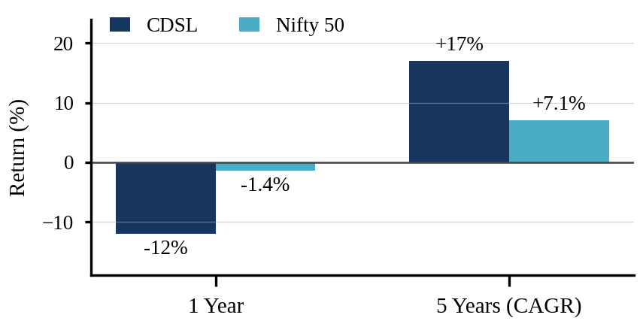  Source: Screener (CDSL, 18 Sep 2026); NSE Indices (Nifty 50 price return, 31 Aug 2026). Returns above one year are CAGR.  Annualised Return (CAGR)  Key Risk  - Margin compression: EBITDA margin has fallen from 83.8% in FY22 to 68.5% in FY26, and the DCF assumes further tapering.  - Regulation and competition: SEBI changes can alter depository economics, and NSDL remains a strong direct competitor.  - Technology or cyber failure could damage trust, market activity and regulatory standing.  - Risk to our call: growth or margins well above the DCF base case could sustain the current premium.  Prepared by: Varad Srivastava
  Recommendation | : Sell
  Current Price | : ₹ 1,414.70
  Target Price | : ₹ 875 (−38%)
  Target Period | : 12 M
  Particulars | Amount
  Market Capitalisation | ₹ 29,567 cr
  Net Worth (FY26) | ₹ 1,598 cr
  Investor Accounts | 18+ crore
  52 Week H/L | 1,674/1,116
  Outstanding Shares | 20,90,00,000
  Face Value | ₹ 10
  Particulars | Sep-25 | Dec-25 | Mar-26 | Jun-26
  Promoters | 15.0 | 15.0 | 15.0 | 15.0
  FII | 11.5 | 12.4 | 11.4 | 8.2
  DII | 14.2 | 15.1 | 14.4 | 15.2
  Public | 59.3 | 57.5 | 59.2 | 61.6
  Period | Return
  1 Year | −12%
  3 Year | +29%
  5 Year | +17%

 | Key Financial Information
Particulars |  | FY24A | FY25A | FY26A | 4Y CAGR | FY27E | FY28E | FY29E | FY30E | 3Y CAGR
Revenue from operations (₹ crore) |  | 641 | 848 | 960 | 23.4% | 1,085 | 1,226 | 1,386 | 1,566 | 13.0%
EBITDA (₹ crore) |  | 494 | 634 | 658 | 17.3% | 703 | 758 | 824 | 908 | 7.8%
Net Profit (₹ crore) |  | 363 | 462 | 468 | 15.4% | 494 | 531 | 576 | 633 | 7.2%
EPS (₹) |  | 17.4 | 22.1 | 22.4 | 15.4% | 23.6 | 25.4 | 27.6 | 30.3 | 7.2%
EBITDA Margin (%) |  | 77.1 | 74.8 | 68.5 |  | 64.7 | 61.8 | 59.5 | 58.0
P/E at current price (x) |  | 81.4 | 64.0 | 63.1 |  | 59.9 | 55.7 | 51.3 | 46.7
E = estimates derived from the base-case DCF assumptions in this report (13% revenue growth, EBITDA margin path from the DCF forecast, D&A of 3.94% of revenue, tax rate of 25.17%); FY24 is derived from reported growth and margin ratios. CAGR columns cover FY22 to FY26 (4Y) and FY26 to FY29E (3Y). P/E is calculated at the current price of ₹1,414.70.

01 | Company Overview

BUSINESS PROFILE
Central Depository Services (India) Limited (CDSL) is a central securities depository and market infrastructure institution. Its core role is to enable securities to be held and transferred electronically, maintain ownership records and support settlement through registered intermediaries.
Area | Assessment
Industry | Capital Markets / Depository Services
Established | 1999
Core role | Electronic custody, transfer and settlement of securities
Major services | Demat, dematerialisation/rematerialisation, settlement, e-voting, KYC, issuer services and repositories
Direct competitor | NSDL, the only other major depository
Business character | Regulated, asset-light infrastructure with strong operating leverage

INVESTMENT PROFILE
• CDSL's strongest structural asset is its scale in the retail demat ecosystem, with more than 80% of demat accounts according to the supplied analysis.
• The business benefits from India's financialisation of household savings, rising retail participation and continuing digitisation of securities.
• The model is highly profitable and effectively debt-free, making cash-flow based valuation conceptually relevant.
• The key counterweight is moderation in growth and margin compression, alongside continuing competitive and regulatory pressure.
FY26 SNAPSHOT
Metric | FY25 | FY26 | Change
Revenue | ₹848.21 cr | ₹960.45 cr | +13.23%
EBITDA | ₹634.14 cr | ₹657.86 cr | +3.74%
Net Profit | ₹462.10 cr | ₹468.21 cr | +1.32%
Operating Cash Flow | ₹442.78 cr | ₹430.73 cr | −2.78%

02 | Economy Analysis

MACROECONOMIC ENVIRONMENT
The supplied workbook assesses India's economy as broadly supportive of CDSL. Strong economic growth, increasing financialisation and rising retail participation expand the potential investor base. At the same time, inflation, interest rates and investor sentiment can affect market participation and transaction activity.
Economic factor | Transmission to CDSL | Direction
GDP growth | Higher income and savings support investment and capital-market participation. | Positive
Inflation | Moderate inflation supports purchasing power; persistent inflation can reduce disposable investment capacity. | Mixed
Interest rates | Lower rates can improve risk appetite and equity-market activity. | Positive when easing
Financialisation | Shift from physical to financial assets expands the securities ecosystem. | Strong positive
Retail participation | More investors and demat accounts enlarge the addressable market. | Strong positive
Market sentiment | Weak sentiment can slow trading activity and new account formation. | Negative in downturns

WHY THE MACRO BACKDROP MATTERS
• CDSL's revenue is linked to the size and activity of India's securities market rather than to a traditional manufacturing demand cycle.
• The long-term thesis is therefore more closely tied to financial inclusion, demat penetration and market participation than to a single economic sector.
• The principal macro risk is a prolonged period of weak equity-market participation, which can reduce transaction-linked activity and slow new demat additions.
Source basis: CDSL workbook, Project 5 Economy Analysis. The supplied reference report uses the same research-report convention of linking macro indicators to company-specific transmission mechanisms.

03 | Industry Analysis

INDUSTRY STRUCTURE
CDSL operates in a highly regulated, concentrated two-player depository market. The supplied workbook identifies NSDL as the principal direct competitor and highlights strong structural growth in India's demat ecosystem.
Factor | CDSL | NSDL | Relative view
Demat account position | ~80%+ | ~20% | CDSL advantage
FY26 Revenue | ₹960.5 cr | ₹704.7 cr | CDSL higher
FY26 EBITDA | ₹657.9 cr | ₹508.0 cr | CDSL higher
FY26 Net Margin | 48.75% | 51.17% | NSDL higher
FY26 ROE | 31.33% | 18.70% | CDSL higher
FY26 ROCE | 36.93% | 24.15% | CDSL higher

INDUSTRY GROWTH DRIVERS
• Rapid growth in demat accounts and retail investors.
• Increasing financialisation of household savings.
• Greater adoption of digital investing and mobile-led market access.
• Increasing securities-market participation and transaction volumes.
• Regulatory development and strengthening of market infrastructure.
• Technology-led expansion of value-added services such as KYC and e-voting.
COMPETITIVE MOAT
Scale → Network → Entry barriers. The workbook identifies scale, network effects and regulatory advantage as the three principal sources of CDSL's competitive advantage. More than 18 crore investor accounts and a broad DP network support economies of scale, while the regulated nature of the business makes new entry difficult.

04 | Porter's Five Forces

PORTER'S FIVE FORCES, CDSL
Force | Intensity | Rationale
Competitive rivalry | Low | The market is concentrated around CDSL and NSDL, limiting fragmentation, although the incumbent competitors remain strategically important.
Threat of new entrants | Low | SEBI regulation, technology requirements, operational resilience and established scale create substantial barriers.
Supplier power | Low | Core operations are not dependent on a small group of irreplaceable suppliers.
Buyer power | Low–Medium | A large retail account base reduces customer concentration, although DPs can influence volumes and distribution.
Threat of substitutes | Low | There is no practical substitute for a regulated electronic securities depository within India's market infrastructure.

STRATEGIC INTERPRETATION
• The strongest protection comes from regulation and infrastructure scale rather than conventional brand advertising.
• The key competitive risk is therefore not a large number of new entrants, but the relative positioning of the two established depositories.
• Technology failure is strategically important because reliability is part of the product itself. Operational disruption can affect trust, market activity and regulatory scrutiny.
• The low substitute threat supports the durability of the core depository franchise, while adjacent digital services provide additional growth avenues.

05 | SWOT Analysis

SWOT MATRIX
STRENGTHS  • ~80%+ share of India's demat accounts.  • 18+ crore investor accounts and significant scale.  • FY26 ROE of 31.33% and ROCE of 36.93%.  • Highly profitable, asset-light model. | WEAKNESSES  • High dependence on Indian capital-market activity.  • Revenue growth moderated from 32.33% in FY25 to 13.23% in FY26.  • Net margin declined from 56.68% in FY24 to 48.75% in FY26.
OPPORTUNITIES  • Continued demat-account and retail-investor growth.  • Financialisation and digitalisation of savings.  • Expansion of KYC, e-voting, insurance and other digital services.  • Unlisted securities, technology services and operating leverage. | THREATS  • NSDL remains a strong direct competitor.  • SEBI regulation can change economics or compliance requirements.  • Cybersecurity and technology failures can damage trust.  • Market volatility can affect transaction-linked activity.
OVERALL SWOT CONCLUSION
CDSL's competitive strengths are structural, but not absolute. The strongest case rests on retail scale, network effects and regulatory barriers. The principal challenge is converting structural market growth into sustainable revenue and earnings growth while protecting margins and system reliability.

06 | Financial Analysis, Growth

HISTORICAL GROWTH
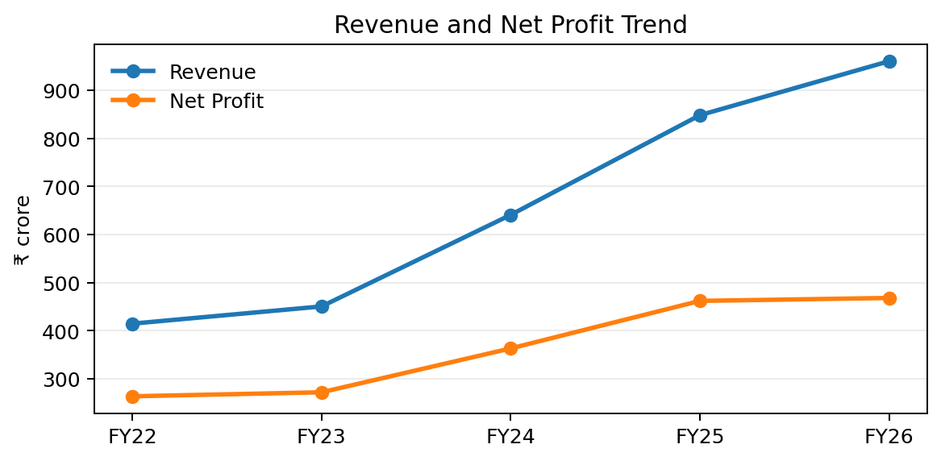
Revenue expanded from ₹414.8 crore in FY22 to ₹960.5 crore in FY26, while net profit rose from ₹263.8 crore to ₹468.2 crore.
Metric | FY22 | FY26 | FY22–FY26 observation
Revenue | ₹414.8 cr | ₹960.5 cr | ~23.4% CAGR
EBITDA | ₹347.5 cr | ₹657.9 cr | Strong absolute growth, slower than revenue in FY26
Net Profit | ₹263.8 cr | ₹468.2 cr | Profitability remains high, but FY26 growth was only ~1.3%
Operating CF | ₹231.9 cr | ₹430.7 cr | Strong conversion over the period

ANALYST INTERPRETATION
• Revenue growth accelerated strongly through FY25, but FY26 marked a clear moderation.
• The most important change is the divergence between revenue growth and profit growth in FY26.
• This suggests that the next stage of the thesis depends less on account growth alone and more on monetisation, operating leverage and margin stabilisation.

07 | Financial Analysis, Common-Size Statements

INCOME STATEMENT STRUCTURE
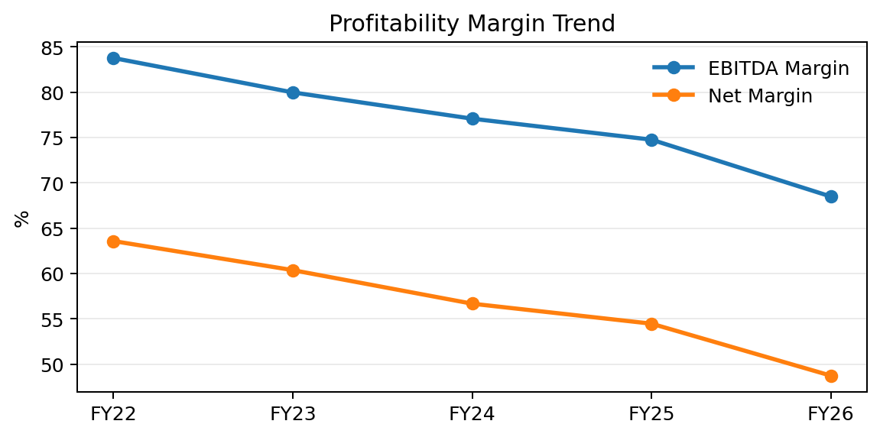
The workbook shows a gradual decline in EBITDA and net margins despite strong revenue growth.
Year | EBITDA / Revenue | Net Profit / Revenue | Non-EBITDA cost / Revenue
FY22 | 83.8% | 63.6% | 16.2%
FY23 | 80.0% | 60.4% | 20.0%
FY24 | 77.1% | 56.7% | 22.9%
FY25 | 74.8% | 54.5% | 25.2%
FY26 | 68.5% | 48.7% | 31.5%

INTERPRETATION
The common-size analysis highlights a key valuation issue: CDSL remains an exceptionally high-margin business, but the direction of margins is downward. EBITDA margin declined from 83.76% in FY22 to 68.49% in FY26, while net margin declined from 63.59% to 48.75%. The DCF therefore assumes continued, but tapering, EBITDA-margin compression.

08 | Financial Analysis, Balance Sheet

BALANCE SHEET STRENGTH
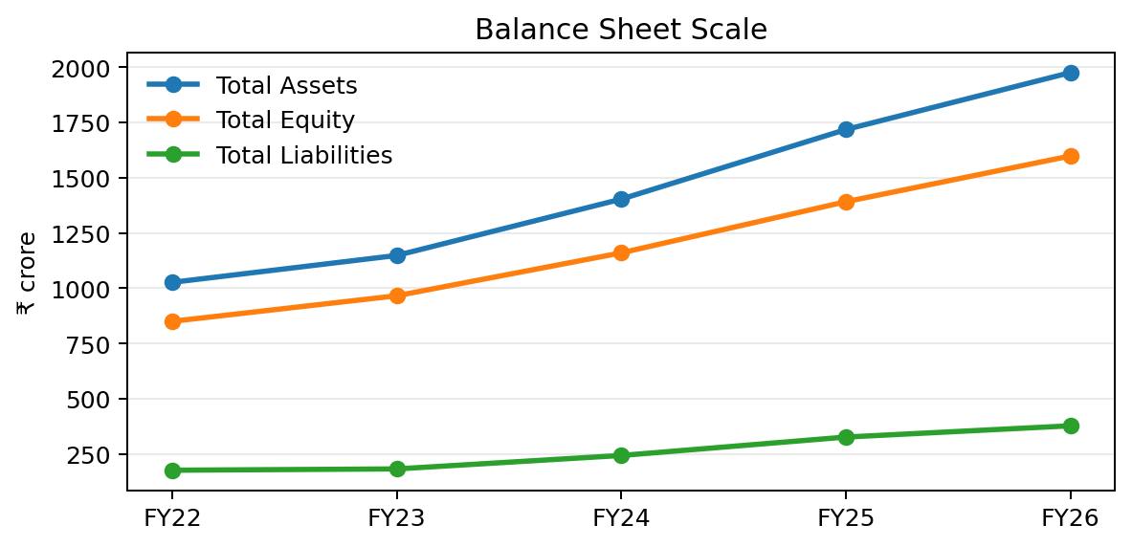
Total assets and equity have expanded materially, while liabilities remain small relative to the equity base.
Metric | FY22 | FY26 | Growth / implication
Total Assets | ₹1,026.5 cr | ₹1,975.5 cr | ~14.0% CAGR
Total Equity | ₹850.1 cr | ₹1,598.2 cr | Strong capital accumulation
Total Liabilities | ₹176.4 cr | ₹377.4 cr | Low relative to equity
Cash & equivalents | ₹65.2 cr | ₹31.8 cr | Lower than FY22, but business remains net cash
Debt-to-Equity | 0.013% | 0.098% | Effectively debt-free

FINANCIAL HEALTH
• The very low debt-to-equity ratio substantially reduces financial leverage risk.
• Capital is predominantly funded through equity and internally generated resources.
• The balance sheet supports the use of an FCFF DCF because financing structure is not a major driver of enterprise value.

09 | Financial Analysis, Cash Flow

CASH FLOW PROFILE
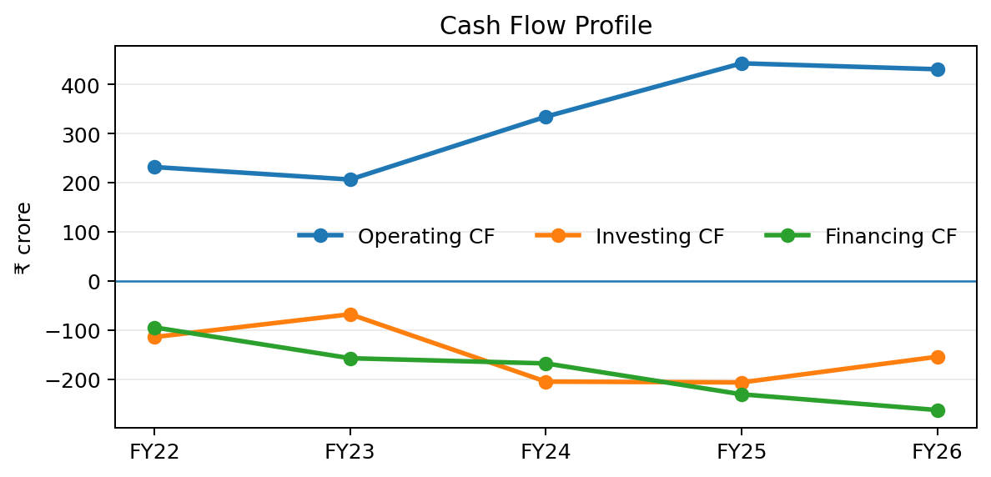
Operating cash flow remained positive in every year, while investing and financing cash flows were consistently negative.
Year | Operating CF | Investing CF | Financing CF
FY22 | ₹231.9 cr | ₹-113.7 cr | ₹-94.1 cr
FY23 | ₹206.6 cr | ₹-67.4 cr | ₹-156.8 cr
FY24 | ₹334.3 cr | ₹-204.3 cr | ₹-167.3 cr
FY25 | ₹442.8 cr | ₹-205.9 cr | ₹-230.1 cr
FY26 | ₹430.7 cr | ₹-153.7 cr | ₹-262.1 cr

INTERPRETATION
• Operating cash generation is a major strength and broadly supports reported profitability.
• Negative financing cash flow is consistent with capital distributions and a low-debt structure rather than dependence on external financing.
• FY26 operating cash flow declined modestly despite higher revenue, reinforcing the need to monitor cash conversion as the business scales.

10 | Financial Analysis, Ratio Analysis

KEY RATIOS
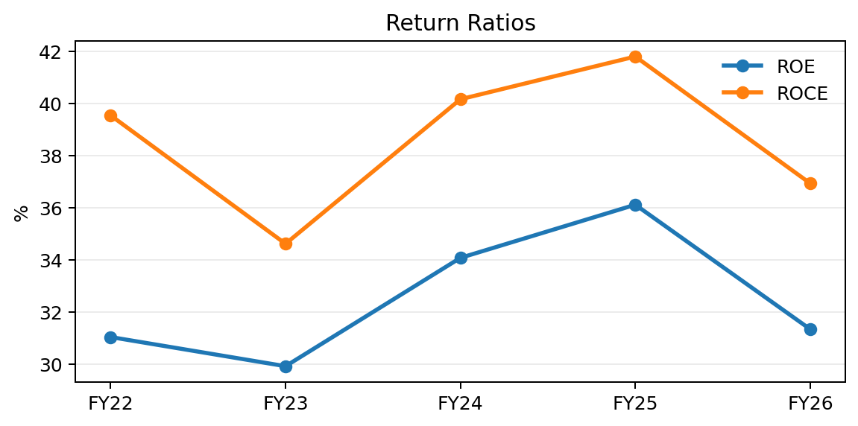
ROE and ROCE remain high, although both moderated in FY26 from their FY25 levels.
Ratio | FY22 | FY24 | FY26 | Interpretation
EBITDA Margin | 83.76% | 77.08% | 68.49% | High but declining
Net Margin | 63.59% | 56.68% | 48.75% | Strong, with compression
ROE | 31.03% | 34.07% | 31.33% | High capital efficiency
ROCE | 39.54% | 40.16% | 36.93% | Strong return on capital
Current Ratio | 4.59× | 3.09× | 2.76× | Strong liquidity
Receivable Days | 22.82 | 19.47 | 18.24 | Generally efficient collection
Debt-to-Equity | 0.013% | 0.023% | 0.098% | Negligible leverage

RATIO CONCLUSION
CDSL's financial profile is fundamentally strong. Liquidity is ample, leverage is negligible and returns remain high. The main deterioration is not balance-sheet risk, but profitability-rate compression as margins have normalised from exceptionally high historical levels.

11 | Financial Analysis, DCF Valuation

DCF ASSUMPTIONS
Assumption | Base case
Revenue growth FY27E–FY31E | 13.0% annually
EBITDA margin | 64.74% → 57.24%, tapering compression
D&A / Revenue | 3.94%
Capex / Revenue | 9.20%, excluding FY23 outlier
Tax rate | 25.17%
WACC | 9.76%
Terminal growth | 5.00%

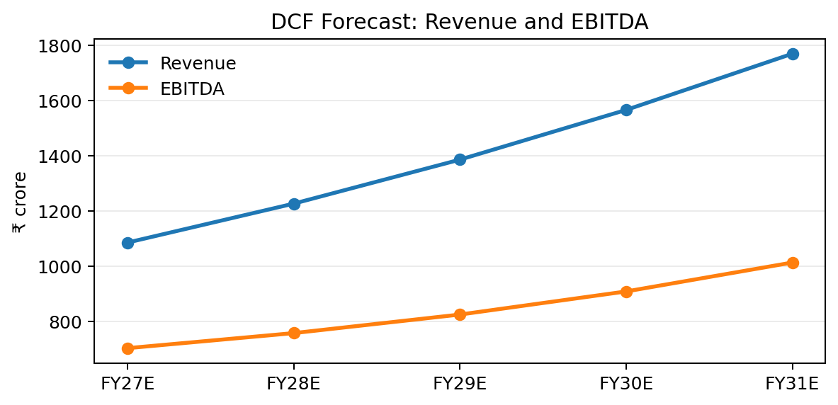
Forecast revenue grows at 13% annually, while EBITDA margins decline gradually under the workbook's base-case assumptions.
DCF OUTPUT
Component | Value
PV of FY27–FY31 FCFF | ₹1,929.40 crore
PV of Terminal Value | ₹8,483.77 crore
Enterprise Value | ₹10,413.17 crore
Cash less debt | ₹807.00 crore
Equity Value | ₹11,220.17 crore
Implied value per share | ₹536.85

The DCF is conceptually appropriate for a highly profitable, asset-light and low-leverage business, but the output is highly sensitive to margin, capex, WACC and terminal-growth assumptions.

12 | Financial Analysis, DCF Sensitivity

SENSITIVITY MATRIX
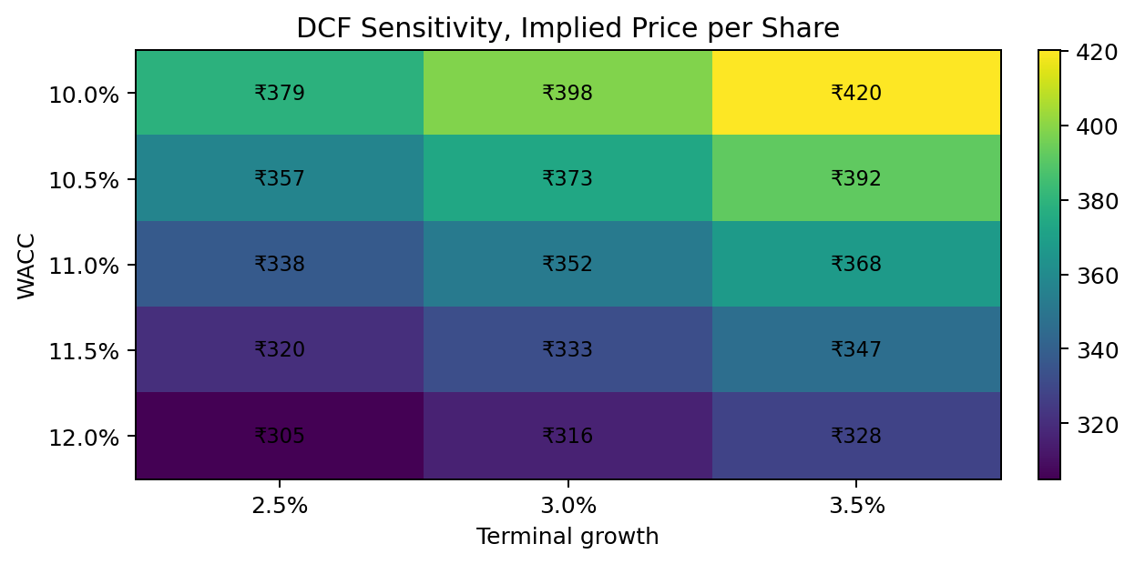
The supplied sensitivity table varies WACC from 10.0% to 12.0% and terminal growth from 2.5% to 3.5%.
WACC \ Terminal growth | 2.5% | 3.0% | 3.5%
10.0% | ₹379.10 | ₹398.17 | ₹420.17
10.5% | ₹357.10 | ₹373.48 | ₹392.21
11.0% | ₹337.69 | ₹351.89 | ₹367.98
11.5% | ₹320.45 | ₹332.85 | ₹346.80
12.0% | ₹305.04 | ₹315.94 | ₹328.12

SENSITIVITY CONCLUSION
The valuation remains highly assumption-sensitive. Within the supplied sensitivity range, the highest value is approximately ₹420 per share, substantially below the current price of ₹1,414.70. This indicates that the market price embeds a materially more optimistic view than the DCF base case.

13 | Financial Analysis, Comparable Valuation

PEER SELECTION
NSDL is used as the direct peer. The workbook explicitly notes that CDSL and NSDL are the two major depositories, making NSDL the most relevant comparable despite the limitation of a one-peer sample.
Metric | CDSL | NSDL | Relative
FY26 Revenue | ₹960.5 cr | ₹704.7 cr | CDSL higher
FY26 EBITDA | ₹657.9 cr | ₹508.0 cr | CDSL higher
FY26 Net Profit | ₹468.2 cr | ₹319.4 cr | CDSL higher
P/E | 63.15× | 50.98× | CDSL premium
EV/EBITDA | 43.72× | 28.83× | CDSL premium
P/B | 14.83× | 6.90× | CDSL premium

IMPLIED VALUATION
Method | Calculation | Implied price
P/E | ₹22.40 EPS × 50.98× | ₹1,141.95
EV/EBITDA | ₹657.90 cr × 28.83×, adjusted for net cash | ₹945.89
P/B | Workbook calculation | ₹243.48

P/E and EV/EBITDA are treated as the principal comparable cross-checks. P/B is shown for completeness but produces a materially lower result and is less informative for this high-ROE, asset-light business.

14 | Final View

VALUATION SUMMARY
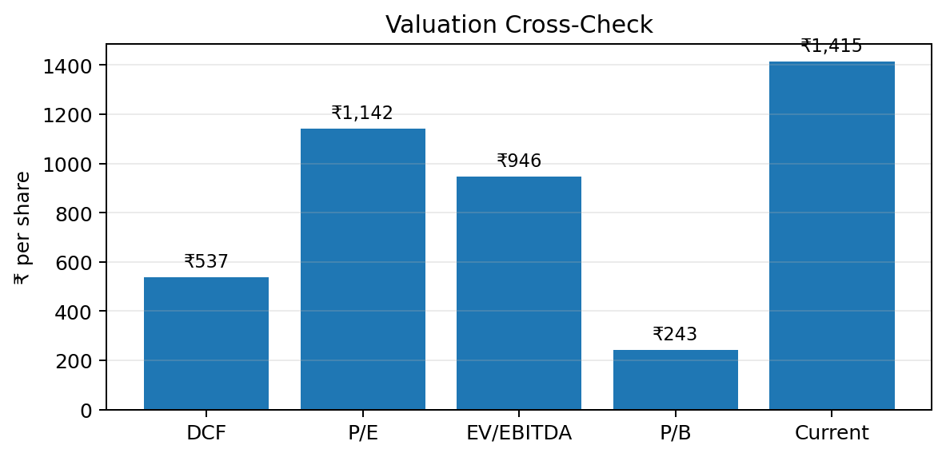
The current market price is above all three principal valuation outputs in the supplied workbook.
Method | Value / share | Premium / (discount) to current
DCF | ₹536.85 | −62.05%
Comparable, P/E | ₹1,141.95 | −19.28%
Comparable, EV/EBITDA | ₹945.89 | −33.13%
Current market price | ₹1,414.70 | —

FINAL VALUATION RANGE
Measure | Range / Value
DCF range | ₹500–₹550
Comparable range | ₹950–₹1,150
Reasonable valuation range | ₹950–₹1,100
Current market price | ₹1,414.70

KEY ASSUMPTIONS AND RISKS TO THE CONCLUSION
• DCF sensitivity: the valuation depends heavily on 13% revenue growth, tapering margin compression, 9.76% WACC and 5.00% terminal growth.
• Comparable limitation: NSDL is the sole direct peer, so P/E and EV/EBITDA are useful cross-checks rather than definitive fair values.
Overall conclusion: On the supplied assumptions, CDSL appears fully valued to overvalued at ₹1,414.70. The DCF is the primary valuation anchor, while P/E and EV/EBITDA provide market-based cross-checks. The central debate is whether future growth and profitability will materially exceed the DCF base case.
Sources: Supplied CDSL workbook; CDSL Integrated Annual Report 2025-26; supplied HDFC AMC report (visual reference). Academic research only, not an investment recommendation.

