Description of your understanding of how
the connection tool is rendered

After the analysis of the frequency table you can observer that the most frequent methods called are the ones from the Java core, usually the ones implemented direclty in the native code in the JVM.

For instance hashCode is called over 2000 times while on the execution of the program.

Other methods that are called frequently are the getters and setters which means that application is build correctly from the encapsulation perspective and it could also mean that the application model class hierarchy.

Notify methods (add/remove notify) are hardly used, under 10 calls while the program is executing which mean that the Observer pattern is hardly used, not very good arhitectural idea because the application is manly a GUI based one.

The connection tool works like the other tools following permanently the mouse motion. Methods like : mouseMoved, updateCursor, hashCode, get
are mainly called while the cursor is moved through the main windows of the application.

After selecting the connection tool button, a start point will be created after the next click on one of the forms created, in this case one of the two circles. Methods like getCursor and mouse moved are still called proving that the app is permanently called while using this connection feature or any other ones; addNode, getNodeCount, isConnectable, draw are methods which are called when the user actually begins draw the connection between the two figure. isConnectable is extensivaly called to check if the user has click on the next figure for the connection to be complete.

Comparable observations with official ones

JHotDraw application framework for graphical drawing editors. It first gives an overview of the design, and then splits it up into three parts: one on the Figure
class hierarchy, one on the Drawing and DrawingView classes, and one on the DrawingEditor and associated functionality classes.

Figure class hierarchy.It discusses the Figure, CompositeFigure, DecoratorFigure, ConnectionFigure, Connector, and Handle classes.

The Drawing and DrawingView classes. This part describes the use of Figure objects in the context of a drawing and its display in a drawing view. It discusses the
Drawing, DrawingView, DrawingEditor, and Painter classes.

The DrawingEditor classes. This part describes the overall drawing editor functionality. It discusses the DrawingEditor, the Tool, CreationTool, HandleTracker, and
SelectionTool classes, and the Handle, TrackHandle, NullHandle, and Locator classes.

This first part of the JHotDraw framework design discussion describes the Figure class hierarchy. Figure is a central abstraction of the drawing editor framework.
It represents a graphical figure that users can work with (arrange them to form the drawing). The discussion comprises the classes Figure, CompositeFigure,
DecoratorFigure, ConnectionFigure, Connector, Handle, and Drawing.
It does not cover all aspects of these classes, but only those relevant from the perspective of the Figure class hierarchy.

This second part of the JHotDraw framework design discussion describes the Drawing, DrawingView, and related classes. A drawing is a set of figures, displayed in a
drawing view. Users manipulate the figures through the drawing view. The discusses the classes Figure, Drawing, DrawingView, Tool, Painter, PointConstrainer, and
DrawingEditor.

This third part of the JHotDraw framework discussion describes the DrawingEditor and related classes. The drawing editor is the coordinating object that creates
all command and tool objects. Drawing views manipulate figures of a drawing using these tool objects. During this direct manipulation, tools make use of handles.

Description of the tool

The design process during the creation of the tool was guided by the fact that the result needed to be able to analyze multiple applications. The recommended method for the analysis was a technique called Phase Analysis. The required the solution to output a log file containing the call depth for each method call. Another two types of logs files needed to be created. The first one contains the number of calls for each method by each calling parent. The second log files contains the number of calls for each method. The format chosen was CSV because of its simplicity and ease of integration with Excel. Excel was used to create charts from the log files.
The most important tool in the development of the tool was the AspectJ plugin for Eclipse. AspectJ is an aspect-oriented extension created for Java. The extension was very easy to use given the available integration with Eclipse. The plugin was used to create the project template. The template used was AspectJ Project. This structure allowed me to execute the analysis process straight from the development environment.
The aspect oriented method was chosen because it offers a great way to inject the code needed to analyze the execution of different applications. The injection was done by defining point cuts. These elements pick out join points in the program and expose data from the execution context. The exposed data was used to trace the execution.
The points of the program that were important to consider: step before a method is called, step after a method is called.
In order to use an aspect oriented method for the analysis an aspect needed to be created. The aspect is called Trace. The role of the aspect is to identify the points in the execution where method are called and where methods have finished their execution. The aspect also declares and contains the names and location of the log files needed to be filled. 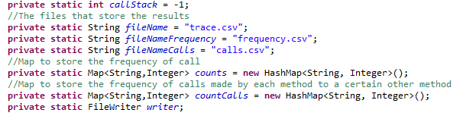
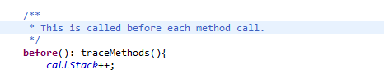
An important field of the aspect is the static callStack field. This attribute stores the current depth of the trace. This variable is incremented when a method is called and decremented when a method execution is finished. This was the most convenient way of measuring the call depth. 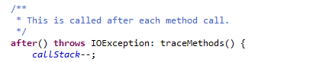
After the call depth of the current method call was determined. The next step was the identification of the method. This was achieved by reading the exposed data from the execution. The first step is reading the signature of the joint point. The name of the current method can be obtained by calling the getName method.
The solution also required to obtain the calling parent of the current method. This part of the code is shown below. This was done by obtaining the current stack trace and reading the parent.

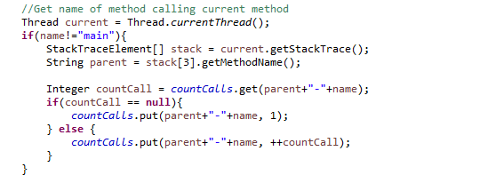
The number of calls for each method was calculated using a HashMap. This Map stores the number of calls for each method. The key is the name of the method and the value is the number of previous call.
In a similar manner the number of call for each method by each parent was calculated using a HashMap. The key for this map was a string obtained by appending the name of the child method’s name to the parent method’s name.
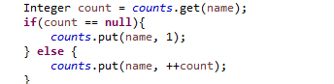
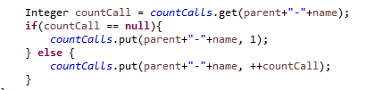
After the target application exits these structures are written to the appropriate log files.
The pointcut used sets the analysis to be applied to the whole execution of the application.
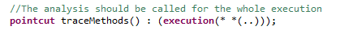

Visual output

