I used three methods to measure the equivalence of the data sets. The values for these can be changed under the //TRESHOLD comment. The method of the analysis can be chosen from the interface.

The attributes analyzed are selected with the checkboxes.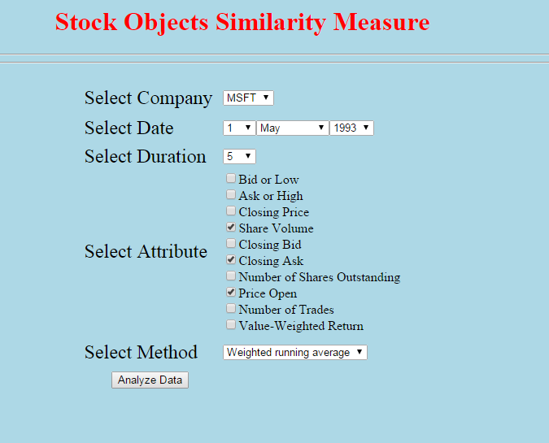

I ran the application on a Tomcat server. The home page is set. If it does not work try <http://localhost:8080/Stock/similar.jsp>. Change the username and password for your database in calc.jsp line 385.

Below is an example of the graph screen.

