**Amazon Elastic Block Storage (EBS)**

**Agenda**

1. **Create Instance, add storage while launching and then mount in instance**
2. **Create, Attach, Detach Volume**
3. **Take Snapshot**
4. **Restore an EBS volume from a snapshot**
5. **Attach the newly created Volume to instance**
6. **Attach/Mount the drive to Windows Instance**
7. **Create Instance, add storage while launching and then mount in instance**
8. Launch a Linux instance using RHEL AMI and add storage while launching

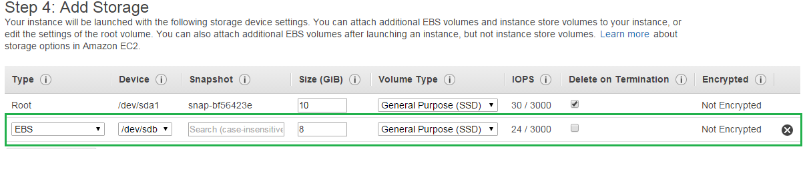

1. Once to get the instance, login to instance and use lsblk command to list the block devices

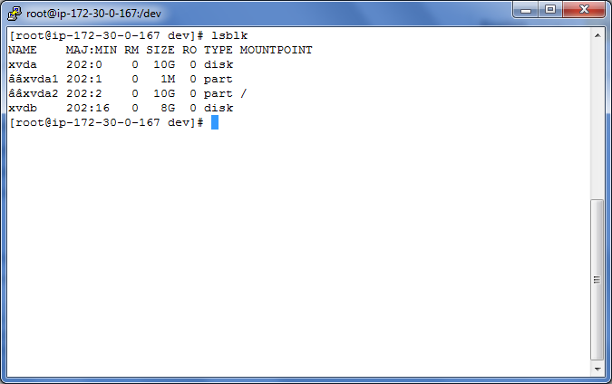

In the above example, **lsblk** reports that there are two block devices attached to the instance; xvda2 is mounted as the root file system (note the MOUNTPOINT value of /) and xvdb is not mounted at all

Some Linux distributions do not provide the **lsblk** command by default. If the **lsblk** command does not work, you can use **sudofdisk -l | grep Disk** instead

In the above example, the xvdb device is not mounted. Sometimes when you create a volume from a snapshot, the data on the volume is contained in a partition (such as /dev/xvdb1) instead of the root of the volume. In such a case, you would mount the /dev/xvdb1 partition (the lsblk command output omits the /dev/ portion of the file path). In this example, there is an empty volume with no partition, so you will mount /dev/xvdb.

Because you created an empty volume instead of restoring a volume from a snapshot in the previous procedure, you need to format the volume using mkfs before you can mount it. Use the following command to create an ext4 file system on the volume. Substitute the device name you used if you did not use /dev/xvdb when you attached the volume.

**Caution:**

This step assumes that you're mounting an empty volume. If you're mounting a volume that already has data on it (for example, a volume that was restored from a snapshot), **don't use mkfs before mounting the volume** (skip to the next step instead). Otherwise, you'll **format the volume**and **delete**the existing data

1. Format the partition: sudomkfs -t ext4 /dev/xvdb

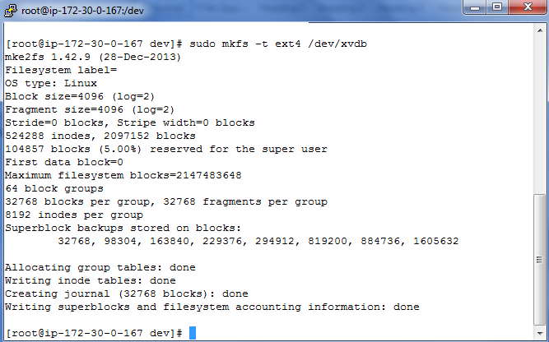

1. Use the following command to create a mount point directory for the volume

**mkdir /u01**

1. Use the following command to mount the volume at the location you just created

**mountdevice_namemount_point**

**Ex : mount /dev/xvdf /u01**

1. To mount this EBS volume on every system reboot, add an entry for the device to the /etc/fstab file
2. Create a backup of your /etc/fstab file that you can use if you accidentally destroy or delete this file while you are editing it

**sudocp /etc/fstab /etc/fstab.orig**

1. Open the /etc/fstab file using any text editor, such as nano or vim.

**Note**

You need to open the file as root or by using the sudo command

Add a new line to the end of the file for your volume using the following format

*device_namemount_pointfile_system_typefs_mntopsfs_freqfs_passno*

If you ever intend to boot your instance without this volume attached (for example, so this volume could move back and forth between different instances), you should add the nofail mount option that allows the instance to boot even if there are errors in mounting the volume

*/dev/xvdf /data ext4 defaults,nofail 0 2*

1. After you've added the new entry to /etc/fstab, you need to check that your entry works. Run the sudo mount -a command to mount all file systems in /etc/fstab

**sudo mount -a**

If the previous command does not produce an error, then your /etc/fstab file is OK and your file system will mount automatically at the next boot. If the command does produce any errors, examine the errors and try to correct your /etc/fstab.

**Warning**

Errors in the /etc/fstab file can render a system unbootable. Do not shut down a system that has errors in the /etc/fstab file.

1. **Create, Attach and Detach Volume**
2. To create an EBS volume using the console
3. Open the Amazon EC2 console.
4. From the navigation bar, select the region in which you would like to create your volume.
5. Click Volumes in the navigation pane.
6. Above the upper pane, click Create Volume.
7. In the Create Volume dialog box, in the Volume Type list, select General Purpose (SSD), Provisioned IOPS (SSD) or Magnetic.
8. In the Size box, enter the size of the volume, in GiB.
9. For Provisioned IOPS (SSD) volumes, in the IOPS box, enter the maximum number of input/output operations per second (IOPS) that the volume should support.
10. In the Availability Zone list, select the Availability Zone in which to create the volume.
11. Click Yes, Create.

**Important**

If you receive one of the following errors, the current volume creation would exceed the default storage limit for your account:

Maximum number of active volumes bytes, 20, exceeded.

Maximum number of active gp2 volumes bytes, 20, exceeded

Maximum number of active io1 volumes bytes, 20, exceeded.

1. **Attaching a Volume to instance**
2. To attach an EBS volume to an instance using the console
3. Open the Amazon EC2 console.
4. Click Volumes in the navigation pane.
5. Select a volume and then click Attach Volume.
6. In the Attach Volume dialog box, start typing the name or ID of the instance to attach the volume to in the Instance box, and select it from the list of suggestion options (only instances that are in the same Availability Zone as the volume are displayed).
7. You can keep the suggested device name, or enter a different supported device name.
8. Click Attach

**Important**

The block device driver for the instance assigns the actual volume name when mounting the volume, and the name assigned can be different from the name that Amazon EC2 recommends.

1. **To detach an EBS volume using the console**
2. First, use the following command to unmount the /dev/sdh device.
3. [ec2-user ~]$ umount -d /dev/sdh
4. Open the Amazon EC2 console.
5. Click Volumes in the navigation pane.
6. Select a volume and then click Detach Volume.
7. In the confirmation dialog box, click Yes, Detach.
8. **Taking Snapshot:**

To create a snapshot for Amazon EBS volumes that serve as root devices, you should stop the instance before taking the snapshot.

1. To unmount the volume in Linux, use the following command:

**umount -d device_name**

Where device_name is the device name (for example, /dev/sdh).

**Ex: umount –d /dev/xvdb**

**Umount /u01**

1. To create a snapshot using the console
2. Open the Amazon EC2 console at https://console.aws.amazon.com/ec2/
3. Choose Snapshots in the navigation pane.
4. Choose Create Snapshot.
5. In the Create Snapshot dialog box, select the volume to create a snapshot for, and then choose Create.
6. **Restore an EBS volume from a snapshot**

You can restore your EBS volume from a snapshot using the AWS Management Console as follows.

1. Open the Amazon EC2 console
2. From the navigation bar, select the region that your snapshot is located in
3. Click Volumes in the navigation pane.
4. Click Create Volume.
5. In the Create Volume dialog box, in the Volume Type list, select General Purpose (SSD), Provisioned IOPS (SSD) or Magnetic
6. In the Snapshot field, start typing the ID or description of the snapshot from which you are restoring the volume, and select it from the list of suggested options
7. In the Size box, enter the size of the volume in GiB, or verify the that the default size of the snapshot is adequate
8. If you specify both a volume size and a snapshot ID, the size must be equal to or greater than the snapshot size. When you select a volume type and a snapshot ID, minimum and maximum sizes for the volume are shown next to the Size list
9. For Provisioned IOPS (SSD) volumes, in the IOPS box, enter the maximum number of input/output operations per second (IOPS) that the volume can support.
10. In the Availability Zone list, select the Availability Zone in which to create the volume. EBS volumes can only be attached to EC2 instances within the same Availability Zone.
11. Click Yes, Create.

**Important**

If you restored a snapshot to a larger volume than the default for that snapshot, you need to extend the file system on the volume to take advantage of the extra space

1. **Attach the newly created Volume to instance**

For this you can repeat the same steps mentioned in section 2