Installing Jenkins on Ubuntu

We'll install the Jenkins on Ubuntu 14.04 system.

Let's use Debian package repository of Jenkins to automate installation and upgrade. First add the key to our system:

**$ wget -q -O - http://pkg.jenkins-ci.org/debian/jenkins-ci.org.key | sudo apt-key add -**

Then add the following entry in our **/etc/apt/sources.list**:

**deb http://pkg.jenkins-ci.org/debian-stable binary/**

Or one liner:

**$ sudo sh -c 'echo deb http://pkg.jenkins-ci.org/debian-stable binary/ > /etc/apt/sources.list.d/jenkins.list'**

We need to update our local package index, and then finally install Jenkins:

**$ sudo apt-get update**

**$ sudo apt-get install jenkins**

Now we have **/etc/init.d/jenkins** start script which starts Jenkins automatically at boot time. In other words, Jenkins will be launched as a daemon up on start.

What does this package do?

1. Jenkins will be launched as a daemon up on start (**/etc/init.d/jenkins**).
2. The **jenkins** user is created to run this service.
3. Log file will be placed in **/var/log/jenkins/jenkins.log**. Check this file if troubleshooting Jenkins. **/etc/default/jenkins** will capture configuration parameters for the launch like e.g **JENKINS_HOME**.
4. By default, Jenkins listen on port **8080**. Access this port with browser to start configuration.

If we start it locally, we can see it running under **http://localhost:8080/** URL.

Just follow the instructions.

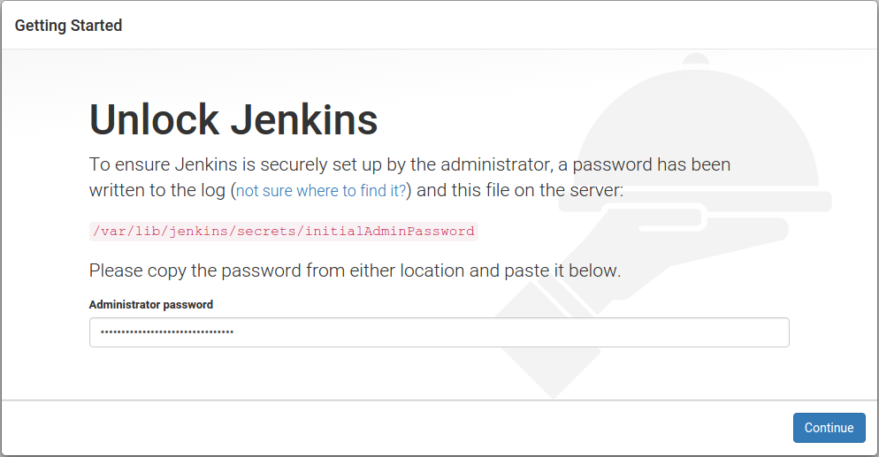  
  
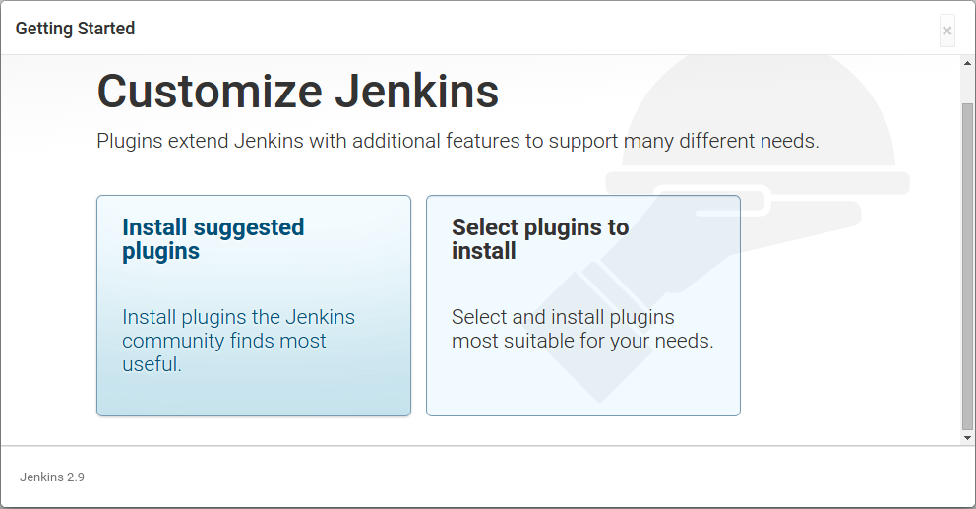

Select "Suggested Plugins":

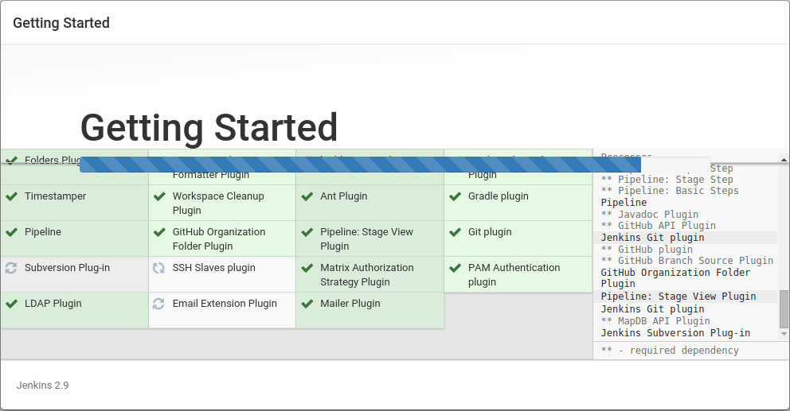  
  
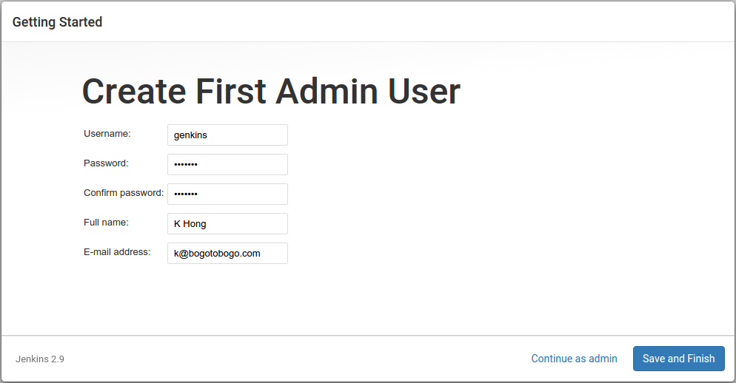  
  
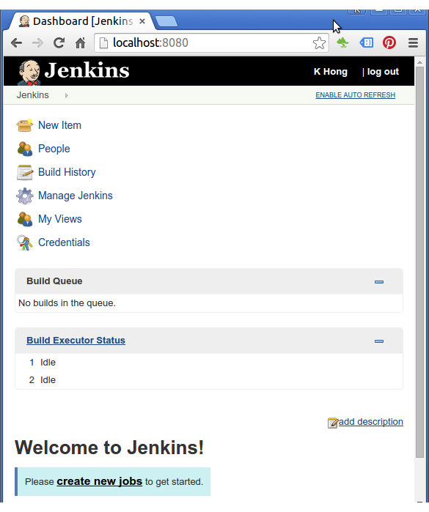

Java

At this point, most likely we already have java installed since Jenkins is a Java web application. We need at least the Java Runtime Environment, or JRE to run it. So, let's check if we have it:

**$ java -version**

**openjdk version "1.8.0_91"**

**OpenJDK Runtime Environment (build 1.8.0_91-8u91-b14-0ubuntu4~14.04-b14)**

**OpenJDK 64-Bit Server VM (build 25.91-b14, mixed mode)**

Note : we'll be using Jenkins mostly to build a Java application using Maven. Maven is a widely-used build tool in the Java world, with many powerful features such as declarative dependency management, convention over configuration, and a large range of plugins. For our build, we will also be using recent versions of the Java Development Kit (JDK) and Maven.