## College Website Design

## Team Members:

1. Srikar Varanasi (18BD1A055U)
2. Nikhil Suraj Yeeda (18BD1A055W)
3. Srinivas Yadav (18BD1A055E)
4. Kaveti Kshitij (18Bd1A0551)

# College Website Design

**Abstract**

* College website is primarily a web page/portal which acts as a central place holder to navigate to various aspects of information sought from and about the college to its audience namely- prospective students, their families, donors, trustees, alumni, organizations, friends, the media and casual visitors.
* The chief purpose of the college website is to advance the institution's mission, brand and message(s) to its audience.
* College website is a primary means by which prospective students learn about the institution and communicate to each prospective student that he/she is special, with needs consistent with the institution’s strengths, and that faculty and staff are readily (and constantly) available to serve the students’ academic and non-academic needs.
* The website provides targeted and user-friendly interaction (e.g. prospective student inquiries, requests for information, online applications, online giving, etc.) with its audience.

**Introduction**

* College websites provide a wealth of information specially tailored toward several target audiences, (the current and prospective students, their families, donors, trustees, alumni, organizations, friends, the media and casual visitors), each with diverse needs and unique pain points. World Wide web has shrunk the distance between the audience by providing a platform to host and access the information they are looking for without physically visiting the institutions.
* Due to this reason, the information provided on an institution’s website has to be a real time information which binds and brings the audience again and again to the portal, just like how we physically approach the various departments of an institution for our needs. .

**Aims & Objectives**

* Developing a web portal for maintaining the information about the college.
* Design and implement a college website to provide information to the campus community (i.e. faculty, staff, administration, students, trustees, alumni, parents).
* Since college website is a vehicle of communication, we intend to employ textual and visual components.
* The website needs to be dynamic and user-friendly, can readily adapt to meet the diverse and changing needs of its audience.
* The information in a website must be of relevance, fresh, authentic and engaging (i.e. mission centric, current information and easily.
* To develop, encourage and fellowship among the students, teachers, senior staff of the college.
* Providing a platform to bring the audience digitally together and stay connected.

**Scope**

* This system would be developed as a series of interlinked static web pages using JavaScript, J2EE and MySQL.
* Provision for student registrations, access to the administrative information related to curriculum, academic calendar, scholarships, fees, examination results, attendance monitoring, educational resources like online teaching material and notes, etc.
* Provision for teachers to track the student’s day to day attendance, activities, performance monitoring, ability to upload teaching material and notes, allow students to submit assignments, etc.
* Periodic, on demand website updating by the web administrator.

**Cardinal aspects considered in the design of the web page**

Five essential characteristics are considered in the website design:

1. Thoughtful, Simple Navigation

It is essential to provide website visitors with a straightforward and intuitive way to navigate the site and find the content they are looking for. Addressing multiple audiences’ unique pain points and content pose challenges. The navigation mechanisms adopted here are:

* Audience segmentation
* Main topic organization
* Hybrid approach.

1. Robust Search Functionality

Often users visit a website to find information on a very specific topic. Website visitors expect to see a search box to assist them in finding content quickly. Robust search functionality is provided so that users can swiftly and easily access the content that they are looking for.

Search bar and portal login both are located in the same general area. Search bar is placed strategically and consistently at the top right corner across all website pages.

1. Mobile Responsiveness

Today’s websites must be mobile responsive! Parents, faculty and students alike increasingly rely on their smartphones and tablets to access content on the web.

Often, elaborate drop down menus do not display clearly via mobile devices and provide a poor user experience to mobile visitors. It is ensured that the menu navigation is presented in a clear format for mobile.

1. Include Calls to Action (CTAs)

Leads visitors to engage with the college using buttons and/or hyperlinks to drive the audience to take action. Visitors can schedule a campus visit, request more information or find out more about the college programs.

**Features List**

* User Registration- allow the students to register themselves.
* Allow college to verify and authenticate the registered user.
* Provision for users to update their details.
* Allow the users to search/ browse the website based on keywords as well as navigation links
* Allow access to student related information.
* Allow access to academic and administrative resources.
* Send messages and emails to users.
* Group chats, create events, publish notices on the portal.
* Security features with login for every user.

**Users of The Software**

* Students
* Parents**/** Guardians
* Faculty
* Visitors
* College Administration
* Web Master/ Web Administrator

**Students**

* Students have access to many pages on the portal.
* They can register in the portal by providing basic information.
* He/She can login and logout of the portal.
* Can change their password.
* Can update his/her details as and when required.
* Can participate in group chats.
* He/she can receive mails and notifications about any event, attendance, examination and academic schedules, fees dues, scholarship disbursement, examination results, holiday notifications, etc.
* Can access his student information like courses enrolled, attendance, examination and academic schedules, fees dues, scholarship disbursement, examination results, holiday notifications, etc.
* Can access teaching materials, notes, presentations, submit assignments

**Parents/ Guardians**

* Parents/ guardians can have access to many pages on the portal.
* They can register in the portal by providing basic information.
* He/She can login and logout of the portal.
* Can change their password.
* Can update his/her details and details of his/her ward as and when required.
* Can participate in group chats with other parents, college administration and faculty.
* He/she can receive mails and notifications about any event, attendance, examination and academic schedules, fees dues, scholarship disbursement, examination results, holiday notifications, etc related to their ward.
* Can access information like courses enrolled, attendance, examination and academic schedules, fees dues, scholarship disbursement, examination results, holiday notifications, etc., of their wards.

**Faculty**

* Web Admin provides access to faculty to many pages on the portal.
* They can register and subscribe in the portal by providing basic information by sending a request to the Web Admin.
* He/She can login and logout of the portal.
* Can change their password.
* Can participate in group chats with students, parents, college administration and other faculty.
* He/she can send emails and notifications about any event, attendance, examination and academic schedules, fees dues, scholarship disbursement, examination results, holiday notifications, etc., related to students to the parents as well as students.
* Can access information like courses enrolled by a student, mark attendance, track the attendance, examination results, assignments submitted by students.
* Upload teaching material and notes.
* Can receive email and chat responses from students and their parents.

**Visitors**

* Visitors can have access to open pages on the portal.
* They can browse with or without registration.
* They can register in the portal by providing basic information.
* He/She can login and logout of the portal.
* Can change their password.
* Can update his/her details as and when required.
* Can receive and send mails and notifications about the admissions, events in the college.
* Can access information related to facilities, faculty, courses offered, fees structure, training and placement and activities in the college

**College Administration**

* College Administration enables information to the students, faculty and parents by updating the background database.
* College Administrator can login and logout of the portal.
* College Administrator provides the data required to authenticate the students and parents.
* The College Administrator will be able to receive and send notifications and emails to students and their parents.

**Web Master/ Web Administrator**

* He/She can also login and logout into the portal.
* His/her main function is to monitor and maintain the portal with upto date information.
* The admin has the access to user information and can search details.
* The super admin can also send and receive the notifications and emails.
* He/She can also publish notices.
* Allows user access after registration, verification and authentication.

**Implementation Details**

Implementation specific details of the features are defined below:

1. **User Registration**

* Users have to first register by providing the following fields:

|  |  |  |  |
| --- | --- | --- | --- |
| Students | Parents/Guardians | Faculty | Visitors |
| Roll No | Name | Faculty Id | Name |
| Branch | Gender | First Name | Gender |
| First Name | Roll no of ward | Middle Name | Mobile # |
| Middle Name | First Name of ward | Last Name | Email address |
| Last Name | Middle Name of ward | Gender | Passsword |
| Gender | Last Name of ward | Mobile # |  |
| Mobile # | Mobile # | Email address |  |
| Email address | Email address | Passsword |  |
| Passsword | Passsword |  |  |

* After registering, the members can login into the system.

1. **Allow Web Administrator to verify and authenticate the registered user**

* Web Master should verify the id with details used when sign-up and also if those match with college records.
* Two options should be selected after verification. Either accept or reject.
* Email should be sent to the student about the same.
* Rejected:

1. Reject message is sent to student.
2. Three chances will be provided to upload the id in case it gets rejected.
3. After three chances are complete the account should be locked. Message on dashboard should be displayed to contact some person in the college.

* Accepted:

1. A message should be visible to the student on the dashboard.
2. **Provision for users to update their details**

* Here the users can update their details after successful login and one time password sent to the mobile and email.
* These details are stored by the database and the can be viewed by the college management.
* These details are useful for colleges to communicate with the student.

1. **Allow the students and parents to access information pertaining to their academic progress and attendance, fees and scholarship info**

* Here the students and parents can access the above information after successful login and authentication.
* The information is accessed from the SQL database.

1. **Communication Module**

* This feature enables two way communication between students and their parents, visitors, faculty, college administration and web master.

1. **Upload and download teaching materials and notes**

* These feature enables the faculty to upload and update the teaching materials and notes.
* Allows students to download the teaching materials and notes.
* Allows students to upload the completed assignments.
* Allows faculty to download the assignments and upload the evaluations.
* The messages and emails are also sent as notifications to notify about the upload of training materials and assignments and the evaluations.

1. **Group chats, create events, publish notices on the portal**

* This feature allows to have group chats to discuss on a particular topic or problem i.e., discussion on current technologies, providing innovative solutions to a problem.
* Creation of events is made possible through this application.
* The college management notifies events that will be held in the college using this feature so that the users get notified and can participate and be a part of the events.

1. **Security features with login for every user**

* The security features are important to any application to prevent any unauthorized access to the application.
* Here we provide limit on the number of attempts made used to login to the application.
* Apart from this the application also provides forget password option as security feature in case if the user doesn’t remember his login password.

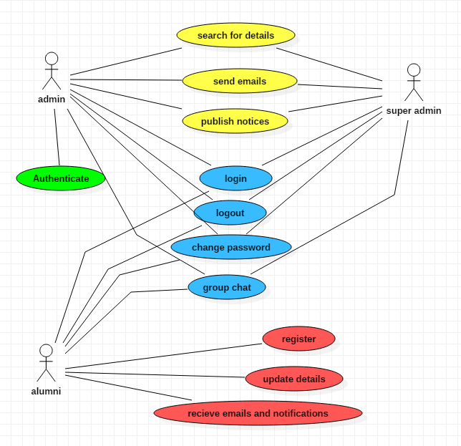**UML DIAGRAM:**