LAB 1: Simple UI

- Building Simple User Interface
  - Replace ConstraintLayout with AbsoluteLayout
  - Add an id to the current TextView

- UI event (Click a button, TextView message is changed to “Test”)
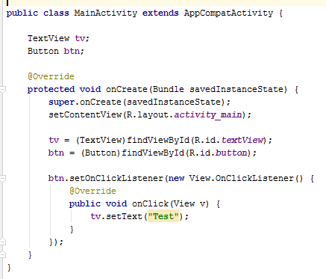
- Add a new Plain Text (EditText) named it as edt
  - Change tv.setText(“Test”) to tv.setText(edt.getText().ToString());

- Exercise
  - Create an app to convert Thai baht to USA dollar (35 baht = 1 $)
  - Input at EditText
  - Output at TextView

  - Create an app to sum two number (Two EditTexts, one button)
  - Create an app with two input
    - EditText1 = start number (x)
    - EditText2 = end number (y)
    - TextView = Show a string “A” whose size = y-x
E.g., x = 1, y=5, result = “AAAA”

