Lab 10

- Create a new Android project
- Create a new java file “Drawable.java” extending View (same place with MainActivity.java)
- Create two constructors of View
- Create onDraw function
- Create a drawable app
  - Draw a rectangle (width = 400, height = 300)a
  - Draw a circle (radius = 200)
  - Draw an oval (width = 200, height = 400)
  - Draw an arc (width = 400, height = 200, start angle 90, sweep 45
  - How to rotate individual draw
    - canvas.save()
      - Rotate operation
    - canvas.restore()
  - How to draw stroke
    - paint.setStyle(Paint.Style.STROKE);
    - paint.setColor(Color.XXXX);
    - canvas.draw(.....

- Draw images
    - Watermellon
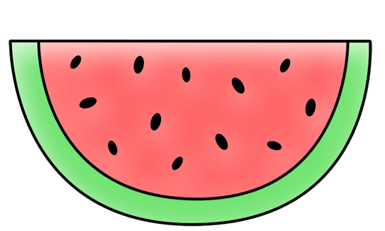
    - Clock
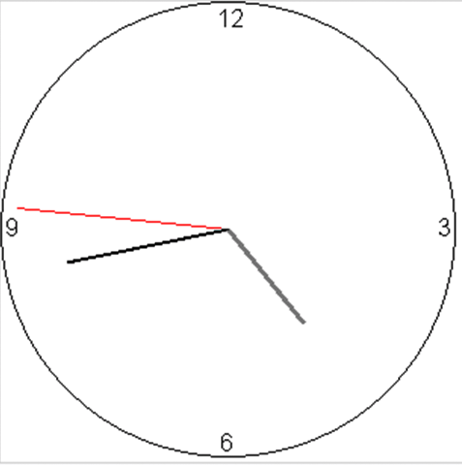

3. Sprite sheet (crop the Grab guy)
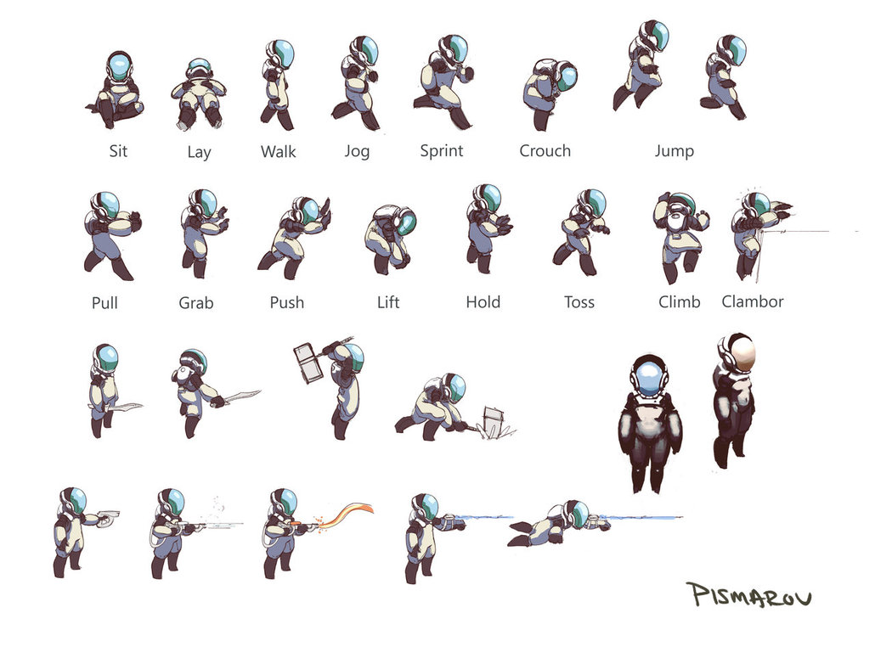

Extension

To draw path (curve) example

Paint paint = new Paint();
paint.setStyle(Paint.Style.STROKE);
paint.setStrokeWidth(5);
Path path = new Path();
path.moveTo(100,200);path.cubicTo(100,100,400,100,400,200);
canvas.drawPath(path,paint);

