2. More advanced

2.1 Create a 4 color pie chart as shown below
2.2 Rotate the circle chart with speed = 10.
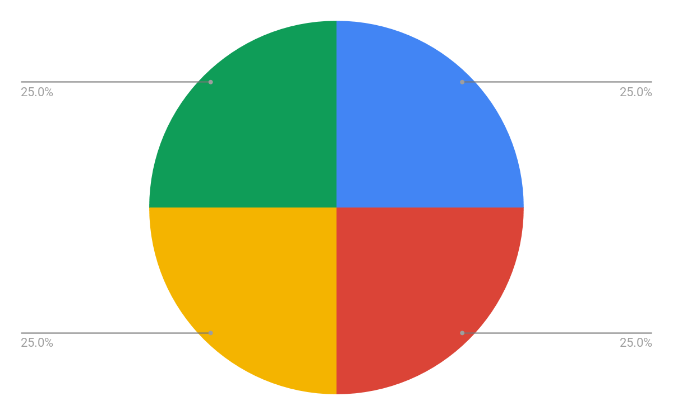

On Touch

public boolean onTouchEvent(MotionEvent event)
{
float touchX = event.getX();
float touchY = event.getY();
switch (event.getAction() & MotionEvent.ACTION_MASK) {
case MotionEvent.ACTION_DOWN:

//Do something
//E.g., change X value
break;
}
}

Solution
<?xml version="1.0" encoding="utf-8"?>
<AbsoluteLayout xmlns:android="http://schemas.android.com/apk/res/android"
xmlns:app="http://schemas.android.com/apk/res-auto"
xmlns:tools="http://schemas.android.com/tools"
android:layout_width="match_parent"
android:layout_height="match_parent"
tools:context="com.example.vdo.week8_workshop.MainActivity">

<com.example.vdo.week8_workshop.Week10_Fri
android:id="@+id/myView"
android:layout_width="wrap_content"
android:layout_height="wrap_content" />

<SeekBar
android:id="@+id/seekBar"
android:layout_width="match_parent"
android:layout_height="wrap_content"
android:layout_x="2dp"
android:layout_y="427dp" />

<TextView
android:id="@+id/textView"
android:layout_width="wrap_content"
android:layout_height="wrap_content"
android:layout_x="164dp"
android:layout_y="472dp"
android:text="TextView" />

</AbsoluteLayout>

package com.example.vdo.week8_workshop;

import android.support.v7.app.AppCompatActivity;
import android.os.Bundle;
import android.widget.SeekBar;
import android.widget.TextView;
import android.widget.Toast;

import org.w3c.dom.Text;

public class MainActivity extends AppCompatActivity {

SeekBar sb;
TextView tv;
Week10_Fri myView;

@Override
protected void onCreate(Bundle savedInstanceState) {
super.onCreate(savedInstanceState);
setContentView(R.layout.activity_main);

sb = (SeekBar)findViewById(R.id.seekBar);
tv = (TextView)findViewById(R.id.textView);
myView = (Week10_Fri)findViewById(R.id.myView);

sb.setOnSeekBarChangeListener(new SeekBar.OnSeekBarChangeListener() {
@Override
public void onProgressChanged(SeekBar seekBar, int progress, boolean fromUser) {
tv.setText("Data: " + progress);
float x = progress * 3.6f;
myView.rot = (int)x;
}

@Override
public void onStartTrackingTouch(SeekBar seekBar) {
}

@Override
public void onStopTrackingTouch(SeekBar seekBar) {
}
});
}
}

package com.example.vdo.week8_workshop;

import android.content.Context;
import android.graphics.Canvas;
import android.graphics.Color;
import android.graphics.Paint;
import android.os.Handler;
import android.support.annotation.Nullable;
import android.util.AttributeSet;
import android.view.View;

/**
* Created by vdo on 8/18/2017 AD.
*/

public class Week10_Fri extends View {

Handler h;
public Week10_Fri(Context context) {
super(context);

}

public Week10_Fri(Context context, @Nullable AttributeSet attrs) {
super(context, attrs);
h = new Handler();
}

Runnable r = new Runnable() {
@Override
public void run() {
invalidate();
}
};

public float x = 0;
public float rot = 0;
@Override
protected void onDraw(Canvas canvas) {
super.onDraw(canvas);

Paint p = new Paint();
p.setColor(Color.RED);
//canvas.drawRect(200+x,200,400+x,400,p);

//canvas.save();
//canvas.rotate(x,300,300);
//canvas.scale(x,1,200,200);
//canvas.drawRect(200,200,400,400,p);
//canvas.restore();
canvas.drawArc(300,300,700,700,270,x,true,p);
p.setColor(Color.WHITE);
canvas.drawCircle(500,500,100,p);

//p.setStrokeWidth(20);
//canvas.drawLine(500,500,700,700,p);

//x+=0.2;
x=rot;

h.postDelayed(r,50);

}
}

