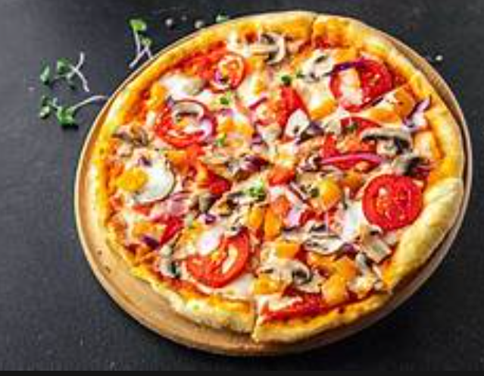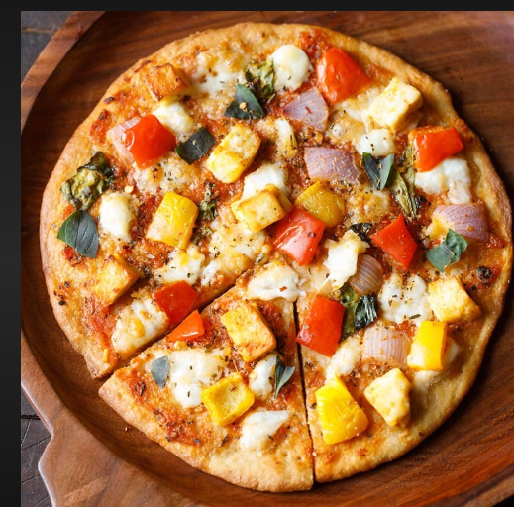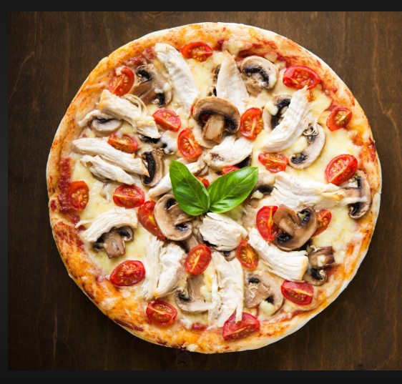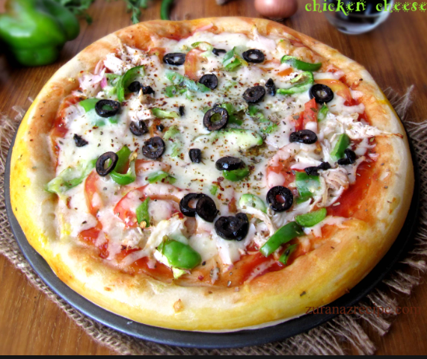

Pizzahut Analysis Report
Reported By :- Naga Siva VaraPrasad

Context
- Data Overview & Description
- Basic Analysis
- Total Orders Count
- Revenue Calculation
- Most Expensive Pizza
- Most Ordered Pizza Size
- Top 5 Popular Pizzas
- Intermediate Analysis
- Pizza Quantity by Category
- Order Trends by Hour
- Pizza Distribution by Category
- Average Daily Pizza Orders
- Top Pizza Types by Revenue
- Advanced Analysis
- Revenue Contribution by Pizza Type
- Cumulative Revenue Over Time
- Top 3 Pizza Types by Revenue in Each Category
- repetitive orders in terms of percentage
- Recommendations & Offers

About Pizza DATA
There is Four Tables used for our pizzas Analysis
1.Pizzas
2.Pizza_Types
3.Orders
4.Order_details
1. Pizzas
Pizzas Table contains information of
a. Pizza_id :- There is unique pizza name with size indication (eg : thai_ckn_l)
b. Pizza_type_id :- This is also similar to pizza_id but exclude the size from it (eg: thai_ckn)
c. size:- This gives information about size of pizza
d. Price :- This gives information about price of pizza
2. Pizza_details
a. Pizza_type_id :- This is also similar to pizza_id but exclude the size from it (eg: thai_ckn)
b. Name :- This gives information Actual pizza Name
c. Category :- This gives information about pizza category
(eg : Classic,Supreme,veggie, chicken)
d. Ingredients :- This gives information about what are ingredients are used.
3. Orders
a. order_id :- This is indication id for the orders include repetitive
b. Date :- This gives information on ordered date in the form of(YYYY-MM-DD)
c. Time:- This gives information on ordered time in 24 Hours Format (HH:MM:SS)
4. Order_details
a. Order_details_id:- This is indication id for the orders exclude repetitive
b. Order_id:- This is indication id for the orders include repetitive
c. Pizza_id :- There is unique pizza name with size indication (eg : thai_ckn_l)
d. Quantity:- This gives information about how many pizzas are ordered

Pizza_types

pizza_type_id
Name
Category
ingredients
Pizza

Pizza_id
Pizza_type_id
Size
Price

Order_details

order_details_id
order_id
pizza_id
quantity

order_id
Date
time

Orders

PIZZA DATA OVERVIEW

- Total Number of Orders
QUERY
OUTPUT
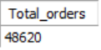
INSIGHTS
- There are 48,620 orders received at the Pizza Hut store

- Total Revenue calculation
QUERY
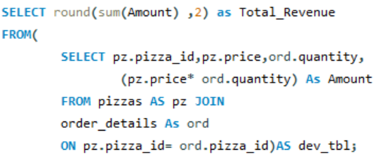
OUTPUT
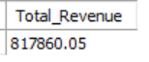
INSIGHTS
- The total revenue generated by Pizza Hut is $817,860.05 .

- Most Expensive Pizzas
QUERY
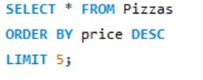
OUTPUT

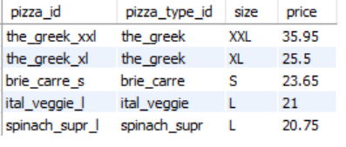

INSIGHTS
- The most expensive pizza is "The Greek XXL," priced at $35.95.
- There is a huge difference between the first and second most expensive pizzas ($10.45).
- Although “Barie Care “is a small size, it is still the third most expensive pizza. Maybe there are some special ingredients used.

- Most Ordered Pizza Size
QUERY
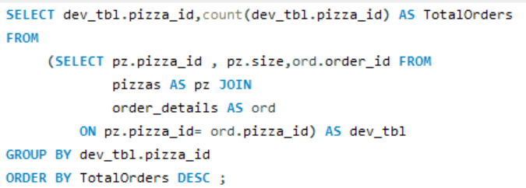
OUTPUT
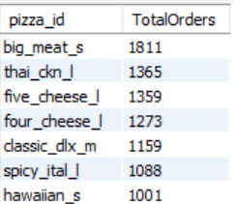
INSIGHTS
- The most ordered pizza is “big_meat_s” with 1811 orders. due to small size the cost of pizza may be cheaper than others.
- Although “thai_ckn_l” and “five_chesse_l” having large size still getting good orders means taste of pizza may be good or due to less ingredients which offer less cost

- Top 5 Popular Pizzas
QUERY
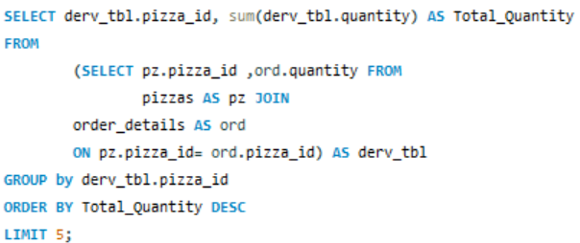
OUTPUT
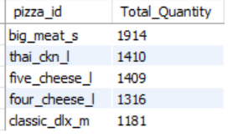
INSIGHT
      - The pizza with the highest quantity is "big_meat_s" with 1,914 .
      - There is no difference in the order-wise sequence between quantities sequence wise for the top 5 pizzas.

- Pizza Orders by Category
QUERY
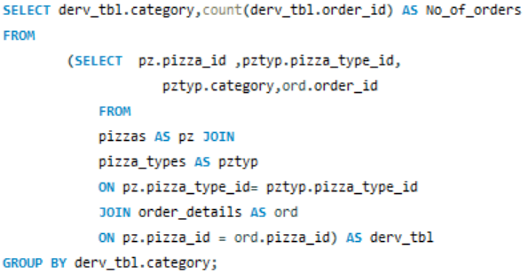
OUTPUT
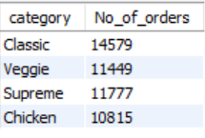
INSIGHTS
    - From Classic category receives Highest no of orders which is 14,579.
    - From this data people prefer veg pizzas when compared to Non-veg pizzas.

- Order Trends by Hour
QUERY
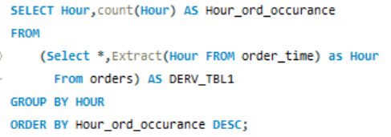
OUTPUT
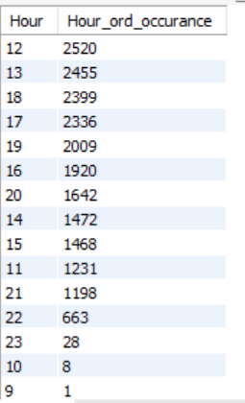
Hourly Trend
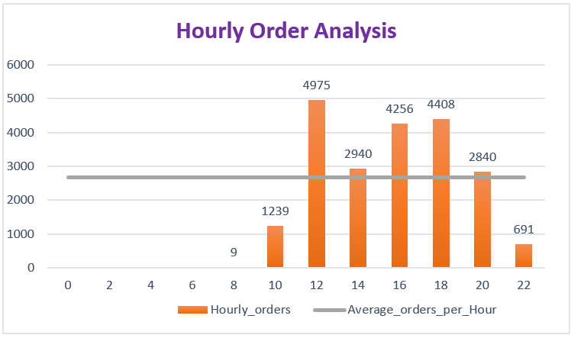
INSIGHTS
- Most orders are placed between 12:00 and 21:00 hours.
- Especially during 12:00 to 13:00 hours, the highest number of orders are placed.
- No orders are placed from midnight until 8:00 in the morning.
- Most orders are placed in the Afternoon (lunch time) and Evening (snack time).
- Pizza Distribution by Category
QUERY
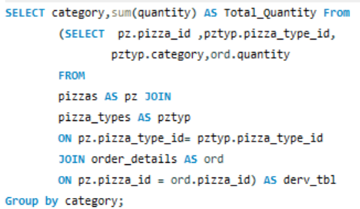
OUTPUT
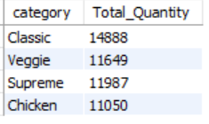
INSIGHTS
- From Classic category receives Highest no of quantity which is 14,888.
- From Chicken category receives Lowest no of quantity which is 11,050.

- Day wise Pizza Quantity
QUERY
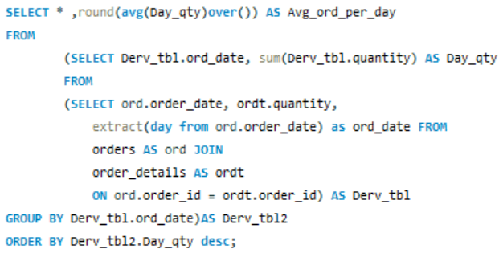
OUTPUT
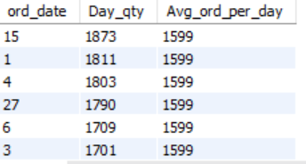
INSIGHTS
- The Average quantity per day is 1,599.
- The Highest number of orders come on the 15th (mid-month).
- A good number of orders are received in the first week.
Due to high spend nature at month starting.

- Top Pizza Types by Revenue
QUERY
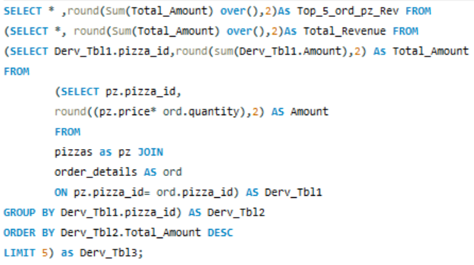
OUTPUT
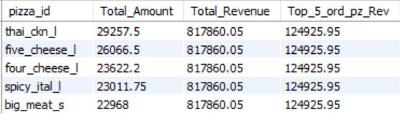
INSIGHTS
- The Major Revenue is generated by ‘thai_ckn_l,’ which amounts to $29,257.50.
- The sum of the top 5 ordered pizza’s revenue is $124,925.95, which is 15% of the total revenue.
- Out of the top 5, Four are large-size pizzas. This could be because they are shared between peoples, or perhaps the small size does not satisfy their needs.

- Revenue Contribution by Pizza Type
QUERY
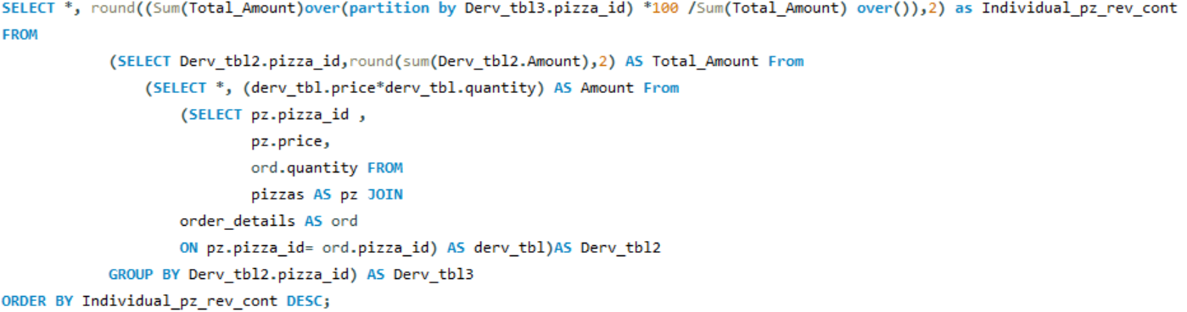
OUTPUT
Top 5 pizzas individual percentages to revenue contribution
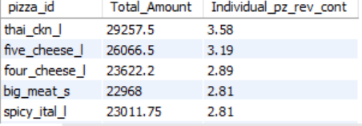
Bottom 5 pizzas individual percentages to revenue contribution
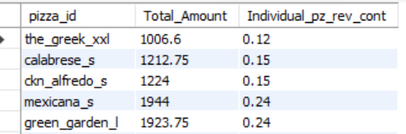
Based on pizza orders how they contribution to Total Revenue
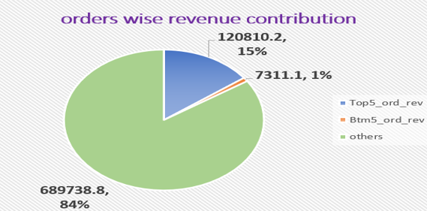
INSIGHTS
- By calculating the individual pizza percentage of revenue growth, the top 5 pizzas contribute 15% to the total revenue.
- The bottom 5 pizzas contribute only 1% to the total revenue.

- Cumulative Revenue Over Time
QUERY
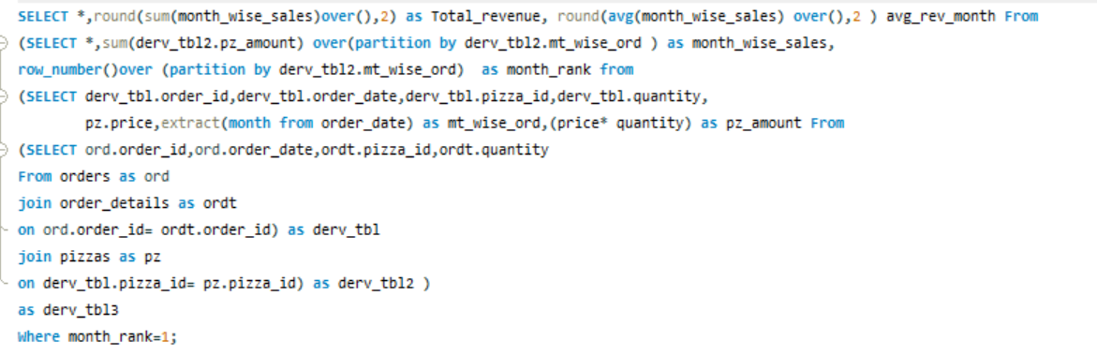
OUTPUT 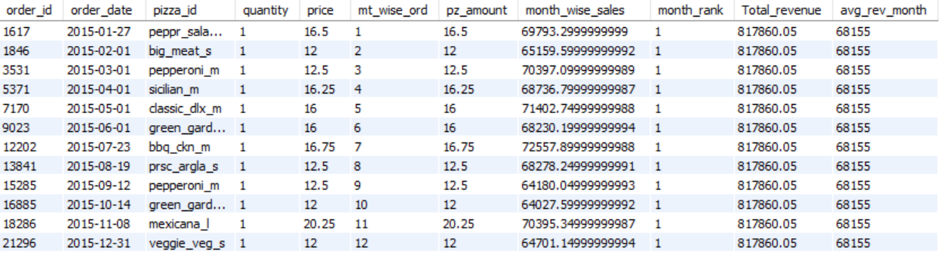

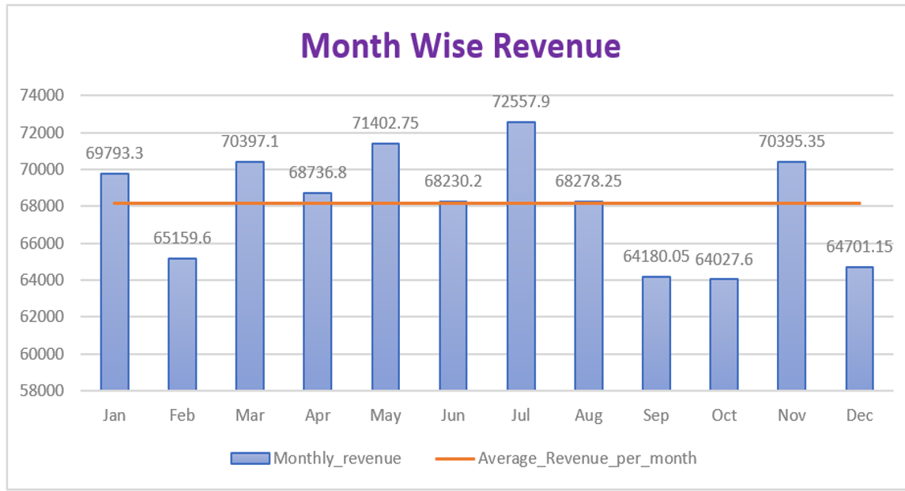

INSIGHTS
- The highest revenue is generated in July and May, likely due to summer vacation and holidays for children.

- The lowest revenue is generated in September and October likely due to the rainy season and more festival vacations.

- The average revenue per month beats by 8 months which is 66.66% it telling business is going in good way.

- Top 3 Pizza Types by Revenue in Each Category
QUERY 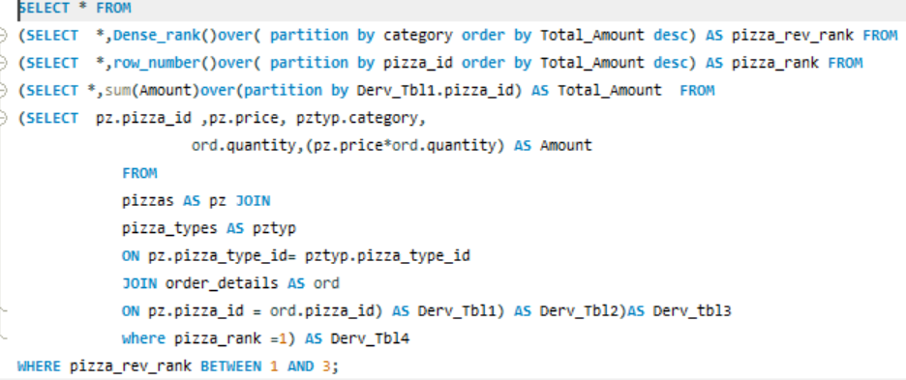
OUTPUT
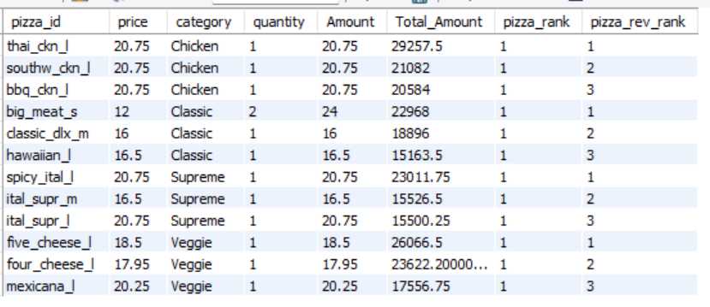

INSIGHTS
- According to order and quantity, the chicken category is at the bottom. However, the top 3 pizzas in the chicken category, with a revenue of $70,923, outperform the top 3 pizzas in other categories.

- The second category is veggie, with a revenue of $67,245.45 from the top 3 pizzas, ranking high in both order and quantity.

- The third category is classic, with a revenue of $57,027.50 from the top 3 pizzas. This category ranks at the top in both order and quantity.

- The category with the least contribution from the top 3 pizzas is supreme, with a revenue of $54,038.

- Calculate the repetitive orders in terms of percentage
QUERY
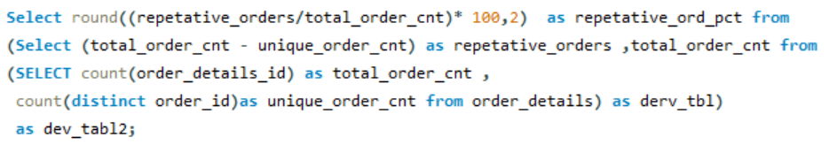
OUTPUT
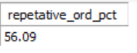
INSIGHTS
There is 56.09% repetitive orders from customers which is good sign for serving tasty food.

Recommendations:-
- At least 5 pizzas contribute only 1% to total revenue, so the ingredients need to be changed to improve the taste. If that still fails, it is better to remove them from the menu.
- Most orders come in the afternoon and evening, so more staff are required during these times. After the 21st hour, orders decrease, and we can manage with fewer staff.
- Instead of selling pizzas individually, create combo packs with the highest-ordered pizzas and the lowest-ordered pizzas at a reasonable price.
- In the chicken category, the top 3 ordered pizzas contribute significantly to total revenue. However, the overall quantity-wise performance is poor, so we need to identify the issue.
- During low-demand times (such as festival seasons and month-end), offer discounts on pizzas
Offers:-
- Offering a referral bonus can help attract new customers.
- If a customer spends $1000, providing a 20%-25% discount on their next order will encourage increased spending behaviour.
- For regular customers, provide excellent service and small discounts to support them during low-demand periods.
- During festival times, conduct a lucky draw to help boost sales during low-demand periods.

