**3.1.5. Requisitos funcionales y no funcionales**

1. **Functionals requeriments**

* **MÓDULO SISTEMA**

|  |  |
| --- | --- |
| **REQUERIMENT** | RF1 Add new customers |
| **FUNCIONALITY** | The system will allow adding new customers. |
| **SPECIFICATION** | A new client entering the sports center will be attended by an advisor and subsequently enrolled and will be able to access the benefits of the establishment. |

|  |  |
| --- | --- |
| **REQUERIMENT** | RF2 Save customers |
| **FUNCIONALITY** | The system will save datas of customers at the moment when they pay for a membresy |
| **SPECIFICATION** | All customer data enrolled in the sports center will be stored in a table |

|  |  |
| --- | --- |
| **REQUERIMENT** | RF3 Register assistance to customers |
| **FUNCIONALITY** | The system will allow you to register customer assistance every day |
| **SPECIFICATION** | A customer already enrolled upon entering the sports center will be registered in the system controlled by a sales consultant |

|  |  |
| --- | --- |
| **REQUERIMENT** | RF4 Modify customers data |
| **FUNCIONALITY** | The system will allow you to modify customers datas opening a new window where to do it. |
| **SPECIFICATION** | System will be able to modify customers datas at the moment when they request a change about their datas. |

|  |  |
| --- | --- |
| **REQUERIMENT** | RF5 Delete customers data |
| **FUNCIONALITY** | The system will allow you to delete customers from table |
| **SPECIFICATION** | System will be able to delete customers |

|  |  |
| --- | --- |
| **REQUERIMENT** | RF6 Send welcome messages to customers |
| **FUNCIONALITY** | The system will allow the sending of messages by whatsapp to the clients. |
| **SPECIFICATION** | At the time of registration, the client will automatically send a welcome message |

|  |  |
| --- | --- |
| **REQUERIMENT** | RF7 Send messages to absent customers |
| **FUNCIONALITY** | .the system will allow send messages to absent customers by whatsapp |
| **SPECIFICATION** | The system will send notification messages to registered customers who do not attend the sports center. |

|  |  |
| --- | --- |
| **REQUERIMENT** | RF8 Send birthday greeting messages |
| **FUNCIONALITY** | The system will allow the sending of birthday greeting messages to the client by whatsapp |
| **SPECIFICATION** | The system will send congratulatory messages to each client for their birthday. |

|  |  |
| --- | --- |
| **REQUERIMENT** | RF9  Send promotions messages to customers. |
| **FUNCIONALITY** | The system will allow the sending of promotional messages by whatsapp to customers |
| **SPECIFICATION** | The system will send promotional messages to its registered customers from time to time. |

|  |  |
| --- | --- |
| **REQUERIMENT** | RF10 Log-in users |
| **FUNCIONALITY** | The system will allow user access through the log-in panel |
| **SPECIFICATION** | Users, when entering the system, will have to enter with their ID and password |

|  |  |
| --- | --- |
| **REQUERIMENT** | RF11 Create users |
| **FUNCIONALITY** | **FUNCIONALITY** |
| **SPECIFICATION** | The system will allow the administrator to add new users to the system |

|  |  |
| --- | --- |
| **REQUERIMENT** | RF12 Delete users |
| **FUNCIONALITY** | The system will allow to delete users from the database |
| **SPECIFICATION** | The system will allow you to delete users created by mistake |

|  |  |
| --- | --- |
| **REQUERIMENT** | RF13 Modify users |
| **FUNCIONALITY** | The system will allow to modify users |
| **SPECIFICATION** | The system will allow to modify the ID and password of the users |

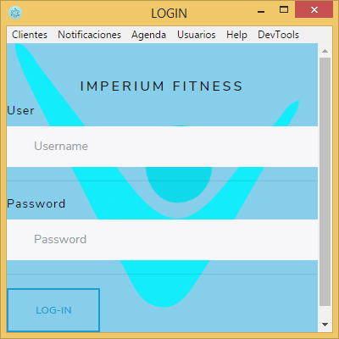

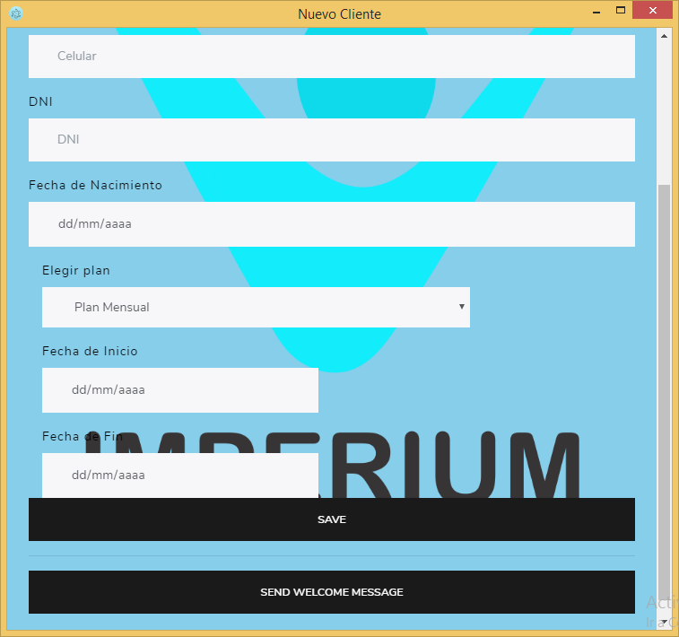

**In this part at the moment when you choose a membrecy ( 1 year , 6 months ) and you choose the start day in “fecha de inicio” automatically depending of the membrecy(1 year , 6 months ) in “fecha de fin “ it must show the end date correctly.  
If i want to edit membrecy to “ one week or two weeks “ or another times i want an option to create that and apply to the combobox**

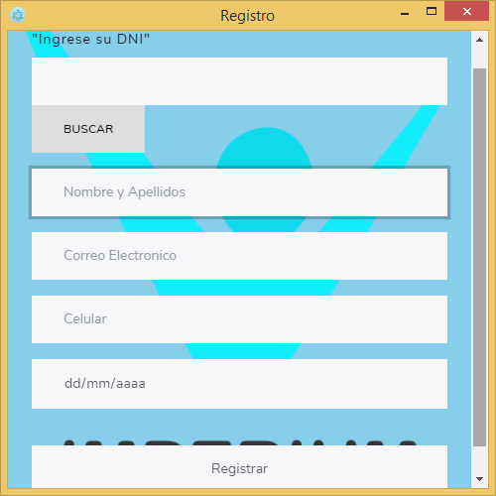

**When you look for a client by DNI (code) datas of clients must be shown in blanks**

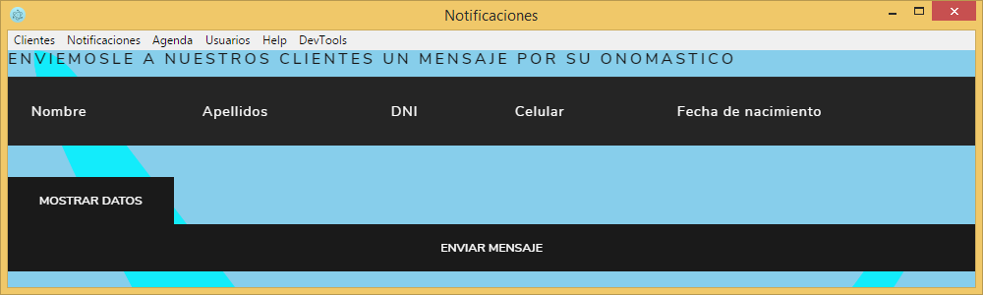

**In this part i need to send messages by whatsapp to clients by their birthday**

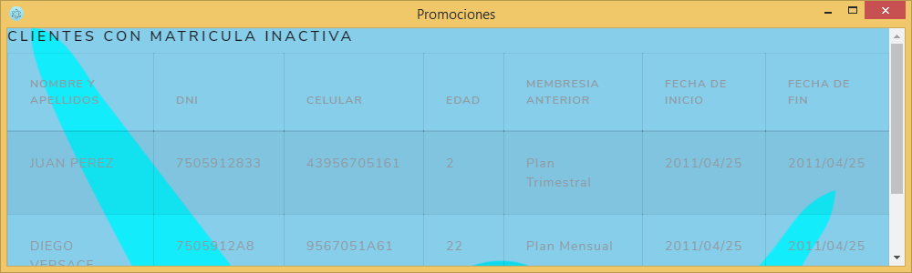

I need to send promotional messages by whatsapp to clients and i need to chose what promotional messages im gonna send

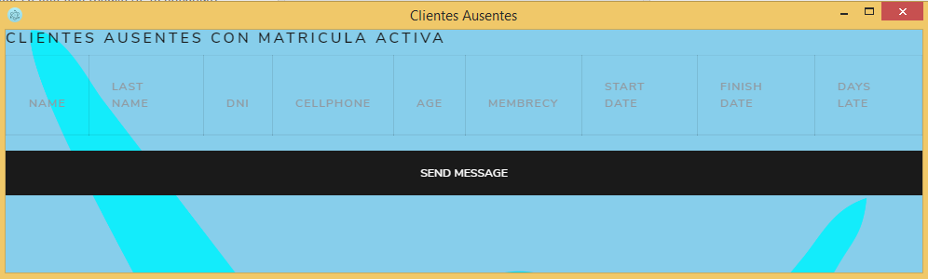 at the moment when you register a client , it must be shown in this table only clients who dont go to the sport center by at least 7 days , and it must be notified by the app that you have a lot of clients who dont go to the sport center even though they bought their membrecy , and i need to send a message to that client by whatsapp

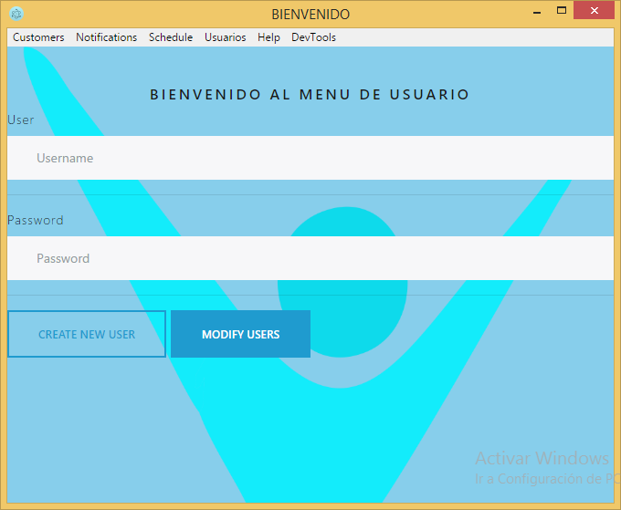

**At the moment when i push “modify users” a new Windows should open where it shows the reports of created users with an option to delete .**

**In this part i need to create a CRUD to each client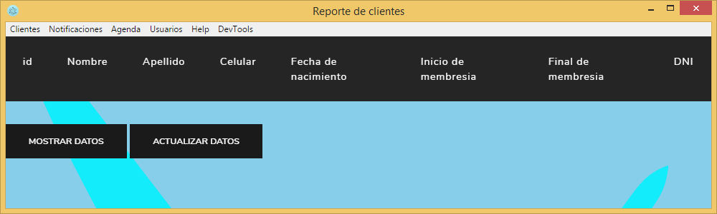 , at the moment when you push Modify , a new window must be created to edit data clients.**

