SUPERMARKET SALES ANALYSIS
Data Analytics Project – Python
Project Report
Prepared for academic submission

1. Introduction
This project analyzes supermarket sales data and converts transaction-level records into useful business insights. The analysis focuses on products, branches, categories, customers, payment methods, sales performance, and customer ratings.

2. Problem Statement
The supermarket needs a systematic way to understand sales performance from its transaction data. Python-based data analysis is used to identify high-performing products and branches, popular categories and payment methods, customer spending patterns, and overall customer satisfaction.

3. Dataset Description
The supplied dataset contains 500 sales transactions. Fields include Invoice ID, Date, Branch, City, Customer Type, Gender, Product, Category, Quantity, Unit Price, Payment, Rating, and Sales.
Field | Description
Invoice ID | Unique transaction identifier
Date | Transaction date
Branch / City | Store branch and city
Customer Type | Member or Normal
Gender | Customer gender
Product / Category | Item and product category
Quantity | Units purchased
Unit Price | Price per unit
Payment | Payment method
Rating | Customer rating out of 5
Sales | Transaction sales value

4. Technologies Used
- Python 3
- Pandas
- Matplotlib
- pdfplumber
- Jupyter Notebook

5. Methodology
- Load the supplied PDF dataset.
- Extract transaction records into a Pandas DataFrame.
- Check missing values and duplicate invoice IDs.
- Validate Sales = Quantity × Unit Price.
- Group and summarize sales by product, branch, category, payment method, customer type, and month.
- Create charts for comparison.
- Interpret results and provide business recommendations.

6. Data Cleaning and Validation
The extracted dataset contains 500 transactions. The dataset has 0 missing values after extraction. The sales formula check passed for 500 of 500 transactions.

7. Exploratory Data Analysis

7.1 Product Sales
Cheese generated the highest total sales at ₹27,906.30.
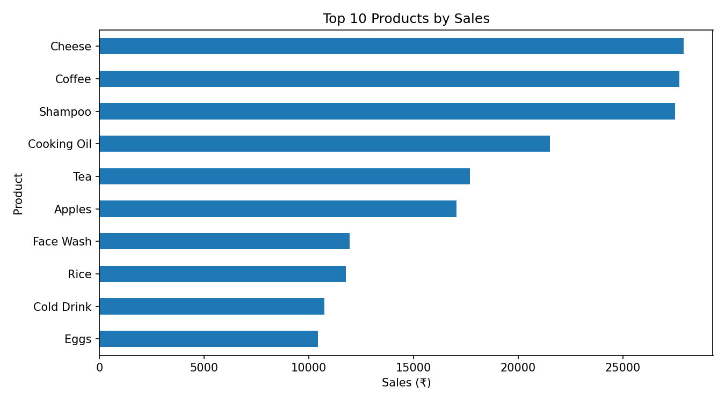

7.2 Branch Performance
Branch C (Mumbai) recorded the highest sales at ₹72,469.45.
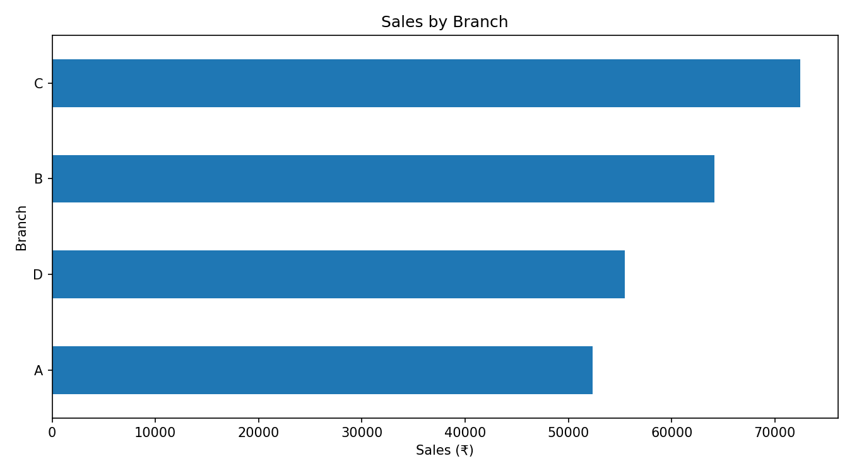

7.3 Category Performance
Beverages was the highest-sales category, with ₹56,108.24.
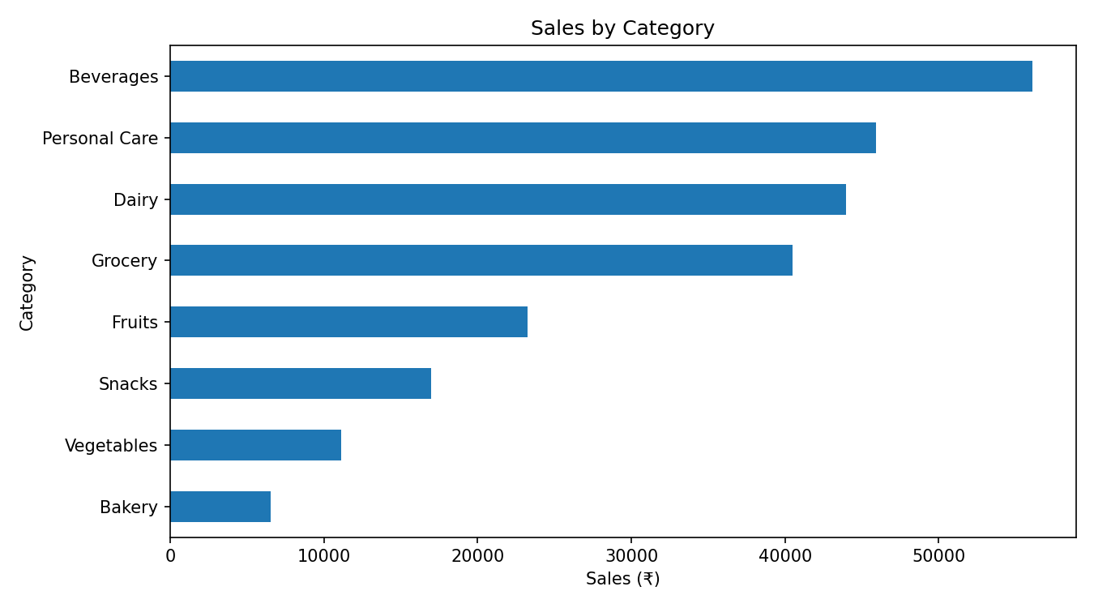

7.4 Payment Methods
UPI was the most-used payment method with 127 transactions.
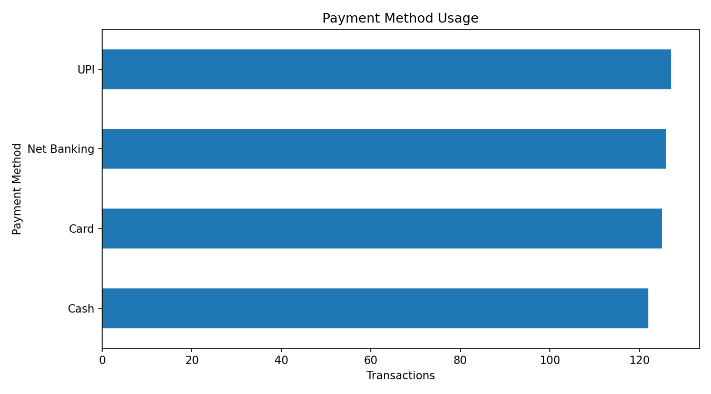

7.5 Customer Type
Member customers averaged ₹483.14 per transaction, while Normal customers averaged ₹497.07. In this dataset, Normal customers had the higher average transaction value.

7.6 Customer Ratings
The average customer rating was 3.99 out of 5.

7.7 Monthly Sales Trend
Monthly sales were grouped by transaction month to observe the sales trend over the available period.
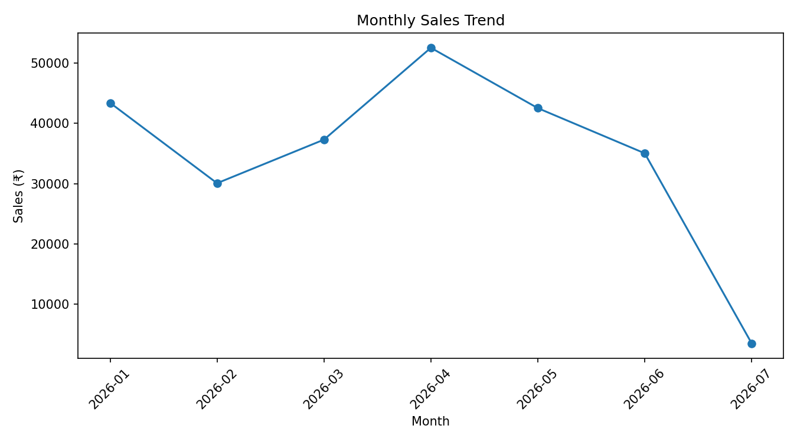

8. Key Findings
- Total sales were ₹244,411.08 across 500 transactions.
- Cheese was the highest-sales product at ₹27,906.30.
- Branch C (Mumbai) was the best-performing branch at ₹72,469.45.
- Beverages was the highest-sales category at ₹56,108.24.
- UPI was the most-used payment method with 127 transactions.
- Normal customers had a higher average transaction value than Members in this dataset.
- The average customer rating was 3.99/5.

9. Business Recommendations
- Maintain sufficient stock for high-selling products and categories.
- Study the practices, product mix, and customer patterns that contribute to Branch C's strong performance.
- Continue supporting UPI payments because it is the most-used payment method.
- Use customer feedback and rating information to improve service quality.
- Compare Member and Normal customer spending when designing membership offers and promotions.

10. Conclusion
This project demonstrates how supermarket transaction data can be transformed into practical business insights using Python. The analysis identifies sales leaders, branch performance, category demand, payment preferences, customer spending patterns, and customer satisfaction. These insights can support inventory planning, branch management, payment support, customer service improvement, and membership strategy.

11. How to Run the Project
Install dependencies with: pip install -r requirements.txt
Start Jupyter with: jupyter notebook
Open the notebook and run all cells from top to bottom.

