Source: <http://education.yahoo.net/articles/six_high-earning_careers.htm>

**Six High-Paying Jobs On The Rise**



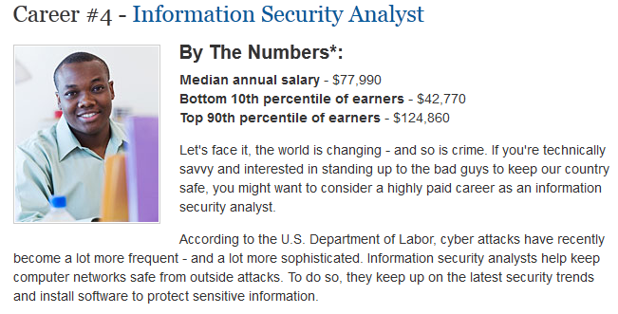

Source: <http://www.cioinsight.com/c/a/Salaries/The-30-Top-Paying-Jobs-in-IT/2/>

# Top 30 IT Jobs

No one is surprised that CIOs are the highest paid IT professionals, with a projected average annual salary of between $126,750 and $210,000 in 2008. But, 30 other IT titles also are projected to have average annual salaries that will top $100,000 next year, according to the just-released [Robert Half Technology 2008 Salary Guide](http://www.roberthalftechnology.com/portal/site/rht-us/menuitem.e4ac4ca54cc4ad003ebda20c02f3dfa0/?vgnextoid=9f2d9926053d8010VgnVCM1000002d3ffd0aRCRD&javax.portlet.prp_b77bfef02f9ec86408b03d1002f3dfa0_dmreq=true&javax.portlet.prp_b77bfef02f9ec86408b03d1002f3dfa0_DMID=rhtC00104&javax.portlet.prp_b77bfef02f9ec86408b03d1002f3dfa0_MATID=2008+Salary+Guide%20target=_blank%3E).

Here are the 30 IT job titles with high-range average salaries topping $100,000 in 2008, according to Robert Half Technology:

1. Applications Architect
2. Applications Development Manager
3. Applications Development Project Manager
4. Business Continuity Analyst
5. Business Intelligence Analyst
6. Chief Information Officer
7. Chief Security Officer
8. Chief Technology Officer
9. Consulting and Systems Integration Director
10. Consulting and Systems Integration Practice Manager
11. Consulting and Systems Integration Project Manager/Senior
12. Consultant
13. Data Architect
14. Data Modeler
15. Data Security Analyst
16. Data Warehouse Analyst
17. Data Warehouse Manager
18. Database Administrator
19. Database Developer
20. Database Manager
21. Information Technology Manager
22. IT Auditor
23. Lead Applications Developer
24. Network Architect
25. Network Security Administrator
26. Senior IT Auditor
27. Senior Web Developer
28. Software Development Project Manager
29. Software Engineer
30. Systems Security Administrator
31. Vice President/Information Technology

Source: <http://www.cio.com/article/699113/IT_Salaries_Growth_Reflects_Positive_Changes_in_the_IT_Job_Market>

# IT Salaries: Growth Reflects Positive Changes in the IT Job Market

Software developers, information security analysts, network architects and business intelligence analysts are among the IT professionals experiencing the most significant salary growth in 2012, according to a new report from IT staffing firm Bluewolf.

### IT Job Titles with the Most Salary Growth

17 IT job titles that are commanding some of the highest salaries and seeing "significant" growth in the 6+ percent range. These salaries are averages CIO.com took across the six major metro markets Bluewolf tracks.

|  |  |
| --- | --- |
| **Job Title** | **Salary Range** |
| Network Architect | $122,666 - $143,500 |
| Information Security Analyst | $107,000 - $142,000 |
| Mobile Developer | $110,333 - $125,333 |
| Front End Developer (3 - 5 years' experience) | $87,500 - $112,000 |
| Front End Developer (7 - 10 years' experience) | $108,000 - $133,500 |
| HTML5 Developer | $82,833 - $118,500 |
| Android Developer | $113,666 - $139,333 |
| iPhone/iPad Developer | $98,000 - $134,333 |
| Software Developers (3 - 5 years' experience) | $71,833 - $92,166 |
| Software Engineer | $117,500 - $153,666 |
| Software Architect (10 years' experience) | $134,166 - $158,500 |
| JAVA/J2EE Developer | $81,833 - $153,666 |
| Ruby on Rails Developer | $87,000 - $122,666 |
| .NET Developer | $92,166 - $138,333 |
| UI/UX Designers (5+ years' experience) | $82,166 - $102,833 |
| Business Intelligence Analyst | $91,833 - $121,500 |
| Data Architect | $97,000 - $124,000 |
| Cognos Analyst | $97,000 - $117,500 |
| SQL Database Administrator | $89,666 - $127,500 |

SOURCE: Bluewolf

Source: <http://investor.google.com/financial/tables.html>

# Google 2013 Financial Tables

