assignment 4.3

varatharajan

June 11, 2018

library(readxl)  
usarrests <- read_excel("C:/R_practice/usarrests.xls")  
View(usarrests)  
states<-rownames(USArrests)  
print(states)  
grep(pattern = "W", x = states, value = TRUE)  
grep(pattern = "w", x = states, value = TRUE)  
hist(nchar(states), main = "Histogram", xlab = "number of characters in US State names")

[1] "Alabama" "Alaska" "Arizona" "Arkansas"

[5] "California" "Colorado" "Connecticut" "Delaware"

[9] "Florida" "Georgia" "Hawaii" "Idaho"

[13] "Illinois" "Indiana" "Iowa" "Kansas"

[17] "Kentucky" "Louisiana" "Maine" "Maryland"

[21] "Massachusetts" "Michigan" "Minnesota" "Mississippi"

[25] "Missouri" "Montana" "Nebraska" "Nevada"

[29] "New Hampshire" "New Jersey" "New Mexico" "New York"

[33] "North Carolina" "North Dakota" "Ohio" "Oklahoma"

[37] "Oregon" "Pennsylvania" "Rhode Island" "South Carolina"

[41] "South Dakota" "Tennessee" "Texas" "Utah"

[45] "Vermont" "Virginia" "Washington" "West Virginia"

[49] "Wisconsin" "Wyoming"

[1] "Washington" "West Virginia" "Wisconsin" "Wyoming"

[1] "Delaware" "Hawaii" "Iowa" "New Hampshire"

[5] "New Jersey" "New Mexico" "New York"

R Console

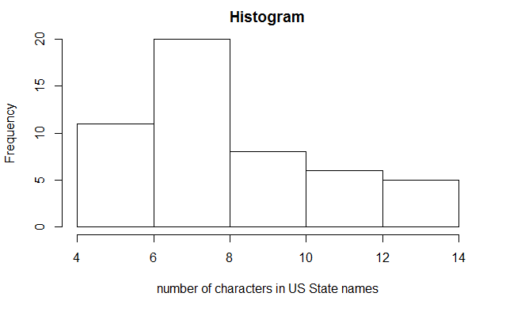

{r setup, include=FALSE} knitr::opts_chunk$set(echo = TRUE)

## R Markdown

This is an R Markdown document. Markdown is a simple formatting syntax for authoring HTML, PDF, and MS Word documents. For more details on using R Markdown see <http://rmarkdown.rstudio.com>.

When you click the **Knit** button a document will be generated that includes both content as well as the output of any embedded R code chunks within the document. You can embed an R code chunk like this:

{r cars} summary(cars)

## Including Plots

You can also embed plots, for example:

{r pressure, echo=FALSE} plot(pressure)

Note that the echo = FALSE parameter was added to the code chunk to prevent printing of the R code that generated the plot.