USA states vowels

S.Varatharajan

June 7, 2018

states<-c("alabama","alaska","arizona","arkansas","california","colorado","connecticut","delaware","florida","georgia","hawaii","idaho","illinois","indiana","iowa","kentucky","louisiana","maine","maryland","massachusetts","michigan","minnesota","mississippi","montana","nebraska","nevada","new hampshire","new jersey","new mexico","new york","north carolina","north dakota","ohio","oklahoma","oregon","pennsylvania","rhode island","south carolina","south dakota","tennessee","texas","utah","vermont","virginia","washington","west virginia","winsconsin","wyoming")  
library(stringi)  
library(stringr)  
str_count(states,"a")

## [1] 4 3 2 3 2 1 0 2 1 1 2 1 0 2 1 0 2 1 2 2 1 1 0 2 2 2 1 0 0 0 2 2 0 2 0  
## [36] 2 1 2 2 0 1 1 0 1 1 1 0 0

str_count(states,"e")

## [1] 0 0 0 0 0 0 1 2 0 1 0 0 0 0 0 1 0 1 0 1 0 1 0 0 1 1 2 3 2 1 0 0 0 0 1  
## [36] 1 1 0 0 4 1 0 1 0 0 1 0 0

str_count(states,"i")

## [1] 0 0 1 0 2 0 1 0 1 1 2 1 3 2 1 0 2 1 0 0 2 1 4 0 0 0 1 0 1 0 1 0 1 0 0  
## [36] 1 1 1 0 0 0 0 0 3 1 3 2 1

str_count(states,"o")

## [1] 0 0 1 0 1 3 1 0 1 1 0 1 1 0 1 0 1 0 0 0 0 1 0 1 0 0 0 0 1 1 2 2 2 2 2  
## [36] 0 1 2 2 0 0 0 1 0 1 0 1 1

str_count(states,"u")

## [1] 0 0 0 0 0 0 1 0 0 0 0 0 0 0 0 1 1 0 0 1 0 0 0 0 0 0 0 0 0 0 0 0 0 0 0  
## [36] 0 0 1 1 0 0 1 0 0 0 0 0 0

vowela<-str_count(states,"a")  
vowele<-str_count(states,"e")  
voweli<-str_count(states,"i")  
vowelo<-str_count(states,"o")  
vowelu<-str_count(states,"u")  
sum(vowela,vowele,voweli,vowelo,vowelu)

## [1] 171

sum(vowela)

## [1] 59

sum(vowele)

## [1] 28

sum(voweli)

## [1] 42

sum(vowelo)

## [1] 35

sum(vowelu)

## [1] 7

vowela<-str_count(states,“a”) vowele.

## Including Plots

You can also embed plots, for example:

Note that the echo = FALSE parameter was added to the code chunk to prevent printing of the R code that generated the plot.

# USA states vowels

#### S.Varatharajan

#### June 7, 2018

states<-c("alabama","alaska","arizona","arkansas","california","colorado","connecticut","delaware","florida","georgia","hawaii","idaho","illinois","indiana","iowa","kentucky","louisiana","maine","maryland","massachusetts","michigan","minnesota","mississippi","montana","nebraska","nevada","new hampshire","new jersey","new mexico","new york","north carolina","north dakota","ohio","oklahoma","oregon","pennsylvania","rhode island","south carolina","south dakota","tennessee","texas","utah","vermont","virginia","washington","west virginia","winsconsin","wyoming")

**library**(stringi)

**library**(stringr)

str_count(states,"a")

## [1] 4 3 2 3 2 1 0 2 1 1 2 1 0 2 1 0 2 1 2 2 1 1 0 2 2 2 1 0 0 0 2 2 0 2 0

## [36] 2 1 2 2 0 1 1 0 1 1 1 0 0

str_count(states,"e")

## [1] 0 0 0 0 0 0 1 2 0 1 0 0 0 0 0 1 0 1 0 1 0 1 0 0 1 1 2 3 2 1 0 0 0 0 1

## [36] 1 1 0 0 4 1 0 1 0 0 1 0 0

str_count(states,"i")

## [1] 0 0 1 0 2 0 1 0 1 1 2 1 3 2 1 0 2 1 0 0 2 1 4 0 0 0 1 0 1 0 1 0 1 0 0

## [36] 1 1 1 0 0 0 0 0 3 1 3 2 1

str_count(states,"o")

## [1] 0 0 1 0 1 3 1 0 1 1 0 1 1 0 1 0 1 0 0 0 0 1 0 1 0 0 0 0 1 1 2 2 2 2 2

## [36] 0 1 2 2 0 0 0 1 0 1 0 1 1

str_count(states,"u")

## [1] 0 0 0 0 0 0 1 0 0 0 0 0 0 0 0 1 1 0 0 1 0 0 0 0 0 0 0 0 0 0 0 0 0 0 0

## [36] 0 0 1 1 0 0 1 0 0 0 0 0 0

vowela<-str_count(states,"a")

vowele<-str_count(states,"e")

voweli<-str_count(states,"i")

vowelo<-str_count(states,"o")

vowelu<-str_count(states,"u")

sum(vowela,vowele,voweli,vowelo,vowelu)

## [1] 171

sum(vowela)

## [1] 59

sum(vowele)

## [1] 28

sum(voweli)

## [1] 42

sum(vowelo)

## [1] 35

sum(vowelu)

## [1] 7

vowela<-str_count(states,“a”) vowele

barplot(part,col="red")

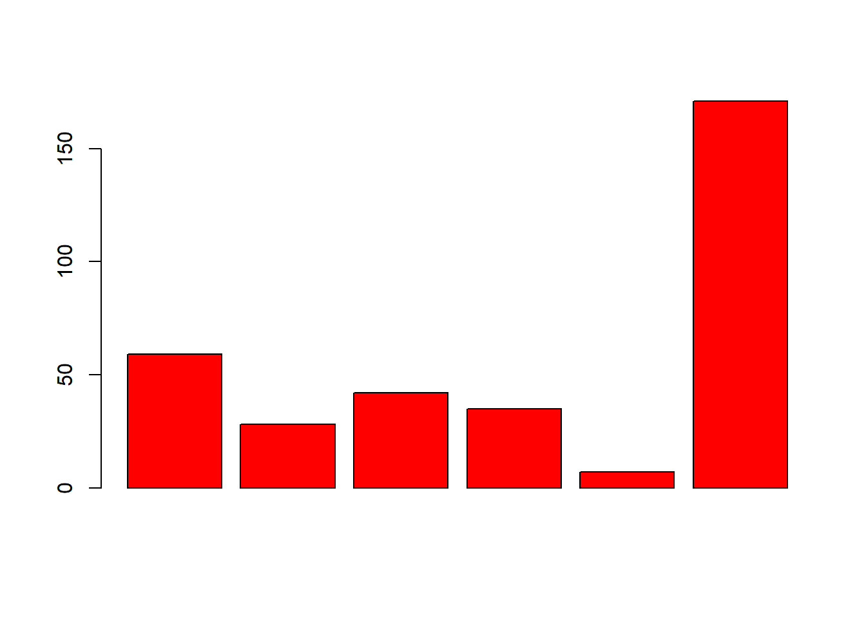pie(part)

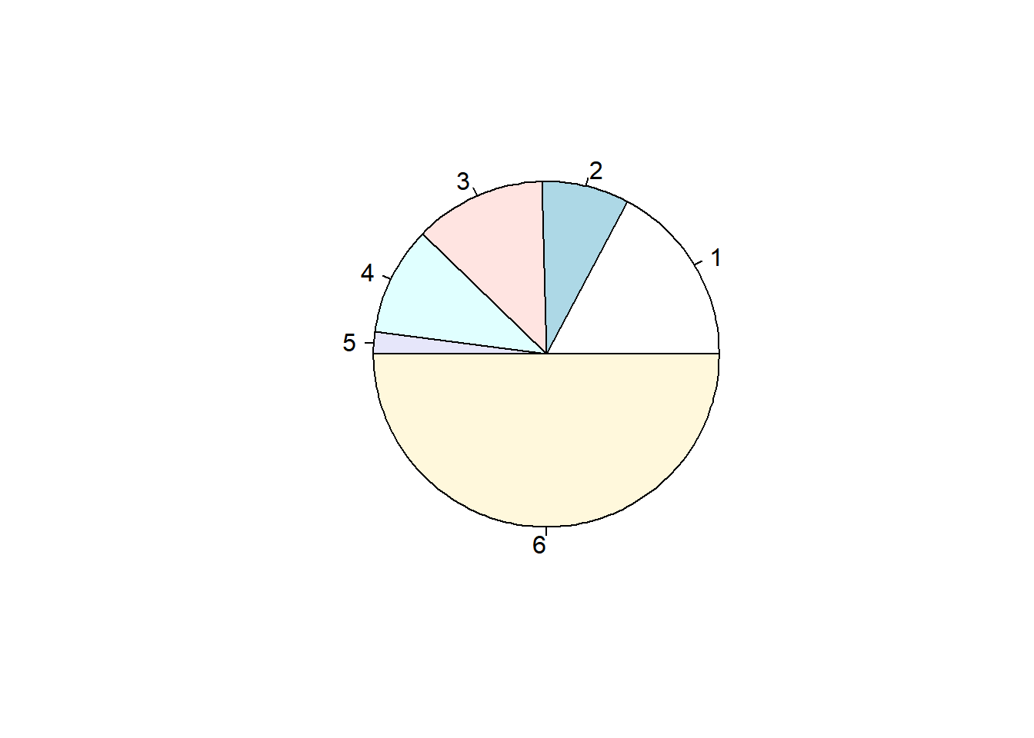```

## R Markdown

This is an R Markdown document. Markdown is a simple formatting syntax for authoring HTML, PDF, and MS Word documents. For more details on using R Markdown see [http://rmarkdown.rstudio.com](http://rmarkdown.rstudio.com/).

When you click the **Knit** button a document will be generated that includes both content as well as the output of any embedded R code chunks within the document. You can embed an R code chunk like this:

summary(cars)

## speed dist

## Min. : 4.0 Min. : 2.00

## 1st Qu.:12.0 1st Qu.: 26.00

## Median :15.0 Median : 36.00

## Mean :15.4 Mean : 42.98

## 3rd Qu.:19.0 3rd Qu.: 56.00

## Max. :25.0 Max. :120.00

## Including Plots

You can also embed plots, for example:

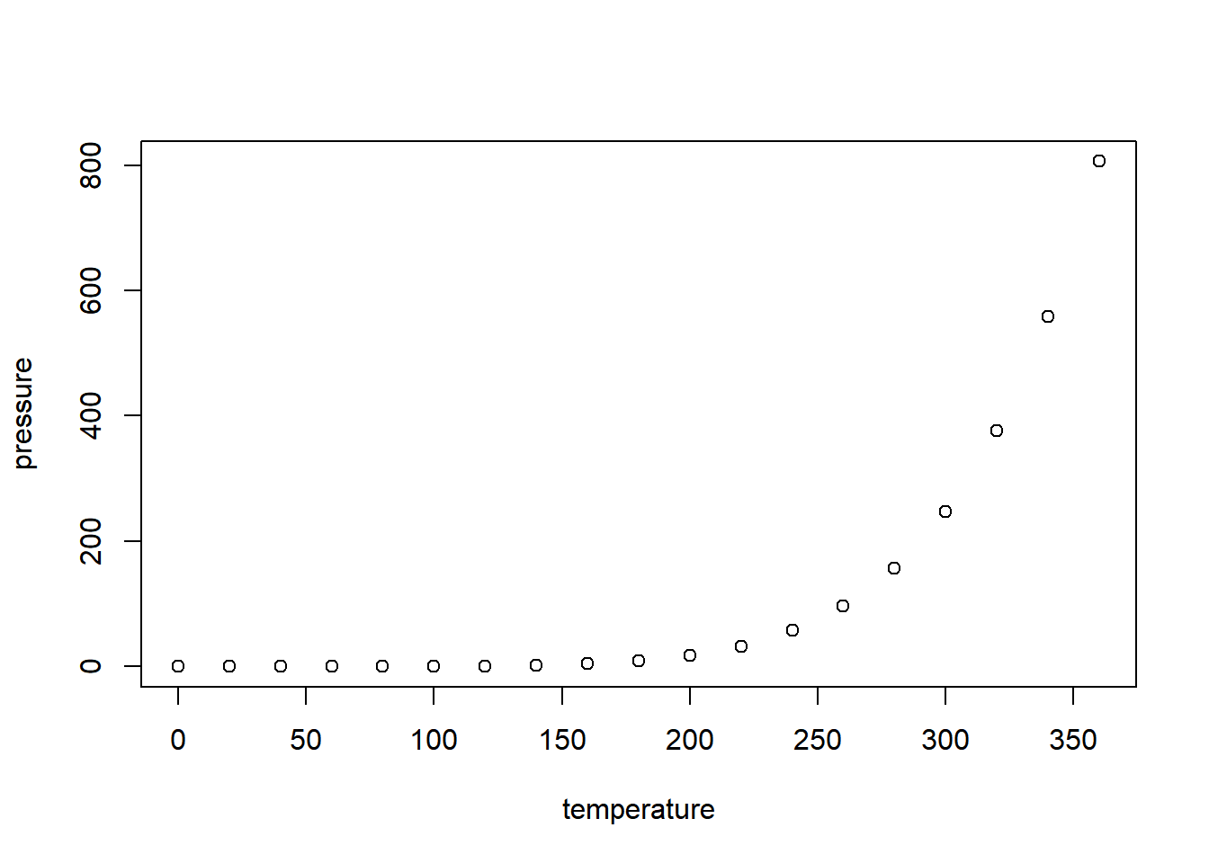Note that the echo = FALSE parameter was added to the code chunk to prevent printing of the R code that generated the plot.