& next

(Box plot & Whiskers) as separate markdown

varatharajan

June 14, 2018

1. Create a box and whisker plot by class using mtcars dataset.

summary(cars)  
boxplot(mtcars$mpg)  
boxplot(mtcars$mpg, horizontal = TRUE)  
boxplot(mtcars$mpg, col = 'blue')  
boxplot(mtcars$mpg, border = 'red')  
boxplot(mtcars$mpg, range = 0)  
boxplot(mtcars$mpg, range = 1)  
boxplot(mtcars$mpg, range = 1, outline = FALSE)  
boxplot(mtcars$mpg ~ mtcars$cyl)  
mpg_split <- split(mtcars$mpg, mtcars$cyl)  
mpg_split  
mpg_4 <- mpg_split$`4`  
mpg_6 <- mpg_split$`6`  
mpg_8 <- mpg_split$`8`  
boxplot(mpg_4, mpg_6, mpg_8)  
boxplot(mtcars$mpg ~ mtcars$cyl, col = 'blue')  
boxplot(mtcars$mpg ~ mtcars$cyl,col = c('red', 'blue', 'yellow'))  
boxplot(mtcars$mpg ~ mtcars$cyl, range = 1, outline = TRUE,horizontal = TRUE, col = c('red', 'blue', 'yellow'), main = 'Miles Per Gallon by Cylinders',ylab = 'Number of Cylinders', xlab = 'Miles Per Gallon',names = c('Four', 'Six', 'Eight'))

{r setup, include=FALSE} knitr::opts_chunk$set(echo = TRUE)

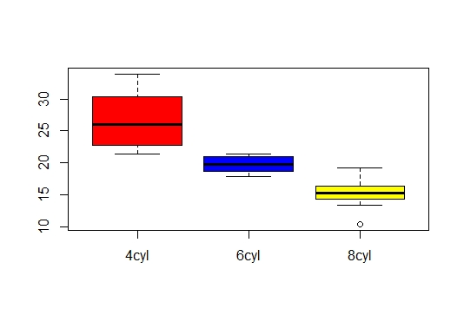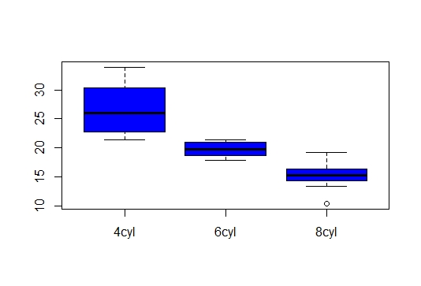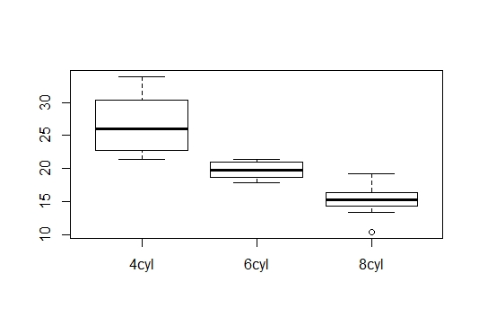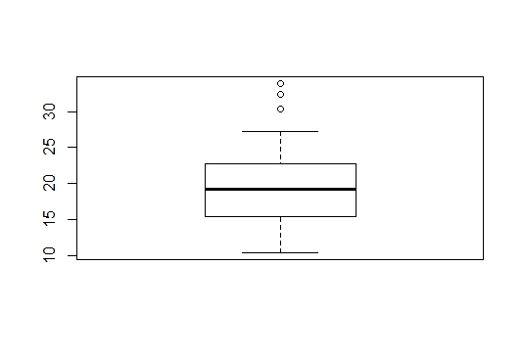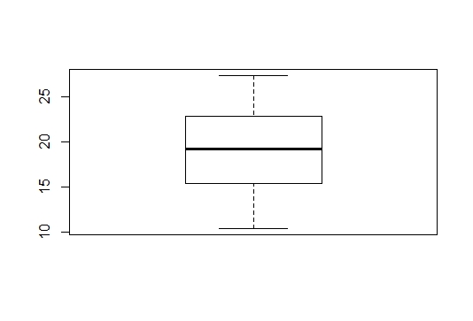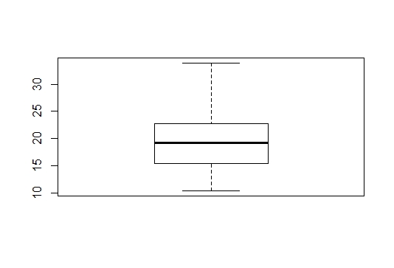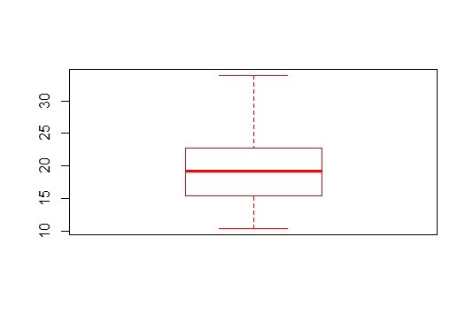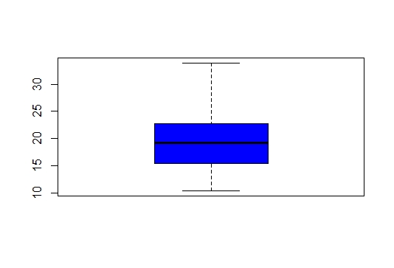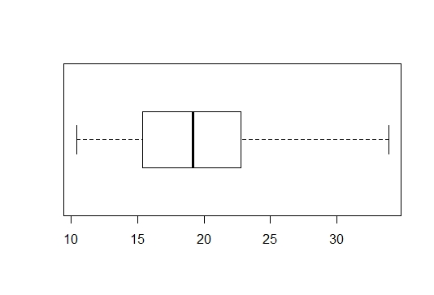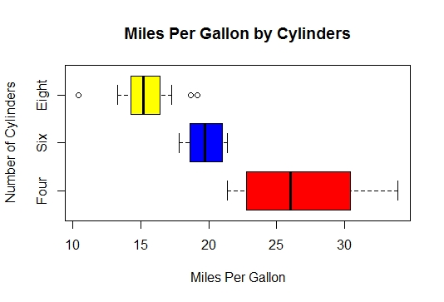

session7 assignment3

(Box plot & Whiskers)

varatharajan

June 14, 2018

library(ggplot2)  
library(xtable)  
head(mtcars)  
mtcars$cyl <- factor(mtcars$cyl)  
mtcars$labels <- row.names(mtcars)  
summary(mtcars)  
library(gridExtra)  
library(ggplot2)  
library(ggthemes)  
library(tufte)  
p <- ggplot(data = mtcars, aes(x = cyl, y = mpg, fill = cyl))

p <- p + geom_boxplot() +ggtitle("Car Milage Data") +labs(x = "Number of Cylinders", y = "Miles Per Gallon") +scale_fill_discrete(name = "Cylinders")

p

p <- ggplot(mtcars, aes(x = wt, y = mpg)) +geom_point() +ggtitle("Cars")  
p2 <- ggplot(mtcars, aes(x = wt, y = mpg, colour = factor(gear))) +geom_point() +ggtitle("Cars")

p3 <- p2 + facet_wrap(~ am)p + geom_rangeframe() +theme_tufte() + scale_x_continuous(breaks = extended_range_breaks()(mtcars$wt)) +scale_y_continuous(breaks = extended_range_breaks()(mtcars$mpg))

p4 <- ggplot(mtcars, aes(factor(cyl), mpg))p4 + theme_tufte(ticks=FALSE) + geom_tufteboxplot()p4 + theme_tufte(ticks=FALSE) +geom_tufteboxplot(median.type = "line")p4 + theme_tufte(ticks=FALSE) +geom_tufteboxplot(median.type = "line", whisker.type = 'point', hoffset = 0)p4 + theme_tufte(ticks=FALSE) +geom_tufteboxplot(median.type = "line", whisker.type = 'line', hoffset = 0, width = 3)

{r setup, include=FALSE} knitr::opts_chunk$set(echo = TRUE)

| **mpg**  <dbl> | **cyl**  <fctr> | **disp**  <dbl> | **hp**  <dbl> | **drat**  <dbl> | **wt**  <dbl> | **qsec**  <dbl> | **vs**  <dbl> | **am**  <fctr> |  |
| --- | --- | --- | --- | --- | --- | --- | --- | --- | --- |
| Mazda RX4 | 21.0 | 6cyl | 160 | 110 | 3.90 | 2.620 | 16.46 | 0 | Manual |  |
| Mazda RX4 Wag | 21.0 | 6cyl | 160 | 110 | 3.90 | 2.875 | 17.02 | 0 | Manual |  |
| Datsun 710 | 22.8 | 4cyl | 108 | 93 | 3.85 | 2.320 | 18.61 | 1 | Manual |  |
| Hornet 4 Drive | 21.4 | 6cyl | 258 | 110 | 3.08 | 3.215 | 19.44 | 1 | Automatic |  |
| Hornet Sportabout | 18.7 | 8cyl | 360 | 175 | 3.15 | 3.440 | 17.02 | 0 | Automatic |  |
| Valiant | 18.1 | 6cyl | 225 | 105 | 2.76 | 3.460 | 20.22 | 1 | Automatic |  |

6 rows | 1-10 of 12 columns

|  |
| --- |
|  |

|  | **mpg**  <dbl> | **cyl**  <fctr> | **disp**  <dbl> | **hp**  <dbl> | **drat**  <dbl> | **wt**  <dbl> |  |
| --- | --- | --- | --- | --- | --- | --- | --- |
| Mazda RX4 | 21.0 | 6cyl | 160 | 110 | 3.90 | 2.620 |  |
| Mazda RX4 Wag | 21.0 | 6cyl | 160 | 110 | 3.90 | 2.875 |  |
| Datsun 710 | 22.8 | 4cyl | 108 | 93 | 3.85 | 2.320 |  |
| Hornet 4 Drive | 21.4 | 6cyl | 258 | 110 | 3.08 | 3.215 |  |
| Hornet Sportabout | 18.7 | 8cyl | 360 | 175 | 3.15 | 3.440 |  |
| Valiant | 18.1 | 6cyl | 225 | 105 | 2.76 | 3.460 |  |
|  |  |  |  |  |  |  |  |

6 rows | 1-7 of 12 columns

data.frame

6 x 12

mpg cyl disp hp drat

Min. :10.40 4cyl:11 Min. : 71.1 Min. : 52.0 Min. :2.760

1st Qu.:15.43 6cyl: 7 1st Qu.:120.8 1st Qu.: 96.5 1st Qu.:3.080

Median :19.20 8cyl:14 Median :196.3 Median :123.0 Median :3.695

Mean :20.09 Mean :230.7 Mean :146.7 Mean :3.597

3rd Qu.:22.80 3rd Qu.:326.0 3rd Qu.:180.0 3rd Qu.:3.920

Max. :33.90 Max. :472.0 Max. :335.0 Max. :4.930

wt qsec vs am gear

Min. :1.513 Min. :14.50 Min. :0.0000 Automatic:19 3gears:15

1st Qu.:2.581 1st Qu.:16.89 1st Qu.:0.0000 Manual :13 4gears:12

Median :3.325 Median :17.71 Median :0.0000 5gears: 5

Mean :3.217 Mean :17.85 Mean :0.4375

3rd Qu.:3.610 3rd Qu.:18.90 3rd Qu.:1.0000

Max. :5.424 Max. :22.90 Max. :1.0000

carb labels

Min. :1.000 Length:32

1st Qu.:2.000 Class :character

Median :2.000 Mode :character

Mean :2.812

3rd Qu.:4.000

Max. :8.000

R Console

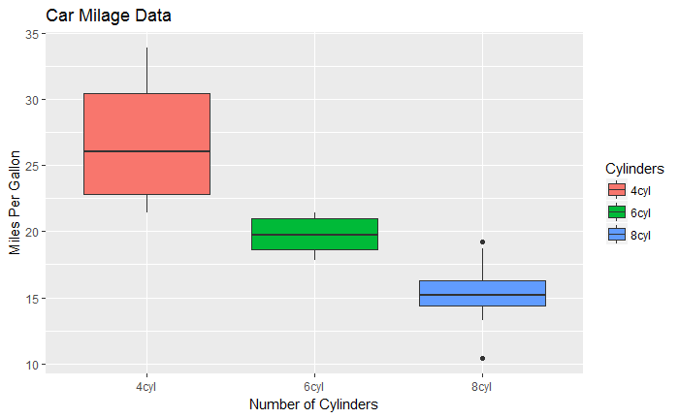

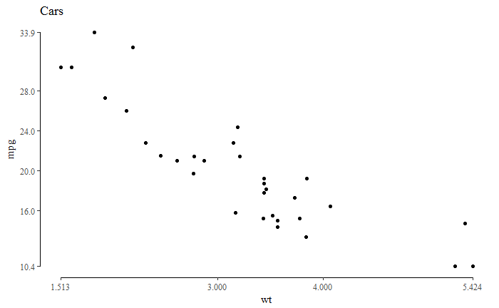

p3 <- p2 + facet_wrap(~ am)p + geom_rangeframe() +theme_tufte() +   
scale_x_continuous(breaks = extended_range_breaks()(mtcars$wt)) +  
scale_y_continuous(breaks = extended_range_breaks()(mtcars$mpg))

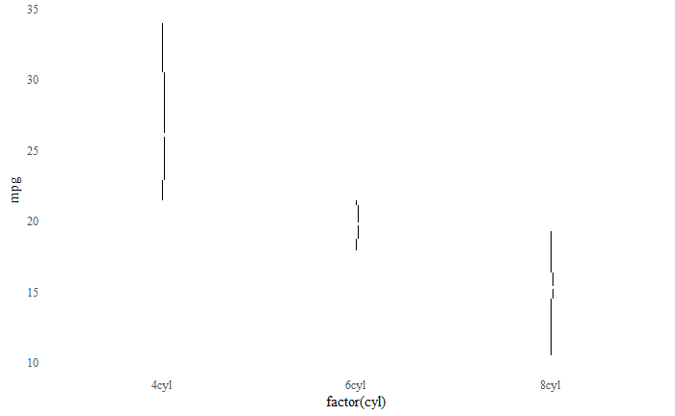

Whisker type box plot

p4 <- ggplot(mtcars, aes(factor(cyl), mpg))p4 + theme_tufte(ticks=FALSE) + geom_tufteboxplot()p4 + theme_tufte(ticks=FALSE) +geom_tufteboxplot(median.type = "line")p4 + theme_tufte(ticks=FALSE) +geom_tufteboxplot(median.type = "line", whisker.type = 'point', hoffset = 0)p4 + theme_tufte(ticks=FALSE) +geom_tufteboxplot(median.type = "line", whisker.type = 'line', hoffset = 0, width = 3)

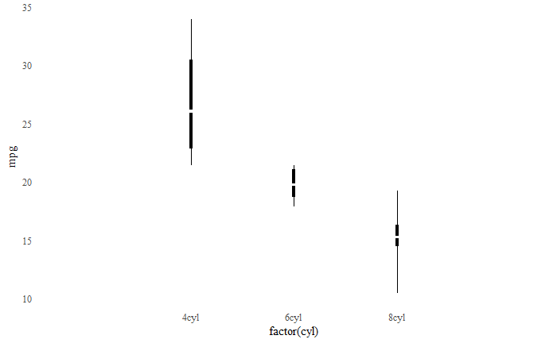

## R Markdown

This is an R Markdown document. Markdown is a simple formatting syntax for authoring HTML, PDF, and MS Word documents. For more details on using R Markdown see <http://rmarkdown.rstudio.com>.

When you click the **Knit** button a document will be generated that includes both content as well as the output of any embedded R code chunks within the document. You can embed an R code chunk like this:

{r cars} summary(cars)

## Including Plots

You can also embed plots, for example:

{r pressure, echo=FALSE} plot(pressure)

Note that the echo = FALSE parameter was added to the code chunk to prevent printing of the R code that generated the plot.

## R Markdown

This is an R Markdown document. Markdown is a simple formatting syntax for authoring HTML, PDF, and MS Word documents. For more details on using R Markdown see <http://rmarkdown.rstudio.com>.

When you click the **Knit** button a document will be generated that includes both content as well as the output of any embedded R code chunks within the document. You can embed an R code chunk like this:

{r cars} summary(cars)

## Including Plots

You can also embed plots, for example:

{r pressure, echo=FALSE} plot(pressure)

Note that the echo = FALSE parameter was added to the code chunk to prevent printing of the R code that generated the plot.

speed dist

Min. : 4.0 Min. : 2.00

1st Qu.:12.0 1st Qu.: 26.00

Median :15.0 Median : 36.00

Mean :15.4 Mean : 42.98

3rd Qu.:19.0 3rd Qu.: 56.00

Max. :25.0 Max. :120.00

$`4cyl`

[1] 22.8 24.4 22.8 32.4 30.4 33.9 21.5 27.3 26.0 30.4 21.4

$`6cyl`

[1] 21.0 21.0 21.4 18.1 19.2 17.8 19.7

$`8cyl`

[1] 18.7 14.3 16.4 17.3 15.2 10.4 10.4 14.7 15.5 15.2 13.3 19.2 15.8 15.0

R Console