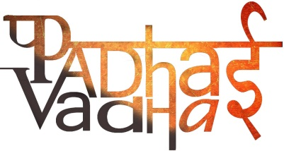

1st April, 2018

**TO WHOMSOVER IT MAY CONCERN**

This is to certify that **Aayushi Rana**, has been an essential part of the Event that took place on 27th March 2018 at Ramjas College , Delhi University where she represented us as an initiative while leading and managing the potential interns and guiding them to learn more about us.

In the same, she was an active speaker and interviewer as well.

We sincerely thank her for her services and wish the best for her future!

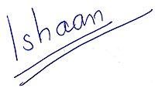

Ishaan Srivastava

(Founder, Padhai Vadhai)