A DISSERTATION ON

RETAIL BANKING

**2010**

Your name

Pgdm-08/009

4/15/2010

ACKNOWLEDGEMENT

I would like to express my heartfelt thanks to many people. This dissertation is an effort to contribute towards achieving the desired objectives. In doing so, I have optimized all available resources and made use of some external resources, the interplay of which, over a period of time, led to the attainment of the set goals.

I take here a great opportunity to express my sincere and deep sense of gratitude to myesteemedfaculty **name** for giving me an opportunity to work on this project. The support & guidance from sir, was of great help & it was extremely valuable.

I also express my sincere thanks to all the people who, directly or indirectly, contributed in time, energy and knowledge to this effort.

**Your name**

|  |  |  |
| --- | --- | --- |
| **CONTENTS** | |  |
|  |  |  |
| **A. Executive Summary** | | **5-10** |
|  |  |  |
| **B. Introduction to the concept** | | **11-16** |
|  |  |  |
| **C. Industry profile** | | **17-19** |
|  |  |  |
| **D. Company profile** | |  |
| **- Product/Services Profile** | | **24** |
| **- Workflow model (end to end)** | | **47** |
|  |  |  |
| **E. Mckinsey’s Seven S Model** | |  |
| **-Structure** |  | **49** |
| **-Skill** |  | **50** |
| **-Style** |  | **51** |
| **-Strategy** |  | **54** |
| **-System** |  | **55** |
| **-Staff** |  | **56** |
| **-Shared Values** | | **56** |
| **-SWOT Analysis** | | **58** |
| **F. Research Methodology** | | **60** |
| **- Title of the Project** | | **61** |
| **- Statement of the problem** | | **61** |
| **- Objectives** |  | **61** |
| **- Operational definitions** | | **62** |
| **- Data collection** | | **62** |
| **- Statistical Tools used for research** |  | **62** |
| **- Sampling Technique – Sampling Unit, Sample Size and** | | **63** |
| **Sampling method.** | |  |
| **- Plan of Analysis** | | **66** |
| **- Limitations to the study** | | **67** |
|  |  |  |
| **G. Data Analysis and Interpretation** | | **68** |
|  |  |  |
| **H. Summary of findings** | | **91** |
|  |  |  |
| **I. Suggestions** | | **93** |
|  |  |  |
| **J. Conclusions – Future Growth** | | **96** |
|  |  |  |
| **K. Learning Experience** | | **97** |
|  |  |  |
| **L. Annexure** |  | **99** |
| **i) Financial Statements** | | **100** |
| **ii) Questionnaires** | | **107** |
| **(iii) Bibliography** | | **111** |

# **EXECUTIVE SUMMARY**

## Title of Project

## “A Study on Retail Banking with special reference to YES BANK”

# **STATEMENT OF THE PROBLEM**

As there is immense opportunities of the retail banking in India. This Dissertation is on the issues and challenges in the retail banking because of the competition of the various banks and the customer satisfaction of the services which the banks are providing and at the same time to solve the complaints of the customer and maintaining the sound relationship for the future and by this way to estimate the future growth of the retail banking.

# **OBJECTIVES**

# To study the issues and challenges in retail banking

# To study the recent trends in retail banking

# To ensure high satisfaction level and reduce percentage of complaints of customers in retail banking.

# To estimate the future growth of Indian retail banking.

1. To understand Optimization of retail banking channels.
2. To suggest strategies for improvement in Customer Service.

**Data collection**

Data was collected from two sources-primary and secondary sources.

1. **Primary data collection-** The primary data was collected by means of survey. It was collected from different customers through questionnaire.
2. **Secondary data collection-**This data was collected from Internet, Company’s websites & Magazines.

**SAMPLE SIZE**

Sample size was restricted to 50 respondents, since it was not possible to cover the whole universe in the available time period.

**Sampling Method**

For this research **Non- Probability Convenience Sampling has been used** because time limit for the completion of the work is limited and also managers and employees were not available all the time.

**Area of Study-** Ghaziabad

**Duration-** 3 months

## LIMITATIONS

* Designing own and new financial products is very costly and time consuming for the bank.
* Customers now-a-days prefer net banking to branch banking. The banks that are slow in introducing technology-based products, are finding it difficult to retain the customers who wish to opt for net banking..
* A major disadvantage is monitoring and follows up of huge volume of loan accounts inducing banks to spend heavily in human resource department.
* The volume of amount borrowed by a single customer is very low as compared to wholesale banking. This does not allow banks to to exploit the advantage of earning huge profits from single customer as in case of wholesale banking.

###### SUMMARY OF FINDINGS

* 90% of customers are happy with the bank timings & they opinioned that it is very good.
* 80% of respondents like the branch ambience & layout & find it friendly. 80% of respondents said branch was clean and well maintained.
* Respondents were of view that Branch personnel had listened to them patiently and have been able to respond to their queries and clarifications.
* 74% of respondent responded that Branch personnel had been very helpful and courteous.
* 72% of respondents opinioned that branch personnel does ‘Need Analyses’ & ‘Risk Assessment’ of customer savings before recommending any investment option to them.
* 86% of respondent that branch personnel are aware of Product and Services and responded to your queries.

**SUGGESTIONS**

* As 10% customer response is not good for the clarification of the queries response towards them so bank personnel should improve this issue because customer is a source through which business can be increase and satisfy customers is a source to create more customers, with reference to table no.4
* As it is only 10% respondent said that sometime there was a error in the transaction happened so to avoid these kinds of errors should be avoided because it is unnecessarily results in wastage of time for both staff members and service rendered, reference to table no. 9
* With reference to table no. 6, larger number of branch personnel should do ‘Need Analyses’ & ‘Risk Assessment’ before recommending any investment option to customer.
* With reference to table no.7, more branch personnel should be aware of Product and Services and responded to customer’s queries.
* With reference to table. 10, YES bank should look into the feedback provided by customer and takes necessary action wherever required.
* With reference to table no. 12, bank should focus on Instant FD facility &E-cheques as small 10% of customer likes this.

## 

## RETAIL BANKING AN INTRODUCTION

Banking in India has come a full circle from the time when you had to wait in a queue to collect cash to getting it delivered at your doorstep at no extra cost. Add to that services like phone banking, Internet banking, 24 hour ATM, draft delivery at home, etc. and you have service spelt with a capital **S**.

Though the contemporary banks' services have changed a lot over the last few years, the core function has remained the same. Banks handle deposits and withdrawal of money, provide loans, pay a part of the surplus as interest and the rest is kept back for the smooth functioning of the bank and profit making.

A banks' functions can be divided into various divisions like:

**Retail/Personal Banking**: This division provides a range of financial services to individual customers and small companies. It operates mainly through branch networks.   
Retail banking includes routine transactions like deposits and withdrawals of money; money transfer; foreign currency exchange and traveller's cheque encashment. They also deal with personal and small loans, credit and mortgages; insurance policies; investment schemes; pension funds; and advice to customers on various financial matters. Apart from offering home loans, car loans, educational loans, consumer loans, etc. they also develop various deposit schemes and help people fill their coffers.

**Corporate Banking**: They deal with medium to large-scale companies and government agencies. It could start at the local branch manager level, though more complex dealings are routed through corporate divisions of clearing banks and their merchant banking subsidiaries. Corporate banking deals with credit and advances, trade finance, foreign exchange management, asset management, lease financing of heavy equipment, infrastructure, machinery, credit risk assessment, etc. They also advise clients on matters such as corporate mergers and acquisition, raising capital and business strategy regarding competitors and outside factors.

**Merchant Banking**: Investment management is the primary activity of this group. It could be on behalf of corporate clients, or institutional investors-like pension funds, investment trusts, or those in the securities business. This groups also handles public issue and marketing of shares, debentures and other such papers. It may also include other stock market functions like dematerialization services, investment advisory services, etc. Merchant banking executives research into capital market, advise and manage funds of various corporate and individual customers.

**Treasury group**: This group takes care of the total funds of a bank including foreign exchange reserves. Responsibilities include bank portfolio management, dealing in foreign currency, etc. There are Forex (foreign exchange) dealers in this group who exclusively deal with the foreign market. They buy and sell foreign exchange at the minimum exchange cost thereby earning maximum profit from the transactions.

**Rural Banking**: This group deals with the banking and credit needs of people in the rural sector. Not all banks have this group and some banks have separate subsidiary companies for rural banking.

**Product Management**: This group conceptualizes various banking services and then develops, implements and manages them. They have the responsibility for a banking product (meaning services like personal loans, home loans, credit cards, loans against shares, educational loans, etc.)

Apart from these main functional groups, there is an appraisal group to analyse economic feasibility of industrial projects, the bank's exposure to financial risk and long term returns. There are internal auditors who audit the bank's internal books of accounts.

There are various groups of professionals like lawyers, engineers, agricultural scientists and economists who work in various departments in advisory capacities. They help make decisions on issues that are legal, technical or economic in nature. For example, the economist advises various functional groups on the implications of the Union budget on the business of the banks, consumer buying pattern, etc.

**Banking In Retail**

With a jump in the Indian economy from a manufacturing sector, that never really took off, to a nascent service sector, Banking as a whole is undergoing a change. A larger option for the consumer is getting translated into a larger demand for financial products and customization of services is fast becoming the norm than a competitive advantage. With the Retail banking sector expected to grow at a rate of 30% [Chanda Kochhar, ED, ICICI Bank] players are focusing more and more on the Retail and are waking up to the potential of this sector of banking. At the same time, the banking sector as a whole is seeing structural changes in regulatory frameworks and securitization and stringent NPA norms expected to be in place by 2004 means the faster one adapts to these changing dynamics, the faster is one expected to gain the advantage. In this article, we try to study the reasons behind the euphemism regarding the Retail-focus of the Indian banks and try to assess how much of it is worth the attention that it is attracting.

### Potential for Retail in India: Is sky the limit

The Indian players are bullish on the Retail business and this is not totally unfounded. There are two main reasons behind this. Firstly, it is now undeniable that the face of the Indian consumer is changing. This is reflected in a change in the urban household income pattern. The direct fallout of such a change will be the consumption patterns and hence the banking habits of Indians, which will now be skewed towards Retail products. At the same time, India compares pretty poorly with the other economies of the world that are now becoming comparable in terms of spending patterns with the opening up of our economy. For instance, while the total outstanding Retail loans in Taiwan is around 41% of GDP, the figure in India stands at less than 5%. The comparison with the West is even more staggering. Another comparison that is natural when comparing Retail sectors is the use of credit cards. Here also, the potential lies in the fact that of all the consumer expenditure in India in 2001, less than 1% was through plastic, the corresponding US figure standing at 18%.

**But how competitive are the players**

The fact that the statistics reveal a huge potential also brings with it a threat that is true for any sector of a country that is opening up. Just how competitive are our banks? Is the threat of getting drubbed by foreign competition real? To analyze this, one needs to get into the shoes of the foreign banks. In other words, how do they see us? Are we good takeover targets?

Going by international standards, a large portion of the Indian population is simply not “bankable” – taking profitability into consideration. On the other hand, the financial services market is highly over-leveraged in India. Competition is fierce, particularly from local private banks such as HDFC and ICICI, in the business of home, car and consumer loans. There, precisely lie the pitfalls of such explosive growth. All banks are targeting the fluffiest segment i.e. the upwardly mobile urban salaried class. Although the players are spreading their operations into segments like self- employed and the semi-urban rich, it is an open secret that the big city Indian yuppies form the most profitable segment. Over-dependence on this segment is bound to bring in inflexibility in the business.

**What according to you would be the next big thing to happen in the Indian retail banking sector**

Outsourcing! If you are a keen observer of the market, you would notice that every sector, including big industrial sectors like car manufacturers, have gone for outsourcing their requirements. Over a period, those players who have gone aggressive on outsourcing have found that it saves them not only cost and time but helps them concentrate on their core business area, a key survival necessity in these times of economic downturns.

**Banking In India**

Retail credit outstanding as on March 22, 2003, amounted to Rs 1,60,000 crore. According to one estimate, the retail segment is expected to grow at 30-40% in the coming years.

Major Players: State Bank of India, HDFC Bank, UTI Bank, IDBI Bank and ICICI Bank.

**What about the foreign giants**

The foreign banks have identified this problem but there are certain systematic risks involved in operating in the Retail market for them. These include regulatory restrictions that prevent them from expanding their branch network.

So these banks often take the Direct Selling Agent (DSA) route whereby low-end jobs like sourcing or transaction processing are outsourced to small regional layers. So now on, when you see a loan mela or a road show showcasing the retail bouquet of an elite MNC giant, you know that a significant commission earned out of any such booking gets ploughed back to our own economy. Perhaps, one of the biggest impediments in foreign players leveraging the Indian markets is the absence of positive credit bureaus. In the west the risk profile can be easily mapped to things like SSNs and this information can be publicly traded. PAN is a step in this direction but lot more work need to be done. What has been a positive step towards this is a negative file sharing started by a consortium of 11 banks. However, as a McKinsey study points out actual write-offs on NPAs show a strong negative correlation with sharing of positive information. On top of this, the spend-now-pay-later “credit culture” in India is just not picking up. A swift legal procedure against consumers creating bad debt is virtually non-existent. Finally, the vast geographical and cultural diversity of the country makes credit policy formulation a tough job and it simply cannot be dictated from a Wall Street or a Singapore boardroom! All these add up to the unattractiveness of the Indian retail market to the foreign players. So over the past few years, in spite of the entry of MNCs in many industries, Retail Banking has seen a flurry of panicky exits. Fewer than 40 remain in India and their share of total bank assets currently 7.2% is falling. Those that remain might be thought to be likely buyers of Indian banks. Yet Citibank, HSBC and Standard Chartered—all in India for more than a century, and with relatively large retail networks—seem to have no pressing need to acquire a local bank. Established foreign banks have preferred to take over customers or businesses from other foreign banks that want to leave. Thus HSBC, in recent years, has o-Mitsubishi. ABN Amro took over Bank of America's retail business.

**So all for the keeping then**

This will perhaps be the most wrongful inference that can be drawn from the above. We just cannot afford to look inwards and repeat the mistakes that were the side effects of the Nationalization of the Banking System. A growing market can never be an alibi for lack of innovation. Indian banks have shown little or no interest in innovative tailor-made products. A case in point is the successful implementation of micro-credit networks in Bangladesh. Positioning a bank as a tech-savvy financial vendor in a country where Internet penetration is an abysmal 1.65% can only add to the over-leveraging as pointed out earlier.

The focus of the sector should remain in macroeconomic wealth creation and not increasing the per capita indebtedness that will do little but add to the NPA burden. Retail Banking in India has to be developed in the Indian way, notwithstanding the long queues in front of the teller counters in the Public sector banks!

**Product/Services Profile of yes bank**

**1. Current account**

-CA30000

-CA70000

-CA200000

-CA500000

**2. Savings account**

-Silver savings account

-Gold savings account

3. FD

4. Smart Saver

5. Smart Access

6. Non resident account (different varient)

**Current Accounts**

Current Account is primarily meant for the purpose of facilitating business transactions.

**Current Accounts – Benefits**

The main advantage of Current Account is its high liquidity and also provides safety of funds to the customer. Current account serves as a low cost of funds for the Bank, provides an opportunity for cross sell and creates stickiness / engagement of the customer because of their transactional nature.

**CA 30**

**Features**

* Swift & Convenient Cheque Collections at YES Bank Locations as well as 2500 Correspondent Bank Locations
* AQT/AQB Criterion for evaluating Non-Maintenance Charges
* Doorstep Banking allowing pickup and delivery of cash and instruments
* CMS Services
* Corporate Net Banking with bulk upload facility
* Flat and aggressive transaction charges for Pay Orders, Demand Drafts, RTGS, Online RTGS, Foreign Outward Remittances (non-trade)

**CA 70**

Features

* Swift & Convenient Cheque Collections at YES Bank Locations as well as 2500 Correspondent Bank Locations
* AQT/AQB Criterion for evaluating Non-Maintenance Charges
* Doorstep Banking allowing pick up and delivery of cash and instruments
* CMS Services
* Corporate Net Banking with bulk upload facility

Flat and aggressive transaction charges for Pay Orders, Demand Drafts, RTGS, Online RTGS, Foreign Outward Remittances (non-trade)

**CA 200**

Features

* Swift & Convenient Cheqfue Collections at YES Bank Locations as well as 2500 Correspondent Bank Locations
* AQT/AQB Criterion for evaluating Non-Maintenance Charges
* Doorstep Banking allowing pickup and delivery of cash and instruments
* CMS Services
* Corporate Net Banking with bulk upload facility
* Flat and aggressive transaction charges for Pay Orders, Demand Drafts, RTGS, Online RTGS, Foreign Outward Remittances (non-trade)
* YES Business Gold Card providing a cash withdrawal limit of Rs 1 lacs

**CA 500**

Features

* Swift & Convenient Cheque Collections at YES Bank Locations as well as 2500 Correspondent Bank Locations
* AQT/AQB Criterion for evaluating Non-Maintenance Charges
* Free Personalized PAP Cheque Books (limits as per account variant)
* Doorstep Banking allowing pickup and delivery of cash and instruments
* CMS Services
* Corporate Net Banking with bulk upload facility
* Flat and aggressive transaction charges for Pay Orders, Demand Drafts, RTGS, Online RTGS, Foreign Outward Remittances (non-trade)
* YES Business Gold Card allowing a cash withdrawal limit of Rs 1 lacs

**Savings Accounts**

Savings Bank Accounts are meant to promote the habit of saving among the citizens while allowing them to use their funds when required. Savings accounts are opened for purpose of personal banking transactions.

**Savings Accounts – Benefits**

The main advantage of Savings Bank Account is its high liquidity and safety. Savings account serves as a low cost of funds for the Bank, provides a platform for cross sell and creates stickiness / engagement of the customer because of its transactional nature.

**SILVER SAVINGS ACCOUNT**

Features:

* Personalized Payable At Par Cheque book
* More than 2500 locations for collection and more than 640 locations for payment services
* Free Instant Money transfer (RTGS/NEFT)to over 54,000 Bank branches in India
* International Silver Debit Card with access to over 1.25 million ATM’s worldwide & 35,000 ATMs of Cashtree/Maestro/NFS in India
* Bill Pay facility with access to over 114 Biller’s in India

**GOLD SAVINGS ACCOUNT**

Features

* Free Instant Money transfer (RTGS/NEFT)to over 54,000 Bank branches in India
* Personalized Payable At Par Cheque book
* More than 2500 locations for collection and more than 640 locations for payment services
* International Gold Debit Card providing Free Access to over 1.25 million ATM’s worldwide & 35,000 ATMs of Cashtree/Maestro/NFS in India
* Free Bill Pay with access to over 114 Biller’s in India

**Fixed Deposits**

In a Fixed Deposit Account, a certain sum of money is deposited in the bank for a specified time period with a fixed rate of interest. The rate of interest for Bank Fixed Deposits depends on the maturity period.

Bank deposits are fairly safe because banks are subject to control of the Reserve Bank of India (RBI) with regard to several policy and operational parameters. The banks are free to offer varying interests in fixed deposits of different maturities. Interest is compounded once a quarter, leading to a higher effective rate.

The minimum deposit amount varies with each bank. The minimum amount of Fixed deposit that can be placed with YES Bank can range from as low as Rs. 10,000 to an unlimited amount.

**Interest Rates for Fixed Deposits**

|  |  |  |
| --- | --- | --- |
|  | **Less than INR 15 lacs** | **Annualized Yield** |
| 7 to14 Days | 2.25% | 2.25% |
| 15 to 30 Days | 2.50% | 2.50% |
| 31 to 45 Days | 3.00% | 3.00% |
| 46 to 60 Days | 3.50% | 3.50% |
| 61 to 90 Days | 4.00% | 4.00% |
| 91 to 120 Days | 4.50% | 4.50% |
| 121 Days to 180 Days | 4.75% | 4.75% |
| 181 Days to 270 Days | 6.00% | 6.14% |
| 271 Days to less than 1 Year | 6.00% | 6.14% |
| 1 Year to 13 Months | 6.60% | 6.77% |
| 13 Months 1 Day | 6.75% | 6.92% |
| 13 Months 2 Days to 15 Months | 6.60% | 6.77% |
| 15 Months 1 Day to 18 Months | 6.60% | 6.77% |
| 18 Months 1 Day to 2 Years | 7.10% | 7.29% |
| 2 Years 1 Day to 25 Months | 7.10% | 7.29% |
| 25 Months 1 Day | 7.25% | 7.45% |
| 25 Months 2 Days to 3 Years | 7.10% | 7.29% |
| 3 Years 1 Day to 5 Years | 7.50% | 7.71% |
| Greater than 5 Years | 7.50% | 7.71% |

|  |  |  |
| --- | --- | --- |
|  | **Less than INR 15 lacs** | **Annualized Yield** |
| 7 to14 Days | 2.75% | 2.75% |
| 15 to 30 Days | 3.00% | 3.00% |
| 31 to 45 Days | 3.50% | 3.50% |
| 46 to 60 Days | 4.00% | 4.00% |
| 61 to 90 Days | 4.50% | 4.50% |
| 91 to 120 Days | 5.00% | 5.00% |
| 121 Days to 180 Days | 5.25% | 5.25% |
| 181 Days to 270 Days | 6.50% | 6.66% |
| 271 Days to less than 1 Year | 6.50% | 6.66% |
| 1 Year to 13 Months | 7.10% | 7.29% |
| 13 Months 1 Day | 7.25% | 7.45% |
| 13 Months 2 Days to 15 Months | 7.10% | 7.29% |
| 15 Months 1 Day to 18 Months | 7.10% | 7.29% |
| 18 Months 1 Day to 2 Years | 7.60% | 7.82% |
| 2 Years 1 Day to 25 Months | 7.60% | 7.82% |
| 25 Months 1 Day | 7.75% | 7.98% |
| 25 Months 2 Days to 3 Years | 7.60% | 7.82% |
| 3 Years 1 Day to 5 Years | 8.00% | 8.24% |
| Greater than 5 Years | 8.00% | 8.24% |

**Returns**

The rate of interest for Bank Fixed Deposits depends on the maturity period (duration) of the FD and the amount invested. [Interest rate](http://www.webindia123.com/finance/bank/fix.htm) also varies between each bank. Some banks have facility to pay interest every quarter or every month, but the interest paid may be at a discounted rate in case of monthly interest.  The Interest payable on Fixed Deposit can also be transferred to Savings Bank or Current Account of the customer or could be paid back by a PO.

|  |  |  |
| --- | --- | --- |
| **FD Value(Rs.)** | **Minimum Tenure** | **Account Type** |
| **Rs.200,000** | **6 Months 1 Day** | **Gold Account** |
| **Rs.25,000** | **6 Months 1 Day** | **Silver Account** |

Target Segment: Resident Individual Customers

**TAX SAVER DEPOSIT**

|  |  |
| --- | --- |
| Product Name | TAX SAVER DEPOSIT |
| Product codes ( Normal Citizens ) | * 439 - FD-5 Yrs Tax Efficient Payout Resident * 440 - FD-5 Yrs Tax Efficient Reinvestment Resident |
| Product codes ( Senior Citizens ) | * 441 - FD 5 Yrs Tax Efficient Payout Senior Citizen * 442 - FD-5 Yrs Tax Efficient Reinvestment Senior Citizen |
| Product codes ( Non Residents ) | * 443 - FD-5 Yrs Tax Efficient Payout Non Resident * 444 - FD-5 Yrs Tax Efficient Reinvestment Non Resident |
| Tax benefit | Tax benefit up to max. Rs.1,00,000/- under Section 80 C of IT Act |
| Tenure | 5 Years |
| Eligible for Benefit | Individuals (Both Residents & Non-Residents) & HUF |
| Joint Holders | Could be Single or Joint holders In case of joint accounts, only first holder would be eligible for tax deduction |
| Pan Card | Mandatory for Primary holder |
| Min Amount | Rs 10,000/- **(**Deposit can be in multiple **of** Rs 1,000 thereafter). |
| Max Amount | Rs.1,00,000/- in a Financial Year with all Banks |
| Deposit denomination | Multiples of Rs 1,000 |
| Interest option | Quarterly Payout  or  Reinvestment only.  **Monthly payout option NOT available** |
| Premature withdrawal | Pre-closure is permissible only in the event of death of the primary account holder. Pre-mat will happen at card rate for the tenure FD is kept with the Bank. |
| Nomination | Only one nomination allowed |

**RECURRING DEPOSIT**

Given the volatility and risk of capital and return across various investment options, customers look for avenues to park funds with assured returns and safety of principal. Recurring Deposit scheme enables the depositor to make a financial provision by paying equated monthly installments for a pre-agreed period. At the end of pre-determined period you are paid back the lump sum including the principal and interest.

**Features and benefits of Recurring Deposit**

* Open a Recurring Deposit with a minimum monthly installment of Rs 1,000
* Choose the convenience of duration between minimum 6 months to maximum 2 years.
* Lock your interest rate now for future bookings (identical to the Term Deposit interest rates).
* Senior citizens get an extra benefit in the interest rates (extra 50 basis points).
* Non-applicability of Tax Deduction at Source (TDS).
* Encourages savings without stress on customer’s finances.
* Easy way of paying monthly installment by providing a onetime standing instruction from customers YES Bank Savings Account.

**SMART ACCESS**

Money kept in the Savings Account earns a lower rate of interest vis a vis the same if placed as a Term Deposit. Money in the Savings account provides liquidity and cover for day to day or immediately foreseeable expenses. SMART ACCESS account gives you the flexibility by linking your term deposit(s) to your savings or current account. Whenever there is a need of funds, the same is swept in from the linked term deposit to meet the requirements.

**Features & Benefits**

* Earn high Term Deposit interest rates on your savings
* Enjoy the flexibility of a YES Bank Savings Account or a Current Account.
* Get easy access to you money whenever you need it through a ATM or any YES Bank branch
* Your Deposit is broken in multiples of Re 1
* Link multiple Term Deposits to your account.
* Get a personalized cheque book in the Savings Account
* Your complete access to your account related information on your fingertips with our phone banking services.
* No extra fee or cost will be charged to the customer for this facility. The Savings/Current Account AQB requirements as well as associated service charges will be as per applicable Schedule of Charges.

**DEBIT/ATM CARDS**



* FREE Unlimited Access to over 19000 ATMs across India
* Free Unlimited Access to over 1.25 million MasterCard ATM’s worldwide and over 19,000 ATM’s in India
* 1st Indian debit card to offer 0% surcharge on fuel purchases at any petrol pump in India- instant 2.5% saving
* Daily cash withdrawal limit of Rs. 75,000 & purchase limit of Rs.75,000
* International transactions are always reflected in Indian Rupees
* Free access to clipper lounges at Airports in major metros

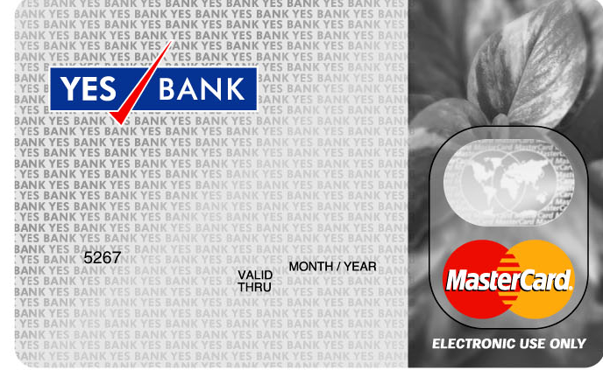

* FREE Unlimited Access to over 19000 ATMs
* Daily cash withdrawal limit of Rs. 25,000 & purchase limit of Rs. 25,000
* Instant updation of account to reflect your debit card transactions. Keeping you in the know, so you can manage your money better
* International transactions are always reflected in Indian Rupees
* Annual fee of only Rs149



* India’s most economical US$ Travel Card: Low fees and cross-currency exchange mark-up not applicable in U.S.
* FREE Access to over 9000 Chase ATMs in the U.S.

**MOBILE BANKING**

* YES Bank is going to provide its customer a service where they can transfer money, send money and pay utility bills through their mobile phone. This will be an addition to the existing Mobile banking facility.
* The YES BANK OBOPAY Mobile Payment Solution is a mobile payment service by YES BANK that lets you Send, Spend and Get Money to/from any of the 240+ million mobile phones in India (provided they are registered users of this service and have a bank account with YES BANK or any of the partner banks).

**Process at the branch**

* For getting registered on the Obopay network customer needs to fill up the application form and submit the same at the nearest YES Bank branch.(Application form attached)
* Branch will verify the signature of the customer against the signature present in the FCR
* Post signature verification branch official will affix a date and time of receipt of application along with his signatures
* Verified forms will be sent to the NOC Mumbai attention to DB Ops team under a covering schedule

**Process at NOC**

* DB Ops on receipt of the forms will enter the data manually into an excel sheet which will be sent to Efunds for Virtual card generation.
* Data to be send to Efunds will contain the customer details like Cust Id, Account No., Name, Mobile No., Type of card to be issued, etc
* Efunds will generate the Virtual card no. along with the PIN mailers and forward the same to DB Ops
* DB Ops will reconcile the Card data received from Efunds against the data forwarded to Efunds
* Virtual card no. generated will be then uploaded in the Obopay admin module along with other customer details (<https://mtrainier.obopay.in/obopaymgmtconsole/login.do>)
* Upload file is to be prepared in the attached format.



* File uploaded needs to be authorized by a verified against the customer data

**NET BANKING**

**NET BANKING SETUP FOR RETAIL AND CORPORATE**

**Retail Net Banking Setup**

Retail net banking setup is done for those customers who have not opted for a Debit Card but wish to avail a Net Banking facility

**Receipt of Data**

* Account opening team receives the forms from the various branches for opening the customer accounts.
* Data for customers who have not opted for Debit Card but wish to avail a Net Banking facility is collated by the account opening team on excel.
* Data collated at Day 0 till EOD is forward to DB Ops team via mail
* DB Ops on Day 1 utilises this data for setting up of Retail Net Banking facility for the customer through FLEX@Retail admin module
* Customer can also submit a letter at the branch for availing net banking facility

Branch needs to verify the signature and affix the branch stamp on the letter which is then send across to DB Ops.

**Processing of request**

* Retail Net Banking Set up for the mentioned customers is done by inputter in the retail admin
* After the setup is complete details of the customers are forwarded to the authoriser
* Authoriser cross checks data provided by the account opening team with the data input done in the retail admin module

On proper verification of the details the data input done is authorized

**Corporate Net Banking Setup**

**Documents required**

View Only facility

* Duly Completed Channel Registration form. (Attached below)
* Form should be signed as per the mode of operation in the account.

Transaction Access

* Duly Completed Channel Registration form
* Form should be signed as per the mode of operation in the account
* Board Resolution for net banking in Desired Format

Bulk Upload Facility

* Duly Completed Channel Registration form
* Form should be signed as per the mode of operation in the account
* Board Resolution for net banking in Desired Format
* Duly filled bulk upload forms mentioning the payment type & debit account number signed as per the mode of operation

2. Factor Authentication

* Duly Completed Channel Registration form
* Form should be signed as per the mode of operation in the account
* 2 Factor authentication should be ticked on the user profile form
* Email Id of the customer is required to be mentioned on setup form
* Setup will be done in Portwise for sending the SEED and PIN at the email id provided by the customer

**Note**:

All the channel registration forms should have the company stamp

Branch to affix date and time stamp on the channel registration form

**Receipt of documents**

* Branch to send the complete set of form along with the checklist under a covering schedule to DB Ops
* A soft copy of the covering schedule is also sent over email to DB Ops.
* DB Ops sends acknowledgement over e mail to the branch and updates the record on the ftp site.

**PROCESS FOR BILL PAYMENT**

* YES Bank is providing its customer a service to pay their bills and make charity/subscription payments through the Internet.
* This is an extension to the existing Internet Banking facility.
* All individual customers who have the right to conduct financial transactions in their account are eligible for this facility.

**Customer Payment Process**

Customer Registration

* The customer needs to register for each Biller separately before paying the bills through Net Banking
* For registration customer needs to submit unique identifiers as per the specifications given by individual Biller.
* If the Biller is a Payment type biller, customer can immediately start paying bills after successful registration
* If the Biller is a presentment type biller, then the customer will be able to view all the bills pertaining to the said Biller from the next billing cycle, after successful registration.
* Customer will able to view and pay presentment type bills under “View & Pay ” option

Payment Process

* Customer can pay the bill through PAY option in the Bill Pay page
* Once the customer provides a confirmation for payment of the bill following entry is passed by the system
* A. Customer account Dr --------- Biller account Cr
* Transactions done by Customers till 11:59:59 pm Day 0 are processed on working Day 1.

Transactions done after 12 pm are processed on the next working day.

**YES BANK announces Q3FY10 Financial Results**

***Net Profit of Rs. 125.9 crore; highest ever since inception***

***Loan growth of 71.1%, Deposit growth of 62.8%***

**Summary Highlights for the quarter**

* **Advances grew by 71.1% y-o-y to Rs. 18,710.4 crore and Deposits grew 62.8% y-o-y to Rs. 22,038.6 crore as at December 31, 2009**
* **Net Interest Income up 69.5% to Rs. 210.9 crores**
* **Net Profit at Rs. 125.9 crore up more than 70% over Q3FY09 net profit adjusted for exceptional treasury gains\***
* **Total Net Income at Rs. 338.7 crore up more than 28% over Q3FY09 total net adjusted for exceptional treasury gains\*\***
* **Net Interest Margin of 3.1% (2.8% in Q3FY09)**
* **Cost to Income ratio of 36.2% (41.3% in Q3FY09)**
* **Return on Average Assets (annualized) of 1.80%**
* **Return on Equity (annualized) of 26.3%**
* **Total CRAR of 16.2% and Tier I CRAR of 9.0% as at December 31, 2009**
* **Gross NPA at 0.29% and Net NPA at 0.09% as at December 31, 2009**
* **Basic EPS of Rs. 4.20 and Diluted EPS of Rs. 4.04 for the quarter**
* **Book value per share of Rs. 65.99 as at December 31, 2009**

**Mumbai, January 20, 2010:**The Board of Directors of YES BANK Ltd. took on record the un-audited Q3FY10 results at its meeting held in Mumbai today.

**Commenting on the results and financial performance, Rana Kapoor, Founder/Managing Director & CEO, YES BANK said**, “YES Bank has achieved record profits second time sequentially on the back of strong and sustainable net interest income and exceptional credit growth of 71.1% y-o-y and 14.8% q-o-q, despite muted credit growth in the industry.  We continue to maintain extremely high productivity and have posted ROEs in excess of 20% for the 5th successive quarter.  We are building a robust branch banking model and are in the process of hiring and retaining world class human capital as the Bank enters its second version of its growth strategy with the Vision to become the Best Quality Bank of the World in Indiaby 2015.”

**Summary P&L**

|  |  |  |  |  |  |  |
| --- | --- | --- | --- | --- | --- | --- |
| **(Rs in Crore )** | **Q3 FY10** | **Q3 FY09** | **Growth** | **9M FY10** | **9M FY09** | **Growth** |
| Net Interest Income | 210.9 | 124.5 | 69.5% | 543.8 | 359.5 | 51.3% |
| Non Interest Income | 127.8 | 189.4 | (32.5%) | 415.4 | 375.7 | 10.6% |
| **Total Net Income** | 338.7 | 313.9 | 7.9% | 959.2 | 735.2 | 30.5% |
| Operating Expense | 122.6 | 129.5 | (5.4%) | 353.4 | 327.5 | 7.9% |
| **Operating Profit** | 216.2 | 184.4 | 1F7.3% | 605.8 | 407.7 | 48.6% |
| **Profit after Tax** | 125.9 | 105.8 | 19.0% | 337.7 | 223.7 | 50.9% |

|  |  |
| --- | --- |
| |  | | --- | | * Net Profit without adjusting for fixed income gains was  up by 19.0%  y-o-y  * * Total Net Income without adjusting for fixed income gains up by 7.9% y-o-y | |

**Summary Balance Sheet**

|  |  |  |  |  |  |
| --- | --- | --- | --- | --- | --- |
| **(Rs in Crore )** | **31-Dec-09** | **31-Dec-08** | **Growth** | **30-Sep-09** | **Growth** |
| Advances | 18,710.4 | 10,934.9 | 71.1% | 16,294.3 | 14.8% |
| Investments | 8,282.0 | 6,952.8 | 19.1% | 6,981.4 | 18.6% |
| Shareholders’ funds | 1,981.3 | 1,544.1 | 28.3% | 1,844.3 | 7.5% |
| Total Capital Funds | 3,751.7 | 2,847.8 | 31.7% | 3,608.1 | 4.0% |
| Deposits | 22,038.6 | 13,539.1 | 62.8% | 19,365.1 | 13.8% |
| **Total Balance Sheet** | 29,587.5 | 19,746.6 | 49.8% | 26,370.1 | 12.2% |

**Q3FY10 Performance highlights**

•   **Strong Net Interest Income (NII)**: Net Interest Income (NII) for Q3FY10 grew by 69.5% to Rs. 210.9 crore (Rs. 124.5 crore in Q3FY09) on account of strong growth in advances & investments and improved Net Interest Margin (NIM). NIM for Q3FY10 increased to **3.1%** as compared to **2.8%** in Q3FY09. Gross yield on advances for Q3FY10 was **10.3%** (13.7% in Q3FY09) while cost of funds reduced to **6.6%** from 9.6% in Q3FY09.

•    **Exceptional growth in Advances and Deposits**: Total Advances grew by **71.1%**to Rs. 18,710.4 crore as at December 31, 2009 from Rs. 10,934.9 crore as at December 31, 2008, despite muted credit growth in the industry. Investments grew by **19.1%** to Rs. 8,282.0 crore as at December 31, 2009 from Rs. 6,952.8 crore as at December 31, 2008.

Total Deposits grew by **62.8%** to Rs. 22,038.6 crore as at December 31, 2009 from Rs. 13,539.1 crore as at December 31, 2008. Current and Savings Account deposits grew by **79.4%** to Rs. 2,228.9 crore while Term Deposits grew by **61.1%** to Rs. 19,809.7 crore during the same period. The Bank’s Balance Sheet grew by **49.8%** to Rs. 29,587.5 crore as at December 31, 2009 from Rs 19,746.6 crore as at December 31, 2008.

Break-up of the total non-Priority Sector Lending as at December 31, 2009 was as follows - Wholesale Banking (72.6%), Commercial Banking (23.1%), and Branch Banking (4.3%).

•   **Sustainable Non Interest Income streams:** Transaction Banking and Financial Advisory business continue to show traction y-o-y and sequentially. Non Interest Income was Rs. 127.8 crore for the quarter (Rs. 189.4 crore in Q3FY09). For the 9 months ended December 31st 2009, non-interest income grew 10.6% to Rs. 415.4 crore (Rs. 375.7 crore for the 9 months ended December 31, 2008) and contributed 43.3% for 9 months ended December 31 ,2010.

 Components of Non interest income for Q3FY10 were as follows: Transaction Banking – Rs. 37.1 crore, Financial Advisory – Rs.57.0 crore, Financial Markets – Rs. 28.0 crore and 3rdparty distribution / retail fee – Rs. 5.7 crore.

•   **Operating and Net profit**: Operating profit for Q3FY10 was up **17.3%** to Rs. 216.2 crore as compared to Rs. 184.4 crore for Q3FY09 driven primarily by sustained revenue growth from multiple revenue streams and lower operating cost to income ratio of **36.2%** in Q3FY10 (**41.3%** in Q3FY09).

Profit after tax for Q3FY10 was up **19.0%** at Rs. 125.9 crore as compared to Rs. 105.8 crore for Q3FY09, which is the highest ever in the Bank’s history.

•    **Consistently healthy Asset Quality:**Gross Non Performing Assets as a proportion of Gross advances was at 0.29% while Net Non Performing Assets as a proportion of Net advances was at 0.09% as at December 31, 2009 as against 0.44% and 0.15% respectively as at December 31, 2008.

Bank’s total loan loss coverage ratio was at 270% while specific provisioning cover was at 70.1% as at December 31, 20

The Bank’s restructured advances declined by Rs. 21.9 crores during the quarter. Total restructured advances were Rs. 134.0 crore as at December 31, 2009 (Rs. 155.9 Crs as of September 30, 2009) which constituted 0.71% of the Gross Advances as at December 31, 2009.

•   **Strong Shareholders’ returns**: RoE of **26.3%**(annualized) and RoA of **1.80%**(annualized) for the quarter consistently continue to be amongst the highest in the Banking industry. RoE has been consistently greater than 20% and RoA has been more than 1.5% for the last 5 consecutive quarters.

•  **Capital Funds**: Tier I Capital stood at **9.0%** and total CRAR stood at **16.2%** as at December 31, 2009.

|  |  |  |  |  |  |  |
| --- | --- | --- | --- | --- | --- | --- |
|  |  |  |  |  |  |  |
| ***Case :- If Non Interest Income is considered as operating Income*** | | | | | | |
|  |  |  |  |  |  |  |
| Interest Income | |  |  | 210.9 |  |  |
| Non Interest Income | | |  | 127.8 |  |  |
| Operating Income | |  |  | 338.7 |  |  |
| Operating Expenses | |  |  | 122.6 |  |  |
| Operating Profit | |  |  | 216.1 |  |  |
| Net Profit after Tax | |  |  | 125.9 |  |  |
| Shareholders fund | |  |  | 3751.7 |  |  |
|  |  |  |  |  |  |  |
| **Net Profit Ratio** | | |  | **37%** |  |  |
| **Net Operating Profit Ratio** | | | | **64%** |  |  |
| **Operating Cost Ratio** | | |  | **36%** |  |  |
| **(as a % of Sales)** | | |  |  |  |  |
| **Return On Investments** | | |  | **5.76%** |  |  |

**Formulae Used:**

**Net profit =** **Net Profit after Tax/** **Operating Income**

**Net Operating Profit Ratio=** **Operating Profit/** **Operating Income**

**Operating Cost Ratio** **(as a % of Sales)=** **Operating Expenses/** **Operating Income**

**Return On Investments=** **Operating Profit/ Shareholders fund**

|  |  |  |  |  |  |  |  |
| --- | --- | --- | --- | --- | --- | --- | --- |
| ***Case :- If Non Interest Income is not considered as operating Income*** | | | | | | |  |
|  |  |  |  |  |  |  |  |
| Interest Income | |  |  | 210.9 |  |  |  |
| Operating Expenses | |  |  | 122.6 |  |  |  |
| Operating Profit | |  |  | 88.3 |  |  |  |
| Shareholders fund | |  |  | 3751.7 |  |  |  |
| Non Interest Income | | |  | 127.8 |  |  |  |
| Net Profit | |  |  | 216.1 |  |  |  |
| Net Profit after Tax | |  |  | 125.9 |  |  |  |
|  |  |  |  |  |  |  |  |
| **Net Profit Ratio** | | |  | **102%** |  |  |  |
| **Operating Cost Ratio** | | |  | **58%** |  |  |  |
| **(as a % of Sales)** | | |  |  |  |  |  |
| **Operating Profit Ratio** | | |  | **42%** |  |  |  |
| **Return on Investments** | | |  | **2.35%** |  |  |  |
|  |  |  |  |  |  |  |  |
|  |  |  |  |  |  |  |  |
|  |  |  |  |  |  |  |  |
| **This assumption is not justifiable because net profit ratio is greater than 100%** | | | | | | | |

**Formulae Used:**

**Net Profit Ratio= Net Profit/ Interest Income**

**Operating Cost Ratio (as a % of Sales)= Operating Expenses/ Operating Income**

**Operating Profit Ratio= Operating Profit/ Interest Income**

**Return On Investments= Operating Profit/ Shareholders fund**

|  |  |  |  |  |  |  |  |  |  |  |  |
| --- | --- | --- | --- | --- | --- | --- | --- | --- | --- | --- | --- |
|  |  | | |  | |  | | |  | |  |
|  | ***Balance Sheet (as on 31 dec 2009)*** | | | | | | | | | | |
|  | LIABILITIES | | |  | | AMOUNT | | | ASSETS | | AMOUNT |
|  |  | | |  | | (Rs in Crore) | | |  | | (Rs in Crore) |
|  | Shareholders’ funds | | |  | | 1,981.30 | | | Other Assets | | 2,595.10 |
|  | (written in details of axis bank) | | | | |  | | |  | |  |
|  | ***Net Profit*** | | |  | |  | | | Investments | | 8,282.00 |
|  | Opening Balance | | | 1,644.50 | |  | | | Advances | | 18,710.40 |
|  | current year | | | 125.9 | | 1,770.40 | | |  | |  |
|  | Deposits | | |  | | 22,038.60 | | |  | |  |
|  | other Liability | | |  | | 3,797.20 | | |  | |  |
|  |  | | |  | |  | | |  | |  |
|  |  | | |  | | **29,587.50** | | |  | | **29,587.50** |
|  |  | | |  | |  | | |  | |  |
|  |  | | |  | |  | | |  | |  |
|  | ***Calculation of Other Liability*** | | | | |  | | |  | |  |
|  | Total of Balance Sheet | | | | | 29,587.50 | | |  | |  |
|  | Less:- Total capital fund | | | | | 3,751.70 | | |  | |  |
|  | Deposits | | |  | | 22,038.60 | | |  | |  |
|  |  | | |  | |  | | |  | |  |
|  | ***Other Liability(balancing figure)*** | | | | | **3,797.20** | | |  | |  |
|  |  | | |  | |  | | |  | |  |
|  |  | | |  | |  | | |  | |  |
|  | ***Calculation of Other Assets*** | | | | |  | | |  | |  |
|  | Total of Balance Sheet | | | | | 29,587.50 | | |  | |  |
|  | Less:- Investments | | |  | | 8,282.00 | | |  | |  |
|  | Advances | | |  | | 18,710.40 | | |  | |  |
|  |  | | |  | |  | | |  | |  |
|  | ***Other Assets*** | | |  | | **2,595.10** | | |  | |  |
|  |  | | |  | |  | | |  | |  |
| **Other Information** | | |  | |  | |  |  | |
| Net Profit after Tax | | |  | | 125.9 | |  |  | |
| Operating Income | | |  | | 338.7 | |  |  | |
| Operating Expenses | | |  | | 122.6 | |  |  | |
| Operating Profit | | |  | | 216.1 | |  |  | |
|  | |  |  | |  | |  |  | |
|  | |  |  | |  | |  |  | |
|  | |  |  | |  | |  |  | |
|  | |  |  | |  | |  |  | |
|  | |  |  | |  | |  |  | |
|  | |  |  | |  | |  |  | |
|  | | ***BALANCE SHEET RATIOS*** | | | | | |  | |
|  | | **Return on Investments** | | | | | **5.76%** |  | |
|  | | **Return On Equity** | | | | | **3.36%** |  | |
|  | | **Return On Net Worth** | | | | | **3.36%** |  | |
|  | | **Return On Total Assets** | | | | | **0.43%** |  | |

**Return On Investments=** **Operating Profit/ Shareholders fund**

**Return On Equity=Net Profit after Tax/Total capital fund**

**Return On Net Worth=Net Profit after Tax/ Total capital fund**

**Return On Total Assets=** **Net Profit after Tax/(** **Investments+** **Advances+** **Other Assets)**

**STAFF**

**SWOT ANALYSIS**

**STRENGHTS :**

* It has an extensive distribution network comprising of 132 branches in 88 locations.
* The Bank has a strong retail depository base & has good number customers.
* Bank boasts of a strong brand equity.
* ISO 9001 certification for its depository & custody operations & for its backend processing of retail operation & direct banking operation.
* The bank has a near competitive edge in area of operations.
* The bank has a market leader in cash settlement service for the major stock exchanges in its country.
* YES Bank is one of the largest private sector bank working in India.
* It has a highly automated environment in terms of information technology & communication system.
* Infrastructure is best.
* It has many innovative products like kids Advantage scheme, NRI services.

**WEAKNESS :**

* Some time acount opening and delivery of cheque book take comparatively more time.
* Lack of availability of different credit products like CC Limit, Bill discounting facilities.

**OPPORTUNITY :**

* Branch expansion
* Door step services
* Greater liberalization in foreign ownership via FDI in Indian Pvt. Sector Banks.
* CC/ OF Facilities.
* Infrastructure improvements & better systems for trading & settlement in the govt. securities & foreign exchange markets.

**THREATS:**

* The bank has started facing competition from players like SBI, PNB Bank in the finance market itself. This reduce the profit margins in the future.
* Some Pvt. Banks have 7 days banking.

## Title of DISSERTATION

## “A Study on Retail Banking with special reference to YES BANK”

## STATEMENT OF THE PROBLEM

As there are immense opportunities of the retail banking in India. This project is onthe issues and challenges in the retail banking because of the competition of the various banks and the customer satisfaction of the services which the banks are providing and at the same time to solve the complaints of the customer and maintaining the sound relationship for the future and by this way to estimate the future growth of the retail banking.

# **OBJECTIVES OF STUDY**

# To study the issues and challenges in retail banking

# To study the recent trends in retail banking

# To ensure high satisfaction level and reduce percentage of complaints of customer in retail banking.

# To estimate the future growth of Indian retail banking.

1. To understand Optimization of retail banking channels.
2. To suggest strategies for improvement in Customer Service.

**Operational Definition**

Retail banking refers to banking in which [banking institutions](http://en.wikipedia.org/wiki/Banking_institution) execute transactions directly with consumers, rather than corporations or other banks. Services offered include: [savings](http://en.wikipedia.org/wiki/Savings_account) and [checking accounts](http://en.wikipedia.org/wiki/Checking_account), [mortgages](http://en.wikipedia.org/wiki/Mortgage), [personal loans](http://en.wikipedia.org/wiki/Personal_loan), [debit cards](http://en.wikipedia.org/wiki/Debit_card), [credit cards](http://en.wikipedia.org/wiki/Credit_card), and so forth. And to know about the customer’s perceptions about the different products of the bank like current account, savings account, FD, Smart Saver, Smart Access and others.

**Data collection**

There are several Approach of data collection. The primary sources of data collection are done through **–**

* Observation
* Questionnaire

**Questionnaire:**

Questionnaire is the method of data collection, which is very much popular, particularly in big cities. Different modes of questions are put up on the paper and the particular universe, on which the research is conducted, are asked to fill theirresponses

The Secondary source includes data collection through:

* Magazines
* Company Website

**Sampling Technique**

**(a) Sampling Unit:-** Walk in customers and the company database of high ended customer.

**(b) Sample Size:-**

Sample size for this project was restricted to 50 respondents. Since it was not possible to cover the whole universe in the available time period, it was necessary for me to take a sample size of 50 respondents.

**(c) Sampling Method:-**

There are three methods of sampling:-

1. Probability Sampling:

2. Non-Probability Sampling:

3. Quota

**For this research work Non- Probability Convenience Sampling** has been chosen because time limit for the completion of the work is limited and also managers and employees were not available all the time.

**Area of Study-** Ghaziabad

**Duration-** 3 months

**Data Collection Method**

Data for the present study is collected from two sources:

1. **Primary Data:**.

The data are collected directly from the universe by conducting interviews, etc. these are the original sources from which the researcher directly gathers data which are not previously referred.All the people from different profession were personally visited and interviewed. They were the main source of primary data. The method of collection of primary data was personal direct interview through a structured questionnaire.

**The primary data was collected by means of survey.** Questionnaires were prepared and customers of YES bank were approached to fill up these questionnaires. The filled up information was later analyzed to obtain the required information.

1. **Secondary Data:**

The data are collected from the secondary sources such as magazines, journals, etc. These sources consist of already variable data in the form of statements, and reports, which may include sensory reports, financial statements of the company, reports of governments departments, etc**.**

It was collected from internal sources. The secondary data was collected on the basis of organizational file, official records, newspapers, magazines, management books, preserved information in the company’s database and the website of the company.

Both Primary and Secondary sources was used for data collection.

**For primary source, Questionnaire was used. For secondary source Internet, Magazines, and Newspaper etc were used.**

**Research Design**

Research design is simply the framework or plan for a study, used as a guide in collecting and analyzing data. There are three types of Research Design:-

1. **Exploratory Research Design**
2. **Descriptive Research Design**
3. **Casual Research Design**

For the study, **Exploratory Research Design** was undertaken to classify the investors on their risk and return profile.

**Plan of Analysis**

The data obtained from the structured questionnaire was interpreted and recorded. The table and graph were constructed using data from the questionnaire through simple techniques like average, percentage, ratios etc.which was then used for analyzing the acquired data.

## LIMITATIONS

1. Designing own and new financial products is very costly and time consuming for the bank.
2. Customers now-a-days prefer net banking to branch banking. The banks that are slow in introducing technology-based products, are finding it difficult to retain the customers who wish to opt for net banking.
3. Customers are attracted towards other financial products like mutual funds etc.
4. Though banks are investing heavily in technology, they are not able to exploit the same to the full extent.
5. A major disadvantage is monitoring and follow up of huge volume of loan accounts inducing banks to spend heavily in human resource department
6. Long term loans like housing loan due to its long repayment term in the absence of proper follow-up, can become NPAs.
7. The volume of amount borrowed by a single customer is very low as compared to wholesale banking. This does not allow banks to to exploit the advantage of earning huge profits from single customer as in case of wholesale banking.

**Profile of Respondents**

Respondents were the customers of YES bank of Ghaziabad city of age group 25-40 years

**A. Opinion on Branch experience.**

**The Branch timings (9:30 am to 6:30 pm from Monday to Saturday) are convenient**

**Table:1**

|  |  |  |
| --- | --- | --- |
| **Parameter** | **In numbers** | **In percentage** |
| **Very Good** | **45** | **90** |
| **Good** | **5** | **10** |
| **Satisfactory** | **0** | **0** |
| **Could be better** | **0** | **0** |

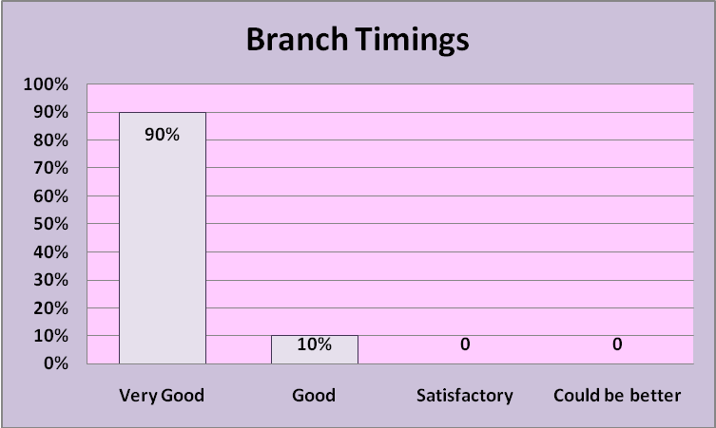

**Interpretation**

The purpose of this question is to know the whether the bank timings are convenient for the customer, 90% of respondents opinioned that bank timings are very good and 10% of respondent opinioned that timings are good. None of the customers have any problem with respect to timings.

**Inference:** As 90% responded very good, it seems high number are happy with bank timings.

**The Branch ambience & layout is very friendly**

**Table:2**

|  |  |  |
| --- | --- | --- |
| **Parameter** | **In numbers** | **In percentage** |
| **Very Good** | **40** | **80** |
| **Good** | **7** | **14** |
| **Satisfactory** | **2** | **4** |
| **Could be better** | **1** | **2** |

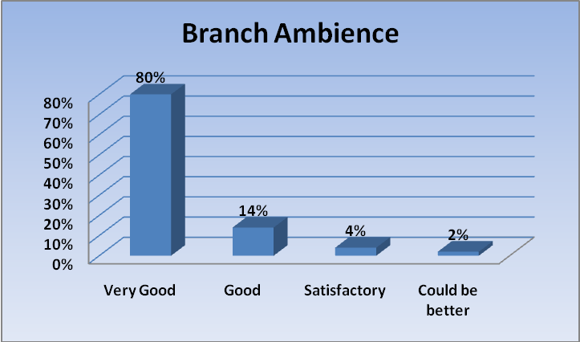

**Interpretation**

80% were of the respondent opinioned that Branch ambience is very good, 14% were of the opinioned that branch ambience is good while 4% opinioned that it is satisfactory & just 1% opinioned that it could be better.

**Inference:** As 80% of respondents say branch ambience is very good, so not too many respondents like the branch ambience.

**The Branch was clean and well maintained**

**Table :3**

|  |  |  |
| --- | --- | --- |
| **Parameter** | **In numbers** | **In percentage** |
| **Very Good** | **40** | **80** |
| **Good** | **7** | **14** |
| **Satisfactory** | **2** | **4** |
| **Could be better** | **1** | **2** |

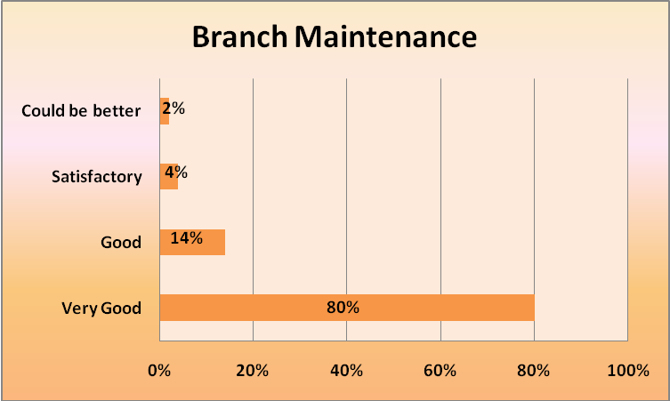

**Interpretation**

80% were of the respondent opinioned that Branch cleanness is very good,14% were of the opinioned that branch cleanness is good while 4% opinioned that it is satisfactory & just 1% opinioned that it could be better.

**Inference:** As 80% of respondents say branch cleanness is very good, so not too many respondents like the branch cleanness.

**B. Opinion of the customer regarding Branch personnel?**

**The Branch personnel have listened to me patiently and have been able to respond to my queries and clarifications**

**Table:4**

|  |  |  |
| --- | --- | --- |
| **Parameter** | **In numbers** | **In percentage** |
| **Very Good** | **38** | **76** |
| **Good** | **7** | **14** |
| **Satisfactory** | **3** | **6** |
| **Could be better** | **2** | **4** |

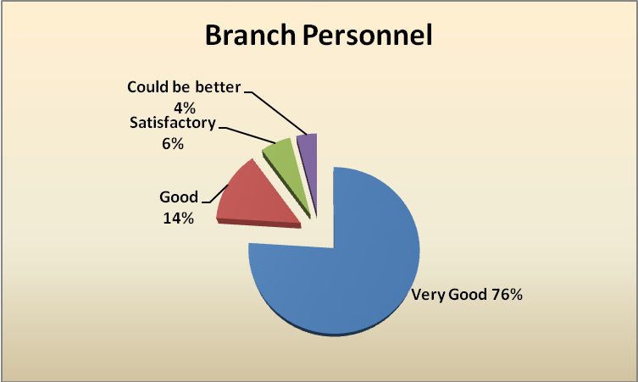

**Interpretation**

76% of respondents opinioned that branch personnel listened patiently& have been able to respond to their queries, 14% of respondents opinioned it is good. While only 6% of respondent opinioned that it is satisfactory and 4% said it could be better.

**Inference:** As only 76% of respondents say branch personnel listens Patiently and have been able to respond to queries and clarifications, so not too many respondents are satisfied.

**The Branch personnel have been very helpful and courteous**

**Table:5**

|  |  |  |
| --- | --- | --- |
| **Parameter** | **In numbers** | **In percentage** |
| **Very Good** | **37** | **74** |
| **Good** | **8** | **16** |
| **Satisfactory** | **3** | **6** |
| **Could be better** | **2** | **4** |

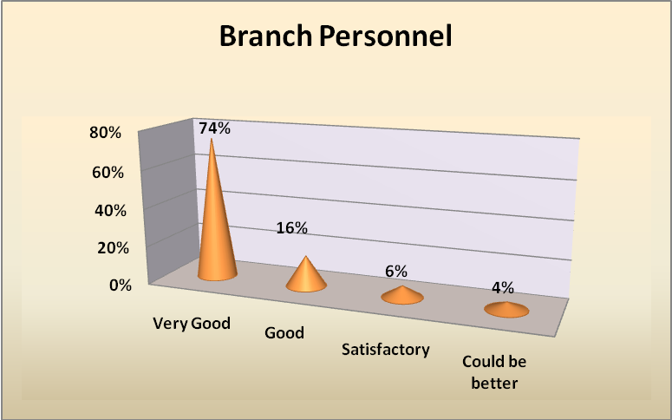

**Interpretation**

74% of respondents opinioned that branch personnel have been very helpful and courteous, 16% of respondents opinioned it is good. While only 6% of respondent opinioned that it is satisfactory and 4% said it could be better.

**Inference:** As only 74% of respondents say branch personnel have been very helpful and courteous, so not too many respondents are satisfied.

**The branch personnel have done a ‘Need Analyses’ & ‘Risk Assessment’ before recommending any investment option**

**Table:6**

|  |  |  |
| --- | --- | --- |
| **Parameter** | **In numbers** | **In percentage** |
| **Very Good** | **36** | **72** |
| **Good** | **10** | **20** |
| **Satisfactory** | **3** | **6** |
| **Could be better** | **1** | **2** |

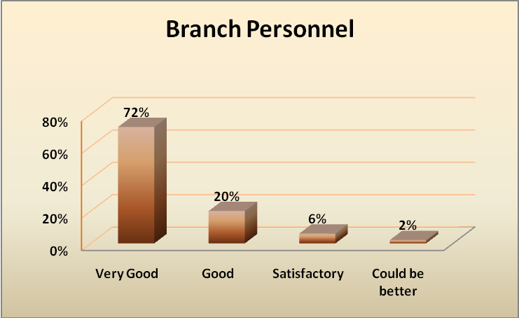

**Interpretation**

72% of the respondents opinioned that risk assessment before recommending any investment is very good, 20% of respondents opinioned that it is good, 6% of respondents opinioned that it satisfactory and only 2% said it could be better.

**Inference:** As only 72% of respondents say branch personnel does a ‘Need Analyses’ & ‘Risk Assessment’ before recommending any investment option, so not too many respondents have positive response.

**The branch personnel were aware of Product and Services and responded to your queries**

**Table :7**

|  |  |  |
| --- | --- | --- |
| **Parameter** | **In numbers** | **In percentage** |
| **Very Good** | **43** | **86** |
| **Good** | **3** | **6** |
| **Satisfactory** | **3** | **6** |
| **Could be better** | **1** | **2** |

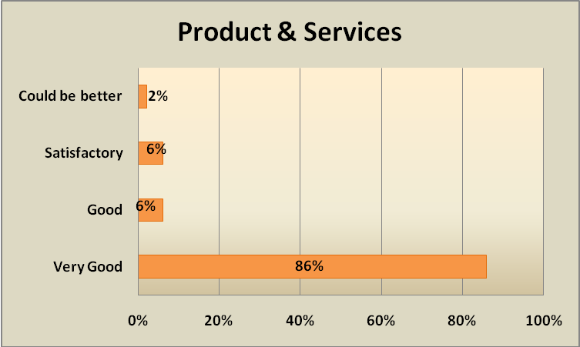

**Interpretation**

86% respondents opinioned that branch personnel responded to their queries and is very good, 6% says to be good & 6% satisfactory. Only 2% said it could be better.

**Inference:** As 86% of respondents say branch personnel were aware of Product and Services and responded to customer queries, so not too many respondents are satisfied.

**C. Customer’s opinion of transacting in Branches?**

**The waiting time at the Teller Counter was minimal**

**Table:8**

|  |  |  |
| --- | --- | --- |
| **Parameter** | **In numbers** | **In percentage** |
| **Very Good** | **40** | **80** |
| **Good** | **5** | **10** |
| **Satisfactory** | **1** | **2** |
| **Could be better** | **4** | **8** |

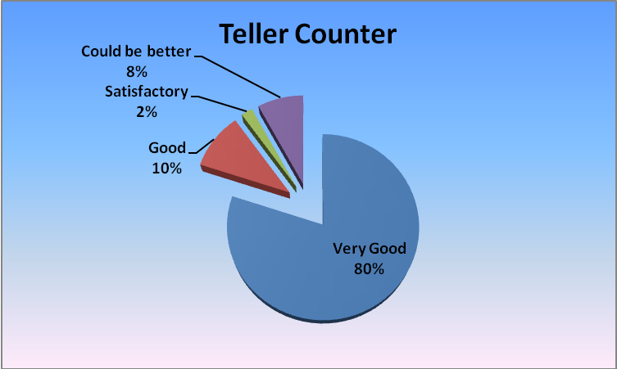

**Interpretation**

80% of respondent opinioned that waiting time is minimum at teller counter and it is very good, 10% of respondent opinioned that it is good, 8% its satisfactory and 2% said it could be better.

**Inference:** As 80% of respondents say waiting time at teller counter was minimal , not too many were satisfied with transaction.

**The transactions done by us have been smooth & error free**

**Table:9**

|  |  |  |
| --- | --- | --- |
| **Parameter** | **In numbers** | **In percentage** |
| **Very Good** | **45** | **90** |
| **Good** | **5** | **10** |
| **Satisfactory** | **0** | **0** |
| **Could be better** | **0** | **0** |

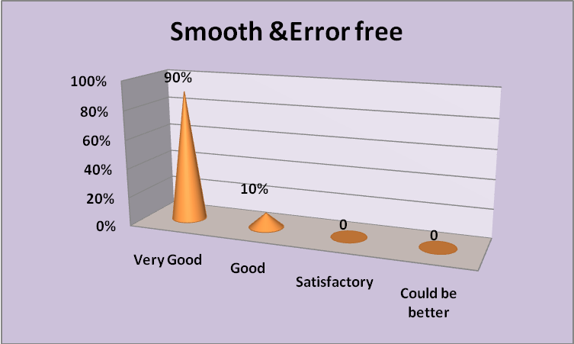

**Interpretation**

90% of respective opinioned that transactions are smooth and error free, 10% of respondent opinioned that transactions are good. None of the customers have any problem with respect to timings.

**Inference:** As 90% responded very good, it seems high number are happy with transactions.

**Yes bank looks into the feedback provided by you and takes necessary action if required.**

**Table:10**

|  |  |  |
| --- | --- | --- |
| **Parameter** | **In numbers** | **In percentage** |
| **Very Good** | **41** | **82** |
| **Good** | **5** | **10** |
| **Satisfactory** | **2** | **4** |
| **Could be better** | **2** | **4** |

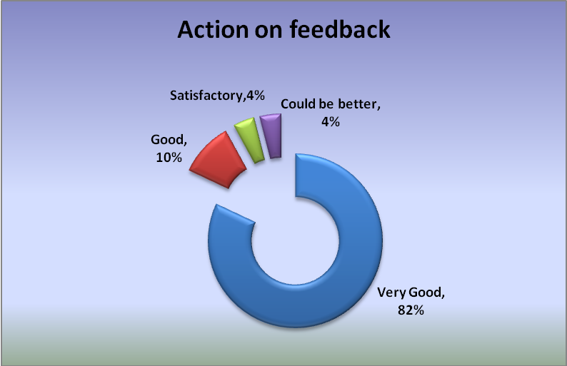

**Interpretation**

82% of respondent responded that Yes Bank looks into the feedback & is very good, 10% said its good, 4% said its satisfactory and 4% said it could be better.

**Inference:** As 82% of respondents says Yes bank looks into the feedback provided by customer and takes necessary action if required, not too many were satisfied with transaction.

**D. Customer’s opinion for Bank sevices?**

**Are you happy with the TAT (Turn around time) post request**

**Table:11**

|  |  |  |
| --- | --- | --- |
| **Parameter** | **In numbers** | **In percentage** |
| **Very Good** | **40** | **80** |
| **Good** | **7** | **14** |
| **Satisfactory** | **2** | **4** |
| **Could be better** | **1** | **2** |

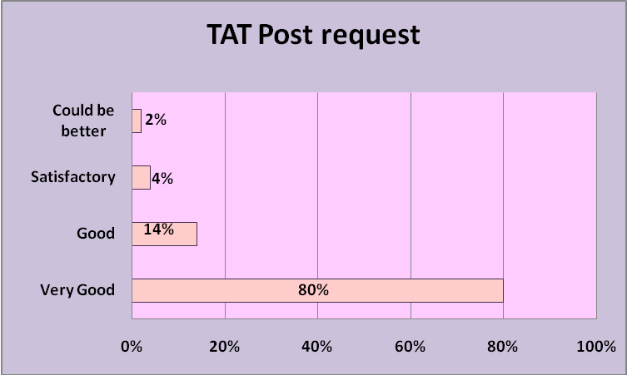

**Interpretation**

80% of respondent opinioned that TAT post request is very good, 14% said its good 4% said its satisfactory 2% said it could be better.

**Inference:** As 80% of respondents says the TAT (Turn around time) post request is very good, not too many were satisfied with TAT post request.

**E.Products and Services**

**Which feature of the YBL Savings account you like most**

**Table: 12**

|  |  |  |
| --- | --- | --- |
| **Parameter** | **In numbers** | **In percentage** |
| **OBOPAY** | **30** | **38** |
| **Money Monitor** | **35** | **45** |
| **Instant FD OD facility** | **10** | **13** |
| **E-Cheques** | **3** | **4** |

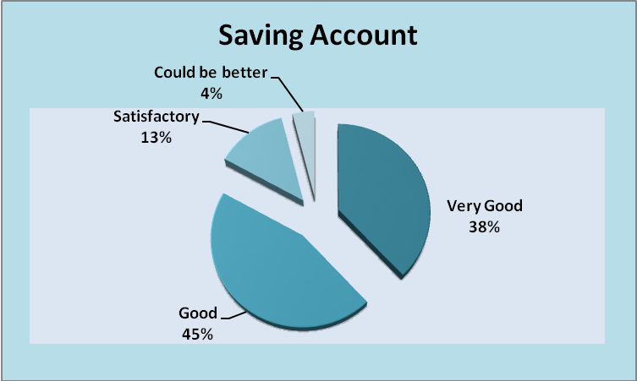

**Interpretation**

38% of the respondents opinioned for OBOPAY , 45% of respondent are in favour of Money Monitor, 13% are in favour of Instant FD OD while only 4% like E-cheques.

**Inference:** Maximum number of people like Money Monitor feature of YBL Savings account.

**How do you rate the ‘YES COMMUNITY EVENTS’ held at yes bank**

**Table:13**

|  |  |  |
| --- | --- | --- |
| **Parameter** | **In numbers** | **In percentage** |
| **Very Good** | **37** | **74** |
| **Good** | **8** | **16** |
| **Satisfactory** | **3** | **6** |
| **Could be better** | **2** | **4** |

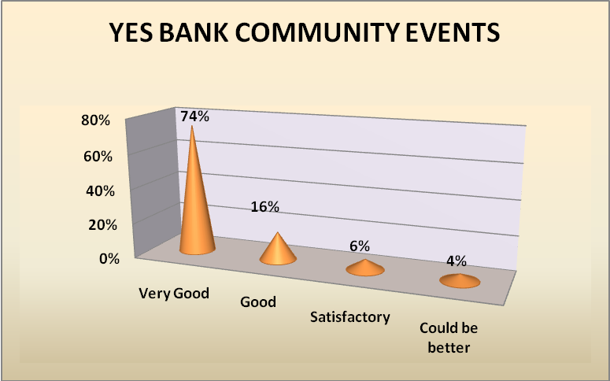

**Interpretation**

74% of the respondent opinioned that YES COMMUNITY EVENTS are very good, 16% of respondents opinioned that events are good, 6% said it is satisfactory and 4% said it could be better.

**Inference:** As 74% of respondents says YES COMMUNITY EVENTS’ is very good, not too many opinioned for community events.

**Is the information in the Bank Statement clear, easy to understand and adequate**

**Table:14**

|  |  |  |
| --- | --- | --- |
| **Parameter** | **In numbers** | **In percentage** |
| **Very Good** | **39** | **78** |
| **Good** | **6** | **12** |
| **Satisfactory** | **5** | **10** |
| **Could be better** | **0** | **0** |

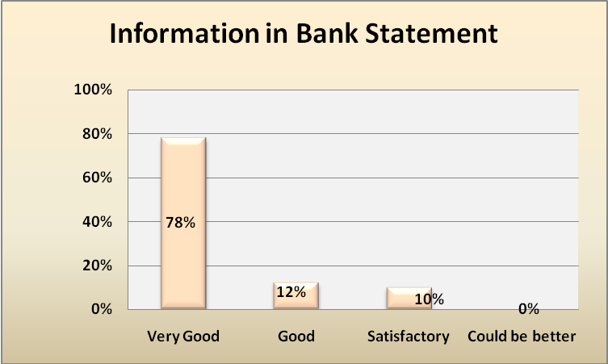

**Interpretation**

78% of the respondent opinioned that information in bank statement is clear, easy & adequate and is very good,12% of respondent opinioned that it is good,10% said it is satisfactory.

**Inference:** As 78% of respondents says information in the Bank Statement is clear, easy to understand and adequate or not, not too many were satisfied with the bank statement.

**Will you recommend YES Bank to your friends and relatives**

**Table:15**

|  |  |  |
| --- | --- | --- |
| **Parameter** | **In numbers** | **In percentage** |
| **Most Definitely** | **45** | **90** |
| **Yes** | **4** | **8** |
| **May Be** | **1** | **2** |
| **No** | **0** | **0** |

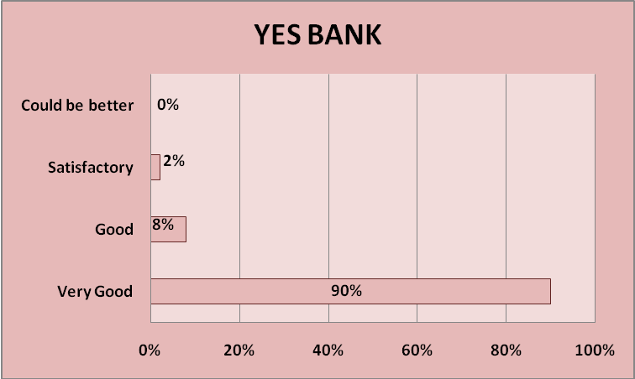

**Interpretation**

90% of respondent opinioned that they will most definitely recommend YES BANK to their friends & relatives, 8% of respondent opinioned yes. Only 2% said may be.

**Inference:** As 90% of respondent opinioned that they will definetly recommend YES BANK to their families & friends, maximum number of respondent opinioned positive.

## OPPORTUNITIES AND CHALLENGES

Retail banking has immense opportunities in a growing economy like India. As the growth story gets unfolded in India, retail banking is going to emerge a major driver. How does the world view us? The BRIC report is viewing India as an economic superpower. A.T. Kearney, a global management-consulting firm, recently identified India as the “second most attractive retail destination” of 30 emergent markets.

The rise of Indian middle class is an important contributory factor in this regard. The percentage of middle to high-income Indian households is expected to continue rising. The younger population not only wields increasing purchasing power, but as far as acquiring personal debt is concerned, they are perhaps more comfortable than previous generations. Improving consumer purchasing power, coupled with more liberal attitudes towards personal debt, is contributing to India’s retail banking segment.

The combination of above factors promises substantial growth in retail sector, which at present is in the nascent stage. Due to bundling of services and delivery channels, the areas of potential conflicts of interest tend to increase in universal banks and financial conglomerates. Some of the key policy issues relevant to the retail-banking sector are: financial inclusion, responsible lending, and access to finance, long-term savings, financial capability, consumer protection, regulation and financial crime prevention.

### What are the challenges for the industry and its stakeholders

*First*, retention of consumers is going to be a major challenge. According to a research by Riechheld and Sasser in the Harvard business review, 5percent increase in customer retention can increase profitability by 35 percent in banking business, 50 percent in insurance and brokerage, and 125 percent in the consumer credit card market. Thus, banks need to emphasis on retaining consumer and increasing the market share.

*Second*, rising indebtedness could turn out to be a cause for concern in the future. India’s position, of course, is not comparable to that of developed world where household debt as a proportion of disposable income is much higher. Such a scenario creates high uncertainty. Expressing concerns about the high growth witnessed in consumer credit segments the reserve bank has, as a temporary measure, put in place risk containment measures and increased the weight from 100 percent to 125 percent in the case of consumer credit including personal loans and credit cards.

*Third*, information technology poses both opportunities and challenges. Even with ATM machines and Internet Banking, many of the customers still prefer the personal touch of their neighborhood branch bank. Technology has made it possible to deliver services throughout branch network, providing instant updates to checking accounts and rapid movement of money for stock transfers. However, this dependency on the network has bought IT department’s additional responsibilities and challenges in managing, maintaining and optimizing the performance of retail banking networks. Illustratively, ensuring that all bank products and services are

available, at all times, and across the entire organization is essential for today’s retail banks to generate revenue and remain competitive. Besides, there are network management challenges, whereby keeping this complex, distributed networks and applications operating properly in support of business objectives becomes essential. Specific challenges include ensuring that account transaction applications run efficiently between the branch offices and data centers.

*Fourth*, KYC Issues and money laundering risks in retail banking is yet another important issue. Retail lending is regarded as a low risk area for money laundering because of the perception of the sums involved. However, competition for clients may also lead to KYC procedures being waived in the bid for new business. Banks must also consider seriously the type of identification documents the will accept and other processes to be completed. The Reserve Bank has issued details guidelines on application of KYC norms in November 2004.

###### Trends In Retail Banking

Growing a retail banking business is becoming increasingly challenging. The yield curve is flattening, reducing banks’ net interest margin. Competition is intensifying, as new, non-traditional players enter the retail banking space. And consumer preferences for financial products, payment methods and distribution channels continue to evolve, providing revenue opportunities, but also introducing new operational challenges.

The changing dynamics of the retail banking business have significant implications for financial institutions. In order to successfully compete in this environment, banks must provide a distinctive customer experience and offer innovative product solutions in order to differentiate their value proposition in the marketplace.

Key trends in retail Banking are:

1. Bifurcation of the retail banking business

* National- Consolidate- Credit Cards, Home Equity Loans Mortgages
* Local- Fragmented- Deposits, Installment Loans, Small Business Loans

2. Lack of differentiation in retail financial services:

Many financial institutions are struggling to differentiate their value propositions

in the retail banking market.

* Free checking is now offered by all or most financial institutions.
* Most institutions no longer charge for online banking or online bill payment.
* Extended branch hours are increasingly common in many markets, as banks
* seek to increase customer convenience.

3. Proliferation and growth of electronic payments: In the last 25 years, the range of payment methods available in the market has exploded. In addition to cash, checks, and credit cards, consumers can now use one of an expanding array of electronic payment options that includes debit cards, prepaid cards, online bill payment, automatic bill payment, and P2P services.

###### 4. Increasing demand for ATM access

###### Strategies for Ensuring high Customer Satisfaction

* Set service expectations and standards of behavior- this means that managers must set clear service expectations and standards of behavior, beginning with defining "excellent service."
* Identify and eliminate barriers and obstacles. Policies that do not make sense; procedures that get in the way; and rules, norms that make satisfying customers difficult all need to be eliminated to successfully improve service
* Learn and develop skills. Clearly, personnel at all levels should learn new skills related to service excellence and serve the customer.
* Listen to your customers. Measurement of customer satisfaction can be a powerful way to improve service if the feedback is not focused on punishment. Managers need to help staff hear, first hand, how they are doing. For this feedback to be effective, however, it must be tied to specific targets and goals and needs to be frontline driven
* Reinforce and support continuous improvement. The real challenge is keeping the energy, learning, and improving alive and going

###### FUTURE OF RETAIL BANKING

How do we see the future of retail banking? What are the major attributes of the shape of things to come in this sector?

*First*, customer service should be the be-all and end-all of retail banking. The other day a document released by the British Bankers Association, entitled UK Retail Banking Manifesto: addressing the challenges that lie ahead for the industry and its stakeholders on September 29, 2004 came to my notice. This document analysed the key policy issues relevant to the retail banking sector and highlighted the role of financial inclusion, responsible lending, access to finance, and consumer protection. It is in this context that that one is reminded of the needs to develop the standards and codes for banking.

The contribution of the Committee on Procedure & Performance Audit on Public Services (CPPAPS) (Chairman: Shri S.S. Tarapore) has been invaluable and has provided great insight. Based on the recommendation of the CPPAPS, the Annual Policy Statement for 2005-06 announced the decision to set up an independent Banking Codes & Standards Board of India on the model of the mechanism in the UK in order to ensure that comprehensive code of conduct for fair treatment of customers is evolved and adhered to. The codes and standards, together with the institutional mechanism to monitor them, are expected to enhance the quality of customer service, to the individual customer in particular. The codes will bring about greater transparency in the system and also tackle the issue of information asymmetry. The Board would function as an industry-wide watchdog of the banking code and ensure that the banks comply with the banking codes. The codes would establish the banking industry’s key commitments and obligations to customers on standards of practice, disclosure and principles of conduct for their banking services. The Board will monitor compliance with the Codes by the affiliated banks..

*Second,* sharing of information about the credit history of households is extremely important as far retail banking is concerned. Perhaps due the confidential nature of banker-customer, banks have a traditional resistance to share credit information on the client, not only with one another, but also across sectors. Globally, Credit Information Bureaus have, therefore, been set up to function as a repository of credit information - both current and historical data on existing and potential borrowers.

The database maintained by these institutions can be accessed by the lending institutions. Credit Bureaus have been established not only in countries with developed financial systems but also in countries with relatively less developed financial markets, such as, Sri Lanka, Mexico, Bangladesh and the Philippines. In Indian case, the Credit Information Bureau (India)

Limited (CIBIL), incorporated in 2000, aims at fulfilling the need of credit granting institutions for comprehensive credit information by collecting, collating and disseminating credit information pertaining to both commercial and consumer borrowers. At the same time banks must exercise due diligence before declaring a borrower as defaulter.

*Third,* outsourcing has become an important issue in the recent past. With the increasing market orientation of the financial system and to cope with the competition as also to benefit from the technological innovations such as, e-banking, the banks are making increasing use of "outsourcing" as a means of both reducing costs and achieving better efficiency. While outsourcing does have various cost advantages, it has the potential to transfer risk, management and compliance to third parties who may not be regulated. A recent BIS Report on “Outsourcing in Financial Services” developed some high-level principles. A basic requirement in this context is that a regulated entity seeking to outsource activities should have in place a comprehensive policy on outsourcing including a comprehensive outsourcing risk management programme to address the outsourced activities and the relationship with the service provider. Application of these principles in the Indian context is under consideration.

*Finally*, retail banking does not refer to lending only. In the whole story of retailing one should not forget the role played by retail depositors. The homemaker, the retail shop keeper, the pensioners, self-employed and those employed in unorganized sector - all need to get a place in the banks. It is in this backdrop that the Annual Policy for 2005-06 pointed out issues relating to financial exclusion and had announced that the RBI would implement policies to encourage banks which provide extensive services while disincentivising those which are not responsive to the banking needs of the community, including the underprivileged.

Furthermore, the nature, scope and cost of services need to be monitored to assess whether there is any denial, implicit or explicit, of basic banking services to the common person and banks have been urged to review their existing practices to align them with the objective of financial inclusion.

###### SUMMARY OF FINDINGS

* With reference to table no.1, 90% of customers are happy with the bank timings & they opinioned that it is very good.

* With reference to table no. 2, 80% of respondents like the branch ambience & layout & find it friendly with reference to table no.3, 80% of respondents said branch was clean and well maintained.
* With reference to table no.4, 76% respondents view that Branch personnel had listened to them patiently and have been able to respond to their queries and clarifications.
* 74% of respondent responded that Branch personnel had been very helpful and courteous with reference to table no.5.
* With reference to table no. 6,72% of respondents opinioned that branch personnel does ‘Need Analyses’ & ‘Risk Assessment’ of customer savings before recommending any investment option to them.
* With reference to table no.7,86% of respondent that branch personnel are aware of Product and Services and responded to your queries.
* With reference to table no 8, 80% of respondents opinioned that waiting time at the Teller Counter is very good.
* With reference to table no.9, 90% of respondent opinioned that transactions are smooth and error free & is very good.
* With reference to table no. 10, 82% of respondent responded that Yes Bank looks into the feedback & is very good.
* With reference to table no.11, 80% of respondent opinioned that they are happy with the TAT post request is very good.
* With reference to table no.12, 45% of respondent are in favour of Money Monitor feature of the YBL Savings account.
* With reference to table no.13, 74% of the respondent opinioned that YES COMMUNITY EVENTS are very good.
* With reference to table no. 14, 78% of the respondent opinioned that information in bank statement is clear, easy & adequate and is very good.
* With reference to table no 15, 90% of respondent opinioned that they will most definitely recommend YES BANK to their friends & relatives. Overall the response of the bank customer is good.

**SUGGESTIONS**

Suggestions are always considered to be the most important part of any project report because for every pros there is cons associated with and to reduce the effect of latter, following suggestions must be taken into consideration in regard to retail banking.

* The Branch personnel should listen to customer patiently and should be able to respond to their queries and clarifications because some customer are new to some of the bank services and until and unless they will come to know about those services they will be not be satisfied.
* With reference to table no. 5 as not many respondent opinioned that Branch Personnel are helpful and courteous, so I will suggest that Bank personnel should be helpful & courteous towards maximum number of customers.
* With reference to table no. 6, larger number of branch personnel should do ‘Need Analyses’ & ‘Risk Assessment’ before recommending any investment option to customer.
* With reference to table no.7, more branch personnel should be aware of Product and Services and responded to customer’s queries.
* With reference to table. 10, YES bank should look into the feedback provided by customer and takes necessary action wherever required.
* With reference to table no. 12, bank should focus on Instant FD facility &E-cheques as small 10% of customer likes this.
* Some time the customer has to wait at the Teller Counter, the service should

be improve by appointing more staff, with reference to table no.11.

* Information in the Bank Statement should be more clear, easy to understand and adequate.
* Along with customer satisfaction employee’s participation must be kept active by appraising their salary as they’ll as their work.
* Frequently customers must be kept delighted by providing them regards and by maintaining customer relationship so that their interest can be kept maintained.
* The YES bank should focus on business and service portfolio for a reputation of being niche players in the industry.
* The bank should concentrate on few reliable high net worth companies and individuals rather than cater to the mass market.
* As 10% customer response is not good for the clarification of the queries response towards them so bank personnel should improve this issue because customer is a source through which business can be increase and satisfy customers is a source to create more customers, with reference to table no.4
* As it is only 10% respondent said that sometime there was a error in the transaction happened so to avoid these kinds of errors should be avoided because it is unnecessarily results in wastage of time for both staff members and service rendered, reference to table no. 9
* Their should increase in the number of events organize by bank because it is a opportunity for the bank to introduce new products and services and at the same time it is a open opportunity for the customer to come forward and suggest its views which might prove to add the values for the bank because 10% customer still not have a good response, with reference to table no.13
* Communication with the customer should improve and increase so bank can easily response towards them and in result the customer would be satisfy and no question that they will recommend the YES Bank to their friends and relatives because 2% customer are no responding it in a positive manner.

**Conclusions – Future Growth**

The project aims to study the retail banking operations of YES BANK. The study was very fruitful, it yielded the desired results, helped me understand the retail banking. The study also helps in what are the customer opinions towards operations of bank & its various product and services.

Any serious discussion of the future of the retail banking industry eventually raises a basic question: will future customers still need retail banks? The answer, it turns out, depends on banks themselves. With technology and nonblank businesses providing new options for safeguarding and managing their finances, customers will continue to depend on banks only as long as banks can provide service and value that cannot be found anywhere else.

The need to become highly customer focused has forced the slow-moving public sector banks to adopt a fast track approach. The unleashing of products and services through the net has galvanized players at all levels of the banking and financial institutions market grid to look a new at their existing portfolio offering. Conservative banking practices allowed.

Indian banks to be insulated partially from the Asian currency crisis.Indian banks are now quoting at higher valuation when compared to banks in other Asian countries (viz. Hong Kong, Singapore, Philippines etc.) that have major problems linked to huge Non Performing Assets (NPAs) and payment defaults. Co-operative banks are nimble footed in approach and armed with efficient branch networks focus primarily on the ‘high revenue’ niche retail segments.

The Indian banking has finally worked up to the competitive dynamics of the ‘new’ Indian market and is addressing the relevant issues to take on the multifarious challenges of globalization. Banks that employ IT solutions are perceived to be ‘futuristic’ and proactive players capable of meeting the multifarious requirements of the large customer’s base.

YES BANK has a great opportunity to increase their market potential in the present market situation.

**Learning Experience**

The Dissertation is to define the retail banking and regarding the general services of bank.

The study was very fruitful, it yield the desire result, helped me to understand the banking services better. The study also yield what are the factors that banking are looking forward for the customer.

The Indian banking has come from a long way from being a sleepy business institution to a highly proactive and dynamic entity. This transformation has been largely brought about by the large dose of liberalization and economic reforms that allowed banks to explore new business opportunities rather than generating revenues from conventional streams (i.e. borrowing and lending). The banking in India is highly fragmented with 30 banking units contributing to almost 50% of deposits and 60% of advances.

Industry estimates indicate that out of 274 commercial banks operating in India, 223 banks are in the public sector and 51 are in the private sector. The private sector bank grid also includes 24 foreign banks that have started their operations here. Under the ambit of the nationalized banks come the specialized banking institutions.

The bank gives great importance towards customer satisfaction .The senior staff with their busy schedule try to advice the customer how to invest in better way.\

The employees in the bank are well behaved and give a great deal of satisfaction to see them how they approach their customers. The bank plays an important role not only to fulfill their duties towards customer but also to understand them better regarding what they want and how to maximize the return on the investment.

The bank has set up separate department for the impart training program for the employees. The biggest achievement is the implementation of core banking solution.

**FINANCIAL STATEMENTS**

**Balance sheet**

|  |  |  |  |  |  |
| --- | --- | --- | --- | --- | --- |
|  | **Mar ' 09** | **Mar ' 08** | **Mar ' 07** | **Mar ' 06** | **Mar ' 05** |
| **Sources of funds** | | | | | |
| Owner's fund | | | | | |
| Equity share capital | 296.98 | 295.79 | 280 | 270 | 200 |
| Share application money | - | - | - | - | - |
| Preference share capital | - | - | - | - | - |
| Reserves & surplus | 1,327.24 | 1,023.13 | 507.06 | 302.69 | 17 |
| **Loan funds** | | | | | |
| Secured loans | - | - | - | - | - |
| Unsecured loans | 16,169.42 | 13,273.16 | 8,220.39 | 2,910.38 | 663.03 |
| Total | 17,793.64 | 14,592.08 | 9,007.45 | 3,483.07 | 880.03 |
| **Uses of funds** | | | | | |
| Fixed assets | | | | | |
| Gross block | 194.88 | 133.01 | 86.66 | 36.24 | 17.59 |
| Less : revaluation reserve | - | - | - | - | - |
| Less : accumulated depreciation | 64.15 | 35.73 | 17.38 | 6.81 | 1.25 |
| Net block | 130.73 | 97.28 | 69.28 | 29.43 | 16.34 |
| Capital work-in-progress | 0.39 | 3.89 | 1.59 | 5.29 | 3.3 |
| Investments | 7,117.02 | 5,093.71 | 3,073.12 | 1,350.14 | 394.86 |
| **Net current assets** | | | | | |
| Current assets, loans & advances | 1,326.86 | 729.7 | 376.88 | 155.01 | 49.66 |
| Less : current liabilities & provisions | 2,918.10 | 1,404.13 | 1,228.68 | 214.72 | 28.4 |
| Total net current assets | -1,591.24 | -674.42 | -851.8 | -59.71 | 21.26 |
| Miscellaneous expenses not written | - | - | - | - | - |
| Total | 5,656.90 | 4,520.45 | 2,292.20 | 1,325.16 | 435.77 |
| **Notes:** | | | | | |
| Book value of unquoted investments | - | - | - | - | - |
| Market value of quoted investments | - | - | - | - | - |
| Contingent liabilities | 43,481.94 | 68,874.54 | 52,061.58 | 17,524.20 | 6,522.22 |
| Number of equity sharesoutstanding (Lacs) | 2969.79 | 2957.9 | 2800 | 2700 | 2000 |

**RATIO ANALYSIS**

**Calculation of the ratios**

|  |  |  |  |  |  |
| --- | --- | --- | --- | --- | --- |
| Particulars | Mar ' 09 | Mar ' 08 | Mar ' 07 | Mar ' 06 | Mar ' 05 |
| Calculation of Owners Fund ( Equity Base) | 1,624.22 | 1,318.92 | 787.06 | 572.69 | 217 |
| Calculation of Net Profit for the Year | 304.11 | 516.07 | 204.37 | 285.69 | 17 |
| Operating Balance of Net Profit | 1023.13 | 507.06 | 302.69 | 17 | 0 |
| Return on Net Worth | 0.19 | 0.39 | 0.26 | 0.50 | 0.07834 |
| Total Fixed Assets | 130.73 | 97.28 | 69.28 | 29.43 | 16.34 |
| Earning Per Share (Rs.) | 0.45 | 0.35 | 0.18 | 0.112107 | 0.0085 |
| Current Assets | 1,326.86 | 729.7 | 376.88 | 155.01 | 49.66 |
| Current Liabilities | 2918.1 | 1404.13 | 1228.68 | 214.72 | 28.4 |
| Current Ratio | 0.45 | 0.52 | 0.31 | 0.72 | 1.74859 |
|  |  |  |  |  |  |
| Debt Equity Ratio |  |  |  |  |  |
| (Loan/ capital + Net Profit) |  |  |  |  |  |
| Loan | 16169.42 | 13273.16 | 8220.39 | 2910.38 | 663.03 |
| Capital +Net Profit | 1,624.22 | 1,318.92 | 787.06 | 572.69 | 217 |
| Debt Equity Ratio | 9.96 | 10.063658 | 10.44443 | 5.081947 | 3.05544 |
|  |  |  |  |  |  |
| Working Capital | -1,591.24 | -674.42 | -851.8 | -59.71 | 21.26 |
| Net Profit for the Year | 304.11 | 516.07 | 204.37 | 285.69 | 17 |
| Return on Working Capital | -0.19 | -0.77 | -0.24 | -4.78 | 0.79962 |

**Chart 1**



**Chart 2**



**Chart 3**



**Chart 4**



**Chart 5**



**Chart 6**



**RATIOS**

* Return on Net Worth = Net Profit / Owners Fund
* Earning Per Share = (Net Profit + Operating Balance of Net Profit) / Net Worth
* Current Ratio = Current Asset / Current Liablities
* Debt Equity Ratio = Total Debt / Equity.
* Return on Working Capital = Net Profit for the year / Working Capital
* Working Capital = Current Asset – Current Liablities.

**INTERPRETATIONS**

* Return on Net Worth is low its shows that bank is getting less rate of return on the invested funds, with the reference to chart no. 1
* Earning per share is continuously increasing which could be helpful to attract more number of customers, with reference to chart no. 2
* The Current Ratio is adverse because it is lower than 1. Its means the bank has more current liabilities than current asset, with reference to chart no. 3
* The Debt Equity Ratio is adverse because it is more than Net Worth, more Debt is not good for bank, with reference to chart no. 4
* Return on working capital is slightly increasing as compare to previous years but it is still need to be more, with reference to chart no. 5
* Company has current liabilities more than current asset which is not good foe the viability of the bank it is not beneficial for short and long term and it is showing is negative sign, with reference to table no. 6

**Questionnaire**

**YES for YOU – Help us to serve you even better**

Dear Valued Customer,

Your candid feedback on our service standards is very important for us to help you serve even better.

We would like to know a little more about you:

Your Name:

Your Cust Id/A/c No.(optional):

Your Branch:

Your E-mail id:

Your Contact details:

How frequently do you visit the Branch (in a month):

We would be extremely grateful if you would let us know how we are doing. We would like to know about your experience of Banking with us. Please tick as appropriate.

**A. How was the Branch experience?**

1) The Branch timings (9:30 am to 6:30 pm from Monday to Saturday) are convenient?

**a) Very Good b) Good c) Satisfactory d) Could be**

**better**

2) The Branch ambience & layout is very friendly?

**a) Very Good b) Good c) Satisfactory d) Could be**

**better**

3) The Branch was clean and well maintained?

**a) Very Good b) Good c) Satisfactory d) Could be**

**better**

**B. How did you find our Branch personnel?**

4) The Branch personnel have listened to me patiently and have been able to respond to my queries and clarifications?

**a) Very Good b) Good c) Satisfactory d) Could be**

**better**

5) The Branch personnel have been very helpful and courteous?

**a) Very Good b) Good c) Satisfactory d) Could be**

**better**

6 The branch personnel have done a ‘Need Analyses’ & ‘Risk Assessment’ before recommending any investment option?

**a) Very Good b) Good c) Satisfactory d) Could be**

**better**

7) The branch personnel were aware of Product and Services and responded to your queries?

**a) Very Good b) Good c) Satisfactory d) Could be**

**better**

**C. How was your experience of transacting in our Branches?**

8) The waiting time at the Teller Counter was minimal?

**a) Very Good b) Good c) Satisfactory d) Could be**

**better**

9) The transactions done by us have been smooth & error free?

**a) Very Good b) Good c) Satisfactory d) Could be**

**better**

10) Yes bank looks into the feedback provided by you and takes necessary action if required.

**a) Very Good b) Good c) Satisfactory d) Could be**

**better**

11) Are you Happy with the TAT (Turn around time) post request?

**a) Very Good b) Good c) Satisfactory d) Could be**

**better**

**12)** Which feature of the YBL Savings account you like most?

**a) OBOPAY b) Money Monitor c) Instant FD d) E-Cheques**

**OD facility**

**D. How do you like what we send to you?**

**13)** How do you rate the ‘YES COMMUNITY EVENTS’ held at yes bank?

**a) Very Good b) Good c) Satisfactory d) Could be**

**better**

**14)** Is the information in the Bank Statement clear, easy to understand and adequate?

**a) Very Good b) Good c) Satisfactory d) Could be**

**better**

**15)** Will you recommend YES Bank to your friends and relatives?

**a) Most Definitely b) Yes c) May be d) No**

**Bibliography**

* <http://economics.about.com/cs/finance/a/india_banking_2.htm>
* <http://www.expresscomputeronline.com/20020610/opinion2.shtml>
* <http://www.yesbank.com/citizen_charter.htm>
* <http://www.vyapaarasia.com/india/banks.asp>
* <http://www.indianexpress.com/ie/daily/20001222/focus10.htm>
* <http://www.peoplesmarch.com/archives/2001/feb2k1/banking.htm>
* <http://www.onlinebangalore.com/fina/pro_yes.html>
* <http://www.yesbank.com/loan.htm#yesSHELTER>
* [www.moneycontrol.com](http://www.moneycontrol.com)
* <http://www.yesbank.com/international_banking.htm#PRODUCTS>
* <http://www.moneycontrol.com/news/hotstocks/newsdetail_new.php?filename=news19062004112840.htm>
* <http://www.livemint.com/2009/06/21220423/Yes-Bank-a-unique-model-No-co.html>