A

Project Report on

**“CUSTOMER SATISFACTION TOWARDS WHATSAPP”**

Submitted

In the partial fulfillment of the Degree of

Bachelor of Business Administration

Semester-VI

By

**Khyati M. Patel (08)**

Submitted To:

**Ms. Ronak Dabgar**

Assistant Professor

Golden Jubilee Institute of Business Administration,

Hemchandracharya North Gujarat University,

Sidhpur



March 2014

**PREFACE**

With the recent $19 billion cash acquisition of WhatsApp by Facebook, the $11 billion market capitalization of Twitter, and the $1 billion acquisition of Instagram by Facebook, it is clear that companies successful on mobile are valued extremely highly. Despite their high valuations, none of these companies are profitable; their value is based on number of users and user growth. There is a market for mobile that has even larger user bases, with even faster user growth, managing to actually generate significant revenues; mobile messaging applications.

In this competitive environment it is of utmost important for the managers to be rational concerning about the each and every aspect of marketing of the products in order to take any decision which would further foster the growth and development of the company. And for doing so, they must have the holistic view of all the marketing strategies, so by considering the future responsibility of us; we have made fine efforts to make qualitative research.

As a part of our research project we found it relay tough and interesting task to analyze “Customer Satisfaction towards WhatsApp."

The report prepared is fully for academic purpose with various analyses part, which shows “Customer Satisfaction towards WhatsApp."

The training was a barometer to test not only our management skills bit to explore and apply our theoretical knowledge practically.

Golden Jubilee Institute of Business Administration  *Khyati Patel (08)*

*Date: ________* *(BBA SEM-VI)*

**ACKNOWLEDGEMENT**

*“It is not possible to prepare a project report without the assistance & encouragement of other people. This one is certainly no exception.”*

On the very outset of this report, I would like to extend my sincere & heartfelt obligation towards all the personages who have helped me in this project. Without their active guidance, help, cooperation & encouragement, I would not have made headway in the project.

I gratefully acknowledge Dr. Preeti Mishra, Prof. & Head, GJIBM,I am sincerely thankful to Ms. Ronak Dabgar, Assistant Professor, GJIBM, my guide of the project, for guiding me with attention and care. She has provided me with valuable insights during the entire project work and her co-operation at every step. Plus, she has taken pain to go through the project and make necessary corrections as and when needed.

I also express my deep gratitude to all who have contributed for the successful completion of this project.

Khyati M. Patel

**EXECUTIVE SUMMARY**

2013 has undoubtedly proven to be the year of virtual chat with more than 90% of smart phone users busy texting each other using some app or other. In fact, Whatsapp has emerged as the most popular app among Indians with virtually every second cell phone customer using the app.

As part and partial fulfillment of management course subject of marketing research for BBA program I have selected "**WhatsApp Inc.**" for general understanding of the marketing research. However in particular my emphasis was on to fulfill the objective of research and to find out and to explore the analyses of primary data.

WhatsApp Inc. was founded in 2009 by Americans Brian Acton and Jan Koum (also the CEO), both former employees of Yahoo!, and is based in Mountain View, California. The company employs 55 people.

This Project Report is to measure the Satisfaction level of WhatsApp Messenger; customer satisfaction is a measure of how products and services supplied by a company meet customer expectation. Customer satisfaction is critical if a company is to register high sales profits.

The study of on this project helped me to know current market scenarios of Whatsapp and also the variety of services that it offers to the users.

In today’s tough economic climate all organizations need to improve efficiency and, even in midsize firms that usually mean coordinating large quantities of information. However, technology and thinking has progressed and, billions of user nowadays using WhatsApp.

Chapter 1presents an introduction toSocial Messengers and includes topics such as what is Mobile Application, different social messenger applications and future of mobile messaging. Other topics discussed competition between social messenger applications.

Chapter 2 introduces WhatsApp, its background, then acquisition by Facebook, advantages of using WhatsApp, Why it’s so popular in India and the milestone of WhatsApp reaching 450 Million Active Users.

Chapter 3 on strategy of WhatsApp covers details of SWOT analysis, Pestle Analysis, Porter’s 5 Forces model on Whatsapp.

Chapter 4 focuses on Research Methodology and covers topics such as objectives of study, research design, sampling methodology with Limitations of the study.

Chapter 5 deals with Data Analysis of the collected data and includes statistical analysis and Interpretation on analysis.

Chapter 6 includes findings of the study with conclusion of research, as well as recommendations addressing the WhatsApp.

The project is done to know, how much a consumer is satisfied about the WhatsApp Messenger and what additional features should company introduce to increase the potential customer.

**TABLE OF CONTENT**

|  |  |  |
| --- | --- | --- |
| **INDEX** | | |
| **SR NO.** | **Particular** | **PAGE NO.** |
| I | Candidate’s Statement | I |
| II | Preface | II |
| III | Acknowledgement | III |
| IV | Executive summery | IV |
| **Chapter1 : Introduction to Social Messengers** | | |
| 1.1 | What is Mobile Application | 2 |
| 1.2 | Different Social Messenger Apps | 3 |
| 1.3 | The Future of Mobile Messaging | 6 |
| 1.4 | Social Messenger War | 8 |
| **Chapter 2 : Introduction to WhatsApp** | | |
| 2.1 | About the WhatsApp | 11 |
| 2.2 | Background | 13 |
| 2.3 | Acquisition: A $19 billion bet by Facebook | 15 |
| 2.4 | Why Use WhatsApp (Advantages) | 16 |
| 2.5 | Why WhatsApp is so popular in India | 17 |
| 2.6 | WhatsApp Reaches 450 Million Active Users | 18 |

|  |  |  |
| --- | --- | --- |
| **Chapter 3 : Strategy On WhatsApp** | | |
| 3.1 | IT Strategy on WhatsApp | 21 |
| 3.2 | SWOT Analysis | 23 |
| 3.3 | Porter’s Five Forces Analysis | 24 |
| 3.4 | PESTLE Analysis | 26 |
| **Chapter 4 : Research Methodology** | | |
| 4.1 | Objectives | 31 |
| 4.2 | Methodology | 31 |
| **Chapter 5 : Analysis & Interpretation** | | |
| 5.1 | Data Analysis | 34 |
| **Chapter 6 : Findings, Recommendation, Limitations and Conclusion** | | |
| 6.1 | Findings & Recommendation | 47 |
| 6.2 | Limitations of the Research | 49 |
| 6.3 | Conclusion | 50 |
| **Appendices** | | |
| 1 | Bibliography | 52 |
| 2 | Questionnaire | 53 |

**Chapter - 1 Introduction to Social Messengers**

* 1. **WHAT IS MOBILE APPLICATION?**

Mobile applications (apps) have been gaining rising popularity due to the advances in mobile technologies and the large increase in the number of mobile users. Consequently, several app distribution platforms, which provide a new way for developing, downloading, and updating software applications in modern mobile devices, have recently emerged.

A mobile application is a software application designed to run on smartphones, tablet computers and other mobile devices. They are usually available through application distribution platforms, which are typically operated by the owner of the mobile operating system, such as the Apple App Store, Google Play, Windows Phone Store, and BlackBerry App World.

Some apps are free, while others must be bought by usually, they are downloaded from the platform to a target device, such as an iPhone, BlackBerry, Android phone or Windows Phone, but sometimes they can be downloaded to laptops or desktops. For apps with a price, generally a percentage, 20-30%, goes to the distribution provider (such as iTunes), and the rest goes to the producer of the app.

**Instant messaging** has become the killer app on mobile as smart phone adoption has grown across the globe and the Indian scene is no exception. Three out of every four smart phone user in India is now high on mobile chatting making the market a lucrative one for chat app companies.

WhatsApp reigns supreme among mobile chat app with about 76% of smart phone users in India using it to text each other, revealed a recent study on smartphone usage in India by Informate Mobile Intelligence.

* 1. **DIFFERENT SOCIAL MESSENGER APPs:**

1. **WhatsApp:**

WhatsApp Messenger is a proprietary, cross-platform instant messaging service for smartphones. In addition to text messaging, users can send each other images, video, and audio media messages. In addition to text messaging, users can send each other images, video, and audio media messages. The client software is available for Android, BlackBerry OS, BlackBerry 10, iOS, Nokia-Series 40, Symbian (S60), and Windows Phone.

1. **Facebook:**

****Facebook is an online [social networking service](http://en.wikipedia.org/wiki/Social_networking_service). Facebook was founded in February 2004 by [Mark Zuckerberg](http://en.wikipedia.org/wiki/Mark_Zuckerberg) with his college roommates and fellow [Harvard University](http://en.wikipedia.org/wiki/Harvard_University) students [Eduardo Saverin](http://en.wikipedia.org/wiki/Eduardo_Saverin), [Andrew McCollum](http://en.wikipedia.org/wiki/Andrew_McCollum), [Dustin Moskovitz](http://en.wikipedia.org/wiki/Dustin_Moskovitz) and [Chris Hughes](http://en.wikipedia.org/wiki/Chris_Hughes). The founders had initially limited the website's membership to students of the University of Harvard, but later expanded it to colleges in the Boston area, the [Ivy League](http://en.wikipedia.org/wiki/Ivy_League), and [Stanford University](http://en.wikipedia.org/wiki/Stanford_University). It gradually added support for students at various other universities before it opened to high school students, and eventually to anyone ages 13 and over. Facebook now allows anyone who claims to be at least 13 years old to become a registered user of the website.

1. **WeChat:**

WeChat (Chinese: 微信; pinyin: Wēixìn; literally "micro message") is a mobile text and voice messaging communication service developed by Tencent in China, first released in January 2011. The app is available on Android, iPhone, BlackBerry, Windows Phone, and Symbian platforms.

WeChat provides multimedia communication with text messaging, hold-to-talk voice messaging, broadcast (one-to-many) messaging, photo/video sharing, location sharing, and contact information exchange. WeChat supports social networking via shared streaming content feeds and location-based social plug-ins ("Shake", "Look Around", and "Drift Bottle") to chat with and connect with local and international WeChat users.

1. **Twitter:**

Twitter is an online social networking and micro-blogging service that enables users to send and read "tweets", which are text messages limited to 140 characters. Registered users can read and post tweets but unregistered users can only read them. Users access Twitter through the website interface, SMS, or mobile device app. Twitter Inc. is based in San Francisco and has offices in New York City, Boston, and San Antonio.

1. **BBM (BlackBerry Messenger):**

BlackBerry Messenger (BBM) is a proprietary Internet-based instant messenger and videotelephony application included on BlackBerry devices that allows messaging (and videocalls for BlackBerry 10 smartphones) between BlackBerry users. It was developed by the manufacturer of the BlackBerry, BlackBerry Limited (formerly known as Research In Motion Limited (RIM)). Messages sent via BlackBerry Messenger are sent over the Internet and use the BlackBerry PIN system, so communication was only possible between BlackBerry devices until 2013. There are 70 million BBM users worldwide and BlackBerry infrastructure handled 30 petabytes of data traffic each month by early 2013.With the release of BlackBerry Messenger 7.0 in December 2012, voice chat was introduced. The new feature is called BBM Voice Call.

BBM was officially released on iOS and Android on 21 October 2013. 5 million downloads were recording in the first 8 hours of its release. In total, the app had over 10 million downloads on the first day. At 24 February BlackBerry officially confirmed BBM for Windows Phone.

1. **Skype:**

Skype is a freemium voice-over-IP (VoIP) service and instant messaging client that is currently developed by the Microsoft Skype Division. The name originally derived from "sky" and "peer".

Skype was first released in August 2003; it was written by Estonian developers Ahti Heinla, Priit Kasesalu, and Jaan Tallinn, Danish Janus Friis, and Swedish Niklas Zennström, who had also originally developed Kazaa. Skype had 663 million registered users as of the end of 2010. It was bought by Microsoft in 2011 for $8.5 billion.

1. **LINE:**

Line is a Japanese proprietary application for instant messaging on smartphones and PCs. Line users exchange text messages, graphics, video and audio media, make free VoIP calls, and hold free audio or video conferences. Line, launched in Japan in 2011, reached 100 million users within eighteen months and 200 million users only six months later.

Line was originally developed as a mobile application for Android and iOS smartphones. The service has since expanded to BlackBerry (August 2012), Nokia Asha (Asia and Oceania, March 2013), and Windows Phone (July 2013). The application also exists in versions for laptop and desktop computers using the Microsoft Windows and Mac OS platforms.

1. **Other:**

**Viber:** Viber is a proprietary cross-platform instant messaging voice-over-Internet Protocol application for smartphones developed by Viber Media. In addition to text messaging, users can exchange images, video and audio media messages. The client software is available for Mac OS, Android, BlackBerry OS, iOS, Series 40, Symbian, Bada, Windows Phone, and Microsoft Windows. Viber works on both 3G/4G and Wi-Fi networks. It first requires installation on a phone in order to work on a desktop operating system environment. Viber reached 200 million users as of May 7, 2013.

It was founded and co-owned by four Israeli partners: Talmon Marco, Igor Megzinik, Sani Maroli and Ofer Smocha. Talmon Marco serves as its CEO. On 14 February 2014, the startup was acquired by Rakuten for $900 million.

**SnapChat:** Snapchat is a photo messaging application developed by Evan Spiegel and Robert Murphy, then Stanford University students. Using the application, users can take photos, record videos, add text and drawings, and send them to a controlled list of recipients. These sent photographs and videos are known as "Snaps". Users set a time limit for how long recipients can view their Snaps (as of December 2013, the range is from 1 to 10 seconds), after which they will be hidden from the recipient's device and deleted from Snapchat's servers.

**Tango:**Tango is third-party, cross platform messaging application software for smartphones developed by TangoME, Inc. in 2009. The app is popular for offering video calls over 3G, 4G and Wi-Fi networks,in addition to video calls, is also optimized for voice calls, texting, photo sharing, and playing games.

Tango has more than 0 million registered users as at March 2013 and, among Android devices, it is the 12th most downloaded app. It is rated by PCMag as "the simplest mobile chat application out there, with a good range of support."

Tango is primarily geared towards Android devices. The app is also compatible with iOS, Windows Phone 7, and PCs. Tango has partnered with Aviary to provide photo-editing capabilities.

* 1. **THE FUTURE OF MOBILE MESSAGING:**

**Premium content, brand development, gaming, and in-app payments offer revenue generation possibilities**

Most apps are focusing on growing its user base and improving the core product with new features, hoping the money will follow. The market valuation of Twitter, the acquisition of WhatsApp &Instagram by Facebook, and the offers for SnapChat from Facebook and Google, suggest that this may be the right strategy, with user growth more highly valued than revenues or profitability.

Like search and social applications before it, mobile messaging applications have not been instantly lucrative. Advertising became the dominant business model in both of these areas, but it is unlikely that advertising will be able to generate the mobile revenues that it was able to do on the PC. The small form factor means display advertising can be more irritating than relevant. Almost all mobile messaging applications are avoiding advertising, and are exploring different ways of generating revenues. Four different business models are being explored by market participants.

Charging for premium content such as wallpapers, stickers, and themes has emerged as the de facto way to generate revenues. Not only does premium content improve the customer experience, it is not intrusive and can be a way for brands to interact with customers. Almost all apps are offering premium content in one way or another.,

Allowing brands to use the platform has emerged as a potential new revenue stream. With official accounts, brands and merchants can connect and interact with fans and customers in a personal and real-time fashion. The possibility of the integration of location-based services such as iBeacons from Apple or Bluetooth Low Energy will enable business to reach their customers at increasingly relevant times driving online and offline purchases.

Gaming and platform SDKs is another revenue stream that has proven to be lucrative for both LINE and KakaoTalk. In-game purchases and the social nature of the platforms offer a very sticky experience and is possibly the only revenue stream that builds an ecosystem of users, developers, and business around the platform. The success of gaming on mobile messaging suggests a real opportunity for these companies to develop into fully fledged content distribution platforms, and further monetizing users. It is not a leap to imagine mobile messaging companies offering music or television clips, and charging content makers for referrals, or even offering full albums, books, or films.

**The companies that expand beyond messaging and develop a content distribution platform will win in this market**

The mobile messaging application market is possibly the hottest in technology right now. As internet giants Google, Facebook, and Yahoo attempt to monetize users on mobile, messaging applications are exploring a variety of different ways to generate revenues. It is clear that the advertising model that worked so well in the PC era will not be as successful on mobile. Instead, new innovative business models are emerging.

Three different ways to monetize users have emerged in the mobile messaging market; distribution of premium content, the platform as a brand building tool, and gaming and in-app purchasing. These monetization techniques take applications beyond the discrete world of mobile messaging into the infinite possibilities associated with mobile distribution platforms. Many apps use a variety of these monetization techniques, and each technique has different regional dynamics. Stickers, for example, are far more popular in Asia than they are in North America and Europe.

In today’s mobile world, generating revenue is almost of secondary importance to user engagement and user growth, so a balance must be struck between monetization and customer experience. The key to success for these companies will be to provide rich and diverse content, and to build an ecosystem around the application. The platform must provide much more than just messaging with friends.

This ecosystem will serve to build a sense of loyalty and stickiness, creating a barrier for the user to leave for another application. The market opportunity is huge, according to Ericsson, as there were 1.9 billion smartphones at the end of 2013 and by the end of 2019 there will be 5.6 billion. For those companies that can attract and retain users, the revenue potential is virtually limitless.

* 1. **SOCIAL MESSENGER WAR:**

A survey of 3,759 Android and iOS smartphone owners in the US, Brazil, South Africa, India and China, carried out by mobile market research company On Device Research, reveals that Facebook Messenger no longer leads in social messaging.





* WhatsApp has overtaken Facebook as the leading social messaging service on mobile, according to a research by [On Device](http://ondeviceresearch.com/blog/messenger-wars-how-facebook-lost-its-lead).
* A survey found that 44 per cent use WhatsApp at least once a week, whereas just 35 per cent use Facebook messenger.
* The report also confirmed that social messaging apps – including WeChat, Twitter, BBM and Skype – are the dominant way in which people communicate on their phone.
* It found that 86 per cent use social messaging daily, while 73 per cent use their phones for voice calls, 75 per cent use SMS messages, and 60 per cent use email.
* Social messaging app use in at least once a week; in US, Brazil, China, South Africa, Indian smartphone

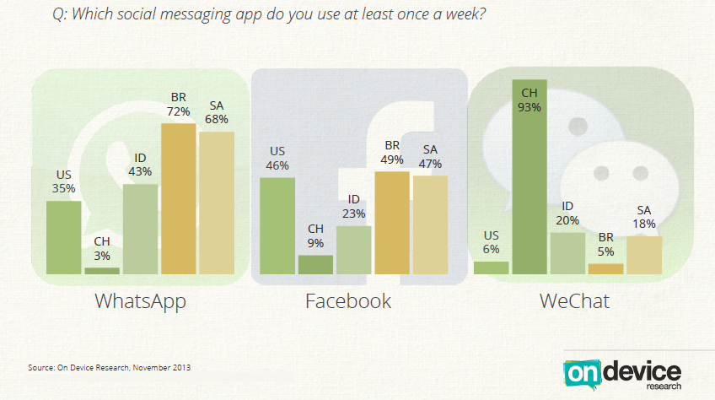- Owners popularity of WeChat is mostly driven by China

**Chapter - 2Introduction to WhatsApp**

* 1. **WhatsApp:**

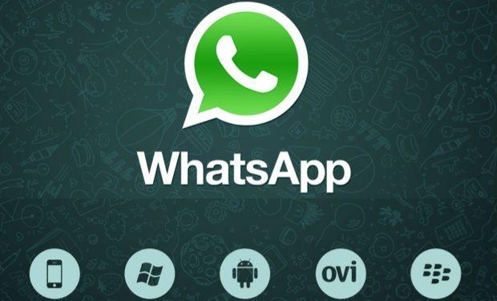

WhatsApp Messenger is a proprietary, cross-platform instant messaging service for smartphoneswithout having to pay for SMS. In addition to text messaging, users can send each other images, video and audio media messages as well as their location using integrated mapping features. The client software is available for Google Android, BlackBerry OS, and Apple iOS, selected Nokia Series 40, Symbian, selected Nokia Asha platform, Microsoft Windows Phone and BlackBerry 10.

WhatsApp Inc. was founded in 2009 by Americans Brian Acton and Jan Koum (also the CEO), both former employees of Yahoo!, and is based in Mountain View, California. The company employs 55 people.

WhatsApp, a dream come true of talking to a friend sitting oceans apart through radio-waves, means absolutely free. What used to cost a somewhere between Rs. 5-15 per message was brought down to being free by online messaging like Way2SMS.

This was still found to be cumbersome by people mainly due the involvement of internet which required logging or signing in a personal computer or laptop. This is where WhatsApp walked in to make life easy for Smartphone users. It leveraged on the increasing popularity of the term, ‘Stay Connected’.

Where people wanted staying in touch with their friends and loved ones for as low a price as possible, WhatsApp removed the price aspect from it. It seems this application builders leveraged on the growing population of ‘Short message service (SMS)’ users.

Competing with a number of Asian-based messaging services (like LINE, KakaoTalk, WeChat), WhatsApp handled ten billion messages per day in August 2012, growing from two billion in April 2012, and one billion the previous October. On June 13, 2013, WhatsApp announced that they had reached their new daily record by processing 27 billion messages. According to the Financial Times, WhatsApp "has done to SMS on mobile phones what Skype did to international calling on landlines."

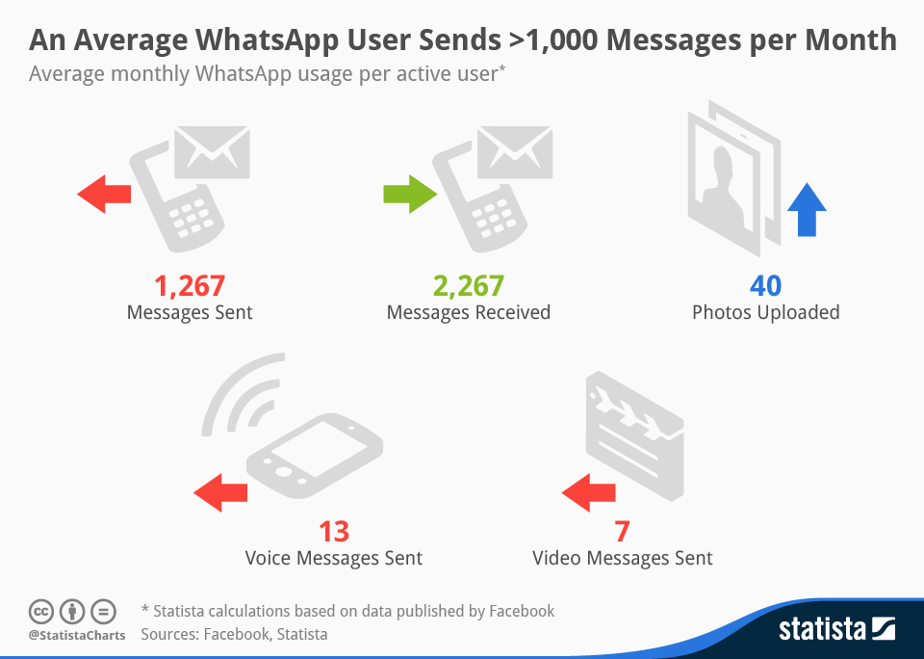

As of November 10, 2013, WhatsApp had over 190 million monthly active users, 400 million photos are shared each day, and the messaging system handles more than 10 billion messages each day. In a December 2013 blog post, WhatsApp claimed that 400 million active users use the service each month.

On February 19, 2014, Facebook Inc. announced it is acquiring WhatsApp Inc. for US$19 billion. Facebook will pay $4 billion in cash, $12 billion in Facebook shares and $3 billion in restricted stock units to be granted to WhatsApp founders and employees that will vest over four years

* 1. **BACKGROUND**

**History**

An invention by ‘two guys with an experience of 20 years at Yahoo! Inc.’ as per the official website, WhatsApp stirred hard the broth BlackBerry (BB) had tried to, but could only cater to BlackBerry users, in the form of BB Messenger. No wonder, the success of WhatsApp is much greater (in terms of number of users) compared to BlackBerry Messenger. It is supported by many platforms – Windows, BlackBerry, Android etc. It has even managed to enter the territory of Apple, which is otherwise difficult to cross for a non-Apple-made application.

‘What’s up’, the on-going homonym pun, somehow makes it easier for the youth to connect with WhatsApp (Intelligent naming).

From being a multi-purpose, user-friendly, connectivity application to allowing sharing of not only messages but also images, audio files and videos, WhatsApp is a rage. The reason is pretty obvious – From downloading it to using it, WhatsApp is free!

But then WhatsApp does cost you something. It demands an internet connection, on the smartphone handset, to be in use. Just out of curiosity, I wonder then why should one not be as crazy about using G-talk or Yahoo messenger or AOL as well. Some of us must have heard of the ‘kik’ application which followed in the footsteps of WhatsApp and was a declared success. Why, all of these are free too, with the internet connection? That makes them as well equipped as WhatsApp.

What, then, distinguishes WhatsApp from the other free of cost applications?

**TECHNICAL**

WhatsApp uses a customized version of the open standard Extensible Messaging and Presence Protocol (XMPP). Upon installation, it creates a user account using one's phone number as the username (Jabber ID: [phone number] @s.whatsapp.net). WhatsApp software automatically compares all the phone numbers from the device's address book with its central database of WhatsApp users to automatically add contacts to the user's WhatsApp contact list. Previously the Android and S40 versions used an MD5-hashed, reversed-version of the phone's IMEI as password, while the iOS version used the phone's Wi-Fi MAC address instead of IMEI. A 2012 update now generates a random password on the server side.

WhatsApp is supported on most Android, BlackBerry, iPhone, Nokia, and Windows smartphones. All Android phones running the Android 2.1 and above, all BlackBerry devices running OS 4.7 and later, including BlackBerry 10, and all iPhones running iOS 4.3 and later.

Multimedia messages are sent by uploading the image, audio or video to be sent to an HTTP server and then sending a link to the content along with its Base64 encoded thumbnail (if applicable).

**PRIVACY**

A major privacy and security problem has been the subject of a joint Canadian-Dutch government investigation. The primary concern was that WhatsApp required users to upload their mobile phone's entire address book to WhatsApp servers so that WhatsApp could discover who, among the users' contacts, is available via WhatsApp. While this is a fast and convenient way to quickly find and connect the user with contacts who are also using WhatsApp, it means that their address book was then mirrored on the WhatsApp servers, including contact information for contacts who are not using WhatsApp. This information was stored in hashed, though not salted form and without "additional" identifying information such as a name, although the stored identifying information is sufficient to identify every contact.

On March 31, 2013, the telecommunications authority in Saudi Arabia, the Communications and Information Technology Commission (CITC), issued a statement regarding possible measures against WhatsApp, among other applications, unless the service providers took serious steps to comply with monitoring and privacy regulations.

One of the drawbacks of WhatsApp is that the user does not need to send a friend request to send messages to another user. However, users can block numbers on WhatsApp.

* 1. **ACQUISITION:A $19 billion bet by Facebook**

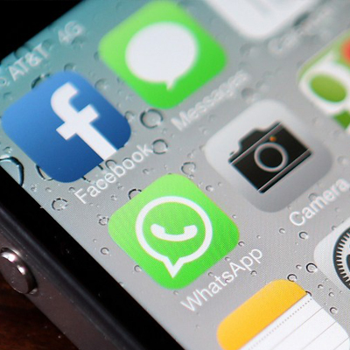On February 19, 2014, Facebook announced it would be acquiring WhatsApp for **US$19 billion**. It will pay $4 billion in cash, $12 billion in Facebook shares and an additional $3 billion in restricted stock units to be granted to WhatsApp's founders, Jan Koum, Brian Acton, and employees that will vest over four years subsequent to closing. The transaction is the largest purchase of a company backed by venture capitalists ever. The deal happened only months after a venture capital financing round valued the business at almost $1.5 billion.

At a keynote presentation at the Mobile World Congress in Barcelona in February 2014, Facebook CEO Mark Zuckerberg said that Facebook's acquisition of WhatsApp was closely related to the Internet.org vision. According to a TechCrunch article, Zuckerberg's vision for Internet.org was as follows: "The idea, he said, is to develop a group of basic internet services that would be free of charge to use — “a 911 for the internet.” These could be a social networking service like Facebook, a messaging service, maybe search and other things like weather. Providing a bundle of these free of charge to users will work like a gateway drug of sorts — users who may be able to afford data services and phones these days just don’t see the point of why they would pay for those data services. This would give them some context for why they are important, and that will lead them to paying for more services like this — or so the hope goes."

* 1. **Why Use Whatsapp (Advantages)**

It may be any one of the following –

* **No Hidden Cost:** Once download the application, can use it to chat as much as one want. Send a million messages a day for free! WhatsApp uses Internet connection: 3G/EDGE or Wi-Fi when available. First year FREE! ($0.99 USD/year after).
* **Multimedia:** Send Video, Images, and Voice notes to friends and contacts. The plethora of cool and funky emoticons offered by WhatsApp.
* **No need to add buddies**: Adding a friend on WhatsApp is simple. Your contacts who already have WhatsApp Messengeron his/her smartphonewill be automatically displayed and connected to you via WhatsApp.
* **No need to Login/Logout** : WhatsApp doesn’t require any ‘Sign-in’ or ‘Log out’. No more confusion about getting logged off from another computer or device. With push notifications WhatsApp is ALWAYS ON and ALWAYS CONNECTED.
* **Group Chat:** Enjoy group conversations with one’s contacts.
* **No International Charges:** just like there is no added cost to send an international email, there is any cost to send WhatsApp messages internationally. Chat with friends all over the world as long as they have WhatsApp Messenger installed and avoid those pesky international SMS costs.
* **Say no to PINs and Usernames:** Why even bother having to remember yet another PIN or username? WhatsApp works with phone number, just like SMS would, and integrates flawlessly with existing phone address book.
* **Offline Messages**: Even if someone miss push notifications or turn off phone, WhatsApp will save messages offline until retrieve them during the next application use.
* **And Much More**: Share location, Exchange contacts, Custom wallpaper, Custom notification sounds, Landscape mode, Precise message time stamps, Email chat history, Broadcast messages and MMS to many contacts at once and much much more!

There can be a lot more than these. For some, it’s the ease of clicking the WhatsApp icon, going to the chat with a friend and seeing when was the last time he/she was seen online on the app. For others, it’s the cool way in which one can update his/her status without really bothering everyone on his/her friend list to become aware of the same by a pop-up in their respective profile ( A friend’s status can be known only by going to ‘View profile’).

The telecom industry did not take long to realize that ‘Conference call’ was a much needed value added service. Hence, accepting the customer demands, WhatsApp too added a fascinating feature of ‘Group Chat’ in Feb 2011. Not only is it easy to create a group on WhatsApp, it is equally easy to quit the group too.

WhatsApp has constantly been adding more and more handsets to its kitty over the time and informing users of the same through its website and blog.

But fame is a double-edged sword. And so it happens that there has been a rumour taking some rounds; recently there was a hoax about WhatsApp charging a fee for its usage to the users whose screen logo did not turn red.

* **WhatsApp tops Nielsen India Consumer Ranking:**

Mobile messenger ‘WhatsApp' emerges as the most engaging mobile app; nearly half (47%) of the respondents engage with smartphone messenger service WhatsApp and spend 24 minutes a day chatting making it the top smartphone app for urban Indian consumers. While social networking website Facebook (2nd), reaches out to over half the respondents (51%), engagement time on the smartphone app is 10 minutes a day.

This is the findings of Consumer Rankings for India launched recently, by **Nielsen**, a global provider of information and insights into what consumers watch and buy.

Source:<http://www.dqweek.com/dq-week/news/174992/whatsapp-flipkart-vodafone-tops-nielsen-india-consumer-ranking>

* 1. **Why WhatsApp is so popular in India:**

According to recent reports, WhatsApp’s active user base has more than doubled to 430 million active users from nearly 200 million users in August 2013 and now handles around 50 billion messages (sent and received) daily. So in the industry it is believe that with such an accelerating growth volume, the cross-platform messaging platform may soon overtake the SMS!

On its growing popularity, users have cited different reasons such as its ease of use, great speed offered by the application and multiple device compatibility. Still others feel that the technology offers a cost effective way of sharing things with people in any part of the world.

1. WhatsApp has been the top driver for smartphone penetration in India.
2. The big appeal of this instant-messaging app that works across all smartphones was that it was nearly free - barring the low cost of a basic mobile data plan - unlike SMS text. WhatsApp did to SMS what Skype did to international phone calls.
3. WhatsApp now packs in more features, while remaining clean, fast, simple. It's the preferred way to share multimedia now -- pictures, audio and video. MMS -- a version of SMS once used for multimedia -- is dead.
4. Its most popular feature today is its handling of groups. That one thing takes it into the realm of social media.
5. **Tata Docomo** too has joined hands with WhatsApp deve­lopers and launched exclusive **WhatsApp data packs**to offer unlimited WhatsApp usage to its subscribers for less than 20. “We have seen a decrease of about 20 per cent in SMS traffic in the recent past after our subscribers started to use mobile application like WhatsApp,” the spoke­sperson for a telecom company said.
   1. **WhatsApp Reaches 450 Million Active Users**

This chart illustrates the incredible growth of smart phone messaging service Whatsapp.

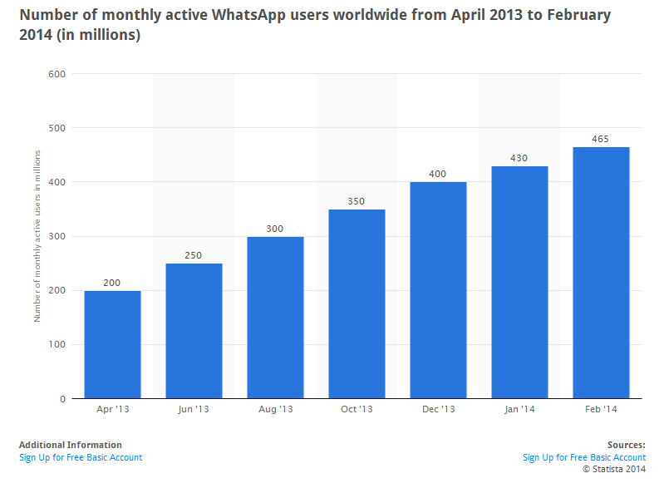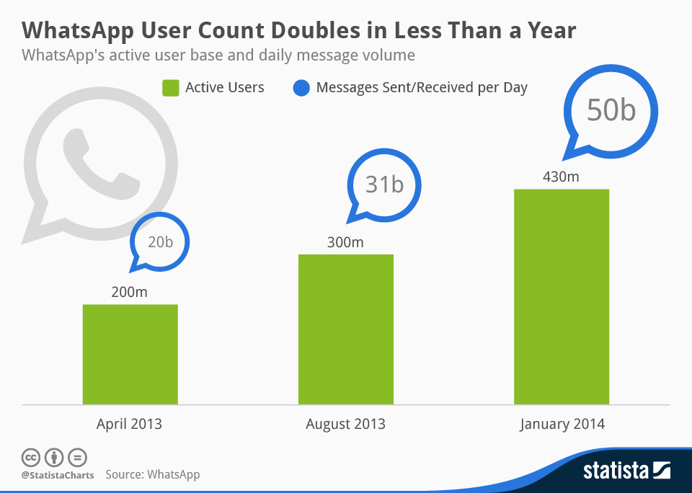

**Chapter – 3Strategyon WhatsApp**

* 1. **IT STRATEGY ON WHATSAPP**

[WhatsApp has been a major contributor of 25% decline of SMS in Spain](http://www.guardian.co.uk/technology/shortcuts/2012/dec/04/whatsapp-new-text-messaging). Chinese [We Chat](http://en.wikipedia.org/wiki/WeChat) has over 300 million users. [Over 90% of Korean smart phone users use Kakaotalk.](http://www.techinasia.com/kakaotalk-windows-phone-app-launch/) These are just a few examples of the rising trend of the mobile instant messaging (MIM).

Instant messaging as such is not a new thing (remember ICQ?), but there are certain reasons why it has had its resurrection now:

1. **Phones are increasingly more about data than talking**

In developed countries nearly every new phone sold is smart phone. Smart phones are increasingly more about being smart than phone. There is app for that, now also for the basic phone features (talking and texting).

1. **That data is getting faster**

[New 4G LTE (Long term evolution)](http://en.wikipedia.org/wiki/LTE_%28telecommunication%29) phones will enable high-speed data for mobile phones. This opens new opportunities for what kind of content we can exchange in MIM platforms.

1. **Facebook is so huge that it is already mass broadcasting**

If you are average Facebook user sending your status update, the odds are that the message will be seen by your family, friends and colleagues plus countless of people you do not even know about. This is great, but serves more of people´s need for vanity and instant recognition. The most meaningful conversations happen with the people you know. Same phenomenon has been also reason for [the success of Path](http://www.postadvertising.com/2012/03/path-the-anti-social-network/).

1. **There is always need for 1-to-1 communication**

Some might argue that Facebook message does the trick. However the challenge is that Facebook is already flooded with so many messages, it is not that reliable way to catch people (at least not all of them). Phone has been relevant for so long because you can be quite certain that your message is received. Although Facebook has increased the number of “friends”, it has not really increase the number of “real friends”. The amount of those real friends is limited and many of interactions with those people we want to keep private.

**Facebook Messenger Vs Whatsapp Messenger in 2013**

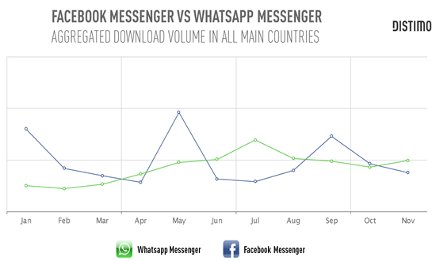

1. **World is getting smaller**

Majority of MIM applications work internationally. The bread and butter of Telcos profit margins has been charging for international calls and roaming. MIM applications do not have those international boundaries. You want to communicate with your friends no matter where they geographically are.

1. **World is getting more visual**

Although SMS-messages have been relatively cheap, telcos are still taking quite big premium with multimedia messages. With MIM applications you can send whatever data possible and the because of the point 2 the alternatives are actually increasing all the time. Basic SMS- type of messaging is just the beginning for MIM applications and there will be probably lots of innovations in what kind of communication there will be.

* 1. **WhatsApp SWOT Analysis:**

**Strengths:**

* Loyal customers
* Market share leadership
* No need to log
* Group Chat
* Allow send videos, pictures, voice notes
* You can put profile picture
* No need to add friends
* No need PIN or user number
* Available for all platforms

**Weaknesses:**

* Not diversified
* Weak distribution network
* To access the account can only be paid by credit card only
* Only works with a data plan or Wi-Fi

**Opportunities:**

* Online
* Advanced technology
* Recognized application
* Modernization of people
* Increased demand for smart phones

**Threats:**

* Competition
* Product substitution
* Similar applications and free
  1. **WhatsApp - MICHAEL PORTER’S FIVE FORCES ANALYSIS**



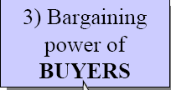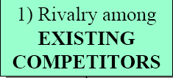

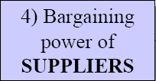

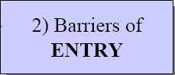

* 1. **Intensity of EXISTING Rivalry**

[**Fast industry growth rate**](http://www.wikiwealth.com/five-forces-rivalry:whatsapp:fast-industry-growth-rate-whats) – When industries are growing revenue quickly, they are less likely to compete, because the total industry size is also growing. The only way to grow in slow growth industries is to steal market-share from competitors. Fast industry growth positively affects.

[**Relatively few competitors**](http://www.wikiwealth.com/five-forces-rivalry:whatsapp:relatively-few-competitors-what)- Few competitors mean fewer firms are competing for the same customers and resources, which is a positive for Whatsapp. "Relatively few competitors (Whatsapp)" has a significant impact, so an analyst should put more weight into it. "Relatively few competitors (Whatsapp)" will have a long-term positive impact on the entity, which adds to its value.

* 1. **Barriers of ENTRY**

[**Strong distribution network required**](http://www.wikiwealth.com/five-forces-competitor:whatsapp:strong-distribution-network) – Weak distribution networks mean goods are more expensive to move around and some goods don’t get to the end customer. The expense of building a strong distribution network positively affects Whatsapp**.**

[**Strong brand names are important**](http://www.wikiwealth.com/five-forces-competitor:whatsapp:strong-brand-names-are-impor) - If strong brands are critical to compete, then new competitors will have to improve their brand value in order to effectively compete. Strong brands positively affect Whatsapp**.**

[**Patents limit new competition**](http://www.wikiwealth.com/five-forces-competitor:whatsapp:patents-limit-new-competitio)-- Patents that cover vital technologies make it difficult for new competitors, because the best methods are patented. Patents positively affect Whatsapp**.** "Patents limit new competition (Whatsapp)" has a significant impact, so an analyst should put more weight into it.

[**Advanced technologies are required**](http://www.wikiwealth.com/five-forces-competitor:whatsapp:advanced-technologies-are-re) - Advanced technologies making it difficult for new competitors to enter the market because they have to develop those technologies before effectively competing. The requirement for advanced technologies positively affects Whatsapp**.**

* 1. **Bargaining Power of CUSTOMERS**

**Large number of customers** - When there are large numbers of customers, no one customer tends to have bargaining leverage. Limited bargaining leverage helps Whatsapp**.**

[**Product is important to customer**](http://www.wikiwealth.com/five-forces-customer:whatsapp:product-is-important-to-custom) - When customers cherish particular products they end up paying more for that one product. This positively affects Whatsapp. This statement will have a short-term negative impact on this entity, which subtracts from its value.

* 1. **Bargaining Power of SUPPLIERS**

[**High competition among suppliers**](http://www.wikiwealth.com/five-forces-supplier:whatsapp:high-competition-among-supplie) – High levels of competition among suppliers acts to reduce prices to producers. This is a positive for Whatsapp. "High competition among suppliers (Whatsapp)" has a significant impact, so an analyst should put more weight into it. This statement will have a short-term positive impact on this entity, which adds to its value. "High competition among suppliers (Whatsapp)" is an easily defendable qualitative factor, so competing institutions will have a difficult time overcoming it. "High competition among suppliers (Whatsapp)" will have a long-term negative impact on this entity, which subtracts from the entity's value.

* 1. **Threat of SUBSTITUTES**

[**Substitute has lower performance**](http://www.wikiwealth.com/five-forces-substitute:whatsapp:substitute3-whatsapp) - A lower performance product means a customer is less likely to switch from Whatsapp to another product or service.

[**Substitute is lower quality**](http://www.wikiwealth.com/five-forces-substitute:whatsapp:substitute2-whatsapp) – A lower quality product means a customer is less likely to switch from Whatsapp to another product or service.

* 1. **PESTLE ANALYSIS**
* **Political**

The popular free unlimited service Whatsapp might be blocked in Saudi Arabia 'within weeks', local newspaper [Aleqtisadiah](http://www.aleqt.com/)reported.

Country's Communications and Information Technology Commission (CITC) claimed that the service doesn’t comply with local rules and regulations.

* **Economic**

Favorable economic environment

* **Social**

Age – Nowadays, whatsapp is used by in between 20 to 40 years of age. Earlier people used text messages, that is, SMS, but nowadays they have started using it for communications with their friends and family. People can also send voice messages, images, as well as video through whatsapp. As we know, whatsapp is available in free of cost for 1 year. And for accessing data, one needs data plant to send and receive messages.

* **Technological**

**Compatibility -** The compatibility for WhatsApp starts from Nokia S40 phones, the least one apps-compatibility wise. After this its compatibility increases to Nokia S40 Symbian, S60, and Android/iOS/BB OS/Windows, etc.

**Interface –** Whatsapp interface is quite easy and simple to handle. Whatsapp launches updates frequently to make its interface more appealing and user friendly but mainly its interface depends on type of platform who are using.

**Bandwidth** – With just texting option, whatsapp does not take much bandwidth. Only downloading may force it to use high network charges, but if you are texting only, then whatsapp takes very less bandwidth.

**Security** – One need to have working registered phone numbers to use whatsapp. The apps scans contact list and searches for people who already use it. One can chat with them, but blocking options is also there for security. If onedoesn’t want to chat or contact that annoying person in one’s contact list, one can block them. Blocking someone means that one don’t receive messages from the person one blocked.

* **Legal**

Whatsapp legal factors consistof:

**Acceptance** – It is an agreement between Whatsapp Inc., the owner and operator of [www.whatsapp.com](http://www.whatsapp.com) , the whatsapp software including whatsapp messenger and user of software. Using the service, user agrees to the terms of service and privacy policy.

**Whatsapp Service** – The terms of service applies to the all users of whatsapp. Information provided by users to whatsapp, may provide links to third party websites.

**Access** – Whatsapp permits user service only for personal use and doesn’t not grand permission to resend or change use of access for service. The user will not be able to duplicates or copy any part of service.

* **Grand Strategy**
  + Grand strategies, often called master or business strategies provide basic direction for strategic actions. It Indicate the time period over which long-range objectives are to be achieved.
  + Many firms involved with multiple industries, businesses, product lines, or customer groups usually combine several grand strategies.
  + Any one of these strategies could serve as the basis for achieving the major long-term objectives of a single firm.

The four alternatives of grand strategy are as follows:

* **Stability –** Stability means to remain the same size or to grow slowly and in a controlled fashion. In case of Whatsapp stability,Whatsapp is available on every operating system of smartphones.
* **Global Brand Strategy–** 
  + Whatsapp should make available in country specific languages.
* **Product Line Development–**

1. Allow requesting other system, that is, user should be able to contact other people who are not in his phone directory.
2. It should be able to make calls.
3. Screen sharing.
   * **Future**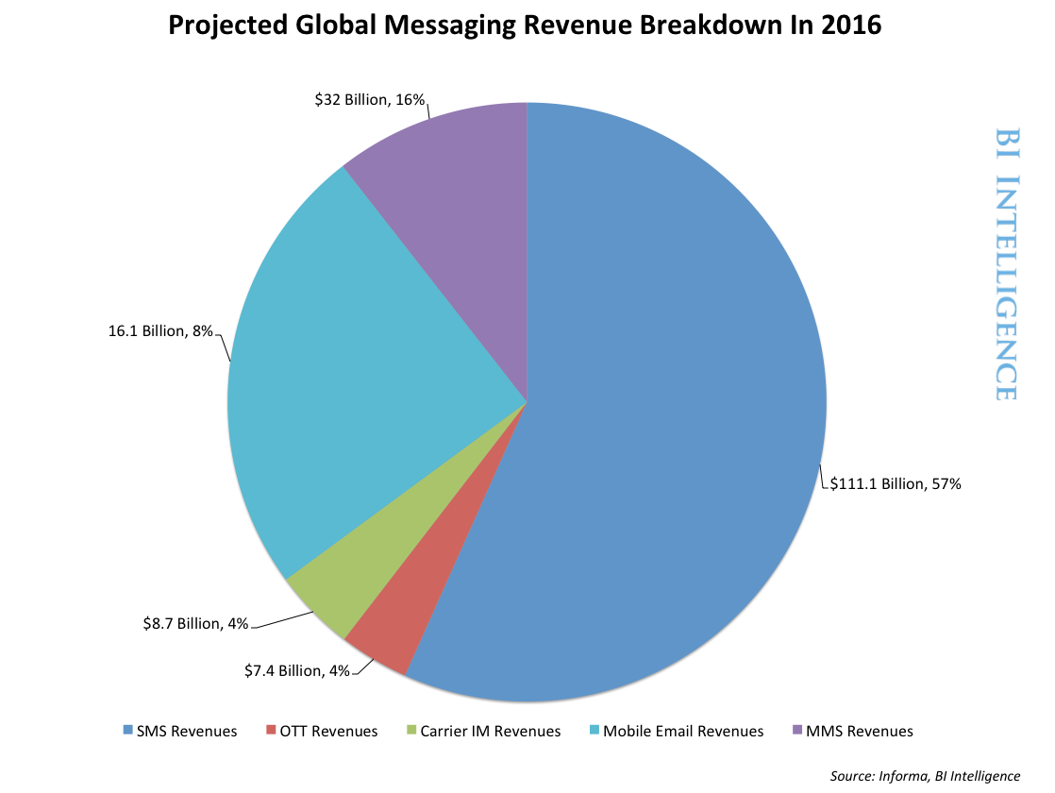

What lies ahead is known by none. The application is free today but may not be tomorrow or so the talks go around.

As far as the facilities provided are concerned, WhatsApp today does not provide the option of ‘Calling’ (although its logo has a phone receiver inscribed in the centre!). It may have this in future. With the technology growing in leaps and bounds, we may also expect a Skype-like free video call via WhatsApp. What has been a user-friendly, connectivity application till date may take a turn towards shared-information holding platform like Drop box, meaning people may not only be able to chat on WhatsApp but also share and store common data.

With the advent of ‘Cloud Computing’, the world has virtually shrunk down to the size of a room. It may not come as a surprise hence, to see such a large network-sharing support on WhatsApp someday.

Whether the mole will actually become a mountain someday is a mystery. Till then, we enjoy the present and await the surprises of future.

**Chapter -4Research Methodology**

**Research Methodology**

**Topic:** Customer Satisfaction towards WhatsApp

* 1. **Objectives:**

“To measure how much customers are satisfied by WhatsApp”

* To know current market scenarios of WhatsApp.
* To know customer behaviour on WhatsApp.
* To knowusage pattern of WhatsApp.
* To find out key success featuresof WhatsApp.
  1. **Methodology**

**4.2.1 Research design used:**

Conclusive Research Design

Descriptive Research Design

Cross-sectional Design

Single Cross-sectional Design

Conclusive research design is more formal and structured than the exploratory design. It is use to test the hypotheses and examine the relationship. Descriptive research design is the part of the conclusive design and it describes the market characteristics or functions. It describes the characteristics of relevant groups such as consumers, organizations etc. The collection of the information from the sample population is drawn only once so it is cross sectional design.

**4.2.2 Sampling methodology**

**Target population:**

Youth&Professionals using Smartphones(M/F) from Gujarat, 2013-14

**Sampling Method:**

Non-probability; Convenience sampling method.

In **nonprobability sampling technique** the chances of selection of all elements of population are not equal and **convenience sampling method** means sample drawn at the convenience of the interviewer people tend to makes the selection at familiar location and choose respondents who are like themselves.

**Sample size: 106 respondents**

**Data Collection methods**

**Primary data**

* + Field Survey
  + Personal Interview (Questionnaire)

**Secondary data**

* + Internet
  + Company database

**Research Area**

* Gujarat State

**Chapter – 5Analysis & Interpretation**

* 1. **DATA ANALYSIS**
* **Overall demographics**

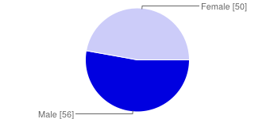

|  |  |  |
| --- | --- | --- |
| **Gender** | | |
| Male | 56 | 53% |
| Female | 50 | 47% |
| **Total** | **106** | **100%** |

|  |  |  |
| --- | --- | --- |
| **Age** | | |
| Up to 15 years | 4 | 4% |
| 16 – 25 years | 53 | 50% |
| 26 – 35 years | 42 | 40% |
| 36 – 45 years | 6 | 6% |
| above 46 years | 1 | 1% |

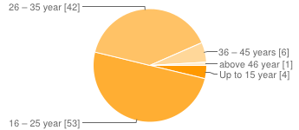

|  |  |  |
| --- | --- | --- |
| **Occupation** | | |
| Student | 40 | 38% |
| Service | 32 | 30% |
| Professional | 21 | 20% |
| Home maker | 10 | 9% |
| Unemployed | 3 | 3% |

|  |  |  |
| --- | --- | --- |
| **Monthly Family Income** | | |
| below 15000 INR | 3 | 2% |
| 15001 to 30000 INR | 39 | 27% |
| 30001 to 45000 INR | 39 | 27% |
| 45001 to 60000 INR | 41 | 28% |
| above 60000 INR | 23 | 16% |

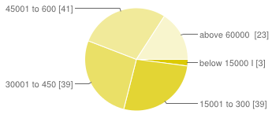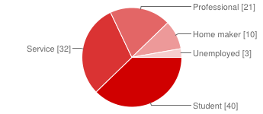

* Here we can observe that, *percentageof male& female in respondentsare almost equal, agegroup 16 – 25 years is more, followed by 26-35 years and the monthly family income is starting from INR15000 to 60000 above.*
* *Students* formed the *major percentage* of the respondent, followed by the *service* category.

**Q.1 Do you want to be in touch with the people by using Apps?**

|  |  |
| --- | --- |
| **PARTICULAR** | **FREQUENCY** |
| YES | 102 |
| NO | 4 |
| **TOTAL** | **106** |

**INTERPRETATION:** - In the above table and graph we can say that, out of the 106 respondent 96% i.e. 102 respondentswant to be in touch with the people by using Apps.

**Q.2 What do you prefer more for staying in touch with people on your phone?**

|  |  |
| --- | --- |
| **PARTICULAR** | **FREQUENCY** |
| Social messaging Apps | 93 |
| Voice calls | 54 |
| SMS | 15 |
| Email | 3 |

**INTERPRETATION**:-93 out of 106 respondents prefer Social messaging Appsfor staying in touch with people from their phone followed by Voice calls. Whereas SMS & Email are less preferred now a day, So Social messaging Apps have overtaken traditional SMS.

**Q.3 Which social messaging app do you use?**

|  |  |
| --- | --- |
| **PARTICULAR** | **FREQUENCY** |
| WhatsApp | 101 |
| Facebook Messenger | 60 |
| WeChat | 30 |
| Twitter | 14 |
| BBM (Blackberry Messenger) | 8 |
| Skype | 3 |
| Line | 5 |
| Other | 11 |

**INTERPRETATION:** -WhatsApp is widely used social messaging app, almost 95% respondents use WhatsApp. Then comes Facebook and WeChat with 57% and 28% respectively and Twitter, Other (like Viber &Tango) isused by average population which is 13% & 10%. App likeBBM, Skype&Line is very less used.

**Q.4 Do you use WhatsApp on an active basis?**

|  |  |
| --- | --- |
| **PARTICULAR** | **FREQUENCY** |
| All The Time | 49 |
| Most Of the Time | 41 |
| Sometimes | 11 |
| Not At All | 5 |

**INTERPRETATION:** - From the above table and graph we can interpret that, 46% people use “WhatsApp” all the Time and 39% people use it Most of the time. It indicates that the majorpart of our samples use WhatsApp frequently. And, 5% people are not using WhatsApp as they are using alternate app like Facebook or they are not having Smartphone with data/Wi-Fi connection.

**Q.5 Tick the reason(s) why you do not use WhatsApp.**

|  |  |
| --- | --- |
| **PARTICULAR** | **FREQUENCY** |
| Did not know WhatsApp Existed | 1 |
| No data plan/lack of easy access to WiFi | 3 |
| Not enough friends using the same application | 0 |
| Using Alternate Messenger (fb, WeChat, Etc) | 2 |
| Unreliable (Poor Connection, WhatsApp unable to work, Etc) | 0 |

**INTERPRETATION:** - From the above analysis I can interpret that, from 5% respondents which are not using WhatsApp, major reason is lack of Smartphone with access to Data-plan/Wi-Fi and others are using alternate Messenger; only 1 respondent did not know WhatsApp existed.

**Q.6 WhatsApp Messenger is a proprietary, cross-platform instant messaging subscription service for smart phones. In addition to text messaging, users can send each other images, video, and audio media messages. The client software is available for Apple, Android, BlackBerry OS, Nokia, and Windows Phone.**

**Did this information about WhatsApp encourage you to use the application?**

* Yes, But due to lack my phone, i am not using whatsapp
* No, dont have Smartphone
* Yes
* Yes
* Yes

**Q.7 Have you purchased Smartphone, only bcoz you can use WhatsApp?**

|  |  |
| --- | --- |
| **PARTICULAR** | **FREQUENCY** |
| YES | 25 |
| NO | 75 |

**INTERPRETATION:** - 25% of respondent have purchased Smartphone, only becausethey can use “WhatsApp”, this shows that WhatsApp has been the top driver for smartphone penetration in India.

**Q.8 From which medium you came to know about WhatApp?**

|  |  |
| --- | --- |
| **PARTICULAR** | **FREQUENCY** |
| Word of Mouth | 60 |
| Internet | 34 |
| Advertisement | 6 |
| Newspaper | 0 |

**INTERPRETATION:**- From the above analysis, I have interpreted that Word of Mouth is the major source of the awareness for ‘WhatsApp’ and after that Internet publicity has also worked well for the WhatsApp. And Advertisement is very less effective.

So it’s easy to conclude that a Mouth Publicity & People recommendation plays highest role in popularity of WhatsApp.

**Q.9 Which WhatsApp features impresses you?**

|  |  |
| --- | --- |
| **PARTICULAR** | **FREQUENCY** |
| Ease of Navigation/ User Friendly Interface | 56 |
| Groups chatting | 57 |
| Speed | 39 |
| Cross-Compatibility (Apple, Android, BlackBerry OS, Nokia, and Windows Phone) | 49 |
| Sharing (e.g. Video, audio, Photo, Status etc) | 73 |

**INTERPRETATION:** -All-most every features of WhatsApp impresses respondents, but major feature which impresses respondent is sharing (e.g. video, audio, Photo, Status etc) because it allows users to send media instantly, then Group Chatting is also popular, followed by User Friendly interface. Cross-Compatibility & Speed of WhatsApp are also impressingfeatures.

**Q.10 Which features you would like to suggest in WhatsApp to enhance its appeal?**

|  |  |
| --- | --- |
| **PARTICULAR** | **FREQUENCY** |
| Video Calling Services | 65 |
| Support voice calls | 26 |
| Support For PCs to PCs/Phone Vice Versa | 25 |
| Privacy - who can view & add | 48 |
| Increase Group Chat Participants from 30 | 8 |
| Other | 11 |

**INTERPRETATION:** - Because of the good services, features of WhatsApp, most of the consumer are satisfied on the existing features. But Respondent believes that there are some features required in WhatsApp for better messaging.

The major feature which are suggestedby respondents are Video Calling Service, Privacy – who can view the status & profile, and voice call &WhatsApp for PC are also one of the suggested features.Some respondents said Photos & Videos of any size must be allowed, it means that WhatsApp should work on additional features to enhance its appeal.

**Q.11 As a social messaging application, how would you rate WhatsApp? From a scale of 1 (Least satisfied) to 5 (Most satisfied)**

|  |  |  |
| --- | --- | --- |
| **PARTICULAR** | | **FREQUENCY** |
| 1 | Least satisfied(don’t download) | 0 |
| 2 | Dissatisfied | 0 |
| 3 | Neutral | 7 |
| 4 | Satisfied | 34 |
| 5 | Most satisfied (A must-use application) | 59 |

**INTERPRETATION:** - Most of the respondents are satisfied by using WhatsApp. 59% of respondent are most-satisfied means WhatsApp is must-use application, 34% at “satisfied” level, only 7% people are neutral. It means WhatsApp earns very good customer satisfaction level among social messenger apps.

**Q.12 Final Question. As the success of WhatsApp depends on being wider spread among users, would you recommend WhatsApp to your friends, families, colleagues?**

|  |  |
| --- | --- |
| **PARTICULAR** | **FREQUENCY** |
| YES | 100 |
| NO | 0 |

**INTERPRETATION:**- From the above analysis, 100% of respondent are going to recommend and suggest to use WhatsApp to their friends, families, colleagues in future.

**6.1 FINDINGS&RECOMMENDATION**

* According to survey, I have found that around 87.7% peopleprefer Social messaging Apps for staying in touch with people from their phone. Whereas SMS & Email are less preferred now a day. So WhatsApp has overtaken traditional SMS.
* Almost 95% people use WhatsApp, so this shows that Whatsapp is most popular amongst chat appslike Facebook, WeChat.
* WhatsApp is popular among youth & professionals disrespect of the demographic variables (like gender, age, income); Youths are using WhatsApp most of the time compare to that of Facebook.
* Word of mouth is major source of spreading of WhatsApp popularity, here the friend’s recommendations, as most of them are using and recommendingit; inspire the person to use WhatsApp.
* Some special data-plans by telecom companies (like DoCoMo), advertisement by smartphone companies helped WhatsApp to gain market, so indirectly WhatsApp has been the top driver for smartphone.
* The features like Groups chatting, easy Sharing (e.g. Video, audio, Photo, Status etc.) and User Friendly Interface of WhatsApp have earned very much customer satisfaction, and these three features are becoming a brand identity of the WhatsApp Messenger.
* General suggestion about WhatsApp from all the users is same. Most respondent who use WhatsApp want video calls as one of the features and privacy is also on priority of most of the user. Voice calls is also one of the important feature to be added as per some respondent &also the support from PC.
* Satisfaction level of WhatsApp is high but it should focus on adding some new and attractive features in order to stay ahead in competition as apps like WeChat, Line are ahead in features, which will increase competition in future.
* Few respondents say that company should allow sharing the photos, and videos of any size.
* Company should introduce the system to share and send documents which will increase usage of WhatsApp and increase the satisfaction of potential customers.
* Peoples now a day are giving more preference to Privacy in internet. So, Social Messengers should look after the privacy of people and give good & safe social connectivity options. And we all know that finally WhatsApp has introduced the new Privacy options from March 2014.
  1. **LIMITATIONS OF THE RESEARCH**

Following are some of the limitations of the study

* I considered Gujarat region only because of limited time.
* As the quantitative research was conducted using online surveys, there was minimal control over the composition of the respondents in total sample.
* Another limitation of the study is that, Findings of the study are based on the assumption that the respondents have given correct information.
* Respondent Bias was one of the major limitations of research, and there might not be perfect positive response from all the respondents.
  1. **CONCLUSION**

From the research I came to know about the important conclusion regarding the customer satisfaction of WhatsApp.

WhatsApp has been in market for quite some time and is being used by most and offers functionality like text based messaging and files transfers.WhatsApp is clearly emerging as an alternate for SMS and MMS messaging.Demographic ratio does not affect the usage of WhatsApp.

The word of mouth has given great advantage to aware the customers about the products. Withincreasing smartphone market WhatsApp has capturedthe market but company has to keep innovating to maintain the satisfactory level of existing customers.

Because with given enough time WeChat, Line are a capable product and in the future they hold the potential to overtake WhatsApp, unless some new innovations is adopted by the world leader in messengers.

**Bibliography**

**BOOKS:**

1. NareshK. Malhotra, *“Marketing Research: An Applied Orientation”4th Edition*. Prentice Hall, 2004.
2. Philip Kotler, Kevin Lane Keller, Abraham Koshy, MithileshwarJha., “*Marketing Management – A south Indian perspective”- 13thedition.*Pearson Education, 2009.

**WEBSITES:**

<http://www.whatsapp.com/>

<http://en.wikipedia.org/wiki/WhatsApp>

<http://www.frost.com/c/10392/blog/blog-display.do?id=3313452>

<http://www.cxotoday.com/story/is-whatsapp-overtaking-the-sms-soon/>

<http://www.wikiswot.com/SWOT/4_/Whatsapp.html>

<http://nivedithg.blogspot.in/2012/10/wechat-mobile-app-review.html>

<http://www.wikiwealth.com/five-forces:whatsapp>

<http://in.news.yahoo.com/whatsapp-19-billion-bet-facebook-050220867.html>

<http://www.statista.com>

**Questionnaire**

Dear Respondent,

Hello and thank you for agreeing to participate in this survey.

We are the students of BBA programme from Golden Jubilee Institute of Business Administration, Semester-VI. As a part of our study, we are required to prepare a project report on **“**Customer Satisfaction towards WhatsApp**”**. So we seek your kind help to assist us by answering few questions.

This study is meant to find the Satisfaction from WhatsApp messaging app. The results that will be obtained here are purely for educational purposes and will in no other circumstance be used for any form of profit, authorised or unauthorised.

Thanking you,

Khyati M.Patel

GJIBM

NOTE: Please tick mark (√) in appropriate boxes to provide your opinion.

If applicable, tick (√) for more than one option.

**Demographic Information:**

Gender: [ ] Male [ ] Female

Age: [ ] Up to 15 years [ ] 16 – 25 years

[ ] 26 – 35 years [ ] 36 – 45 years

[ ] above 46 years

Occupation: [ ] Student [ ] Service

[ ] Professional [ ] Home maker

[ ] Unemployed

Monthly Family Income: [ ] below 15000 INR [ ] 15001 to 30000 INR

[ ] 30001 to 45000 INR [ ] 45001 to 60000 INR

[ ] above 60000 INR

1. Do you want to be in touch with the people by using Apps?

□Yes

□No

1. What do you prefer more for staying in touch with people on your phone?  
   □Social messaging Apps □Voice calls □SMS □Email
2. Which social messaging app do you use

□ WhatsApp

□ Facebook Messenger

□ WeChat

□ Twitter

□ BBM

□ Skype

□ Line

□ Other___________

1. Do you use WhatsApp on an active basis?

□All The Time □Most Of the Time

□Sometimes □Not At All

**If your ANSWER to Q4 is [Always], [Most of the Time], [Sometimes] skip Question 5 & 6.**

1. Tick the reason(s) why you do not use WhatsApp.

□Did not know WhatsApp Existed □No data plan/lack of easy access to WiFi

□Not enough friends using the same application □Using Alternate Messenger (fb, WeChat, Etc)

□Unreliable (Poor Connection, WhatsApp unable to work, Etc)

1. WhatsApp Messenger is a proprietary, cross-platform instant messaging subscription service for smart phones. In addition to text messaging, users can send each other images, video, and audio media messages. The client software is available for Apple, Android, BlackBerry OS, Nokia, and Windows Phone.  
     
   Did this information about WhatsApp encourage you to use the application?

□Yes

□No (Why not?) ____________________________

___________________________________________

___________________________________________

1. Have you purchased Smartphone, only bcoz you can use WhatsApp?

□Yes

□No

1. From which medium you came to know about WhatApp?

□Word of Mouth □Internet

□Advertisement □Newspaper

1. Which WhatsApp features impresses you?(You can tick more than one)

□Ease of Navigation/ User Friendly Interface □Groups chatting

□Speed □Cross-Compatibility (Apple, Android, BlackBerry OS, Nokia, and Windows Phone)

□Sharing (e.g. Video, audio, Photo, Status etc)

|  |  |
| --- | --- |
|  |  |
|  |  |
|  |  |

1. Which features you would like to suggest in WhatsApp to enhance its appeal?

□Video Calling Services □Support voice calls

□Support For PCs to PCs/Phone Vice Versa □Privacy - who can view & add

□Increase Group Chat Participants from 30 □Other (please specify) __________________

1. As a social messaging application, how would you rate WhatsApp? From a scale of **1** (Least satisfied) to **5** (Most satisfied)

**Rating 1 2 3 4 5**

□Least satisfied □Dissatisfied □Neutral □Satisfied □Most satisfied

(Don’t download) (A must-use application)

1. Final Question. As the success of WhatsApp depends on being wider spread among users, would you recommend WhatsApp to your friends, families, colleagues?

|  |
| --- |
|  |

□Yes

□No