PROJECT REPORT
ON
STUDY OF CONSUMER AWARENESS ABOUT TITAN AND POSITIONING STRATEGIES ADOPTED IT

Submitted By: Kshitiz Agarwal
Enrollment no.:05214701711

(Affiliated to GGSIP University Delhi)
(2011-2014)
Table of Contents
Page No.
List of Illustrations 7
List of Tables 8
Executive Summary 9

Chapter 1 – Introduction 11
1.1 Theory and concept 11
1.2 Literature Review 13

Chapter 2 -Research methodology 18
2.1 Objectives 18 2.2 Limitations 18 2.3 Sources of Data Collection 19 2.4 Sampling Procedure 19
2.5 Primary Data Collection 19

Chapter 3 - Industry Overview 20
3.1 History of watch market 20
3.2 Indian watch industry 20
3.3 Present situation of Indian watch market 22
3.4 Major brands in Indian watch market 23
3.5 Segmentation of Indian watch market 23

Chapter 4 - Company Profile 24

4.1 Overview 24
4.2 Products 25
4.3 Precision Engineering 26
4.4 Awards 26

Chapter 5 - Titan watches: Brand positioning strategies 27

5.1 Overall strategies 27
5.2 Men’s segment 28
5.3 Women’s segment 32
5.4 Children’s segment 33

Chapter 6 - Titan watches: Brand Repositioning strategies 34

6.1 New logo and tagline – “Be More” 34
6.2 The ad making – Aamir Khan 36
6.3 New collections and designs 36
6.4 Other strategies 39

Chapter 7 – Consumer Awareness Survey 40

7.1 Data Interpretation 40
7.2 Findings of the survey 55

Chapter 8 – Conclusion 57
Appendix 58
References 60

List of illustrations

Number Title Page No.
- Stages in brand strategy development 13
- The principle of repositioning 15
- Porter’s Five Forces Model 20
- Titan sub-brands possessed by respondents 40
- Period of Titan watch’s use 41
- Reasons for brand preference 42
- Recall of Titan’s original tagline 43
- Major advertisement media 44
- Awareness of brand ambassador 45
- Awareness of new tagline 46
- Consumer perception of new designs 47
- Awareness of new campaign 48
- Consumer perception of new campaign 49
- Consumer perception of store ambience 50
- Consumer perception of sales personnel 51
- Consumer perception about after sales service 52
- Consumer perception about display of watches 53
- Overall perception about Titan showroom 54

List of Tables
Number Title Page No.
1 Reasons for brand preference 42
2 Major Advertisement media 44

Executive Summary
Many brands and companies are constantly reinvigorating their businesses and positioning them for growth. There is a constant need to innovate, reinvigorate, update, recalibrate, or just simply fend off the competition in an effort to better explain "why buy me."
Brand positioning creates a specific place in the market for the brand and product offerings. It reaches a certain type of consumers and delivers benefits that meet the needs of several key target groups and users.
The actual approach of a company or brand's positioning in the marketplace depends on how it communicates the benefits and product attributes to consumers and users. As a result, the brand positioning of a company and/or product seeks to further distance itself from competitors based on a host of items, but most notably on five key issues: Price, Quality, Product Attributes, Distribution, and Usage Occasions.
In recent times, consumerism has undergone a sea change. Consumers today are well informed about the products, as compared to earlier times. Hence, the marketplace has become customer centric. Recognizing the importance of the customers in the business structure, companies have started effecting brand repositioning exercises on a regular basis.
In the recent times, a major brand repositioning exercise has been planned by Titan Industries Ltd. in order to provide more to its customers. The company has first gone for change in logo and tagline. Then the communication strategy has been revamped to convey its new position. The present study consists of reviewing the positioning strategies of Titan watches. An analysis of repositioning strategies of Titan also forms part of the study.
The main objective of the study is to find out whether the loyal consumers of titan watches are aware of the new positioning strategies of the company and how they perceive them.

Primary and secondary sources of data have been made use of in the study. The first part of the project, i.e., analysis of brand repositioning strategies of Titan Company has been completed on the basis of secondary data. For this purpose, internet, journals, books, magazines and so on have been made use of.
The second part of the project comprises of conducting a survey with the help of questionnaire. The survey is proposed to be conducted on a sample of 50 consumers who are loyal to Titan Company, selected through convenience sampling technique. The questionnaire consists of appropriate mix of open ended and closed ended questions. The data is presented using pie charts and bar diagrams.
The conclusion part of the report would provide an insight of consumer awareness regarding brand repositioning strategies and their effectiveness in revamping the brand, Titan.

Chapter 1 - Introduction

1.1 Theory & Concept

"A business has two - and only two - basic functions: marketing and innovation."
- Peter Drucker

The rapid pace of change and intense competitive pressure in today's marketplace demand that brands continuously innovate and reinvent themselves to maintain their relevance and market position. In this context, brand repositioning and other revitalization strategies have become a business imperative for battling brand erosion. The appeal of brand repositioning is further heightened by the rising costs and high risk associated with launching a new brand.

Brand repositioning has received little attention in the marketing literature and has mostly been treated as a variation of brand positioning. Biel, for example, has defined brand positioning as "building (or rebuilding) an image for a brand". The goal of positioning and repositioning strategies relates to the management of consumers' perceptions. However, positioning focuses on the creation of brand associations - consumers' perceptions of the attributes that differentiate the brand from competitive offers – while repositioning also implies managing existing brand associations. The unique challenge of a repositioning
strategy, thus, lies in rejuvenating the brand image to make it relevant in an evolving environment, while honoring the brand equity heritage.

Repositioning can be required as the market changes and new opportunities occur. Through repositioning the company can reach customers they not intended to reach in the first place. If a brand has been established at the market for some time and wish to change their image they can consider repositioning, although one of the hardest actions in marketing is to reposition a familiar brand.

According to Solomon, position strategy is an essential part in the marketing efforts because companies have to use the elements in the marketing mix to influence the customers understanding of the position. During the movement from something less attractive and relevant towards a more attractive and relevant position several of strategic choices has to be made. The ones responsible for the repositioning have to evaluate why a reposition is necessary, and if the offer is the one who will change or just the brand name. There are several risk factors that have to be taken into consideration when preparation for a repositioning of the offering or the brand. During repositioning, the risk of losing the credibility and reliability is high and the need for a thorough strategy is therefore necessary to avoid this occurrence. Some analyst argue that to successfully reposition a establish brand name is almost impossible because repositioning of a brand can make the most loyal customer to switch brand. But, in some circumstances a repositioning is necessary to gain credibility if the brand is eroded. Whenever a reposition is in question it has to be of relevance from a customer perspective, is this achievable? Some brands will on no account be thought on as a luxury brand and therefore an attempt to reposition will only damage the brand image or the actual company.

Numerous failed attempts at brand repositioning testify to the difficulty of developing and implementing such a tactic. For example, while the soft drink brand, Mountain Dew has remained relevant to the youth market through continuous repositioning in its thirty years of existence, Levis' Jeans has been losing market share to newcomers such as The Gap, despite numerous campaigns designed to reposition the brand as trendy.

The strategic importance of brand repositioning in preserving and enhancing brand equity, coupled with the mixed results of repositioning attempts, underscores the need to develop a better understanding of the dynamics of brand repositioning. Specifically, questions of whether, when and how brands should be repositioned need to be addressed.

Research into brand repositioning is relevant not only to the development of brand management theory, but also extends to corporate strategy through an examination of corporate brands.

1.2 Literature Review

The repositioning strategy is rolled out in three stages: introductory, elaboration and fortification stages. This involves the introduction of a new or a repositioned brand, seeking to underline the brand’s value over others, and to broaden the brand proposition. It is truly tough to change the customer’s perceived attitude towards a brand, and therefore the risk is great that the attempt to repositioning might be unsuccessful.

After rolling out the strategy, it is time to modify the proposition through update of the personality and through repositioning. There are benefits and risks with both of this segments and it is of great significance that they are truly evaluated when deciding the next step in the process. To further understand the stages stated above, figure.1 will guide you through the different phases that follow after establish a brand proposition.
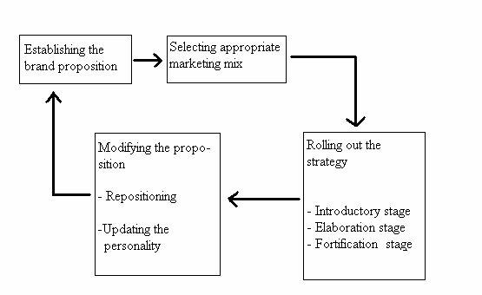
Figure 1: Stages in brand strategy development

The implication with the term” repositioning” is that a company modifies something that is already present in the market and in the consumer’s mind. The definition of repositioning changes different individuals and professions. To view the different definitions and perceive a greater understanding about this concept, three examples of repositioning given by individuals in different professions is stated below:

“Repositioning is a change, principally about trigging the vision, mission and value in a new direction that is more suited for the brand in the future”. (Brand manager consultant)

“Principally, reposition concerns change the consumer’s perception of the brand”
(PR- consultant)

“Repositioning is built upon the change unique and differentiated associations with the brand in some kind of direction, it is about having a balance between the category party and differentiation when using reposition strategies” (Leading brand strategist)

From these definitions, it is obvious that reposition is about moving something to a newer and hopefully to a more attractive and relevant position. The purpose of the movement differs with regards to what the company wants to achieve. A company might want to reach out to a larger target group, or be involved in several different positions at the market. There is also a visible relation between price and quantity aspects. When a company perceives the market as a demand curve, the purpose is to down stretch or up stretch in this curve. When moving down it is often spoken of as an expansion down wards, and when moving up and there is a need for reaching the premium segment and expand up wards.

Figure 2: The principle of repositioning

New Position

Price

Previous Position
Experienced quality

When striving towards a new position in the market, it is important to understand that consumer’s minds are limited. People’s minds select what to remember and it is therefore significant to convince the consumers with great arguments. The market demand changes rapidly and therefore reposition can be necessary to meet these demands, newer and stronger arguments have to be established to convince them to stay as loyal customers.

As stated in the literature, repositioning is a very complicated matter and therefore there are no detailed theories or models. The aim with repositioning differ from person to person, and the only connection between all the different theories is that repositioning is moving something from somewhere towards a greater position at the market.

Corstjens and Doyle (1989) identified three types of repositioning strategies:
(1) zero repositioning, which is not a repositioning at all since the firm maintains its initial
strategy in the face of a changing environment;
(2) gradual repositioning, where the firm performs incremental, continuous adjustments to its positioning strategy to reflect the evolution of its environment; and
(3) radical repositioning that corresponds to a discontinuous shift towards a new target market and/or a new competitive advantage.

After examining the repositioning of several brands from the Indian market, the following 9 types of repositioning have been identified. These are:
- Increasing relevance to the consumer
- Increasing occasions for use
- Making the brand serious
- Falling sales
- Bringing in new customers
- Making the brand contemporary
- Differentiate from other brands
- Changed market conditions.
It is not always that these nine categories are mutually exclusive. Often one reason leads to the other and a brand is repositioned sometimes for a multiplicity of reasons.
A four-phased brand repositioning approach can be followed to achieve the intended benefits:
Phase I. Determining the Current Status of the Brand
Phase II. What Does the Brand Stand for Today?
Phase III. Developing the Brand Positioning Platforms
Phase IV. Refining the Brand Positioning and Management Presentation

The benefits that can be derived from brand repositioning exercises can be summarized as:
- Value over others
- Updated personality
- Relevant position
- “Up to date” image

The risks associated with such strategies are:
- Loss of focus
- Neglecting original customers
- Losing credibility for the brand
- Confusing the brand

Therefore, brand repositioning is more difficult than initially positioning a brand because one must first help the customer “unlearn” the current brand positioning (easier said than done). Three actions can aid in this process: (1) carefully crafted communication, (2) new products, packaging, etc. that emphasize the new positioning and (3) associations with other brands (co-branding, co-marketing, ingredient branding, strategic alliances, etc.) that reinforce the new brand positioning.
This exercise is so critical to an organization’s success that the organization’s leadership team and its marketing/brand management leaders should develop it, preferably with the help and facilitation of an outside brand-positioning expert.

Chapter 2 - Research Methodology

2.1 Objectives
- To review the brand positioning strategies of different sub-brands of Titan watches
- To analyze the brand repositioning strategies of Titan watches.
- To study consumer awareness and perception about the brand repositioning
strategies of Titan watches
- To recommend suitable measures to be taken by the Titan Company to further
improve its brand perception and loyalty among its customers.

This study would help titan industry to understand the gaps in its communication strategy regarding brand repositioning exercises and the further measures to be taken for effective marketing communications.

2.2 Limitations
- The study is confined to Hyderabad area only
- There is possibility of sampling errors in the study
- The responses of the consumers may not be genuine
- The questions included in the questionnaire may not be comprehensive.

2.3 Sources of Data Collection
The relevant data was collected from both primary sources and secondary sources. The starting point of my information gathering has been the secondary sources such as internet, books, and journals and so on.
First, I made a study of the brand positioning and repositioning strategies of Titan watches through secondary sources such as internet, insurance magazines, and journals and so on. Then I conducted a consumer awareness survey on brand repositioning strategies undertaken by Titan watches in recent times.

2.4 Sampling Procedure
A sample of 50 consumers who are brand loyal to Titan watches since more than a year and in the age group of 20 – 30 years have been considered for this study. As Titan has taken up brand repositioning strategies since July 2008, consumers who have seen the previous and new campaign have been targeted

2.5 Primary Data Collection
Data was collected through an interview schedule, consisting of both open ended and closed ended questions. The schedule covered parameters like reasons for consumers’ brand preference; recollection of earlier tagline and advertisement, brand ambassador of Titan; awareness of new tagline and campaign featuring Aamir Khan, new designs and so on. The data was collected through e- mails, telephone contacts and one-to-one personal interviews.

Chapter 3 - Industry Overview

3.1 History of the watch market
The Indian watch industry began in the year 1961 with the commissioning of the watch division of HMT. The first watch model manufactured by HMT was the Janata model in the year 1962. HMT was the leader in the watch market till the Tatas formed Titan Watches in association with Tamil Nadu Industrial Development Corporation in the year 1987. They took a major strategy decision, which later changed the face of the Indian watch market- to manufacture only quartz watches. Liberalization in 1992 and the removal of quantitative restrictions due to WTO has opened the doors for many foreign brands in the Indian market viz. Tissot, Swatch, Omega, Rado, TAG Heuer, Rolex and many others. The import duties on watches are falling which makes the Indian market look attractive for the global majors like Casio, Swatch and Citizen.

3.2 Indian Watch industry:

Figure 3: Porter’s Five Forces Model
SUPPLIER POWER
No strong suppliers
Lack bargaining power
Rise of China, Taiwan as low cost suppliers
BARRIERS  TO ENTRY  Cluttered Market  Lack of Differentiation | DEGREE OF RIVALRY  Increased number of firms  Low switching costs  Strategic stakes are high | THREAT OF  SUBSTITUTES  No close substitutes
BUYER POWER
Price sensitivity , Buyers’ Preferences

1. Supplier Power:
HMT has its own fully integrated operation for production of its watches. Titan has its own production facilities for which it has invested roughly 120 crore rupees over the years, the manufacturing capacity of which is 6 million units. Also there has been a rise of low cost producers in China & Taiwan which has provided an opportunity for watch makers to outsource watches at low cost, just as Titan has done to outsource the components for Dash. Due to the large supply of watch movements available, there is little supplier power in the watch market.

2. Buyer Power:
The Indian watch buyers are very price sensitive, especially in the lower end of the market. There is still a huge untapped market in India with market penetration of only 20 units per thousand people while the world average is more than 100. At the same time there are a segment of people who are willing to pay a premium for watches with good performance and with a recognized brand name. So understanding the buyers’ preferences is very crucial in this industry in order to gain a substantial market share.

3. Entry Barriers:
The Indian watch market in the recent years has shown a dramatic increase in the number of brands available in the market due to removal of quantitative restrictions. So the new entrant has to have an offering, which can be positioned and differentiated from the other players in the market. This could be either price or functional or emotional appeal. So the prime barrier for entry, in the current context, for a new entrant is to build a brand image and price competitively.

4. Threat of Substitutes:
There are no such substitutes to watch as a product. However, in terms of the companies offering various variations for watches such as pendant watches and jewellery watches, some sort of substitution has developed. Rich consumers prefer to purchase watches more as a fashion accessory rather than simply for its typical use.

5. Degree of Rivalry:

There are many companies in the Indian watch market, however, the product ranges offered by them are manifold. This makes the competition very stiff. Also at the lower end of the market it is basically the Value for Money, which differentiates the players. The strategic stakes for the producers are very high. Titan Ltd., the largest company in terms of market share in the organized sector has faced losses in the quarter ended June 2001 despite increase in the market share due to macroeconomic situation. HMT faced a similar situation when Titan was introduced in the 1980s leading to a sharp fall in its market share.

3.3 Present Situation of the Indian Watch Market

The Indian watch market is today of 40 million units, out which 60% is in the unorganized sector in which the maximum number of watches are sold are below Rs.300. Quartz watches form two thirds of the organized sector and the rest is split between mechanical and digital watches. Even in the organized sector, three fourth of the sales by volume comes from watches that are priced below Rs.1000.
Plastic as such is not acceptable to average Indian consumers, especially those from the small towns and rural areas who regard it as cheap and flimsy. They want toughness- which translates into a good quality metal model at a reasonable price.
Watch is one of the consumer durables whose replacement rate is very high. The replacement rate of watch is 33.8%(Source: India market demographics report, 1998). This is also due to the fact that the estimated scrap rate of wrist watches is 7.8%, which is applicable after 6 years (Source: India market demographics report, 1998). So due to high scrap rate, outdated models, and the shift from the mechanical watches to the quartz watches is causing a very high replacement demand for watches. This along with the low penetration levels represent the untapped market potential for watches in India.

3.4 Major brands in the Indian watch market
The major players in the Indian watch market include HMT, Titan and Timex. The other players include Westar, Shivaki, Maxima, SITCO. Foreign brands such as Cartier, Piaget, Omega, Tiffany’s and Corrum, Gucci, Longines, Casio, Citizen, Tag Heuer and Espirit are also making an inroad into the Indian market.
Titan has been consolidating its market share over the past decade. Timex watches, which entered in India with collaboration with Titan, now independently has also gained substantial market share.

3.5 Segmentation of Indian Watch industry

Based on price
- Mass (Rs.350-600),
- Popular (Rs.600-900),
- Premium (Rs.900-1500),
- Super-premium (Rs.1500-8000)
- Connoisseur segments (above Rs.8000)

Based on user category
- Men’s watches
- Women’s watches
- Youth watches
- Kids watches
- Sports watches

Chapter 4 - Company Profile

4.1 Overview
Titan Industries was established in 1984 as a joint venture between the Tata Group and the Tamil Nadu Industrial Development Corporation. The company brought about a paradigm shift in the Indian watch market, offering quartz technology with international styling, manufactured in a state-of-the-art factory at Hosur, Tamil Nadu. Leveraging its understanding of different segments in the watch market, the company launched a second independent watch brand-Sonata, as a value brand to those seeking to buy functionally styled watches at affordable prices. In addition it focused on the youth with its third brand – Fastrack. It has also premium fashion watches by acquiring a license for global brands such as Tommy Hilfiger and Hugo Boss, while. It has also in its portfolio its first Swiss Made watch brand – Xylys.
In 1995, the company diversified into jewellery under the brand – Tanishq to capitalize on a fragmented market operating with no brands in urban cities. In 2005, the company launched its second Jewellery brand, Gold Plus, for capitalizing on the opportunity in small towns and rural India.
The company has now diversified into fashion Eyewear by launching Fastrack Eye-Gear sunglasses, as well as Prescription Eyewear. The Company leveraged its manufacturing competencies and branched into Precision Engineering Products and Machine Building from 2003.
Today Titan Industries is India's leading manufacturer of watches and jewellery employing 3,800 people. Titan and Tanishq are among the most admired brands in their categories.

4.2 Products
The company manufactures over 8 million watches per annum and has a customer base of over 80 million. It has manufacturing and assembly operations at Hosur, Dehradun, Roorkee and Baddi in Himachal Pradesh and an ECB plant in Goa. Its main products are:
- Watches : Currently manufactures four main watch brands viz. Titan for the premium segment, Fastrack – focused on the youth and trendy fashion space, Sonata for the mass market and Xylys for the premium market. The Titan brand architecture comprises several sub-brands, each of which is a leader in its segment. Notable among them are: Titan Edge – The world's slimmest watch which stands for the philosophy of "less is more"; Titan Raga – the feminine and sensuous accessory for today's woman, Nebula - crafted in solid gold and precious stones and several other collections like Wall Street, Heritage, Regalia, Octane, Orion, Diva, Zoop, WWF and the Aviator series, all of which form a part of the Titan wardrobe. Sonata is today India's largest watch selling brand and is priced between Rs 295/- and Rs 1200/-. The company's first Swiss Made watch – Xylys is for the hi-end connoisseur and new age achiever. It also markets Tommy Hilfiger watches under a licensing arrangement and is introducing Hugo Boss. Today, the Titan portfolio has about 65% of the domestic market share in the organized watch market.
The company has 255 exclusive showrooms christened 'World of Titan', making it amongst the largest chains in its category. Titan watches are sold through over 12,000 outlets in over 2,500 cities and internationally in over 30 countries, primarily in the Middle-East and Asia Pacific. Its after-sales-service is itself a benchmarked operation with a network of 750 service centres and amongst the world's fastest turnaround times. The company has a world-class design studio for watches and accessories.
- Jewellery : Tanishq is India's largest and fastest growing jewellery brand with a premium range of gold jewellery studded with diamonds or coloured gems and a wide range in 22kt pure gold. Platinum jewellery is also a part of the product range Tanishq is one of India's largest speciality retailers and is transforming the jewellery market in India 102 boutiques in 72 cities across the country. ‘Gold Plus' is the recent retail offering for the mass market with plain gold jewellery selling through 19 stores in 19 towns. The jewellery division has its own design studio.
- Eye wear : Titan Eye+ is currently on a pilot mode with 5 stores in 2 cities and has sunglasses under Fastrack brand and prescription eyewear consisting of Frames, Lenses, Sunglasses, Accessories and Contact Lenses of in-house brands and other premium brands.

4.3 Precision Engineering
The company's Precision Engineering Division supplies precision components to the avionics and the automotive industry. It also manufactures dashboard clocks as OEM to car manufacturers in Europe and America. The division also provides fully integrated Automation solutions

4.4 Awards
The company has been awarded the following distinctions:
- Being named the No.1 Brand in the Consumer Durables category in the "Brand Equity" Survey of The Economic Times, a leading Indian financial daily.
- The Titan Design Team won the Young Design Entrepreneur of the Year award at the design awards instituted by the National Institute of Design and Business World, a leading Indian magazine. The team has won 7 accreditations also.
- Both Titan and Tanishq have been adjudged "Most Admired Brands" as well as "Retailer of the Year" by Images Fashion Forum in consecutive years.
- Retail Asia and Media Magazine – Singapore adjudged Titan Industries as amongst the leading Retailing Companies in India.
- Titan has won the Brand Leadership award at the India Brand Summit.
- The Time Products Division of the company was awarded the JRD QV Award in 2006.

Chapter 5 - Titan Watches: Brand Positioning Strategies

5.1 Overall strategies
Since its introduction, Titan has been positioned as a premium brand, providing high quality products. With its numerous sub-brands catering to different segments, the challenge that Titan faces is to create a strong brand image. It follows different positioning strategies, these strategies can also be analyzed as given below:

- Attribute Positioning:
When the company launched its products, it was the first to bring quartz watches to the Indian market. The company successfully leveraged this to penetrate the market and gain a market share. Raga, Classique and Regalia come under this strategy. Classique has been positioned as elegant corporate wear that leaves a quiet, but definite impression and fusion of function and sophistication. Power dressing now has a new weapon! As Magic in gold and bicolour look, the 'Regalia' range represents the essence of dress-wear. Raga has been differentiated and positioned as exclusive watches for women. The Raga and Silver Raga collection is elegant, delicate and feminine with each piece being truly unique.

- User Positioning:
Titan caters to several user groups- children (the Dash), sportspersons and adventurers (PSI4000 and Fastrack range). The Fastrack range is seen as being contemporary, sturdy and reliable. The advertising, packaging and merchandising of this range is young, vibrant and ‘cool’ (the ad line says “Cool watches by Titan”)

- Benefit Positioning:
The Fastrack Digital range offers the customer a functional watch that is also attractive. The digital watch has a “techno-geek” image, but Titan seeks to differentiate its offering on the basis of superior style and attractiveness.

- Competitor Positioning:
With the entry of several foreign watchmakers into the market, Titan had to counter the threat. Most of the entrants are catering to the upper end of the market- Omega, Tissot, Cartier etc. Titan already had the Tanishq brand in this segment. However, it has tried to reposition this brand by increasing the price range to encourage more customers.

- Quality or Price Positioning:
In the overseas market, especially in Europe where it is competing with Swiss and Japanese watches, it is positioning itself as ‘value- for- money’: reasonably priced (less than Swiss watches and higher than Japanese), attractively styled and of good quality. In Indian market, Sonata is a perfect example of Price positioning, titan came up with this segment when it was facing heavy competition from lower end segment.

5.2 Men’s segment:

With Titan positioning its range of watches as a life-style, the Indian market started viewing watch more as a complement to dress than just a time showing machine. They are also realising that, unlike other forms of art that are meant to be admired, high-end jewellery watches have that added bonus: practical luxury with a function other than beauty. Watches have joined the list of tie, deodorant and shoes to represent the occasion and flaunt your status.

Dress Wear
Titan has three brands positioned for this segment: Nebula, Regalia and Insignia.

Nebula:
Marketed as the “Jewellery collection from Titan”, Nebula is targeted towards affluent men who consider wearing gold jewellery a symbol of status. Magical blend of most coveted of metals, Gold and craftsmanship; Nebula is more of a connoisseur watch with the lowest price model at Rs.5500. It is marketed as a “watch for discerning individual” positioned as a gold jewel.

Regalia:
“Incredibly eye-catching…. magic in gold”.
The watch uses the unique combination of gold and bicolour looks representing the essence of dress-wear. In India, gold-look is associated with status but at the same time, the silver-look is the fashion of the day in international watches. With the combination of both, this watch is targeted towards affluent businessmen. The elegant looks and colours make it a strong competitor to the foreign brands like the Tissot, Piaget and Rado.
This is also marketed as a watch for gift “Special Watch for special occasion”, positioning this as a costly gift.

Insignia:
‘The World Watch from Titan.’
The watch with fascinating designs and precision engineering was targeted towards the European markets. The complexity of this watch is 10 times more than a regular titan watch. Though it didn’t meet with much of a success in Europe, this tag line and keyword “International” are used to position this watch as a world-class watch for international traveller with European tastes.

Classic Watches
Watches that are for every-day use and those with less frills and more value are classified as Classic watches. These watches are normally targeted towards middle and upper middle-income class consumers.

Classique:
“Power dressing now has a new weapon!”
“Timeless elegance captured on the wrist.”
Classique' is marketed as a fusion of function and sophistication. Classique with its looks fits the formal corporate image and is positioned as a watch for corporate employees. This also reinforces the importance of watch along with the dress worn. These watches are generic in their simplicity and find no real competitors except HMT.

Royale:
“Collection of designs that suit everyday wear”.
Royale with its gold plated case and golden straps represents a formal every day watch targeted towards the employees who can’t afford multiple watches for occasions. The watch includes designs from simple to dressy eveningwear switching between informal and formal looks based on the place and situation.

Spectra:
“Designed for those who look beyond the ordinary”.
This brand from Titan extends over wide range of prices from 900-7000. It is a classic premium watch with style, which boasts of combining the sturdiness of steel with richness of gold. The positioning of the watch is not very clear as it is targeted towards the salary earners with its lower price point models and appealing models for the corporate executives at the higher end.

Sports Watches
In the Indian scenario the sport awareness is not quite there. And the market is not mature enough that consumers buy special watches for sporting except in the super-premium and segments above that. A sports watch in the mind of an average Indian is a polyamide watch with stopwatch and trendy look. So there is no clear distinction between sports watches and casual watches. But in the available market Timex, Casio, and Titan are major players and after the lifting of QR restrictions, world famous Tag- Heur has also entered India but in the Connoisseur segment of sports watches.

PSI2000:
Titan has introduced a range of contemporary Precision Sports watches. The brand is marketed as tough, outdoor, adventure brand. (Psychographically segmented) Ranging from 800 to 7500, these watches are in direct competition with foreign brands like Swatch Irony.

Casual Wear:
The segment of watches that has a variety of brands and models to appeal to the youth and mentally young people is casual wear. The watches in this segment are mainly sporty watches, which are unconventional and typically symbolize the attitudes of younger generation.
Titan Fast Track
“Cool watches from Titan”.
The target audience for this watch, in the 20-35 age group include working adults and postgraduate students of both sexes in metros and mini metros. The Fast Track user, in terms of attitude is one who wears an informal dress, wears branded jeans, shirts, sunglasses and branded informal shoes. The Fast Track personality is that of a young, energetic, achievement oriented person, who seeks to express his or her individuality by braking free from constraints of formal environment, without being a rebel. Built around the Cool concept, this watch from Titan has virtually very few competitors because no one offers the feature combination and price but Casio (in digital range) and Espirit and Swatch (in the analog range) can be considered as competitors feature-wise.

Technology Watches
Wrist Watches have changed a lot from the inception- a time showing convenience machine to a status symbol. But the underlying concept remained unchanged, convenience. Stretching this concept a bit with the development of technology are the technology watches available in the market. Watch for time, status has in the new technology era is looked for convenience of carrying data. In to the competitive market with people willing to pay a premium for that advantage, a good number of brands have ventured.

Technology (2350-8200):
“Multi-functional watches for the Tech-savvy”.
This brand is marketed as mergers of classic elegance and technological mastery giving rise to multi-functional chronographs using the solar power. This brand is positioned to compete against the Citizen’s EcoDrive.

5.3 Women’s segment

Dress Wear
Titan has chiefly three brands in this category.

Nebula (6000-65000)-

“The Jeweler’s Collection”
Nebula is a precious jewellery watch from Titan. It is marketed as ‘a magical blend of most coveted of metals and engineering excellence’. The Nebula range of watches is positioned as objects of ornamentation. A 21 carat gold watch, studded with gems it is targeted at the upper most end of the market in competition with brands such as Rolex and Cartier.
Regalia
Regalia range is positioned as “Essence of dress wear”. It is marketed as “Incredibly eye catching…magic in gold”. With the unique combination of gold and bicolor looks and sleek case, Regalia is targeted towards middle-aged women who consider watch to be a status symbol and also representing their delicacy. It is available in many price points between Rs.1800 onwards.

Raga and the Silver Raga
Raga and the Silver Raga collection are positioned as “Ethnic Indian styling for the sophisticated woman”. Each piece is truly unique and represents elegance, delicacy and feminine. The designs and the bracelets represent traditional Indian ornaments as well as contemporary style.
Both the watches are exclusively designed to appeal to women more as an ornamental possession than a watch. The Silver Raga has been crafted exclusively for the sophisticated woman who believes in value-for-money and who wears silver jewellery with élan.
At the beginning, when the brands were launched, they were positioned as “Watches for all dresses” with changeable dials matching the sari color. But the proposition was viewed with skepticism and hence didn’t meet with much success. Keeping in mind Indian women’s love for jewellery, both these brands are repositioned as a perfect accessory that completes a woman's wardrobe.

Casual Wear

Fastrack
The woman's collection presents the all-new international 'Frosted' look, which is trendy and chic. The ad line : ‘Fastrack- ‘Cool watches from Titan’, aims at building the brand around the ‘cool ‘ concept.
Fastrack is targeted at a personality that is young, energetic, achievement-oriented, who seeks to express her individuality by breaking free from constraints imposed by formal environments, without being a rebel. The positioning of Fastrack for men and women is almost the same.

5.4 Children’s Segment
Titan has a brand called Dash! for kids. These are bright, colorful watches targeted at children aged 6-14 years. These watches are priced Rs.250 onwards to Rs.495 and are marketed under the ad line: “Wow! Watches from Titan”. The three main collections from Dash include the ‘Popeye Collection’, which feature cartoon character Popeye, and his friends. There is also a Digital Range, which has features like Ellight, compass, Velco straps. So Titan is positioning Dash watches as ‘Fun’ watches for kids. Its features such as comic characters also appeal to the frivolous nature of the children.
Dash also has a special collection for girls, with changeable bezel rings, priced at Rs.295.
There are some other watches such as Pop-Swatch from Swatch, which are positioned using the same appeal that of Dash and are expected to give Dash a tough time at the same competitive prices

Chapter 6 - Titan Watches: Brand Repositioning Strategies

Titan Industries decided to revamp its flagship watch brand, Titan, with the intention of making it more youthful and relevant to the changing times. The brand, launched more than 24 years ago, has undergone a major repositioning exercise only once before – five years ago, when Hindi film actor Aamir Khan was appointed brand ambassador. What followed later was the ‘What’s Your Style?’ campaign, which tried to increase watch consumption per person, by suggesting the use of different watches for different occasions.
6.1 New logo and tagline - “Be More”

Beyond style
Now, Titan wants to move from style statements to personality statements. According to Harish Bhat, chief operating officer, watches, Titan Industries, a watch ought to denote the wearer’s mood and personality. “With the explosion of options in a person’s life, our core consumer is changing. And to keep up with them, Titan has evolved too,” he says.

On the adoption of ‘Be More’, Bhat says that that statement is supposed to denote the aspirations of consumers to make more of their lives and be whatever they want to be. “The watch allows for such imaginative travels,” he says.
Titan’s agency, Ogilvy India, has devised a campaign featuring Aamir Khan that encourages people to find a new strand of their personality every day. It all started with a logo change a few months ago (the same font in a red and white combination), followed by a campaign rolled out now.

The ad film opens on a shot of Aamir Khan sitting alone on a roller coaster, stating, ‘Be born every day’. Next, he is seen chasing the shadow of an aircraft on a beach, then, sitting beside a truck driver, in the middle of nowhere, with a trail of chassis trucks behind him. Here, he asks the viewers to try the adventure of getting off at an unknown station, of exploring unknown lands.
As he crashes his vehicle while go-karting, Khan waves to the others around him, while his voiceover explains the importance of making one’s own mistakes. Further on, he talks of not making your passport photos last longer than three months – you need to constantly reinvent yourself and adopt a new look every day (cut to shots of Khan’s varied hairstyles and looks in his movies, shown in an ambient way through posters and T-shirts).
“Shock your reflection!” says Khan, as we see him with funny accessories framing his face. The next vignette has him practising meditation while slyly checking out a girl walking past (‘Explore’). Cut to a shot of children, with Khan explaining how we aspired to be different people as kids – “let’s revive that aspiration today”. Wearing armour (sword and all), Khan reiterates, ‘Be Born, Every Day. Titan. Be More’.
Malvika Mehra, group creative director, Ogilvy & Mather Bangalore, says, “‘Be More’ pushes people to live many lives in one. We want to trigger people into questioning, ‘Why should we be single minded and boring? Time to be multi-faceted, just like Titan!’”
Khan fit the bill as Ogilvy borrowed from his own life and work and his need to constantly experiment and reinvent himself. “Be it Mangal Pandey or Lagaan or Dil Chahta Hai, Aamir always manages to look different in every role,” explains Mehra. “So we showed him doing things that were spontaneous, such as exploring places or go-karting.” The idea, simply put, is to live life to the fullest – with Titan being the instrument of such expressive liberation.
The film was conceptualised by Mehra along with Amit Akali, Anil Thomas, Kunj Shah (who wrote the script) and N Ajesh of Ogilvy. In a sense, says Mehra, the spontaneity in the ad is an indication of Titan’s gradual shift from the old to the youthful (from ‘My Dad’s Brand’ to ‘My Brand’). “That is the way many categories are moving,” she says.

6.2 The ad making – Aamir Khan
The ad was directed by Prasoon Pandey of Corcoise Films; this is Pandey’s third Titan film, the earlier two involved Khan and his assistant, played by the late Vihang Nayak. The first film had Khan confused about which watch to match with each outfit he’s packing before a trip, while the second film showed him delighting a girl in a mall with a watch. “This third film has a much stronger script than those two,” shrugs Pandey. “It’s about bringing a mindset onto the screen with a better celeb-brand marriage.”

Shot entirely in Chennai, the film has been shot in a way that suggests that multiple locations were used for the shoot, as opposed to one city. “We had fast paced shots to spread the look of the film,” says Pandey. When asked why Chennai, he quips, “Because it was
raining in Mumbai then!”
Several layers were added to the film. To show the aspirations of children, a young girl was shown staring at an object and, later in the frame, you see the object is a butterfly – the girl wants to fly.
“Kids are freer in their thinking than adults and we hope this has been portrayed,” Pandey says. Even the last frame of the ad, which has Khan dressed as a mock warrior (with an impromptu utensil serving as his helmet), was made to look like the man had made use of things lying nearby in a spontaneous way.

6.3 New Collections and Designs

Sonata’s sub-brands
Sonata has launched the Yuva 2008 collection, a series of colourful watches. They are available in both casual and formal styles to complement the young, new look for college or office wear. The collection has watches for both men and women at price s starting at Rs 645. They are available in both gold and steel looks, with both metal and leather straps.

Sonata, the watch brand from the Tatas, launched the Super Fibre, targeted at the sub-Rs 500 market in urban, semi-urban and rural India. The watches have been designed
primarily for youth in the 16-30 age group, and will be available in a price range of Rs 275 to Rs 550. The tag line for this sub-brand is ‘Super Strong, Super Style.’

The company announced 360-degree marketing campaign for the new offerings. It also unveiled its TV commercial featuring Indian ODI captain Mahendra Singh Dhoni, “in a brand new avatar”.

Titan Raga – Hazel Collection
Titan Raga has launched the Hazel collection, inspired by the hues of nature. Priced between Rs 2,195 and Rs 4,000, this range comprises five styles with versions in gold, steel and bi-metal finish. They are available as bracelets and kadas with textured or patterned look and mother-of-pearl dials.

Octane
Titan has launched the Octane collection of chronograph, multifunction and retrograde watches for the urban man. The range is described as blending style and technology. The collection has over 35 styles and is priced between Rs. 5,000 and Rs 7,500.

Nebula Celeste
It is a limited edition collection of jewellery timepieces. They are crafted in 18k white and yellow gold. Prices range from Rs 6 lakh to Rs 12 lakhs.

Raga Crystals
Titan Industries Ltd has unveiled its new Raga Crystals collection of watches in Kerala. The two new watches, called Venus and Fairy Dust, are available in yellow metal and bi-metal versions. Venus is priced at Rs 4,450 and Fairy Dust at Rs 4,750.

Titan’s Stambha
A new ladies Heritage wrist watch ‘Stambha’ signifying fame, prosperity and good luck was unveiled as part of Heritage collection. MrVijesh Rajan, Regional Sales Manager (South), launching the watch collection, said that plans are on the anvil to launch one new collection every month, reflecting the 3000-year old art and cultural history of the country.
A sale of around 7,500 watches has been fixed as a target for this fina ncial year in the Heritage collection, he added. The prices in the collection range between Rs 5,000 and Rs 10,000.

Nebula Zeus
It is a mechanical automatic watch in solid gold for men. Priced at Rs.1,10,000, the limited edition watch (500 pieces) harks back to an older era of luxury and romance. The Nebula Zeus watch has been crafted using Swiss made mechanical automatic movement with gold finish and a sapphire crystal back cover. Other features include an instant start, a second hand stop device for accurate time setting; 42 hours reserve powers and auto wind convenience. The watch collection was launched by singer and actor, Vasundhara Das.
Raga Shimmer
It comprises of a collection of exquisitely designed studded watches that complement both Indian-wear as well as Western-wear. Priced between Rs 2,995 and Rs 4,495, the new collection comprises watches in gold, steel and bi-metal finishes.

Raga Diva
An exquisite range of watches for women in the Kerala market. Inspired by traditional Kundan work, this collection has been rendered in a delightfully contemporary form. It is priced between Rs 4,000 and Rs 10,000.

Titan Nebula – Duet Collection
Titan Nebula, the premium 18K gold watch brand from Titan, today launched the Duet collection – three pairs of specially crafted gold watches for the wedding season. The most premium collection for this wedding season was unveiled by popular actor Gul Panag. Available in mother of pearl dials in both champagne and white options it is priced between Rs.30, 500/- and Rs.1,35,000.

  - Other Strategies
- Titan is also trying to reach new customer segments. They are now trying to target all adults in socio economic classes A&B.
- Titan is also looking at innovative retail strategies and planned to launch ten innovative product collections soon.

Chapter 7 – Consumer Awareness Survey

7.1 Data Interpretation

Titan sub-brand owned
This was a multiple choice question where respondents were asked to choose sub-brands of Titan which they possess. It was found that around 72% of the consumers in the age group of 20-30 years possess Fastrack brand, 14% Sonata, 6% Raga, 4% Nebula and only 2% own WWF and Edge.

Figure 4: Titan sub-brands possessed by respondents
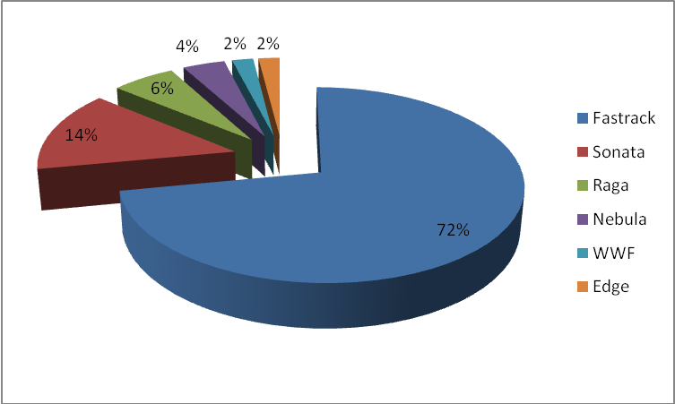

Period of use
The respondents were asked to mention since how long they have been brand loyal to Titan. This was an open ended question and hence various responses were received. The minimum period of use was set as one year, as mentioned earlier, while the maximum period of use was determined. For convenience, the different responses are categorized into three: 1year – 4years, 4years – 7years and 7years – 10years.

64% of the respondents fall into first category, i.e., they are using Titan watch in the range of one to four years. 24% respondents are in second category and the rest 12 % are using it for more than seven years.

Figure 5: Period of Titan watch’s use
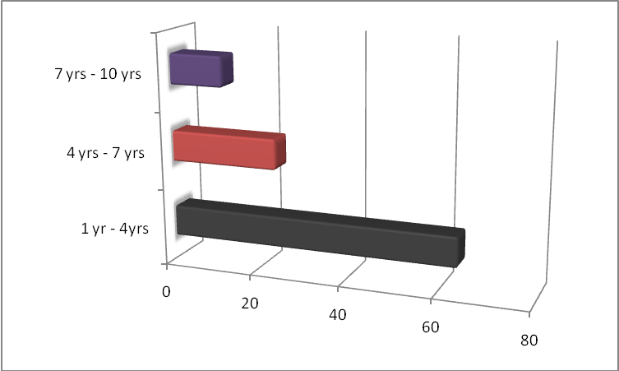

Reasons for brand loyalty
The respondents were asked to select the reasons from the options given for their preference for Titan watches. For this question, multi-responses were received from the respondents.

Table 1: Reasons for brand preference
Reasons | No. of respondents ( out of total 50)
Attractive designs | 39
Reasonable Price | 7
Brand image | 22
Good quality | 25

Figure 6: Reasons for brand preference
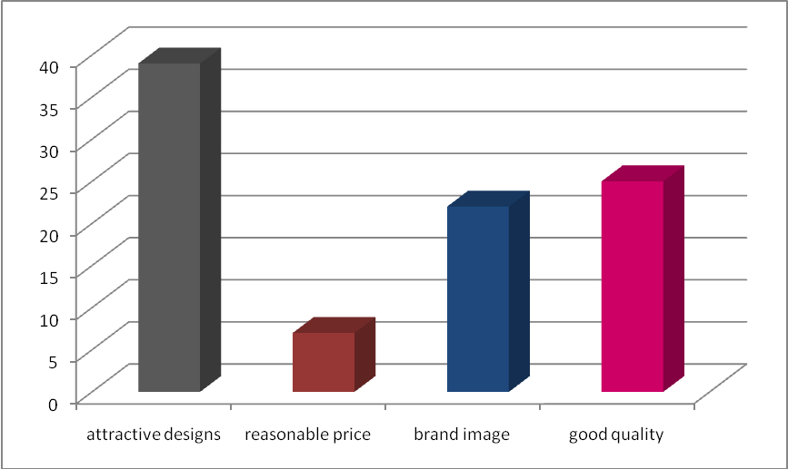

Recall of Titan’s tagline
Titan’s tagline, before brand repositioning exercise has been undertaken, was
“What’s your style”. This tagline was adopted during first rebranding exercise in 2004.
The respondents were asked to indicate whether they remember the tagline in dichotomous way, i.e., as “yes” or “no”. It was found that only 22% of the respondents were able to recall the tagline and the remaining 78% answered in negative.

Figure 7: Recall of Titan’s original tagline

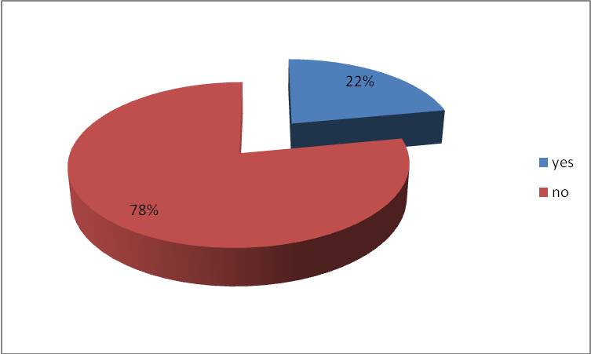

Titan’s advertisements
Titan advertises its watches in almost all media vehicles. The advertisements can be seen in TV, magazines, newspaper, hoardings, billboards, radio and so on.
All the 50 respondents have seen the advertisements of Titan watches in various media. This was a multi-response question and the options given to select were restricted to TV, magazines, newspapers, hoardings and radio.
The findings of the survey have been summarized in a table as follows:

Table 2: Major Advertisement media
Types of media | No. of respondents
TV | 46
Magazines | 25
Newspapers | 36
Hoardings | 15
Radio | 4

Figure 8: Major advertisement media
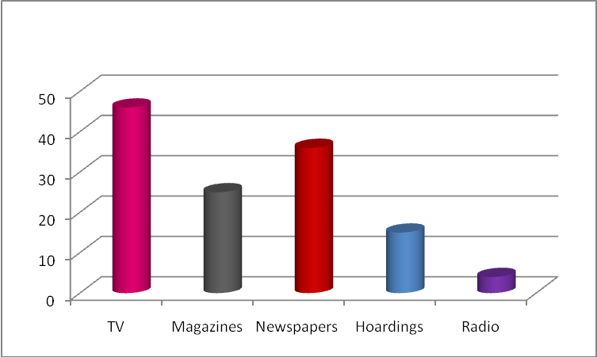
Brand Ambassador of Titan
Aamir Khan is the brand ambassador of Titan since 2004. When the respondents were asked to recollect the same, it was found that 46 of 50 sample size were able to correctly mention the brand ambassador while the remaining 4 did not give any response implying that they are not aware of it.

Figure 9: Awareness of brand ambassador
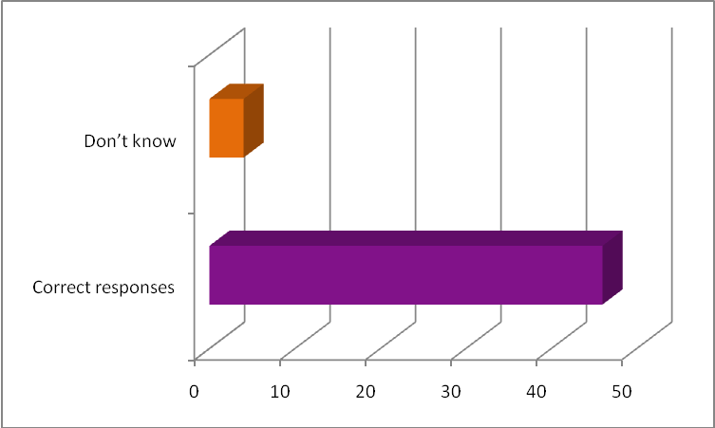

Awareness of new tagline – “Be More”
The survey has revealed that less than half of the total numbers of respondents are aware of new tagline. 36% of the respondents could correctly mention the tagline while the rest are not even aware that Titan has adopted major rebranding strategies last year.

Figure 10: Awareness of new tagline

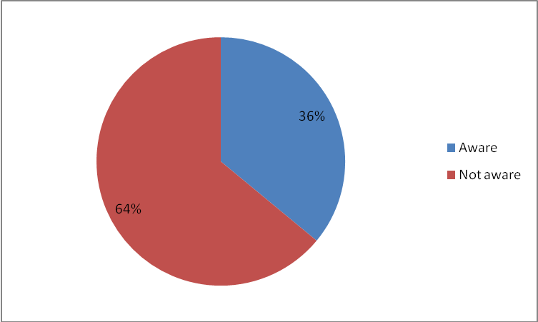

New designs of Titan
Titan has launched several new designs in 2008 in its existing collections and as per its plans introduced new product collections also. The respondents were asked to rate the new designs as “poor”, “average”, “above average”, “good” and “excellent”.
7 respondents feel that their designs are “excellent”, 39 have rated them as “good” and 4 have rated as “average”.

Figure 11: Consumer perception of new designs
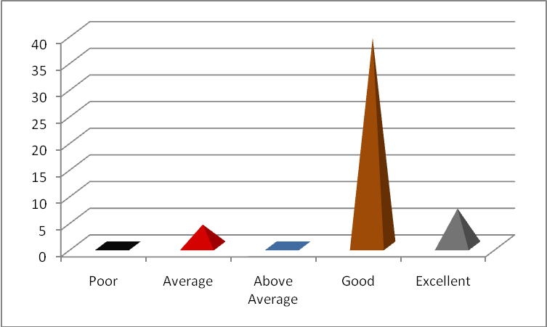

New Campaign of Titan
The survey has revealed that the percentage of respondents who have seen the new campaign focussing on “be more” featuring Aamir Khan is 50%.

Figure 12: Awareness of new campaign
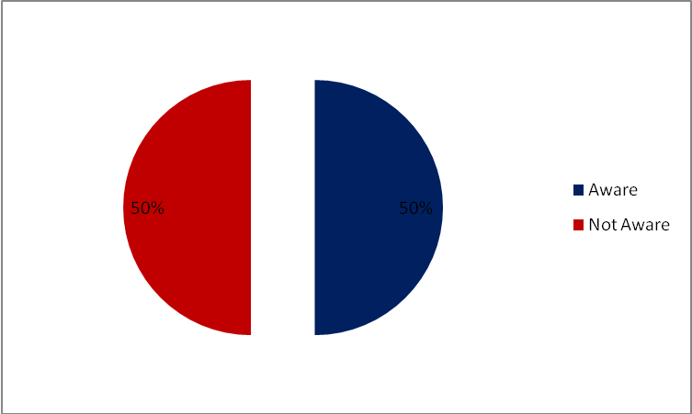

Rating of New Campaign
The 50% of the respondents who have seen the new campaign were asked to rate it with respect to how effective the campaign is in inspiring consumers to have a new look everyday and be more in lives.
The respondents were asked to rate it as “not at all effective”, “effective” and “highly effective”. 16 out of 25 respondents consider the new campaign to be “highly effective” while the remaining 9 rated it as “effective”

Figure 13: Consumer perception of new campaign
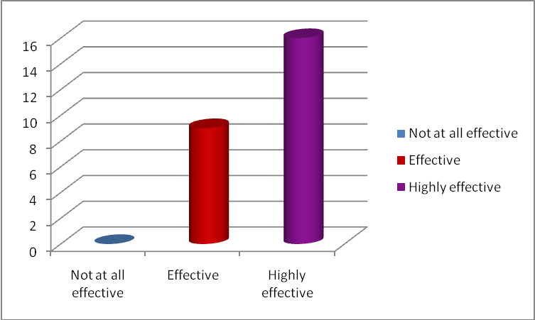

Titan’s exclusive showrooms
The respondents were asked to rate Titan’s exclusive showrooms on 5 point rating scale – Poor, Average, Above Average, Good and Excellent. The factors related to showrooms that were provided to the respondents for rating are – store ambience, sales personnel, after sales service and display of watches.

Figure 14: Consumer perception of store ambience
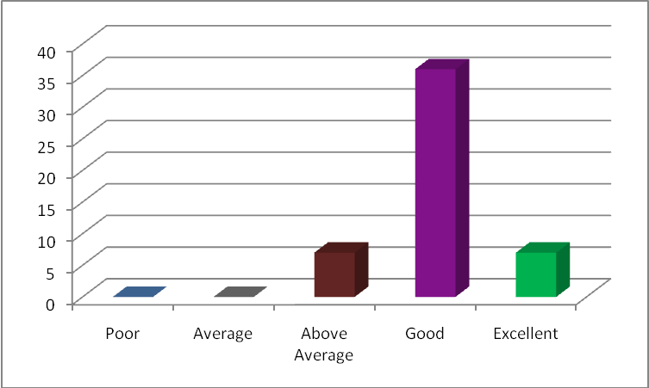
36 of the 50 respondents have rated store ambience as “Good” and 7 each rated as “Above Average” and “Excellent”. This proves that store ambience plays an important role in consumer perception of service quality.

Figure 15: Consumer perception of sales personnel
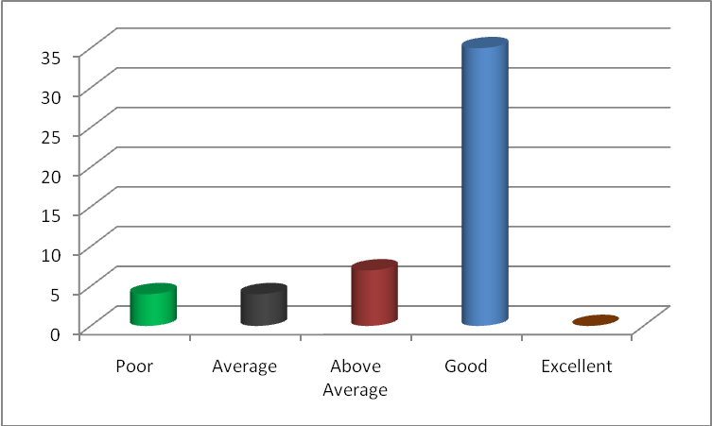
With respect to sales personnel, 35 respondents rated them as “Good”, while 4 each rated as “Poor” and “Average”, 7 respondents gave rating of “Above Average”.

Figure 16: Consumer Perception about after sales service
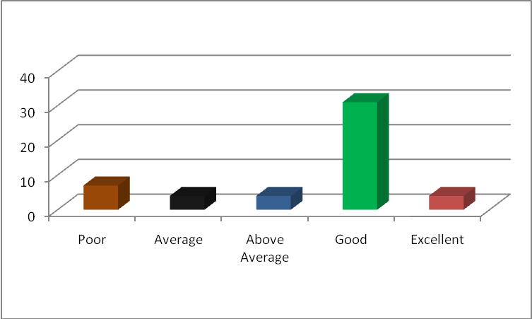

In the survey, 31 out of 50 respondents rated after sales service as” Good”, 4 each as “Average”, “Above Average”, “Excellent” while 7 respondents rated as “Poor”.

Figure 17: Consumer perception of Display of watches
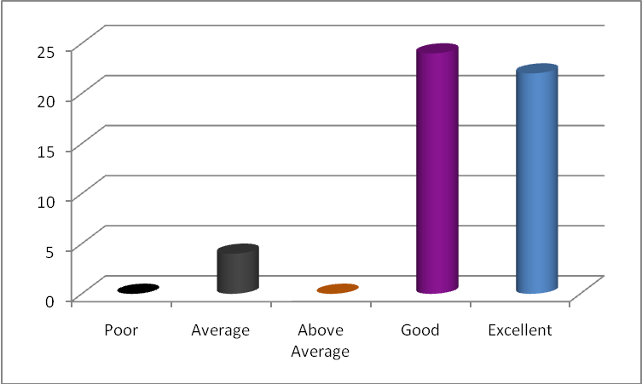

Most of the respondents have given high ratings to the display of watches in Titan showroom. 22 respondents rated it as “Excellent”, 24 respondents as “Good” and only 4 respondents gave rating of “Average”

Figure 18: Overall perception about Titan showrooms
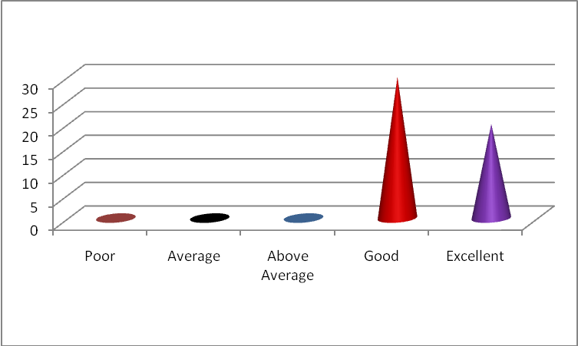

The respondents were also asked to give overall rating to Titan’s exclusive showrooms. It was found that out of total 50 respondents, 30 rated as “good” while the remaining considered the showrooms to be “excellent”.
Around 50% of the respondents rated all the variables related to Titan’s exclusive showrooms as “good”. This shows that the store ambience, sales personnel, after sales service and display of watches in the showrooms play a major role in determining the customer perception about brand.

Suggestions given by the respondents to improve brand image
Varied responses were received for this question. All the responses have been summarized as follows:
- Introduce more trendy and innovative designs
- Focus on niche markets such as working men and women
- Spread awareness about availability of watches in lower segments as most of the consumers feel that Titan brand is synonymous with premium watches.
- Take steps to change consumer perception that Titan watches are high priced.
- Improve after sales service.

7.2 Findings of the survey
The findings of the consumer awareness survey are listed below:
- 72% of the respondents in the age group of 20 – 30 years possess fastrack watch. This shows that the positioning strategy of these watches has been good.
- Most of the consumers prefer Titan watches for their attractive designs and good quality. However, there is a misconception about pricing of Titan products among the consumers. They perceive them to be high priced.
- Logos and taglines are rarely noticed by the watch consumers. Hence, any change in them also goes unnoticed.
- Advertisement in mass media such as television, newspapers, and magazines are best means to spread awareness about brand.
- Celebrity endorsement of watches not only increases the visibility of the product but also gives an assurance to the consumers that it is of high quality.
- Titan watches’ designs are rated as “good” by 78% of the respondents. This indicates that they are looking forward for more innovative designs to be introduced by the company.
- Only 50% of the respondents have seen the new campaign launched by Titan watches in July 2008. This implies that the reach of the campaign in six months has been to more or less half of the consumers. However, those who have seen the new campaign consider it to be effective in conveying the message it intended to deliver, i.e., to “be more” in lives.
- The after sales service and behavior of sales personnel have been given low ratings compared to other variables mentioned in the questionnaire with respect to Titan’s exclusive showrooms.

Chapter 8 – Conclusion

The suggestions to improve consumer awareness about brand repositioning strategy of Titan are as follows:

- To increase its visibility, Titan Company can sponsor events similar to fashion shows in which all latest designs launched are displayed. This would have multiplier effect as the latest designs launched by the company gets noticed by different segments of the customers in varied ways.
- Tie –up with FM radio channels for reminder advertisements and informing customers about various sales promotion offers from time-to-time.
- Invest more in R&D as customer expectations are changing rapidly. Though Titan has got more product collections, it should focus on introducing more varieties in already existing product collections. In other words, having a limited but more depth in product collections would be more advantageous.
- Introduce exclusive collection for working women which is more contemporary and complements both traditional and western wear.
- Majority of the population in India live in rural areas. So, showrooms should be set up at places nearer to them. Introduce cheaper and rough use watches for this segment.
- After sales service has to be improved. That is, the process of servicing and repairing of watches should be made faster. This can be done by ensuring the spare parts availability and training all sales personnel in Titan showrooms to undertake these tasks.
- Tie up with international watch brands and make them available locally.
- Make use of internet to spread awareness among consumers about the brand.

QUESTIONNAIRE

- Which sub-brand of Titan watches do you possess?
a) Fastrack
b) Sonata
c) Raga
d) Nebula
e) Others, please specify…………………………….

- Since how many months / years have you been using Titan watch?

- Why do you prefer Titan brand?
a) Attractive designs,
b) Reasonable price
c) Brand image
d) Good quality

- Do you remember the original tagline of Titan watches? If yes, please mention.

- Have you seen the advertisement of Titan watches?
a) Yes b) No

- In which media have you seen the advertisement?
a) TV
b) Newspaper
c) Magazines
d) Hoardings
e) Radio

- Who is the brand ambassador of Titan watches?

- Are you aware of the new tagline of Titan?

- How do you rate the new designs of Titan?
a) Poor
b) Average
c) Above Average
d) Good
e) Excellent

- Have you seen the new campaign of Titan?
a) Yes b) No

- Do you think the new advertisement is effective in inspiring consumers to have a new look everyday and be more in lives?
a) Not at all effective
b) Effective
c) Highly effective

- How do you rate Titan’s exclusive showrooms with respect to the following:
(1–Poor, 2-Average, 3-Above Average, 4-Good, 5-Excellent)

- Ambience -
- Sales personnel -
- After sales service -
- Display of watches -
- Overall showroom -

13. What suggestions would you like to give to improve Titan’s brand image among customers?

References
- Sengupta Subroto(2006), “Brand Positioning: Strategies for Competitive Advantage”. Second Edition, Tata McGraw Hill Publishing Company Limited, New Delhi.
- Gopalakrishnan PS (ed.) (2007),”Rebranding: An Introduction”. ICFAI University Press, Hyderabad.
- ICFAI Journal of Marketing Management
- ICFAI Journal of Brand Management
- www.marketingprofs.com
- www.brandingstrategyinsider.com
- www.scribd.com
- www.thehindubusinessline.com
- www.economictimes.com

