A study on CUSTOMER SATISFACTION FOR FASTRACK WATCHES

PROJECT REPORT


SUBMITTED BY

BELLI P K

S2 MBA

UNDER THE SUPERVISION OF

ASST PROF DHANYA

DEPARTMENT OF BUSINESS ADMINISTRATION

COLLEGE OF ENGINEERING

TRIVANDRUM

DECLARATION

We hereby declare that the project work, entitled “ASSESSMENT OF PRODUCT AND SERVICE QUALITY OF FASTRACK WATCHES” for the degree of MASTER OF BUSINESS ADMINISTRATION is my original work and project work has not formed that the basis for the award previously of any degree, associate ship, Fellowship or any other similar titles.

Signature of the Guide Signature of the Candidates

BELLI P K

Place : Trivandrum

Date : 09/02/2012
ACKNOWLEDGEMENT

All praise and honour to Almighty God who guided us throughout this project.

I am indebted to my Guide Asst. Prof. Dhanya for her support and guidance at each stage of the project work failing which project completion would have been a rather difficult task.

I also thank Associate Prof Suresh Subhramoniam for guiding me and also helping me in solving problems related to my research, forming hypothesis etc

I also extend my gratitude to Asst Prof Sini V Pillai who taught me how to solve problems related to research, specially the problems regarding Chi square

I am also indebted to my Parent and to our Beloved Friends for their care and encouragement.
Contents

TITLE PAGE ……………………………………………………………………………………………………………………………………………..1

DECLARATION 2

ACKNOWLEDGEMENT 3

INTRODUCTION 9

INTRODUCTION ABOUT WRIST WATCHES 9

INTRODUCTION TO THE STUDY 9

TITLE OF THE STUDY 9

OBJECTIVES OF THE STUDY 10

RESEARCH METHODOLOGY 10

RESEARCH 10

RESEARCH DESIGN 10

SAMPLING TECHNIQUE 10

NON-PROBABILITY SAMPLING 11

CONVENIENCE SAMPLING 11

SAMPLE SIZE 11

DATA COLLECTION 11

PRIMARY DATA 11

SECONDARY DATA 11

SIGNIFICANCE OF THE STUDY 11

LIMITATIONS OF STUDY 12

THEORETICAL PERSPECTIVE…………………………………...11

HISTORY OF WRIST WATCHES 13

COMPANY PROFILE 15

TITAN INDUSTRIES 15

FASTRACK WATCHES 19

PROMOTION 21

PRICING 24

PRICE DISCOUNTS AND ALLOWANCES 24
LITERATURE REVIEW 25

Customer perception 26

Customer Satisfaction Vs Service Quality 27

Customer satisfaction 27

Determinants of customer satisfaction 28

Brand loyalty 29

ANALYSIS AND INTERPRETATION 30

OCCUPATION OF THE RESPONDENTS 30

TABLE 1.1 30

INTREPRETATION 31

OCCUPATION OF THE RESPONDENTS 31

CHART 1.1 31

EDUCATIONAL QUALIFICATION OF THE RESPONDENTS 32

TABLE 1.2 32

INTREPRETATION 32

EDUCATIONAL QUALIFICATION OF THE RESPONDENTS 33

CHART 1.2 33

AGE OF THE RESPONDENTS 33

TABLE 1.3 33

INTREPRETATION 33

AGE OF THE RESPONDENTS 34

CHART 1.4 34

GENDER OF THE RESPONDENTS 34

TABLE 1.5 34

INTREPRETATION 34

GENDER OF THE RESPONDENTS 35

CHART 1.6 35

AWARENESS ABOUT THE PRODUCT THROUGH ADS ......................................... 35

Table 1.6 35

Interpretation 36

COMPARISON OF FASTRACK WATCHES WITH OTHER TITAN BRANDS 36

TABLE 1.7 36

INTREPRETATION 37

COMPARISON OF FASTRACK WATCHES WITH OTHER TITAN BRANDS 37

CHART 1.8 37

COMPARISON OF FASTRACK WATCHES WITH ITS COMPETITORS 37

TABLE 1.9 37

INTREPRETATION 38

COMPARISON OF FASTRACK WATCHES WITH ITS COMPETITORS 38

CHART 1.9 38

PERIOD OF USAGE OF FASTRACK WATCHES BY THE RESPONDENTS 38

TABLE 1.10 38

INTREPRETATION 39

PERIOD OF USAGE OF FASTRACK WATCHES BY THE RESPONDENTS 39

CHART 1.11 39

AFFORDABILITY OF FASTRACK WATCHES 40

TABLE 1.12 40

INTREPRETATION 40

AFFORDABILITY OF FASTRACK WATCHES 41

CHART 1.13 41

CUSTOMER SERVICE OF FASTRACK WATCHES 41

Table 1.14 41

Chart No 1.14 42

Interpretation 42

GENERAL BEHAVIOR OF CUSTOMER SERVICE PERSONNEL 42

Table 1.15 42

Chart No 1.15 43

Interpretation 43
PRODUCT OF COMPETITOR 43

Table 1.16 43

Chart No 1.16 44

Interpretation 44

Table No 1.16.2 44

Chart No 1.16.2 45

Interpretation 45

RESPONSE OF STAFF TOWARDS CUSTOMER’S ENQUIRY 45

Table 1.17 45

Chart No 1.17 46

Interpretation 46

SUGGESTIONS FOR IMPROVING QUALITY OF SERVICES 47

Table 1.19 47

Chart No 1.18 47

Interpretation 47

PRODUCT RANGE OF FASTRACK WATCHES 48

Table 1.19 48

Interpretation 49

CHANCE OF PURCHASING RIVAL BRAND 49

Table 1.20 49

Chart No 1.20 50

Interpretation 50

OPINION ABOUT WEBSITE 50

Table 1.21 50

Chart No 1.21 51

Interpretation 51

STATISTICAL STUDY 51

TESTING OF HYPOTHESIS 51

HYPOTHESIS 1 51

Interpretation 52
Hypothesis 2 53

Interpretation 54

FINDINGS AND SUGGESTION 55

FINDINGS 55

SUGGESTIONS 56

CONCLUSION 57

Bibliography 58

WEBLIOGRAPHY 58

QUESTIONNAIRE 59

INTRODUCTION

INTRODUCTION ABOUT WRIST WATCHES

Clocks and Watches are devices used to measure or indicate the passage of time. A clock, which is larger than a watch, is usually intended to be kept in one place; a watch is designed to be carried or worn. Both types of timepieces require a source of power and a means of transmitting and controlling it, as well as indicators to register the lapse of time units.

Wrist watches were once a need, but now it has become a demand. Different brands with different technology, design and innovations have entered into the market.

INTRODUCTION TO THE STUDY

Fastrack is one of the leading wrist watch brand in India, Fastrack was launched in 1998. The brand was aimed at the youth segment (15-25 years of age). The brand was promoted with the slogan "Cool Watches from Titan‖ Fastrack has an established brand image for quality, price and ranges of style it offers. However it is often found that customers have still certain issues with this brand, one of the issue is that the service after sales is not good. Customer often find it difficult to repair the watch or change the strap, dial etc. most of the retail stores doesn‘t keep spare parts reason being that Fastrack watches style changes at a faster rate, hence customers are forced to go with domestic brands straps which doesn‘t even suit the watch. Another issue is that all varieties of the brand is not available in all retail store, the customers are forced for online shopping to get their desired watches.

TITLE OF THE STUDY

CUSTOMER SATISFACTION FOR FASTRACK WATCHES
OBJECTIVES OF THE STUDY

- To understand the existing product quality in Fastrack watches.

- To investigate whether the product quality of Fastrack watches is capable of addressing all demands made by customer.

- To identify the difference between Expectation & Perception of customers in product quality offered by Fastrack watches.

- To understand about the customer satisfaction for Fastrack watches.

RESEARCH METHODOLOGY

RESEARCH

Once the problem has been carefully defined, the researcher needs to establish the plan that will outline the investigation to be carried out. The research design indicates the steps that have been taken and in what sequence they occurred. It is a systematic and purposive Investigation of facts with an objective of understanding the customer satisfaction for Fastrack watches. The methodology that will be applied by the study has been chosen in order to acquire information and deduce conclusions about the ‗Customer satisfaction for Fastrack watches‘. The main purposes of this study is to obtain an insight into the problems faced by the Fastrack watches customers in order to propose further recommendations for better customer satisfaction.

RESEARCH DESIGN

Research design is the arrangement of conditions for collection and analyze of data in a systematic manner that aims to combine relevance to research purpose with economy in procedure. The research study applied here is purely descriptive.

SAMPLING TECHNIQUE

The simple random sampling method was used for the primary data collection. Simple random sampling is the basic sampling technique where we select a group of subjects (a sample) for study from a larger group (a population). Each individual is chosen entirely by chance and each member of the population has an equal chance of being included in the sample. Every possible sample of a given size has the same chance of selection; i.e. each member of the population is equally to be chosen stage in the sampling process. There are two types of sampling techniques.

They are Probability sampling and Non-Probability sampling. The researcher adopted Non-probability sampling.

NON-PROBABILITY SAMPLING

Non-probability sampling procedure, which does not afford any basis for estimating the probability that each item in the population has been include in the sample

CONVENIENCE SAMPLING

The researcher has adopted convenience sampling method for this study.

SAMPLE SIZE

50 respondents are chosen as a sample size for the study.

DATA COLLECTION

Target Audience: Fastrack watches customers in CET campus, Sreekaryam, Trivandrum Area of Study: CET campus, Sreekaryam region.

PRIMARY DATA

Information obtained from the original source by research is called Primary Data. They offer much greater accuracy and reliability. The data was collected from the respondents through the questionnaire.

SECONDARY DATA

In means data that are already available i.e. it refers to the data which have already been collected and analyzed by someone else. The data was collected from the websites and journals.

SIGNIFICANCE OF THE STUDY

The watch industry is in the current scenario is booming and undergoing a rapid growth. The emergence of new generation private and foreign watches in the Indian watch market has raised the competitiveness in the industry. The study aims at identifying the extend to which the product quality of a watch affects its competitiveness. The outcome of the study reveals the current perception about the watches rooted in the minds of the customers which could be useful in formulating the strategies in future operations of the company, for the attainment of its goals in this competitive scenario.
LIMITATIONS OF STUDY

The following are the limitations of the study

- Mobile phone has become the most necessary commodity/service, so it was difficult to define the population in a particular place.

- 50 respondents cannot represent the population, as a whole. So the findings may be biased.

- Time plays a havoc role in data collection. So, the sample is restricted to 50.

- Chances of biased responses from the customers

HISTORY OF WRIST WATCHES

Today, a wristwatch is considered as much of a status symbol as a device to tell time. In an age when cell phones and digital pagers display tiny quartz clocks, the mechanical wristwatch has slowly become less of an object of function and more a piece of modern culture. Walk into the boardroom of any Fortune 500 company and you‘re likely to see dozens of prestigious wristwatches, including such names as Rolex, Vacheron Constantine, Frank Muller, Jaeger-LeCoultre and even Patek Philippe.

However, this was not always the case. Less than 100years ago, no self-respecting gentleman would be caught dead wearing a wristwatch. In those days of yore, real men carried pocket watches, with a gold half-hunter being the preferred status symbol of the time²no pun intended. Wrist lets, as they were called, were reserved for women, and considered more of a passing fad than a serious timepiece. In fact, they were held in such disdain that many a gentlemen were actually quoted to say they ³would sooner wear a skirt as wear a wristwatch´. The established watch making community looked down on them as well. Because of their size, few believed wristlets could not be made to achieve any level of accuracy, nor could they withstand the basic rigors of human activity. Therefore, very few companies produced them in quantity, with the vast majority of those being small ladies¶ models, with delicate fixed wire or chain-link bracelets.

Watch works were developed when coiled springs were introduced as a source of power. This type of spring was used in Italy about 1450. About 1500 Peter Henlein, a locksmith in Nürnberg, Germany, began producing portable timepieces known popularly as Nürnberg eggs. In 1525 another artisan, Jacob Zech of Prague, invented a fusee, or spiral pulley, to equalize the uneven pull of the spring. Other improvements that increased the accuracy of watches included a spiral hairspring, invented about 1660 by Robert Hooke, for the balance wheel, and a lever escapement devised by British inventor Thomas Mudge about 1765.

Minute and second hands, and crystals to protect both the dial and hands, first appeared on 17th-century watches. Jeweled bearings to reduce friction and prolong the life of watchworks were introduced in the 18th century.

In the centuries that preceded the introduction of machine-made parts, craftsmanship of a high order was required to manufacture accurate, durable clocks and watches. Such local craft organizations as the Paris Guild of Clockmakers (1544) were organized to control the art of clockmaking and its apprenticeship. A guild known as the Clockmakers Company, founded in London in 1630, is still in existence. The Netherlands, Germany, and Switzerland also produced many fine artisans whose work was noted for beauty and a high degree of mechanical perfection.

This all started to change in the nineteenth century, when soldiers discovered their usefulness during wartime situations. Pocket watches were clumsy to carry and thus difficult to operate while in combat. Therefore, soldiers fitted them into primitive ³cupped´ leather straps so they could be worn on the wrist, thereby freeing up their hands during battle. It is believed that Girard-Perregaux equipped the German Imperial Naval with similar pieces as early as the1880s,which they ore on their wrists while synchronizing naval attacks, and firing artillery. In 1906, the evolution of wristlets took an even bigger step with the invention of the expandable flexible bracelet, as well as the introduction of wire loops (or lugs) soldered onto small, open-faced pocket watch cases, allowing leather straps to be more easily attached. This aided their adaptation for military use and thus marked a turning point in the development of wristwatches for men.

Another timely issue was the vulnerability of the glass crystal when worn during combat. This was addressed by utilizing ³pierced metal covers´, frequently called shrapnel guards. These were basically metal grills (often made of silver), placed over the dial of the watch²therebyprotecting the glass from damage while still allowing the time to be easily read. A less common solution was the use of leather covers, snapped into place over the watch. While they did offer protection from damage, they were cumbersome to use, and thus were primarily seen in the extreme climates of Australia and Africa Over the next decade, watch companies slowly added additional models to their catalogs, and finally, by the mid-1930s, they accounted for 65 percent of all watches exported by Switzerland. It was an uphill battle, but the wristwatch had finally arrived. They were now accurate, waterproof and, by 1931, perpetually self-winding, when Rolex introduced the Auto Rotor, a revolutionary design, which is used to this day by watch companies around the world.

The success of the wristwatch was born out of necessity, and Rolex continued this tradition by introducing a series of Professional, or ³tool watches´ in the early 1950s. These models, including the Submariner, Explorer, GMT-Master, Turn-O-Graph, and Milgauss were also designed out of necessity, as they included features and attributes that were essential for a specific task or profession. Because of its rugged design, variations of the Submariner have subsequently been issued to numerous militaries, including the British Royal Navy, Royal Canadian Navy and British Royal Marines, as well as the U.S. Navy Seals. Over the years, dozens of companies like Omega, Benrus and Panerai have also supplied specialty watch models for military duty..With the general public now leaning toward high-tech, digital gadgets, the classic mechanical wristwatch were come to the market.

COMPANY PROFILE

TITAN INDUSTRIES

Titan Industries is the world's fifth largest wrist watch manufacturer and India's leading producer of watches under the Titan, Fastrack, Sonata, Nebula, RAGA, Regalia, Octane & Xylys brand names. It is a joint venture between the Tata Group, and the Tamil Nadu Industrial Development Corporation (TIDCO). Its product portfolio includes watches, accessories and jewellery, in both contemporary and traditional designs. It exports watches to about 32 countries around the world with manufacturing facilities in Hosur, Dehradun, Goaand manufactures precious jewellery under the Tanishq brand name, making it India's only national jewellery brand. It is a subsidiary of the Tata Group.

Titan Watch division was started in 1987. At launch it was the third watch company in India after HMT and Allwyn. Titan formed a joint venture with Timex, which lasted until 1998, and setup a strong distribution network across India. As of 2010, Titan watches account for a 60% share of the total Indian market and are also sold in about 40 countries through marketing subsidiaries based in London, Aden, Dubai and Singapore. Titan watches are sold in India through retail chains controlled by Titan Industries.

Titan Industries has claimed to have manufactured the world's slimmest wrist watch - Titan Edge. Produced indigenously after four years of research and development, the Titan Edge has a total slimness of just 3.5 mm and a wafer thin movement of 1.15 mm. Apart from the Titan Edge,

Titan also offers Steel, Regalia, Raga, Fastrack, Technology, Nebula, Bandhan, Sonata, Octane, special RHosur, Tamil Nadu. Fastrack is a popular brand among youth in India. Fastrack watches come in a variety of styles, shapes and colors. On 4 March 2010, Titan Industries Announced the launch of its very first Titan flagship store is located at Opposite Shoppers Stop, Bandra Linking Road, Mumbai, India. Store is spread over a spacious 2,500 sq ft (230 m²) and houses more than 1500 watches on display from Titan like Purple, Automatics, Orion, Raga, Edge, Nebula, and many more. On November 16, 2011, Titan Industries acquired Swiss watch maker Favre- Leuba for Euro 2 million

Titan watches , the major Indian watchmaker embarked on the fashion watches category with the launch of the Titan Fastrack watches in the year 1998. As the ever changing fashion industry influenced the watch industry during this era, Titan watches came up with the stylish and trendy Titan Fastrack watches collection.

Extraordinarily innovative technology coupled with a fresh sense of style in the Titan Fastrack watches became an instant rage especially with youths. In the Titan portfolio it is believed to contribute a 4% value. Significant rise in Titan Fastrack watches sales has subsequently compelled Titan to establish it as a separate brand.

Titan has an enviable brand image in India, being ranked number 1 six times in the last seven years, and second once. Reason for success- appeals to youth market and is inspirational. Mass market brand with a strong presence at the lower end. ‘Mass with class‘ Equally popular with men and women. Brand expenditure = £339,305 - £407,166 brand building. Value for money. Titan ranks very highly in all surveys. Company is now keen to translate its brand advantage in to profits.

HTSE Technology

In July 2011 Titan launched the HTSE (High Tech Self Energized) collection of watches which run on light. According to Titan these watches can be charged with as low as 200 lux of light which makes them chargeable with light even from a candle. In its press release the company said that "HTSE draws its design inspiration from the most complex self-energizing bodies built by mankind — space stations, satellites and spaceships. Targeted at the tech-savvy, young urban

male, this ultra-modern assortment is truly an epitome of style and technology." These watches are at current available at select outlets in select cities throughout the world.

PRECISION ENGINEERING DIVISION

Precision Engineering Division of Titan was started in 2002. It has become one of the leading manufacturers of Precision Parts for Automotive and Aerospace Industries.

The Diverse Product range includes pointers, dashboard clusters like Fuel Gauge, Temperature Gauge, Gear Shift Indicators, Clocks for Automobiles and any kind of Injection molded Plastic parts, Electromechanical Assemblies for automobiles, all kinds of pressed and turned parts for automobiles. The Tooling Sector of Precision Engineering Division manufactures all kinds

of Press Tool, Molds, Jigs, and Fixtures for various industries.

Titan Automation Solution, a part of Precision Engineering Division is a leading Automation Solution Provider for all kind of industries. They made significant contributions to add value during the product development stages of the low-cost water purifier, Tata swach, developed by Tata Chemicals. The Automation Solution applied its precision engineering capabilities to supply automation solutions for the development of special assembly presses that enabled mass production of Tata swach.

JEWELLERY DIVISION

Tanishq is currently the most prominent jewellery brand of India, and it pioneered the concept of branded jewellery and ornaments in India."Tan" in Sanskrit/Urdu means body and "Ishq" in Urdu means love. Hence "Tanishq" which is becoming popular as an Indian baby name means "embodiment of love". "Tan" in Sanskrit also means to extend or to spread. Hence "to extend love" or "to spread love" are other meanings attributed to the name Tanishq. The name Tanishq has been formed by combining "Ta" (the first two letters of Tata) and "Nishk or Nishkh" (meaning gold coin or necklace in Sanskrit).

Tanishq is India's largest jewellery brand with a wide range of jewellery in 22Kt pure gold studded with diamonds or coloured gems. It is the fastest growing jewellery brand in India. Tanishq, established in 1995, challenged the established family jeweller and introduced new rules in precious jewellery; a category as old as civilization. Tanishq challenged the age-old jeweller's word with Tata's guaranteed purity. Tanishq's initial foray into the jewellery business

was a failure though. Tanishq at first introduced 18 Kt gold jewellery advertising 18 Kt as the 'international standard.' This less pure gold was completely rejected by the market dominated by (purported) 22 Kt gold. Later on, it exploded the market with facts about rampant impurity across India. It introduced technology-backed challenge in a category completely governed by blind individual trust. Tanishq introduced innovations like Karatmeter, the only non destructive means to check the purity of gold; machine made jewellery, which offers superior finish and value to the customer and handcrafted jewellery which is influenced by various jewellery traditions of India.

Tanishq has set up production and sourcing bases with thorough research of the jewellery crafts of India. The 135,000 sq ft (12,500 m²). factory is equipped with the latest and most modern machinery and equipment. The factory complies with all labour and environmental standards, located at Hosur, Tamil Nadu. The brand brings together the work of karigars, who specialize in different styles of making jewellery. Karigars, who continue to be an exploited lot with other jewellers, are paid fair remuneration and work under good working conditions in Tanishq.

FACE OF TITAN

The Company also runs a one of a kind contest in the retail industry called the Face Of Titan (FOT) contest to identify the most talented Sales person, Manager & Service personnel Technician & Cashier. The contest recognizes the best based on a set of parameters that give a measure of the overall development of the individual in each of the categories mentioned above and is not solely on sales.

This program was conceived as an assessment center for front-line staff - by Aparna Ponnappa, inspired at that time by staff who expressed their desire to 'perform' and 'be recognized' for what they do. This program enabled the retail wing of Titan to empower staff to take charge of their own skill development and provided them with a healthy and fun environment to compete and showcase their own talent.

The contest leapfrogged into the digital era from the year 2006-07 with the introduction of IT in the capturing of survey data across all of its 200+ stores, that year also saw the introduction of the data gathered at the store level being used to profile the staff at various levels using a custom built web based software developed by I.GEN Labs.

TITAN company has good reputation in Indian stock market (NSE). Sonata reached the top 100 most trusted brands of India in a study - The Brand Trust Report conducted by Trust Research Advisory. The same study has also ranked Titan as 10th Most Trusted Brand.

FASTRACK WATCHES

Fastrack is the brand for the young generation which is part of the Titan brand. Many brands have vice lines which target a separate segment of population. This helps to maintain a unique identity for each brand and also helps the mother company to differentiate between the focus areas for the different brands. Thus, in India, Titan is a company which is part of the renowned Tata group and it has launched Fastrack which caters mostly to the young generation.

When a brand targets the youth, it needs to keep changing and reinventing itself to stay in tune with the latest trends in the market which attract the urban youth. Fastrack similarly is one such brand which has been changing its product lines, introducing new elements in accessories as well as in designs so that it attracts the urban youth of India today. It is said to be one of the inventive youth brands. Initially the brand started off with watch designs which were trendy and youthful; since then it has moved onto eyewear, bags which are again marketed in different eye catching ways. While watches are marketed as wrist gear, sunglasses are marketed as eye gear. The campaigns for Fastrack are loud and shocking, with taglines open to interpretation and innovative designs in their showrooms.

Today Fastrack features a wide range of products for the young at heart. From watches and sunglasses, they have moved onto bags, belts, wallets and even wristbands.

Watches

There are various collections which can be found amongst the Fastrack watches. Each collection signifies a certain style which is present in each of the models in that collection. The New collection signifies all the latest models being introduced by Fastrack while there are the Grunge, Hip Hop, Neon, Digital Fashion, Aluminum, Colour Play, Bikers, Army and others, each with their distinct range of watches.
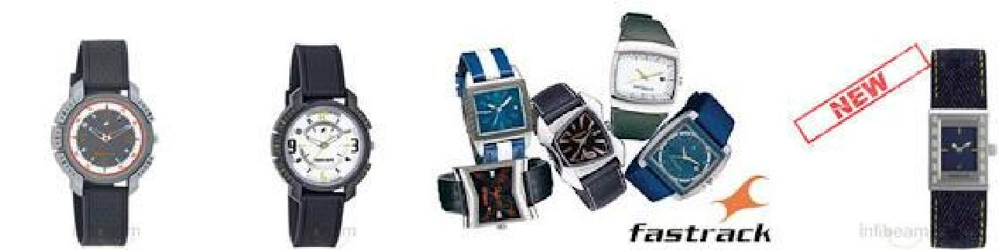

The Hip Hop range

The latest collection which is featured is the Hip Hop range. True to the flamboyant style of the hip hop culture, the watches have distinct styles and surprise elements in their design. The most stunning piece is the 3049YM01 for guys. This watch comes in gold or white metal and is to be worn like a pendant on a chain around the neck. The strap is in the form of a chain and the watch is designed like a pendant representing the male symbol.

The Denim range

The Denim collection amongst Fastrack watches are unique and are highly in demand. These feature mostly square designs where the case may be round but the dial is square shaped. The dial shapes and case shapes differ in each model and so do the straps. From leather to metal, there are straps which come in the denim material, making it perfect for pairing with your favorite pair of jeans.

The Bikers range

If you look at the Bikers collection, you would be taken aback by some of the sleek designs that this collection has for young women. Overall the designs are sporty and come with round dials, leather or metal straps and are trendy and sporty in style.

The Army range

This range probably represents the most elaborate designs amongst Fastrack watches. The straps are wide in which the watch is embedded. The dial is in the form of a bullet and the glass is designed to camouflage the dial. The leather straps add an expensive aura to these watches which are made for true army fans.

The other collections are all worth a look. The Color Play collection has classy designs which flaunt square cases with bold patterned dials and have alligator skin pattern leather straps. The Aluminum range features silvery white watches of different designs while the Basics collection features watches in plastic and rubber.

Thus, there is ample choice when it comes to watches for young men and women amongst Fastrack watches.

CUSTOMER SEGMENTATION:

After carrying out an in-depth market study, Titan identified three distinct market segments for its watches. The segments were arrived at using benefit and income level as the bases. The first consisted of the high income/ elit e consumers who were buying a watch as a fashion accessory not as a mere instrument showing time. The next segment consisted of consumers who preferred some fashion in their watches but to them price did matter. The third segment consisted of the lower - income consumers who saw a watch mainly as a time-keeping device and bought mainly on the basis of price

PROMOTION

Before Titan‘s arrival on the scene, Indian watches manufacturers saw advert ising as a rather unnecessary expense.

Titan saw it as a v it a l i n v e s t m e nt , a s it w e nt a bo u t fa s h i o n i n g br a nd - bu i l d i n g criteria that has since been embraced by the ent ire industry.

Thebr a nd h a s a l w a ys i n v e s t e d he a v i l y i n s ho w c a s i n g it s p r o d u c t s , t hr o u g h m e a s u r e s s u c h a s ‗ c a t a lo g u e ‘ a d v e r t i s i ng a nd b y u s i n g

t he p r i n t m e d i a r e g u l a r l y a n d e f f e c t i v e l y t o m e r c h a n d i s e m o d e l s A d v

e r t is i n g | o f t h i s | k i n d e na b l e d c o n s u m e r s |  |  | t o s ho p ‗ o f f |  | the page‘ and decide which
model they wanted.
Titan has made a mark in television promotions, too, where |  |  |  |  |  | its advert isements |  |  | have been
noticed | for the | music tracks | used | in | them. | In | 1991, | Titan created a
s e t o f | t h r e e p r o m o t i o n a l |  | f i l m s | t o | d e v e l o p |  | t h e | ‗gift ing‘ | market .

Watches had always been a great gift favorite, but Titan was convinced that much of t he

s e g m e nt ‘ s p o t e nt i a l relationship, wherein the moment for those involved.

l a y u nt a p p e d . E a c h o f t he films explored a particular g i f t i n g o f a T i t a n g e n e r a t e d a m o v i n g p e r s o n a l

Advertising |  | aside, | the | conception | and | ambience |  | of | Titan‘s own | retail |  | outlets
have b e e n |  | a p o w e r f u l |  | p r o m o t i o n a l |  | t o o l | f o r | t h e | c o m p a n y ‘ s | p r o d u c t s ,
T h e s e | a r e | strategically located in the newer parts of cit ies and towns, |  |  |  |  |  |  |  |  |  | always
with | a | highly | refined and |  | uniform |  | frontage |  | wit h window |  | displays

that invit e people to walk in. Inside, the Titan experience takes over. Brand offerings are

highlighted in highly refined settings that have the best of light ing, props and contextual informat ion. Even if a visit does not consummate in a purchase, the Titan touch is imprinted on consumers.

The 160 ‗World of Titan‘ showrooms across 90 cit ies in the country,

r e fu r b i s h e d i n 2 0 0 1 , a r e s y m bo l i c o f t h e br a nd ‘ s s o p h i s t i c a t io n . C o n t i n u o u s innovation of retail design sustains the ‗invitation‘ to visit the store.

T h e d e p e n d a b i l i t y q u o t i e n t i n t h e r e l a t i o n s h i p t h a t T i t a n h a s n u r t u r e d w i t h c o n s u m e r s h a s b e e n i m p r o v e d b y t h e br a n d ‘ s n e t w o r k o f a ft e r -

s a l e s s e r v i c e c e nt r e s , |  |  | w h i c h | i s | u n p a r a l l e l e d | fo r | it s | r e a c h | a n d
r e s p o ns i v e n e s s .
A d d i n g | t o | t he be n e f it s t ha t c o n s u m e r s c a n e x p e c t a r e T it a n ‘ s h i g h -
e nd ‗ w a t c h - c a r e |  | c e nt r e s ‘ , which offer showroom-like ambience and comfort.

Essentially Fastrack was a sub-brand endorsed by the Titan Brand. In most of the campaigns, the brand was promoted as Titan Fastrack. The brand was targeting young consumers who were moving towards the competitor Timex. It was during this time that Timex and Titan parted ways.

Fastrack had a good start. During the first year, the brand clocked a turnover of Rs 15 crore. The good run continued till 2001-2002 and the brand was worth Rs 25 crore at that period. But the sales stagnated. Although the brand appealed to the youngsters, price was significant dampener.

The brand found that the target group which consisted of college students could not afford this brand.

During 2003-04, the brand went in for a repositioning exercise targeting executive segment as well as casual watch segment. It was a suicidal experiment. The brand sales came down to Rs 23 crore. The change in positioning did not fit well with the brand. The consumers were not willing to pay Rs 1200-2700 for a watch that did not have the executive image.

It was in 2004 that Fastrack launched its range of sunglasses. The move was made after a consumer research which shoed that mobiles/deo/sports shoes and sunglasses are popular accessories in the purchase list of youngsters. And Sunglasses fitted perfectly as a brand extension for Fastrack. In my personal view, sunglasses offered a great opportunity for the brand. There was no Indian brand of sunglasses at that time. The brands available were Ray-Ban and other foreign brands which were imported. These brands were damn expensive and often consumers chose local unbranded sunglasses.

In 2005, the brand went for another repositioning exercise with a new logo and new positioning. The brand adopted the famous break-away positioning of Swatch. The brand decided to target the youngsters again but for that the brand had to break the price barrier.

The brand discarded the steely look of the watches and looked at a mix of plastic and steel. It was a perfect cut-copy from the strategy adopted by Swatch . By doing so, the brand was able to reduce the price range to Rs 500.

The brand then took the help of advertising to change the perception of watches as a functional tool to a fashion accessory. The brand launched a campaign with the slogan " How many you have ".

The campaign , the positioning and the price was a great hit . The brand sales zoomed to Rs 35 crore. The sunglasses also contributed significantly to this sales boost.

Fastrack have adopted the following core brand values >Fashionable and trendy

>Affordable Pricing

>Fresh Communication to attract the young consumers. The brand wanted to be the ultimate fashion accessory for the youth.

For the sunglasses, the brand roped in the youth icon John Abraham as the brand ambassador. The celebrity fitted well with the brand. Taking a cue from the fact that most of the TG for Fastrack owned a bike, Fastrack launched a biker's collection which again is a classic example of consumer-centric product innovation.

The latest innovation is the neon - disc range of Fastrack watches that does not have Hands to show the time but have electroluminescent disc that lits up to show the time.

Another advantage for this brand is the freshness that the agency had bought in its communication. Most of the Fastrack ads has been refreshing. The brand had adopted a 360 degree approach in its communication and it is an example of a brand which had used Social media to its advantage.

PRICING

T he p r i c e o f t h e mo d e l s o f F a s t r a c k r a ng e d fr o m R s . 5 5 0 t o R s 2 , 4 3 0 a nd

w a s | designed | exclusively | keeping | in | mind | the Generation |  | X | of
the subcontinent.T i t a n ‘ s p r i m a r y |  |  | p r i c i n g | o b j e c t i v e |  | i s | t o k i l l C o m p e t i t i o
n . B e i n g a n I n d i a n manufacture and infusing the advantages |  |  |  |  |  |  | of the Indian market with

the dynamics of the western market the company has carved itself a place difficult to achieve by foreign players

PRICE DISCOUNTS AND ALLOWANCES

F a s t r a c k o nc e a ye a r c o me s o u t w it h a P r i c e d i s c o u nt s a l e o n t he M R P o f t he w a t c h e s w h i c h i s b a s e d o n t h e s t o c k c a r r i e d b y t he c o m p a n y a t t he

ye a r e n d . Warranties and Service Contracts Fastrack provides warranty or service contract to its watches and this is backed up by the name TATA which is especially needed to convince and march ahead in the lower segment market. Product Line Pricing Tata‘s have paid Rs.10 crore for the three-year contract.

For t h e T a t a s | t h e m s e l v e s , i t m e a n t m o r e t h a n j u s t s p o n s o r s h i p –
i t s i g n a l e d | t h e beginning of a new era in the Tata regime. One of the main reasons for the

sponsor of this event is ―Global event like these provide a great opportunity to corporate to satisfy their marketing objectives and cross-promote their brands‖, The differences in the prices of the watches are justified by the features, the style, and the differences which make up each watch. Titan prices all its watches in such a way that it maximizes the total profit on the

total mix. The Tata Open T he ba t t le g r o u nd f o r t h i s n e w s t r a t e g y o f s y n e r g y s t a r t e d w it h t he T a t a O p e n (India‘s biggest tennis tournament) held every year

in December – January.

LITERATURE REVIEW

In educated societies, the human brain has been trained to analyze text in a way that a reader is able to interpret writing as whatever he or she sees in the meaning of the words by analyzing the context in

which the text was written. Through teaching people to read and analyze literature, the educated society has become more accustomed to picking apart the words they are reading. That same process, however, does not hold true for the human perception of images. Through societal norms, we have grown accustomed to accept images as truth without using the same analytical process to pick apart images in the way we do text. The human perception of ―truth in images‖ plays a major role in the modern day trend of manipulating photographs. In this increasingly digital age, photographs can be manipulated to portray an illusion of whatever the manipulator wants the picture to be. This can be especially prevalent in print advertising, where the main goal is to influence the needs or desires

of a consumer with persuasive images. (Barry, Ann Marie Seward: Visual intelligence, 1997.)

World of time keeping in general and mechanical watches in particular is a fascinating and complex field. Highly complex micro-mechanical systems, the history of development of movements and design trends and political and personal intrigues of industry provide for interesting reading and endless opportunity for research. (David S Landes; Revolution in time, 2004).

Titan's play in the lifestyle category is similar to what US watch and accessory brand Fossil did - -diversifying into eyewear, handbags, jewellery, shoes and apparel (in some geographies). Titan

Industries, which started as a watch brand in 1984, is taking a fresh gamble--to turn into a full-scale lifestyle company. The firm's youth brand Fastrack will drive this transformation, an effort partly to ensure that the parent brand Titan is shielded from any risk. Fastrack is already into watches and eyewear, and now it is looking at categories like bicycles, helmets, shoes and apparel. (Economic Times, 10 march 2012)

Every year hundreds of wrist watches are introduced. Some features innovative designs or mechanical improvements and others available only in limited editions, keeping the field interesting for collectors. (Peter Bron; Wrist watch annual, 2004)

Extraordinarily innovative technology coupled with a fresh sense of style in the Titan Fastrack watches became an instant rage especially with youths. In the Titan portfolio it is believed to contribute a 4% value. Significant rise in Titan Fastrack watches sales has subsequently compelled Titan to establish it as a separate brand. More than a need, wristwatch has now become a fashion statement among the youth. They don‘t consider the Fastrack brand as cheap but affordable. Titan has made a mark in television promotions, too, where its advert isements

have | been not iced for the music | tracks | used in them. | In 1991, Titan |  | created a
s e t | o f t h r e e p r o m o t i o n a l | f i l m s | t o d e v e l o p | t h e | ‗gift ing‘ | market .

Watches had always been a great gift favourite, but Titan was convinced that much of t h e s e g m e nt ‘ s p o t e nt i a l l a y u nt a p p e d . (Times magazine, March 2001)

Customer perception

Perceptions are always considered relative expectations. Because expectations are dynamic, evaluation may also shift over the time – from person to person from culture to cultures.

Customers perceive the services in terms of the quality of the service and how satisfied they are allover with their experiences. These customers – oriented terms – quality and satisfaction – have been the focus of attention for executives and researchers alike over the last decade or more. Companies today organize so that they can compete more effectively by distinguishing themselves with respect to service quality and improved customer satisfaction
Customer Satisfaction Vs Service Quality
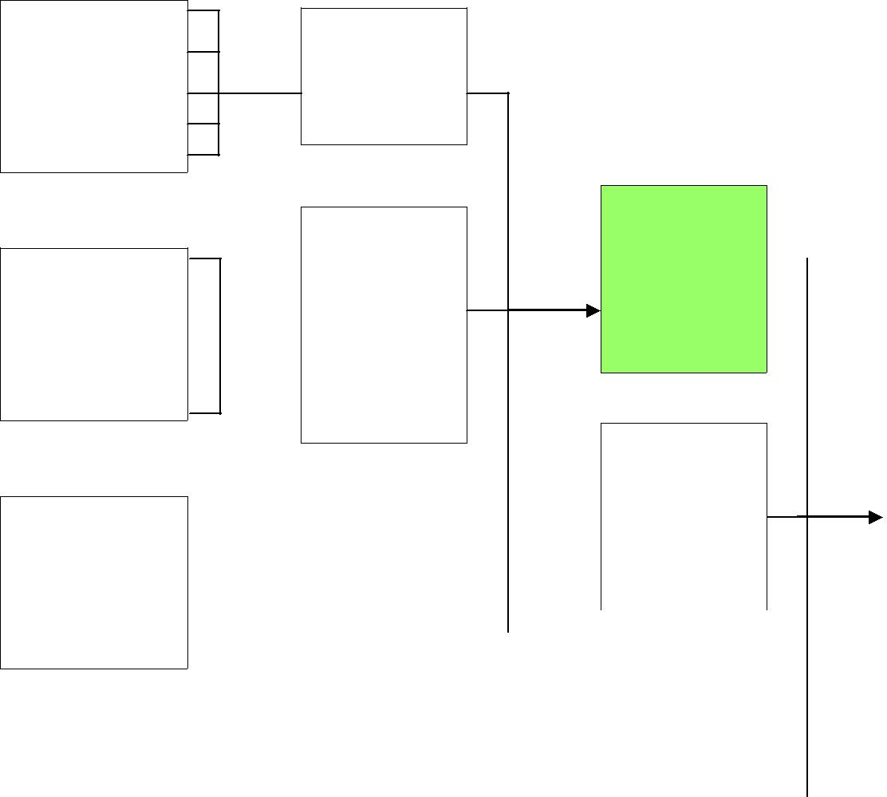

Reliability

Responsiveness
Interaction
Assurance
quality
Empathy

Tangibles


 |  |  |  |  | Situational
Service quality |  |  |  |  | factors
Reliability |  |  | Physical
Responsiveness |  |  | environment
Assurance |  |  | quality
Empathy
Tangibles


Customer satisfaction

Reliability
 |  |  |  |  |  |  |  |  | Product quality
Responsiveness
Assurance |  |  |  | Outcome
Assurance |  |  |  | quality
Empathy
Tangibles
Price |  |  |  |  |  | Personal
 |  |  |  |  |  | factors

Fig. 2.4 Customer perception of Quality and Customer

Satisfaction

Customer satisfaction

Satisfaction is the customer‘s fulfillment response. It is a judgment that a product or a service feature, or the product or service itself, provides a pleasurable level of consumption – related, fulfillment. In minimal technical terms, this definition can be translated to mean that satisfaction is the customers evaluation of a product or service in It is also important to recognize that, to measure the customer satisfaction at a particular point of time as if it were static, satisfaction is a dynamic, moving target that may evolve over the time, influenced by a variety of factors. Particularly when product usage or the service experience takes place over the time,

satisfaction may be highly variable depending on which point the usage or experience cycle is focused on.

Determinants of customer satisfaction

Customer satisfaction is influenced by specific product or service features and by perception of quality as suggested in Fig 2.6. Satisfaction is also influenced by customers

Product and service features: Customer satisfaction with a product or service is influenced significantly by the customer‘s evaluation of product or service features. Customers of services will make trade – offs among different service features depending on the type of service being evaluated and the criticality of the service.

Customer emotions: Customer‘s emotions can also affect their perceptions of satisfaction with products and services. These emotions can be stable, pre-existing emotions.

Attributions for service success or failure: Attributions – the perceived causes of events – influence perceptions of satisfaction as well. When they have been surprised by an outcome (the service is either much better or much worse than expected) consumers tend to look for the reasons, and their assessments of the reasons can influence their satisfaction.

Perceptions of equity or fairness: Customer satisfaction is also influenced by perceptions of equity and fairness. Customers ask themselves: have I been treated fairly compared with other customers? Did other customers get better treatment, better prices, or better quality service? Did I pay a fair price for the service? Was I treated well in exchange for what I paid and the effort I expended?

Other customers, family members and coworkers: In addition to product and service features and one‘s own individual feelings and beliefs, consumer satisfaction is often influenced by other people like other customers, family members and co-workers.

2.8 OUTCOMES OF CUSTOMER SATISFACTION

Individual firms have discovered that increasing the levels of customer satisfaction can be linked to customer loyalty and profits. There is an important relationship between customer satisfaction and customer loyalty. This relationship is particularly strong when customers are very satisfied. Thus firms that simply aim to satisfy customers may not be doing enough to endanger loyalty – they must instead aim to more than satisfy or even to delight their customers. At the opposite end of the satisfaction spectrum, researchers have also found that there is a

strong link between dissatisfaction and disloyalty – or defection. Loyalty can fall off precipitously when customers reach a particular level of dissatisfaction or when they are dissatisfied with service/ product.
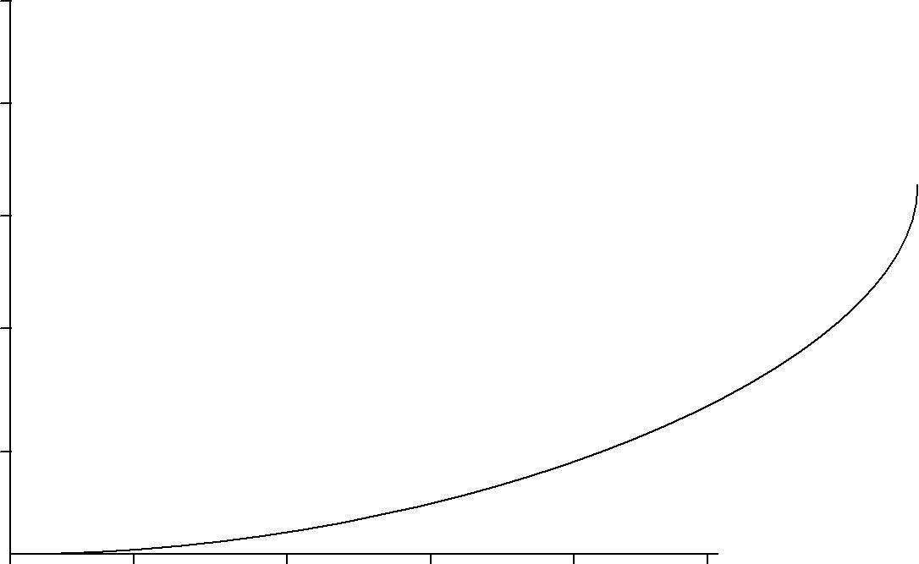

100

80

60

40

20

0 | 1 | 2 | 3 | 4 | 5
Very | Dis-satisfied | Neither | Satisfied | Very | Most
dissatisfied |  |  |  |  | satisfied
dissatisfied |  | satisfied nor |  | satisfied | satisfied
 |  | dissatisfied

Fig: Relationship between customer satisfaction and loyalty in competitive industry

Brand loyalty

The degree to which consumers are committed to particular brands of goods or services depend on no. of factors: the cost of changing brands(switching cost), the availability of substitutes, the perceived risk associated with the purchase, and the degree to which they have obtained satisfaction in the past etc. It may be more costly to change brands as awareness of substitutes is limited, and because higher risks may accompany services, consumers are more likely to remain customers of particular companies with services or goods. Greater search costs and monetary costs may be involved in changing brands of services than in changing brands of goods. Because of the difficulty in obtaining information about services, customers may be unaware of alternative or substitutes for their brands, or they may be uncertain about the ability of alternatives to increase satisfaction over present brands. If consumers perceive greater risks

with services, as is hypothesized here, they probably depend on brand loyalty to a greater extent than when they purchase products. Brand loyalty, described as a means of economizing decision effort by substituting habit for repeated, deliberate decision, functions as a device for reducing the risks for consumer decisions.

Final reason for consumers being more brand loyal with services, is the recognition of the need for repeated patronage in order to obtain optimum satisfaction from the seller.

Becoming a regular customer allows the seller to gain knowledge of the customer‘s tastes and preferences, ensures better treatment, and encourages more interest in the consumer‘s satisfaction. Thus a consumer may exhibit brand loyalty to cultivate a satisfying relationship with the seller. This is more pre-dominant in the case of corporate consumers, who regularly make purchases, year after year.

Brand loyalty has two sides. The fact that a service provider‘s own customers are brand loyal is not a problem. The fact that the customers of the provider‘s competitors are difficult to capture, however, creates special challenges. The marketer may need to direct communications and strategy to the customers of competitors, emphasizing attributes and strengths that he or she possesses and the competitor lacks. Marketers can also facilitate switching from competitors‘ services by reducing switching costs.

ANALYSIS AND INTERPRETATION

For evaluating the quality of customer satisfaction of Fastrack watches, a number of critical variables are selected for conducting an in depth analysis. The results of the analysis are presented in the following sections.

OCCUPATION OF THE RESPONDENTS

TABLE 1.1

S.NO OCCUPATION PERCENTAGE

1 | Professional | 14
2 | Business | 30
3 | Employee | 34
4 | Student | 22
 | Total | 100

INTREPRETATION

From the above table, it shows that, 34% of the respondents were employee, 30% of the respondents were Business People, 22% of the respondents were students and 14% of the respondents were professional.

It inferred that Majority (34%) of the respondents were employees.

OCCUPATION OF THE RESPONDENTS

CHART 1.1
 |  |  | 34
 | 35
 |  | 30
 | 30
RESPONDENT |  |  |  | 22
RESPONDENT | 25
RESPONDENT | 20
OF THE | 20
OF THE | 14
OF THE | 15
PERCENTAGE | 15
PERCENTAGE | 10
 | 5
 | 0
 | Professional | Business | Employee | Student

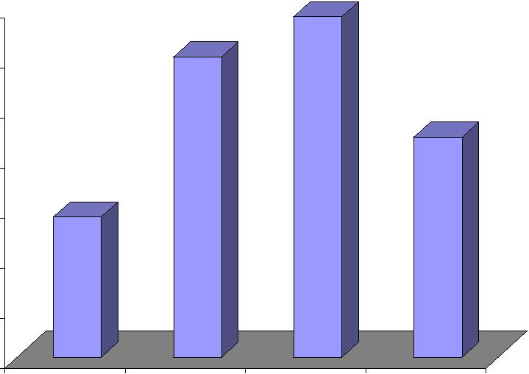
EDUCATIONAL QUALIFICATION OF THE RESPONDENTS

TABLE 1.2

S.NO | EDUCATION | PERCENTAGE
1 | School Level | 34
2 | Under Graduate Level | 50
3 | Post Graduate Level | 14
4 | Others | 2
 | Total | 100

INTREPRETATION

From the above table, it shows that, 50% of the respondents were under graduates, 34% of the respondents studied up to school level, 14% of the respondents were post graduates and 2% were included in others.

It inferred that majority (50%) of the respondents were under graduates.

EDUCATIONAL QUALIFICATION OF THE RESPONDENTS

CHART 1.2
 |  |  | 50
 | 50
 | 45
THE RESPONDENT | 40 | 34
THE RESPONDENT | 35
THE RESPONDENT | 30
THE RESPONDENT | 25
OF
PERCENTAGE | 20 |  |  | 14
PERCENTAGE | 15
PERCENTAGE | 10
 |  |  |  |  | 2
 | 5
 | 0
 |  | School Level | Under Graduate Level | Post Graduate Level | Others
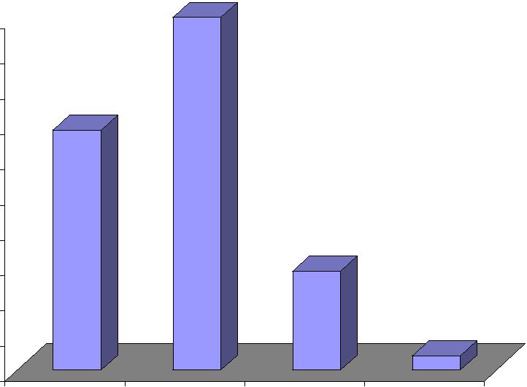

AGE OF THE RESPONDENTS

TABLE 1.3

S.NO | AGE | PERCENTAGE
1 | Below 25 | 38
2 | 26 – 35 | 42
3 | 35 – 45 | 14
4 | Above 45 | 6
 | Total | 100

INTREPRETATION

From the above table, it shows that, 42% of the respondents belong to the age group 26 - 35, 38% of them were below 25, 14% belong to the age group 35-45, only 6% of the respondents were above 45.

It is inferred that, (42%) Majority of the respondents belong to the age group 26-35.

AGE OF THE RESPONDENTS

CHART 1.4
 |  | 42
 | 45
 | 38
 | 40
RESPONDENT | 35
RESPONDENT | 30
RESPONDENT | 25
OF THE | 25
OF THE | 20 |  |  | 14
PERCENTAGE |  |  |  | 14
PERCENTAGE | 15
PERCENTAGE | 10 |  |  | 6
 | 5
 | 0
 | Below 25 | 26 – 35 | 35 – 45 | Above 45
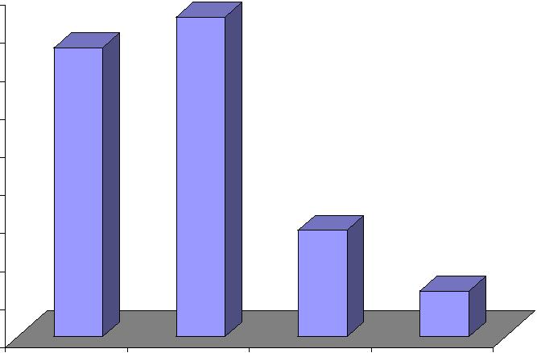

GENDER OF THE RESPONDENTS

TABLE 1.5

S.NO | GENDER | NO OF RESPONDENTS | PERCENTAGE
1 | Male | 30 | 60
2 | Female | 20 | 40
 | Total | 50 | 100

INTREPRETATION

The analysis shows that, 60% of the respondents were Male and 40% of the respondents

were Female.
GENDER OF THE RESPONDENTS

CHART 1.6

PERCENTAGE OF THE RESPONDENT


Male

Female
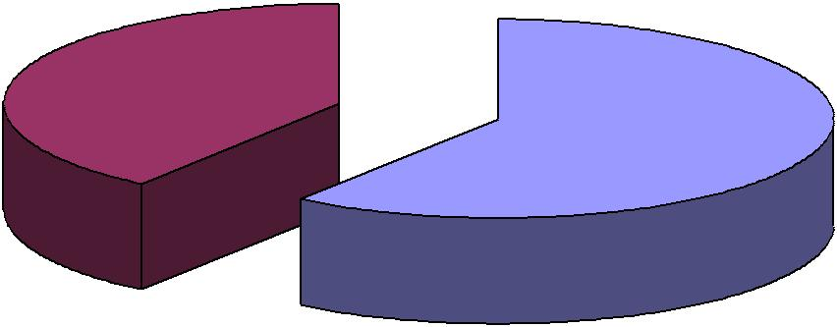

40%

60%

AWARENESS ABOUT THE PRODUCT THROUGH ADS

Table 1.6

Response | Percentage
Strongly agree | 54
Some what agree | 31
Disagree | 8
Strongly disagree | 7
Neutral | 0
Total | 100

Percentage

 |  | Strongly agree
 |  | Some what agree
60 |  | Disagree
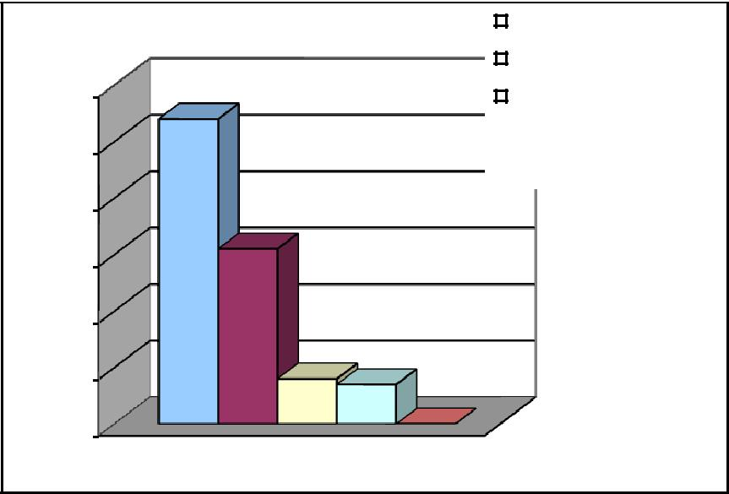

Strongly disagree
50
Neutral

40

30

20

10

0

Chart No 5.2

Interpretation

54% of the respondents strongly agree that they are aware about the range of products provided by Fastrack watches through advertisements‘. 31% of the respondents somewhat agree. While 8% of them disagree this and 7% of the respondents strongly disagree this.

Majority of respondents are aware about the various range of products provided by Fastrack watches through advertisements‘.

COMPARISON OF FASTRACK WATCHES WITH OTHER TITAN BRANDS

TABLE 1.7

S.NO | OPINION | PERCENTAGE
1 | Strongly Agree | 20
2 | Agree | 56
3 | Disagree | 2
4 | Strongly Disagree | 22
 | Total | 100

INTREPRETATION

From the above table, it shows that, 56% of the respondents agreed, 22% of the respondents strongly disagreed, 20% of them strongly agreed and only 2% of the respondents disagreed that Fastrack watches and other Titan brands only differ in price range.

It inferred that 56% of the respondents agreed Fastrack watches and other Titan brands only differ in price range

COMPARISON OF FASTRACK WATCHES WITH OTHER TITAN BRANDS

CHART 1.8
 |  |  | 56
 | 60
 | 50
THE RESPONDENT | 40
THE RESPONDENT | 30 |  |  | 22
OF | 20
PERCENTAGE | 20
PERCENTAGE | 20
 | 10 |  |  | 2
 | 0
 | Strongly Agree | Agree | Disagree | Strongly Disagree
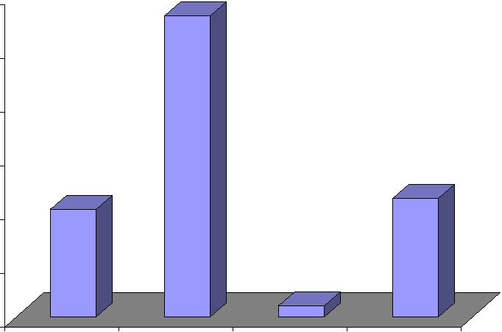

COMPARISON OF FASTRACK WATCHES WITH ITS COMPETITORS

TABLE 1.9

S.NO | OCCUPATION | PERCENTAGE
1 | Excellent | 30
2 | Good | 46
3 | Satisfactory | 20
4 | Poor | 4
 | Total | 100

INTREPRETATION

From the above table shows that, 46% felt that Fastrack watches are good than its competitors, 30% of them felt excellent, 20% of them were satisfied and only 4% of the respondents felt poor.

It inferred that majority (46%) of the respondents felt that Fastrack watches are good than its competitors

COMPARISON OF FASTRACK WATCHES WITH ITS COMPETITORS

CHART 1.9

PERCENTAGE OF THE RESPONDENT

 |  |  | 46
50
45
40
35 | 30
30
25 |  |  | 20
20
15
10 |  |  |  | 4
5
0
 | Excellent | Good | Satisfactory | Poor

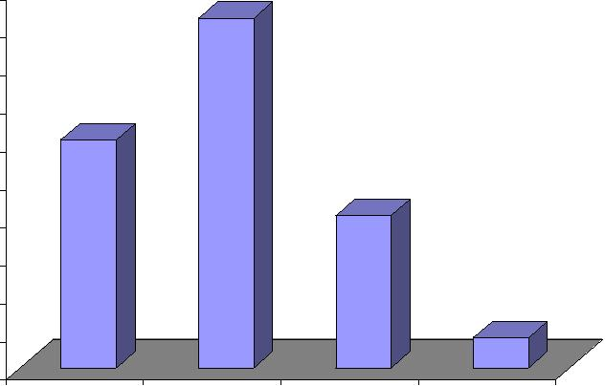

PERIOD OF USAGE OF FASTRACK WATCHES BY THE RESPONDENTS

TABLE 1.10

S.NO PERIOD OF USAGE PERCENTAGE

1 | More than 1 year |  | 66
2 | 1 | Year | 20
3 | 6 | Months | 4
4 | Recently |  | 10
 | Total |  | 100

INTREPRETATION

The above table shows that, 66%% of the respondents used Fastrack watches for more than 1 year. 20% of them used for 1 year, 10% of the respondents used only recently & only 4% of the respondents used only before 6 months.

It inferred that (66%) majority of the respondents used the Fastrack watches for more than 1 year.

PERIOD OF USAGE OF FASTRACK WATCHES BY THE RESPONDENTS

CHART 1.11

PERCENTAGE OF THE RESPONDENT

66
70
60
50
40
30
 |  | 20
20 |  |  | 10
 |  |  | 4
10
0
More than 1 year | 1 Year | 6 Months | Recently

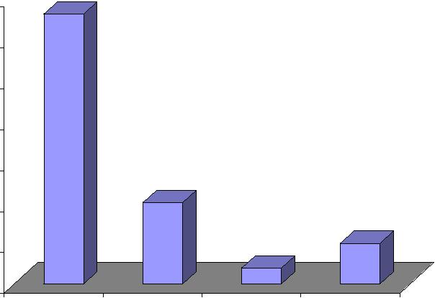
AFFORDABILITY OF FASTRACK WATCHES

TABLE 1.12

S.NO | AFFORDABLE | PERCENTAGE
1 | Strongly Agree | 32
2 | Agree | 56
3 | Disagree | 6
4 | Strongly Disagree | 6
 | Total | 100

INTREPRETATION

From the above table shows that, 56%% of the respondents agreed that Fastrack watches are affordable. 32% of them strongly agreed it. Only 6% of them disagreed and strongly disagreed it.

It inferred that majority (56%) of the respondents agreed that Fastrack watches are affordable.
AFFORDABILITY OF FASTRACK WATCHES

CHART 1.13

 |  |  |  | 56
 | 60
 | 50
THE RESPONDET | 40 | 32
THE RESPONDET | 30
OF | 30
PERCENTAGE | 20
PERCENTAGE |  |  |  |  | 6 | 6
 | 10
 | 0
 |  | Strongly Agree | Agree | Disagree |  | Strongly Disagree
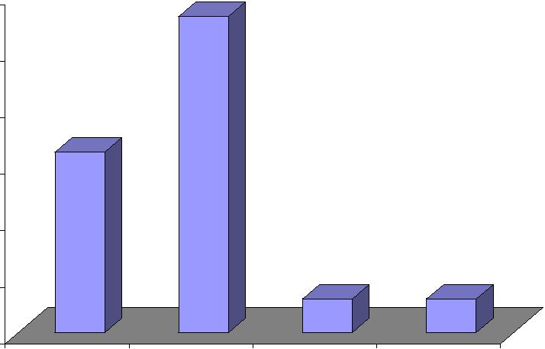

CUSTOMER SERVICE OF FASTRACK WATCHES

Table 1.14

Response | Percentage
Strongly agree | 28
Some what agree | 38
Disagree | 16
Strongly disagree | 12
Neutral | 6
Total | 100

Percentage

 |  |  | Strongly agree
40 |  |  | Some what agree
40 |  |  | Disagree
35 |  |  | Disagree
35 |  |  | Strongly disagree
30 |  |  | Strongly disagree
30 |  |  | Neutral
25 |  |  | Neutral
20
15
10
5
0

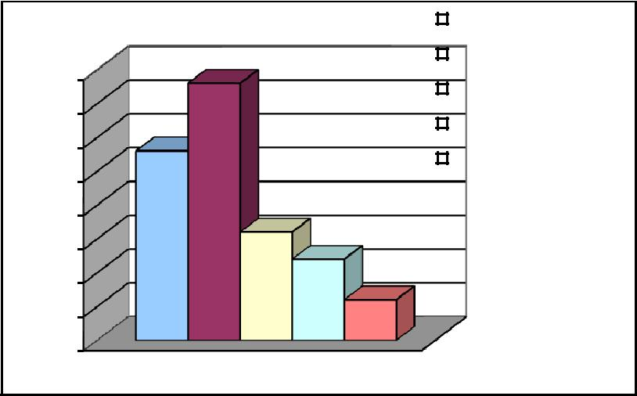

Chart No 1.14

Interpretation

As from the above table it can be seen that 28% of the respondents have strong agreement that the customer service personnel have sufficient knowledge about their products. 38% of them somewhat agree to this. 16% of the respondents disagrees to this and 12% of the strongly disagrees this. Remaining 6% of the respondents neutral to this.

Most of the customers felt that customers service personnel has good knowledge about the product.

GENERAL BEHAVIOR OF CUSTOMER SERVICE PERSONNEL

Table 1.15

Response | Percentage
Strongly agree | 42
Some what agree | 12
Disagree | 32
Strongly disagree | 5
Neutral | 9
Total | 100

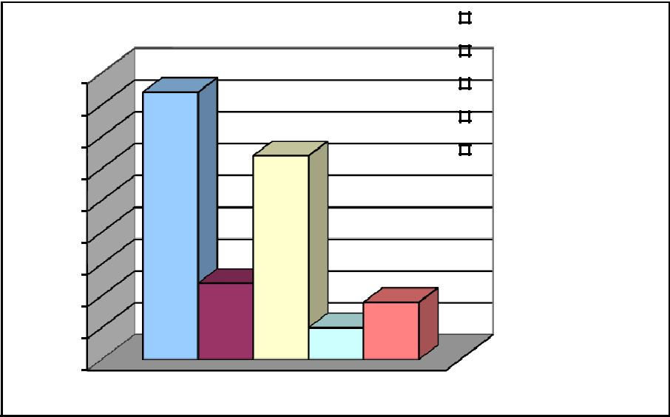

Percentage

 |  |  | Strongly agree
 |  |  | Some what agree
45 |  |  | Disagree
40 |  |  | Strongly disagree
35 |  |  | Neutral

30

25

20

15

10

5

0

Chart No 1.15

Interpretation

It can be seen from the above table that 42% strongly agrees that the general behaviour of customer service personnel of Fastrack watches was good. 21% of the respondents somewhat agrees that it was good. While 32% of them disagrees and according to them it was not good, only 5% of the respondents strongly disagrees this.

Only 42% of customers are satisfied with General Behavior of customer service personnel of Fastrack watches, majority of customers are not satisfied because the product range of Fastrack is vast and it is difficult for the service personnel to give proper service aids to Fastrack watches.

PRODUCT OF COMPETITOR

Table 1.16

Response | Percentage
Yes | 36
No | 64
Total | 100

Percentage
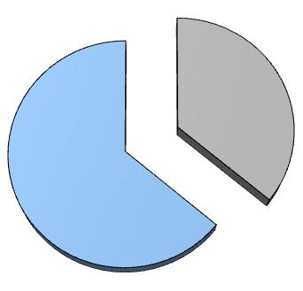

Yes 36%

No 64%

Chart No 1.16

Interpretation

From the above table it can be seen that 36% of the respondents have watches of competitor,

64% of them do not have any other watches.

Table No 1.16.2

Reason | Percentage
Better quality | 28
Modern technology | 12
Affordability | 48
Others | 12
Total | 100

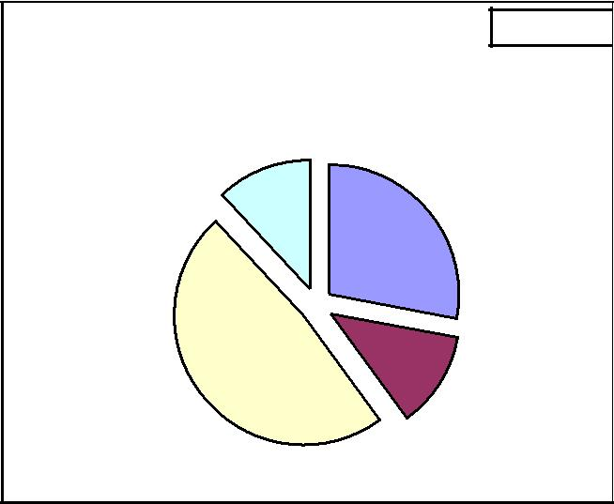

Percentage

Others
12%

Better quality 28%

Affordabi lity

48% Modern technolog

y 12%

Chart No 1.16.2

Interpretation

It is clear from the above table that 28% of the respondents have watches of competitor due to better quality. Because of modern technology 12% of respondents have watches of competitor. While 48% of the respondents choose the same due to the reason that it is affordable. 12% of them select the same due to other reasons.

Majority of customers use Fastrack watches only, this shows that loyalty of customers enjoyed by company. This strong customer loyalty is laying an effective foundation for Fastrack watches.

RESPONSE OF STAFF TOWARDS CUSTOMER’S ENQUIRY

Table 1.17

Response | Percentage
Strongly agree | 14
Some what agree | 38
Disagree | 20
Strongly disagree | 28
Neutral | 0
Total | 100

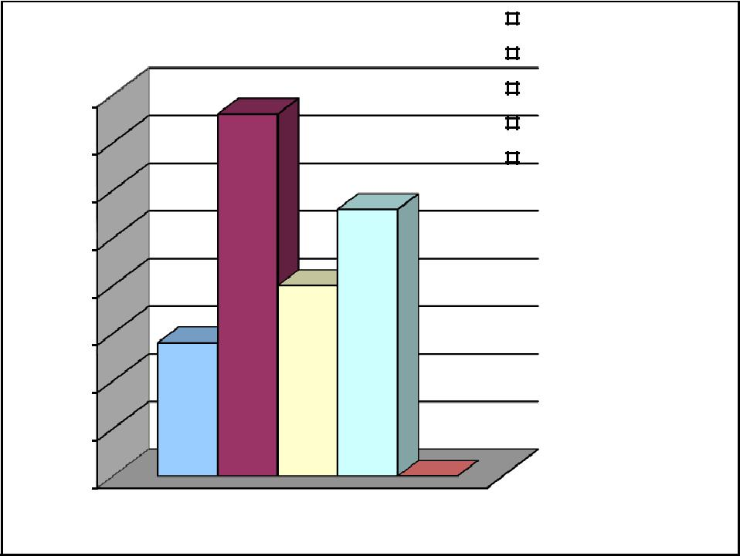

Percentage

 |  |  | Strongly agree
 |  |  | Some what agree
40 |  |  | Disagree
40 |  |  | Strongly disagree
35 |  |  | Strongly disagree
35 |  |  | Neutral

30

25

20

15

10

5

0

Chart No 1.17

Interpretation

It can be seen from the above table that 14% of the respondents strongly agrees that whenever they approached the staff with a question they responded properly. 38% of the respondents somewhat agree with this, while 20% of the respondents disagree this, remaining 28% of them strongly disagree this.

Most of customers are not satisfied with Fastrack‘s customers enquiry, so Fastrack should give proper knowledge & awareness to their staff regarding their products & services so they can give sufficient clarification for all queries that arise from customers.

SUGGESTIONS FOR IMPROVING QUALITY OF SERVICES

Table 1.19

Suggestion | No. of respondents | Percentage
Minimization of service | 0 | 0
time | 0 | 0
Better customer care | 69 | 69
Better communication of | 21 | 21
product detail | 21 | 21
Modern technology | 10 | 10
Total | 100 | 100

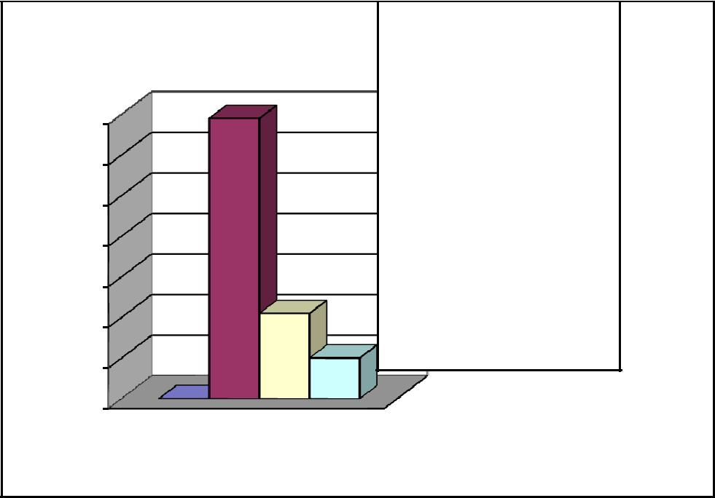

Percentage

70

60

50

40

30

20

10

0

Minimization of

service time

Better customer care

Better communication of product detail

Modern technology

Chart No 1.18

Interpretation

It can be seen from the above table that according to 69% of the respondents better customer care is the suggestion for improving quality of services. According to 21% of the respondents

better communication of product detail is the suggestion. According to 10% of them modern technology is the suggestion. None of the respondents put forward the suggestion of minimization of service time.

Most of respondents are demanded that Fastrack should better its customer care with more pleasing nature, willing to help them etc in order to attain the customer satisfaction.

PRODUCT RANGE OF FASTRACK WATCHES

Percentage

40

35

30

25

20

15

10

5

0

Table 1.19

Response | Percentage
Strongly agree | 37
Some what agree | 25
Disagree | 16
Strongly disagree | 11
Neutral | 11
Total | 100
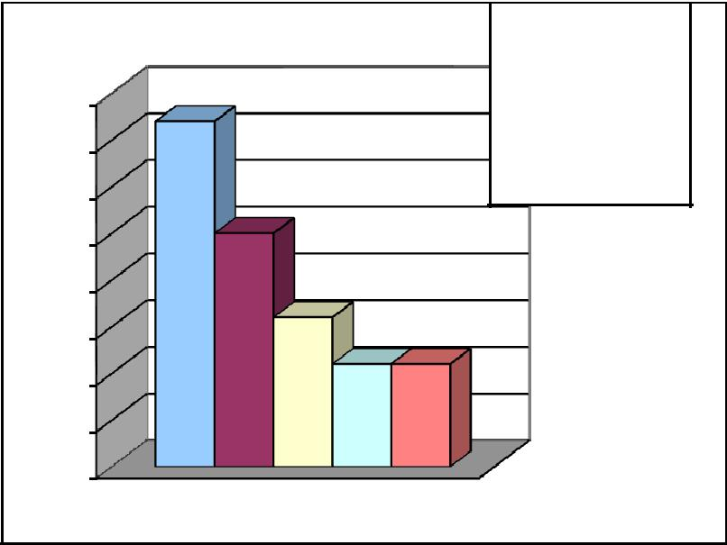

Strongly agree

Some what agree

Disagree

Strongly disagree

Neutral

Chart No 1.19

Interpretation

The above table shows that 37% of the respondents strongly agrees that the product range provided by Fastrack is satisfying. 25% of the respondents somewhat agrees to this. While 16% disagree this, 11% strongly disagree and remaining 3% neutral this.

Majority of customers are satisfied with product range of bank. It will help the brand to establish new leads & to have new customers with reference to their existing customers.

CHANCE OF PURCHASING RIVAL BRAND

Table 1.20

Response | Percentage
Strongly agree | 15
Some what agree | 22
Disagree | 46
Strongly disagree | 17
Neutral | 0
Total | 100

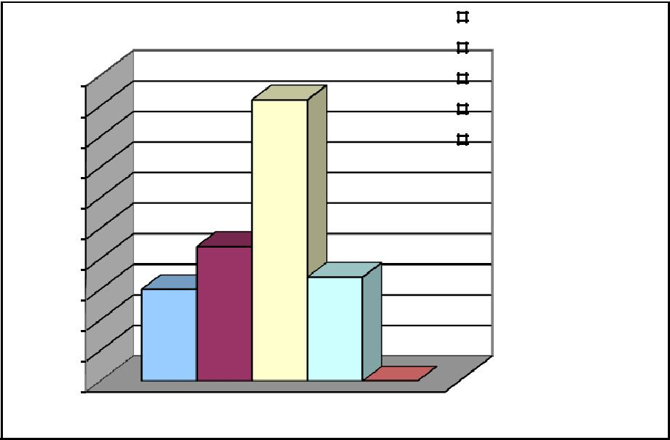

Percentage

 |  |  | Strongly agree
 |  |  | Some what agree
50 |  |  | Disagree
45 |  |  | Strongly disagree
40 |  |  | Neutral
35
30
25
20
15
10
5
0

Chart No 1.20

Interpretation

As from the above table it can be seen that 15% of the respondents strongly agrees that they will purchase watches of rival brand. 22% of the respondents somewhat agree to this. While 46% of them disagree this. 17% of the respondents strongly disagree that they will purchase watches of rival brand.

63% of customers are disagree the fact that they will purchase rival brand, it show the Fastrack providing excellent service and products to their customers to keep its customer & to survive in competitive environment.

OPINION ABOUT WEBSITE

Table 1.21

Reason | Percentage
Excellent | 40
Good | 35
Satisfactory | 21
Needs improvement | 4
Total | 100
 | Needs |  | Percentage
 | improve
 | ment
Satisfact | 4%
ory
21%
 |  | Excellent
 |  | 40%
 | Good
 | 35%

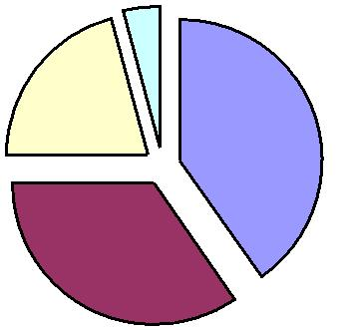

Chart No 1.21

Interpretation

From the above table it can be seen that 40% of the respondent are of the opinion that the website of Fastrack watches is excellent. 35% of the respondents expressed that it is good. According to 21% of the respondents it is only satisfactory. Remaining 4% of them expressed their opinion that it needs improvement.

Study shows that Fastrack watches website have excellent rating and it can be further improved again by including detailed information of various vouchers, offers & promotions related to their products.

STATISTICAL STUDY

TESTING OF HYPOTHESIS

The statistical test, in which the test statistics follow a chi-square distribution, is called the chi-square test. Therefore chi-square test is a statistical test, which tests the significance of difference between observed frequencies and the corresponding theoretical frequencies of a distribution, without any assumption about the distribution of the population. Chi-square test is one of the simplest and most widely used non-parametric test in statistical work. This test was developed by Prof. Karl Pearson in 1900.

HYPOTHESIS 1
H₀ : There is no significance difference between customers opinion about affordability of Fastrack watches.

H₁ : There is significance difference between customers opinion about affordability of Fastrack watches
.

 | O | E | (O – E) ² | (O – E ) ²
 | O | E | (O – E) ² | E
Strongly agree | 12 | 10 | 4 | .4
Some what agree | 15 | 10 | 25 | 2.5
Disagree | 10 | 10 | 0 | 0
Strongly disagree | 12 | 10 | 4 | .4
Neutral | 1 | 10 | 81 | 8.1
 | 50 | 50 |  | 11.4

X² = Σ (O – E)² = 11.4

E

Degree of freedom, n-1 = 5 – 1 = 4

Significance level = 0.05

Table value = 9.488

Interpretation

Table value is less than calculated value so we reject null hypothesis and accept alternate hypothesis.
∴ There is significanct difference between customers’ opinion about affordability of

Fastrack watches

Hypothesis 2

H₀ : There is no significance difference between customers‘ opinion about product range provided by Fastrack watches.

H₁ :There is significance difference between customers‘ opinion about product range provided by Fastrack watches
.

 | O | E | (O – E) ² | (O – E ) ²
 | O | E | (O – E) ² | E
Strongly agree | 13 | 10 | 9 | .9
Some what agree | 15 | 10 | 25 | 2.5
Disagree | 11 | 10 | 1 | .1
Strongly disagree | 6 | 10 | 16 | 1.6
Neutral | 5 | 10 | 25 | 2.5
 | 50 | 50 |  | 7.6

X² = Σ (O – E)² = 7.6

E

Degree of freedom, n-1 = 5 – 1 = 4

Significance level = 0.05

Table value = 9.488
Interpretation

Table value is greater than calculated value so we accept null hypothesis.

∴ There is no significance difference between customers’ opinion about product range

provided by Fastrack watches

FINDINGS AND SUGGESTION

FINDINGS

- Majority of respondents are aware about the various range of products provided by

Fastrack watches through advertisements‘.

- Majority of the respondents agreed Fastrack watches and other Titan brands only differ in price range

- Majority of the respondents felt that Fastrack watches are good than its competitors

- Majority of the respondents used the Fastrack watches for more than 1 year.

- Majority of the respondents agreed that Fastrack watches are affordable.

- Most of the customers felt that customer service personnel has good knowledge about the product.

- Majority of customers are not satisfied with general behavior of customer service personnel because the product range of Fastrack is vast and it is difficult for the service personnel to give proper service aids to Fastrack watches.

- Majority of customers use Fastrack watches only, this shows that loyalty of customers enjoyed by company. This strong customer loyalty is laying an effective foundation for Fastrack watches.

- Most of customers are not satisfied with Fastrack‘s customers‘ enquiry, so Fastrack should give proper knowledge & awareness to their staff regarding their products & services so they can give sufficient clarification for all queries that arise from customers.

- Most of respondents are demanded that Fastrack should better its customer care with more pleasing nature, willing to help them etc in order to attain the customer satisfaction.

- Majority of customers are satisfied with product range of bank. It will help the brand to establish new leads & to have new customers with reference to their existing customers.

- Majority of customers disagree the fact that they will purchase rival brand, it show the Fastrack providing excellent service and products to their customers to keep its customer & to survive in competitive environment.

- Study shows that Fastrack watches website have excellent rating and it can be further improved again by including detailed information of various vouchers, offers & promotions related to their products

SUGGESTIONS

- Customer of Fastrack watches is well known about the product range provided by the brand.

- From the survey it is clear that majority of the customers were young people and the advertisements, products offered by Fastrack watches exactly matches the demand of youth. This makes Fastrack watches ahead of its competitors

- From the survey it is clear that service quality offered by the Fastrack brand has a good influence on customers. So Fastrack should improve its customer service quality to retain and satisfy customers

- In order to improve its sales, ad promotion should be taken care, excellent customer care should be provided and also it should reduce its service time.

- There is so much percentage of customer are dissatisfied with general behavior of customer service personnel, so they should be given proper training to improve the quality of service

- Often the product range displayed in the ads are not available in stores, so it should be ensured that product ranges are available as soon as possible. Or the website should provide a solution like e-tailing.

- Due to emergence & tough competition from rivals Fastrack watches should soon implement online ordering and selling. If cash on delivery scheme is implemented it can enhance sales

- For common doubts & queries suitable recordings can be made. Queries & recommendations can be uploaded in website of Fastrack.

- Website of Fastrack can be improved again by including detailed information of new products, offers & promotions. It should also provide Customer‘s feedback option while they use online

CONCLUSION

On the growing influence of globalization on the Indian watch industry, a number of global manufacturers are coming into the Indian watch industry. In such a dynamic environment Fastrack need to be more quality conscious since the products offered are almost similar by all the watch manufacturers in the industry. Fastrack needs to take serious efforts to make itself competitive and stable in the dynamic market situation by focusing on the service quality aspects.

Gaining and maintaining consumer preference is a battle that is never really won. Cont inued and consistent branding init iat ives that reinforce the consumer‘s purchase decision will, over t ime, land t he product in consumer preference set s. Attaining and sust aining preference is an import ant st ep on t he road to gaining brand loyalty. Most of the consumers prefer Fastrack watches due to it s st rong brand image, and t he main fact or forcing t he customers to buy Fast rack watch is advertisements through the print and electronic media
Bibliography

- Philip Kotler (2006) ,―Marketing management‖, 10th edition

.

- Kothari. C.R.(2005), ―Research Methodology Methods and Techniques‖, 4th edition

- L R Potty (2011), ―Research Methodology‖

- Barry, Ann Marie Seward. (1997). Visual Intelligence: Perception, Image and Manipulation in Visual Communication.

- Kotler & Keller (2008), Marketing management, 8th edition

WEBLIOGRAPHY

- http://encartaupdate.msn.com/wristwatches.aspx

- http://realestate.msn.com/branding/titanindustries.aspx?cpdocumentid

- http://watches.about.com/od/history/a/Deontological.htm

- http://productquality.about.com/b/2003/12/31/product
QUESTIONNAIRE

Questionnaire for the Project on the topic “Assessment of product and service quality of Fastrack watches”

Name | : | Gender | :
Age | : | Occupation | :
Education | : | Signature | :

Do you own Fastrack watch?

- Yes

- No

2.Reason for selecting Fastrack watch

- Brand value

- Style

- Prestige symbol

- Others (specify________________)

3.You came to know about the brand via

- Ads

- Social network

- Peers

- Family

- Others (Specify________________)

4.How long have you been using Fastrack watch?

- 0-6 months

- 6-12 months

- 12-18 months

- More than 18 months
5.how many times you went to repair the watch

- Never

- One time

- Two time

- Three time

- More than three times

6.Put tick mark for your choice

Strongly | Agree Disagree Strongly
agree | disagree

Style range is good

It is worth the money

Advertised collection is available in store

Satisfied with what I paid for what I bought

7.In your most recent customer service experience how did you contact the representative?

- In person

- By phone

- Through retailer/dealer

- Other (specify______________)

- Not applicable

8.Did the representative (select all that apply)

- Quickly identify the problem

- Appear knowledgeable and competent

- Help you understand the cause and solution to the problem

- Handle issue with courtesy and professionalism
Not applicable

9.About how long it take to get this problem resolved?

- Immediate resolution

- Less than a day

- 2-3 days

- More than a week

- Problem is still not resolved

- Not applicable

10.Compared to other brands Fastrack is

- Much better

- Somewhat better

- About the same

- Somewhat worse

- Much worse

11.Fastrack watches are affordable

- Strongly agree

- Agree

- Neutral

- Disagree

- Strongly disagree

12.Titan brands like Raga, Sonata etc only differ in price range

- Strongly agree

- Agree

- Disagree

- Strongly disagree

13.Fastrack is excellent for the following (Answer if only applicable)
Strongly agree Agree Neutral Disagree Strongly disagree

Overall quality

Purchase experience

Usage experience

After purchase service (warranty, repair etc)

14.Put tick for the applicable ones

 | Definitely | Probably | Not sure | Probably | will | Definitely will
 | will | will |  | not |  | not
Buy Fastrack again
Recommend others to
buy Fastrack
Will buy other brand

Chapter - 1

INTRODUCTION

Chapter - 2

THEORETICAL PERSPECTIVE

Chapter – 3

ANALYSIS AND INTERPRETATION OF

DATA COLLECTED

Chapter – 4

MAJOR FINDINGS, SUGGESTIONS

AND CONCLUSION

BIBLIOGRAPHY

