

MINOR PROJECT REPORT
ON
“MARKETING STRATEGY OF
HALDIRAM’S”
MAHARAJA SURAJMAL INSTITUTE
RECOGNISED BY UGC, U/S 2 (F)
(AFFILATED BY GURU GOBIND SINGH INDRAPRASTHA
UNIVERSITY)
C-4, JANAKPURI, NEW DELHI – 110058
SUBMITTED TO:
MS. PARUL DESHWAL
(ASSISTANT PROFESSOR)
DEPTT. OF BUSINESS
ADMINISTRATION
SUBMITTED BY:
APOORVA SAXENA
ROLL NO- 01514901709
BBA (GEN.) III -SEM

CERTIFICATE
This is to certify that the project entitled “MARKETING STRATEGY OF
HALDIRAM’S’’prepared by Apoorva Saxena has been completed under my
guidelines and I am completely satisfied with the work carried out by her. The project
was successfully carried out by Apoorva Saxena in partial fulfillment of BBA,
IIIrd Semester, required for the award of degree of BBA of Maharaja Surajmal
Institute.
Project Guide
Ms. Parul Deshwal
Assistant Professor
(Deptt. Of Business Administration)

ACKNOWLEDGEMENT
This project work , which is my first step in professionalism , has been successfully
accomplished only because of timely support of my well wishers. I would like to pay
my sincere regards to those , who directed me at every step in my project work. First
of all, I would like to express my thanks to PROF. AZAD S. CHILLAR (Director,
Maharaja Surajmal Institute) for giving me such a wonderful opportunity to widen the
horizons of my knowledge. I extend my thanks to my project guide Ms. Parul
Deshwal for her scholarly guidance, constant supervision and encouragement. It is
due to her personal interest and initiative that the project work is published in the
present form. Last but not the least, I would also like thank all the staff members of
Maharaja Surajmal Institute, friends and parents who have directly or indirectly
contributed in making this project a success, it is a tribute for their valuation. Despite
all efforts I have no doubt that error and obscurities remain that seen to afflict a
working project for which I am capable.
(APOORVA SAXENA)
Roll no.- 01514901709
BBA (Gen.) 3rd Sem.

TABLE OF CONTENTS
CHAPTER 1:- INTRODUCTION
•
•
•
Objectives
Research Methodology
Limitations
CHAPTER 2:- BACKGROUND AND PROFILE OF THE
ORGANISATION
•
•
Background
Company’s profile
I.
II.
Profile
Certificates and honors
CHAPTER 3:- ANALYSIS AND INTERPRETATION
CHAPTER 4:- CONCLUSION AND RECOMMENDATIONS
•
•
•
Conclusion
Recommendations
References

CHAPTER 1
INTRODUCTION
OBJECTIVES
The objective of our project is
•
•
•
To study the marketing strategies and brand loyalty of Haldiram’s
To study the marketing mix of Haldiram’s
To study the behaviour of the consumer with respect to attributes such as
Brand Loyalty and come up with recommendations as to what all needs to be
considered keeping the consumer in mind
•
To analyze Haldiram’s competitor and compare their strategies and come up
with recommendations for any problem being faced by it.
RESEARCH METHODOLOGY
The study is an exercise involving estimation of parameters as regard to
organizational requirements- Research was designed so as to get the relevant
information that can be used for various organizational purposes.
DATA SOURCE:
Research included collecting both primary and secondary data.
PRIMARY DATA is the first hand data, new data gathered to help solve the
problem at hand. Data is collected personally for the specific project through research.
Questionnaire was prepared to gather information on the company marketing and
services.
SECONDARY DATA is the is the second hand data collected by someone else with
is gathered through internet, publications, articles, company books, etc.
DATA COLLECTION:
The data collection method used was none other than survey method which is usually
incorporated for collection of raw information. The survey method is advantageous
because it helps to collect a great deal of information about an individual respondent.
Survey:
The type of survey undertaken was that of sample type keeping in consideration the
time constraint and paraphemalic, besides the viability of census survey. The sample
survey thus being taken to the right path to reach the desired destination was carefully
planed to convert of the operation by using selected samples.
Statistical Tool:
The tool for obtaining the information was questionnaire. A structured questionnaire
was administered. The questionnaire was designed in the view both major and minor
objective of study.
Sampling:
With the customer being unknown and given the time and resource
constraints random sample was obtained from different people.
Data completion and analysis:
After the data was collected, it was tabulated and findings of the project were
presented followed by
analysis and interpretation to reach certain conclusions.


LIMITATIONS
1. The sample was collected using sampling techniques. As such result may not give
an exact representation of the population.
2. Most of the data being secondary can be biased towards the company.
3. Shortage of time is also a reasonn for incomprehensiveness.
4. Most of the information was taken from secondary sources being based on
previously printed data.

Chapter 2
BACKGROUNG AND
PROFILE OF THE
ORGANISATION
BACKGROUND
HALDIRAM – is a name associated with consumers for sweets and namkeens for the
past six decades in India and abroad. It made its modest start in the beginning 1941 in
Bikaner in the State of Rajas than. Today the company has diversified into snack
food, sweets, syrups, biscuits and fast food. It is the leader in the Namkeens segment
with a 70% of that total share in the market.
Haldiram’s is a huge brand and has diversified its activities into various industries.
The one industry where it is the king right now is the “namkeens” industry. Hence the
project mainly focuses on studying Haldiram’s namkeen division, though other areas
have been briefly mentioned.
Haldiram’s offers a wide range of products to its customers. The product range
includes namkeens, sweets sharbats, bakery items, dairy products, chips, pappad and
ice creams. However namkeens remain the main area of focus for the group as it
contributes close to 60% of its total revenues. By specializing in the manufacturing in
the namkeen market the company has created a niche market. The raw materials used
to prepare namkeens are of best of quality and are sourced from all over India.
The food industry in India is forever changing to suit their consumers’ palate,
preference and pocket. All the players in the industry thus, have to constantly adapt to
the ever-changing trends and invent and re-invent themselves to stay in the league.
Haldiram’s competes on the basis of numerous factors including brand recognition
due to distinct packaging, product quality, traditional taste and authentic Indian
flavour.
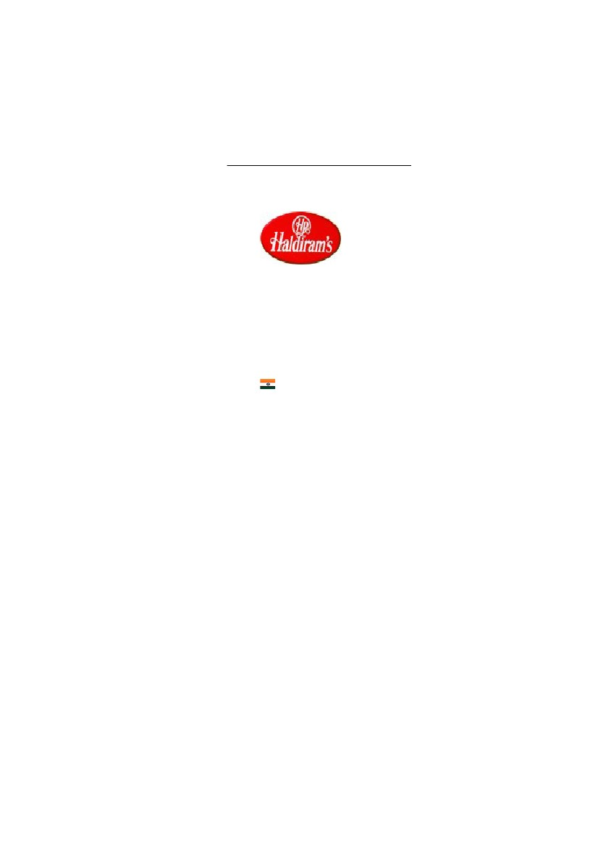
COMPANY PROFILE
Name
Company Logo
Haldiram Foods International Ltd
Address
City
State/Province
Zip/Postal Code
Country
Phone
Fax
Website
Products
880, Haldiram House, Bhandara Road
Nagpur
MS
440008
India
00917122681191
00917122680218
http://www.haldirams.com/
- Asian Foods
- Candy & Confectionery
- Processed Food
- Snacks
Awards
•
Haldiram’s bagged the prestigious ‘INTERNATIONAL AWARD FOR
FOOD & BEVERAGES’ awarded by Trade Leaders Club in Barcelona,
Spain in 1994.
•
The Group has also to its credit ‘KASHALKAR MEMORAIL AWARD’
presented by All India Food Preservers Association (Regd.) in 1996 at its
Golden Jubilee Celebration for manufacturing the best quality food products.
•
‘BRAND EQUITY AWARD 1998’ was awarded by Progress Harmony
Development Chamber of Commerce & Industry in recognition of creating
successful Indian Brand ‘HALDIRAM’.
•
‘APEDA EXPORT AWARD 2001-2002’, awarded by Agricultural &
Processed Food Products Export Development Authority for the outstanding
contribution to the promotion of Agricultural & Processed Food Products
during the year 2001-2002.
•
‘MERA DELHI AWARD – 2004’ for the exemplary contribution in the field
of export.
Certifications
Haldiram’s has the following quality certifications:
•
•
ISO 9002
HACCP


CHAPTER 3
ANALYSIS AND
INTERPREATETION
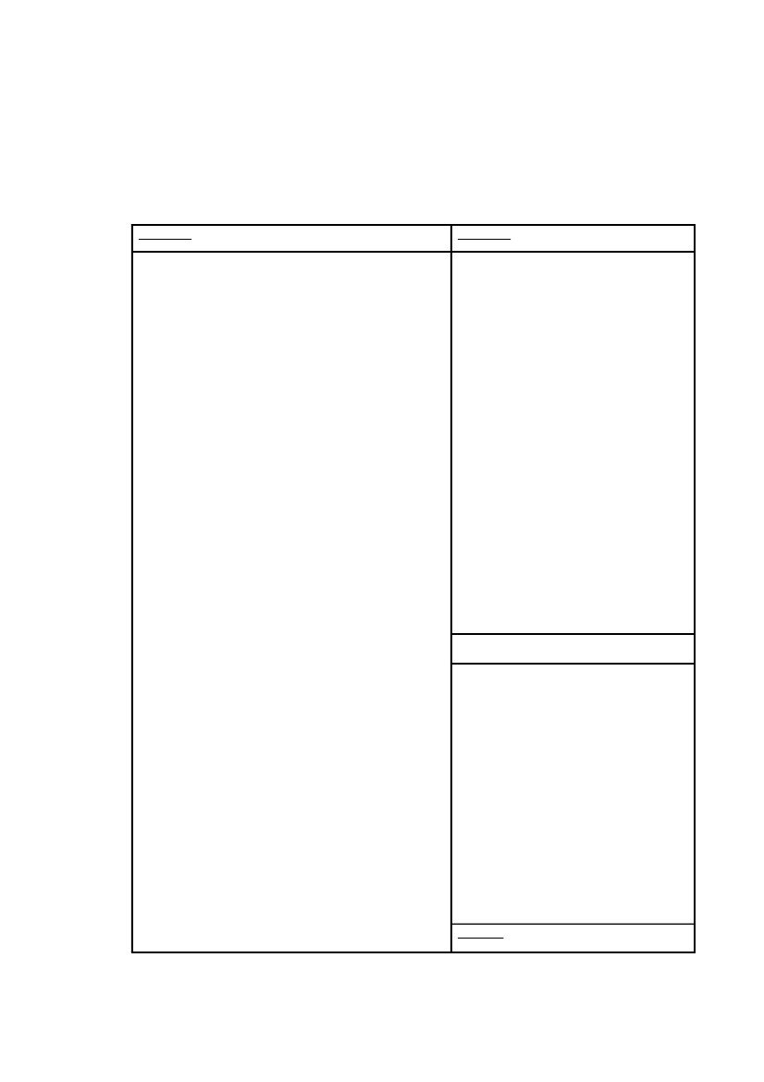
MARKETING MIX
Product
Haldiram’s offers a wide range of products to its customers. The product range
includes namkeens, sweets sharbats, bakery items, dairy products, chips, pappad and
ice creams. However namkeens remain the main area of focus for the group as it
contributes close to 60% of its total revenues. By specializing in the manufacturing in
the namkeen market the company has created a niche market. The raw materials used
to prepare namkeens are of best of quality and are sourced from all over India.
Haldiram’s customizes its products to suit the tastes and preferences of customers
from different parts of India. It launched products, which catered to the tastes of
people belonging to specific regions. For example it launched ‘Murukkus’ a south
Indian Snack and Chennai Mixture’ for south Indian customers. Similarly Haldiram’s
launched ‘bhelpuri’ keeping in mind customers residing in western India. The
company offered certain products such as ‘Nazarana’, ‘Panchratan’ and ‘Premium’
only during the festival season in gift packs. These measures have helped Haldiram’s
compete effectively in a market that is flooded with a variety of snack items in
different shapes, sizes & flavors. It has also recently launched biscuits & cookies.
Table 1.2 on the following page shows the list of Haldiram’s products

Table 1.1: Product List
Namkeens
200 Gms
1. Plain Bhujia
2. Bhujia
3. Karanchy Mixture
4. Navrattan
5. Nut Cracker
6. Khatta Meetha
7. Bombay Mixture
8. Chana Dal
9. MasalaMoong Dal
10. Moong Dal
11. Boondi Masala
12. Boondi Plain
13. Dal Biji
14. Ghatia
15. Kabli Chana
16. Bhavnagri Sev
17. Aloo Masala
18. Mathri
19. Samosa
20. Bhelpuri
21. All in One
22. Aloo Bhhujia
23. Nimbu Masala
400 Gms
1. Plain Bhhujia
2. Bhhujia
3. Navrattan
4. Khatta Meetha
5. Masala Moong Dal
6. Moong Dal
7. Nut Cracker
8. Dal Biji
9. All in One
10. Aloo Bhhujia
11. Chana Jor Garam
12. Kashmiri Mixture
13. Hara Chiwda
14. Cornflakes Mixture
15. Kaju Mixture
16. Panchrattan
75 Gms
1. Bhhujia
2. Navrattan
3. Khatta Meetha
4. Moong Dal
5. Nut Cracker
6. Aloo Bhhujia
7. Boondi Plain
8. Boondi Masala
9. Nimbu Masala
10. Peanut Salted
11. Masala Moong Dal
30 Gms
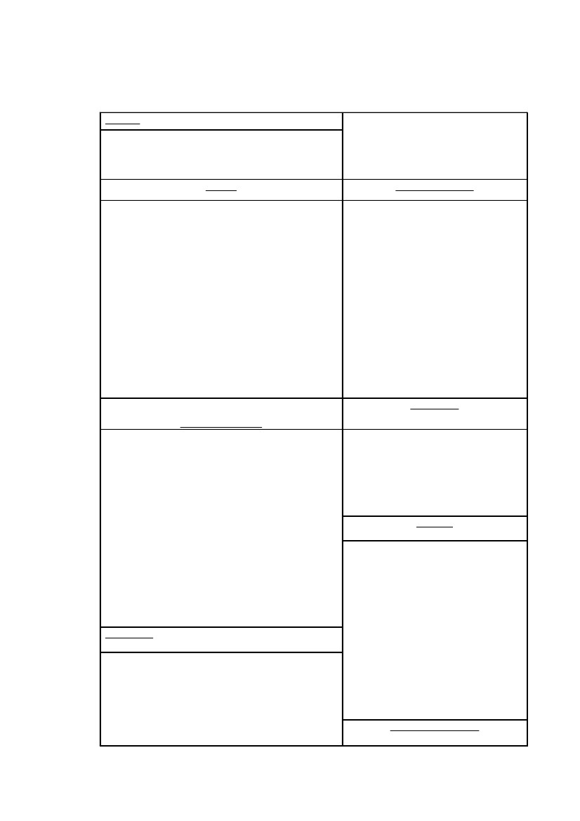
24. Long Sev
25. Methi Sev
26. Peanut Salted
27. Peanut Masala
28. Chana Jor Garam
29. Bombay Chana
30. Kashmiri Mixture
31. Cornflakes Mixture
32. Hara Chiwda Mixture
33. Mint Lachha
34. Chilli Chatak Lachha
35. Kaju Mixture
36. Panchrattan
37. Shahi Mixture
1. Nut Cracker
2. Peanut Salted
3. Aloo Bhujia
4. Bhujia
5. Navrattan
6. Moong Dal
7. Khatta Meetha
8. Nimbu Masala
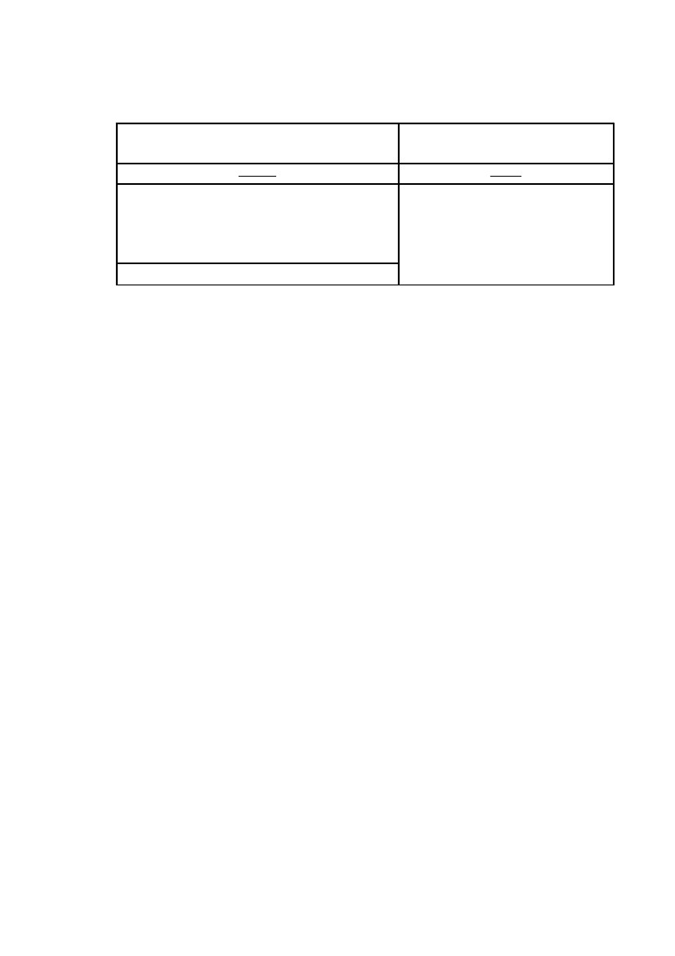
65 Gms
1. Kahmiri Mixture
2. Cornflakes Mixture
3.
Kaju Mixture
Sweets
1. Rasgulla (1 Kg Tin Pack)
2. Jamphal (1 Kg Tin Pack)
3. Cham Cham (1 Kg Tin Pack)
4. Kesar Rasbhari (1 Kg Tin Pack)
5. Kalam Petha (1 Kg Tin Pack)
6. Keasar Ganderi (1 Kg Tin Pack)
7. Raj Bhog (1 Kg Tin Pack)
8. Dry Petha
9. Karachi Halwa (250/500 Gms)
10. Soan Papdi (250/500/1000 Gms)
11. Soan Cake (250/500 Gms)
Can Packs
Perishable Sweets
1. Moti Choor Ladoo/Boondi Choor Ladoo
2. Plain Burfee
3. Dhoda Burfee
4. Moong Dal Burfee
5. Besan Ladoo
6. Atta Ladoo
7. Pinni
8. Kaju Gunjia
9. Anjeer Burfee
10. Mix Sweets
11. Mix Sweets 750 Gms
Gift Packs
1. Namkeen Nazrana
2. Sweet Spicy
3. Meetha Chatpata
4. Thoda Sa Meetha Thoda Sa Namkeen
5. Meethe Meethe Pal
7.
Gms)
Ready To Eat Food
1. Bombay Mixture
2. Aloo Bhujia
3. Cornflakes Mixture
4. Panchrattan
5. Khatta Meetha
Cookies
1. Jeera Cookies (75/300 Gms)
2. Atta Cookies (75/300 Gms)
3. Ajwain Cookies (75/300 Gms)
4. Coconut Cookies (75/300 Gms)
5. Butter Badam Cookies (75/300
Gms)
6. Kaju Pista Cookies (75/300
Gms)
Choco Chip Cookies (75/300
Syrups (700 ML)
1. Rose Syrup
2. Khus Syrup
3. Orange Crush
4. Pineapple Crush
5. Lemon Crush
6. Mango Crush
7. Kala Khatta
8. Badam Kesaria
9. Thandai Kesaria
6. Double Mazaa
Pickles
1. Mango Pickle (400/1000 Gms)
2. Lime Pickle (400/1000 Gms)
3. Chilli Pickle (400/1000 Gms)
4. Mix Pickle (400/1000 Gms)
1. Panipuri (340 Gms)
2. Bhelpuri (160/320 Gms)
Chips
1. Classic Salted (400/1000 Gms)
2. Pudina (400/1000 Gms)
3. Peprica (400/1000 Gms)
4. Mast Masala (400/1000 Gms)
5. Takatak (55/120 Gms)
•
Namkeens
Savouries or namkeens, as they are known, is where the Haldiram’s story began.
Savoury snacks have been a part of Indian food habit since ages. They are normally
consumed at teatime. The variety is almost mind-boggling with specialties from all
regions, which have gained national acceptance.
The company has a team of experienced Bikaneri namkeen makers who employ
techniques that have remained unchanged for over two hundred years. They use the
most high quality and original ingredients. So much so, that even the spices are
grinded in special spice grinders to give that original Bikaneri flavour which no one
else can deliver. Small wonder then that, they have managed to capture a lion’s share
of the market. And today “Haldiram’s” is a name synonymous with authenticity in
namkeen’s.
Sweets
Sweets, which is must for some, an indulgence for others; and for Haldiram’s another
area to establish its superior quality. Haldiram's sweets have found their way into
millions of households and left behind an after taste of great satisfaction, which is not
surprising because all the sweets here are made traditionally, by expert cooks using
the freshest and purest ingredients each day. After which they are tested for quality
and taste. Haldiram’s sweets are known for their range too. Delicious sweets like
Rasgullas, Jamphal (GulabJamuns), Raj Bhog, Nargisi Rolls, are hot favourites
among people in India and across the world.
The fact that Haldiram’s sweets are packaged and tinned in mechanized plants, which
gives them a long shelf life of about 12 months, is also of great significance.
Syrups
Imagine a hot summer day and a tall glass of chilled orange crush to cool you down.
Or a glass of hot badam milk for a cold winter night. Sounds delicious, doesn't it?
And Haldiram's range of crushes and sherbets are another fine example of its plan to
diversify and be present in every sphere of the food market.
Price
Haldiram’s offers its products at competitive prices in order to penetrate the huge
unorganized market of namkeens and sweets.
•
The company pricing strategy has taken into consideration the price conscious
nature of consumers in India. Haldiram’s has launched namkeens in small packets
of 30 grams, priced as low as Rs. 5. The company also launched namkeens in 5
different packs with prices varying according to their weights
•
The prices also vary on the basis of the type of namkeens and the raw
materials used to manufacture it. The cost of metallized packing also has an
impact on the price, especially in the case of snack foods.
•
The company revises the prices of its products upwards only when there is a
steep increase in the raw material costs or if additional taxes are imposed
Place
The Haldiram’s products are distributed all over the country and outside country also.
Haldiram’s is successfully exporting its products to USA, UK, Australia, Middle East
& Far East Countries, Germany, Philippines, New Zealand, Nepal, Sri Lanka, UAE,

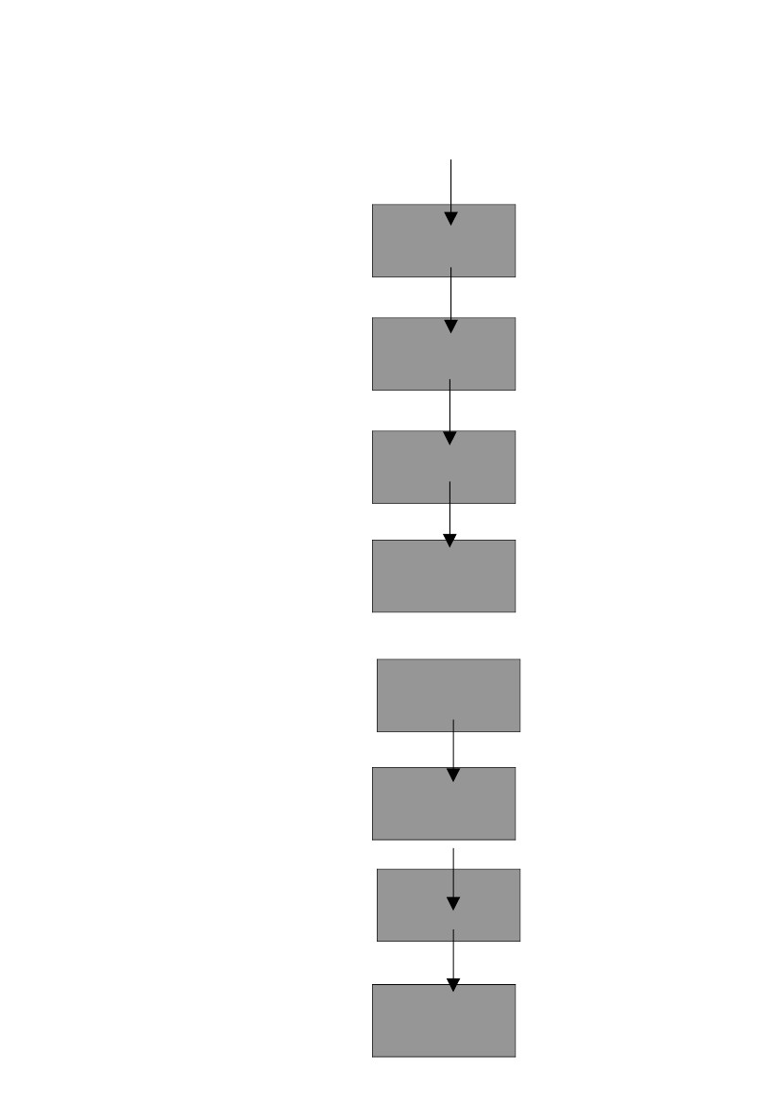
France, Spain, Italy, Holland, Japan, etc., Haldiram’s is an ISO and HACCP Certified
Company and is approved by FDA, USA.
•
Haldiram’s has developed a strong distribution network to ensure the widest
possible reach for its products in India as well as overseas. From the
manufacturing unit, the company’s finished goods are passed on to the carrying &
forward (C&F) agent. C&F agents passes on the products to distributors, who ship
them to retail outlets. While the Delhi unit of Haldiram’s has 25 C&F agents and
700 distributors in India, the Nagpur unit has 25 C&F agents and 375 distributors.
Haldiram’s also has 35 sole distributors in the international market. The Delhi and
Nagpur units together cater to 0.6 millions retail outlets in India.
•
C&F agents receive a commission of around 5% while distributors earn
margins ranging from 8% to 10%. The retail outlets earn margins from 14% to
30%. At retail outlet level, margins vary according to the weight of packs sold.
Retailers earn more margins ranging from 25% to 30% by selling 30gms pouches
(priced at Rs.5) compared to the packs of higher weights.
•
Apart from the exclusive showrooms owned by Haldiram’s, the company
offers its products through retail outlets such as supermarkets, sweet shops,
provision stores, bakeries and ice cream parlors. The products are also available in
public places such as railway stations and bus stations that account for a sizeable
amount of its sales.
•
Haldiram’s products enjoy phenomenal goodwill and stockists compete with
each other to stock its products. Moreover sweet shops and bakeries stock
Haldiram’s products despite the fact that the company’s products compete with
their own products.
A. Distribution Channel Structure
Fig 2.1: Outside Delhi
Haldiram’s
Organization
C&F
Distributor
Retailer
Consumers
Fig. 2.2: Within Delhi
Haldiram’s
Organization
Distributor
Retailer
Consumers
B. Functions Performed by the Channel Member
•
The main functions of different channel members are to supply goods, to
achieve targets and to increase sales.
•
One of the main functions of C&F agents is to achieve the targets assigned to
them. They are responsible for all the activities of their areas.
•
Maximum sale of the Haldiram’s products comes from the Nankeens and
other packed products which is nearly Rs.250 crore yearly.
•
The sale of other goods including the sales of its entire outlet is around Rs.150
crore.
C. Selection of Channel members
Channels members are selected if the following facilities are available: -
•
•
•
•
•
•
Warehouse Facilities
Experience sale persons.
Van, truck, three-wheelers for transportation.
Registered office.
Proper computer facility for maintaining accounts.
Financially strong
D. Order processing
•
Sales persons of C&F agents and distributors go to the retailers of their areas
and bring the order daily. After that they give order in the Corporate Office of
Haldiram’s in Mathura road to the general manager. From corporate office
general manager gives order in the factory. (Nodia/Gurgaon/Mathura Road)
•
As the order is ready to deliver and on confirming from the corporate office,
the goods are delivered in the trucks.
•
Orders within Delhi and the places near Delhi (like Meerut) are delivered
within 24 hours.
•
Orders outside Delhi are delivered according to the distance. It takes from 24
hours to 72 hours.
•
•
Every distributor and C&F agent has a fixed day in a week to give an order.
Haldiram’s has its own warehouse, which is managed by its own staff.
E. Physical movement of the goods
The order of Haldiram’s is delivered by truck. Haldiram’s pays the expenses for
transportation of the goods.
Promotion
Haldiram’s product promotion had been low key until competition intensified in the
snack foods market. The company tied with ‘Profile Advertising’ for promoting its
products. Attractive posters, brochures and mailers are designed to enhance the
visibility of the Haldiram’s brand.
•
Different varieties of posters are designed to appeal to the masses. The punch
line for Haldiram’s products was ‘Always in good taste’. Advertising depicting
the entire range of Haldiram’s sweets and namkeens were published in the print
media (magazines and newspapers). These advertisements had captions such as
‘millions of tongues can’t go wrong’, ‘what are you waiting for, Diwali??’ and
‘Keeping your taste buds on their toes’.
•
To increase the visibility of the Haldiram’s brand, the company has placed its
hoardings in high traffic areas such as train stations and bus stations. Posters are
designed for display on public transport vehicles such as buses and hoardings.
•
Captions are developed that focus on individual products such as ‘yeh corn
hai’ (this is corn), ‘chota samosa – big mazaa’ (small samosa- big entertainment)
‘yeh kashmiri mix khoob jamega’ and ‘oozing with taste’ (for Rasgoolas)
promoted individual products .
•
Special brochures are designed for those customers who want to know more
about Haldiram’s products. The brochures describe the products and give
information about the ingredients used to make those products. Mailers are also
sent to loyal customers and important corporate clients as a token of appreciation
for their patronage.
•
Packaging is an important aspect of Haldiram’s product promotion. Since
namkeens are impulse purchase items, attractive packaging in different colors
influences purchases. Haldiram’s uses the latest technology (food items were
packed in nitrogen filled pouches) to increase the shelf life of its products. While
the normal shelf life of a similar product is under a week, the shelf life Haldiram’s
product is about six months. The company projects the shelf life of its products as
its unique selling proposition.
•
Posters highlighting the shelf life of its products carried the caption ‘six
months on the shelf and six seconds in your mouth’.
•
During festival season, Haldiram’s products are sold in attractive looking
special gift packs.
•
The showrooms and retail outlets of Haldiram’s give importance to the point
of purchase (POP) displays. Haldiram’s snacks are displayed on special racks,
usually outside retail outlets. The showrooms has sign boards displaying
mouthwatering delicacies with captions such as ‘Chinese Delight’, ‘Simply
South’, ‘The king of all chats.’ Posters containing a brief account of the history of
Haldiram’s along with pictures of its products are also displayed at these
showrooms.
•
Haldiram’s has also diversified into the restaurant business to cash on its brand
image. The company has established 6 restaurants overall in India. The restaurant
at Nagpur devised an innovative strategy to increase its business. It facilitated
people who were traveling by train to order food from places where stockists of
Haldiram’s, Nagpur unit were located. The customer could order for lunch/dinner
by sending a demand draft or a cheque to the Nagpur unit or giving the same to
specified local distributors belonging to the Nagpur unit. Along with the
DD/Cheque, customers had to provide information such as the same name of the
train, its likely time of arrival at Nagpur, their names and coach and seat numbers.
•
Haldiram’s restaurants in Delhi also use innovative ways to attract customers.
The restaurants located at Mathura and Lajpat Nagar have special play area for
children.
•
To cater to NRI’s and foreign tourists, who hesitate to consume snack foods
sold by the roadside vendors since they do not prepare the foods in a hygienic
manner, Haldiram’s restaurant uses specially purified water to make snack foods
including ‘pani puri’ & ‘chat paapri’.
These promotional strategies have helped Haldiram’s to compete effectively with the
local restaurant chains such as Nathu’s, Bikanerwala and Aggarwal’s and with
western fast food chains such as Mc Donald’s and Pizza Hut.
A. Advertising Strategy
Haldiram’s advertisements have traditionally been copy heavy for various reasons and
do not have any face, known or otherwise, attached to them. They are graphic heavy
as well with extremely vibrant use of colour. Its advertisements earlier had a mature
approach with the base line “Always in good taste”, but of late due to a shift in target
audience the base line of the advertisements too has been changed to “Every zuban
pe”. This year, an otherwise conservative company, it has upped ad budgets by more
than 60% to Rs 1 crore - still a far cry though from Lays which spends over Rs 30
crore annually. But these ads were for what it calls its `new generation products' -
chips, funchees, masala balls and Taka-tak.
a) Visual (Typography, Layout)
Haldiram’s typography contains a very stylized and sophisticated font style, which
conveys the image and the personality of the brand.
The layout is picture heavy with extensive use of colour so as to make the
advertisement attractive and tempting, which is true of any food advertisement.
b) Verbal (Copy Style)
Initial advertising of the brand contained long copy but this phenomenon has recently
changed as the company is now going in for a very precise and clear form of
communication in an informal manner.
c) Attitudinal
Haldiram’s advertisements are not attitudinal in nature but are rather formal and
mature. This trend is steadily converting into a more informal, relaxed and ‘hinglish’
style.


THE BRAND
Introduction
The food industry in India is forever changing to suit their consumers’ palate,
preference and pocket. All the players in the industry thus, have to constantly adapt to
the ever-changing trends and invent and re-invent themselves to stay in the league.
Haldiram’s competes on the basis of numerous factors including brand recognition
due to distinct packaging, product quality, traditional taste and authentic Indian
flavour. The company’s timely introduction of new products and line extension has
played a major part in the buying behaviour of consumers as well.
A word of caution for the company though is that it should concentrate on its
branding activities, which will be its saving grace in the future. As the competition
toughens the only thing to see a company through would be its ability to adapt to
change, share of space and share of voice in the market.
Figure 3.1 on the following page shows the ‘Eleven Brand Definitions’
Eleven Brand Definitions
Fig 3.1: Eleven Brand Definitions
BRAND
EQUITY
PRODUCT
BRAND
BRAND
PROPERT
Y
BRAND
NAME
BRAND
MNEMON
I C
HALDIRAM’S
BRAND
CORE
VALUE
BRAND
POSITION
ING
BRAND
POSITION
BRAND
PERSONA
LITY
BRAND
CHARAC
TER
a) Product
Haldiram’s products are traditional high quality Indian sweets, namkeens and snack
food items at a premium yet affordable price. They were the first in India to use state-
of-the-art technology for manufacturing traditional Indian snack items thus setting
quality standards and improving the shelf life of the products as well.
b) Brand
When it comes to sweets, namkeens and snack food items, Haldiram’s is a name
trusted across the Indian sub-continent. It is a name associated with high quality and
traditional taste.
c) Brand Name
The brand name Haldiram’s came from the owner’s forefathers and one thing is clear,
the name has been chosen on a purely personal basis. What was chosen as a name for
the company decades ago has today revolutionized the way we look at the ethnic
snack food industry.
d) Brand Core Values
Haldiram’s brand core values are quality, taste, variety, traditional and very Indian.
e) Brand Character
The brand character of Haldiram’s that distinguishes it from its main competitor
FRITO LAYS is its ‘traditional Indian taste’.
f) Brand Personality
It is not the brand alone but the manner in which the brand presents its characteristics.
Haldiram’s depicts the personality of a man, who is rooted in his tradition out of
choice and not compulsion. He is very Indian in his tastes, choices and behavior and
puts a high premium on quality as well.
g) Brand Position
This refers to the consumers’ placement of a company vis-à-vis its competitors.
Haldiram’s has also been rated as the second fastest growing FMCG Company in
India, has 70% of the total market share in the namkeens category and is posing to be
the biggest threat to the multinational giant FRITO LAYS in the snack food market.
As far as the sweets and namkeens are concerned it is the undisputed leader in the
organized sector.
Its position in terms of pricing is premium yet affordable. It enjoys top of the mind
recall and awareness in its target audience but this could very easily be subverted if
the company does not bring into place strong branding strategies immediately.
h) Brand Positioning
Haldiram’s has uniquely positioned its brand. It has positioned itself as a premium
segment product available to all those who can afford it. It is in not perceived to be
cheap but does offer good value for money giving high priority to quality and taste
standardization throughout its outlets, which are suitably located in posh areas of the
city. Initially the brand catered only to the 35+ category with its positioning statement
“Always in good taste” but lately the company has started to target kids and teenagers
as well with a hinglish baseline “Every zuban pe”.
Haldirams has also gained an edge over its competitors by minimizing promotion
costs. Haldirams once was just another sweet maker but it had moved into trained
brands by improving the product quality and packaging. Through its clever products
& brilliant distribution it has moved into the star category of brands.
i) Mnemonic
Whenever one things of a brand, the first thing that comes to the mind that reminds us
of just the brand and not the features attached to it is considered as the mnemonic for
that brand. In Haldiram’s case it is not available as yet but is under consideration. For
the time being the logo itself could be taken as the mnemonic for the brand.


j) Brand Property
It is the memory device, which not only reminds the consumers of the brand name but
also its core values. In case of Haldiram’s the brand property would be its red and
white stylized logo and its base line “Every zuban pe” which is reminiscent of the
fact that the brand is an established one with top of the mind recall.
k) Brand Equity
In case of Haldiram’s the brand equity is its 70% holding of the entire market for
namkeens, its undisputed leadership in the sweets category and also top of the mind
recall amongst the target audiences’ vis-à-vis the competitors in the sweets and
namkeen market achieved through decades of quality and taste control measures. The
taste that Haldiram’s provides through its products is very Indian and yet it maintains
international quality standards.
COMPETITION ANALYSIS
Introduction
To retain and expand its market share for higher profitability a company must
understand it’s competitive environment. It must know its competitors, their
strategies, the strengths and their weaknesses.
The major objectives of this comparison are to:
•
Analyze Haldiram’s competition (in Namkeens Segment) from an industry
and marketing point of view
•
Analyze the intrinsic long run profit attractiveness through Porter’s 5 force
model
•
Formulation of competitive strategies
•
Study the designing of competitive strategies
Competitors of Haldiram’s (in Namkeen Segment)
The following are the major competitors of Haldiram’s:
•
•
•
•
Frito Lays
Bikano
MTR
Unorganized Sector
However the comparison is restricted to Frito Lays, as this is the closest competitor of
Haldiram’s.
Levels of Competition
This analysis covers all four levels of competition for Haldiram’s: Brand, Industry,
Form and Generic.
Table 6.1: Levels of Competition
Brand
Bikano, Frito Lays, MTR, Lehar, Unorganized
Sector
Industry
Form
Differentiated Oligopoly
Traditional snacks like Samosa, Kachori, etc.,
Burgers, Pizzas, Salty Biscuits, Bakery Items
Generic
Any product competing for the same of amount
consumer dollars
A. Brand Competition
Brand Competition includes other companies offering similar products and services to
the same customers at similar prices. Here, the brand competition would be all the
companies selling Namkeens along the same lines as Haldiram’s. Because of this
brands like Bikano, Frito Lays, etc… and the unorganized sector are considered as
brand competitors.
B. Industry Competition:
The namkeens industry is essentially made up of a few players producing the same
product partially differentiated along the lines of quality, styling and services. This
means that the namkeens industry follows the pattern of ‘Differentiated Oligopoly’.
C. Form Competition:
Form competition essentially means that competitors who produce products that
supply the same service. In case of Haldiram’s Namkeens, it faces stiff competition
from traditional snacks like samosas, kachoris etc. and others like salty biscuits,
pizzas, burger and bakery items as people tend to substitute namkeens very easily with
these products.
D. Generic competition
Generic competition essentially includes those companies competing for the same
amount consumer money. In case of Haldiram’s, it includes all edible products in the
same price range
Porter’s Five Forces Model
Porter’s five forces determine the intrinsic long-run profit attractiveness of a market
or a market segment. The following is the analysis of this model with respect to
Haldiram’s:
1) Threat of Intense Segment Rivalry (Industry Competitors)
Haldiram’s did not face any intense segment rivalry in the initial stages and some time
after that, but the last few years have seen a lot of players entering the
namkeens/snack food segment. This has led to various new products being introduced
by all. Variety and higher quality standards have been set & the companies are
competing with each other to grab a larger market share in this segment and hence
there is evident segment rivalry. The primary and potential threat that appears to
Haldiram’s is from the unorganized segment with its lower pricing and variety in the
products.
2) Threat of New Entrants
There is a threat of new entrants especially from the unorganized sector that has lesser
quality pressures. The entry and exit barriers are both low leading to stable returns,
therefore big companies may enter this segment looking for a quick profit.
3) Threat of Substitute Products
Threat of substitute products arises from the ability of the consumer to substitute
namkeens by other things that suit him. For example ice creams, biscuits, bakery
products. Like wise and outing for burger and other fast food items may also
substitute for namkeens. The players have to monitor prices closely as a fall in the
prices of these substitute products may lead to a price cut in the namkeen segment as
well.
4) Threat of Buyer’s Growing Bargaining Power
There’s no threat of buyers’ growing bargaining power, as it doesn’t represent a
significant portion of the buyers’ cost. The buyers do not seem to be very price
sensitive and nor are they more concentrated (buyers are distributed across a wide
geographical region in the country) or organized.
5) Threat of Supplier’s Growing Bargaining Power
Suppliers are unorganized and there are a lot of substitutes available to the company.
Moreover the number of suppliers being large and the size of the suppliers being very
small as compared to the company, the company is in a strong bargaining position.
Hence there is no such threat of suppliers’ growing bargaining power.
Figure 6.1 on the following page shows the ‘Porter’s 5 Force s Model’ with respect to
Haldiram’s
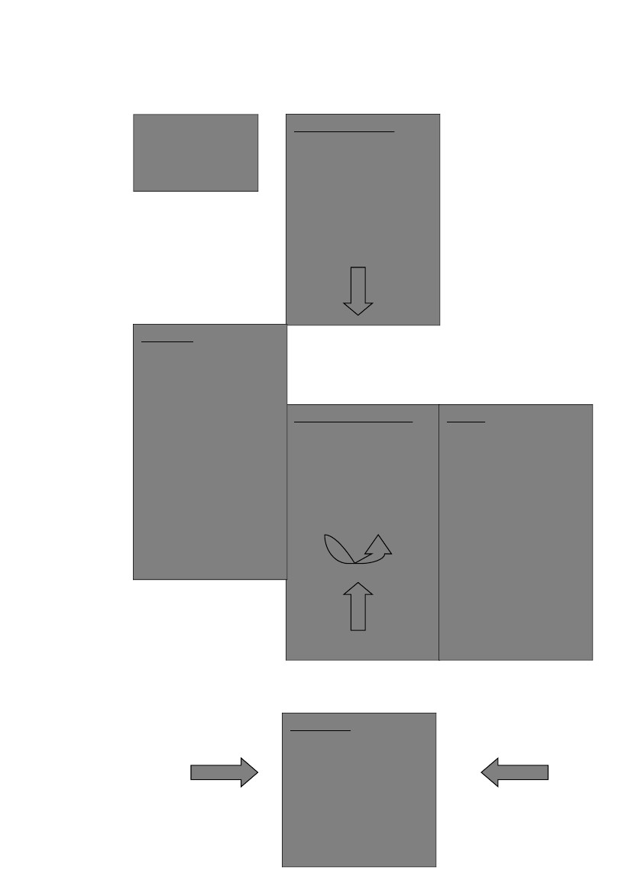

Fig 6.1: Porter’s
Five Forces Model
(for Namkeen
segment)
Potential Entrants
•
•
•
•
•
Low entry and exit
barriers
Stable return
Industry Growth rate
Economies of scale
Incumbents’ defense
of market share
Suppliers
•
•
•
Many competitive
suppliers
Low costs to switch
suppliers
Size small as
compared to company
Industry Competitors
•
•
•
•
•
Good market growth
rate
Market equilibrium
intact
Low exit cost.
Frequent innovation
making it expensive to
compete
Presence of strong and
aggressive competitors
Buyers
•
Product doesn’t
represent significant
fraction of buyers’
cost
Price sensitivity is
low.
Buyers are distributed
and not organized
•
•
Substitutes
•
•
Lot of substitutes for
namkeens
Price trends have to be
monitored closely
(threat of form
competition)
CUSTOMER VALUE ANALYSIS
A. Haldiram’s
Haldiram’s being the market leader offers enormous benefits to its customers. On the
basis of the consumer behavior survey, the highest benefit that Haldiram’s offers is by
way of hygiene and taste. Another big strength of Haldiram’s, which a factor rated
pretty high by the consumers, was Packaging. By providing fresh and tight packaging
Haldiram’s ensures that their consumers can use it for a longer period of time.
Another benefit that Haldiram’s offers is the immense variety in their product line. In
fact in the namkeens segment itself Haldiram’s offers about 40+ varieties and ensures
that this benefit stays on by constantly innovating and coming out with new types of
namkeens. The best part is that they offer traditional snacks rather than modern
snacks, which go down very well with the Indian consumer.
B. Frito Lays
According to the consumer behavior survey, the consumers rated packaging the
highest thereby signifying that this is one of the best benefits that the consumers get
from Frito Lays. Apart from that price and quality were the other benefits that the
consumers got from Frito Lays. The biggest benefit is the availability of the product
as it is a product is of Pepsi Foods and hence is backed up by a string distribution
network. However it’s on the variety factor that they actually pale in comparison with
Haldiram’s.
Types of Competitive Strategies
From the information based on the consumer survey, out of 32 people 28 consumed
Haldiram’s products. Since 91% of responses indicate consumption of Haldiram’s
products, we conclude that Haldiram’s is the market leader in the namkeens
segment. In the consumer survey that we had done, hygiene and taste had come out as
the highest priority factors that influence the buying behavior. Haldiram’s adopts the
following market leader strategies.
A. Market leader strategies adopted by Haldiram’s
a) Increasing the total market share
Being a market leader, one of Haldiram’s strategies has been to solicit new users for
their products. They have done this by targeting the NRI’s living abroad and
exporting their namkeens there. This in turn has also helped create awareness about
their product among the non-NRI’s abroad. Its foray into the foreign markets has been
carefully strategised as in the customization of its products. Apart from this, they have
also penetrated the rural markets quiet effectively by bringing out their products in
small, affordable packets. All these new markets have helped consolidate Haldiram’s
position as a market leader.
b) Defending Market Share:
To protect its position as market leader, Haldiram’s makes use of two defense
strategies: Position Defense and Mobile Defense.
1) Position Defense
Haldiram’s has built for itself quite a superior brand image, making it extremely
difficult for its competitors to break this image. Thus the competitors have to put
in extra efforts to create a brand much more superior than Haldiram’s.
2) Mobile Defense
This involves the leader stretching its domain over new territories that can serve
as future centers for defense and offense. Under this defense, Haldiram’s follows
the ‘Market Broadening’ mobile defense. The recent establishment of their
Nagpur plant shows that they are now concentrating on the Southern region. Also
their foray into the international market and their deeper penetration into the rural
market coupled with the introduction of their new product range like syrups,
pickles, etc.
3) Counteroffensive Defense:
When Haldiram’s had started its business there were very few other players in the
market. That brought in complacency in Haldiram’s as far as advertising of its
products was concerned. The popularity of Haldiram’s has till date spread through
the word of mouth. Now with new competitors coming in and advertising their
products aggressively Haldiram’s has realized the need to advertise its own
products and has lately forayed into TV advertisement. Thus Haldiram’s has
followed counter offensive defense as in it has responded to the competitors
attack.
c) Expanding Market Share
1) Haldiram’s
Over the years, Haldiram’s has been diversifying its product line and entering
newer markets. This has resulted in considerably expanding the market share of
Haldiram’s, thus also substantially increasing their products.
2) Frito Lays
With regard to the namkeens segment, Frito Lays is a relatively new player when
compared to Haldiram’s. In fact according to the consumer behavior survey that
we had carried out, out of the 32 respondents, 29 of them consumed Haldiram’s
while only 21 of them consumed Haldiram’s. This shows that Lays still has to go
a long way if it wants to be the market leader. Haldiram’s has a very strong brand
loyalty. Hence the strategy currently being adopted by Lays is that of a ‘Market
Challenger’.
B. Market Challenger Strategy adopted by Frito Lays
a) Flank Attack
The strategy being adopted by Lays currently is that of a flank attack. One of the main
points of a flank attack is that the enemy’s weak points are a natural target. One of the
biggest weaknesses of Haldiram’s has been advertising. Most of the publicity has
been word of mouth for Haldiram’s. But Lays, being a product of Pepsi Foods, didn’t
have any problem on this front and in fact has a strong advertising campaign to back it
up. Also with an extensive distribution network, it has been able to penetrate the
Indian market in areas that probably even Haldiram’s has not been able too.
Share of Market, Mind and Heart
Haldiram’s has got the biggest share of mind market because generally it is the first
name that comes to the mind of the consumers when namkeens are mentioned. This is
re-iterated by the fact that in the consumer behavior survey, 91% of the respondents
actually consumed Haldiram’s as compared to the other brands. Thus the market share
of Haldiram’s coincides with the mind share mainly because of the high level of
market penetration and the word of mouth publicity that the brand enjoys. Haldiram’s
has become a household name today because of the variety of products it offers, the
taste and the good quality of the products, innovative and packaging has also helped
in building the brand image. Haldiram’s has also got the biggest share of heart
because most of the people prefer consuming Haldiram’s products. A large share of
heart predicts a high market share in the future. Thus Haldiram’s enjoys a good share
of heart and mind along with the biggest market share. This would help Haldiram’s in
retaining its share in the market in the future.

SWOT ANALYSIS
Introduction
A. Strengths
•
Haldiram’s has a large product basket for the customers to choose from. One
of the biggest reasons for their namkeen segment succeeding is the continuous
updation of their product range.
•
•
Their brand is associated with tradition and quality.
Their products are known among the most hygienic products available in
this segment.
•
long.
•
Their production processes are semi-automated and by using state of the
Their packaging is attractive and innovative which makes for easy
discernment of their products on the shelves, is safe and keeps contents fresh for
art technology they have been able to increase the shelf life of their products from
one week to six months.
•
•
They are the undisputed market leaders in the namkeen segment.
Haldiram’s has been able to build its brand today on the basis of word of
mouth publicity, which has actually taken a lot of people by surprise.
•
Approval by FDA-HACCP, ISO 9002 and SPA stand testimony to the
emphasis that Haldiram’s lays on the high quality for its products.
•
Haldiram’s is aggressively trying to capture the international markets by
customizing its products and packaging according to foreign tastes.
•
Though a large percentage of their consumers are middle-aged customers
who are fond of namkeens, yet they are successfully catering to all age groups and
sections of society.
•
By launching small packets of their diverse namkeen products, they have
successfully penetrated the rural markets.
•
Online selling of their products through indiatimes.com
B. Weaknesses
•
Haldiram’s doesn’t lay emphasis on the need to carry out market surveys
either to know the consumer needs or their feedback.
•
Haldiram’s started advertising its products too late, as it is not a firm
believer in big marketing budgets and lavish promos because of which they might
have lost the initial advantage.
•
The Company has no policies on Corporate Social Responsibility and
environmental norms, which may affect their Goodwill in the long run.
•
The Haldiram’s group consists of three concerns that are independent of
each other and also there is a lack of collaboration between the three concerns,
which affects the reputation of the company and is a hindrance in its growth.
•
The company is not as cash rich as its competitors, which gives its
competitors an edge.
•
Company portfolio does not include western snack foods
C. Opportunities
•
Though till now, Haldiram's presence in the western snack foods segment is
restricted to potato chips. It has plans to market convenience food products in the
ready-to-eat format, such as paneer, pulao, dal and vegetables.
•
If the company starts associating itself with other brands, it will help
strengthen the brand image and bring in larger profits.
•
Haldiram’s doesn’t have any special namkeen for the kids and teenagers
segment, which is a huge potential target market.
•
•
Diversifying the namkeen product line further through constant innovation.
Greater scope to increase market share and profits as they have just started
advertising. Opportunity to go into radio advertising leading to greater rural
penetration.
•
To cut into the unbranded sector by reducing prices to capture value conscious
customers.
•
Having a premium product line to capture high-end consumers.
D. Threats
•
A large number of competitors have started entering this segment which might
erode the market share of Haldiram’s. For example companies like Frito Lay’s,
ITC, etc, which is cash rich companies, can actually undercut Haldiram’s profits
as they can afford to reduce their prices.
•
As there are three concerns under the Haldiram’s group, the quality standards
differ substantially and any irresponsibility on the part of any one concern will
have a negative impact on all the three as they share the same brand name.
•
Competitors such as MTR, Tasty Bites and ITC have already entered the
western snack food market and taken the initial advantage whereas except for
potato chips, Haldiram’s is still considering entering this segment.
•
If Haldiram’s doesn’t realize the importance of aggressive advertising, its
competitors will cut into its market share as they do advertise on a large scale.
•
•
Competition from local restaurants cum sweet shops.
High market presence and share of the unorganized sector.

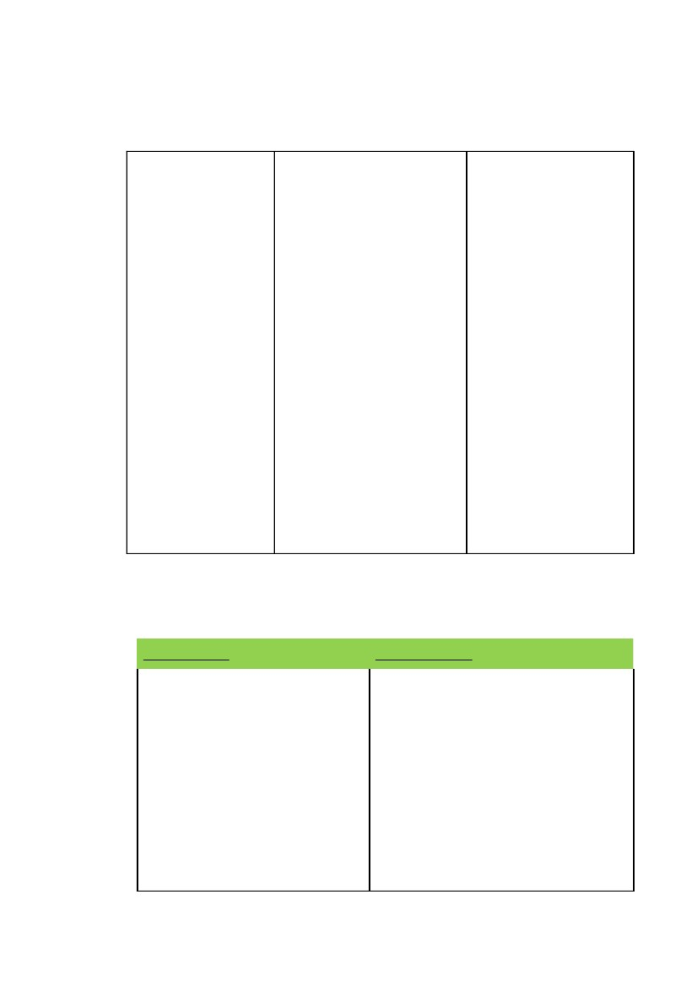
SWOT Matrix – 1 (Figure 4.1)
STRENGTHS
OPPORTUNITIES
• Existing customer base
largely middle-aged
people, with an
opportunity to tap kids and
teenager segment using
their brand name.
• Ability to use superior
technology, brand name
and packaging techniques
to cut into the unbranded
sector.
WEAKNESSES
• Opportunity to
spread the brand name
and increase market
share through
aggressive advertising,
which they haven’t yet
resorted to.
• By integrating all
the three concerns
under the group,
Haldiram’s can
eliminate brand
fragmentation and
increase its profits.

THREATS
• Overcoming
competition by utilizing
their wide variety of
products.
• Conflict between
concerns resulting in
cutting into each
other’s market share.
• Lack of
transparency in the
organization, which
may cause difficulty in
raising funds for
further expansion.
• Lack of Corporate
Social Responsibility
(CSR), which may
affect the Goodwill of
the organization.
SWOT Matrix – 2 (Fig 4.2)
STRENGTHS
1. Variety
2. Brand Image
3. Hygienic
4. Packaging
5. Technology
6. Market Leader
WEAKNESSES
1.Market Surveys
2.Started advertising too late
3.No policies on CSR
4.Lack of collaboration between the three
concerns
5.Not cash rich as it’s competitors
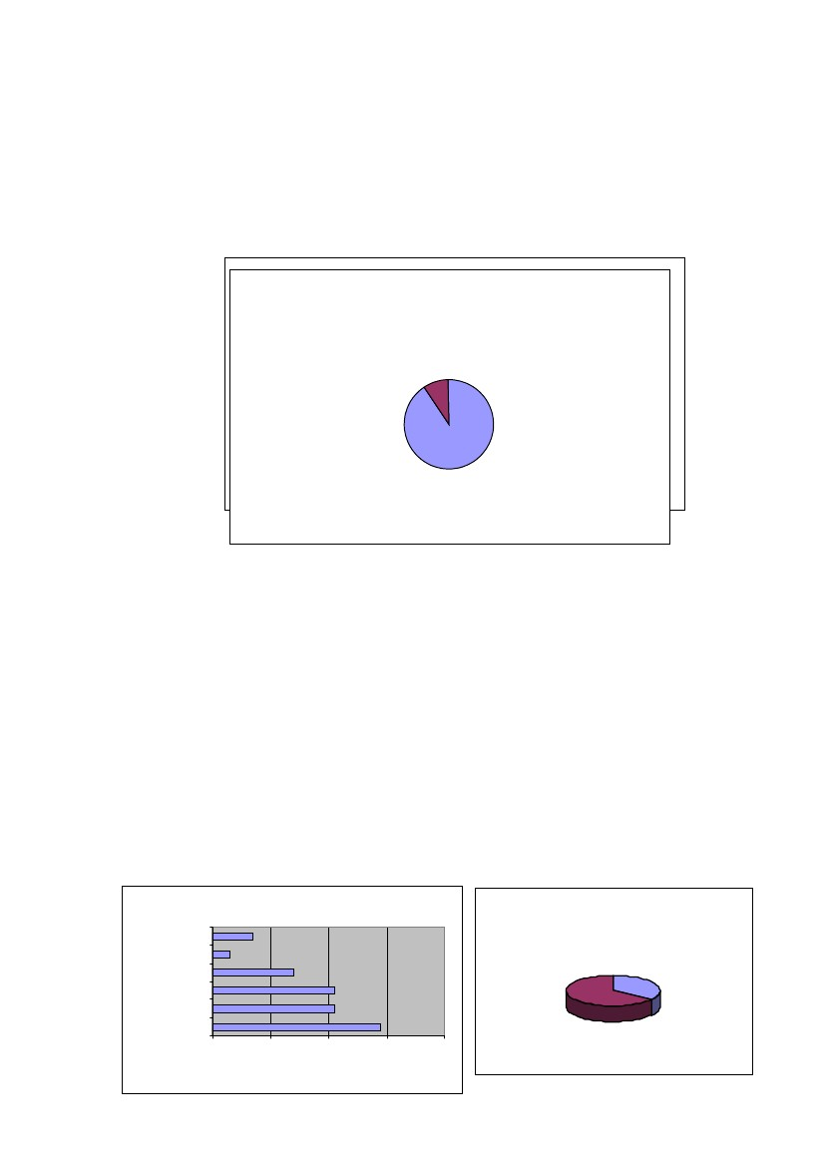
7. Word of mouth publicity
8. Quality
9. Exports
10.Wide consumer base
11.Rural penetration
12.Online selling
OPPORTUNITIES
1.Western snack foods segment
2.Associating with other brands
3.Kids and teenagers segment
4.Diversifying further
5.Radio advertising
THREATS
1.Large number of competitors
2. Three concerns affecting each other’s
image.
3. Competitors have already entered the
western snack foods market.
4. Lack of aggressive advertising.
FINDINGS AND ANALYSIS
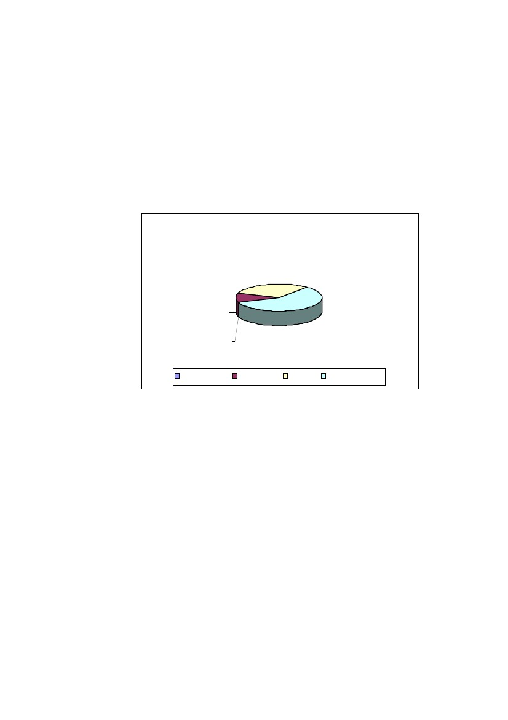
The following chart shows the distribution of the respondents according to the age
group:
A. Consumption Patterns
Do you consume Haldiram's products?
m ore than 50
6%
15-20
6%
Age Profile of Respondents
NO41-50
9% 9%
31-40
22%
21-24
19%
YES
91%
25-30
38%
•
In response as to whether or not they consumed Haldiram’s products, 29 of the
32 answered in the positive, which translates into almost 91% of the sample size.
This establishes the superiority and awareness of the product among the people.
Also another interesting point observed was that the three who didn’t consume
Haldiram’s products weren’t actually averse to Haldiram’s products but did not
consume them because they either didn’t consume namkeens generally or had
some medical constraints.
•
Another point that came across was that when questioned about the
consumption of other brands, the closest competition for Haldiram’s came form
Namkeen Consumption
OTHERS
MTR
Pr e fe r L o cal Sn ack s ?
7
3
14
21
21
29
0
10
20
30
40
Brand
BIKANER
LEHAR
LAYS
HALDIRAM'S
Y ES
34%
NO
66%
No. of Respondents
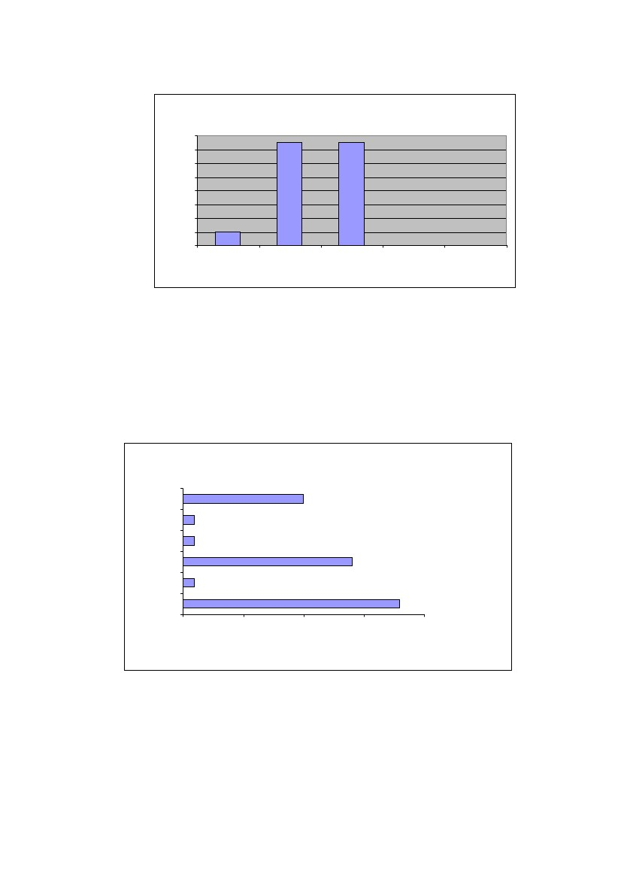
Lehar and Lays as 21 of the surveyed people consumed these too. Also only 34%
preferred local snacks when compared to branded snacks which shows that the
branded snacks segment is cutting into the unbranded segment.
B. Brand Loyalty
H a v e b e e n c o n s u m in g H a ld ira m 's s in c e .......
1- 3 y ear s
31 %
6mths - 1 y ear
10%
le s s tha n 6 mths
0%
gr eater than 3
y rs
59%
les s than 6 mths6mths - 1 y ear1- 3 y ears greater than 3 y rs
•
59% of the respondents have been consuming Haldiram’s namkeens for over 3
years while 31% have been consuming it for between 1-3 years. With the arrival
of so many competitors on the scene, even a period of year is long enough to
prove brand loyalty which is established very firmly in this case. Thus the chances
of the substitutability of the Haldiram’s namkeens by any other brand seem to be
rather low as there has been no switching of brands by any of these respondents.
Those who have tried it have maintained their loyalty towards it. This is again re-
iterated by the following chart, which depicts the perceived change in the quality
of Haldiram’s namkeens by the consumer.
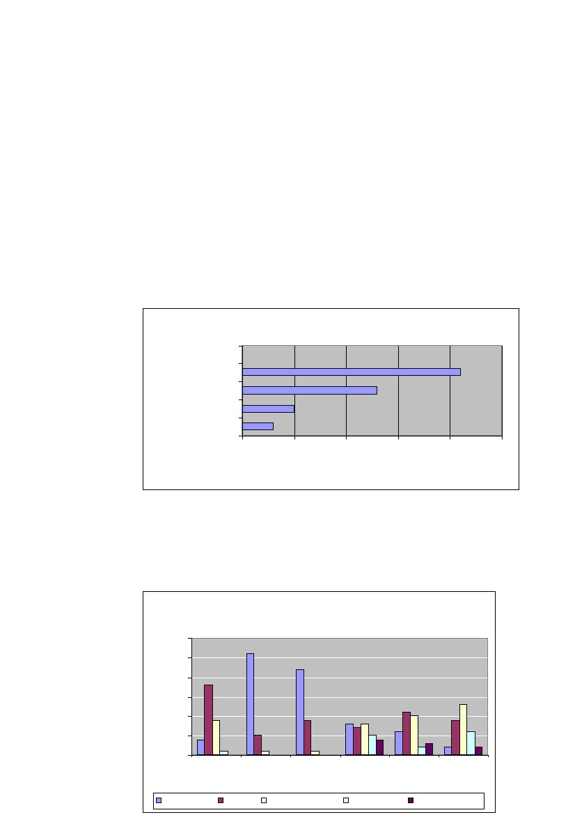
Comparison of quality over the period of use
16
14
No. of Respondents
12
10
8
6
4
2
0
Significantly
Better
Better
Neutral
Worse
Significantly
Worse
•
None of the respondents subscribed to the view that the quality of Haldiram’s
namkeens has got worse. They were either neutral or found it to be
better/significantly better than before. This might be one of the reasons for the
strong brand loyalty.
Buying Roles
The Influencer
Friends
Neighbours
Relatives
Family
A ds
Self
0
5
10
No. of Re s ponde nts
15
10
1
1
14
1
18
20
•
On the basis of the chart above, it is evident that when it comes to buying
namkeens people tend not to get influenced by others. They rely on their own
sense of judgement to buy namkeens. However in some cases the family members
tend to influence the buying patterns of the buyer. Hence in this case there seems
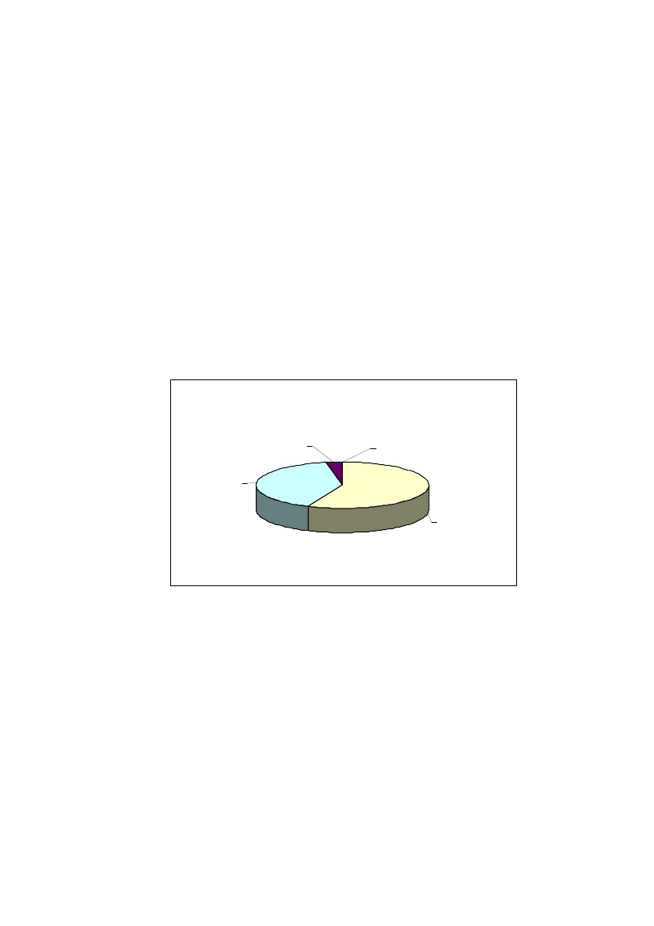
to be a vacuum when it comes to the role of the ‘Influencer’. Because of this the
respondent himself also usually plays the role of the ‘Decider’.
•
Another interesting observation is that only 1 respondent of the 32 considered
advertisements as being influential while buying. This correlates with Herzberg’s
two-factor theory as the absence of advertisements may have led to
dissatisfaction among the consumers but its presence doesn’t seem to have had
any significant impact on the satisfaction or buying trends of the consumer.
C.
ors Influencing Buying Behaviour of Namkeens
Factors affecting purchase ofNamkeens
Fact
Packaging
Factors
Quality
Price
0
5
10
15
20
25
No. of Re s ponde nts
•
Consumers gave the highest priority to the taste of the namkeens as compared
to the other factors. Quality came in a close second on their priority list. What
came, as a surprise was that none of the respondents considered packaging as part
of their selection criteria, on which Haldiram’s usually lays so much stress.
Feature Preference(s)
30
No. of Respondants
25
20
15
10
5
0
Variety
Food Taste &
Quality
Hygiene
Nutritional
Value
Least Important
Price
Packaging
Very Important
Important
Somew hat Important
Not at all Important
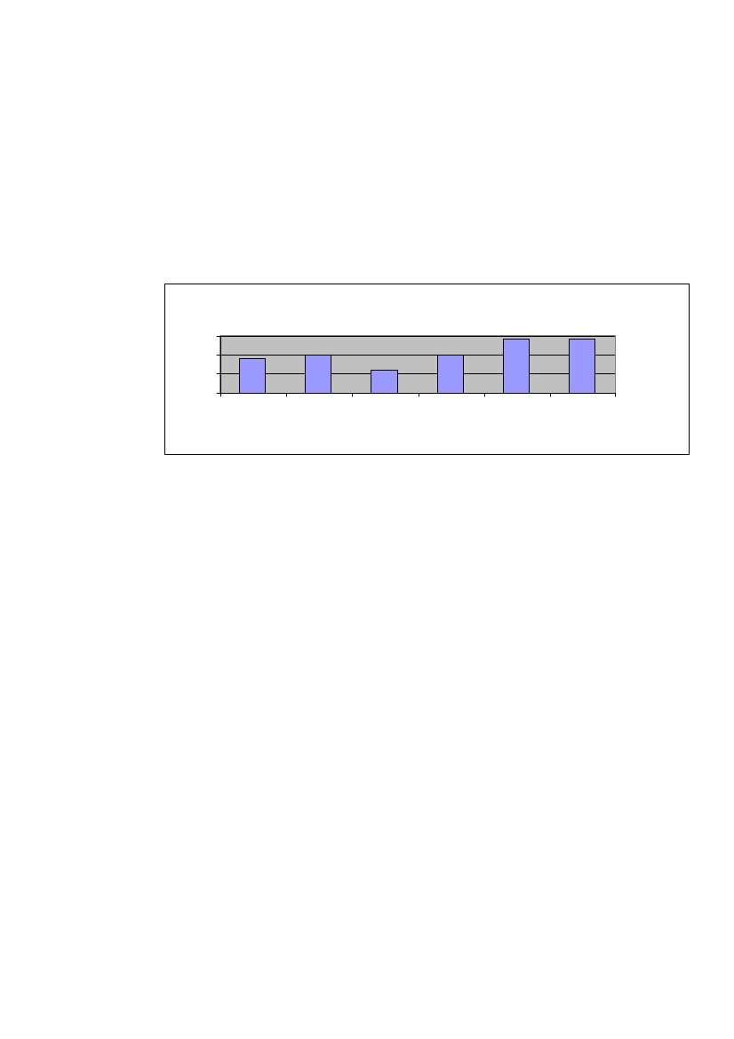
•
Again when asked to rate the importance level of six factors, the results were
interesting as most of the respondents considered ‘Packaging’ as only
somewhat important. Also the opinion on the price feature was divided as
some of them considered it being important while some others considered it
somewhat important and some even didn’t find it important. The strongest
factors that influenced the buyer while purchasing namkeens were Food taste
and quality and Hygiene. The majority of the respondents rated these two
factors as being ‘Very Important’. Apart from this consumers also considered
‘Variety’ as an ‘Important’ factor while buying Namkeens. Nutritional value
didn’t seem to have much of an effect on the buying trends as opinion here
again seems to be divided.
I find Haldiram's price...
Very High
3%
High
41%
Reasonable
56%
Very Low
0%
Low
0%
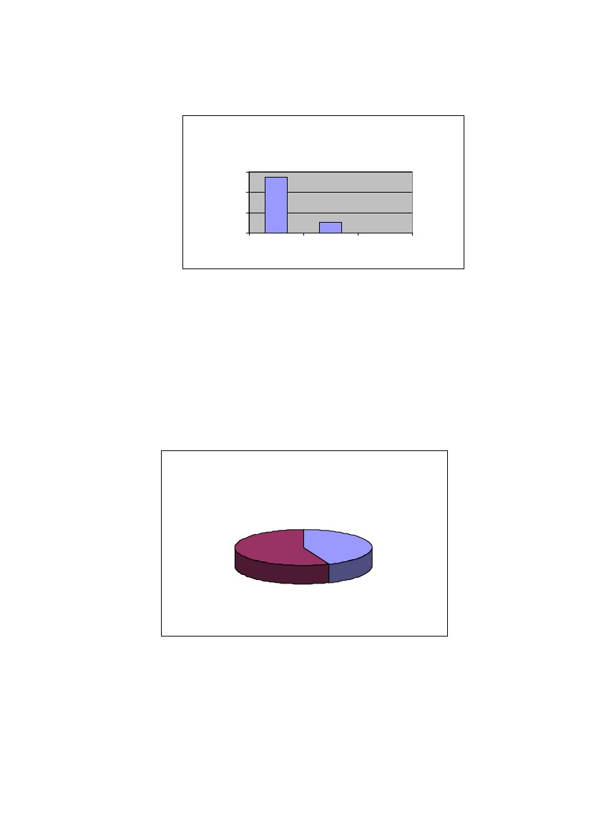
•
With respect to Haldiram’s it was found that 56% of the respondents
considered the price to be reasonable. However 41% also considered it to be
high. This confusion is however solved when viewed in the light of the
following graph that analyses the rating of various factors.
Rating of factors influencing buying behaviour for Haldiram's
Total Score
95
90
85
80
Packaging
Variety
Price
Quality
Hygiene
Taste
Factor
•
In the above chart, the respondents were asked to rate the factors based on a 5-
point scale, 5 being the highest. The total score for each factor has been computed
by multiplying the rating with the corresponding number of respondents. Here
again the same trend of hygiene and taste being given the highest priority is
reiterated. The confusion relating to the price factor is solved as ‘Price’ gets the
least priority among the people surveyed. Hence people don’t mind paying for
Haldiram’s namkeens as long as they get a tasty and hygienic product as value for
their money. Once again Packaging, which is a top priority for Haldiram’s, fails to
get top priority among the consumers and finishes fifth on the priority list. This
can be correlated to Herzberg’s two-factor theory. The absence of good packaging
may lead to dissatisfaction among the consumers but the presence of it does not
seem to create any particular satisfaction among the consumer.

I find Haldiram's Namkeens nutritional
value...
No. of
Respondants
30
20
10
0
Minimal
Adequate
5
0
Healthy
27
•
When it comes to then nutritional value of Haldiram’s namkeens, 84% of the
respondents felt that the nutritional value was minimal while none of them felt
that it was healthy. But despite this the average consumer still prefers to buy
Haldiram’s namkeens thereby proving that the lack of sufficient nutritional value
isn’t a deterrent in purchasing their namkeens.
Do you buy Haldiram's gift packages?
YES
44%
NO
56%
Haldiram’s attaches a lot of value to its gift packages offered during the festive
season. However, 56% of the respondents didn’t buy such packages. This shows that
the gift packages being offered don’t play such an important role on the buying
behaviour of the consumer.
D. Type of Buying Behaviour
Signifiacnce Difference between
Haldiram's and other brands?
No
31%
Yes
69%
•
When asked to whether they found any significance difference between
Haldiram’s and any other brand, 69% are of the view that there does exist a
significant difference. Also a product like namkeens involves low involvement
levels while buying. Thus it can concluded that buying behaviour of the
consumers of Haldiram’s namkeens is the ‘Variety-seeking buying behaviour’.
This translates into a positive for Haldiram’s, as the consumers, in spite of trying
different brands, seem to be coming back to Haldiram’s.
E. Future Expectations of The Consumers
The survey also sought to know as to what the consumers expect in the future from
Haldiram’s Namkeens and otherwise. Many creative ideas came out. With regard to
Namkeens, people are looking forward to popcorn, cheese balls, much more variety in
the wafers, banana chips, roasted nuts, etc… Many of the respondents are seeking low
calorie namkeens from Haldiram’s and there is also a demand for many more varieties
in bhujia’s. The minimal nutrition levels do not seem to be affecting the buying trends
of the consumers right now; but as people are becoming more and more health
conscious, in the future consumers might be looking forward to low calorie namkeens
and snacks from Haldiram’s. Apart from the Namkeens segment, the consumers in
general are looking forward to products like masalas, milk and milk related products,
ice creams, etc… from Haldiram’s.

FINDINGS
‘Consumer Behaviour Analysis’
•
Consumers have started increasing their consumption of other brand items which
is evident from the fact that 29 of the 32 respondents eat Haldiram’s Namkeens
while a close 21 each eat products of Lays and Lehar. However local snacks seem
to be losing their hold on the consumers mainly because of their lack of stress on
hygiene and quality. However, consumers seem to be very loyal towards the brand
called Haldiram’s primarily because of the high priority they give to taste, quality
and hygiene as is evident from the statistics mentioned above.
•
Another interesting finding that is that in the absence of the role of the
‘Influencer’, the roles of the ‘Decider’ and ‘User’ seem to be shared by the same
person.
•
The consumers have given top priority to ‘Food taste and Quality’ and ‘Hygiene’.
Haldiram’s needs to be appreciated for having pioneered these factors in the
packaged namkeens segment. However, to retain their stronghold on existing
consumers and attract new consumers, Haldiram’s needs to maintain and even
improve these standards.
•
One aspect, however, that Haldiram’s needs to focus on is their price. 41% found
it to be ‘High’. Haldiram’s needs to focus on this factor as any reduction in the
price cut by it’s competitors may influence the buyer to drift towards another
brand.
•
Overall, Haldiram’s is undoubtedly the most favored namkeen of the consumers
and this is established by one of the findings whereby 91% of the total
respondents actually consume Haldiram’s.
‘Competition Analysis’
•
There are no two ways about the fact that when it comes to the namkeens
segment Haldiram’s is way ahead of its competitors. It has a very strong brand
loyalty, which is what makes the task of its competitors even more difficult.
However with the entry of Lays, MTR into this segment and the prior presence of
Bikano in this segment the competition has really heated up and the market share
is gradually being grabbed by various players. Hence its important for Haldiram’s
to keep innovating and concentrating on its strengths – quality and taste in order to
further consolidate its position as a market leader in the namkeens segment.
•
Another thing that Haldiram’s has to be wary about is the immense form
competition that it faces. Namkeens is a consumable, which can be easily
substituted. There are various substitutes like salty biscuits, bakery items but the
biggest threat that it faces is the traditional snack items like samosas,
kachoris,etc…. However it has already started to take steps in this direction
bringing out packaged ready-to-eat small samosas.
•
Another plus for Haldiram’s is that it has started targeting the international
market. It now doesn’t face any major competition in this market and can hence
make the best of it. This long-term strategy of Haldiram’s has already started
yielding results.
•
Haldiram’s is a specialist when it comes to the namkeens segment, whereas for
most of it competitors like Frito Lays and MTR, namkeens is a very small
segment and they are not looking to specialize in this segment. This factor will
always help Haldiram’s to consolidate its position as a market leader.
Overall, the best part about this segment is that neither Haldiram’s nor its competitors
indulge in situations that disturb the market equilibrium. Hence this segment is such
that everyone plays their role in maintaining the market equilibrium and in the long
run this shall work out to be favorable for Haldiram’s and this segment


CHAPTER 4
CONCLUSION &
RECOMMENDATIO
NS

CONCLUSION
The market is clogged with dominant players such as Frito-Lay India, PepsiCo’s
snack foods arm, which has almost brought in a snack-chip revolution in the country,
Haldiram’s and the Delhi-based snack-food-retailer Bikanerwala Foods Pvt Ltd etc.
Even the dairy major Mother Dairy has a presence in the category. With the entry of
companies such as ITC and HLL into this industry, it is getting tough for companies
such as Haldiram’s who till now have not paid serious attention to its branding
activities.
Increased media exposure, ever increasing purchasing power of the target audience
coupled with their desire to spend more on eating out due to lifestyle changes will fuel
the demand for snack food items and only those companies which have a considerable
share of voice and space in the market will be able to survive. Haldiram’s has the
capability of meeting these demands and only requires a certain revision in its
strategies to be able to do so successfully, which it already has begun to consider.

RECOMMENDATIONS
Haldiram’s should aim at constructing a comprehensive media mix.
•
•
•
It could venture into corporate tie-ups at its various outlets.
Set up mini outlets inside the multinational office complexes.
Cash in on the call center wave and have tie-ups with business process
outsourcing companies.
•
Undertake catering at get together, wedding and kitty parties for women
who form a chunk of its target audience.
•
Conduct road shows on various campuses nation wide.
Whatever tools and methods the company chooses to employ, interactive
communication should be given high priority.

BIBLIOGRAPHY
Book Material
•
•
•
Marketing Management by Philip Kotler
Sales & Distribution Management by Tapan K Panda & Sunil Sahadev
Service marketing , Pearson Education Ptc Ltd., New Delhi by Lovelock,
Christopher H.
Company Visits
•
Mr. K K Goyal (Sales Manager)
Corporate Office
Haldirams Marketing Pvt. Ltd.
B-1/H-8,
Mohan Co-Operative Ind. Estate,
Mathura Road, New Delhi-4
Websites:
•
•
•
•
•
•
•
•
www.Indianfoodindustry.net
www.haldirams.com
www.haldiramsusa.com
www.bikaji.com
www.google.co.in
www.samratnamkeen.com
The Hindu(www.hinduonnet.com)
Times news Network(www.economictimes.indiatimes.com)
ANNEXURE
QUESTIONNAIRE
Q1. What age profile do you belong to?
□ 15-20
□ 41-50
□ 21-24
□ More than 50
31-40
Q2. Do you consume Haldiram’s products?
□ Yes
□ No
Q3. What is your brand preference for namkeens?
□ Haldirams □ Lays
□ MTR
0
□ Lehar
Bikaner
□ Others
Q4. Do you prefer local snacks?
□ Yes
□ No
Q5. Since when have you been consuming Haldiram’s Products?
□ Less than 6 months
□ 1-3 years
□ 6 month – 1year
□ Greater than 3 years
Q6. How would you rate the quality of Haldiram over the period of use?
□ Significantly better
□ Natural
Worse
□ Better
□ Significantly worse
Q7. What factors motivated you to buy Haldiram’s products?
□ Friends
□ Family
□ Neighbours
□ Ads
□ Relatives
□ Self
Q8. Which of these factors influence your buying bahaviour of namkeens?
□ Packaging □ Quality
□Price
Q9. How would you rate the following factors in order of your preference?
□ Variety
□ Hygiene
□ Price
□ Food taste and quality
□ Nutritional value
□ Packaging
Q10. How you find Haldiram’s price ?
□ High
□ Low
□ Very high □ Very low
□ Reasonable
Q11. Would you buy Haldiram’s products for their
□ Packaging □ Variety
□ Quality
□ Hygiene
□ Price
□ Tatste
Q12. How would you rate the Haldiram’s namkeens for their nutritional value?
□ Minimal
□ Adequate □ Healthy
Q13. Do you buy Haldiram’s gift packages?
□ Yes
□ No
Q14. Do you think that is there any significance difference between Haldiram’s
products and other brands?
□ Yes
□ No

