A PROJECT REPORT
ON
COMPARATIVE ANALYSIS OF HEWLETT PACKARD WITH HCL INFOSYSTEMS

In

HCL Technologies Limited

SUBMITTED IN PARTIAL FULFILLMENT OF THE REQUIREMENT OF BACHELOR OF BUSINESS ADMINISTRATION BBA (B&I)


Guide: Submitted By:
Ms. Sneha Singh Anchit Arora
(Lecturer) 0512051808

BLS INSTITUTE OF TECHNOLOGY MANAGEMENT
Delhi- Rohtak Road, NH-10
Jakhoda, Bahadurgarh -124507
Batch (2008-2011)

ACKNOWLEDGEMENT

The present work is an effort to throw some light on “A COMPARATIVE ANALYSIS OF HEWLETT PACKARD WITH HCL INFOSYSTEMS”. The work would not have been possible to come to the present shape without the able guidance, supervision and help to me by number of people.
I convey my heartful affection to all those people who helped and supported me during the course for completion of my Project Report.

Anchit arora

DECLARATION

I, Mr. Anchit Arora, Roll No. 051205108 certify that the Project Report entitled “COMPARATIVE ANALYSIS OF HEWLETT PACKARD WITH HCL INFOSYSTEMS In HCL Technologies Limited” is done by me and it is an authentic work carried out by me. To the best of my knowledge and belief, the material embodied in this report has not been submitted earlier for the award of any Degree or Diploma by any University or Institution.

Signature of the Student
Date:

CERTIFICATE

Certified that the Project Report entitled “COMPARATIVE ANALYSIS OF HEWLETT PACKARD WITH HCL INFOSYSTEMS In HCL Technologies Limited” done by Mr. Anchit Arora, Roll No. 0512051808 has been completed under my guidance and supervision.

Signature of the Guide
Date: Name of the Guide:
Designation:

Countersigned

Director

Preface

Computer hardware market is highly competitive and dynamic today. With strong players operating, the key message is “Survival of the fittest”. Computer hardware market has grown a lot in last 20 years.The names like “HCL Infosystems” and “Hewlett-Packard Development Company” strikes first to the mind when one talks of Computer hardware. It is surprising how these brands have continued to retain position of ‘Market Leaders’ for such a long period of time. The project undertaken is aimed at understanding the various variables affecting the marketing strategies of HCL Infosystems & HP. This includes competitors, customers, company’s strategy etc. HCL Infosystems & HP are operating in a highly competitive environment with players like Epson, Xerox, Samsung, Lexmark, and Canon etc.
HCL Infosystems & HP are the pioneer in the printer market and hold dictating positions position in the market. Other brands, which emerged in the market, have created niche markets and targeted a specified type of customers. HP/HCL competes with these brands on quality, speed and service based attributes. The only way HP/HCL are combating this competition is by continues innovation and creativity in terms of differentiation in its products and other promotional patterns like advertisement, sales promotion scheme, publicity etc. with its various variants, HP is targeting both individual and industry consumers. If one talks about consumer, behavior, people consider HCL as the best. Quality and services are the most critical factors determining the buying decisions. As far as income pattern is concerned, all those in upper middle and upper class could afford to but. Thus, higher income group can be potential segment for these companies.
Even though HCL & HP are the market leader now, but with increasing competition from Indian as well as foreign brands, they should realize that customer is the ‘king’ and should make continuous efforts to identify and fulfill consumer needs. The following report is a deliberate effort on the part of the author to compare & analyze the marketing strategies of the two giants of the Indian IT Industry.
TABLE OF CONTENTS
Chapter No. | TITLE | Page No.
 | INTRODUCTION  1.1 Overview of the industry  1.2 Problems of the company  1.3 Competition Information  1.4 SWOT ANLYSIS | 1 - 15  2 – 6  7 - 8  9 – 14  15
 | PURPOSE OF STUDY  2.1 SIGNIFICANE OF THE STUDY  2.2 OBJECTIVES  2.3 SCOPE OF THE STUDY | 16 - 17  17  17  17
 | COMPANY PROFILE | 18 - 24
 | CONCEPTUAL DISCUSSION | 25 – 44
 | RESEARCH METHODOLOGY  - RESEARCH DESIGN  - MARKETING RESEARCH  - DATA ANALYSIS | 45- 60  46- 47  47- 50  51- 60
6. | FINDINGS | 61 - 62
7. | LIMITATIONS | 63 - 64
8. | RECOMMENDATIONS | 65 - 66
9. | BIBLIOGRAPHY | 67- 68
10. | ANNEXURES | 69- 71

CHAPTER-1
introduction

1.1 OVERVIEW OF INDUSTRY:

IT INDUSTRY IN INDIA

The vision of Information Technology (IT) policy is to use IT as a tool for raising the living standards of the common man and enriching their lives. Though, urban India has a high internet density, the government also wants PC and Internet penetration in the rural India.

- In Information technology (IT), India has built up valuable brand equity in the global markets. In IT-enabled services (ITES), India has emerged as the most preferred destination for business process outsourcing (BPO), a key driver of growth for the software industry and the services sector.

- India's most prized resource in today's knowledge economy is its readily available technical work force. India has the second largest English-speaking scientific professionals in the world, second only to the U.S.

- According the data from ministry of communication and information technology, the ITES-BPO industry has grown by about 54 per cent with export earnings of US$ 3.6 billion during 2005-06. Output of the Indian electronics and IT industry is estimated to have grown by 18.2 per cent to Rs. 1, 14,650 crore in 2006-07.

- The share of hardware and non-software services in the IT sector has declined consistently every year in the recent past. The share of software services in electronics and IT sector has gone up from 38.7 per cent in 1998-99 to 61.8 percent in 2005-06. However, there has been some welcome acceleration in the hardware sector with a sharp deceleration in the rate of decline of hardware's share in electronics and IT industry. Output of computers in value terms, for example, increased by 36.0, 19.7 and 57.6 per cent in 2003-04, 2004-05, and 2005-06, respectively.

- All sub-sectors of the non-software component of electronic and IT industry grew at over 8 per cent in 2005-06, but this was far below the rate of growth of software services. Overall, after declining precipitously from 61.4 per cent in 1998-99 to 40.9 percent in 2001-02, the share of hardware in this important industry declined only marginally to 38.2 percent in the subsequent years.

- Export markets continue to dominate the domestic segment. The size of the domestic market in software relative to the export markets for Indian software, which was 45.2 percent in 2002-03, after declining rapidly to 29.8 percent in 2003-04, fell only to 29.1 percent and 27.7 per cent in the two subsequent years.

- Value of software and services export is estimated to have increased by 30 percent to US$12.5 billion in 2005-06. The Software Technology Parks of India have reported software exports of Rs. 31,578 crore (US$ 6,947 million) during April - December 2005- 06 as against Rs. 22,678 crore (US$ 4,913) during the corresponding period last year.

- The annual growth rate of India's software exports has been consistently over 50 percent since 1991. No other Indian industry has performed so well against the global competition.

- According to a NASSCOM-McKinsey report, annual revenue projections for India’s IT industry in 2008 are US $ 87 billion and market openings are emerging across four broad sectors, IT services, software products, IT enabled services, and e-businesses thus creating a number of opportunities for Indian companies. In addition to the export market, all of these segments have a domestic market component as well.

- The IT- enabled service industry in India began to evolve in the early nineties when companies such as American Express, British Airways, GE and Swissair set up their offshore operations in India.

MAJOR STEPS TAKEN FOR PROMOTION OF IT INDUSTRY

With the formation of a ministry for IT, Government of India has taken a major step towards promoting the domestic industry and achieving the full potential of the Indian IT entrepreneurs. Constraints have been comprehensively identified and steps taken to overcome them and also to provide incentives.

- In order to broaden the internet base, the Department of Information technology has also announced a programme to establish State Wide Area Network (SWAN) up to the block level to provide connectivity for e-governance. The Department has also set up Community Information Centres (CICs) in hilly, far-flung areas of the North-East and Jammu and Kashmir to facilitate the spread of benefit of information and communication technology. It is also proposed to set up CICs in other hilly, far-flung areas of the country like Uttaranchal, Andaman & Nicobar and Lakshadweep.

- A number of steps have been taken to meet the challenge of zero duty regimes in 2005-06 under the Information Technology Agreement (ITA-1). Tariffs on raw materials, parts, other inputs and capital goods have been rationalized to make domestic manufacturing viable and competitive.

- In order to broaden the internet base, the Department of Information technology has also announced a programme to establish State Wide Area Network (SWAN) up to the block level to provide connectivity for e-governance. The Department has also set up Community Information Centres (CICs) in hilly, far-flung areas of the North-East and Jammu and Kashmir to facilitate the spread of benefit of information and communication technology. It is also proposed to set up CICs in other hilly, far-flung areas of the country like Uttaranchal, Andaman & Nicobar and Lakshadweep.

INDIAN HARDWARE PIPE DREAM OR GOLD RUSH ?

For the beleaguered Indian hardware industry, survival is often more important than growth. Yet, a recent MAIT-Ernst & Young study said that this very industry could zoom to revenues of $62 billion by 2010.

- IT hardware manufacturing in India is a classic case of the chicken and egg syndrome. Should we wait for the market to grow to high volumes that justify creating a manufacturing base in India, or should we just kick-start manufacturing so that prices then come down and thereby create volumes? The debate has raged on long enough and no consensus seems to be emerging. Rather, things took a turn for the worse with recent years witnessing a perceptible decline in manufacturing activity. Therefore, when a recent MAIT study, conducted jointly with Big Five firm Ernst & Young, concluded that the Indian hardware industry had the potential to reach a size of $62 billion by 2010, it not only raised many an eyebrow, but derisive laughter from sceptics.

- Sample some salient conclusions of the study which paint a rosy future for India Hardware Inc: By 2010, the Indian hardware industry has the potential to grow to twelve times its existing market size, with the domestic market accounting for $37 billion and exports accounting for another $37 billion. The study has identified major export opportunities in the areas of innovative new devices, contract manufacturing and design services. The study says that component exports offers an opportunity worth $5 billion, while that of design and related services in embedded systems and wireless telecommunication services can bring in another $7 billion by 2010. Further, ambitious projections have been made in the area of contract manufacturing, which represents a $11 billion opportunity if India succeeds in capturing a share of only 2.2 percent of the global pie by 2010.

- Though the rosy projections look good on paper, is this growth really possible? Sceptics deride the study as an attempt by the hardware industry to copy its software counterpart, which has been tom-tomming Nasscom and McKinsey’s projection of $87 billion in software revenues by 2008. MAIT officials are however quite upbeat. Says Vinay Deshpande, president of MAIT, “There are four key steps which we need to take to make India a manufacturing-friendly country. Firstly, market India as a hardware destination and build a brand akin to software. Making India manufacturing-friendly through improvements in infrastructure and logistics should follow this. We should also emphasise on design and innovation through the development of Indian solutions for Indian needs. All these initiatives need to be backed up by the government with adequate funds.”

THE BRIGHT SIDE:

For a country whose economy is so heavily dependent on agriculture, a vibrant hardware industry has the potential to generate three million jobs, especially for Indians who come from economically underprivileged sections, who aren’t very highly educated. So, in the words of Deshpande, the hardware industry can be some sort of a panacea for India’s unemployment problem. Also, with the size of the contract manufacturing industry expected to be over $500 billion by the year 2010, Indian firms could grab a significant chunk of the pie in a manner pretty similar to India’s emergence as a key player in the global BPO stakes. And, with a potentially huge market in embedded systems emerging, Indian firms with the right mix of hardware and software can be big players here. For the record, of all the high-end processors produced in the world, only 6 percent are used in PCs and the remaining 94 percent are used in entertainment electronics, non-PC devices and communication products and embedded electronics.

- The hardware revolution is also essential for the continued high growth of the software industry. As Vinnie Mehta, director of MAIT puts it: “India can lose out on the software advantage it has already built up, and the future potential.

- It does not concentrate on the hardware front. For example, the estimated domestic hardware requirement by 2008 to meet the software target of $87 billion is $160 million.”
1.2 PROBLEMS OF THE COMPANY:

But before India Inc. can go into ballistic mode on the hardware front, there are lots of serious issues that need to be addressed. Issues like lack of local availability of input raw material, ever changing government policies, inconsistent sales tax structures in different states, high interest rates, customs duties on capital goods, poor infrastructure, inordinately long and variable transit times all add to uncertainty, delays and increased costs.Something that hardware manufacturers dread.Explains Manoj Churra, country manager-manufacturing, IBM India, “Everyone in India cribs about duty, but even China has a similar duty structure. The main reason why companies prefer to locate their manufacturing operations in China is because customs processing in China is much faster.” Here, even after a manufacturer’s raw material arrives at a port it might take another month or so before the goods reach his factory. In the fast changing world of technology, that’s virtually suicidal for companies into hardware manufacturing. Besides, labour laws in China are also very flexible.

- In India, laments Raj Saraf, chairman and managing director of Zenith Computers, there are a lot of restrictions for the hardware industry. “The software industry has grown in leaps and bounds simply because there have been no restrictions. On the other hand, even if I do manufacture in an SEZ in India, I cannot sell my products in the domestic market. The government says everything should be exported. But it should realise that the industry will always flock to an area where there are least restrictions.” The government can also take a cue from the fact that if the industry is allowed to grow to three times the size it currently is today, it can earn more tax from its revenues.

- The manufacturing industry in India also suffers from a lack of proper environmental standards. With environmental concerns mainly ignored or casually overlooked by Indian corporates, MNCs desist from setting up manufacturing bases here since there is no compliance with ISO 14000 standards, which deal with environmental issues.

- On the design front too, there are lots of opportunities left to be explored. Design exports are a $7 billion opportunity in areas like embedded systems and wireless telecommunications. While Indian firms do some work on hardware design exports, many unfortunately show this as software exports to avoid tax. Fact is, some experts say a robust design sector could play a huge role in bringing down PC prices too a significant reason why PC penetration remains low in India. For example, on a CPU that costs $150, the material cost is not even $4. Adds Deshpande, “If we can get a design, like say a PII, made either by ourselves or if we can get the government to buy out a design and start manufacturing here, this would bring costs down substantially in PCs.”

- Service delivery / Logistics perception is weak.

- Negative Environment
- Top management takes large amount of time to approve high value loan borrowers.

1.3 COMPETITION INFORMATION:

HP INDIA

Stanford University classmates Bill Hewlett and Dave Packard founded HP in 1939. The company's first product, built in a Palo Alto garage, was an audio oscillator - an electronic test instrument used by sound engineers. One of HP's first customers was Walt Disney Studios, which purchased eight oscillators to develop and test an innovative sound system for the movie "Fantasia".

Since their first year in business in1939, HP has given back to the communities in which they do business in the form of philanthropic donations of money, equipment and time.
HP having acquired COMPAQ now markets Laptops under two brands, being HP and COMPAQ. They are renowned for their technological excellence and innovation. They are global leaders in personal computer and other hardware manufacturing. In India, they have carved a niche for themselves and have 37% market share in the Laptop market.
Currently, they're employing new models of engagement and new business and technology solutions to enable more people to participate in the world economy via information technology. They are -
- Globally in inkjet, all-in-one and single-function printers, mono and color laser printers, large-format printing, scanners, print servers, and ink and laser supplies
- Globally in total server revenue and shipments
- Globally in total disk storage systems, total external disk storage systems and open storage area networks
- Globally in network and system management software
- Globally in notebook PCs
- Globally in Pocket PCs

HP is a technology solutions provider to consumers, businesses and institutions globally. The company's offerings span IT infrastructure, personal computing and access devices, global services and imaging and printing for consumers, enterprises and small and medium businesses.
Their $4 billion annual R&D investment fuels the invention of products, solutions and new technologies, so that they can better serve customers and enter new markets. They invent, engineer and deliver technology solutions that drive business value, create social value and improve the lives of our customers.

The 2002 merger with Compaq Computer Corporation forged a dynamic, powerful team of 140,000 employees with capabilities in 178 countries doing business in more than 40 currencies and more than 10 languages. Chairman and CEO Mark Hurd leads HP, which has corporate headquarters in Palo Alto, California.
Compaq Computer Corporation was formed after a 1982 meeting in a Houston, Texas, pie shop. Together, employees in the new HP share a passion for satisfying customers, an intense focus on teamwork, speed and agility, and a commitment to trust and respect for all individuals.

LENOVO
Lenovo is an innovative, international technology company formed as a result of the acquisition by the Lenovo Group of the IBM Personal Computing Division. As a global leader in the PC market, they develop, manufacture and market cutting-edge, reliable, high-quality PC products and value-added professional services that provide customers around the world with smarter ways to be productive and competitive. The company employs more than 19,000 people worldwide.

Lenovo has outperformed top competitors in customer satisfaction with PC hardware quality, reliability and product design features, according to the Technology Business Research (TBR) 2Q 2006 "Corporate IT Buying Behavior and Customer Satisfaction Study: Notebooks.
Highlights include the following as likely drivers of Lenovo's leading position:

- Lenovo achieved significantly lower notebook PC failure rates than industry averages.

- The use of Active Protection System, an air-bag like mechanism that protects the hard drive, is found to reduce hard drive failures by 30% as compared to other systems.

- Lenovo's customer complaint management was identified as a strong differentiator for its proactive approach to remediate customers' technology-related concerns.

Lenovo is a well recognized and respected brand in the Laptop market in India. They have about 18% share in the market and are known for their fabulous customer service and sufficient warranty. They are vying for the top spot in the Indian market and use aggressive marketing strategies.

They base our success on their customers achieving their goals ~ productivity in business and enhancement of personal life.

In 1981, IBM envisioned computing at a new level – a personal level – to extend the power and the productivity of information technology from the mainframe to the individual, at home and at work. That vision led to the founding of a new unit within IBM, the Personal Computing Division, which virtually invented personal computing
In 1984, 11 computer scientists in Beijing, China also had a vision – to create a company that would bring the advantages of information technology to the Chinese people. The company they founded, Legend, opened the new era of consumer PCs in China.

Since it was established, the company has affected the lives of millions of Chinese: It first introduced PCs to households, and then promoted PC usage in China by establishing retail shops nationwide. By 1994, Legend was trading on the Hong Kong Stock Exchange; four years later, it produced its one-millionth personal computer. In 2003, Legend changed its brand name to Lenovo, taking the “Le” from Legend, a nod to its heritage, and adding “novo,” the Latin word for “new,” to reflect the spirit of innovation at the core of the company. The company name changed from Legend to Lenovo a year later.

Today, these two visionary companies are united under the Lenovo name. With Lenovo's landmark acquisition of IBM's Personal Computing Division in May 2005, the new Lenovo is a leader in the global PC market, with approximately $13 billion in annual revenue, and products serving enterprises and consumers the world over.

Globally, the company offers customers the award-winning ThinkPad notebooks and ThinkCentre desktops, featuring the ThinkVantage Technologies software tools, as well as ThinkVision monitors and a full line of PC accessories and options. The Think family is consistently ranked as the undisputed premium-brand leader in the global PC industry, with products rated "best-in-class” and "number one” in survey after survey. No other family of personal computers has won as much recognition.

Lenovo and IBM have a strategic alliance designed to provide a best-in-class experience for enterprise customers. Lenovo's customers are able to count on the entire IBM team including sales, services and financing – for access to IBM's legendary end-to-end IT solutions.

Acer India

Few IT companies offer the breadth and depth of products that Acer Group does. Leveraging the vast collective technological resources available - Acer India (Pvt) Ltd., was incorporated as a wholly owned subsidiary of Acer Computer International Ltd. on 9th September 1999.

Acer India offers a wide range of Laptops in the Indian Market catering to all market segments. They offer high quality Laptops at very reasonable prices and are most dominant in the Entry level segment. They are known for their strong customer support and have 15% of the market of Laptops in India.

With a focused customer-centric approach, Acer in India is offering unmatched uptime for all it's systems through a vast network of Service points, innovative and user friendly functionality while continuously lowering barriers that limit the access to the fruits of technology.
It's no wonder then that they are the world's 3rd largest PC producer and the market leaders in more than 12 countries across the region!
Acer India has its headquarters in Bangalore, with branch offices in New Delhi, Mumbai, Chennai and Hyderabad. Our 100 man strong team in India comes with over 1000 man-years of IT experience, geared to listen and provide to the IT user in India the very best in Sales & Marketing support, After-Sales support backed up with infrastructure to bring fresh technology to India. They have a customer base of about 300,000 satisfied consumers in India.
Within a year of operations, Acer India has managed several accolades in its endeavors: A state of the art reconfiguration centre for fast and flexible offerings to different customer needs; Acer Care Clinics to service notebooks in the top nine cities in the country and a unique unmatched guarantee within the warranty period to provide peace of mind to the customer. An extremely robust service coupled with the ability to make the latest technology affordable makes Acer India a force that shapes the dreams of millions of people.
Acer ranks as the world's No. 4 branded PC vendor, designing easy, dependable IT solutions that empower people to reach their goals and enhance their life. Since spinning-off its manufacturing operation, Acer has focused on globally marketing its brand-name products: mobile and desktop PCs, servers and storage, LCD monitors and high-definition TVs, peripherals, and e-business solutions for business, government, education, and home users.
Acer's unique Channel Business Model has been instrumental in the company's latest success. The model encourages partners and suppliers to collaborate in a winning formula of supply-chain management, allowing Acer to provide customers with fresh technologies, competitive pricing, and quality service.

DELL

In the early 2000s Dell opened kiosk locations in shopping malls across the United States in order to give personal service to customers who preferred this channel to using the Internet or telephones. Despite the added expense, prices at the kiosks equaled or an even undercut price available on Dell’s other retail channels.
Michael Dell while still a student at the University Of Texas At Austin in 1984 founded the company as PC's Limited with just $1000.
In 1985, the company produced the first computer of its own design, the "Turbo PC”. In 1990, Dell Computer tried selling its products indirectly through warehouse clubs and computer superstores, but met with little success, and the company re-focused on its more successful direct-to-consumer sales model. In 1992, Fortune magazine included Dell Computer Corporation in its list of the world's 500 largest companies. In 1999, Dell overtook Compaq to become the largest seller of personal computers in the United States of America.
In February 2005, Dell appeared in first place in a ranking of the "Most Admired Companies" published by Fortune magazine.
During 2005, Dell opened kiosk locations in shopping malls across Australia, and in 2006 opened kiosk locations in shopping malls across Canada following the approach used in the United States.
On 23 March 2006, Dell purchased the computer hardware manufacturer Alienware.
Recently, Dell became the lowest-price major computer-manufacturer in the United States. To maintain its low prices, Dell continues to accept most purchases of its products via the Internet and through the telephone network, and to move its customer-care division to India.
As of 2006 Dell employs more than 63,700 people worldwide and manufactures more computers than any other organization in the world. According to the Fortune 500 2006 list, Dell ranks as the 25th-largest company in the United States by revenue. In 2006, Fortune magazine ranked Dell as No. 8 on its annual list of the most-admired companies in the United States.

1.4 SWOT ANALYSIS:
STRENGTHS:
- HCL INFOSYSTEMS draws it's strength from 29 years of experience in handling the ever changing it scenario
- Strong customer relationships
- Ability to provide the cutting edge technology at best-value-for-money
- An excellent service & support infrastructure.
WEAKNESSES:
The company needs to evolve a comprehensive plan & strategy to make inroads into a part of middle class & upper middle class.
- Lack of production centers in India makes the product costlier as most of the parts have to be imported.
- Lack of R & D centers also makes it difficult to launch new products over here.
OPPORTUNITIES:
The present rate of growth of the Information and technology Industry & a large potential available in these areas provides excellent opportunity for the company to widen its market.
- With the fast growing economy the pricing strategy needs to be tackled with care as it can decide upon long term decisions of the company.
- Globalization is yet another opportunity, if followed effectively & promptly.
THREATS: It is natural that threats from the existing as well as new entrants will affect the present turnover & Market share. The nearest competitors having the identical product range are the greatest threat to the company.

CHAPTER-2
PURPOSE OF THE
STUDY

2.1 significance of the study:
The main aim behind working on this research project work is to study and understand the key issues related to the marketing of IT products in India at large, & analyze and compare the marketing strategies of HCL and HP in particular. I sincerely believe that working on this project will help me to gain huge confidence and experience in the marketing field.
.
2.2 objective of the study:
The Objective of My Research Study is
- To study and analyze the marketing strategies of HCL Infosystems Ltd.
- To study and analyze the marketing strategies of HP.
- To make a comparison of the marketing strategies of the two Giants of Indian IT sector, i.e. HCL and HP.

  - scope of the project:

- This project helps in analyzing the marketing strategies of HP.
- This project is very useful to study and analyze the marketing strategies of HCL Info system Ltd. and comparison of the marketing strategies of the two Giants of Indian IT sector, i.e. HCL and HP.
- The present rate of growth of the Information and technology Industry & a large potential available in these areas provides excellent opportunity for the company to widen its market.
- With the fast growing economy the pricing strategy needs to be tackled with care as it can decide upon long term decisions of the company.
- Globalization is yet another opportunity, if followed effectively & promptly.

CHAPTER-3
COMPANY PROFILE

company profile:


HCL Info systems Ltd is one of the pioneers in the Indian IT market, with its origins in 1976. For over quarter of a century, we have developed and implemented solutions for multiple market segments, across a range of technologies in India. We have been in the forefront in introducing new technologies and solutions. The highlights of the HCL saga are summarized below:

Y E A R | H I G H L I G H T S
1976 | - Foundation of the Company laid  - Introduces microcomputer-based programmable calculators with wide acceptance in the scientific / education community
1977 | - Launch of the first microcomputer-based commercial computer with a ROM -based Basic interpreter  - Unavailability of programming skills with customers results in HCL developing bespoke applications for their customers
1978 | - Initiation of application development in diverse segments such as textiles, sugar, paper, cement , transport
1980 | - Formation of Far East Computers Ltd., a pioneer in the Singapore IT market, for SI (System Integration) solutions
1981 | - Software Export Division formed at Chennai to support the bespoke application development needs of Singapore
1983 | - HCL launches an aggressive advertisement campaign with the theme ' even a typist can operate' to make the usage of computers popular in the SME (Small & Medium Enterprises) segment. This proposition involved menu-based applications for the first time, to increase ease of operations. The response to the advertisement was phenomenal.  - HCL develops special program generators to speed up the development of applications
1985 | - Bank trade unions allow computerization in banks. However, a computer can only run one application such as Savings Bank, Current account, Loans etc.  - HCL sets up core team to develop the required software - ALPM (Advanced Ledger Posting Machines). The team uses reusable code to reduce development efforts and produce more reliable code. ALPM becomes the largest selling software product in Indian banks  - HCL designs and launches Unix- based computers and IBM PC clones  - HCL promotes 3rd party PC applications nationally
1986 | - Zonal offices of banks and general insurance companies adopt computerization  - Purchase specifications demand the availability of RDBMS products on the supplied solution (Unify, Oracle). HCL arranges for such products to be ported to its platform.  - HCL assists customers to migrate from flat-file based systems to RDBMS
1991 | - HCL enters into a joint venture with Hewlett Packard  - HP assists HCL to introduce new services: Systems Integration, IT consulting, packaged support services (basic line, team line)  - HCL establishes a Response Centre for HP products, which is connected to the HP Response Centre in Singapore.  - There is a vertical segment focus on Telecom, Manufacturing and Financial Services
1994 | - HCL acquires and executes the first offshore project from IBM Thailand  - HCL sets up core group to define software development methodologies
1995 | - Starts execution of Information System Planning projects  - Execution projects for Germany and Australia  - Begins Help desk services
1996 | - Sets up the STP ( Software Technology Park ) at Chennai to execute software projects for international customers  - Becomes national integration partner for SAP
1997 | - Kolkata and Noida STPs set up  - HCL buys back HP stake in HCL Hewlett Packard
1998 | - Chennai and Coimbatore development facilities get ISO 9001 certification
1999 | - Acquires and sets up fully owned subsidiaries in USA and UK  - Sets up fully owned subsidiary in Australia  - HCL ties up with Broad vision as an integration partner
2002 | - Sets up fully owned subsidiary in Australia  - Chennai and Coimbatore development facilities get SEI Level 4 certification  - Bags Award for Top PC Vendor In India  - Becomes the 1st IT Company to be recommended for latest version of ISO 9001 : 2000  - Bags MAIT's Award for Business Excellence  - Rated as No. 1 IT Group in India
2003 | -Launched Pentium IV PCs at below Rs 40,000  -IDC rated HCL Info systems as No. 1 Desktop PC Company of 2003
2004 | -Declared as Top PC Vendor by Dataquest  -HCL Info systems & Sun Microsystems enters into a Enterprise Distribution Agreement  - Realigns businesses, increasing focus on domestic IT, Communications & Imaging products, solutions & related services
2005 | - Became the first vendor to register sales of 50,000 PCs in a quarter  - First Indian company to be numero uno in the commercial PC market  - Enters into partnership with AMD  - Launched Home PC for Rs 19,999  - HCL Info systems Info Structure Services Division received ISO 9001:2000 certification  - Launches Infiniti Mobile Desktops on Intel Platform  - Launched Infiniti PCs, Workstations & Servers on AMD platform
2006 | - 1st to announce PC price cut in India, post duty reduction, offers Ezeebee at Rs. 17990  - IDC India-DQ Customer Satisfaction Audit rates HCL as No.1 Brand in Desktop PCs  - Maintains No.1 position in the Desktop PC segment for year 2005  - Enters into partnership with Port Wise to support & distribute security & VPN solutions in India  - Partners with Microsoft & Intel to launch Beanstalk Neo PC  - Becomes the 1st company to cross 1 lac unit milestone in the Indian Desktop PC market  - Partners with Union Bank to make PCs more affordable, introduces lowest ever EMI for PC in India  - Launched RP2 systems to overcome power problem for PC users  - Registers a market share of 13.7% to become No.1 Desktop PC company for year 2006  - Crosses the landmark of $ 1 billion in revenue in just nine months

- HCL INFOSYSTEMS LTD.
An HCL Info system is India's premier information enabling company.Leveraging its 28 years of expertise in total technology solutions, HCL Info systems offers value-added services in key areas such as system integration, networking consultancy and a wide range of support services.
  - HCL Info systems is among the leading players in all the segments comprising the domestic IT products, solutions and related services, which includes PCs, servers, networking products, imaging & communication products.
  - Continuously meeting the ever increasing customer expectations and applications, its focus on integrated enterprise solutions has strengthened the HCL Info systems capabilities in supporting installation types ranging from single to large, multi-location, multi-vendor & multi-platform spread across India. HCL Info systems, today has a direct support force of over 2000+ members, is operational at 300+ locations across the country and is the largest such human resource of its kind in the IT business. A majority of the team members have been specially trained in a variety of supporting solutions, the company's key focus area.
  - HCL Info systems manufacturing facilities are ISO 9001 - 2000 & ISO 14001 certified and adhere to stringent quality standards and global processes. With the largest installed PC base in the country, four indigenously developed and manufactured PC brands - 'Infiniti', 'Busybee' 'Beanstalk' and 'Ezeebee' and its robust manufacturing facilities; HCL Infosystems aims to further leverage its dominance in the PC market. It has been consistently rated as Top player in PC industry by IDC .The 'Infiniti' line of business computing products is incorporated with leading edge products from world leaders such as Intel. A fully integrated and business-ready family of servers and workstations, the 'Infiniti Global Line' is targeted at medium and large companies to help them to manage their enterprise-related applications.
  - The Channel Business of HCL Infosystems has an extensive network of over 2500+ resellers across 300 locations. It has actively promoted the penetration of PCs in the home and the small office/home office (SOHO) segments, through Beanstalk, Ezeebee & Busybee PCs and Toshiba Laptops.
  - HCL Infosystems has two focused business units. While HCL Infosystems concentrates on the IT products, solutions and related services business, HCL InfiNet focuses on the rapidly growing communication and imaging products, solutions and services industry.
  - HCL InfiNet, with a presence in more that 35 cities, has the ability to service around 250 cities in its catchment area. It provides corporate networking services like Virtual Private Network, Broadband Internet Access, Hosting & Co-location services, designing & deploying Disaster Recovery Solutions & Business Continuity solution, Application Services, Managed Security Services & NOC Services over its state-of-the-art IP network to over 200 corporates. With the Office Automation (OA) Division being part of it, HCL InfiNet now has an exclusive sales and support partnership with Toshiba Corporation, Japan, for its photocopier products.
  - HCL has closely seen the IT industry rise from scratch, and has actively participated in its progress. During the twenty-eight year journey, it has picked up valuable lessons in serving the IT needs of the Indian customer and gathered domain expertise to successfully service various businesses.
  - As a leading information enabler, HCL Infosystems has long standing relationships with world technology leaders such as SUN for enterprise computing solutions, Intel and AMD for PCs & PC Servers; Microsoft, Novell and SCO for operating systems and software solutions; Toshiba Corp. for business automation equipment; SAP AG for specialist ERP solutions; and Oracle, Sybase and Informix for RDBMS platform, EMC, Veritas for storage solutions. The aim is to straddle the entire landscape of information enabling technology far more comprehensively, effectively and competitively. Indeed, a vision to create enterprises of tomorrow.

CHAPTER-4
CONCEPTUAL DISCUSSION

PRODUCTS AND SERVICE GALLERY
OF HCL
HCL Infosystems' portfolio of products covers the entire spectrum of the information technology needs of its customers.
- By virtue of the immense diversity of markets and customers that it addresses, HCL Infosystems' products offerings include everything from high end enterprise level servers for mission critical applications to multimedia home computers.
- You may be a large multi-location company exploring solutions to e-enable your organization or you may be a new born rising star looking for someone for IT planning or setting up your IT Infrastructure, HCL Infosystems has a solution tailor-made for you.

PRODUCTS & SOLUTIONS
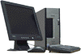
DESKTOPS & NOTEBOOKS
• Business PCs
• Home PCs
• HCL laptops


INTEL WORKSTATIONS
• Infiniti Challenger Workstations
• SUN Workstations

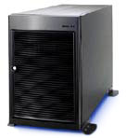
AMD WORKSTATIONS
• Infiniti Xcel Line 2200NL
• Infiniti Xcel Line 2200SY

AMD Opteron Servers
• Infiniti Xcel Line 2200AT
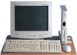
• Infiniti Xcel Line 2200MI
• Infiniti Xcel Line 2200AZ
• Infiniti Xcel Line 4200TL

Other Servers
• SUN Servers
• HP Risc Servers & Workstations


THIN CLIENTS
• Winbee Thin Clients
• SUN Thin Clients

DISPLAY PRODUCTS
• SUN Thin Clients

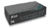
NETWORKING PRODUCTS
• Overview
• WinSmart Switch
• SNMP Managed Switch

SECURITY PRODUCTS
• HCL InfoWall
• HCL InfoSecuAccess
• HCL InfoVPNe

• HCL InfoSecuMon
• HCL InfoNetMon
• HCL InfoSurveillance
• HCL InfoSecuDesk - Biometric Logon
• HCL InfoSecuDesk - SmartCard Logon
• HCL InfoSmartCard
• HCL InfoLoadBalancer
• HCL InfoSMS
• HCL InfoDashboard
• HCL InfoAttendance - BN model

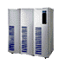
STORAGE SOLUTIONS HCL STORAGE SOLUTIONS
• HCL Infiniti SAN ARRAY 2502FC
• HCL IGL NAS Servers
• IGL NAS 1400 BT
• IGL NAS 2700 SP
• IGL NAS 2700 BD
• SUN Storage Solutions
• EMC Storage Solutions

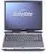
TOSHIBA NOTEBOOKS
• Product Line-up

SOLUTIONS
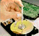
• Infostructure Services
• Networking Services
• Security Services
• Facilities Management Services
• Domestic Hardware Services

SOFTWARE LICENSES
• Overview

PRODUCTS PROFILE OF HP

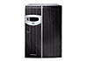
Products:

HP ProLiant servers

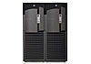

- HP Integrity NonStop Servers

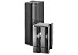

- HP Integrity NonStop Servers

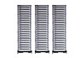
- HP 9000 servers

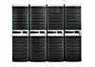
- HP AlphaServer systems

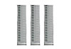
- Telco and carrier-grade servers

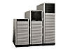

- HP e3000 servers

HOME PRINTERS: LASERJET PRINTERS

HP Color LaserJet 2550 printer series
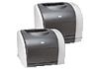
- Enhance your work documents with HP’s most affordable colour laser printer in a simple-to-use design.
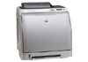
Impressive colour, remarkably affordable

HP Color LaserJet 2600n printer series
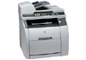
- High-impact, surprisingly affordable, built-in networked colour printing
HP Color LaserJet 2820 all-in-one printer
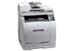
- Your 3-in-1 business centre for professional colour laser print, copy and scan (network-ready)
HP Color LaserJet 2840 all-in-one printer
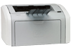
- Your 5-in-1 creative and business centre. Network ready, ideal for small and medium businesses.

HP LaserJet 1020 printer
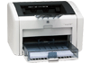
- Simple. Compact. Affordable.

HP LaserJet 1022 printer series
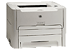
- Quick Start. Professional laser results.

HP LaserJet 1160 printer
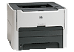
- Professional performance at an affordable price

HP LaserJet 1320 printer series
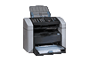
- Fast, expandable, network-capable

HP LASERJET 3015 ALL-IN-ONE PRINTER
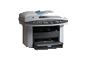
- The most affordable and compact LaserJet all-in-one designed to save office space. A versatile device and ideal for those looking to replace or upgrade their fax machines.

HP LASERJET 3030 ALL-IN-ONE PRINTER
- LaserJet all-in-ones that delivers fast and reliable results for SOHO/SMB users in a space-saving design. The HP LaserJet 3020 provides businesses with integrated quality laser printing, fast flatbed copying and colour scanning, while the HP LaserJet 3030 all-in-one includes an additional fax function.

Desktop PCs
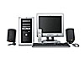
For Home & Home Office HP Pavilion desktop PCs Perfect for digital imaging needs.

Compaq Presario desktop PCs: Advanced home and wireless networking capabilities

For business:

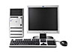
Business desktop PCs
Stable computing solutions to deliver optimal performance
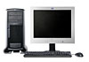
Workstations
  - Personal Workstations
  - Engineered for ultimate value and performance

PA-RISC
- Leadership HP-UX stability and performance

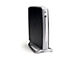
Thin clients
- Thin clients Simple, dependable, manageable, and secure solutions

MONITORS:
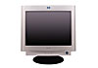
For Home & Home Office
- Monitors for Home & Home Office
Complements your PC

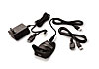
OPTIONS AND ACCESSORIES:

For Home & Home Office
- Options & Accessories for Home and Home Office

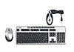
For business
- Business Options & Accessories

Notebooks & Tablet PCs

Monitors & Projectors
Fax, copiers, & scanners
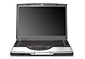
Versatile mobile solutions for a demanding environment

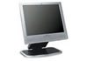
•Ideal ultramobile PCs that adapt to the way you work

Designed to improve the way you look at business
•Monitors and projectors for the enterprise.

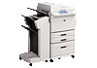
Innovative digital imaging products for a demanding enterprise environment
• Scanners and copiers for the enterprise

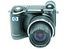
DIGITAL PHOTOGRAPHY:

Digital photography for your enterprise
HP's digital photography solutions give you a competitive edge

Supplies & Accessories

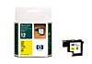
Supplies and accessories designed together to work together

• Supplies and accessories for the enterprise

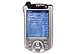
Handheld devices

Handheld devices for your enterprise
Satisfy business needs on the go
Some other Services of H.P

Applied research:

Experimental "game" helps Ford save time, money
Experimental economists at HP Labs have helped the company improve revenue forecasting and design new incentive programs for retailers, and they've explored such questions as pricing contracts and currency fluctuations. But they aren't keeping their expertise to themselves: They've also worked with partners like Ford Motor Company.

Riding the peaks: Market-based systems help manage demand
A reservations system allows people to pay up front to keep a resource (say an airline ticket, or computing power in a data center) available to them at some point in the future. The price they pay to hold that resource for peak times is less than if they bought it at the time they actually needed it.

Protecting privacy: Building in safeguards for personal data
With security breaches and online fraud on the rise, consumers, businesses and government organizations are growing more concerned about protecting individuals' privacy. A team at HP Labs is working on tools to make it easier for businesses to do just that.

HP huge among patents for the tiny
HP's patent portfolio for micro- and nano-electronics has been named the strongest in the U.S., according to an independent survey

Marketing strategies of HP:
HP Corporate Marketing
HP is a company unlike any other. They serve everyone from consumers to small and mid-sized businesses to enterprises to public sector customers with an extensive portfolio of market-leading solutions specifically designed to meet the needs of each customer segment. They focus on helping people apply technology in meaningful ways to their businesses, personal lives and communities. Their annual R&D investment of nearly $4 billion fuels the invention of products, solutions and new technologies, to serve customers better and enter new markets. They produce an average of 11 patents a day worldwide. In addition to the R&D and innovation in their product and services groups, HP Labs provides a central research function for the company focused on inventing new technologies to improve the customers’ lives, change markets, and create business opportunities.
Source: Technology Business Research, Inc., October 26, 2006 Millions of people around the world uses HP technology every day. They re the largest consumer IT company, the world’s largest SMB IT Company and a leading enterprise IT Company. For more than 100 million cell phone subscribers, it is HP software that identifies them when they turn on their phones and allows them to place calls. HP powers 100 of the world’s stock and commodity exchanges, including the New York Stock exchange and 14 of the world’s largest trading markets. In response to customer needs and the changing market conditions, they have built a portfolio unequaled in the industry. HP technology now ranges from consumer handheld devices all the way to some of the world’s largest and most powerful supercomputer installations. Their strategy is to offer products, services and solutions that are high tech, low cost and deliver the best customer experience. No other company has the portfolio, people and expertise to deliver on all three. They have a dynamic, powerful team of 150,000 employees doing business in more than 170 countries. Revenues reached $89.9 billion for the fiscal year that ended October 31, 2006 HP has corporate headquarters in Palo Alto, California.

HP has a significant presence in all markets we serve

Consumer – “Our consumer business has leadership in handhelds, notebooks, printers and cameras – focused on delivering simple, rewarding experiences to hundreds of millions of customers”.

Small and medium business – Working with local reseller partners, HP serves business customers worldwide to provide specialized expertise, a complete portfolio of products, solutions, and services, and a simplified ownership experience. They have market-leading positions in datacenter and office computing, and the imaging and printing market.

Enterprise – The enterprise segment draws from HP’s full portfolio of products, services and solutions. We collaborate with large customers to build an Adaptive Enterprise helping them achieve more simplicity, agility and value across their organization. We are No.1 or No. 2 in all three server-based operating environments, and we hold top positions in enterprise storage and IT services management.

Public sector, health & education – With more than 60 years of experience serving the technology needs of the public sector, HP brings the full breadth of its portfolio and alliances to help governments, educators, healthcare providers and others working in the public interest to lower their costs, increase efficiencies and serve their citizens, businesses and other government agencies better.

Their Key Words “Doing well by doing good”
“As proud as we are of our capabilities, we are equally proud of our people, our standards and values, and our deep commitment to global citizenship. Since our first year in business in 1939, HP has given back to communities through philanthropic donations of money, equipment and time. While the scale and reach of our business have changed in 66 years, our commitment to communities hasn’t. The challenge is to continue to shape the impact of corporations as a constructive force, using our heritage and our actions as tools for doing so.

- HP and TIBCO Software Announce Multi-year Agreement to Develop Marketing Strategies & Products for Service Providers and Telecoms
- Hewlett-Packard Company and TIBCO Software Inc. announced an agreement to jointly develop products, solutions and marketing strategies for the service provider and telecommunications markets. Through a three-year collaboration agreement, the companies plan to support high-volume online transactions and to enhance the performance, reliability and advanced middleware needs of global customers.
- The alliance will leverage HP Open View management solutions to integrate TIBCO Software's real-time e-business infrastructure software with the HP Net action Internet operating environment to help customers implement reliable, secure, scalable and manageable e-business solutions.
- TIBCO's integration, B2B and XML solutions enable customers' disparate applications to interact in real time. In addition to the collaboration that will use HP's process management technology and application development toolset, the HP Middleware Division will lead HP's joint development activities using standards such as J2EE and XML technologies that will complement the current TIBCO products, providing a development pathway for future jointly developed products and services.
- "This agreement is an important step in HP's software strategy," said Bill Russell, vice president, HP Software Solutions Organization. "TIBCO is a leader in business integration software and this agreement builds on HP and TIBCO's shared vision of the evolution of e-business technologies, our joint development plans and our collaborative market strategies."
- "The old model of business was standalone, but today's model is collaborative," said Vivek Ranadivé, chairman and CEO, TIBCO Software. "This agreement shows the commitment of TIBCO and HP to bring industry-leading solutions to the telecommunications marketplace."
- In addition to the joint development work, HP Consulting will recommend TIBCO as a preferred integration solution vendor for the service provider and telecommunications markets. HP and TIBCO are currently working together with joint customers, and jointly developed software products are expected to be available to the marketplace within one year.
- TIBCO Software Inc. is a leading provider of total business integration solutions delivering infrastructure software that enables companies to seamlessly integrate business systems in real time. TIBCO's products enable the real-time distribution of information through patented technology called The Information Bus™, or TIB®. TIBCO technology was first used to digitize Wall Street and has since been adopted in diverse industries including financial services, telecommunications, electronic commerce, transportation, logistics, manufacturing and energy. TIBCO's global customer base includes more than 1,000 customers such as Cisco Systems, Yahoo!, Ariba, NEC, Enron, Sun Microsystems, GE Capital, Philips, AT&T, Pirelli and AOL/Netscape. Headquartered in Palo Alto, Calif
- Hewlett-Packard Company is a leading global provider of computing and imaging solutions and services is focused on making technology and its benefits accessible to individuals and businesses through simple appliances, useful e-services and solutions for an Internet infrastructure that's always on.
- HP had total revenue from continuing operations of $48.8 billion in its 2002 fiscal year. Information about HP and its products can be found on the World Wide Web.
- TIBCO, The Information Bus and TIB are trademarks or registered trademarks of TIBCO Software Inc.
- Legal Notice Regarding Forward-Looking Statements: This release contains forward-looking statements regarding TIBCO's business, customers, markets served or other factors including the performance of TIBCO's strategic partner, the continuation of this relationship, and the ability of products to meet customers' expectations, needs, or perform as described that may affect future earnings or financial results. TIBCO's actual results could differ in such forward-looking statements. Reasons for why actual results could differ materially include if the relationship does not continue, or the products are unable to successfully meet customers' expectations, needs, or perform as described. Additional information concerning factors that could cause TIBCO's actual results to differ materially from those contained in the forward-looking statements can be found in TIBCO Software's filings with the Securities and Exchange Commission (SEC), including but not limited to its most recent reports on Forms 10-Q and 10-K filed with the SEC on Oct. 13, 2005, and Feb. 25, 2005, respectively, which identify important risk factors that could cause actual results to differ from those contained in the forward-looking statements including limited independent operating history, history of losses, unpredictability of future revenue, dependence on a limited number of customers, relationship with Reuters Group PLC, rapid technological and market changes, risks associated with infrastructure software and volatility of stock price. Copies of filings made with the SEC are available through the SEC's electronic data gather analysis and retrieval system (EDGAR) at www.sec.gov. TIBCO assumes no obligation to update the forward-looking statements included in this document.
- This news release contains forward-looking statements that involve risks and uncertainties, as well as assumptions that, if they never materialize or prove incorrect, could cause the results of HP and its consolidated subsidiaries to differ materially from those expressed or implied by such forward-looking statements. All statements other than statements of historical fact are statements that could be deemed forward-looking statements, including any projections of earnings, revenues, or other financial items; any statements of the plans, strategies, and objectives of management for future operations; any statements concerning proposed new products, services, or developments; any statements regarding future economic conditions or performance; statements of belief and any statement of assumptions underlying any of the foregoing. The risks, uncertainties and assumptions referred to above include the ability of HP to retain and motivate key employees; the timely development, production and acceptance of products and services and their feature sets; the challenge of managing asset levels, including inventory; the flow of products into third-party distribution channels; the difficulty of keeping expense growth at modest levels while increasing revenues; and other risks that are described from time to time in HP's Securities and Exchange Commission reports, including but not limited to the annual report on Form 10-K for the year ended Oct. 31, 2005, and subsequently filed reports. HP does not intend to update these forward-looking statements.
- As Vice President of OS Marketing for the Industry Standard Server Group at HP, Rick Becker leads the alignment of marketing strategies and programs with HP's leading strategic OS partners to drive HP server sales. His Industry Standard Server Group is responsible for the market-leading ProLiant server business, which offers the best in open source Linux solutions on industry-standard server platforms.
- Previously, as the Director of Strategic Relationships for HP, Server Products Division, and Becker led strategic marketing, strategic planning and post merger integration projects for HP's highly successful server business.
- Before joining Compaq, now the new HP, in 1994, Becker was Director, Corporate Strategy at Novell. During his seven years at Novell, Becker held a variety of management assignments in corporate strategy and business development.
- Becker earned a Bachelor of Science degree in Computer Science from University of North Texas.
- HP would like to be able to provide information to everyone who seeks it, but unfortunately we're limited by both business and legal restrictions about what we can disclose.
- In addition, time constraints prevent HP executives, managers or any other HP employees from granting interviews to members of the public and from participating in academic surveys, either oral or written.
- Types of information that cannot be made available to people outside of HP include:
- Nonpublic product details: We cannot reveal internal details regarding existing, new or proposed products or processes. Public product information is available online.
- Financial: HP cannot disclose nonpublic consolidated financial information, production and overhead costs, profit margins, bids, sales forecasts, sales and order volumes prior to quarterly release, budgets, quotas and targets, information on a particular product's sales, orders or projections. Marketing: HP does not disclose product-introduction plans and dates; short- and long-term market strategy or customer lists; sales, marketing and pricing plans; information about market share, market strategy or marketing plans other than what has been publicly discussed in press releases or otherwise publicized. We do not make HP promotional items available.
- Research and development: HP cannot reveal technical and performance specifications, lab notebooks, product plans, projects in progress, project problems or product code names
- Manufacturing: We do not reveal vendor names/relationships, manufacturing-operations data, production and inventory levels, future plans and sites, material cost or product failure rates, or process strategies.
- Personnel data: Aside from information on executive salaries that is available in HP's 10K filing, HP does not reveal personnel data such as compensation information, ranking and job descriptions, names and titles of employees below the functional-manager level or departmental organization charts. Training manuals, employee handbooks, internal communications or evaluation forms are also not available to the public.
- There are over 8 million businesses in the United States alone, with each one trying to stand-out from the crowd and grow their market share. Here to help you with that daunting task is HP Balu Doraisamy, who is a Managing Director, HP India, Marketing small business marketing system. Balu will be providing tips, tricks and guidance to help you improve your business, your relationships with your customers (and prospects) and ultimately you’re bottom-line.
- “It may not be that glamorous but one of the best ways to differentiate your business is to show your clients and prospects checklists.
- See, lots of folks talk about quality, speed and accuracy but few really deliver it. If you could offer your prospects proof that you not only deliver the goods you have a 10 point system that guarantees it, well, I think your business would be the obvious choice.
- Almost every business has checklists (even mental ones) that they go through to ensure the job gets done right, the order gets packaged right or the service is delivered on time. Few however, take the time to document those systems in the form of a checklist and fewer still think to use those checklists as marketing tools.
- What if you produced a document that read: Our 10 point white glove inspection guarantees that your car will be spotless - and then proceeded to list all 10 steps.
- How about your web site optimization process, your financial investment risk analysis, your safety process, your service punchlist.There is no end to the creative ways you can approach this. People love top 10 lists and checklists because they take something that is often complicated or boring and turn it into something that is simple and even entertaining.
- Few things are sold without a prospect reading a written word or two. Business owners often ask me what they should be looking for in marketing assistants and I always say - find someone who can write.
- Now, let me back up and tell that what I really mean. Find someone who will write. Many people claim that they are not good writers and my take is that they simply don't write. In order to become a good writer, in order to use writing as a marketing skill you must write. You can always have someone edit what you write, but it's the act of writing that starts the marketing ball rolling. (I know my editor friends out there wish I would take that editing advice.)

CHAPTER-5
RESEARCH METHODOLOGY

5.1 RESEARCH DESIGN:
The salient features of Methodology of a research would be:
- Developing a plan.
- Collecting the information.
- Analysis
- Developing a plan
  - Data Source – The research commences with a study of the secondary data to get the information on HCL & HP.
The primary data will be collected from the field surveys with the help of structured questionnaire.
  - Research Approach – Conducting surveys is considered the best suited to collect information for the descriptive project in hand.
  - Research Instruments – In the project like this the most common and most important research is to collect primary data. Questionnaires are used for this purpose, to help methodically co-relate the information.
- Collecting the information
The exercise of collecting the primary data is a tedious task done through interviews of the respondents based on the standard set of questions. The interviews will be conducted informally and the observations will be meticulously charted. The choice of an informal mode was intentionally made so as to keep the respondents comfortable. This will make the process of interaction easy and thus help in gaining an insight to the perception of the respondents.
SAMPLE AREA: National Capital Region of Delhi.
SAMPLE SIZE: 100
The questionnaire included both close ended and open-ended questions in a systematic order.

SAMPLING PLAN: Random Sampling Methods will be used to collect the information.
- Analysis
Analysis is carried out with the help of secondary data and primary data to arrive at the correct picture of the IT market. Analysis of industry as a whole and comparative analysis of HCL with HP will be highlighted.

5.2 MARKETING RESEARCH:

Staying competitive in today’s dynamic business environment means finding new ways to reduce costs while maximizing the value of your technology and personal resources.More than ever, your ability to "do more with less" determines how successful your organization will be. That's why HCL Insystems helps you achieve. By channeling our in-depth expertise gained from over 28 years of IT Domain experience. We provide a full bandwidth of services specifically designed to meet your complete IT needs.And as a single window for completing business solutions wherever you are located.......
We make IT possible to save money......as well as time.

SOLUTIONS:
- The one stop shop solution center for all your IT needs, customized to meet and scale with your unique Business Needs.

SERVICES:
- A range of value added services in IT infrastructure operations and management.

SUPPORT:
- Pan-India footprint of support and logistics locations. Over 260 Direct service support locations. Technically sound workforce of over 1700 certified professionals.

STANDARDS:
- World Class Quality standards maintained for PPP (People, Processes & Performance). Alliance with global technology leaders.
- SAVINGS:
- We help you find new ways to reduce costs & "do more with less" by maximizing the value of your technology and personal resources, thereby reducing your total cost of ownership (TCO).

SATISFACTION:
- Complete Satisfaction for the customers through the HCL 6S offering that enables one to maximize system uptime through rapid response and resolution services, thereby optimizing your IT investments.
- Networks are multiplying day by day in every organization. Systems are becoming more & more dependent on the availability of data resources of various departments / divisions / locations of an organization and thereby increasing the load and requirements of Networks. The well known networked applications such as Email, Internet / Intranet, GroupWare solution, Relational Databases render the users completely in-effective services, in the event of network shutdowns.

- Network Management involves Network Monitoring of Bandwidth Utilization, Network Errors / Collisions, Network Troubleshooting, Day-to-day Network Operations, Network performance monitoring, Tuning Network Operating System and advice action plan.

SERVICE OFFERINGS
- Liaison with networking hardware support provider for all hardware related problems.
- Use the NMS (Network Management Software) tool available with the customer (if not, then to be made available) to monitor the functioning of Network.
- Use the special device/software tool for monitoring the port/network traffic and take appropriate action or recommend preventive actions. (Device / Software tool to be made available by the customer.)
- Co-ordinate with cabling warranty providers for repair of faulty points / cables and other related issues.
  - Setup Network File System - NFS - Configuration of files and folders for sharing across the network.
  - Setup Network Information Service - NIS
  - Setup Domain Name Service - DNS
  - Setup Heterogeneous Networking
  - Setup Dynamic Host Configuration Protocol - DHCP
  - Provide detail documentation for all the above-mentioned activities.

SERVICES - FACILITIES MANAGEMENT
Today IT assets have become widely distributed and less visible. Many organizations are spending a very high portion of their technology budget on "soft costs" like purchasing, installing, managing, administration, troubleshooting, training, recruitment, etc for supporting the IT Hardware and Software. So if your systems are critical to the operation of your business, downtime can have a disastrous impact on production, customer satisfaction and revenues.

We are in the business of helping customers to use their equipment better. Our Facilities Management Services are a comprehensive set of services that helps customers to fully utilize their IT investments by improving availability, reliability and performance. We achieve this by offering a complete portfolio of customized services and expertise, from planning and design to procurement, installation, integration, migration assistance to system management, telephone support and on-site hardware and software fixes.

Through our Total Facilities Management Solution, we offer a range of service options, customized to the specific requirements of yours. These include:
- 365x24x7 Support for mission critical sites
- Value added Support Services
- System Administration
- Helpdesk Services
- Network Consulting
- Network Implementation and Management
  - All this helps customer in deriving maximum value from the investment in IT hardware and software.

  - Our longstanding association with Global leaders like Intel, Microsoft, Hewlett-Packard, Cisco, Lucent, Novell, Oracle, SAP etc. has helped us gain immense technical knowledge allowing us to offer direct support to large installation across diverse platforms, through its committed professionals, even in the remotest of locations.

HCL - BPO
HCL BPO represents one of HCL's most significant strategic business extensions and investment to date. The focus and commitment to BPO is based around HCL's global client base and relationships, related technology domain expertise (such as CRM/ ERP/ SCM/ Imaging/ Workflow) and relevant industry practices (such as Financial Services, Retail and Telecom), In only its 3rd full year of operations, HCL BPO crossed $ 100 Million in revenue at a growth rate of 82% for FY06 ended 30th September 2006. HCL manages processes in payment services, customer contact services, technical support services, F&A, order management and research analytics & modeling across telecom, retail, financial services and products & services.

The essence of BPO is risk-mitigated, high quality service delivery with focus around enhanced delivery infrastructure, service delivery excellence and customer relationship management. The accent is on advanced customer handling and communication skills imparted through the 'Empathy Lab', a sensitized approach for managing client-side process stakeholders, integration with process experts and certifications such as COPC and BS: 7799, SAS 70.

5.3 Data ANALYSIS:

- Computers have become a necessity these days, do you agree?
(a) Yes (b) no

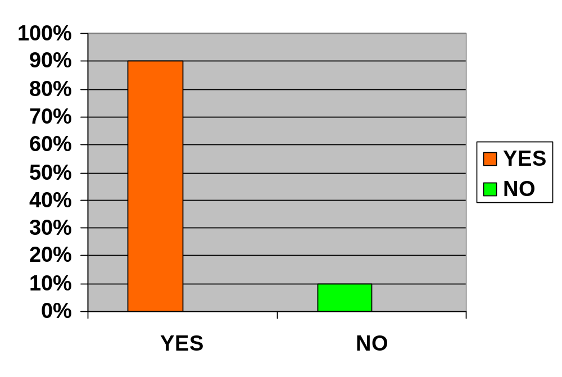

INTERPRETATION:
- Almost all the respondents argued to the fact that Computers have become the utmost priority in modern times. Therefore it is a good opportunity for the companies like HCL & HP to explore the maximum market opportunities.

- Have you heard of HCL Info systems and HP?
Yes No

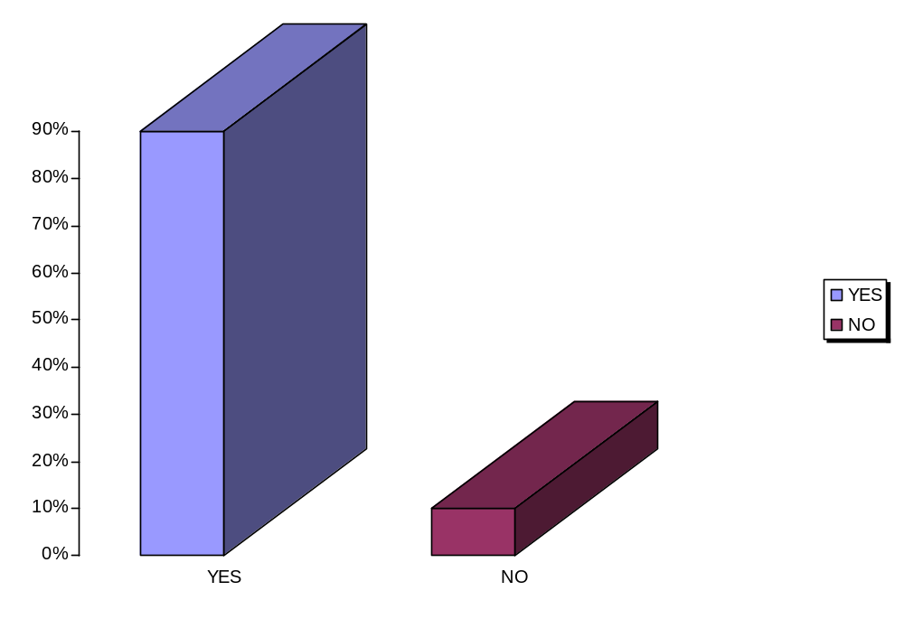
AWARENESS ABOUT HCL INFOSYSTEMS

INTERPRETATION:
- Respondent agree in majority that they are very well aware about HCL infosystems as a brand.
- Are you aware that HCL & HP offer many products other than the computers?

Yes No
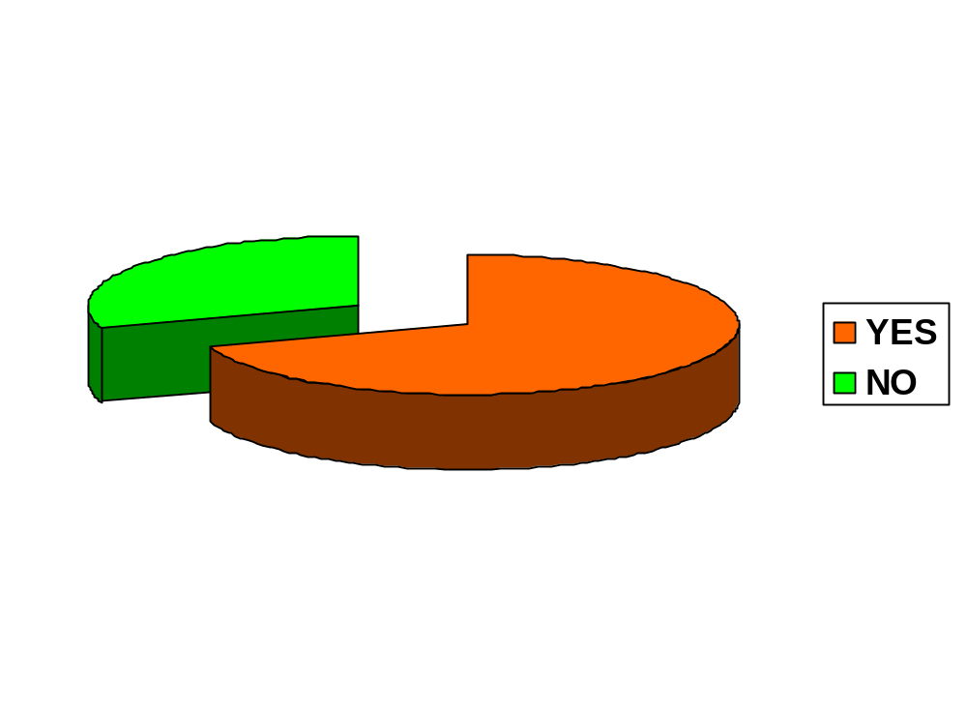

INTERPRETATION:
- Respondent are aware at large that the companies like HCL and HP manufacture other computer Hardware as well in additions to PC.

- Which brand of computers and other accessories do you buy?
- HCL (b) HP (c) Others

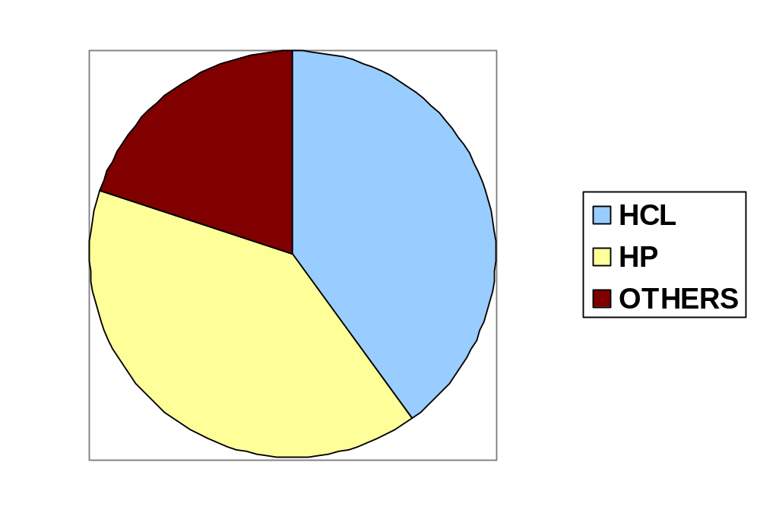

INTERPRETATION:
- HCL seems to have an edge over HP, according to the customers response. However these two combined together constitute the bulk of the market share in India.

- Are you satisfied with the performance of the products of HCL and HP?
(a) Yes (b) No

SATISFACTION LEVEL OF HCL CUSTOMERS
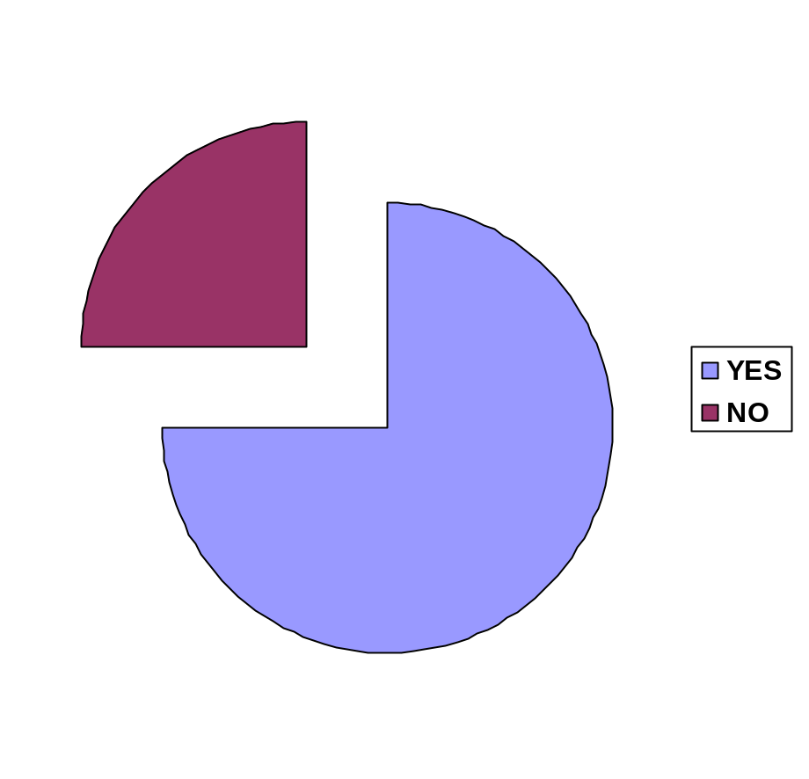
75%
25%

INTERPRETATION:
- 75% of the total respondents expressed their satisfactions about the performance of HCL Infosystems.

- From where do you buy these products?
(a) Distributor (b) company outlets (c) others

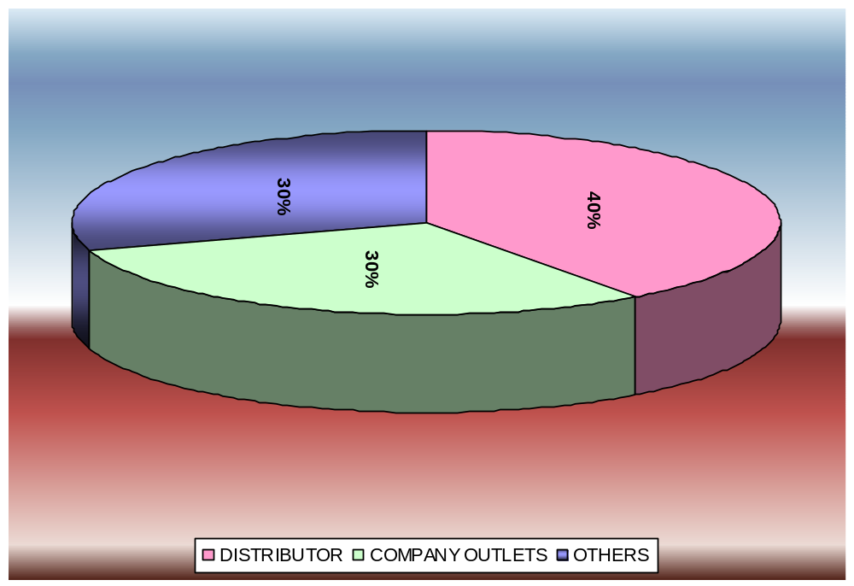

INTERPRETATION:
- Company distributors seem to be successful in making bulk of the Sale with, company outlets and others sources to follow.

- Are you satisfied price structure of HCL Info systems?
Yes No

CUSTOMER SATISFACTION ABOUT PRICING STRUCTURE OF HCL INFOSYSTEMS

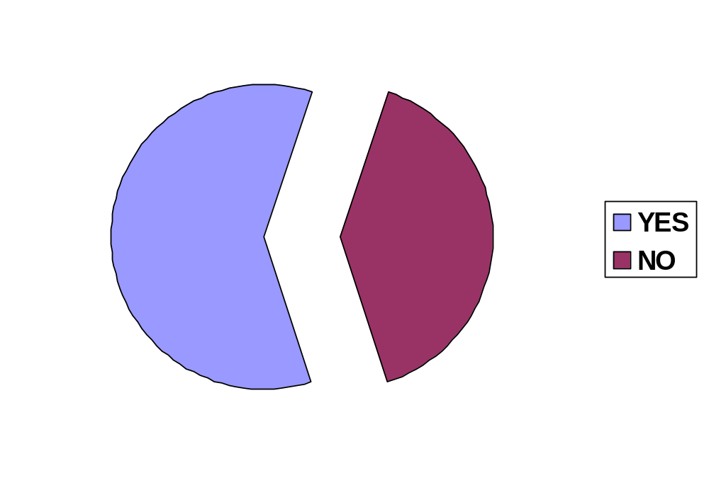
40%
60%

INTERPRETATION:
- 60% of the Respondents appeared their satisfaction about the pricing structures of HCL. The company still needs to work hard on its pricing strategy to satisfy the remaining 40% of the customers.

- Are you satisfied price structure of HP?
Yes No

CUSTOMER SATISFACTION ABOUT PRICING STRUCTURE OF HP

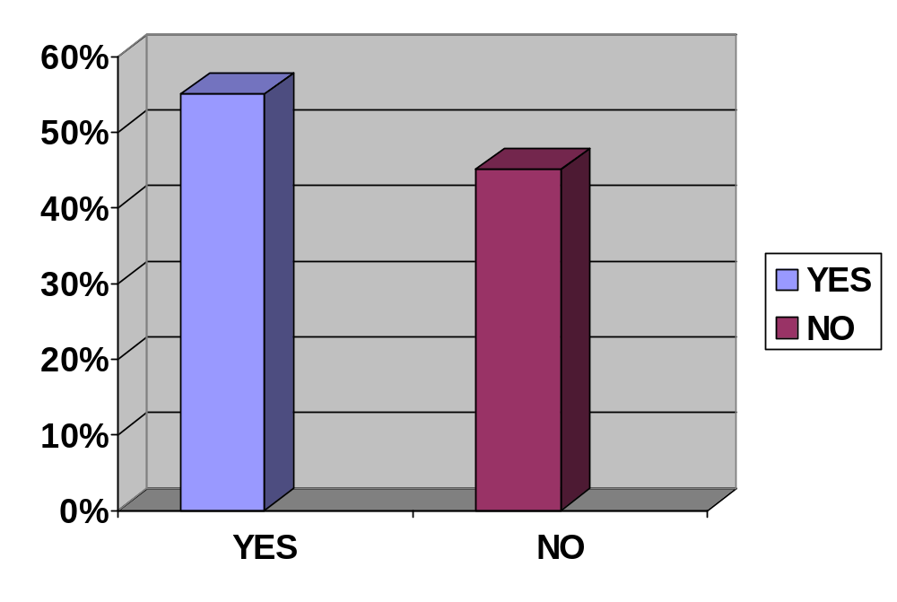
45%
55%

INTERPRETATION:
- 55% of the Respondents appeared their satisfaction about the pricing structures of HP. The company still needs to work hard on its pricing strategy to satisfy the reasoning 45% of the customers.

- Which brand would you prefer over the other?
(a) HCL (b) HP

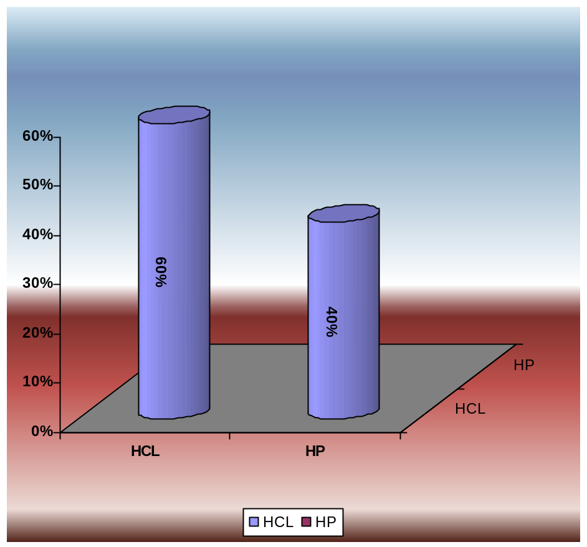

INTERPRETATION:
- HCL holds an edge over HP in regard to the customer Brand preference.

- Do you have any knowledge of all the promotional activities of HCL and HP products?

Yes No

AWARENESS ABOUT PROMOTIONAL ACTIVITIES OF HCL INFOSYSTEMS

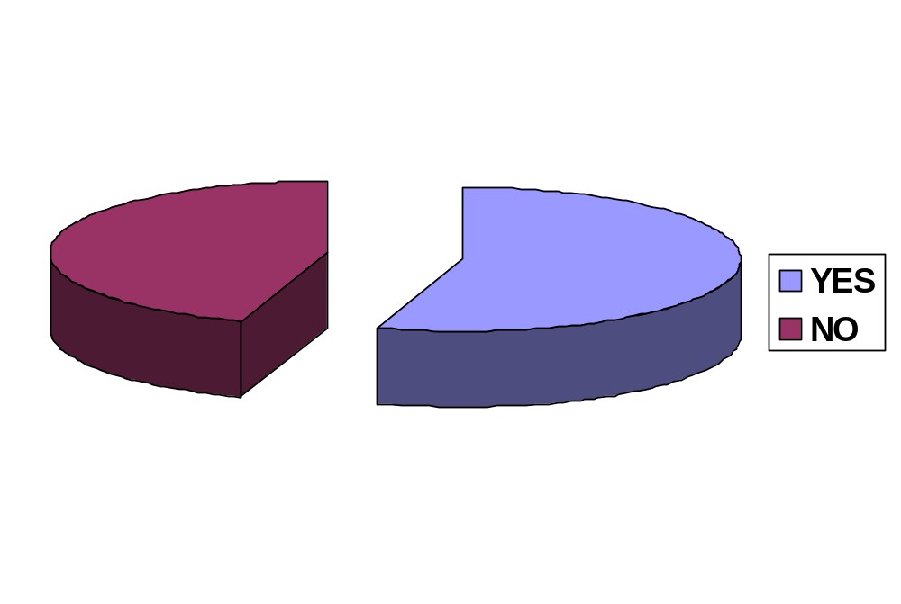
60%
40%

INTERPRETATION:
- At large, the customers have expressed their good awareness about the promotional activities conducted by HCL Info systems.

CHAPTER- 6
FINDINGS
findings
The Indian I.T. market currently appears to be at a crossroads, where I.T. marketers are attempting to change customer perceptions of their brands and where specific buying motivations appear to be replacing generalities.
This meanwhile is quite unlike the west where buyers consider aesthetics, comfort and safety, not necessarily in that order, before finalizing a purchase. “It’s smarter to think about emotions and attitudes, if marketers are to do a better job of marrying what a HP/HCL offers to the consumer’s image of the offerings.
The mindset of the Indian consumer is such that he is delighted if he buys a pen a little cheaper than his neighbor. Things are, however, slowly changing and customers at the upper end of the market are now ready to pay more for more. I hope that this approach will soon enter the new era, maybe not with the same intensity.
“Success will largely be determined to the extent a company can differentiate itself in terms of intangibles that go with a Product”. Thus, success could well hinge on the best of bundle of services that HP & HCL INFOSYSTEMS provides.
HCL INFOSYSTEMS grew from zero to the 180 Million $, mark and the number One sales of Printer, Scanner & TFT in India in this year. Looking at the present scenario it can be said that though there is lot of competition in the I.T. world HCL INFOSYSTEMS is picking up well.
The landmark achievement comes in 66 years after clinching its first overseas sale.
In 1973 HP becomes the first U.S. Company to institute flexible working hours, or flex-time. Under the program, HP employees can begin work at any time during a two-hour period and leave after completing an eight-hour work day. The purpose, as explained by Bill, is "to gain more time for family leisure, conduct personal business, and avoid traffic jams or to satisfy other individual needs."

CHAPTER- 7
LIMITATIONS

LIMITATIONS:
  - The company needs to evolve a comprehensive plan & strategy to make inroads into a part of middle class & upper middle class.
  - Lack of production centers in India makes the product costlier as most of the parts have to be imported.
  - Lack of R & D centers also makes it difficult to launch new products over here.

CHAPTER- 8
RECOMMENDATIONS

RECOMMENDATIONS
Key attributes components:
- Value for money and Customer Care
- Operational attributes.
- Physical attributes.
- Brand Image.
- Customer Specific Details.

In any correspondence with the customers the message should be sent in these components only to have the maximum benefit from the advertisement. Also these components should be dealt with independently. The advertisements should speak only of the believable concepts rather than glorifying the pretentious ones. The basic need of the customer need to be addressed which is actually saving time and better quality.
HP Deskjet 3745 printer, COMPAQ PRESSARIO 1310 this particular model has a problem with promotion and pricing. Although being the most competitive product on the basis of the Market Operating Price (MOP), the machine is still not selling much. This is perhaps due to the bargaining stress on the customer and the weak push given by the dealer to the particular model, when actually it should be sold like a high volume product.
Another important outcome of the research is the believability of the claims. Most of the claims are realistic and easy to understand. Most of the people don’t understand the technical claims like Software problems and Hardware resale and the dealers don’t provide much support to the customers in making them understand the real technology behind them. Either, the technical details should me presented in a clearer manner or the dealers need to be educated properly.

CHAPTER- 9
Bibliography
BIBLIOGRAPHY

BOOKS
  - Jeffrey Gitomer, Customer Satisfaction is Worthless
  - Jean-Noel Kapferer (1994), “Strategic Brand Management”.
  - Philip Kotler (Eight-Edition), “Marketing Management”, Prentice Hall of India Pvt. Ltd.
  - Shiffman Consumer Behavior
  - Market Analysis, Thomson and Shaun, Edn. 2005 , pp-185-190
  - Kotler Philips, Marketing Management, 11th Edn.
INTERNET LINKS
  - http://www.hcltech.com
  - http://www.texas400.com
  - http://publib.boulder.ibm.com
  - www.hcl.in
  - www.hclinfosystems.com
  - www.hclstore.in/contactus.html
  - www.hp.com
JOURNALS
  - Financial Press Release of HCL Infosystems
  - Executive Journal of icfai University Press
  - Electronics for You
  - Business and Economy
  - Business Today

CHAPTER- 10
Annexures
ANNEXURES

- Computers has become a necessity these days, do you agree?
(a) Yes (b) No

- Have you heard of HCL Infosystems and HP?
Yes No

- Are you aware that HCL & HP offer many products other than the computers?
Yes No

- Which brand of computers and other accessories do you buy?
(a) HCL (b) HP (c) Others

- Are you satisfied with the performance of the products of HCL and HP?
(a) Yes (b) No

- From where do you buy these products?
(a) Distributor (b) company outlets (c) others

- Are you satisfied price structure of HCL Infosystems?
Yes No

- Are you satisfied price structure of HP?
Yes No

- Which brand would you prefer over the other?
(a) HCL (b) HP

- Do you have any knowledge of all the promotional activities of HCL and HP products?
(A)Yes (B) No

