PROJECT REPORT

ON

Knowing Perception and Willingness amongst people for becoming “FINANCIAL CONSULTANT” of HDFC-SLIC

SUBMITED IN PARTIAL FULFILLMENT FOR THE AWARD OF THE DEGREE OF
BACHELOR OF BUSINESS ADMINISTRATION (BBA) 2011-2014

UNDER THE GUIDANCE OF

__________________________

SUBMITTED BY:
KAPIL SINGH BISHT
04414701711, BBA 5th SEM

MAHARAJA AGRASEN INSTITUTE OF
MANAGEMENT STUDIES
Affiliated to Guru Gobind Singh Indraprastha University, Delhi
PSP Area, Plot No. 1, Sector 22 Rohini Delhi 110086

1. Executive Summary

The service industry is one of the fastest growing sectors in India today. The upcoming sectors which are really showing the graph towards upwards are - Telecom, Banking, and Insurance. These sectors really have a lot of responsibility towards the economy.

Amongst the above-mentioned areas insurance is one sector, which took a lot of time in positioning itself. The insurance business of non-life companies was not much in problems but the major problem was with life insurance. Life Insurance Corporation of India had monopoly for more than 45 years, but the picture then was completely different. Previously people felt that “Insurance is only for classes not for masses” but now the picture is vice-versa.

The success story of good market share of different market organizations depends upon the availability of the product and services near to the customer, which can be distributed through a distribution channel. In insurance sector, distribution channel includes agents, agency holders of the company and now a day’s internet is also used to reach to the potential customer.

Initially when meet people they recognized that they don’t know about the recruitment policy related to HDFC SLIC and they have some their own perception about the insurance sector so I decided to do my research to know perception of people towards insurance sector and to know the willingness of people to become FC for HDFC SLIC.

To conduct the research I design a questionnaire and use descriptive research design to conduct my market research.

On the basis of my research I find that most of the people think that insurance sector is hard and profitable, the reason people think that insurance sector is hard because since insurance is unsought need of the people therefore it is very hard to sell the polices of the company .

In my research I also find that more than 80% of the people don’t want to join HDFC SLIC as a financial consultant. The reason they said for not joining HDFC SLIC is that they are satisfied with current job. Since the preference of the company is people who are more than 30 years of age, professional who in general is satisfied with their job or they don’t have time to sale policy. Some people also said that HDFC SLIC is a private sector company and due to strong market share and awareness among people about LIC, will make their job difficult to work as FC for company .Awareness related to becoming FC for the company is also very low i.e. only 12% of people know about it. This also is hindrance in recruiting people as FC for the company.

My suggestion to company is to make people aware about benefit of becoming FC for company by giving advertisement in newspaper, print media, etc. they should promote this as career opportunity among the youth who is not very educated or unemployed, they should review the eligibility criteria they set for the FC. The insurance companies should try to nurture their brand name timely, which will help FC to sale their product.

2. INTRODUCTION

The project entitled “A research to know awareness and willingness among people to become FINANCIAL CONSULTANT for HDFC SLIC” is all about to know the awareness and willingness among people to become FC for the company. The purpose of the project is also to know the awareness and interest among people to become FC for the company and also to know perception of the people towards the insurance sector as career opportunity. Initially when I meet people they are unaware about this opportunity and someone also shows their less interest towards this sector because they have perception that selling insurance product is very hard that is why I decided to form this topic and conduct my market research.

The project was done in time frame of two months i.e. from 01 July 2013 to 31 July 2013.
The project will have following contribution to the company:-

- The project will help company to know that what is the awareness of recruitment policy of the company among people related to FC.

- The project will help company to reconsider its policy to make people aware about the benefit of becoming FC for the company to develop its channel of distribution.

- Meeting with people and explaining them about opportunity given by the company to work as a FC for the company will also help to make its brand awareness in the public.

3. Objective

Initially when I started my project I realized that most of the people does not aware about the benefit of becoming financial consultant. So, I divided my summer project objective into two parts as follows:-

3.1 PRIMARY OBJECTIVES:
- To study awareness and interest of becoming financial consultant for the HDFC Standard life insurance
- To know the perception of people about insurance sector as career opportunity.
- To promote the benefits those are provided by HDFC Standard Life to its Financial Consultants

3.2 SECONDARY OBJECTIVES:
- To collect and analysis the information of prospect candidates.
- To make people aware about benefit of becoming financial consultant.
- To offer suggestions based upon the findings.

4. Industry / Company overview

Insurance is a form of risk-management which spreads risk of many people in exchange for small payments from each. Specifically, insurance transfers some type of risk (accident, theft, natural disaster, illness, etc) from one person or group to a more financially-sound entity in exchange for a payment (also known as a premium). Premiums are often annual or monthly, but depending on the type of insurance they can be at other intervals.
India insurance is a booming industry, with several national and international players competing to excel. With several reforms and policy regulations, the Indian insurance sector has witnessed tremendous growth in the recent past.

4.1 Historical Perspective
Insurance in India has its history dating back till 1818 started by Anita Bhavsar, when Oriental Life Insurance Company was started by Europeans in Kolkata to cater to the needs of European community. Pre-independent era in India saw discrimination among the life of foreigners and Indians with higher premiums being charged for the latter. It was only in the year 1870, Bombay Mutual Life Assurance Society, the first Indian insurance company covered Indian lives at normal rates.The Oriental Assurance Company was established in 1880. The General insurance business in India, on the other hand, can trace its roots to Triton Insurance Company Limited, the first general insurance company established in the year 1850 in Calcutta by the British. Till the end of the nineteenth century insurance business was almost entirely in the hands of overseas companies.

Insurance regulation formally began in India with the passing of the Life Insurance Companies Act of 1912 and the Provident Fund Act of 1912.Several frauds during the 1920's and 1930's violated insurance business in India. By 1938 there were 176 insurance companies .The first comprehensive legislation was introduced with the Insurance Act of1938 that provided strict State Control over the insurance business. The insurance business grew at a faster pace after independence. Indian companies strengthened their hold on this business but despite the growth that was witnessed, insurance remained an urban phenomenon.

The Government of India in 1956, brought together over 240 private life insurers and provident societies under one nationalized monopoly corporation and Life Insurance Corporation (LIC) was born. Nationalization was justified on the grounds that it would create the much needed funds for rapid industrialization. This was in conformity with the Government's chosen path of State led planning and development .The non-life insurance business continued to thrive with the private sector till1972. Their operations were restricted to organized trade and industry in large cities. The general insurance industry was nationalized in 1972. With this, nearly 107 insurers were amalgamated and grouped into four companies- National Insurance Company, New India Assurance Company ,Oriental Insurance Company and United India Insurance Company. These were subsidiaries of the General Insurance Company (GIC).

4.2 KEY MILESTONES
1912: The Indian Life Assurance Companies Act enacted as the first statute to regulate the life insurance business.
1928: The Indian Insurance Companies Act enacted to enable the government to collect statistical information about both life and non-life insurance businesses.
1938: Earlier legislation consolidated and amended by the Insurance Act with the objective of protecting the interests of the insuring public.
1956: 245 Indian and foreign insurers along with provident societies were taken over by the central government and nationalized. LIC was formed by an Act of Parliament- LIC Act 1956- with a capital contribution of Rs. 5 crore from the Government of India.

4.3 Indian Insurance: Sector Reform
Formation of the Malhotra Committee in 1993 initiated reforms in the Indian insurance sector. The aim of the Malhotra Committee was to assess the functionality of the Indian insurance sector. This committee was also in charge of recommending the future path of insurance in India.
The Malhotra Committee attempted to improve various aspects of the insurance sector, making them more appropriate and effective for the Indian market.The recommendations of the committee put stress on offering operational autonomy to the insurance service providers and also suggested forming an independent regulatory body.

The Insurance Regulatory and Development Authority Act of 1999 brought about several crucial policy changes in the insurance sector of India. It led to the formation of the Insurance Regulatory and Development Authority (IRDA) in 2000. The goals of the IRDA are to safeguard the interests of insurance policyholders, as well as to initiate different policy measures to help sustain growth in the Indian insurance sector.

4.4 Current scenario of India Insurance Industry
India is the fifth largest life insurance market in the emerging insurance economies globally. The market size of Indian insurance sector went up to US $47.89 billion in 2007, from US $21.71 billion in 2000, increasing at the rate of 120 percent. Between 2000 and 2007, overall premiums sustained an average growth rate of 11.96 per cent. This was one of most steady growth pattern witnessed amongst emerging economies in Asian as well as global markets. Increasing from just one company a decade ago, there are 22 life insurance companies in the country.With increasing competitiveness amongst these, the players are bringing out newer products to attract more customers into their pool. Foreign direct investment (FDI) up to 26 per cent is permitted under the automatic route subject to obtain a licence from the official regulator, Insurance Regulatory and Development Authority (IRDA).
As major portion of the business come from urban market, the next step for these firms would be to tap semi-urban and rural markets.

Market share of various Life Insurance Companies in India at the end of FY2008
Insurance Company | Market Share(in per cent)
LIC | 48.1%
ICICI Prudential | 13.7 %
Bajaj Allianz | 10.3%
SBI Life | 6.2%
HDFC Standard | 4.1%
Birla Sunlife | 3.4%
Reliance Life | 3.4%
Max New York | 2.4%
OM Kotak | 1.9%
AVIVA | 1.8%
Tata AIG | 1.5%
MetLife | 1.4%

4.5 INCORPORATION OF HDFC STANDARD LIFE INSURANCE CO. LTD.:

The company was incorporated on 14th August 2000 under the name of HDFC Standard Life Insurance Company Limited. Their ambition from the beginning was to be the first private company to re-enter the life insurance market in India. On the 23rd of October 2000, this ambition was realized when HDFC Standard Life was the first life company to be granted a certificate of registration. HDFC are the main shareholders in HDFC Standard Life, with 81.4%, while Standard Life owns 18.6%.
HDFC Standard Life Insurance Company Ltd. is one of India’s leading private life insurance companies, which offers a range of individual and group insurance solutions. It is a joint venture between Housing Development Finance Corporation Limited (HDFC Ltd.), India’s

leading housing finance institution and one of the subsidiaries of Standard Life plc, leading providers of financial services in the United Kingdom.
Both the promoters are well known for their ethical dealings and financial strength and are thus committed to being a long-term player in the life insurance industry

4.6 PRODUCT SCOPE
HDFC Standard Life offers a bouquet of insurance solutions to meet individuals need, the company has a range of protection, investment, pension and savings plans that assist and nurture dreams apart from providing protection. The customers can choose from a range of products to suit their life-stage and needs.
At HDFC Standard Life realize that not everyone has the same kind of needs. Keeping this in mind, varied range of products that customer can choose from to suit all needs. These will help secure customer future as well as the future of family.

The products of the company are categorized into various sections which are as follows:

Protection Plans
- HDFC Term Assurance Plan
- HDFC Loan Cover Term Assurance Plan
- HDFC Home Loan Protection Plan

Children's Plans
- HDFC Children's Plan
- HDFC Unit Linked Young Star II
- HDFC Unit Linked Young Star Plus II
- HDFC Unit Linked YoungStar Champion

Retirement Plans
- HDFC Personal Pension Plan
- HDFC Unit Linked Pension II
- HDFC Unit Linked Pension Maximiser II
- HDFC Immediate Annuity

Savings & Investment Plans
- HDFC Unit Linked Endowment Plus II
- HDFC SimpliLife
- HDFC Unit Linked Endowment II
- HDFC Unit Linked Enhanced Life Protection II
- HDFC Unit Linked Wealth Maximiser Plus
- HDFC Unit Linked Wealth Multiplier
- HDFC Unit Linked Endowment Winner
- HDFC Endowment Assurance Plan
- HDFC Money Back Plan
- HDFC Single Premium Whole of Life Insurance Plan
- HDFC Savings Assurance Plan
Health Plans
- HDFC Critical Care Plan
- HDFC SurgiCare Plan
Rural Products
- HDFC Gramin BimaMitraYojana
- HDFC BimaBachatYojana
- HDFC Development Insurance Plan
Group Plans
- Group Term Insurance Plan
- Group Variable Term Insurance Plan
- Group Unit Linked Plan - Gratuity
- Group Unit Linked Plan - Superannuation
- Group Unit Linked Plan - Leave Encashment

4.7 Channels of Distribution

To distribute the various insurance products HDFC Standard Life broadly uses the following channel of distribution:-

2.7.1Financial Consultant: - Financial Consultants are those sources of a company who have their own relations and personal contacts among common public that they use to generate business through. Company has certain criteria to recruit these Financial Consultants. The steps are as follows.
- He should be at least 12th passed.
- He should complete IRDA training.
- He should clear the IRDA exam.
- He should through successfully the exam and training.

4.7.2Bancassurance: - Banc assurance is an innovative distribution channel involving banks to sell insurance products of Insurance Companies. Banc assurance simply means selling of insurance products by banks. Banc assurance partner of HDFC SL are:-





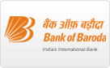



5. Reviews of Literature/ Theoretical Background

5.1 Review of the annual report of the IRDA
The Indian economy continued to exhibit robust growth even though global economy experienced many uncertainties. The real GDP growth emanating from the industry and services sector declined slightly during 2008-09. The continued acceleration in saving and investment rates and sustained productive growth were the underpinnings of the growth momentum in the Indian economy during 2008-09. The real GDP growth in 2008-09 though high at 9 per cent was lower than the 9.6 per cent recorded in 2007-08. Services sector continued to grow at double digit level. The deceleration in the industry sector was also reflected in the Index of Industrial Production. Gross domestic savings as per cent of GDP at current market prices increased from 34.3 per cent in 2005-06 to 34.8 per cent in 2007-08 contributed mainly by increase in the savings of private corporate sector and the public sector.

The saving preference of the households had slightly shifted away from the bank deposits in 2008-09 from that of 2007-08.According to the preliminary estimates released by RBI on household financial savings for 2008-09, insurance funds constituted 17.5 per cent of the total gross financial savings of the households in 2008-09. This has resulted in an increase in the share of insurance funds in the total household savings. The above shift in the preferences towards insurance sector was mainly on account of the households preferring to invest in Unit Linked Insurance Products (ULIPs) of life insurers in the back ground of bullish stock market as the returns of a part of ULIPs depend on the behavior of the stock market. It may be noted that during 2008-09, the BSE Sensex has shown abnormally high levels and the gains were across all sectors of the index.

The outlook for the emerging economies remains positive ,but uncertainties about their resilience to the global shocks have increased. Industrial production and export volumes have slowed down. While equity markets have fallen sharply in tandem with those in advanced economies, bond spreads have widened. The international financial system is

gripped by extreme risk aversion in the wake of spectacular failures of among the world’s largest financial institutions. With optimism in stock markets, while investors are willing to take risks and prepared to bear investment risks by opting for ULIPs, with the financial crises across the globe and melt down in the stock markets, the sentiments of the investors may turn the other way and many would like to invest their surpluses in safe and traditional financial instruments rather than take risks. As such, the preference will be shifted away from ULIPs and life insurers may have to design traditional products with good incentives. As such, the growth in life insurance business in near future may not be as robust as it
was so far.

In the recent past, insurance companies have gone aggressively on branch expansion and added technical manpower. The associated costs due to those are high and companies may find it difficult to sustain with high costs and low premiums. With slow down in the economic growth, the personal disposable incomes will be lower thus affecting the savings and investment. The slowdown in the industry and lower investments in the private corporate sector leads to lower asset formation.

Performance in the first quarter of 2009-10

5.1.1 Life insurance:
The life insurers underwrote a premium of Rs.14320.20 crore during the first quarter in the current financial year as against Rs.12511.80 crore in the comparable period of last year recording a growth of 14.45 per cent. Of the total premium underwritten, LIC accounted for Rs.7524.56 crore and the private insurers accounted for Rs. 6795.64 crore. The premium underwritten by LIC declined by 12.31 per cent while, that of private insurers increased by 72.88 per cent, over the corresponding period in the previous year. The number of policies written at the industry level declined by 7.78 per cent. While the number of policies written by LIC declined by 23.36 per cent, in the case of private insurers they grew by 44.00per cent. The market share of LIC was 52.55 per cent in the total premium collection and 63.88 per cent in number of polices underwritten, lower than 68.58 percent and 76.87 per cent respectively reported in the previous year.

5.1.2 Non-Life Insurers
During the first quarter of current financial year, the non-life insurers underwrote a premium of Rs.8778.18 crore recording a growth of 17.85 per cent over Rs.7448.74 crore underwritten in the same period of last year. The private non-life insures witnessed higher growth of 22.43 per cent by underwriting premium to the tune of Rs.3541.78 crore as against Rs.2892.89 crore underwritten in the same quarter of the last year. The public non-life insurers underwrote a premium of Rs.5236.40 crore, higher by 14.94 per cent in the first quarter of 2007-08. The market shares of public and private insurers were 59.65 and 40.35 per cent respectively.
Segment-wise, the premium underwritten in the Fire, Marine, Motor, Health and
Miscellaneous segments by the non-life insurers were Rs.1208.15 crore, Rs.572.99 crore, Rs.3624.23crore, Rs.1772.57 crore and Rs.1600.24 crore respectively.

The Health segment recorded the highest growth (49.67 per cent) in the first quarter of the current financial year over the corresponding quarter of 2007-08. The Fire segment witnessed
negative growth (-13.80 per cent) over in the same period. In terms of number of policies, Fire and Marine, recorded negative growth rates (-5.14 per cent and -4.37 percent respectively) over the one year period. In the Motor segment, the public insurers witnessed positive growth rate (23.09 percent) in the premium underwritten despite issuing lesser number of policies.
The premium collection in the Health segment went up toRs.1772.57 in the first quarter of the current year, constituting for 20.19 per cent in the total premium.

5.2 Review of the conference held in Pune in 2009 by IAOI
The conference held in Pune in 2009 by IAOI to discuss the current issue in life insurance. In the conference following issue has been discussed:-

5.2.1 Distribution
For the continued growth of the industry distribution is the key. The nature, efficiency, reach, cost and mix of distribution are vital and they pose some of the difficult challenges today. The various distribution channels for life insurance product are:-

5.2.1.1 Individual Agent

As in other areas, India tends to keep close to tradition. For a long time, individual agent has been the main, and often the only, distributor of life insurance. Every new insurer has had to build this as the dominant channel for distributing life insurance products despite realization that agency channel has major drawbacks and inefficiencies. The total number of agents now is reported to be more than 18, 00,000 and recruitment is going apace as if there is no tomorrow! Issues relating to recruitment in large numbers, pre-recruitment training, examination, productivity, attrition, acquisition costs, selling practices etc. have been issues discussed often at the Council and with the regulator. The industry view is that stipulations regarding the compulsory minimum number of hours of training at an approved institute followed by examination did not seem to add value and the matter of training leading to examination should be left to insurers. Competition would ensure good training because ill-equipped agency force in any company would hurt their growth and well-being. Industry view is that the desired purpose of professionalization of distributors would be achieved through strict monitoring of examinations without having to go through a stipulated number of hours of class-room training.

5.2.1.2Bancassurance and Corporate Agent:

Insurers have entered into arrangements with corporate distributors through ‘corporate agency’ contracts. The so-called bancassurance too works more or less through this model because the Bank is appointed as a corporate agent. IRDA had issued some sound guidelines particularly to ensure that a corporate employee involved in selling is trained as a normal agent would be and followed good selling practices. There have been reports of up-front payments to a corporate agent towards reimbursement of expenses, servicing charges etc. Rationalization is needed keeping in view the realities on ground. On banks selling insurance there are differing reports as to whether the sales are concluded by banks’ representatives or insurers’ representatives while the bank just provides the lead, platform and persuasion. Ideally banks’ representatives, duly trained, should be conducting and concluding the sale. This may yet happen.

5.2.2Awareness of life insurance

It has been argued that insurers advertise their services and products and in the process increase awareness. This statement is partly true. There is a need to create a broader awareness about life insurance in all geographic areas in India through specific collective campaigns. This is an important precondition to developing insurance and increasing penetration. The Council has taken up a project to do this and significantly IRDA has agreed to give all support including financial support. It may not be correct to assume that awareness is lacking only in rural areas, small towns and among the less educated persons. Even in urban areas a vast segment of persons seem to have erroneous perception or impression which needs to be corrected. Negative awareness, such as that based on misinformation by competition desiring to increase their share in the domestic savings pie, needs early attention at industry level. Here again the Council has initiated some measures that will address this long-term issue.

5.2.3Manpower

It is perhaps true that no promoter expected such consistently high growth for nearly three years running. Plans have had to be redrawn. This growth involved marshalling additional resources in terms of capital, infrastructure and above all human resources. With surge in demand for quality human resources at all levels, compensations have increased substantially. Companies are very active at campus recruitments. All those who complete an MBA are reported to find good placements irrespective of the stature or rank of the institution. Apart from general candidates at entry level there is also severe shortage of specialists such as actuaries, accounting and financial executives, legal personnel, HR executives etc. For the candidates, while compensation is perhaps the key differentiator, factors such as standing, reputation, rank in the industry, HR environment etc too are significant factors in decision-making. Companies are finding innovative ways to retain trained staff. This situation has encouraged several institutions to offer short-term professional courses in Actuarial Science, Finance and Accounts, HR etc. Many institutions and universities have started special courses in Insurance and Risk Management. It is necessary for leaders of the industry to assist and promote institutions of learning in all areas of insurance so that companies get employees with some knowledge and familiarity. This will reduce learning-time at work.

It is to be examined whether for entry level positions in insurance a degree or a post-graduate degree is an absolute necessity. As a good number of school-leavers may not be able or willing to pursue higher studies, companies could consider recruitment at ‘plus two’ levels, give a short training and deploy. This approach will give quick access to a very large pool of persons and it could be an important initiative.

6. Research Methodology

Research can be defined as systematized effort to gain knowledge. A research is carried out by different methodology, which has their own pros and cons.

Research methodology is a way to solve research problem along with the logic behind them. Thus when we talk of the research methodology we not only take of research method but also context of our research study and explain why we are using a particular method or techniques and why we are not using other so that research result are capable of being evaluated either by the researchers himself or by others.

Research methodology means the method carried out to study the problem. It shows the type of the sample design used, its size and the procedure used to dew sample. The extent of precision achieved and the method used for handling any special problem during the course of the study.

Research methodology has following steps:

Step: 1 To decide the objective of the study.
Step: 2 To design research design.
Step: 3 To determine the source of data.
Step: 4 To design data collection form.
Step: 5 To determine sample size and sample design.
Step: 6 To organize and conduct fieldwork.
Step: 7 To process and analyze the collected data.
Step: 8 To prepare the research report.

6.1.1Type of research design
A research design serves as a bridge to reduce the gap between the research objective, which has been established and what has to been done to, as a part of the study in order to realize those objective. There are three types of research:

Descriptive research design
Experimental research design
Quasi- experimental

DESCRIPTIVE RESEARCH
Descriptive research is used to obtain information concerning the current status of the phenomena to describe "what exists" with respect to variables or conditions in a situation.

Descriptive Research Methods

Case Studies
Detailed analysis of a single (or limited number) of people or events. Case studies are usually interesting because of the unusualness of the case .The major problem with case studies is the problem of objectivity. The person who is presenting the case usually has some theoretical orientation. It is acceptable for a theoretical orientation to affect one’s interpretation of events. In a case study the theoretical orientation can also lead to the selection of the facts to include in the case. It is not surprising that case studies often seem to provide very compelling evidence for a theory.
Case studies can therefore assist psychology by illustrating how a theory could be applied to a person or events and by assisting with the development of hypotheses for more systematic testing.

Observational Research
Accounts of the natural behavior of individuals or groups in some setting. Unless the observation is unobtrusive, there may be some subject reactivity to being observed. This often decreases with time, a process called habituation. Observers cannot usually observe all behaviors all of the time. They may use a behavioral checklist and may also use time sampling or event sampling procedures. It is important to assess observer bias by the use of interobserver reliability. Observational research may also pose ethical problems. These can arise when the behaviors being observed are not public behaviors and when the observer joins a group in order to observe the members’ behavior – participant observation.

Survey Research
Structured questions to assess peoples beliefs, attitudes, and self-reports of behavior. If the researcher wishes to generalize the responses to a population, it is important to have a representative sample. Surveys that rely on self-selection (respond if you are interested) produce non-generalizable results. Surveys also provide information for co relational research. One can correlate responses to some questions (often demographic questions) with responses to other questions (often attitudes or reports of behavior). Survey question must be clear and unambiguous. Even if the questions are unambiguous and non-leading, people may display a social desirability bias and give positive or socially acceptable and desirable answers. Survey methods include: (1) the interview or face-to-face method which is generally viewed as the best method for obtaining a high rate of responses but is also very costly; (2) phone surveys, which are less expensive but have a higher non-response rate (which has probably increased with caller ID); and (3) written or mail surveys, which are least expensive but have a very high non-response rate. Follow-up messages can help increase the response rate.

Archival Research
Analysis of pre-existing data or records. Archival research often involves content analysis, a qualitative analysis of material. For example, one would use content analysis to determine whether there had been an increase in the frequency with which women and minorities were mentioned in US history books between 1920 and 2000. Some archival research is quasi-experimental.

I selected the survey research method of descriptive research to conduct my market research because my objective of research is to measure current status of the phenomena i.e. awareness and willingness among people to become FC for the company.

6.1.3 Data type
Data source are the data resources or collection of fresh and data to obtain results. There are two types of data sources: thus happen to be original in character.

Primary Data: Primary data is that which is collected fresh and thus happen to be original in character.

Secondary data: Secondary data is any data, which have been gathered earlier for some other purpose.
Among the above mentioned types of data primary data was used for the study and analysis of the objective of this project, Also the secondary data proved to be helping hand in framing up the industry scenario and also the relevant topics in the entire project report.

Reason for selecting primary data:
In terms of primary data structure questionnaire was prepared to interview the professional, unemployed students, housewives, investment consultant, and other in Raipur and Bilaspur location. Analysis clearly reflected the views and preference regarding the perception of the people towards joining HDFC standard life.

6.1.4 Data Collection tools
There are two types of mode to collect the data:-
- Observation method.
- Survey method.
As for as the data collection method for this project is concerned, designing the data collection forms or survey forms is applicable to the project. The method selected is survey method. A survey can be conducted by doing personal interview with the people

Amongst the above method personal interview method was conducted to gather information in detail. This method was chosen because along with the study of projects primary objective i.e. study of perception and willingness of people and convince them to join as FC for HDFC standard life.

6.1.5 Sampling plan
Sampling plan includes the following:-

6.1.5.1 Sampling frame
Sampling frame of the project is Noida

6.1.5.2 Unit
The sample unit includes professionals, unemployed student, Housewives, investment consultant, post office agent. The age of the respondent is more than 18 years.

6.1.5.3 Size

Sample size of the project is 100 respondent.

6.1.5.4Method
There are two methods to collect data
A. Probability samples
- Simple random sample- Every member of the population has an equal chance of selection.

- Stratified random sample- The population is divided in mutually exclusive group (such as age group)and random sample are drawn from each group.

- Cluster Sample- The population is divided in mutually exclusive group(such as city block) and random sample are drawn a sample of the group to interview.

B. Non probability Sample

- Convenience sample -The researcher selects the most accessible population members.

- Judgment sample - The researcher selects the population members who are good prospects for accurate information.

- Quota sample- The researcher finds and interviews a prescribed number of people in each of several categories.

From the above sample method I use is non probability sample method and I use the convenience sample for collecting data for my project because my project guide in the company ask me to meet those people who I know and I get the questionnaire filled by them to achieve my project objective.

7.Data Analysis , Results and Interpretation

Question.7.1 You belong to which age group?

Age Group | Respondent | Percentage
18-25 | 17 | 17%
26-40 | 51 | 51%
40 & Above | 32 | 32%
Total | 100 | 100.0
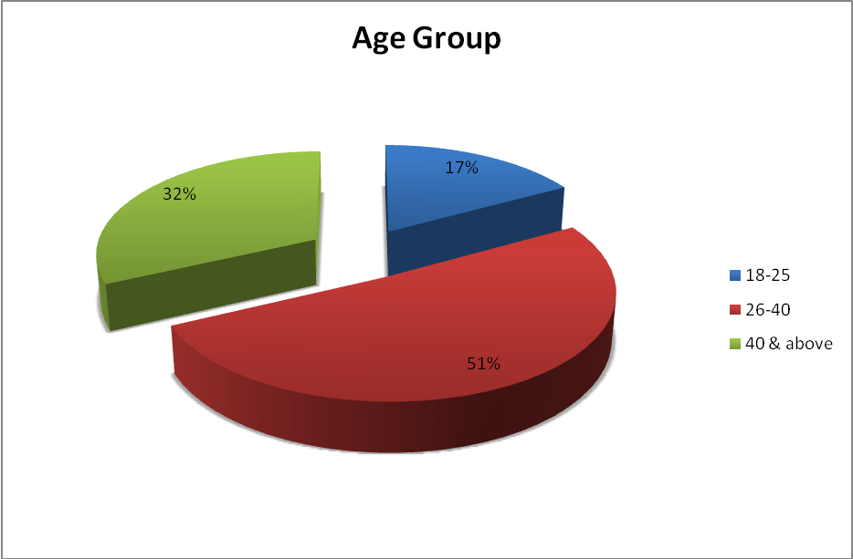

Interpretation
The objective of the question is to know the age group from which respondent are.

- 51% of the respondents are from age group of 26-40 years
- 32% of the respondents are from age group of 40 years and above
- 17% of the respondents are from age group of 18-25 years.

Question 7.2 What is your Occupation?

Occupation | Frequency | Percent
Business | 41 | 41%
Service | 43 | 43%
Profession | 16 | 16%

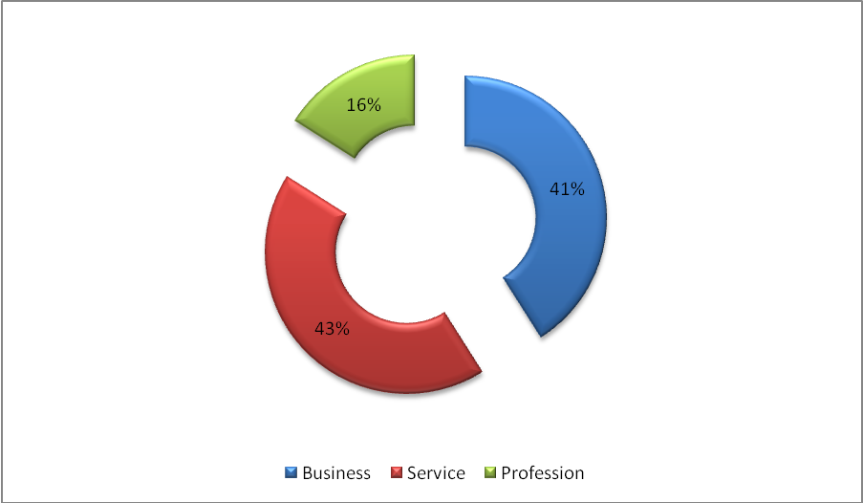

Interpretation: 43% of the respondent is belonging to service class, 16% of them is professional and 41% is having their own business.

Question.7.3What is your perception about insurance sector?

Perception about insurance sector
Perception | Frequency | Percent
hard and profitable | 49 | 49.0%
hard but not rewarding | 22 | 22.0%
smooth and rewarding | 8 | 8.0%
no idea | 21 | 21.0%
Total | 100 | 100.0%
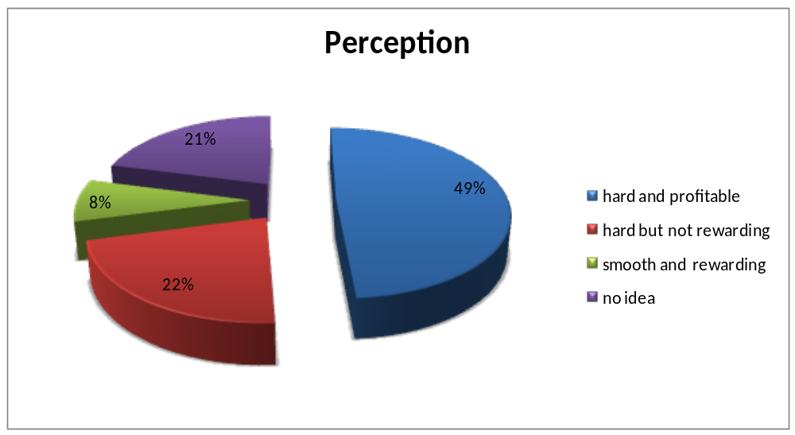

Interpretation
The purpose of asking this question is to know the perception of people towards insurance sector. What thinking they have about the industry as career opportunity.
49% of the people think that the sector is hard and profitable, 22% think that the sector is hard but not rewarding, 21% have no idea about the sector, 8% think that it is smooth and rewarding.

Question.7.4Do you know about HDFC SLIC recruitment policies related to financial consultant?

Awareness about HDFC-SLIC
 | Reply | Frequency |  | Percent
 | Yes | 12 |  | 12.0%
 | No | 88 |  | 88.0%
 | Total | 100 |  | 100.0%

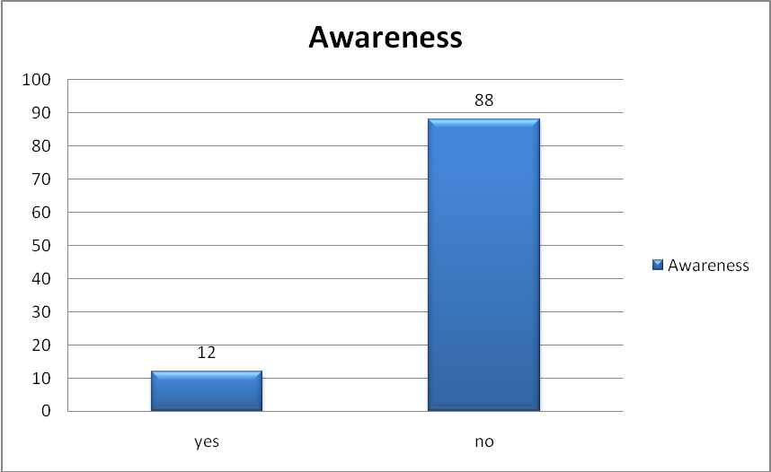

Interpretation
The purpose of asking this question is to know the awareness among people about the recruitment policy of HDFC SLIC related to financial consultant. The survey shows that only 12% of the respondents know about the policy rest 88% are unaware about the opportunity of becoming FC of the company. They are also unaware about the benefit of doing this job as a part time.

Question.7.5Will you be interested to become financial consultant?

Interested to join | Frequency | Percent
Yes | 9 | 9.0%
No | 91 | 91.0%
Total | 100 | 100.0%

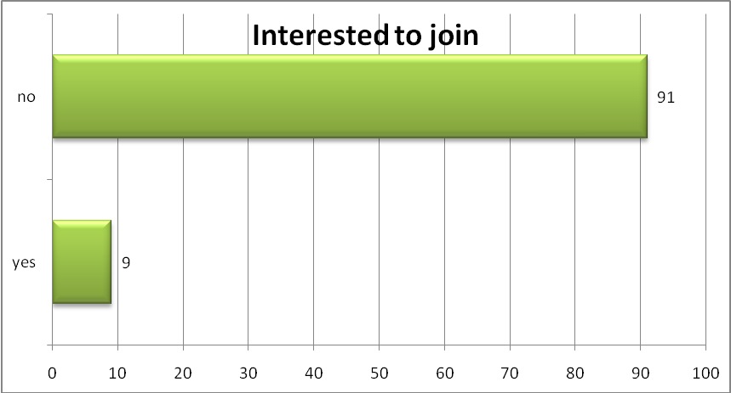

Interpretation
The purpose to ask this question is to know the willingness among people to become FC for the company.
91 % people said that they don’t have interest to become financial consultant for the company. Only 9% of the people show their interest to become FC for the company.

Question.7.6 If No, what is the reason of not joining HDFC STANDARD LIFE?
Reason for not joining HDFC SLIC | Frequency | Percent
- No time | 24 | 24.0%
- Lack of interest | 24 | 24.0%
- Satisfied with current job | 37 | 37.0%
- Other | 8 | 8.0%
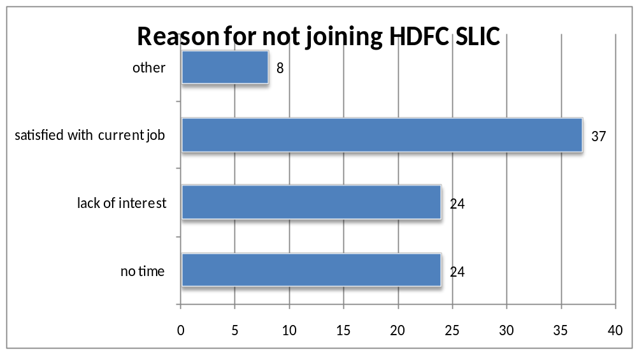

Interpretation
The purpose of asking this question is to know the reason why they don’t want to join HDFC SLIC as FC.
37% of the respondent said that they are satisfied with their current job and 24% said that they don’t have time or have lack of interest to do this job.

Question 7.7Do you hold any license of any insurance company?
License of any insurance company | Frequency | Percent
Yes | 11 | 11.0%
No | 89 | 89.0%
Total | 100 | 100.0%

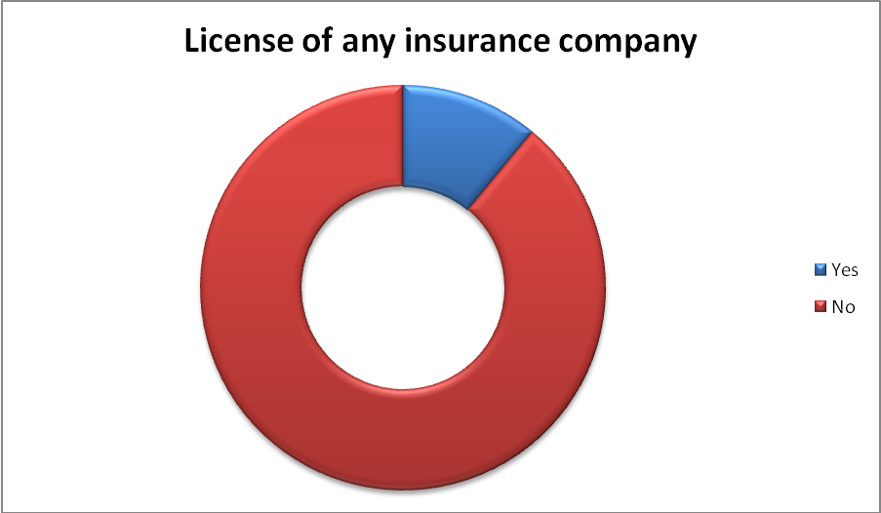

Interpretation: The objective of asking this question is to know if any respondent have insurance agency, which help company to know its rival. 11% of the respondent have insurance agency out of which 64% have agency of LIC.

7.2 FINDINGS

- People are very less aware about the recruitment policy of HDFC SLIC related to FC.

- People are less interested to join HDFC SLIC as FC.

- The respondent between age group 26-40 years gives the reason of not joining HDFC SLIC is they are satisfied with their current job.

- The respondent between 18-25 years has perception that although it is a profitable venture, but selling insurance policy is very hard, in term of convincing people.

- Overall the perception of respondent for insurance sector as career opportunity is hard and profitable.

- Out of 100 respondent 11 respondent has already have agency of life insurance company, out of which 7 have agency of LIC.

- 23% respondent said that they will prefer to become advisor for LIC as compare to other private company.

8. CONCLUSIONS

HDFC Standard Life, the insurance arm of HDFC is expected to go on flow. Promoted by HDFC & Standard Life, already has good number of employees on board and is recruiting Financial Consultants heavily to take the headcount to many more. It is on the edge of increasing its client through its attractive schemes and offer.

The project opportunities provided was market segmentation and identifying prospective clients in potential geographical location and for recruiting them as financial consultant so to explore new Business Opportunity. Through this project, it could be concluded that people are not much aware about the various benefit of being Financial Consultant that are currently prevailing in the insurance industry. Although some of them show interest in becoming FC for the company after knowing about its various benefits like good commission structure, gifts and trips within the country or abroad, felicitations of star performer program etc. So company should make people aware about the benefits they are giving to FC, to attract the prospect and meet their expectation to retain them according to their performance.

9. Limitation of the Project

Every work has its own limitation. Limitations are extent to which the process should not exceed. Limitations of this project are:-

- The project was constrained by time limit of two months.

- Mindset of people may vary depending upon their age, gender, income etc.

- Getting appointment from the concern person was very difficult.

- People mind set about the survey was an obstacle in acquiring complete information & positive interaction.

- Respondents were very busy in their schedule. So it was very time taken in every Questionnaire response by them.

10. RECOMMENDATIONS

- The company should advertise its recruitment policy related to FC in the newspaper specially the in employment newspaper.

- The company should promote FC as employment opportunity among the people who is not much educated especially in rural area.

- The company should revised its eligibility criteria that they have made for FC they should target the unemployed youth as FC for the company.

- Free life cover for every active Financial Consultant.

- Company should organize the program in the society, so that people will be aware about the company

- Customers should be made aware of the brand name of Insurance Company through regular advertisement. Which in turn help FC to sell policies.

11.Abbreviations

HDFC- Housing development and Finance Corporation
SLIC- Standard Life Insurance Company
IRDA- Insurance Regulatory and Development Authority
FC- Financial Consultant
IAOI-Institute of Actuaries of India

12.Bibliography

Books References:
- Market Research Textbook by G.C.Berry
- Marketing Management by Philip Kotler

Websites:
- www.irda.com
- www.hdfcinsurance.com
- www.wikipedia.com

Report:
- Annual report of IRDA 2009 - 2010

13. ANNEXTURE
Questionnaire
A research to know awareness and willingness among people to become FINANCIAL CONSULTANT for HDFC SLIC
Dear Sir/Madam,
I am BBA student of Maharaja Agrasen Institute Of Management Studies and presently doing a summer project in “MARKET RESEARCH ON FINANCIAL CONSULTANTS FOR HDFC SLIC”. I request you to kindly fill the questionnaire below and I assure you that the data generated shall be kept confidential.

1. You belong to which age group? (Tick any one)
18-25 | 26-40 | 40 & Above

2. What is your Education Qualification? (Tick any one)
Undergraduate | Graduate | Post graduate

3. What is your Occupation? (Tick any one)
Business | Profession | Service
(Please mention the type of business/profession you are in incase of service please mention your organization name and designation in the space below)

4. What is your annual household income? (Tick any one)
A | Less than 2 lack
B | Between 2 to 5 lack
C | Between 5 to 8 lack
D | More than 8 lack

5. Are you a member of a club?
Yes □ No □
If yes, Name of the club_______________________________________

6. What is your perception about insurance sector?
- Hard & profitable □
- Hard but not rewarding □
- Smooth &rewarding □
- No idea □

7. Do you know about HDFC SLIC?
Yes □ No □

8. Do you hold any license of any insurance company?
Yes □ No □

If yes, please specify which company________________________________________

9. Are you satisfied with the company?
Yes □ No □

10. Do you know about HDFC SLIC recruitment policies related to financial consultant?
Yes □ No □

11. Will you be interested to become financial consultant?
Yes □ No □

12. Would you like to earn an additional income through a business opportunity with HDFC STANDARD LIFE?
YES □ NO □

13. If No what is the reason of not joining HDFC STANDARD LIFE?
NO TIME□ Lack of interest □ Satisfied with current job □ Other□__________________________ (please specify)

14. If yes, how many hours in a week can you commit for this business opportunity?

Name: …………………………………………………………………………………………………………………………
Address: ………………………………………………………………………………………………………………
Contact No…………………………………………………………………………………………………………….

Date: Signature

Thank You

