A

PROJECT REPORT ON

“COMPARATIVE ANALYSIS OF CUSTOMER BEHAVIOUR IN STANDARD CHARTERED BANK & BARCLAYS BANK”

Submitted in partial fulfillment of the requirements
for the award of the Degree of

Bachelor of Business Administration BBA (B&I)

To

Guru Gobind Singh Indraprastha University, Delhi



Guide: Submitted by:
Ms. Parul Paliwal Gitesh Arora
0082051808

BLS INSTITUTE OF TECHNOLOGY MANAGEMENT
Delhi- Rohtak Road, NH-10, Jakhoda, Bahadurgarh -124507
Batch (2008-2011)

DECLARATION

I, Mr. Gitesh Arora, Roll No. 0082051808 certify that the Project Report entitled “COMPARATIVE ANALYSIS OF CUSTOMER BEHAVIOUR INSTANDARD CHARTERED BANK & BARCLAYS BANK” is done by me and it is an authentic work carried out by me. To the best of my knowledge and belief, the material embodied in this Report has not been submitted earlier for the award of any Degree or Diploma by any University or Institution.

Signature of the Student
Date:

CERTIFICATE

Certified that the Project Report entitled “STUDY ON COMPARATIVE ANALYSIS OF STANDARD CHARTERED BANK WITH BARCLAYS BANK ON CONSUMER BEHAVIOUR IN STANDARD CHARTERED BANK” done by Mr. Gitesh Arora, Roll -No. 0082051808 has been completed under my guidance and supervision.

Date : Signature Of The Guide
Name Of The Guide :
Designation

Countersigned

Director

TABLE OF CONTENTS

S NO. | CONTENTS | PAGE NO.
1 | CHAPTER–1 INTRODUCTION  - INDUSTRY PROFILE | 5-18
2 | CHAPTER–2 PURPOSE OF STUDY  - OBJECTIVE OF STUDY  - SCOPE OF THE STUDY | 20  21
3 | CHAPTER-3 COMPANY PROFILE | 23-28
4 | CHAPTER-4 LITERATURE REVIEW | 29-32
5. | CHAPTER-5 RESEARCH METHODOLOGY  - RESEARCH DESIGN  - DATA COLLECTION  - SAMPLE SIZE  - ANALYSIS AND INTERPRETATION | 33-42
6. | CHAPTER-6 FINDINGS | 43-58
7 | CHAPTER-7 LIMITATIONS | 59-60
8 | CHAPTER-8 CONLCUSIONS AND RECOMMENDATIONS | 61-65
9 | BIBLIOGRAPHY | 66
10 | ANNEXURE | 67-70

CHAPTER-1
INTRODUCTION

INDUSTRY PROFILE
INTRODUCTION
Banking is a customer oriented service industry, where the customer is in focus and the lifeblood of a banker business .The main objective of the banker therefore, is to create, cultivate and retain customer. Financial institutions like banks are intermediaries as they raise funds from those who have surplus and lend it to those who need them to meet their financial needs. Hence banks serve as a link between those who want to save and those who want to invest. Financial services constitute an integral part of the infrastructure required for rapid industrial and agricultural development. Improved Functioning of the banking industry may result in the overall improvement of the economy. What is common between a game of football & good management? In football it is important to mobilize the energy of the players to score as well as defend goals. In a bank it is important to mobilize the energy of all the employees to develop the bank and its team.
Banking industry has been going through a process of transformation during last many years. This is evident from the changes occurred in the financial markets, institution and products. The process of liberalization, deregulation and globalization started in 1991 has open up new vistas for banks to augment revenues. It has brought about greater risks and stiffer competition. Earlier banking was a monopoly of Public sectors Banks with full protection from state. Before nationalization of banks, the facilities of banking were available to only a select few, mainly in major cities and towns. Smaller banking network meant less number of branches and therefore, lesser number of employees as such the branches could directly interact with the Head Office resulting in a feeling of belongingness to the institution.
Banking business has a history of over 200 years. From the times of the Bank of Bengal (1806) the sector has been witnessing qualitative and quantitative changes. Main players during the pre-independence period were Credit Lyonnais, Allahabad Bank, Punjab National Bank and Bank of India. With 1935 regulation the Reserve Bank of India was proclaimed the Central Bank of India and was vested with controlling powers over the commercial banks.
The drastic development taken place during the first 25 years since independence was Nationalization of many private banks.
With this, the central government became major policy maker for these nationalized banks. With economic liberalization measures many private and foreign banking companies were allowed to operate in the country. Favourable economic climate and a variety of other factors such as demand for wide range of financial products from various sections of the society led to mutually beneficial growth to the banking sector and economic growth process. This was coincided by technology development in the banking operations. Today most of the Indian cities have networked banking facility as well as Internet banking facility. A customer is empowered to operate his account from any part of the country. UTI Bank, ICICI, HDFC Bank and Bank of Punjab are the main winners of the race.
With the Indian economy moving on to a high growth trajectory, consumption levels soaring and investment riding high, the Indian banking sector is at a watershed. Further, as Indian companies globalise and people of Indian origin increase their investment in India, several Indian banks are pursuing global strategies.
GROWTH
A burgeoning economy, financial sector reforms, rising foreign investment, favourable regulatory climate and demographic profile has led to India becoming one of the fastest growing banking market in the world. The overall banking industry's business grew at a CAGR of about 20 per cent from US$ 469.4 billion as of March 2002, to US$ 1171.29 billion by March 2008.
Aggregate bank deposits of banks increased by US$ 129.26 billion (22.1 per cent) at the end of March 2008 over the corresponding in 2007. It further increased by 21.2 per cent to US$ 161.47 billion as at end-March 2009 over the corresponding period in 2008. While aggregate demand deposits increased by 19.2 per cent, aggregate time deposits increased by 21.6 per cent in the same period, indicating migration from small savings schemes of the Government.

Similarly, aggregate deposits of the scheduled commercial banks (SCB) grew by 17.8 per cent and 24.6 per cent in 2006-07 and 2007-08. In 2008-09, aggregate deposits of SCBs have increased by 22.2 per cent in absolute terms to US$ 136.55 billion, against US$ 118.30 billion in 2007-08.
Simultaneously, loans and advances of SCBs rose by over 30 per cent (i.e. 33.2 per cent in 2005-06, 31.8 per cent in 2006-07 and 30.6 per cent in 2007-08) in the last three financial years, underpinned by the robust macroeconomic performance. The growth has continued in the current fiscal with non-food credit by SCBs increasing by 22.3 per cent, year-on-year, as on March 31, 2009.
Significantly, the asset quality of the banks has also improved over this period. The gross non-performing assets (NPA) as a per cent of total assets has declined from 4 per cent as of March 2002 to 1.46 per cent as of March 2008. Simultaneously, the capital adequacy ratio of all SCBs has improved from 11.1 per cent as of March 2002 to 12.3 per cent by March 2008.
Also, the banking sector has been doing exceedingly well on the financial front. For example, in the quarter ended March 2009, while the interest income of the 18 public sector banks and seven private banks rose by 28.4 per cent, the net profit rose at much higher rate of 33.61 per cent.
THE 2009–10 FISCAL YEAR
With the economy continuing to grow at a rapid rate, the Indian banking industry has also continued its growth story. According to the Reserve Bank of India (RBI), credit extended by the Indian banking sector grew by 25.3 per cent at the end of May 23, 2009, with the outstanding credit estimated at US$ 551.6 billion.
Banks have disbursed US$ 3.71 billion of advances between April 1 and May 23, 2009 compared to a decline of US$ 11.07 billion in the corresponding period last year.
Simultaneously, deposits have recorded a year-on-year growth of 23.2 per cent to US$ 754.61 billion as on May 23, 2009. There has been an increase of US$ 10.02 billion in deposits of the Indian banking system between April1 to May 23, 2009 compared to a decline of US$ 317.86 million in the corresponding period last year.

INDIAN FINANCIAL SECTORS

Indian Financial Sector

Development Banking Banking Institutions Non Banking
Financial

Cooperative Banks Commercial Banks Regional
Rural Banks

Nationalized Banks Private Banks Foreign Banks
Eg. SBI Eg. Indus Ind Bank Eg. ANZ Grindlays

PLAYERS IN THE MARKET:
The players have been classified on the basis on three main constituents, as is evident from the industry structure, viz. the public sector banks, the foreign banks and the private sector banks. The banking segment in India functions under the umbrella of Reserve Bank of India – the regulatory, central bank. This segment broadly consists of:
Commercial banks
Co-operative banks

A. Commercial banks:
The commercial banking structure in India consists of:
Scheduled Commercial Banks
Unscheduled banks
Scheduled commercial banks constitute those banks which have been included in the Second Schedule of Reserve Bank of India (RBI) Act, 1934. RBI in turn includes only those banks in this schedule which satisfy the criteria laid down vide section 42((60 of the Act). Some co-operative banks are scheduled commercial albeit not all co-operative banks are. Being a part of the second schedule confers some benefits to the banks in terms of access to accommodation by RBI during the times of liquidity constraints. At the same time, however, this status also subjects to the fulfillment of the certain conditions and obligations towards the reserve regulations of RBI.
This sub sector can broadly be classified into:
Public sector
Private sector
Foreign banks

Public Sector Banks:
The Public Sector Banks have dominated the Indian banking scene for over three decades since the nationalization of bank since 1969. The major players are State Bank of India, Canara Bank and Corporation Bank. Public sector banks are those banks in which the government has a major stake. This control by the Government makes these banks emphasis on social objectives than on profitability.

Foreign Banks:
After the liberalization process started, a lot of foreign banks have proliferated in India, attracted by the large Indian market. The major foreign banks existing in India are Citibank, Bank of America, Standard Chartered, ANZ Grindlays, American Express Bank and Hongkong Bank. These banks have realized the potentially big market in the retail-banking sector.
Private Banks:
In the first phase of financial reforms in 1991, a major recommendation was to allow the entry of private players in the banking sector. This was done to compete with the foreign banks on near equal footing since public sector banks were in bad shape and burdened with fulfilling social objectives. Many of these private banks were promoted by financial institutions like IDBI, ICICI HDFC etc. In a way, the banking sector was also because these financial institutions could then mobilize deposits at lower cost through the retail sector.
Earlier, the Government used to provide these institutions loans at subsidized rate, so that they could match their medium and long-term assets. These subsidized loans had stopped and therefore the Government had to give these institutions some kind of sops as compensation. Private sector entities and banking professionals have also been permitted to setup their own banks, though getting licenses is still very difficult. Though the regulations and policies for this sector are not very concrete till now, the players that have entered the scene are UTI, Indusind, ICICI, HDFC and Centurion.
B. Co-operative Banks:
There are two main categories of the co-operative banks:
Short-term lending oriented co-operative banks – within this category there are three sub categories of banks viz. State co-operative banks, District co-operative banks and Primary Agricultural co-operative societies.
Long term lending oriented co-operative Banks – within the second category there are land development banks at three levels, state level, district level, and village level.

Details of Foreign, Private and PSU Bank’s Market Share (%)
Banks | 31/03/2006 | 31/03/2007 | 31/03/2008
Foreign Banks | 34.13 | 39.41 | 52.00
ICICI Bank | 2.66 | 5.67 | 11.00
SBI-GE | 6.00 | 9.03 | 13.00
Others | 5.86 | 5.57 | 24.00

CONSUMER BEHAVIOUR
Consumer behaviour (in consumer business context) referred to as the study of when, why, how, where and what people do or do not buy products. It blends elements from psychology, sociology, social psychology, anthropology and economics. It attempts to understand the buyer decision making process, both individually and in groups. It studies characteristics of individual consumers such as demographics and behavioural variables in an attempt to understand people's wants. It also tries to assess influences on the consumer from groups such as family, friends, reference groups, and society in general. Customer behaviour study is based on consumer buying behaviour, with the customer playing the three distinct roles of user, payer and buyer. Relationship marketing is an influential asset for customer behaviour analysis as it has a keen interest in the re-discovery of the true meaning of marketing through the re-affirmation of the importance of the customer or buyer. A greater importance is also placed on consumer retention, customer relationship management, personalisation, customisation and one-to-one marketing. Social functions can be categorized into social choice and welfare functions. Each method for vote counting is assumed as a social function but if Arrow’s possibility theorem is used for a social function, social welfare function is achieved. Some specifications of the social functions are decisiveness, neutrality, anonymity, monotonocity, unanimity, homogeneity and weak and strong Pareto optimality. No social choice function meets these requirements in an ordinal scale simultaneously. The most important characteristic of a social function is identification of the interactive effect of alternatives and creating a logical relation with the ranks. Marketing provides services in order to satisfy customers. With that in mind, the productive system is considered from its beginning at the production level, to the end of the cycle, the consumer.
Belch and Belch define consumer behaviour as 'the process and activities people engage in when searching for, selecting, purchasing, using, evaluating, and disposing of products and services so as to satisfy their needs and desires'.'

Black box model
ENVIRONMENTAL FACTORS |  | BUYER'S BLACK BOX |  | BUYER'S RESPONSE
Marketing Stimuli | Environmental Stimuli | Buyer Characteristics | Decision Process | BUYER'S RESPONSE
Product  Price  Place  Promotion | Economic  Technical  Political  Cultural | Attitudes  Motivation  Perceptions  Personality  Lifestyle | Problem recognition  Information search  Alternative evaluation  Purchase decision  Post-purchase behaviour | Product choice  Brand choice  Dealer choice  Purchase timing  Purchase amount

The black box model shows the interaction of stimuli, consumer characteristics, decision process and consumer responses.^{[1]} It can be distinguished between interpersonal stimuli (between people) or intrapersonal stimuli (within people).^{[2]} The black box model is related to the black box theory of behaviourism, where the focus is not set on the processes inside a consumer, but the relation between the stimuli and the response of the consumer. The marketing stimuli are planned and processed by the companies, whereas the environmental stimuli are given by social factors, based on the economical, political and cultural circumstances of a society. The buyers’ black box contains the buyer characteristics and the decision process, which determines the buyers’ response.

The black box model considers the buyers response as a result of a conscious, rational decision process, in which it is assumed that the buyer has recognized the problem. However, in reality many decisions are not made in awareness of a determined problem by the consumer.
Information search
Once the consumer has recognized a problem, they search for information on products and services that can solve that problem. Belch and Belch (2007) explain that consumers undertake both an internal (memory) and an external search.
Sources of information include:
Personal sources
Commercial sources
Public sources
Personal experience
The relevant internal psychological process that is associated with information search is perception. Perception is defined as 'the process by which an individual receives, selects, organises, and interprets information to create a meaningful picture of the world'
The selective perception process
Stage Description
- Selective exposure consumers select which promotional messages they will expose themselves to.
- Selective attention consumers select which promotional messages they will pay attention to
- Selective comprehension consumer interpret messages in line with their beliefs, attitudes, motives and experiences
- Selective retention consumers remember messages that are more meaningful or important to them.
The implications of this process help develop an effective promotional strategy, and select which sources of information are more effective for the brand.
Information evaluation
At this time the consumer compares the brands and products that are in their evoked set. How can the marketing organization increase the likelihood that their brand is part of the consumer's evoked (consideration) set? Consumers evaluate alternatives in terms of the functional and psychological benefits that they offer. The marketing organization needs to understand what benefits consumers are seeking and therefore which attributes are most important in terms of making a decision.
Purchase decision
Once the alternatives have been evaluated, the consumer is ready to make a purchase decision. Sometimes purchase intention does not result in an actual purchase. The marketing organization must facilitate the consumer to act on their purchase intention. The provision of credit or payment terms may encourage purchase, or a sales promotion such as the opportunity to receive a premium or enter a competition may provide an incentive to buy now. The relevant internal psychological process that is associated with purchase decision is integration.
Post-purchase evaluation
It is common for customers to experience concerns after making a purchase decision. This arises from a concept that is known as “cognitive dissonance”. The customer, having bought a product, may feel that an alternative would have been preferable. In these circumstances that customer will not repurchase immediately, but is likely to switch brands next time.
To manage the post-purchase stage, it is the job of the marketing team to persuade the potential customer that the product will satisfy his or her needs. Then after having made a purchase, the customer should be encouraged that he or she has made the right decision.

Internal influences
Consumer behaviour is influenced by: demographics, psychographics (lifestyle), personality, motivation, knowledge, attitudes, beliefs, and feelings. consumer behaviour concern with consumer need consumer actions in the direction of satisfing needs leads to his behaviour behaviour of every individuals depend on thinking process
External influences
Consumer behaviour is influenced by: culture,sub-culture, locality, royalty, ethnicity, family, social class, reference groups, lifestyle, and market mix factors.

CHAPTER-2
PURPOSE OF STUDY

OBJECTIVE OF THE STUDY
The following survey was mainly done with an objective to know the state of mind of an individual who is opening an account with STANDARD CHARTERED BANK.

- Features and services that influences the customer while he / she into opening an account with a bank.
- To Study Customer perception regarding the services provided by the STANDARD CHARTERED BANK.
- To Study Consumer Behavior towards services provided by the STANDARD CHARTERED BANK.

SCOPE OF THE STUDY

The following study was done parallel when an individual or a group of individual are opening an account with the Standard chartered bank.
The study helps us to know the state of mind of an individual while he / she is opening an account with the bank.
The bank will also be benefited as the bank will come to know that what an individual expects while opening an account with Standard chartered bank and if bank is lacking in some area, what is that area and how the bank can overcome.
Banking is a very vast field, apart from the above mentioned areas there are numerous areas where one could work in the banks. There are several other departments like Legal department, Credit collection department, Human Resource department, Foreign Exchange department, etc. where research or study could have been conducted apart from the above mentioned areas. Another non - conventional area where one can work in Banking industry are in setting up of main branches and ATM’s in different parts of the country and working in the purchase department of the banks which deals with the purchases of different types goods which are required for the smooth functioning of bank.
The Legal department is concerned with the legalities involved in banking processes. Credit collection department is concerned with the collection of payments of credit cards. H.R. department is concerned with the recruitment and selection of the required workforce.

CHAPTER-3
COMPANY PROFILE

PROFILE
STANDARD CHARTERED BANK
History
Standard Chartered was formed in 1969 through a merger of two banks: The Standard Bank of British South Africa, founded in 1863, and the Chartered Bank of India, Australia and China, founded in 1853.
Both companies were keen to capitalise on the huge expansion of trade and to earn the handsome profits to be made from financing the movement of goods between Europe, Asia and Africa.

The Chartered Bank
Founded by James Wilson following the grant of a Royal Charter by Queen Victoria in 1853.
Chartered opened its first branches in Mumbai (Bombay), Kolkata and Shanghai in 1858, followed by Hong Kong and Singapore in 1859.
Traditional trade was in cotton from Mumbai (Bombay), indigo and tea from Kolkata, rice from Burma, sugar from Java, tobacco from Sumatra, hemp from Manila and silk from Yokohama.
Played a major role in the development of trade with the East which followed the opening of the Suez Canal in 1869 and the extension of the telegraph to China in 1871.
In 1957 Chartered Bank bought the Eastern Bank together with the Ionian Bank's Cyprus Branches. This established a presence in the Gulf.

The Standard Bank Founded in the Cape Province of South Africa in 1862 by John Paterson. Commenced business in Port Elizabeth, in January 1863.
Was prominent in financing the development of the diamond fields of Kimberley from 1867 and later extended its network further north to the new town of Johannesburg when gold was discovered there in 1885.
Expanded in Southern, Central and Eastern Africa and, by 1953, had 600 offices.
In 1965, it merged with the Bank of West Africa, expanding its operations into Cameroon, Gambia, Ghana, Nigeria and Sierra Leone.
From the early 1990s, Standard Chartered has focused on developing its strong franchises in Asia, Africa and the Middle East. It has concentrated on consumer, corporate and institutional banking and on the provision of treasury services - areas in which the Group had particular strength and expertise.

maintaining Accounts with STANDARD CHARTERED bank

ZERO BALANCE ACCOUNT
The Standard Chartered Zero Balance account offers you freedom from maintaining the mandatory balance in the account. Your money is now in your control.
ADVANTAGE ACCOUNT
Stay one step ahead with the Standard Chartered Advantage account. Avail of many benefits like free unlimited transactions for cash withdrawals at any banks' VISA ATMs.

SAVINGS PLUS ACCOUNT
Easy banking that encourages savings. The Standard Chartered Savings Plus account makes saving really easy with the smart sweep-out facility.
TERM DEPOSIT ACCOUNT
A term deposit is a deposit held for a contracted period of time and a contracted rate of interest. Watch your money grow at a steady pace with a Term Deposit from Standard Chartered.
DOCUMENTS REQUIRED
Documents required for opening a Standard Chartered bank Savings account:
Identity Proof (Any one):
- Passport
- Voter ID
- Driving License
- PAN Card
- Photo Ration Card
- Defense ID Card
- ID Card issued by Govt. Department / Govt. Company with date of birth

Address Proof (Any one):
- Landline or post-paid mobile / WLL telephone bill not more than 6 months old
- Bank account / Credit card statement / passbook (not more than 6 months old)

- Utility (water / electricity / gas) bill (not more than 6 months old)
- Property tax bill received from a Government department (not more than 12 months old)
- Bill issued by a co-operative housing society for monthly dues (not more than 6 months old)
- Life insurance policy (not more than a year old) or Premium renewal notice (not more than 12 months old)
- Valid registered lease deed
- Passport
- Voters Identity Card (if not provided as Identity proof)
- Driving License (if not provided as Identity proof)

Other Mandatory Documents:
- PAN Card / PAN intimation letter / GIR no. / Form 60
- One photograph of each customer

Additional Services
PHONE BANKING
As part of commitment to meeting all needs, STANDARD CHARTERED offer Phone Banking – a service that enables you to access a wealth of financial information, 24 hours a day, 7 days a week.
Through Phone Banking:
- Check your account balance

- Get details about specific transactions
- Inquire about the status of a particular checque.
- Order demand drafts
- Transfer funds amongst your linked accounts
- Get information on deposit rates, lending rates, exchange rates and bank charges.
- Access information on any of our products and services
- Call Room Service to open your account
- Make complaints and suggestions

MOBILE AND E-MAIL ALERTS
STANDARD CHARTERED always try and make life simple. ‘Mobile and E-mail Alerts’ service is designed just for that.
ATM
STANDARD CHARTERED ATMs give the freedom to conduct most of the banking transactions 24 hours a day, 365 days a year. The ATM card is and absolutely free. There are no transaction charges on the use of card. What’s more, use ATM card at any of the ATM centers across the country.
CREDIT CARD HELP-LINE
As part of commitment to meeting all needs, STANDARD CHARTERED offer the facility of calling them over the phone to access a wealth of information on credit cards, 24 hours a day, 7 days a week.

ELECTRONIC CLEARING SYSTEM
STANDARD CHARTERED introduces ECS (Electronic Clearing System), an innovative facility for busy people. With this facility, Card bill amount automatically gets debited from your savings bank account, so that customer doesn’t have to worry about the last minute payment rush. Since this entire process happens through the Reserve Bank of India’s electronic clearing mechanism, customer can enjoy the advantages of ECS.

DOORSTEP BANKING
Standard Chartered provide a unique service of doorstep banking where one don’t need to visit the branch for the withdrawal or deposit of money. The employee will themselves visit to your doorstep for making the transactions.

CHAPTER-4
REVIEW
OF
LITERATURE

LITERATURE REVIEW
The concept of marketing is not a particularly complicated or even original idea. Sayings such as ‘the customer comes first’, or ‘the customer is always right’, have been used by forward-thinking entrepreneurs throughout the ages. Based on that age-old principle, marketing is really a more formalized business orientation that has developed into a management discipline over the years.
In the retail banking industry there are four emerging consumer patterns that will shape the future. First, customers want to feel comfortable dealing with a Financial institution. Second, customers continue to thirst for financial knowledge presented in an easy to understand and personable way. Third, they want products and services delivered conveniently. Fourth, customers will reward useful relationships. The fascinating thing about each of these patterns is that they do not represent revolutionary thinking. Rather, the opportunity lies in the simple fact that no retail bank has adapted its marketing mix to address all of them adequately.
To adapt to emerging consumer patterns, banks must institute a marketing theory based on solid principles. They must build their business vision, objectives and strategies on achieving those principles.
For Standard chartered bank, in supporting the U.K. Retail Bank with the execution of its business strategy, Marketing’s role is to listen to our customers and make sure we have their needs in mind with everything we do. The better we understand consumer behavior and our marketplace, the more effectively we can help each of the Standard Chartered bank’s businesses deliver the products and marketing communications that keep us ahead of the competition.
Standard chartered bank have recently restructured the Marketing team, aligning ourselves across the Retail product areas to drive commerciality. We are now organised into six teams:
Research: supports both traditional market research and behavioural data analysis Customer Segments: manages categories of products and customer segments
Marketing Communications: handles our advertising and main in-branch promotional campaigns Response Based Marketing: manages all our direct marketing activity.
Corporate Affairs: looks after our internal communications, media relations and events
Operations: delivers finance, planning, HR, IT and change management support across the whole marketing function.

Consumer Behaviour: a Literature Review
(Moneesha Pachauri)It is argued that consumer behaviour itself emerged as a distinct field of study during the 1960s; and is characterized by two broad paradigms, the positivist and the non-positivist. The positivist paradigm encompasses the economic, behavioural, cognitive, motivational/trait/attitudinal, and situational perspectives; these perspectives are referred to as the traditional perspectives as they pre-date the development of the non-positivist paradigm. The positivist paradigm, which is still the dominant paradigm, emphasizes the supremacy of human reason and that there is a single, objective truth that can be discovered by science. This paradigm regards the world as a rational and ordered place with a clearly defined past, present, and future. The assumption of rationalism is therefore fundamental to the traditional perspective.
The opposing, non-positivist paradigm, envelops the interpretive and postmodern perspectives, which have emerged more recently during the period post-1980 to date. The proponents of this emerging perspective argue that positivism overemphasizes the rational view and the ideology of a homogenous social culture and thereby denies the complex social and cultural world in which consumers live. This paradigm instead stresses, the importance of symbolic and subjective experience and the idea that consumers construct meanings based on unique and shared cultural experiences, and thus there can be no single unified world view.

Unsurprisingly, the two paradigms differ in their views on the benefits derived from consumption and the objectives that underscore consumer research. The traditional, positivist perspective takes a very utilitarian approach to the benefits from consumption. While the non-positivist perspectives place much greater emphasis on the symbolic dimensions of choice. The objective of non-positivist research endeavour is to achieve a better understanding of consumer behaviour with no specific intent to influence consumer processes. Conversely, outcomes of positivist research are directed toward advancing the goals of marketing practice. By identifying the paradigmatic shifts within the field, this article aims to identify different streams of thought that could guide future consumer research.

Relationship between service quality and customer satisfaction: a study in Banking
Author: Parmita Saha; Yanni Zhao; [2005]
Keywords: Banking; Service Quality; Customer Satisfaction;
Abstract: In the last few years we have witnessed a substantial growth of internet-based services, both from pure Internet businesses and from traditional companies that are customer satisfaction. The purpose of this research was to gain a better understanding of the service quality dimensions that affect customer satisfaction in the banking sector from a consumer perspective. Based on a detailed literature review, a frame of reference was developed. Five service quality dimensions were selected to be tested in the banking sector in order to explore the relationship between service quality and customer satisfaction. A qualitative research approach was used to get a better understanding of this issue. However, a small quantitative survey was also conducted to support the results obtained from the qualitative study. The empirical data were gathered through in-depth interviews with people by using a semi-

structured questionnaire and a survey were conducted with 100 people. Data presentation and analysis were done in accordance with the research questions and the frame of reference. Finally, in the last chapter findings and conclusions were drawn by answering the research questions. Nine service quality dimensions in banking were identified in this study (i.e., efficiency, reliability, responsiveness, fulfillment, privacy, communication, personalization, technology update, and logistic/technical support). The quality performance of all the nine dimensions was shown to have a strong impact on customer satisfaction. Efficiency, reliability, responsiveness, fulfillment, privacy was found to be the core service quality dimensions in banking. Finally, technology update and logistical or technical support was two new dimensions found in this study.
With the research conducted I concluded that for Standard chartered bank to attract and gain more customers, it needs to understand the customer’s inputs and needs to build brand personality with which customers can relate themselves.

CHAPTER-5
RESEARCH METHODOLOGY

RESEARCH DESIgn
Our research is based on the Exploratory Study.
Research is exploratory when you use no earlier model as a basis of your study. The most usual reason for using this approach is that you have no other choice. Normally you would like to take an earlier theory as a support, but there perhaps is none, or all available models come from wrong contexts.
EXPLORATORY STUDY:
It tend towards loose structure and immediate objective of the study. The immediate purpose of the exploration is to develop the questions for the further research.
It is Also known as “Inductive" or “Theory-Building".
We don't begin with a theory. Instead, we collect data that, after analysis, we will use to develop a theory.
Then design a study to test the theory.
SAMPLING DESIGN
Sampling technique used here is simple random sampling which is a technique of Probability Sampling or Random Sampling. All the respondents were randomly selected and were given Questionnaires both in printed and electronic form so as to get Feedback and responses from them.
UNIVERSE: STANDARAD CHARTERED BANK AND BARCLAYS BANK of India.
POPULATION: STANDARAD CHARTERED BANK AND BARCLAYS BANK of New Delhi & NCR Customers.
SAMPLE : Branches of Bank in DELHI: Netaji Subhash Place,
SAMPLING SIZE : 50 customers each.
DATA COLLECTION

TYPES OF DATA
DATA SOURCES
Mainly two types of data were taken into consideration for the preparation of this project. But major emphasis was given on gathering of primary data. The secondary data have been used for making things more clear and precise.

The methodology followed by the researcher, during the preparation of the report was:
[A] Primary data
[B] Secondary data
[A] PRIMARY DATA
Primary data is that kind of data, which is collected by the investigator himself for the purpose of specific study. The data such collected is original in character. The advantage of this method of collection is the authentic.
The primary data required for the study was collected with the help of:
Survey through Questionnaire: A set of questions was put together in the form of questionnaire to collect the information from customers in Delhi.
Personal Interviews and meetings: Information about the products was also collected from the bank, and the internal information about the organization was also collected from sales representative of Standard Chartered bank through personal visit.

[B] SECONDARY DATA
When an investigator uses the data that has already been collected by other is called secondary data. The secondary data could be collected from journals, reports and various publications.
The advantages of secondary data can be – it is economical both in term of money and time spent. The researchers of the report also did the same and collected secondary data from brochures and various Internet sites of the company.

STATISTICAL TOOLS USED
The next step is to extract the pertinent information from the collected data. In this report the collected data is tabulated and presented with the help of relevant statistical tools. The bar charts and pie-charts with percentage were prepared to render the impact of study.
Microsoft Excel.

ANALYSIS AND INTERPRETATION

COMPETITIVE ANALYSIS
Standard Chartered operates in a financial industry against an elite group of powerhouse banks known as the “Money Market Banks.” These include banks that service customers’ checking and savings deposits, manage assets, provide investment banking solutions, and other general financial transactions on a national (and often international) scale. As one of the largest asset managers in the world ($1.8 trillion in assets under management) and the top corporate debt issuer in Europe, Standard Chartered has earned its stripes within the money market banking industry, though its market capitalization is much smaller than some of its competitors.
In terms of deposits and cards in force, Standard Chartered lags all of its competitors. With its operations focused historically in the UK, Standard Chartered has expanded internationally through its International Retail and Commercial Banking and Global Investors segments. Despite its deficiencies in these areas, Standard Chartered shows the highest return on equity (24.5%) out of its peers within this universe, overshadowing the next highest ROE by about 7 percentage points.
SWOT ANALYSIS
SWOT analysis is done for a company, to find out its overall Strengths, Weaknesses, Threats and Opportunities leading to gauging the competitive potential of the company.
The SWOT Analysis enables a company to recognize its market standing and adopt strategies accordingly. Here SWOT analysis of Standard Chartered bank is made to understand the positioning of the bank better: SWOT analysis groups key pieces of information into two main categories:
INTERNAL FACTORS - The strengths and weaknesses internal to the organization.
EXTERNAL FACTORS - The opportunities and threats presented by the external environment.

STRENGTHS  HIGH LEVEL OF SERVICES  DOORSTEP BANKING  24*7 BANKING  STRONG FINANCIAL BACKBONE TO VENTURE INTO A NEW MARKET WITH THE INTRODUCTION OF CREDIT CARDS.  VALUING DIVERSITY. | WEAKNESSES  POOR MARKETING STRATEGY.  POOR CUSTOMER CARE.  FOCUS ONLY ON HIGH END CUSTOMERS.  ANNUAL TRANSACTION VALUE PER CARD IS LOW.

OPPORTUNITIES | THREATS
GROWING INDIAN BANKING SECTOR.  PEOPLE ARE BECOMING MORE SERVICE ORIENTED.  DISSATISFIED CUSTOMERS OF OTHER BANKS.  SPENDING ON CREDIT AND DEBIT CARDS AMOUNTED TO 43% OF TOTAL RETAIL SALES*  TECHNOLOGICAL DEVELOPMENTS AND NEW PRODUCTS WOULD IMPROVE SECURITY AND FLEXIBILITY OF PAYMENT BY PLASTIC SYSTEMS | FROM VARIOUS COMPETITORS:  NATIONAL BANKS  OTHER PRIVATE BANKS  NEW ENTRANTS SUCH AS INDUSTRIALIZING SOCIETIES OFFERING SIMILAR PRODUCTS  LOW ANNUAL PERCENTAGE RATE CARDS BEING OFFERED BY NEW ENTRANTS.
COMPARISON CHART

Services | Barclays bank  Plc | Standard chartered bank
BRANCHES | 1 (DELHI)- 4(IND) | 13(DEL)-57(IND)
ATM | YES | YES
ATM/DEBIT CARDS | YES | YES
CHARGES FOR DEBIT CARD | RS 1250 + SERVICE TAX | RS.100/- P.A.
ATM CARD ACCESS TO OTHER BANK | NO | YES
DEBIT CARD ACCESS TO OTHER BANK | YES | YES
CHARGES PER TRANSACTION | FREE | 4TRANS FREE  (RS.50 PER TRANS)
LOCKER FACILITY | NO | RS 2000/- P.A
CHQ DEPOSITS BOXES | YES | YES
GLOBAL DEBIT CARD | YES | YES
GLOBAL CREDIT CARD | YES | YES
AVERAGE BANKING HOURS | 9.30 A.M – 7 P.M | 10 A.M – 7P.M
SUNDAY BANKING | YES | YES
MINIMUM BAL-SAVING | RS 10,000 | RS 10,000
STATEMENT CHARGES | YES | YES
24 HRS BRANCH | YES | YES
365 DAYS BRANCH | YES | YES
MULTI CITY BANKING | YES | YES
NATIONAL CLEARING | YES | YES
SPEED CLEARING | YES | YES
NET BANKING | NO | YES
MOBILE BANKING | YES | NO
PHONE BANKING | YES | YES
DMAT | NO |  | YES
PRIORITY BANKING | YES |  | YES
DOOR STEP BANKING | YES |  | YES
CHASH DELIVERY | YES |  | YES
CASH PICK UP | YES |  | YES
CHQ PICK UP | YES |  | YES
PAY ORDER | YES |  | YES

STANDARD CHARTERED’s EDGE :
By encouraging to use other bank’s ATM, it is enhancing the accessibility of the customer as well as saving up the costs of setting & maintenance of ATM’S.
Customers need not bother to search for a Standard Chartered ATM, which provides extra pleasure & comfort to him. He can walk to any other bank’s ATM without bothering to pay any extra cost. This enhances the value of the bank.
365 days and multi branch banking provides extra pleasure to people who are busy and are always on the move.
Since, Standard Chartered has large target audience which travel abroad free international debit card is a boon to them and its presence in Asia and Middle East edges out its competitors like BARCLAYS, CITI BANK, ABN AMRO & HSBC.

CHAPTER- 6
FINDINGS

FINDINGS AND ANALYSIS

1. In which bank do you have an account?
Standard Chartered Bank
Barclays Bank

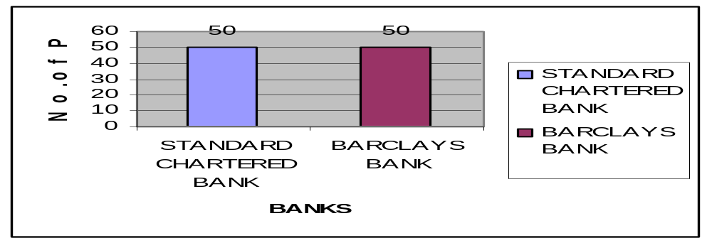
INTERPRETATION:
As 50 customers of each bank were interviewed so in both the banks people have an account.

2. How long you have been associated with this bank?
- 0-1year
- 1-2 years
- 2-5 years
- 5 years and above
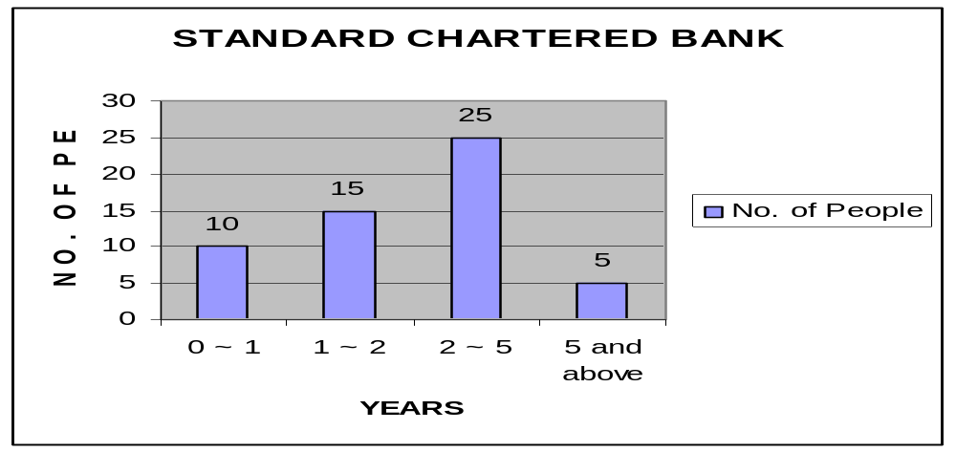
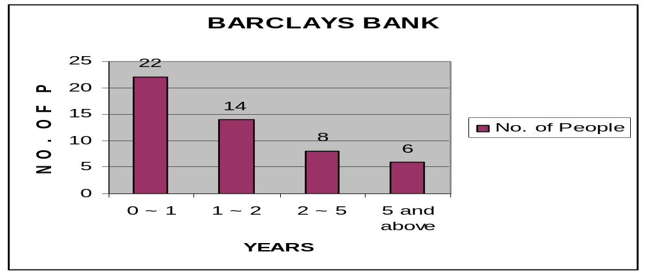

INTERPRETATION :
Standard Chartered Bank has more loyal customers in comparison to Barclays Bank as Standard Chartered has more number of customers associated with it from a long time whereas Barclays bank have more newly added customers.

3. Which type of account do you have in the mentioned banks?
- Saving a/c
- Current a/c
- F.D. a/c
- Any other

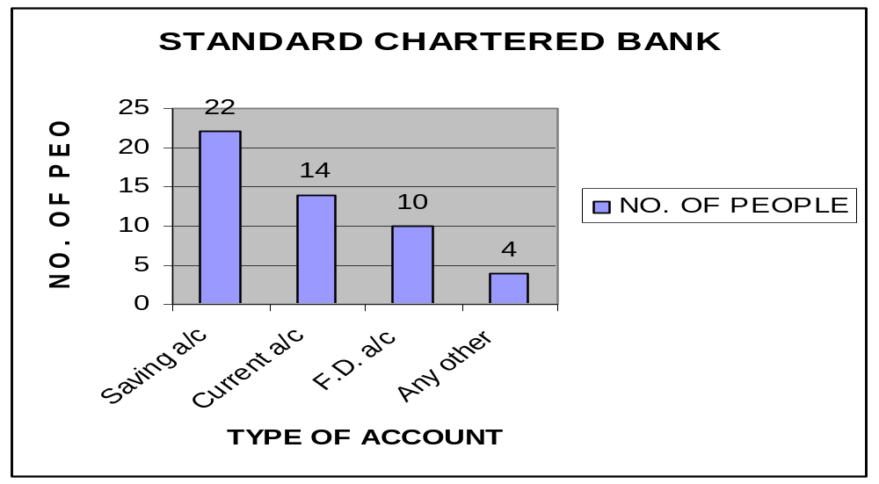

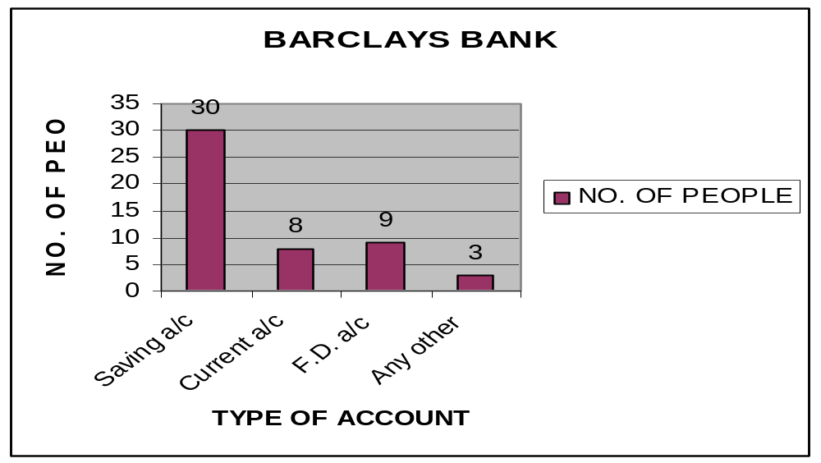

INTERPRETATION :
In both the banks customers prefer to open the Saving a/c the most, whereas in terms of Current a/c and F.D. a/c, customers has a preference for Standard Chartered Bank.

4. How much time did it take to open an account?
- 1 week
- 2 weeks
- 3 weeks
- Others

STANDARD CHARTERED CUSTOMERS
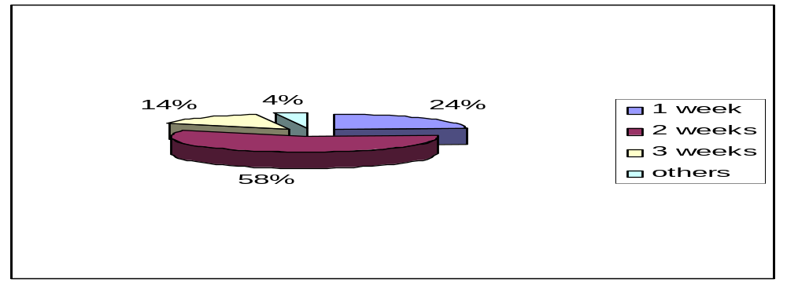

BARCLAYS CUSTOMERS
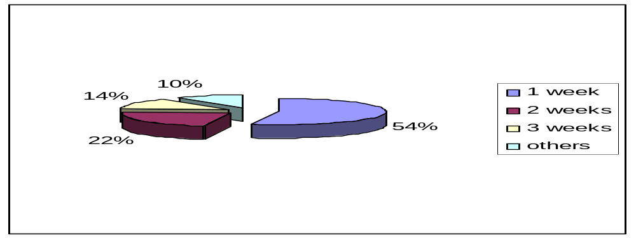

INTERPRETATION:
For Standard Chartered bank most of the people got accounts open in 2 weeks , which implies that what maximum banks claim of one week is not practically present. Whereas customers are satisfied with Barclays bank services.

5. How did you came to know of the facilities provided by the bank?
- Print
- T.V.
- Direct marketing
- Personal relations
- Others

STANDARD CHARTERED CUSTOMERS
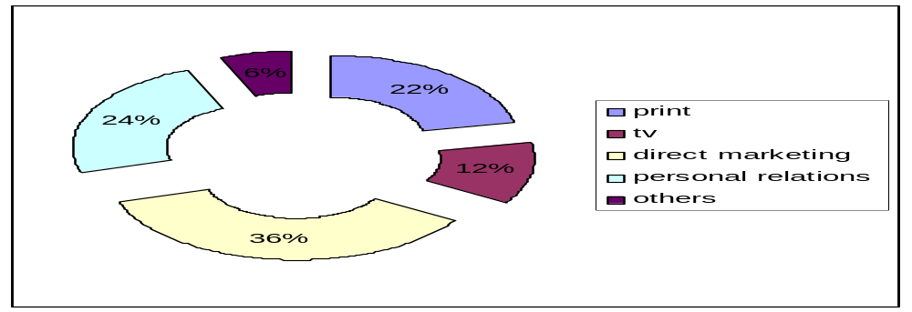

BARCLAYS CUSTOMERS
STANDARD CHARTERED | No. of Respondents
ATM | 46
Door Step Banking | 39
Phone Banking | 12
Mobile Banking | 23
Multi-city Branching | 17
24-Hour Banking | 28
Internet banking | 10
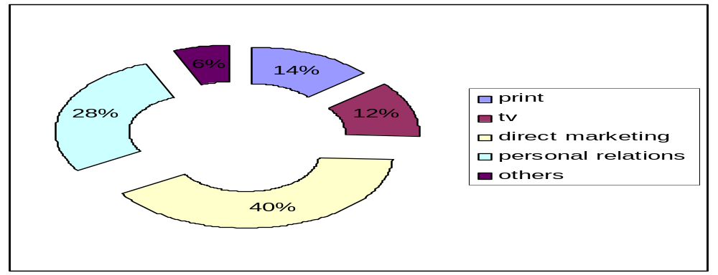
INTERPRETATION:
Both the bank has poor marketing strategy. The customers are only attracted through public relation and direct selling, so banks need to work on it promotion and advertisement.
6. What are the various services you availed from the mentioned bank?
STANDARD CHARTERED BANK
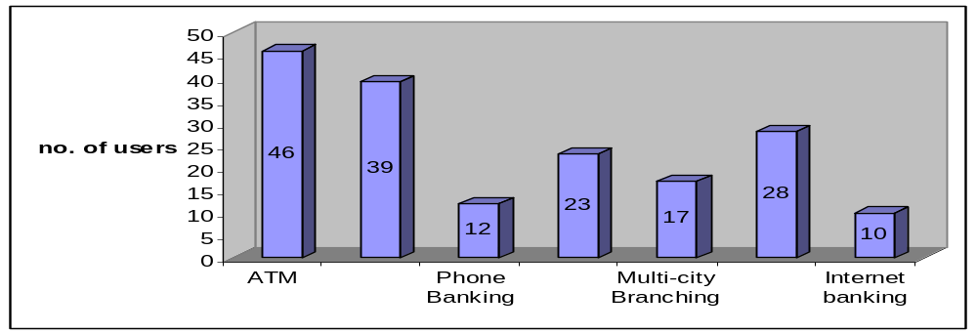
Services of BARCLAYS | No. of Respondents
ATM | 42
Door Step Banking | 0
Phone Banking | 12
Mobile Banking | 20
Multi-city Branching | 10
24-Hour Banking | 25
Internet banking | 32

BARCLAYS BANK
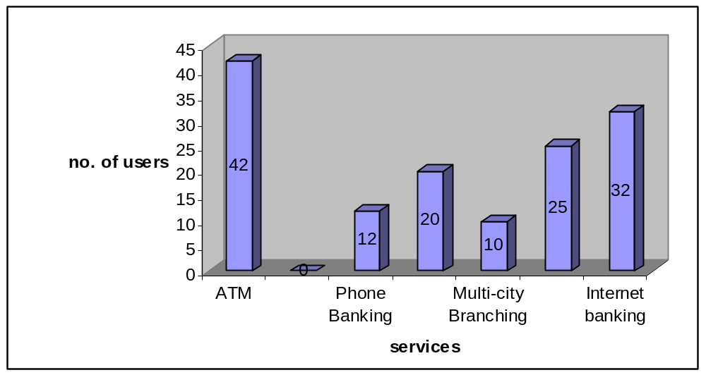

INTERPRETATION:
Both banks customers are satisfied with the ATM services, while the major difference lie in doorstep banking and internet banking. Standard Chartered bank have a unique facility of doorstep banking which helps it to attract more customers but on same side its internet banking is a disadvantage for it.

7. What are the factors that influence your decision while availing any service of a bank?
- Good Customer Care
- Security of your Money
- Goodwill of the Bank
- Network of the Bank
STANDARD CHARTERED BANK
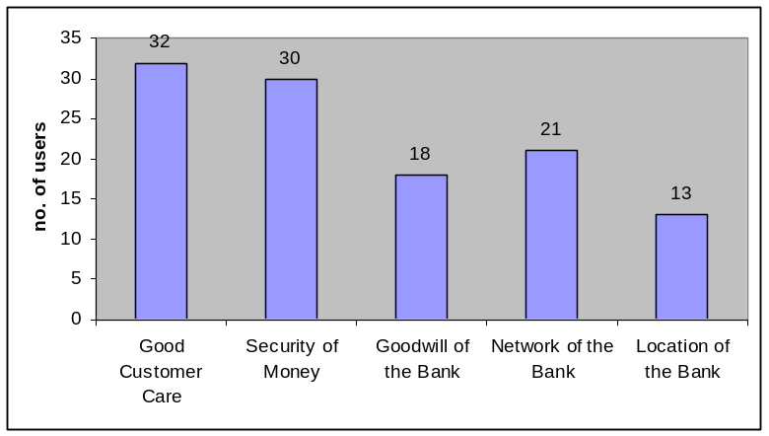

BARCLAYS BANK

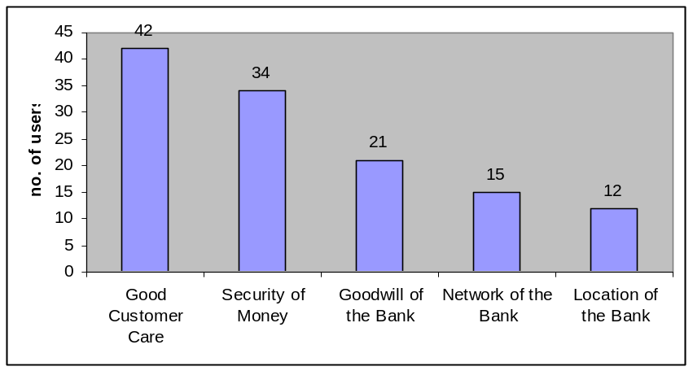

INTERPRETATION:
Good customer care is one of the key factors that can influence the customer towards the bank.. Other factors like Security of the money, goodwill of the bank, good network, and location of the bank also play an important role while attracting the customer towards the bank. Customers from both the bank look forward towards customer care services and security of their money.
8. Are the solutions/replies to queries prompt in the mentioned banks?
- Yes
- No

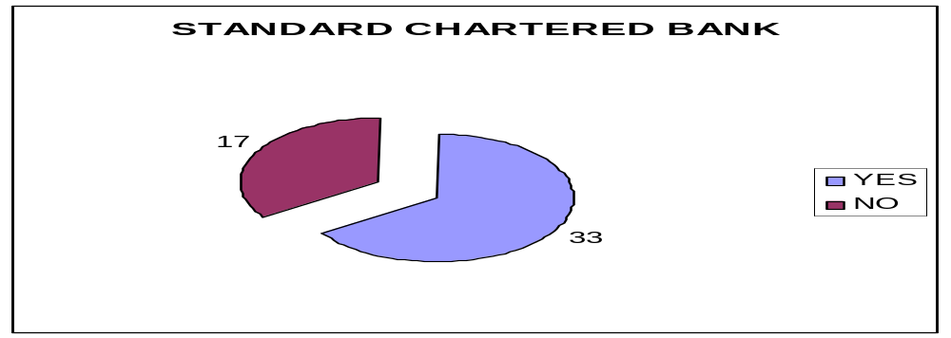
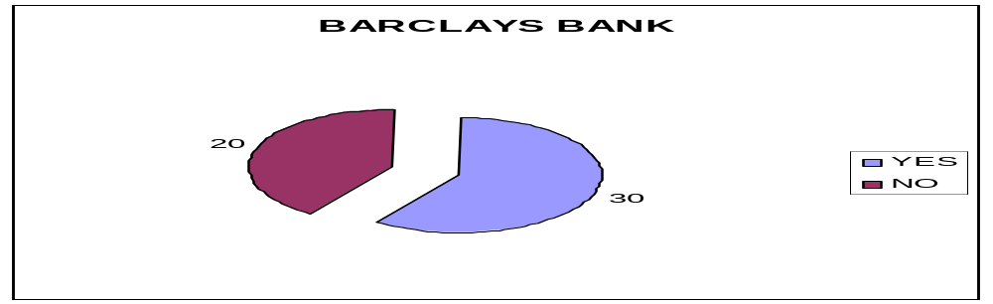
INTERPRETATION :
In both the banks almost 60% of the customers are satisfied with the promptness of handling queries but still customers are more satisfied with the services of Standard Chartered Bank.

9. Are the services provided by the bank customized?
- Yes
- No

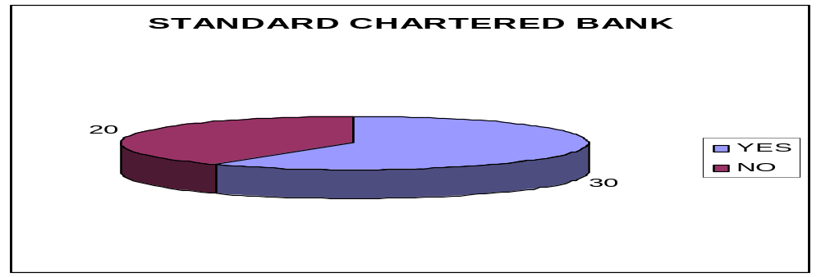
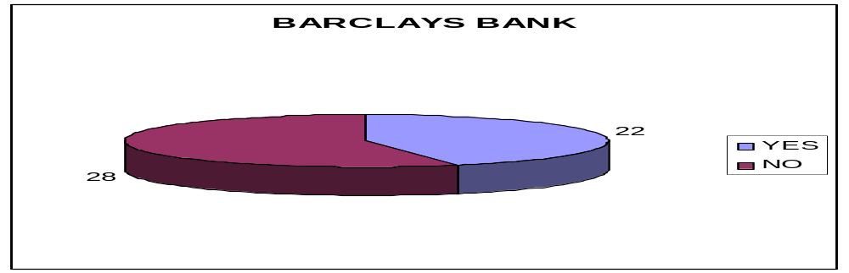
INTERPRETATION :
Greater number of customers of Standard Chartered Bank agrees that the services provided by the bank are customized but still it needs to work on them whereas Barclays Bank still need to work upon its services to make them customize.

10. Are you satisfied with employees behavior?
- Yes
- No
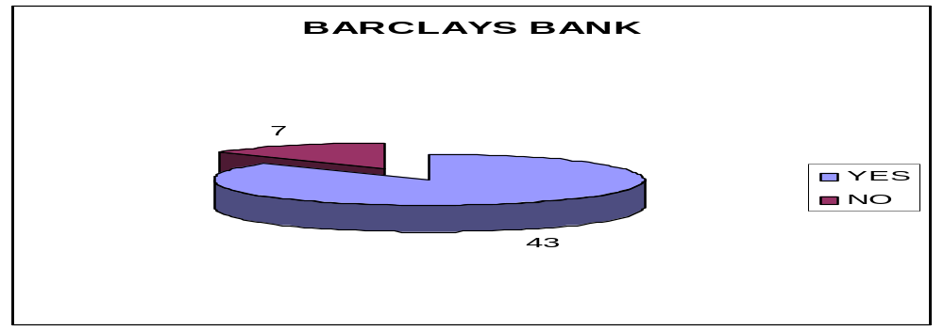
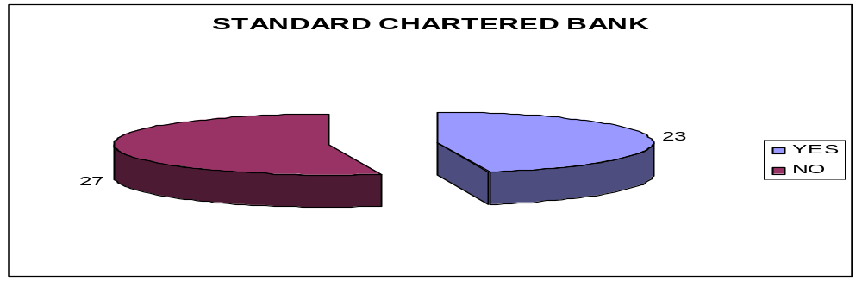
INTERPRETATION:
Standard Chartered customers are still not happy with employee’s behavior which would let Standard Chartered to loose its customers in future; on the other hand people are not facing any customer care problems with Barclays bank.

11. Would you recommend your bank to your friend or relative?
- Yes
- No
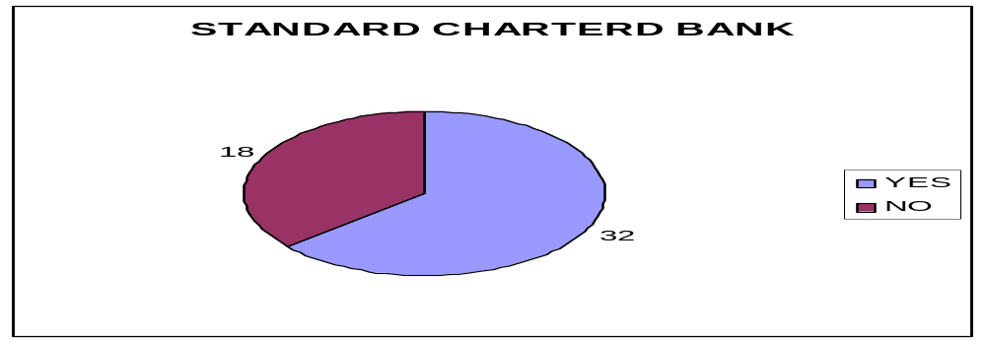

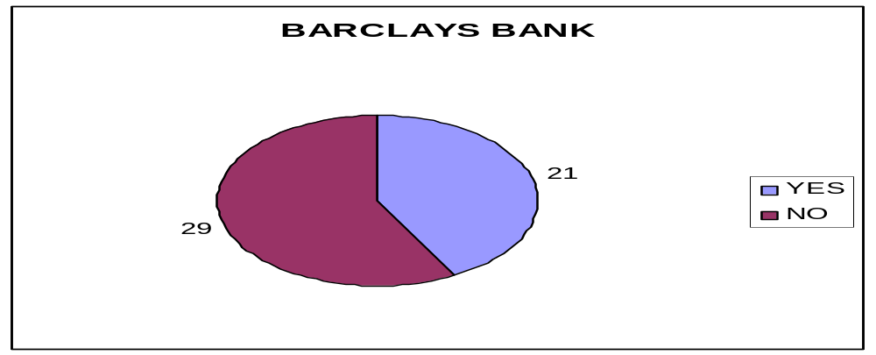
interpretation :
Customers of Standard Chartered Bank are quiet happy with it’s services and replied in positive about referring the bank to their friends and relatives, while, the large number of Barclays customers refused to recommend the bank to others. Still Standard Chartered Bank need to develop its services in order to attain greater chunk of market.
FINDINGS
- Word of Mouth is the most influencing factor which influences the person before opening of the bank account, hence a bank’s positive image and satisfied customers will attract more customers. It is clear that majority of people open their bank account on Word of Mouth.
- It is clear that most customers open their bank a/c in those banks whose branch is in the proximity to their homes or offices.
- The potential account holders normally go for the Individual a/c.
- Services offered by the banks are highest on the priority list of account holders.
- Customers are satisfied in an overall survey, this shows that the Standard Chartered Bank is catering to the needs of customers in a near perfect manner.
- Customers of Standard Chartered Bank wants more Branches and ATM’s.
- Few respondents say that sales force do not provide the consumers with entire information, which may pose future problems as this may create bad image of the bank for future.

CHAPTER- 7
LIMITATIONS

LIMITATIONS OF THE STUDY
Following are the limitation faced by the researcher during the study.
- The source of information was the customer so the study was totally dependent on customer’s response.
- Some unreliable response from the customers was received due to lack of time.
- No response condition in the presence of the customers.
- Questions on sales were highly sensitive and sometimes resulted in non-response from the customers.
- Questionnaire method could be used only with literate and co-operative customers; otherwise most of the customers were questioned informally and at their convenience.
- Time and other factors also worked as limitation in this study.
- Limited area of survey, as survey was conducted in Delhi only so it may not be representative of the whole population.

CONCLUSION

AND RECOMMENDATIONS

CONCLUSION
To conclude, it can be said that the research findings clearly reveal the goodwill and reputation of the bank among the customer. But there is a need to strengthen the bank by spreading awareness about the services offered by STANDARD CHARTERED BANK through advertisement and by expanding the branches of the bank all over the country and also by tapping the potential customers through innovative means.
Standard Chartered Bank should focus on building long-term relationship with its customers, as Word of Mouth is the factor which brings maximum amount of business. It should go for customer delight.
The misinformation by sales force may pose future problems as this may create bad image of bank for future, in today’s competitive scenario it is equally important to retain the existing customers apart from creating new ones. Since cost incurred on new customer is approximately five times more than the existing customer.

IMPLICATION
Standard Chartered Bank has well understood the need of customer but still it need to work on its marketing strategy as much people are yet not aware of the bank.
Through the survey it can be observed that customers opt more for those bank which has broad network and is connected with the customers. So, Standard Chartered Bank need to open more ATM’s, and branches to penetrate more customers.

RECOMMENDATIONS
1. STRONG NEED OF BRAND BUILDING
The bank needs to make a lot of marketing effort. A lot of noise is made whenever a child is born and as long as that noise is not made, the doctors are not sure about the life of that child. Same is the case in marketing. Whenever a new branch comes into existence it is necessary that they announce their birth. Here comes the pre-launch exercise, and similar is the case after the birth. The name has to be taken again. Boast about yourself, about the strong points that you have over and above your competitors. Pull the consumer towards you. As said earlier it is a relationship of trust and this trust can be generated through better and better performance of the bank. Now, as working with the bank for some time the facts have come out that they believe in low costing and want to keep low profile. So better way of marketing can be sought which are low at cost.
2. PROMOTIONAL STRATEGIES
Press publicity
Paper inserts
Advertisements in newspaper (local and national).
Interest cards distribution
Mailers / personal invitations to selective section of the society
Leaflets
Outdoor publicity
Banners in commercial areas and prime sites.
Air balloons at shopping complex.
Bus stands shelters.
Off site ATM for developing business
Advertisements on Dividers and Railings.

Media
Local channel advertisement (cable TV scrolls)
Advertisements in news channels and business channels

3. ADVERTISEMENT STRATEGIES SEGMENTED ACCORDING TO THE TARGET CUSTOMER
Senior citizens, housewives, students, service class
Personal mailers
Contacting at parks during morning and evening walks
Contacting at stop lights
Road shows at market sights
Cable TV advertisements during prime time
Stick on the newspaper
Leaflet on the wiper of the vehicles in the parking lots
Educational bodies
Sponsoring some events in schools and colleges.
Meeting the top management for opening of salary accounts and fee payment system of the students.
4. Solid network required to develop the business further
If we see the results of the survey, it is evident that people prefer strong networking system to make their banking life as comfortable and reachable as possible. For Bank to enjoy a good customer base, they should make efforts towards developing more and more ATM in the city and extension counters to facilitate better and fast service. Updating of technology from time to time is very necessary.

5. MAKE THE BRANCH SELF-INFORMATIVE
The branch should be decorated in a manner, which would provide maximum information to the customers without any difficulty. All the schemes and products, all the service charges, days and time of transactions should be printed in a beautiful manner and hanged on the walls of the branch where customer can see with ease. By doing so the customer would feel more attached and will be converted in higher number of accounts.

bibliography

STANDARD CHARTERED Brochures and Manual’s
ICFAI Journal.
The Marketing Review, Volume 2, Number 3, Autumn 2001 , pp. 319-355(37)
BOOKS:
Marketing Management – Philip Kotler
Research Methodology Method’s and Technique - C.R. Kothari
- Kotler, Philip (2005), Marketing Management (6th Ed.) :Tata Mc Graw - Hill Company Ltd.
- Kothari, C.R.(2004) Research Methodology Method’s and Technique (8th Ed), :Sultan Chand And Sons, 2004.

MARKET RESEARCH SITE:
www.standardchartered.co.in, Monday, July 06, 2009, 1:02:38 PM
http://en.wikipedia.org/wiki/Consumer_behaviour, Friday, June 26, 2009, 1:56:04 PM
www.marketreasearch.com Tuesday, June 30, 2009, 10:59:20 AM
www.corporateinformation.com, Tuesday, June 30, 2009, 11:13:48 AM
http://www.essays.se/essay/d1bf8462a7, Monday, September 07, 2009, 9:14:26 PM
http://www.ingentaconnect.com/content/westburn/tmr/2001/00000002/00000003/art00006, Monday, September 07, 2009, 10:02:35

ANNEXURE

STANDARD QUESTIONNAIRE
[This is to get the general information from all the customers of Standard Chartered Bank and Barclays bank, and what they think about the bank and how Standard Chartered can be an ideal bank]
1. NAME :
AGE :
SEX : MALE F FEMALE
PROFESSION :
INCOME : LIG
MIG
HIG
1. In which bank do you have an account?
Standard Chartered Bank
Barclays Bank

- How long you have been associated with this bank?
- 0-1year
- 1-2 years
- 2-5 years
- 5 years and above

3. Which type of account do you have in the mentioned banks?
- Saving a/c
- Current a/c
- F.D. a/c
- Any other

4. How much time did it take to open an account?
- 1 week
- 2 weeks
- 3 weeks
- Others

5. How did you come to know of the facilities provided by the bank?
- Print
- T.V.
- Direct marketing
- Personal relations
- Others

6. What are the various services you availed from the mentioned bank?
- ATM
- Door Step Banking
- Phone Banking
- Mobile Banking
- 24 Hours Banking

7. What are the factors that influence your decision while availing any service of a bank?
- Good Customer Care
- Security of your Money
- Goodwill of the Bank
- Network of the Bank
- Location of the Bank

8. Are the solutions/replies to queries prompt in the mentioned banks?
- Yes
- No
9. Are the services provided by the bank customized?
- Yes
- No
10. Are you satisfied with employees behavior?
- Yes
- No
11. Would you recommend your bank to your friend or relative?
- Yes
- No

